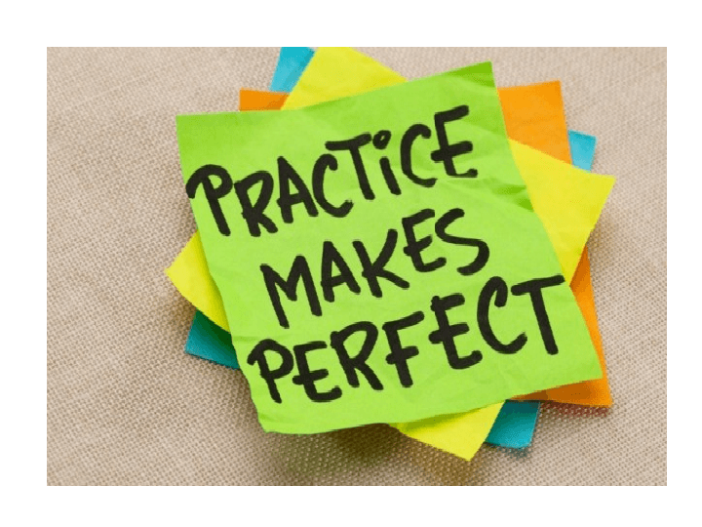
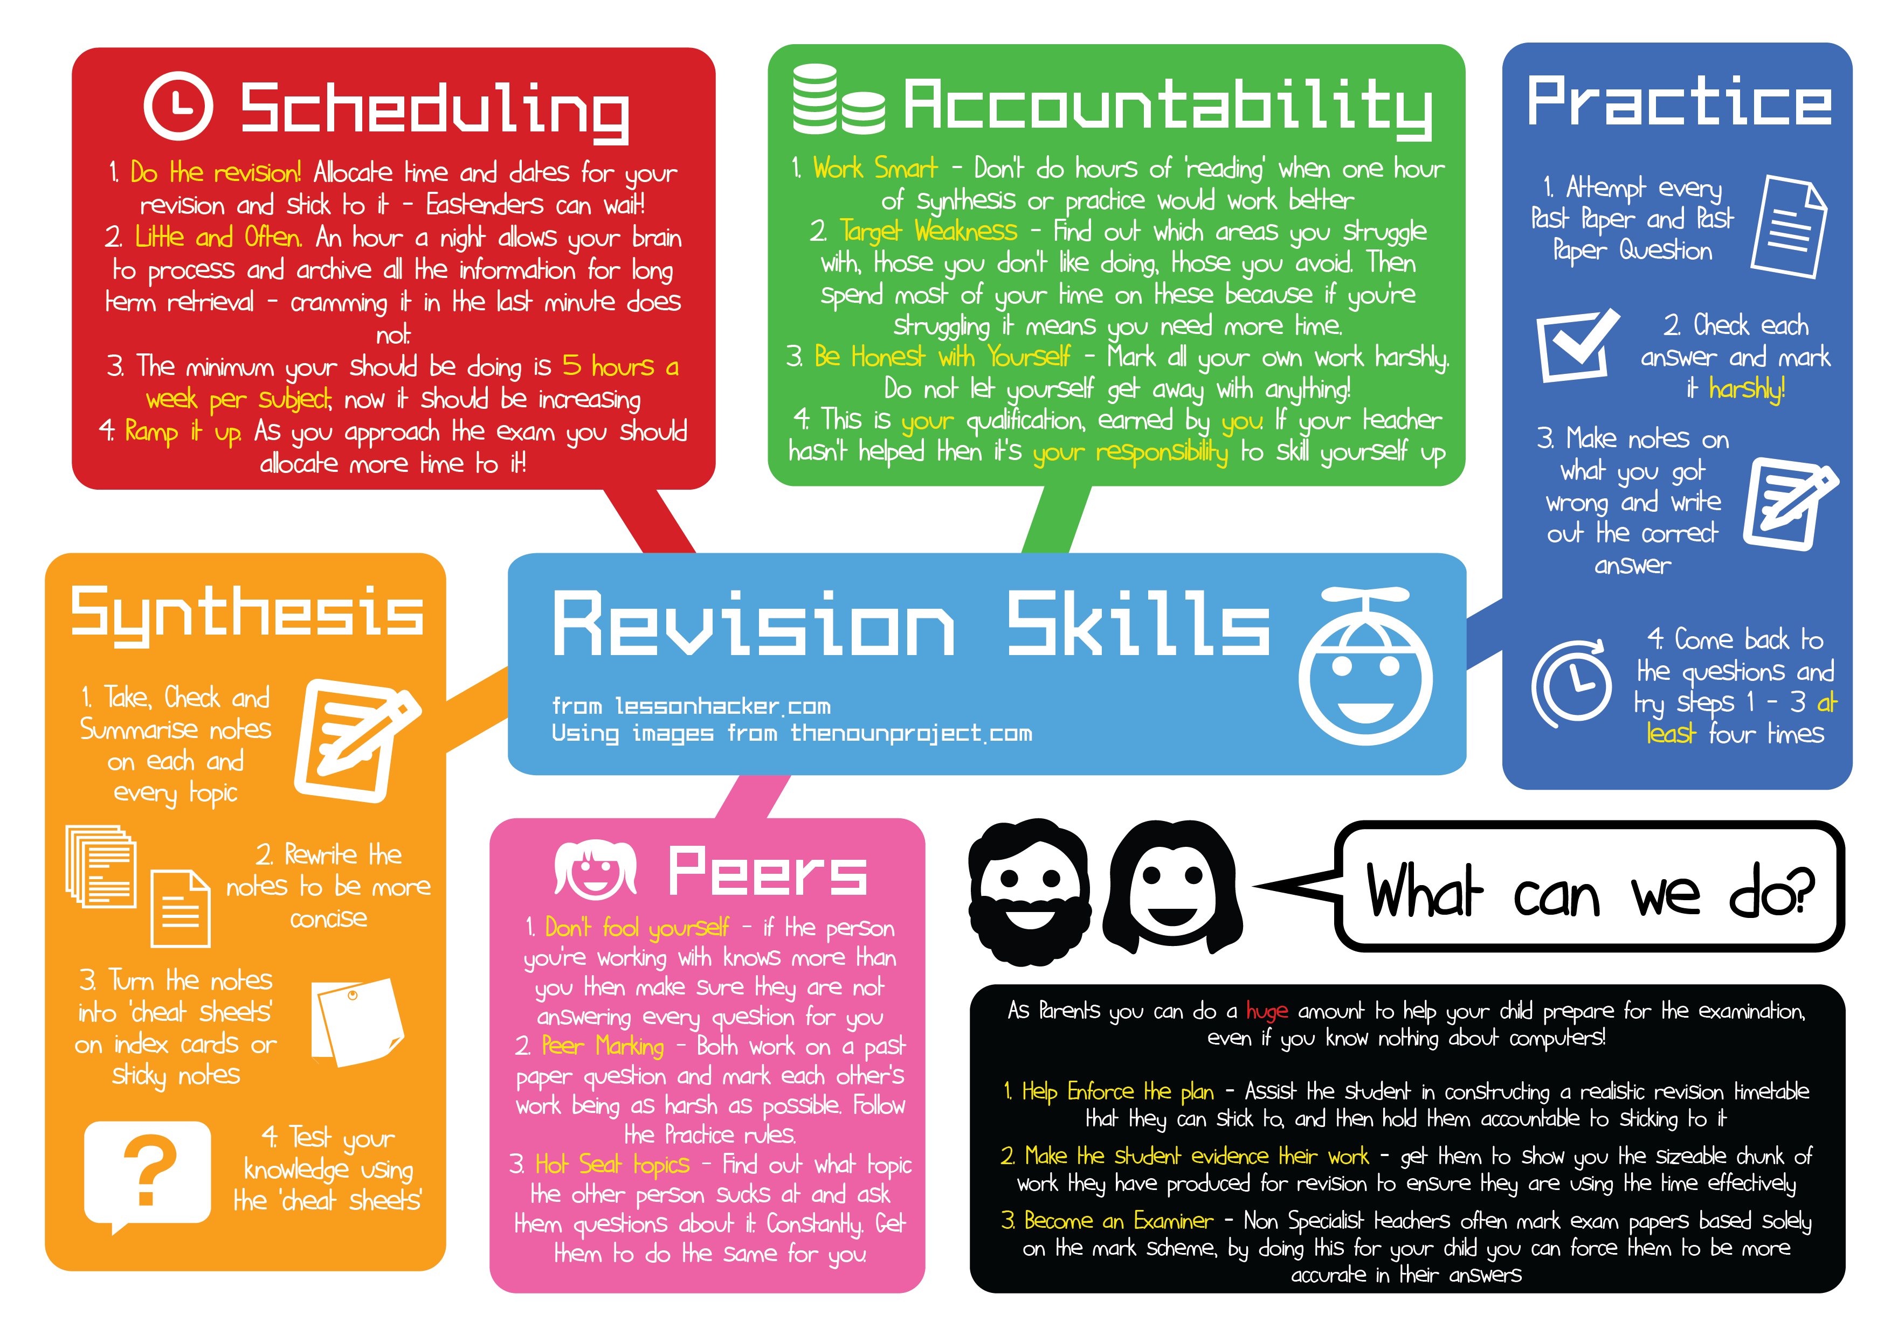
Use this to help with your revision!
This is your qualification earned by you. Your choice to do the work!

