Study Skills Checklist
The following checklist includes some key behaviour that are commonly associated with academic success. Think about how you would respond to each item: Is this a behaviour that you engage in on a regular basis? Highlight in green if YES, yellow if SOMETIMES, and RED if NO. If your response to any item is NO or SOMETIMES, it is something to think about carefully. If you want assistance developing any of these skills, ask your tutor, come to a tutorial, look at our revision skills areas on Connect or book an appointment in the study skills area in the library.
Areas essential to strong study habits include:

• Goal Setting
• Time Management
• Homework Effort and Environment
• Classroom Performance and Behaviour
• Concentration & Memory
• Textbook Reading
• Note Taking
• Test/Exam Preparation

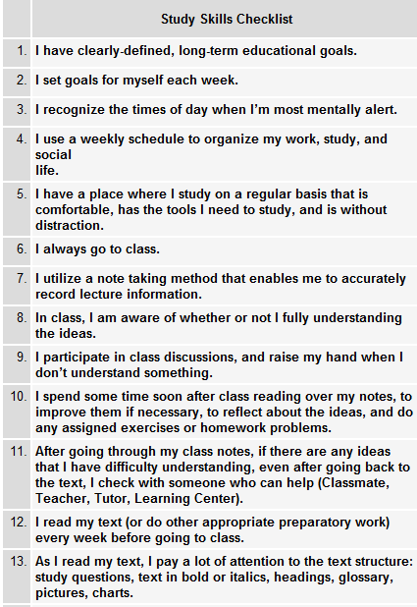 | 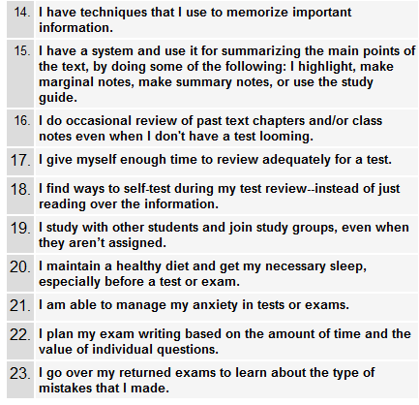
What are your strengths (in terms of study skills)?

What do you need to think about developing to help you progress?

