Chi-squared test:
Formula you need to learn:
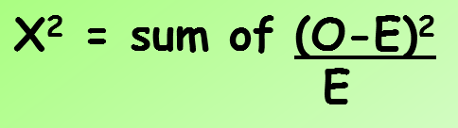
O= Observed results (the results your experiment produced), E= Expected results (the results you predicted using your null hypothesis)
- Watch the video link below and answer the questions.
https://www.youtube.com/watch?v=qYOMO83Z1WU

- What is meant by a null hypothesis? Watch to the end of the video and give 2 examples of null hypotheses.

- Why do we carry out the Chi-squared test?

- What are the degrees of freedom and how do we work this out?

- What is the probability value all scientists use to compare out chi-squared value? What does this probability value actually mean?
Note: In AQA we call the Chi-squared value the critical value.

- If the critical value lines up with a probability value higher than 0.05 or 5% what does this mean?

- If the critical value lines up with a probability value lower than 0.05 or 5% what does this mean?

- Complete the dihybrid chi-squared test calculation below. Remember to make your conclusions

- Complete the ladybug chi-squared test calculation below. Remember to make your conclusions

