Surface area, volume and SA:V- Homework
Surface Area: The area of a shape that is in contact with the environment. To work out the SA of a cube you do L X W X 6 (6 is the number of sides a cube has)
Volume: The space inside an object/cell. To work out the V of a cube you do L X W X D
SA:V: Surface area to volume ratio; the proportion of the surface area to the volume of an object/cell. E.g. If the SA:V is 2:1 for a cell we would say there are 2 units of cell membrane covering every 1 unit of cytoplasm.
Why is SA:V so important?
- On cell B label the
Membrane, cytoplasm, nucleus, ribosomes, vacuole, mitochondria.
- Which cell has the larger SA?
- Which cell has more channels in its membrane for more exchange of substances into/out of the cell?
- What is the advantage of having a larger SA?
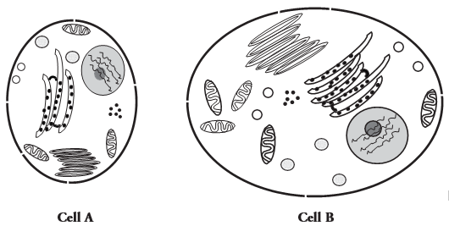

Calculating SA and V of a cube
Every side of a cube is exactly the same size.
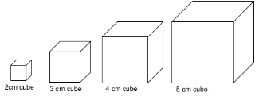
5. Use the calculations given in the definitions to work out the SA and V’s of the cubes in the table. The first one has been done for you.
Cube size (cm) | SA of cube (cm²) | Volume of cube (cm³)
2 | 24 (2x2x6) | 8 (2x2x2)
3
4
5
69
1202
Extension: Can you write your answer to the SA and V of the final cube (1202cm) to 2 significant figures. Suggest why we haven’t asked you to do this on the table?
6. Describe the change in the surface area of the cube when the length of the side doubles.
7. Describe the change in the volume of the cube when the length of the side doubles.
8. When a shape gets larger, which increases at a faster rate, surface area or volume? Can you use the data from the table to support your answer.
Work out the SA:V of a cube.
For the cube that is 2cm by 2cm we would write the SA:V as 24:8 but we can simplify this to 3:1. We can work this out by 24/8=3, 8/8=1 which gives us 3:1
9. The title of the final column of the table is SA:V. fill in the final column of the table.
Extension: Suggest why the SA:V doesn’t have any units?

10. Describe the change in the SA:V when the length of the side doubles

Lots of small objects combined have more surface area in the same volume as one large object.
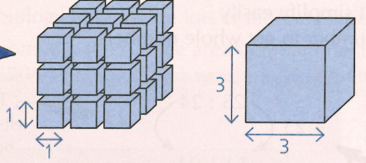
12. Work out the SA and V for the 3 by 3 cube.
SA: _____________
V:______________
SA:V: ___________
You need to work out the SA of each individual cube first then x by how many cubes there are.
E.g. 1 cube = 1 x 1 x 6= 6cm²
There are 27 cubes; 6 x 27 = 162cm²
11. Work out the combined volume of the cubes. Show your working
___________________________
Work out the SA:V: ___________________

