Working out magnification calculation using a scale bar
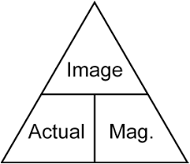
Sometimes questions want you to use the diagram to carry out 2 calculations instead of 1.
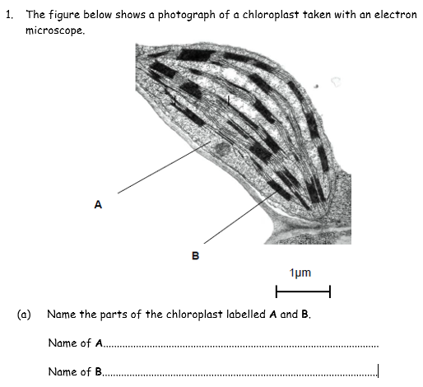
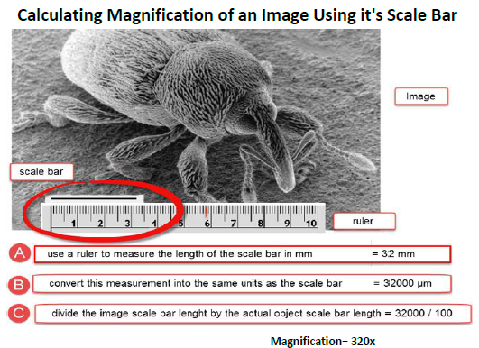
Note: To work out actual length you need to calculation:
A= I/M
You can measure the longest length of the chloroplast in mm using your ruler but you are missing the magnification. What do you do?
Answer: Use the scale bar to work out Magnification

(b) Calculate the actual length of the chloroplast in the image.
Step 1: Use the scale bar to work out the magnification of the image

Step 2: Measure the chloroplast in mm’s using a ruler then use your answer from step 1.

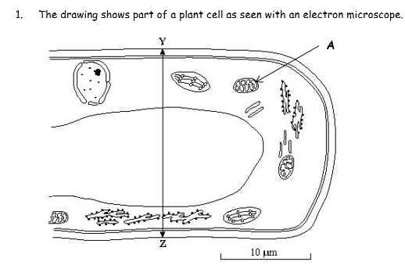
- Calculate the actual length of the line Y-Z. Show your working.

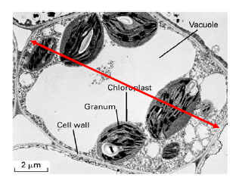
- Calculate the actual length of the plant cell. Show your working.

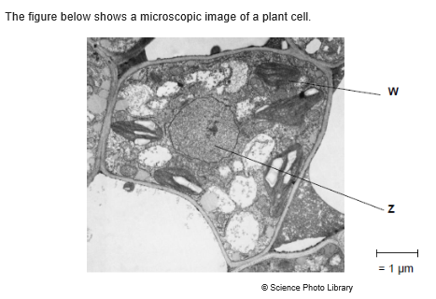
- Calculate the magnification of the plant cell. Show your working.

Mark scheme:
- (a) A= Stroma (b) Grana/Granum
b) A= I/M Missing Magnification, use the scale bar. M of scale bar = I/A
Image size of scale bar = 9mm x 1000= 9000um
Actual size of scale bar = 1um
M of scale bar = 9000um/1um = x90000
A= I/M A = 40mm/9000= 0.004mm or 4.44um.
- A= I/M Missing magnification, use the scale bar.
M=I/A 18mmx 1000 = 180000/10= x1800
A= I/M A= 38mm/1800= 0.02mm or 21.1um

- A=I/M M=I/A 17mm x 1000 = 17000/2 = x8500
A= I/M A= 45mm/8500 = 0.005 or 5.3um.

- M=I/A You don’t need to measure the cell you can just use the scale bar.
M= 5mm x 1000= 5000 / 1 = x 50000

