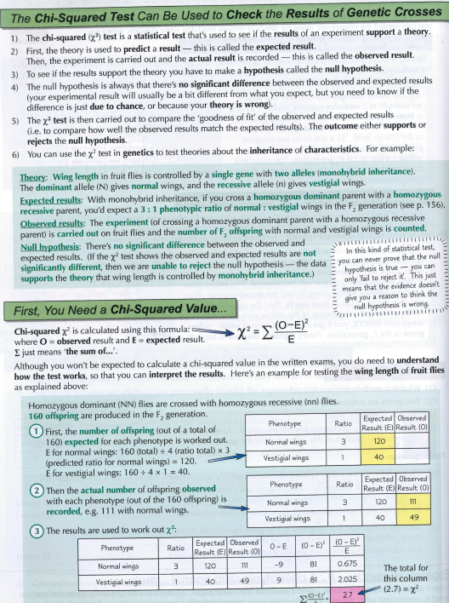
4. Once you have calculated your X2 value you need to compare this to a critical value.
5. The critical value is found on a probability table. You will always be given either the probability table or the critical value to use.
This is your calculated value

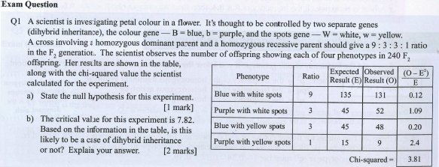
Complete the table and work out the chi-squared value.
Probability and critical values:
Biologists use a probability value of 0.05 or 5%. This is a hurdle which is set to determine if the difference in observed results and expected results might simply be due to chance or because another factor is affecting the outcome.
0.05 means that if scientists were to carry out the same experiment 100 times the probability of these exact results coming up by chance would be at least 5 times.
If these observed results came up more than 5 times then these results are even stronger, so the probability value is bigger than 0.05 or 5%
If these observed results came up less than 5 times, then the probability value is less than 0.05 or 5%.
Some very clever mathematicians have produced probability tables with calculated critical value, you will need to be able to compare your calculated value to these critical values then draw conclusions.
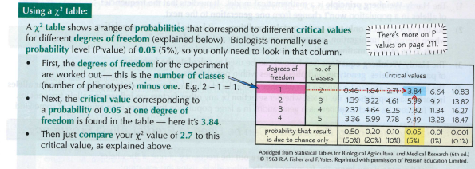
You then compare your calculated value to the critical value.
Q1) Work out the critical value the petal colour example above. Is your calculated value bigger or smaller than the critical value? Which probability value is your calculated value closest to?
4 categories (blue with white spots, purple with white spots, blue with yellow spots and purple with yellow spots)
D of F: 4-1 =3 degrees of freedom with a P value of 0.05 (5%). The critical value is 7.82
The calculated value is smaller than the critical value.
The calculate value is between the probability value of 0.50 (critical value of 2.37) and 0.20 (critical value of 4.64)

Q2) Work out the critical value for the fruit fly win example above. Is your calculated value bigger or smaller than the critical value? Which probability value is your calculated value closest to?
2 categories (normal and vestigial wings)
D of F: 2-1 = 1 degree of freedom with a P value of 0.05 (5%). The critical value is 3.84
The calculated value is smaller than the critical value.
The calculated value is closest to the probability value of 0.10 (critical value of 2.71)

Q3) What is the critical value if you had 4 degrees of freedom?
Critical value is 9.49

Q4) What is the critical value if you had 4 phenotypes?
4 phenotypes. D of FL 4-1= 3 degrees of freedom. Critical value is 7.82

Drawing conclusions and hypotheses.
We now need to compare the calculated value to the critical value so we can work out the probability of the difference between the observed and expected results being due to chance or another factor, so if we can accept or reject our null hypothesis.
What do we know?
If the calculated value is smaller than the critical value then the probability value is bigger than 0.05 or 5%.
The probability of the difference between the observed and expected results being due to chance is high, no other factor is affecting these results.
What do we need to say in the exam?
- The calculated value is smaller than the critical value so the probability that the difference between the observed and expected results is due to chance is higher than 5%. We accept the null hypothesis.

What do we know?
If the calculated value is bigger than the critical value then the probability value is lower than 0.05 or 5%.
The probability of the difference between the observed and expected results being due to chance is low, another factor is affecting these results.
What do we need to say in the exam?
- The calculated value is bigger than the critical value so the probability that the difference between the observed and expected results is due to chance is lower than 5%. So we reject the null hypothesis.
Note: In your sentence you are talking about the DIFFERENCE between the observed and expected you are NOT saying the results are due to chance.
Q1) Complete the sentence below for the petal colour example above.
The calculated value is smaller than the critical value so the probability that the difference between the observed and expected results is due to chance is higher than 5%. We accept the null hypothesis.

Q2) Write out the sentence for the fruit fly wing example above.
The calculated value is smaller than the critical value so the probability that the difference between the observed and expected results is due to chance is higher than 5%. We accept the null hypothesis.
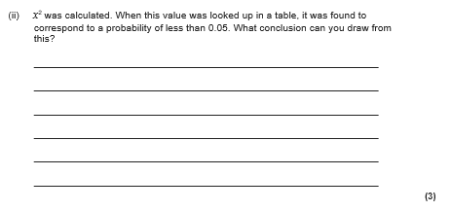
You do not need to know the actual calculated value to be able to answer this, look for the pattern in the sentences you have already written.


You do not need to know the actual calculated value to be able to answer this, look for the pattern in the sentences you have already written.

