Units of measurement

- Complete the diagram below to show: names of the units of measurement, unit symbols, mathematical operations for converting between units.

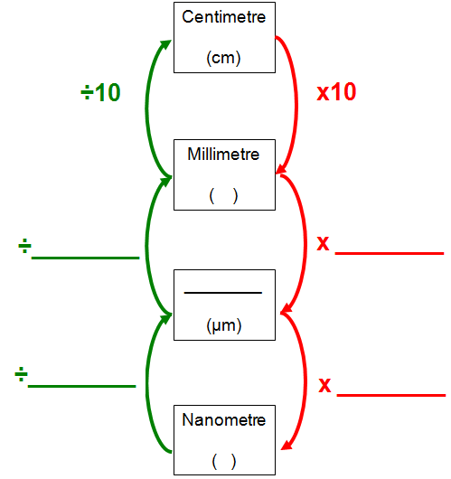

- Complete the table below to show the corresponding value nanometres, micrometres and millimetres for the measurements given in each row. The first row has been completed for you. Ensure that your answers use the correct unit symbols.

Nanometre | Micrometre | Millimetre
5 | 0.005 | 0.000005
1
 | 1
 |  | 1
 | 3
7
 |  | 0.5

- When studying cells structure using a microscope the smallest unit of measurement commonly used to describe findings is the nanometre. Explain why.

Magnification and Resolution

- Define the following terms:

Magnification:

Resolution:

Calculating total Magnification of a compound light microscope

Eyepiece Magnification | Objective Magnification | Overall Magnification
X10 | X4
X10 | X10
X10 | X40
X10 | X100

Calculating Cell Magnification from images
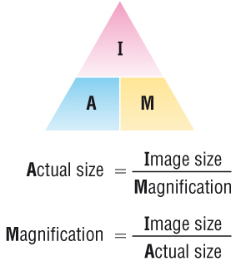

The diagram below is a drawing of an organelle from a ciliated cell as seen with an electron microscope.
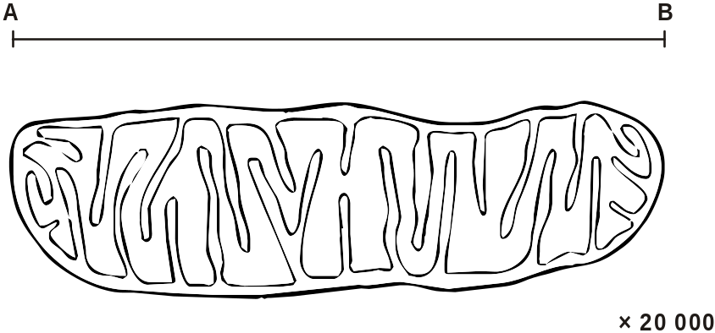

Calculate the actual length of the organelle as shown by the line AB in the diagram. Express your answer to the nearest micrometer (μm).
Show your working.

Answer = ........................................... μm

The diagram below is a drawing of an alveolus together with an associated blood capillary.
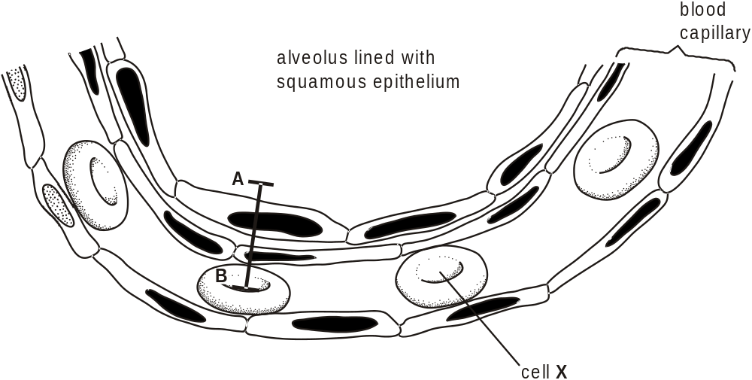
The line AB in the diagram represents an actual distance of 1.5 µm.
Calculate the magnification of the drawing. Show your working.

Answer = × .................................................

The diagram below shows the general structure of an animal cell as seen under an electron microscope.
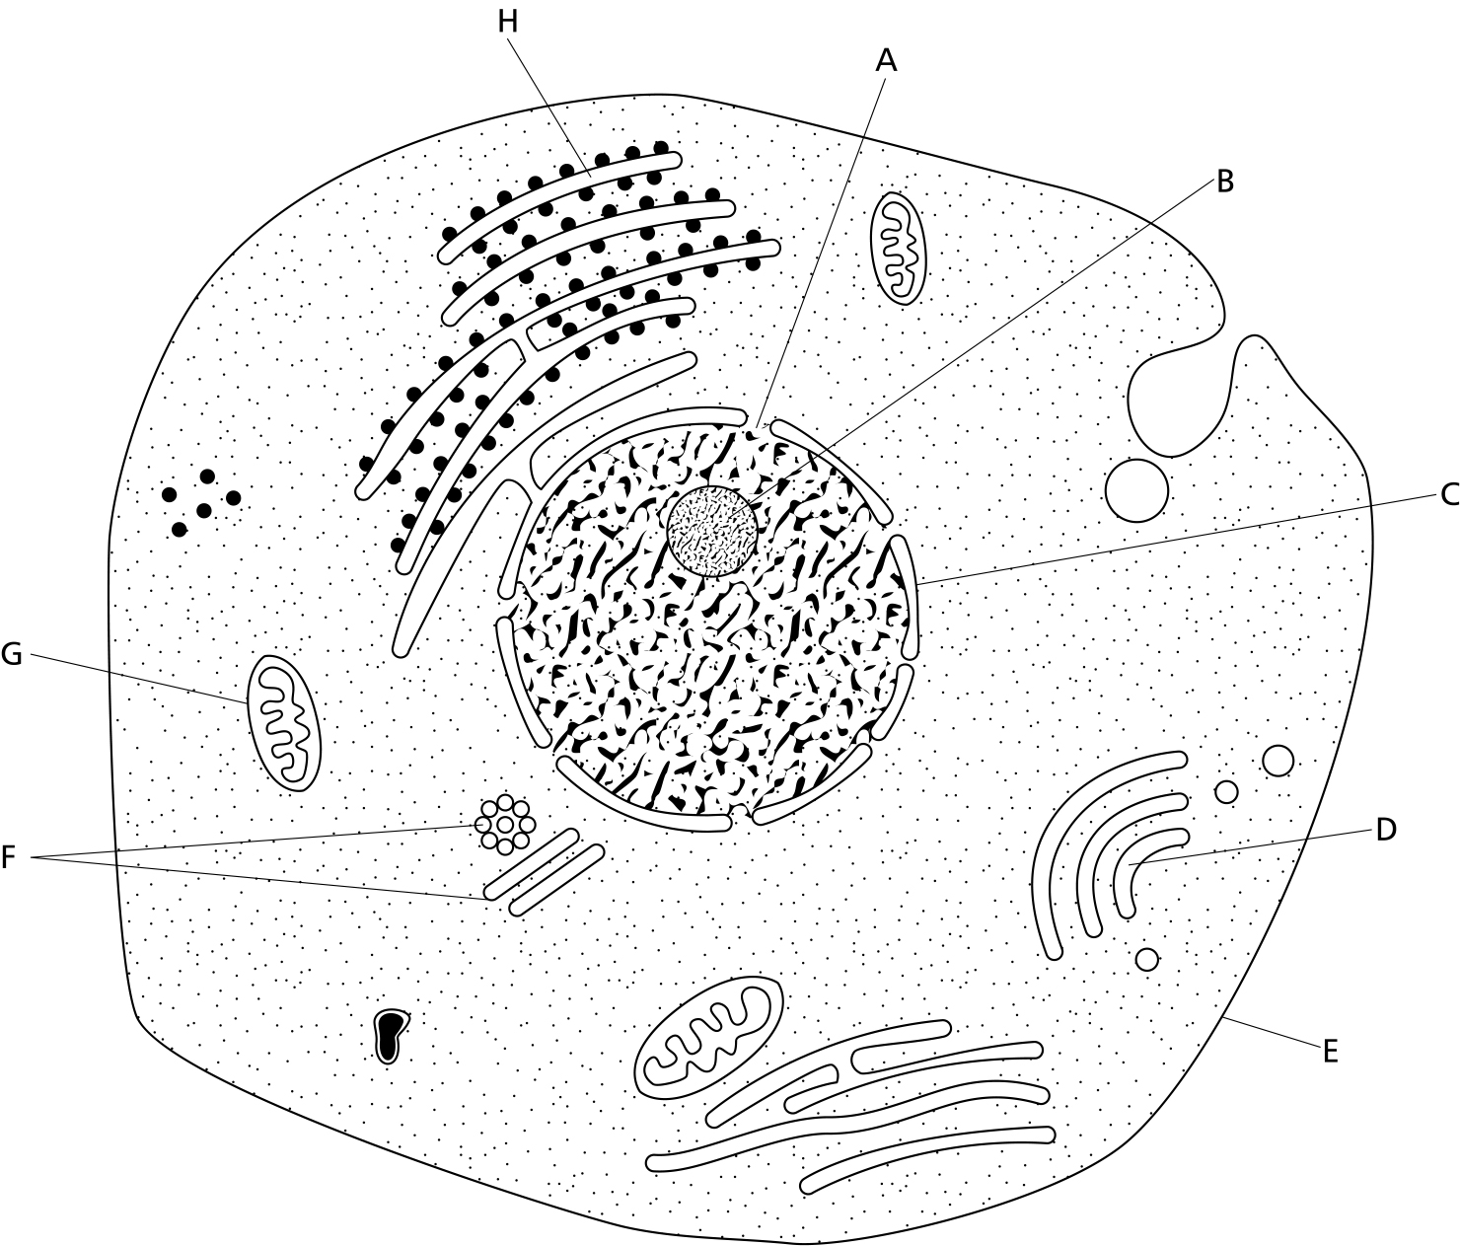

_________
5μm

- Calculate the magnification factor of the diagram

- Calculate the actual length of structure G

- Calculate the diameter of the nucleolus (structure B)

- Calculate the diameter of the nucleus

- Calculate the diameter of the cell at its widest point

The diagram below shows the general structure of a plant cell when viewed under and electron microscope.
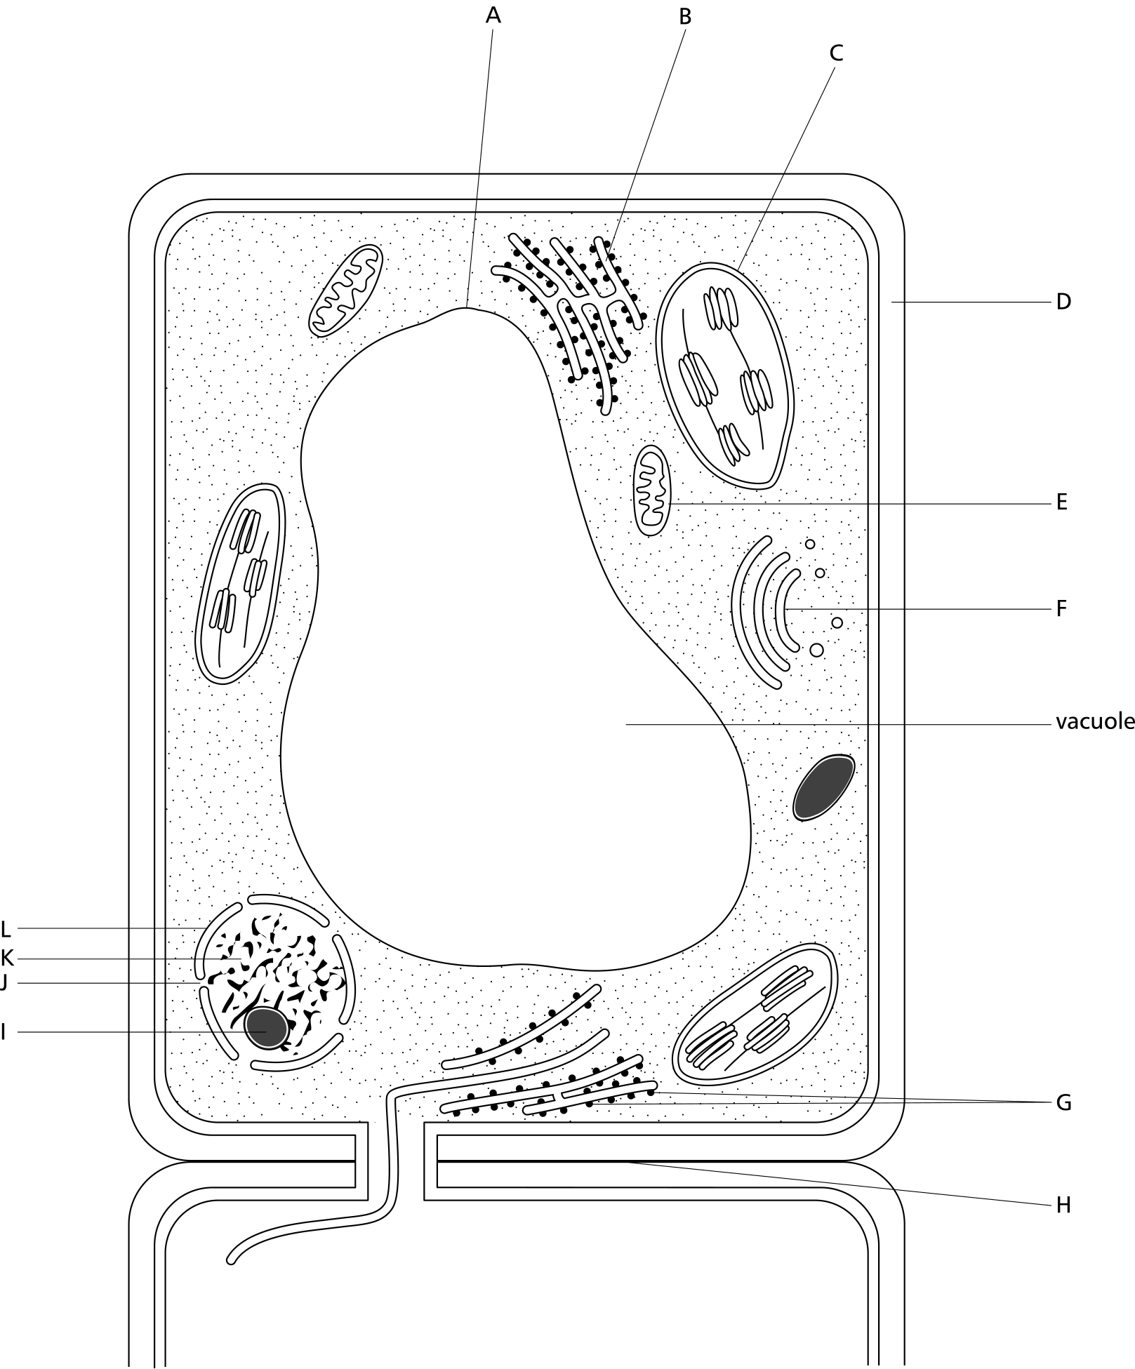
___________
40μm
- Calculate the magnification factor of the diagram

- Calculate the thickness of the cellulose cell wall.

- Calculate the length of the cell.

- Calculate the length of structure C.

- Calculate the length of the vacuole.

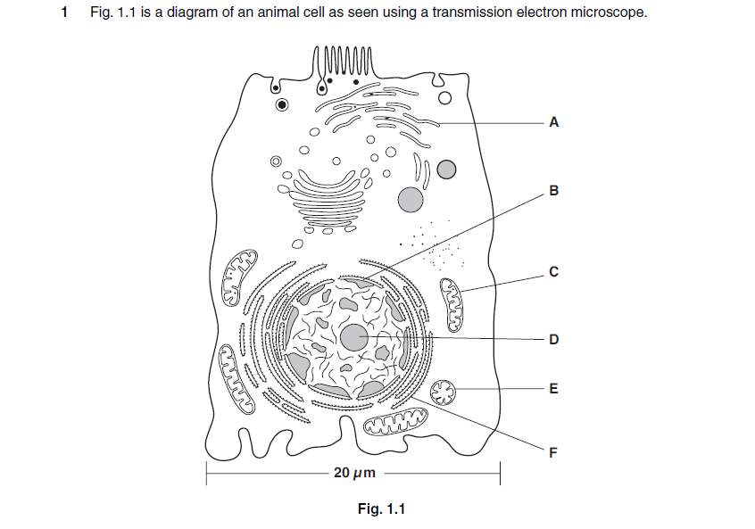

Calculate the actual length of structure C.
Show your working and give your answer in micrometres (μm).

Answer = ………………………………………………………….. μm

