Standard Deviation Questions
Use the following equation to complete the standard deviation for each of the following questions:
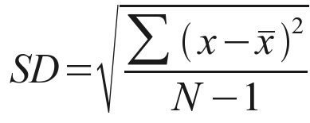

- A student carried out an investigation to see if the rate of enzyme reaction was affected by temperature. The recorded enzyme activity by looking at the concentration of the product produced in 1 minute. The student’s results are shown below:
Temperature | Concentration of product produced (%) min -1
Temperature | Trial 1 | Trial 2 | Trial 3 | Average | Standard Deviation
10 | 40 | 42 | 38
15 | 56 | 58 | 61
20 | 60 | 75 | 62

Calculate the student’s average, and then the standard deviation.

- A student collected data about the length of leaves on an oak tree. The results collected were (mm): 89,87,65,97,86,92,88,75,84,83. Calculate the standard deviation for their results.

- A group of eight students were surveyed to determine their heights, which were as follows (cm): 165,172,171,168,190,181,184,177. Calculate the standard deviation for these results.

- Students were carrying out an experiment to see if the colour of light affected the number of bubble produced by a pond weed plant in one minute. Their results were:
Blue light - 50,58,62; Green light – 20,16,18; Red light – 45,47,51
Using the grid below, draw an appropriate results table with units and headings. Then calculate the average and standard deviation.

- Students were carrying out an investigation to see if the concentration of acid affects the rate at which proteins are denatured. The students did the experiment for 5 different pHs from a pH of 2, using intervals of 0.5pH. The first pH results were: 155,162,157; the second pH results were: 135,137,142; the third pH results were: 127,122,124; the fourth pH results were: 90,87,93; the final pH results were: 60,40,55. Use the table below to record the results, average and standard deviation.

Simpson’s Biodiversity Index
Use the following equation to complete the biodiversity indexes.
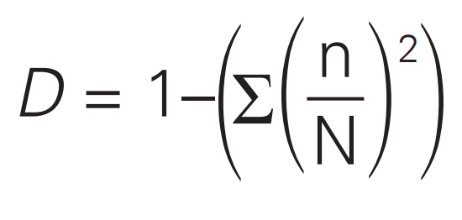

- A student carried out an investigation, looking at two different fields. They calculated the percentage coverage of each species for the two fields which are shown below:

Species Observed | Percentage Cover
Species Observed | Field A | Field B
Cocksfoot grass | 57 | 38
Timothy grass | 32 | 16
Meadow buttercup | 3 | 14
White clover | 3 | 22
Creeping thistle | 1 | 5
Dandelion | 4 | 5
Total | 100 | 100

- What could be concluded about the species evenness and richness of both of the fields?

- Complete the tables below to calculate the biodiversity of both of the fields.

Species Observed | Field A
Species Observed | n | n/N | (n/N)²
Cocksfoot grass
Timothy grass
Meadow buttercup
White clover
Creeping thistle
Dandelion
Sum
1-Sum

Species Observed | Field B
Species Observed | n | n/N | (n/N)²
Cocksfoot grass
Timothy grass
Meadow buttercup
White clover
Creeping thistle
Dandelion
Sum
1-Sum

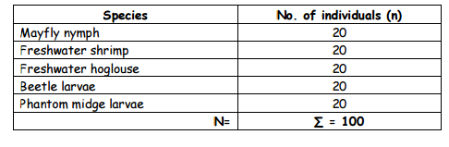
- Students looked at the presence of different species in two water sources. Their results are shown below:

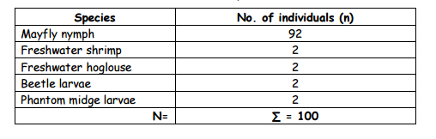

Using the table provided, complete the headings and carry out a Simpson’s Biodiversity index for both samples.

- Which of the two samples was more diverse? Explain why you have chosen this sample (use data in your answer)

- What could be concluded about the species richness and evenness of both of the samples? You should refer to data in your conclusion.

Percentages and Percentage Change

To calculate a percentage you do:

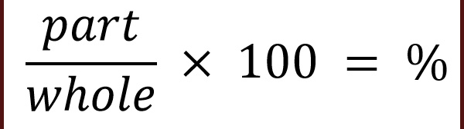

To calculate change in percentage you do:
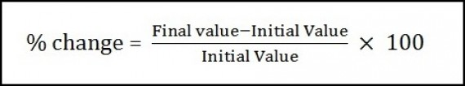

Remember that a percentage change could be a negative percentage change. Check through the question to see if the answer it correct – should it be a positive change or a negative change?

- The volume of a solution increased from 40ml to 50ml. Calculate the percentage increase

- Students were carrying out an investigation. The found that the mass of the substance wasn’t enough to see a change. One student suggested to increase the mass used by 23%. The starting mass was 30mg. Calculate what the new value would be.

- Another student suggested that they should decrease the mass used. They suggested decreasing the mass by 25% from the original. Calculate what the new value would be.

- A student was investigating the changes of heart rate during exercise. Their resting rate was 73bpm. After one minute of exercise their heart rate increased to 85bmp, it then increased to 92 bmp after 10 minutes. Calculate the percentage change between resting and the first working heart rate, first working heart rate and final, and overall change in heart rate.

