Synoptic Essays in Biology
- The transfer of substances containing carbon between organisms and between organisms and the environment
- The causes of variation and its biological importance.
- Mean temperatures are rising in many parts of the world. The rising temperatures may result in physiological and ecological effects on living organisms. Describe and explain these effects.
- Cells are easy to distinguish by their shape. How are the shapes of cells related to their function?
- Enzymes and their importance in plants and animals
- The process of osmosis and its importance to living organisms.
- How microscopes have contributed to our understanding of living organisms
- How bacteria affect human lives
- Energy transfers which take place inside living organisms.
- How the structure of proteins is related to their functions
- The structure and functions of carbohydrates
- Cycles in biology
- The movement of substances within living organisms.
- The biological importance of water.
- How the structure of cells is related to their function.
- Heat and many different substances are transferred within the body and between the body and the environment. Explain how surface area is linked to this transfer.
- The different ways in which organisms use ATP.
- Bacteria affect the lives of humans and other organisms in many ways. Apart from causing disease, describe how bacteria may affect the lives of humans and other organisms.
- Inorganic ions include those of sodium, phosphorus and hydrogen. Describe how these and other inorganic ions are used in living organisms.
- Condensation and hydrolysis and their importance in biology.
- Negative feedback and its importance in biology.
- Ways in which different species of organisms differ from each other
- The transfer of energy between different organisms and between these organisms and their environment
- The structure and functions of carbohydrates
- How carbon dioxide gets from a respiring cell to the lumen of an alveolus in the lungs.
- The biological importance of water
- The functions of nucleic acids.
- The factors which determine an organism’s phenotype.
- How the structure of cells is related to their function (see 18)
- The factors which influence the concentration of glucose in the blood
- The different ways in which living organisms obtain their nutrients.
- The many causes of human disease.
- How the structure of cell organelles is related to their functions
- Maintaining constant conditions in the body.
- Relationships between animals and plants
- How the structure of proteins in relation to their functions.
- A Polymers have different structures. They also have different functions.
- Describe how the structures of different polymers are related to their functions

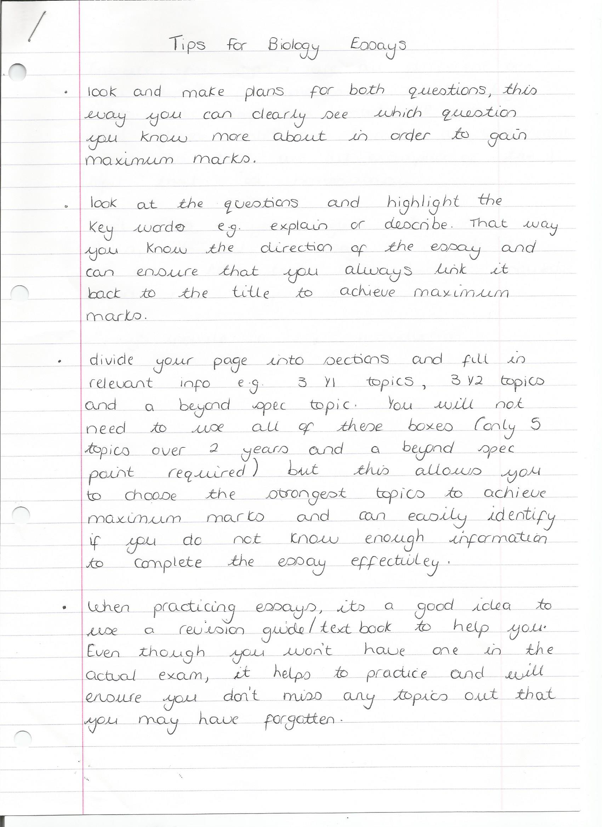
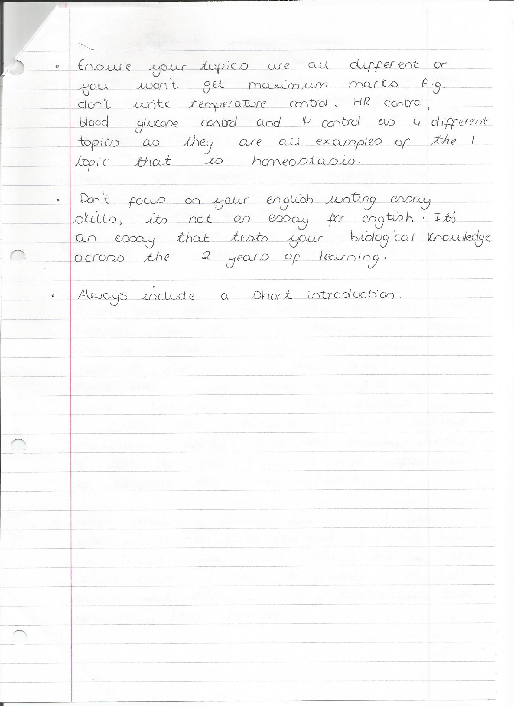
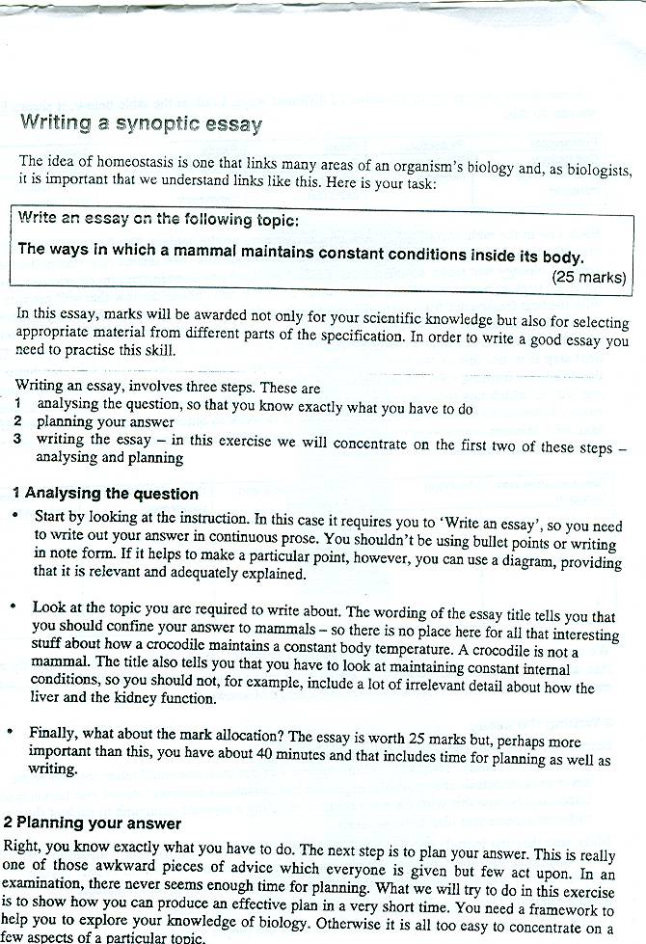
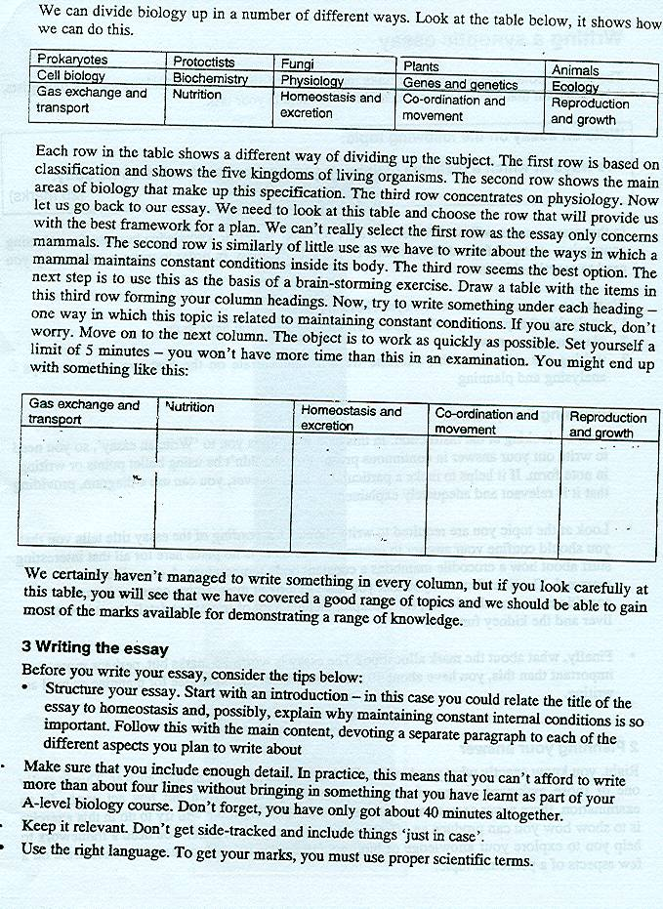
An exceptional essay
• reflects the detail that could be expected from a comprehensive knowledge and understanding of relevant parts of the specification
• is free from fundamental errors
• maintains appropriate depth and accuracy throughout
• includes two or more paragraphs of material that indicates greater depth or breadth of study
A good essay
• reflects the detail that could be expected from a comprehensive knowledge and understanding of relevant parts of the specification
• is free from fundamental errors
• maintains appropriate depth and accuracy throughout
An average essay
• contains a significant amount of material that reflects the detail that could be expected from a knowledge and understanding of relevant parts of the specification.
In practice this will amount to about half the essay.
• is likely to reflect limited knowledge of some areas and to be patchy in quality
• demonstrates a good understanding of basic principles but will contain some errors and evidence of misunderstanding
A poor essay
• contains much material which is below the level expected of a candidate who has completed an A-level Biology course although there will be occasional valid points
• Contains fundamental errors reflecting a poor grasp of basic principles and concepts
Trying to write the essay
The rule of five: this provides a framework to help you explore the main areas of the subject so you can be sure so that you have thought about all the different ways the aspect in question is involved in biology.
First consider biology can be divided up in different ways
(The first row is not needed for the current A level course, but it is based on classification)
Prokaryotae | Protoctista | Fungi | Plants | Animals
Cell Biology | Biochemistry | Physiology | Genes/genetics | Ecology
Gas exchange and transport | Nutrition | Homeostasis and excretion | Coordination and movement | Reproduction and growth

The second row shows the main areas that make up an A level specification and the third concentrates on physiology.
We need to consider the topic provided and look for the row that will provide the best framework for exploring the ways the topic relates to different aspects of biology.
Consider an essay: Diffusion and its importance in living organisms
We could choose the first row and look at gas exchange in these animals, including aspects of SA:VOL and the importance of diffusion but the essay would be boring and repetitive, with the second row we will find difficulties relating diffusion to genetic and ecology, leaving the third row as the best option.
Now use this row as the basis of a brainstorming exercise. Draw a table with the items in the row forming the headings. Now try to write under each heading, one way in which diffusion is important in th e functioning of each of these systems. It does not matter if you can’t think of something for each column; take no more than 5 minutes.
Gas exchange and transport | Nutrition | Homeostasis and excretion | Coordination and movement | Reproduction and growth
Respiratory gases | Absorption from the gut | Kidney tubules | Synapses  Action potential | placenta

Functions of proteins
Gas exchange and transport | Nutrition | Homeostasis and excretion | Coordination and movement | Reproduction and growth
Haemoglobin  Tissue fluid  antibodies | Enzymes  Carriers in membranes | Hormones | Muscle proteins | Protein and growth

Use the result to draw a spider diagram and add some details to the branches
Key tips
Essay Title
Nutrition
Co-ordination and movement
Homeostasis and excretion
Reproduction/growth
Gas exchange/transport
Essay Title
Biochemistry
Ecology
Physiology
Genes/genetics
Cell Biology
Look at the essay titles at the start of the examination; try to make a decision which one interests you. This means it is not a shock when you get there, but most importantly, you can begin to think about it as you move through the paper, the paper is synoptic you may find ideas of aspects of the course being assessed that can be used in the essay, you may even find useful material in the questions.
To get the breadth of knowledge mark, include three areas from the entire specification
To get the relevance mark ensure that these three areas are related directly to the task at hand
To get the Quality of written communication mark, write in a logical manner, using good scientific language, spelling key terms correctly and do not use bullet points (but if time is running away from you, then as a last resort, but you will lose some communication marks).
This means that a student can get 7-9 marks even if the essay is quite poor in terms of the detail.
Write about 4 sides as a guide, a page of less is too short; you can’t communicate well, include all the relevant details or show a good breadth of knowledge with a page of less. Examiners are on a very, very, very strict deadline, they will not spend time trying to read to decipher your writing, so make it very clear.
To get the content mark, worth 16 marks you must talk in detail about the three aspects of the course you have included. An examiner reads the essay quickly to get a feel for whether it is a poor, good or excellent essay. After this they read it carefully and award a final mark. Thus, ensure you don’t waffle, get to the point, include the detail and get into the essay quickly, so include a brief introduction to set the scene. It is essential that you include information that shows you have went above and beyond the specification, it does not have to be massive detail, but it should be evident that you used additional material.
Do a plan on the first half page (under the essay titles); put a thin line through it
Avoid on all questions writing outside the space provided, write within the black lines provided (the papers appear on a computer screen and the examiner can only see a small bit of the margin and a small area below the bottom black line, so arrows to guide them to the bottom of the page/or writing below the black line may not be clear and you could lose those marks. If you have to do it, then do an asterisk to indicate they need to look elsewhere.
General Principles for marking the Essay:
Scientific Content (maximum 16 marks)
Category | Mark | Descriptor
 | 16
Good | 14 | Most of the material reflects a comprehensive understanding of the principles involved and a knowledge of factual detail fully in keeping with a programme of A-level study. Some material, however, may be a little superficial. Material is accurate and free from fundamental errors but there may be minor errors which detract from the overall accuracy.
 | 12
 | 10
Average | 8 | Some of the content is of an appropriate depth, reflecting the depth of treatment expected from a programme of A-level study. Generally accurate with few, if any, fundamental errors. Shows a sound understanding of the key principles involved.
 | 6
 | 4
Poor | 2 | Material presented is largely superficial and fails to reflect the depth of treatment expected from a programme of A-level study. If greater depth of knowledge is demonstrated, then there are many fundamental errors.
 | 0
Breadth of Knowledge (maximum 3 marks)
Mark | Descriptor
3 | A balanced account making reference to most areas that might realistically be covered on an A-level course of study.
2 | A number of aspects covered but a lack of balance. Some topics essential to an understanding at this level not covered.
1 | Unbalanced account with all or almost all material based on a single aspect.
0 | Material entirely irrelevant or too limited in quantity to judge.
Relevance (maximum 3 marks)
Mark | Descriptor
3 | All material presented is clearly relevant to the title. Allowance should be made for judicious use of introductory material.
2 | Material generally selected in support of title but some of the main content of the essay is of only marginal relevance.
1 | Some attempt made to relate material to the title but considerable amounts largely irrelevant.
0 | Material entirely irrelevant or too limited in quantity to judge.
Quality of language (maximum 3 marks)
Mark | Descriptor
3 | Material is logically presented in clear, scientific English. Technical terminology has been used effectively and accurately throughout.
2 | Account is logical and generally presented in clear, scientific English. Technical terminology has been used effectively and is usually accurate.
1 | The essay is generally poorly constructed and often fails to use an appropriate scientific style and terminology to express ideas.
0 | Material entirely irrelevant or too limited in quantity to judge.
1) Ways in which organisms use inorganic ions.
Inorganic ions are charged particles; Do not contain C-C bonds. Organisms function depends on inorganic ions
Nitrates, hydrogen, calcium, sodium.
Ammonium ions released from organic matter by activity of decomposers is used by nitrifying bacteria (nitrosomonas and nitrobacter) to produce nitrite and then nitrate.
Nitrogen fixing bacteria reduce atmospheric nitrogen to ammonium using the nitrogenase complex and a large amount of ATP. Free living soil bacteria can produce ammonium compounds that must undergo nitrification by nitrifying bacteria

Rhizobium in a symbiotic relationship with leguminous plants give ammonium compounds directly to the plants. Plants use nitrates to make, proteins, amino acids, DNA and ATP, chlorophyll. They may take the nitrates form the soil or use the ammonium compounds produced by N/fixing bacteria in their nodules.

Plants use the nitrates they actively remove from the soil to lower the water potential of the root cells so that water enters by osmosis, water that is required in the photosynthesis process.

Uses of hydrogen ions form photolysis of water to form reduced NADP which then along with the hydrolysis of ATP leads to triose phosphate and hexose compound production

Hydrogen ions play an important role in the production of ATP in the electron transport chain, chemiosmostic theory suggests that Hydrogen ions are pumped in to the intermembrane space of the cristae and provide an electrochemical gradient that will release the energy for activation of ATPase and the subsequent phosphorylation of ADP to ATP.

Hydrolysis of ATP, release phosphate that can be used in the activation of glucose in glycolysis, making it more reactive, and also prevents it form leaving the cell and ensures a steep concentration gradient.

The importance of ions in the generation of nerve impulses. Sodium potassium pump, requires ATP in maintaining the resting potential. 3 sodium pumped out of the axon and 2 potassium pumped in. the higher permeability of the membrane to potassium helps keep a potential difference of -70mv across the membrane. The action potential uses ionic movement to cause depolarisation, caused by the opening of sodium channels. This depolarisation occurs until the threshold value of +40mv.

Calcium ions are involved in the release of neurotransmitter at the synaptic bulb. They cause the vesicles to fuse with the membrane and release the transmitter which diffuses across the synapse and causes opening of sodium channel on the post synaptic membrane, leading to depolarisation.

Calcium ions have an important role in muscle contraction, it activates the myosin ATPase, and this allows the hydrolysis of ATP to raise the myosin head to its high energy configuration, where it can attach the myosin binding site on the actin. Calcium also attaches to the troponin and causes the tropomyosin to change shape and unblock the myosin binding site. Muscle activity is important in skeletal muscle movement, but also, smooth muscle movement in vasoconstriction and dilation, controlling light entry to the eye, ventilation.
Use of sodium in the co-transport of glucose from the small intestine
Iron in the loading of oxygen to haemoglobin
Calcium in the development of strong bones
2) Gene technology and its applications

Expect descriptions and discussion within all or most of the following areas.

Manipulation of DNA, the isolation of the required lengths of DNA
The role of restriction endonucleases to cut out desired gene, at palindromic sequences
Production and role of ‘sticky ends’
Use of mRNA from cells producing the gene product and reverse transcriptase, to produce cDNA reason for use, easier then trying to find a single gene among thousands, the introns are already removed and there is plenty available in the cells producing the product

Insertion of DNA into vector
Use of DNA ligase
Plasmids and viruses as vectors
Insertion of vector into host cell
Treatment of bacterial host cell to increase likelihood of uptake of vector (heat shock described, electroporation, use of viruses to insert the genetic material
Credit descriptions of insertion of foreign DNA into plant or animal cells

Identification of transformed bacteria, using genetic markers, screening (GFP and enzyme) and selective (antibiotic resistant genes on plasmid)

Multiplication of host cells
Switching on of protein synthesis
Synthesis of the required product

PCR: polymerase chain reaction, steps, separation of DNA, addition of primers and synthesis. Increasing the small amount of DNA, uses in

Genetic fingerprinting: paternity tests and criminal investigations. Makes use of VNTRs/ minisatellites, found in introns, they contain repeated sequences of base pairs. These sequences, called Variable Number Tandem Repeats (VNTRs), can contain anywhere from twenty to one hundred base pairs. These are inheritable and unique to an individual as it depends which combinations they inherit. Process described briefly, extraction, digestion, separation (gel electrophoresis and then in alkali), hybridisation with probe.

Examples of pharmaceutical products from microorganisms e.g., human insulin
Use of genetically modified plants e.g., increased shelf life of tomatoes, herbicide, and pesticide, tolerance to harsh conditions (pros and cons)
Genetically modified animals ‘pharming’
Gene therapy: treatment of cystic fibrosis and SCID
Ethical considerations

The transfer of substances containing carbon between organisms and between organisms and the environment essay plan
Essay checklist (make sure you have done all of the following!)
- 4-5 Topics that are relevant to the question  - Detailed A Level content for each topic  - 2-3 Points per topic  - Use of key words of phrases  - Links between topics | - State why the point is relevant to the question  - No waffle or scientific errors  - Introduction and conclusion  - Beyond the specification when aiming for A* grades

Topic | 1) Activities that release CO₂ | 2) Photosynthesis | 3) Energy and Ecosystems | 4) Digestion | 5) site of exchange
Key Points | - Respiration  - Activity of decomposers  - Human activities e.g. combustion, and deforestation | - Process of photosynthesis  - Production of sugars – contain carbon  - Carbon sourced from atmosphere and respiration | - CO₂ locked up as chemical energy by producers  - Energy is passed on through feeding | - Biological molecules contain carbon  - Digestion breaks down and uses the organic compounds  - Products absorbed into blood stream | - Transport of molecules in and out of cells  - Transport of CO₂ in gas exchange
Links | Link to photosynthesis as some of the carbon dioxide released is used in photosynthesis | Link to energy and ecosystems as plants that photosynthesise are the producers of food chains | Links to photosynthesis as that is the process carbon is locked up as chemical energy | Links to energy and ecosystems as producer’s digest consumers and energy is passed along food chain | Links to digestion as organic molecules passthrough bilayer by FD and AT
Beyond the specification | - Thermal decomposition of CaCO₃ releases carbon dioxide in manufacture of iron by humans.  - Increase in global warming causes less carbon dioxide to be dissolved in the ocean – global warming caused by human activities | - RUBISCO is ribulose-1,5-bisphosphate carboxylase | - Examples of biological control such as the ladybirds and aphids  - Examples where biological control has harmed the yield of crops
Key words | detritivores, saprotrophs | light dependent and light independent reaction, Calvin cycle, NADP, RUBSICO | producers, trophic levels, consumers | names of enzymes, hydrolysis, catalysed, surface area to volume ratio | Phospholipid bilayer, alveoli, adaptations, exchange, spongy mesophyll
Other topics: Respiration, global warming.
Why use a table? A table is a really good way or methodically planning out each paragraph and ensuring that you have included all the important points to get as many marks as possible.
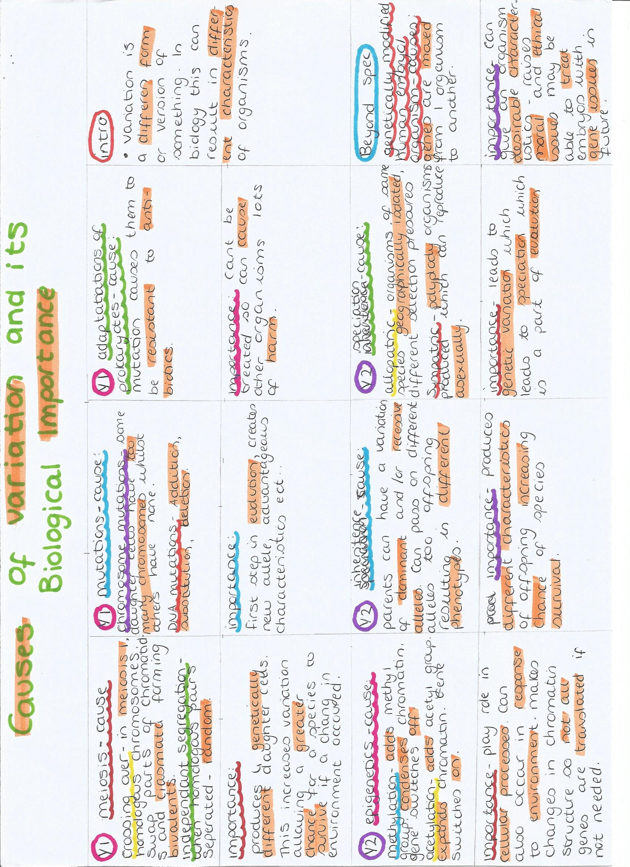
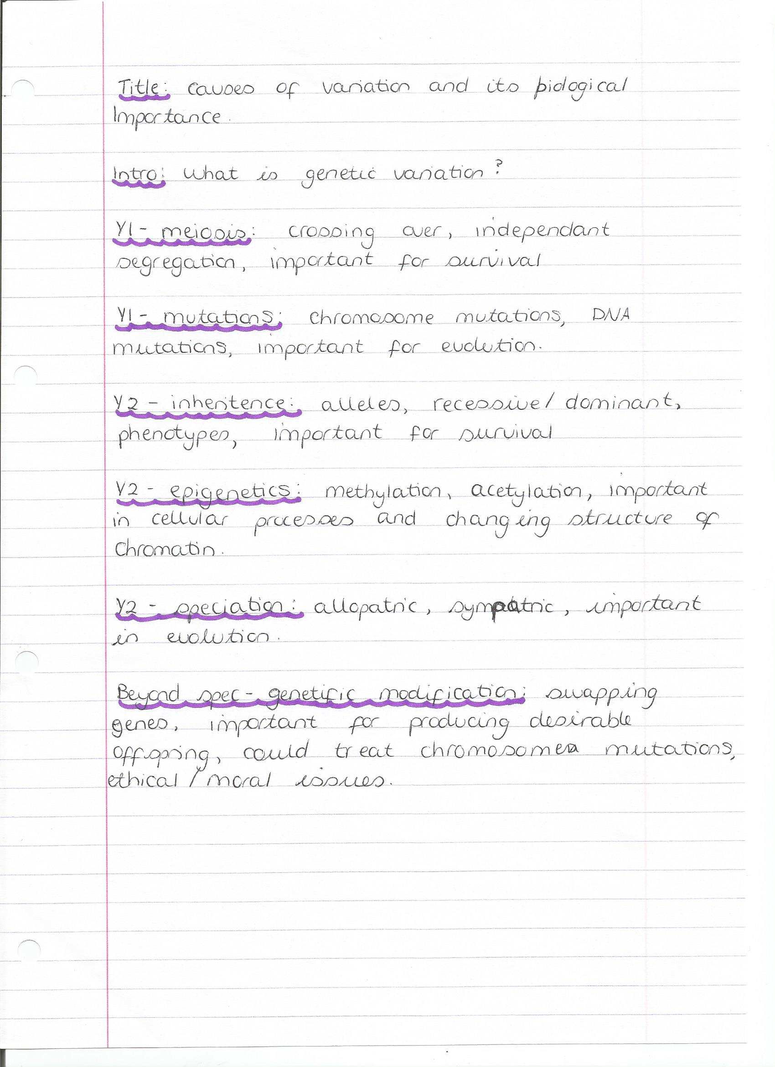
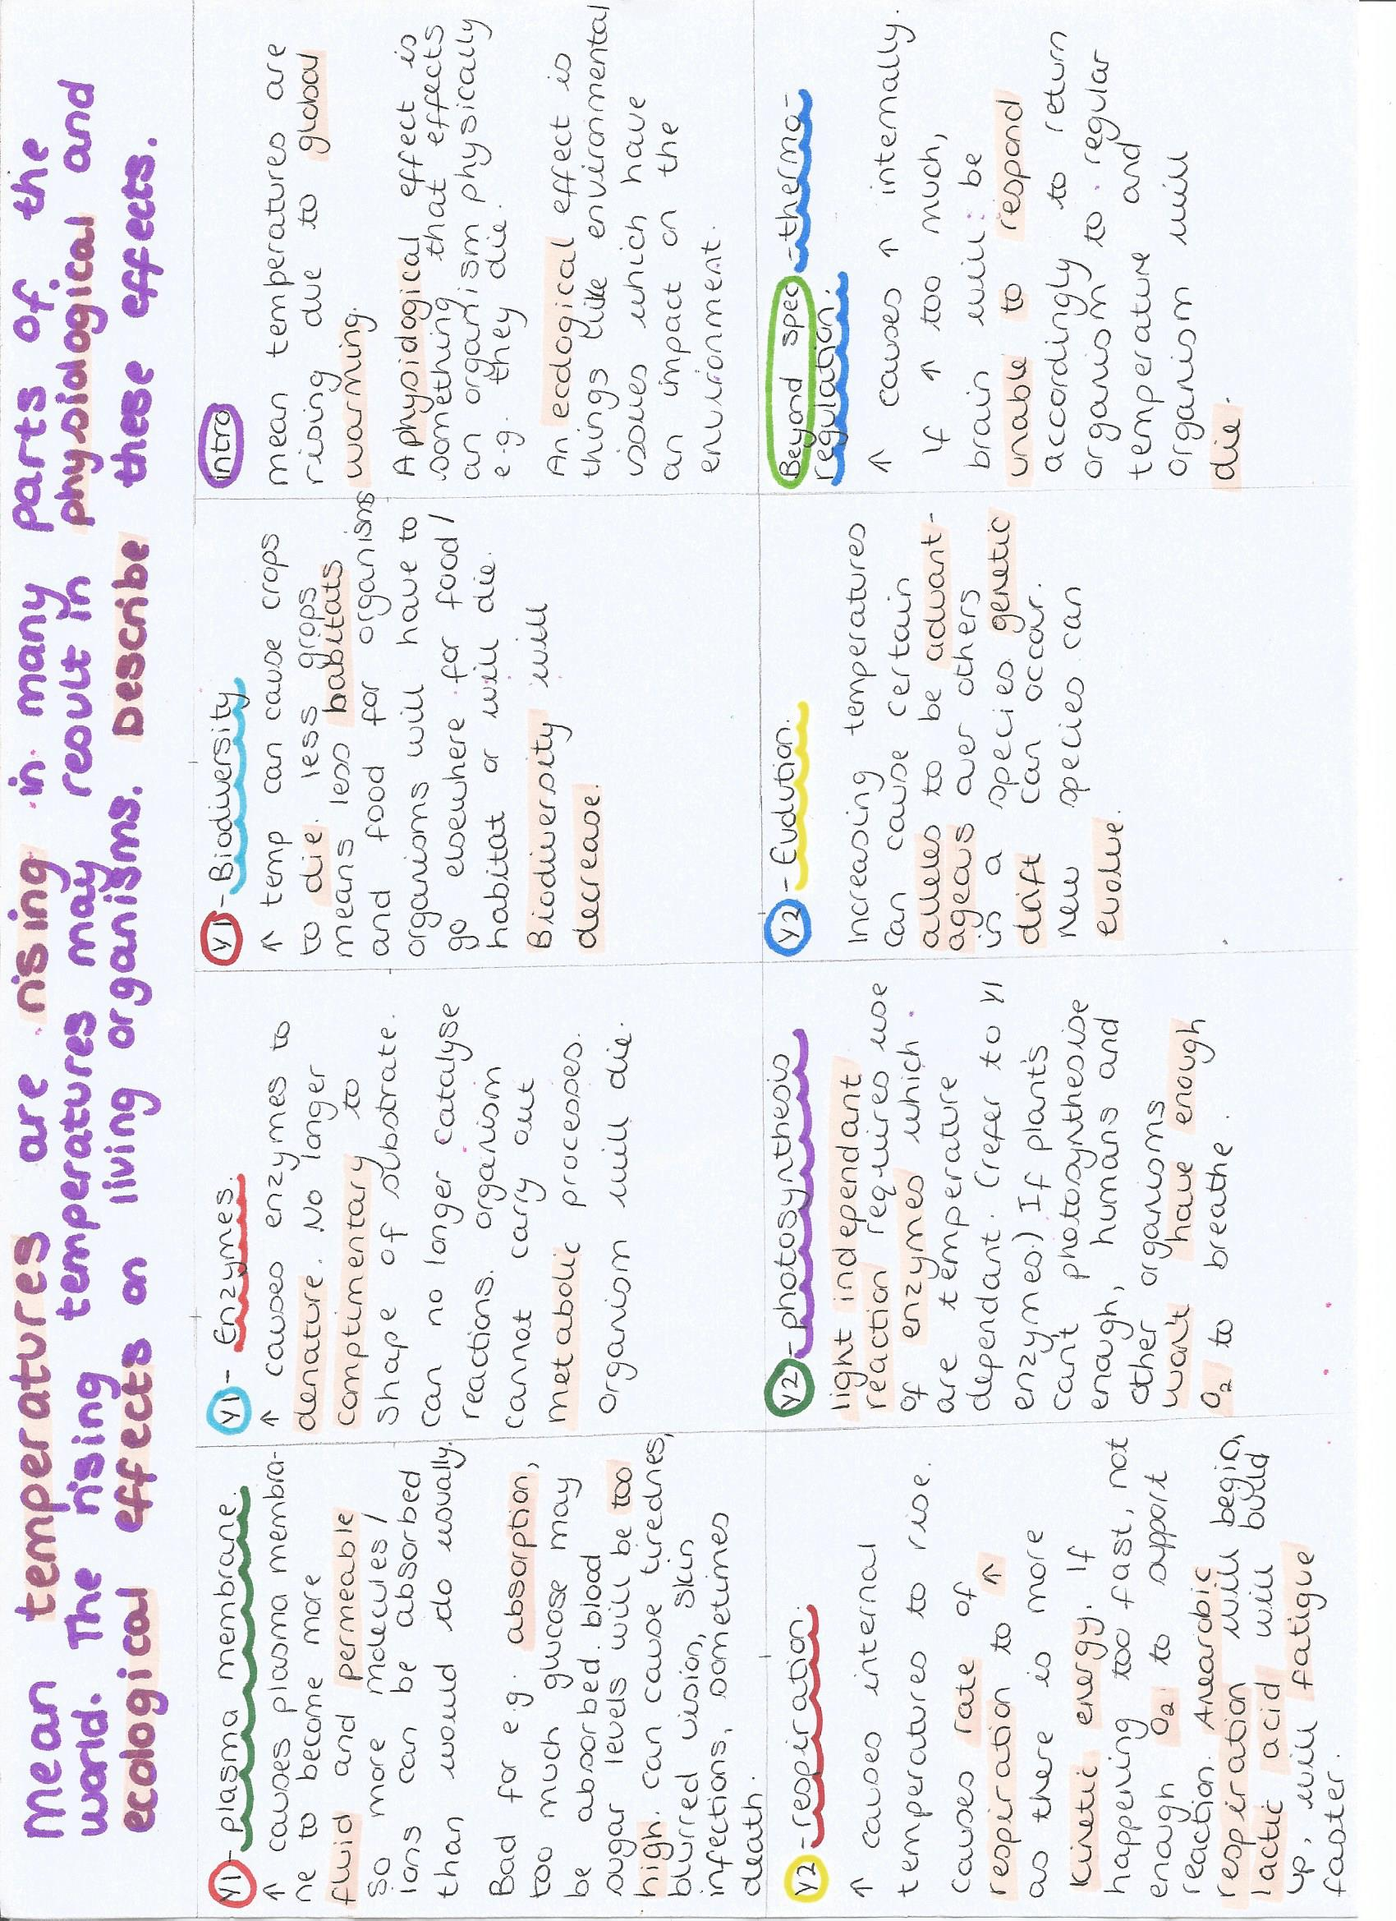
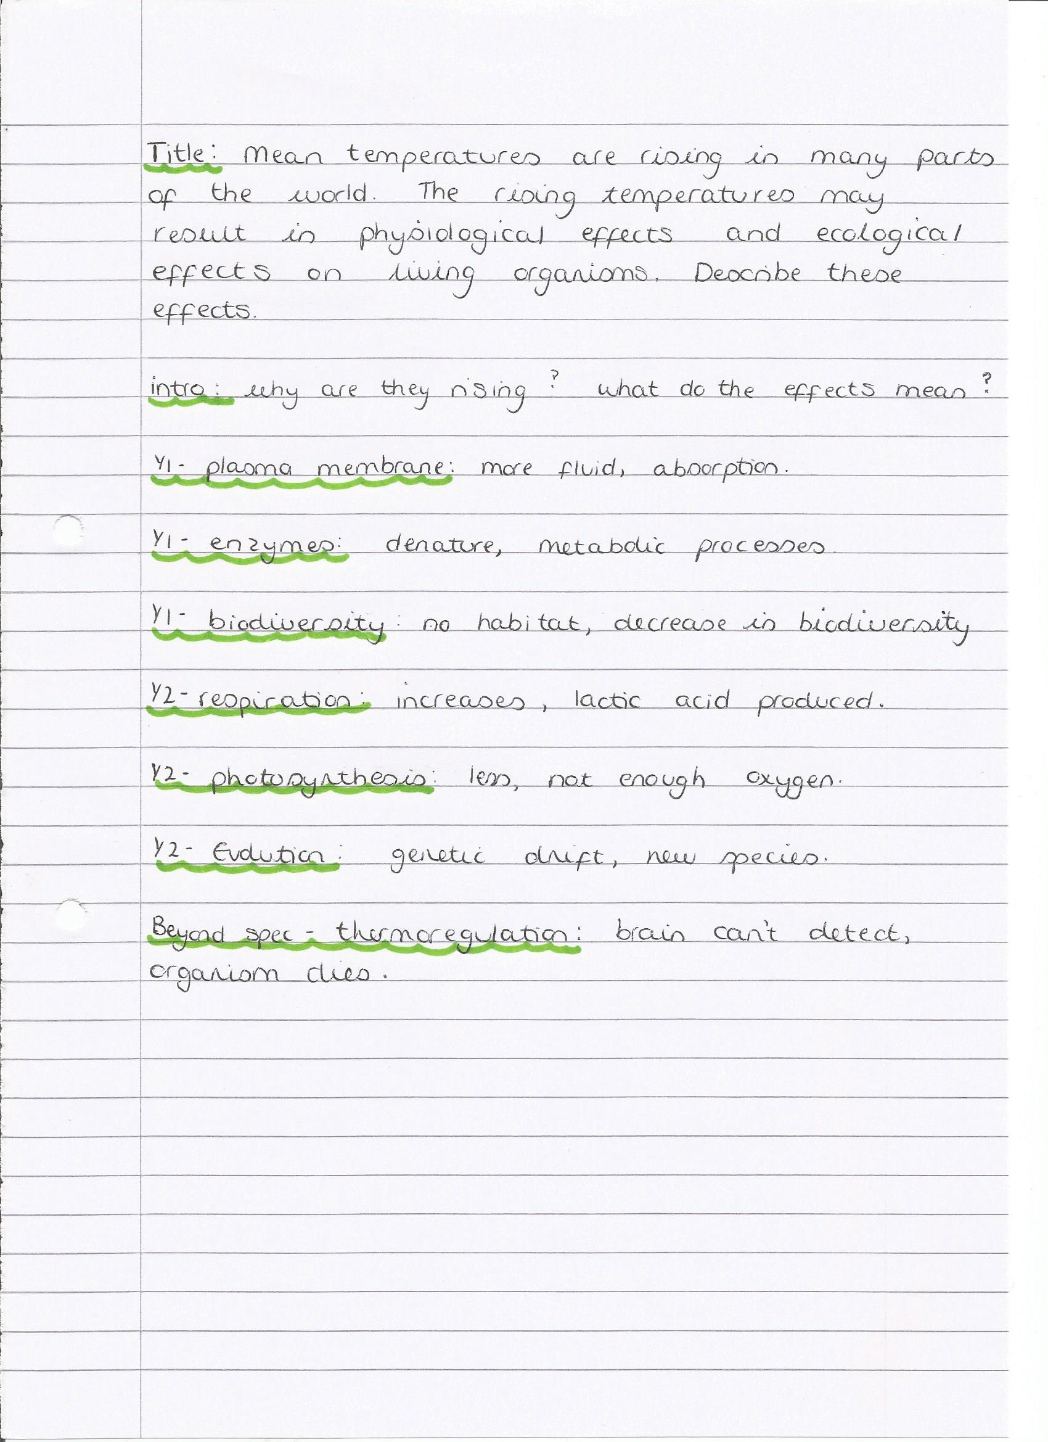
Enzymes and their importance in plants and animals
Essay checklist (make sure you have done all of the following!)
- 4-5 Topics that are relevant to the question  - Detailed A Level content for each topic  - 2-3 Points per topic  - Use of key words of phrases  - Links between topics | - State why the point is relevant to the question  - No waffle or scientific errors  - Introduction and conclusion  - Beyond the specification when aiming for A* grades

Topic | - Enzyme structre and function | - Factors affecting reactions | - Metabollic pathways | - Muscles/ nerves | - digestion
Key Points | - Tertiary structure  - Specific, complementary shape  - Globular proteins  - Induced fit model of enzyme action | - Temperature effecting enzyme-controlled reactions  - pH effecting enzyme-controlled reactions  - Inhibition | - Respiration – dehydrogenation in electron transport chain, ATP synthase  - Photosynthesis – RUBISCO in calvin cycle | - Muscle contraction – ATPase  - Neuromuscular junctions – acetylcholine esterase, | - Break down of biological molecules using enzymes  - Lipids, proteins, starch
Links | Enzyme structure is related to its function | Links to enzyme structure as bonds are broken by temperature and pH | Links to enzymes as without enzymes reactions couldn’t take place | Links to metabolic pathways as ATP is required and links to enzymes as enzymes are requires | Links to enzyme controlled reactions due to pH changes in stomach and enzyme’s function
Beyond the specification | - soluble in water because they have a hydrophilic R group on the outside and a hydrophobic R group on the inside |  | - RUBISCO is ribulose-1,5-bisphosphate carboxylase | - ATP ADP is a dephosphorylation reaction
Key words | Complementary, active site, specific, substrate, catalyst, | Hydrogen bonds, ionic bonds, disulphide bridges, denaturisation, competitive/non-competitive inhibitor | Light independent reaction, oxidative phosphorylation | Hydrolysis, vesicles, release energy, acetylcholine, adenine tri phosphate | Lipase, protease, maltase, surface area to volume ratio

Other topics: DNA replication
Why use a table? A table is a really good way or methodically planning out each paragraph and ensuring that you have included all the important points to get as many marks as possible.
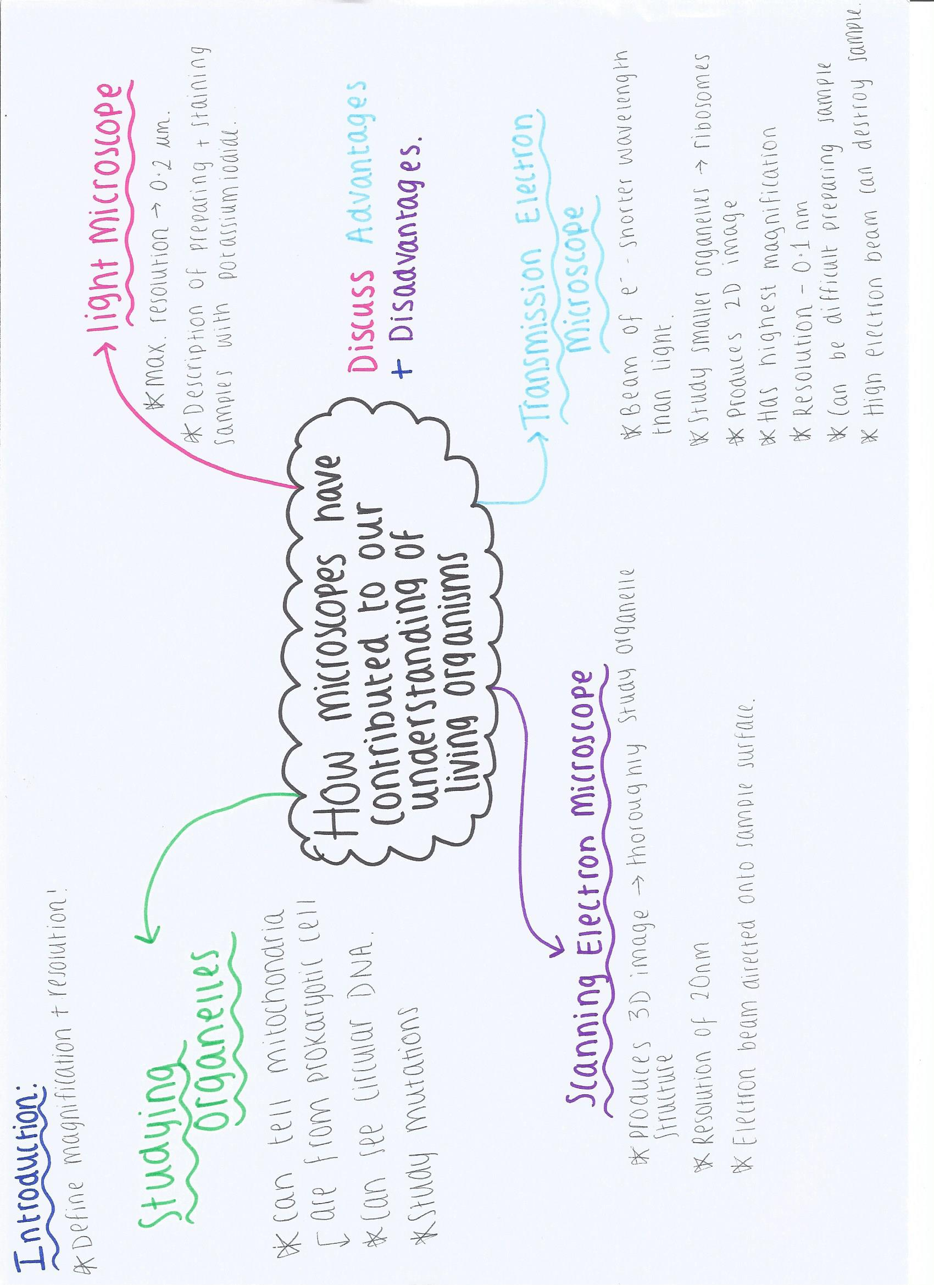

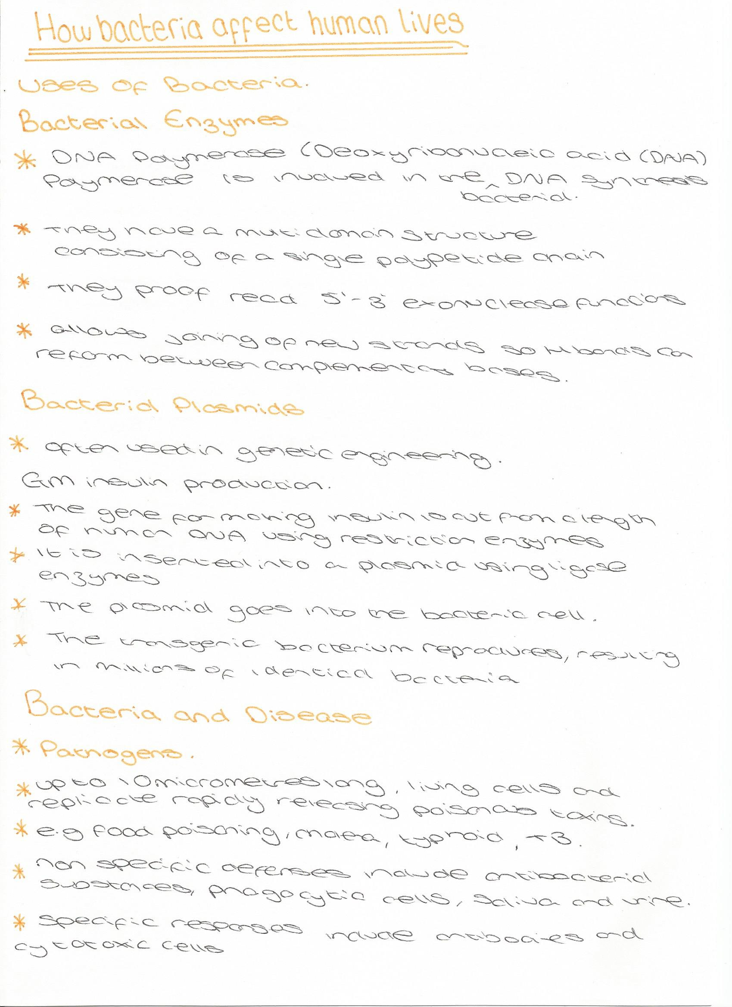
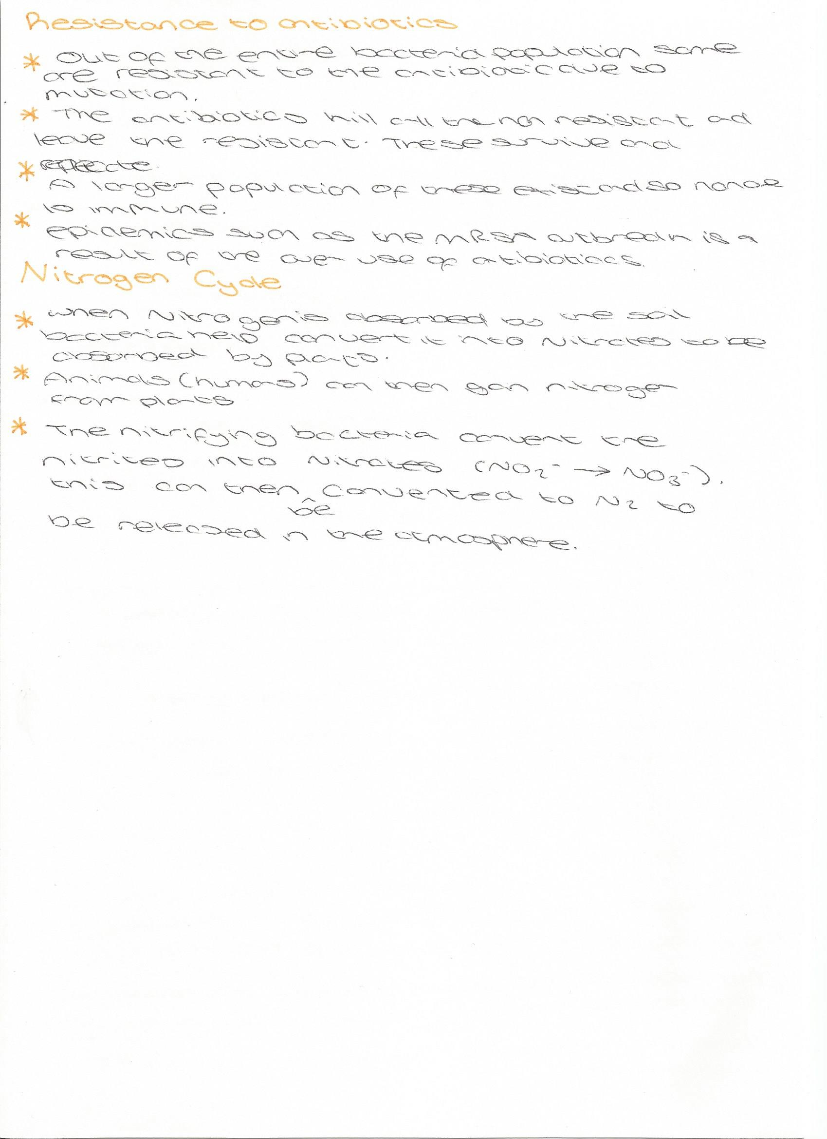
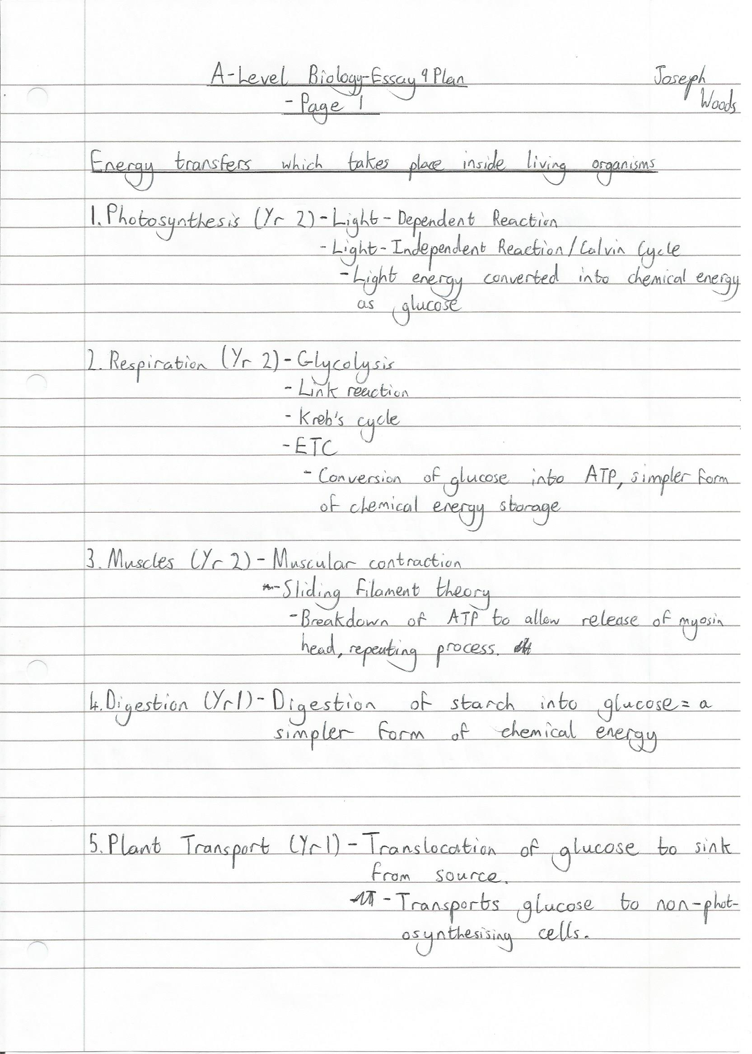
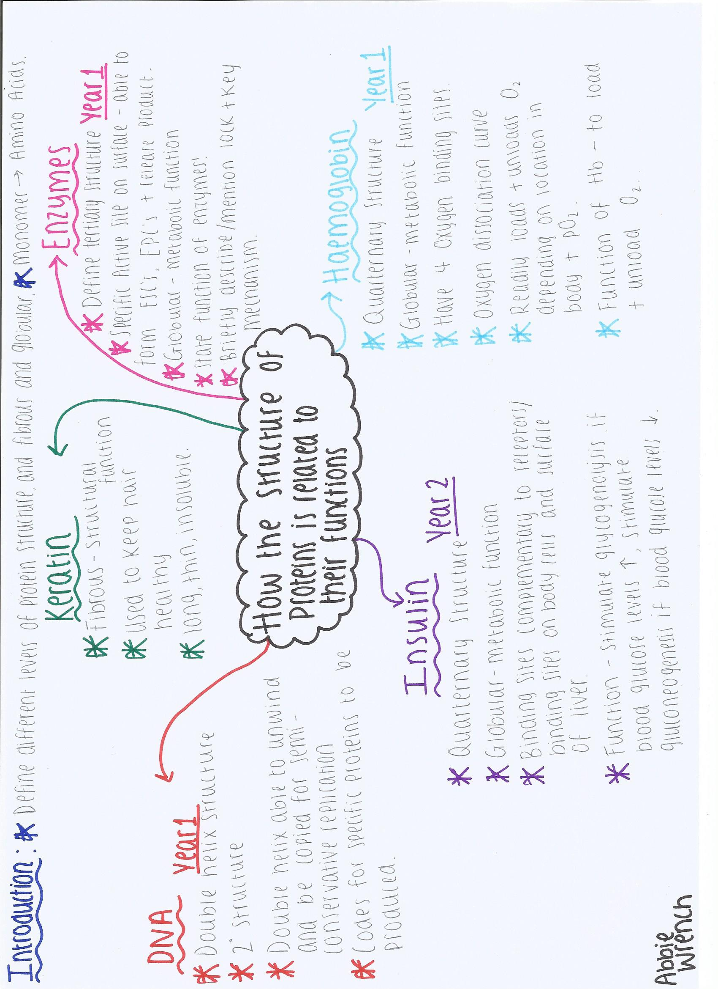
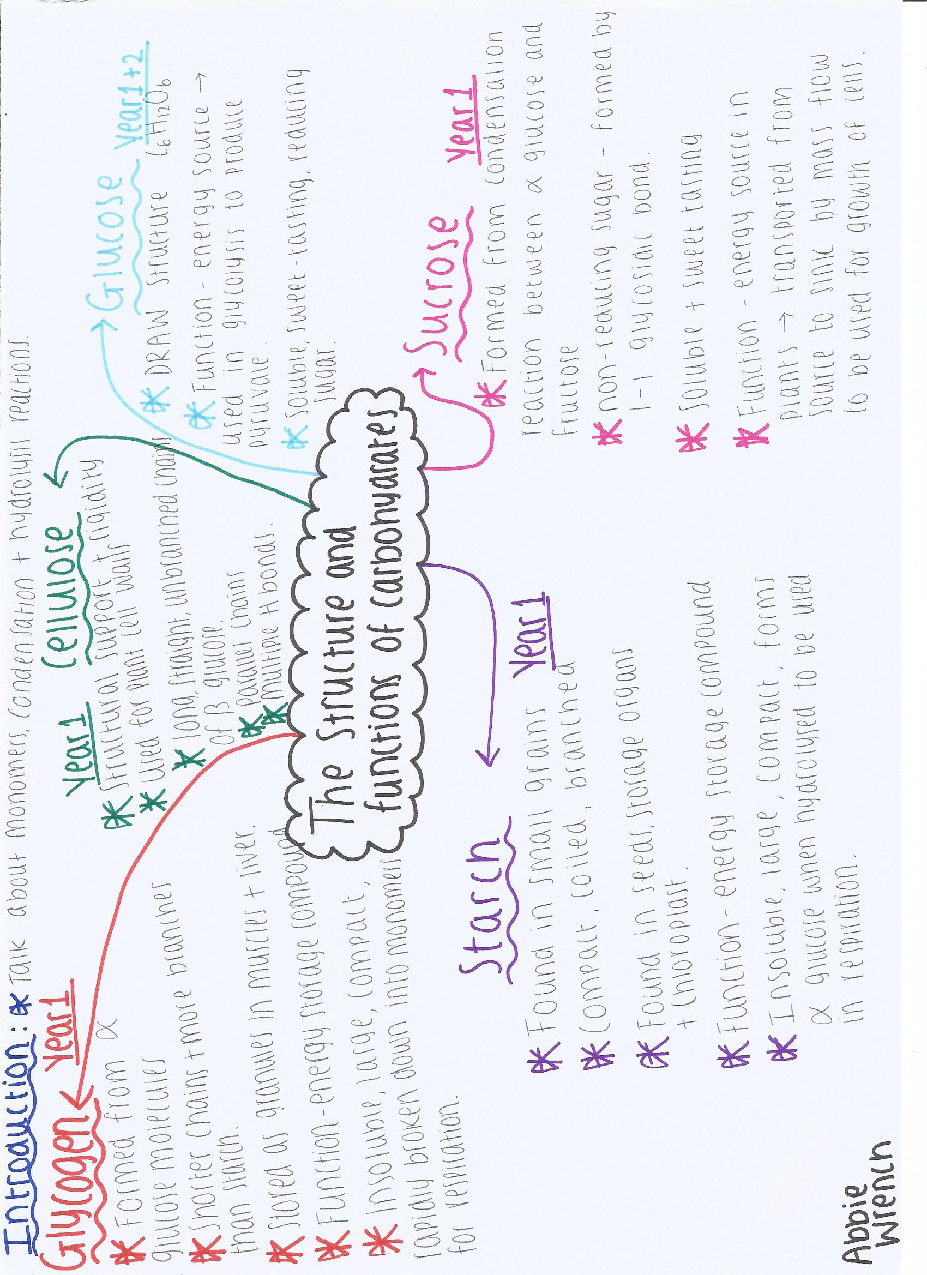
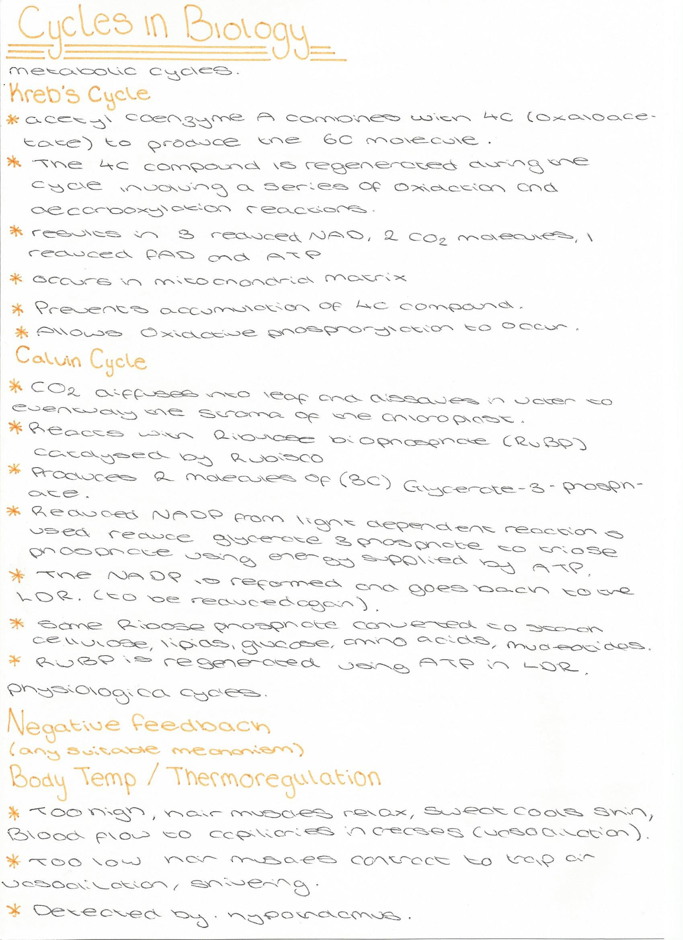
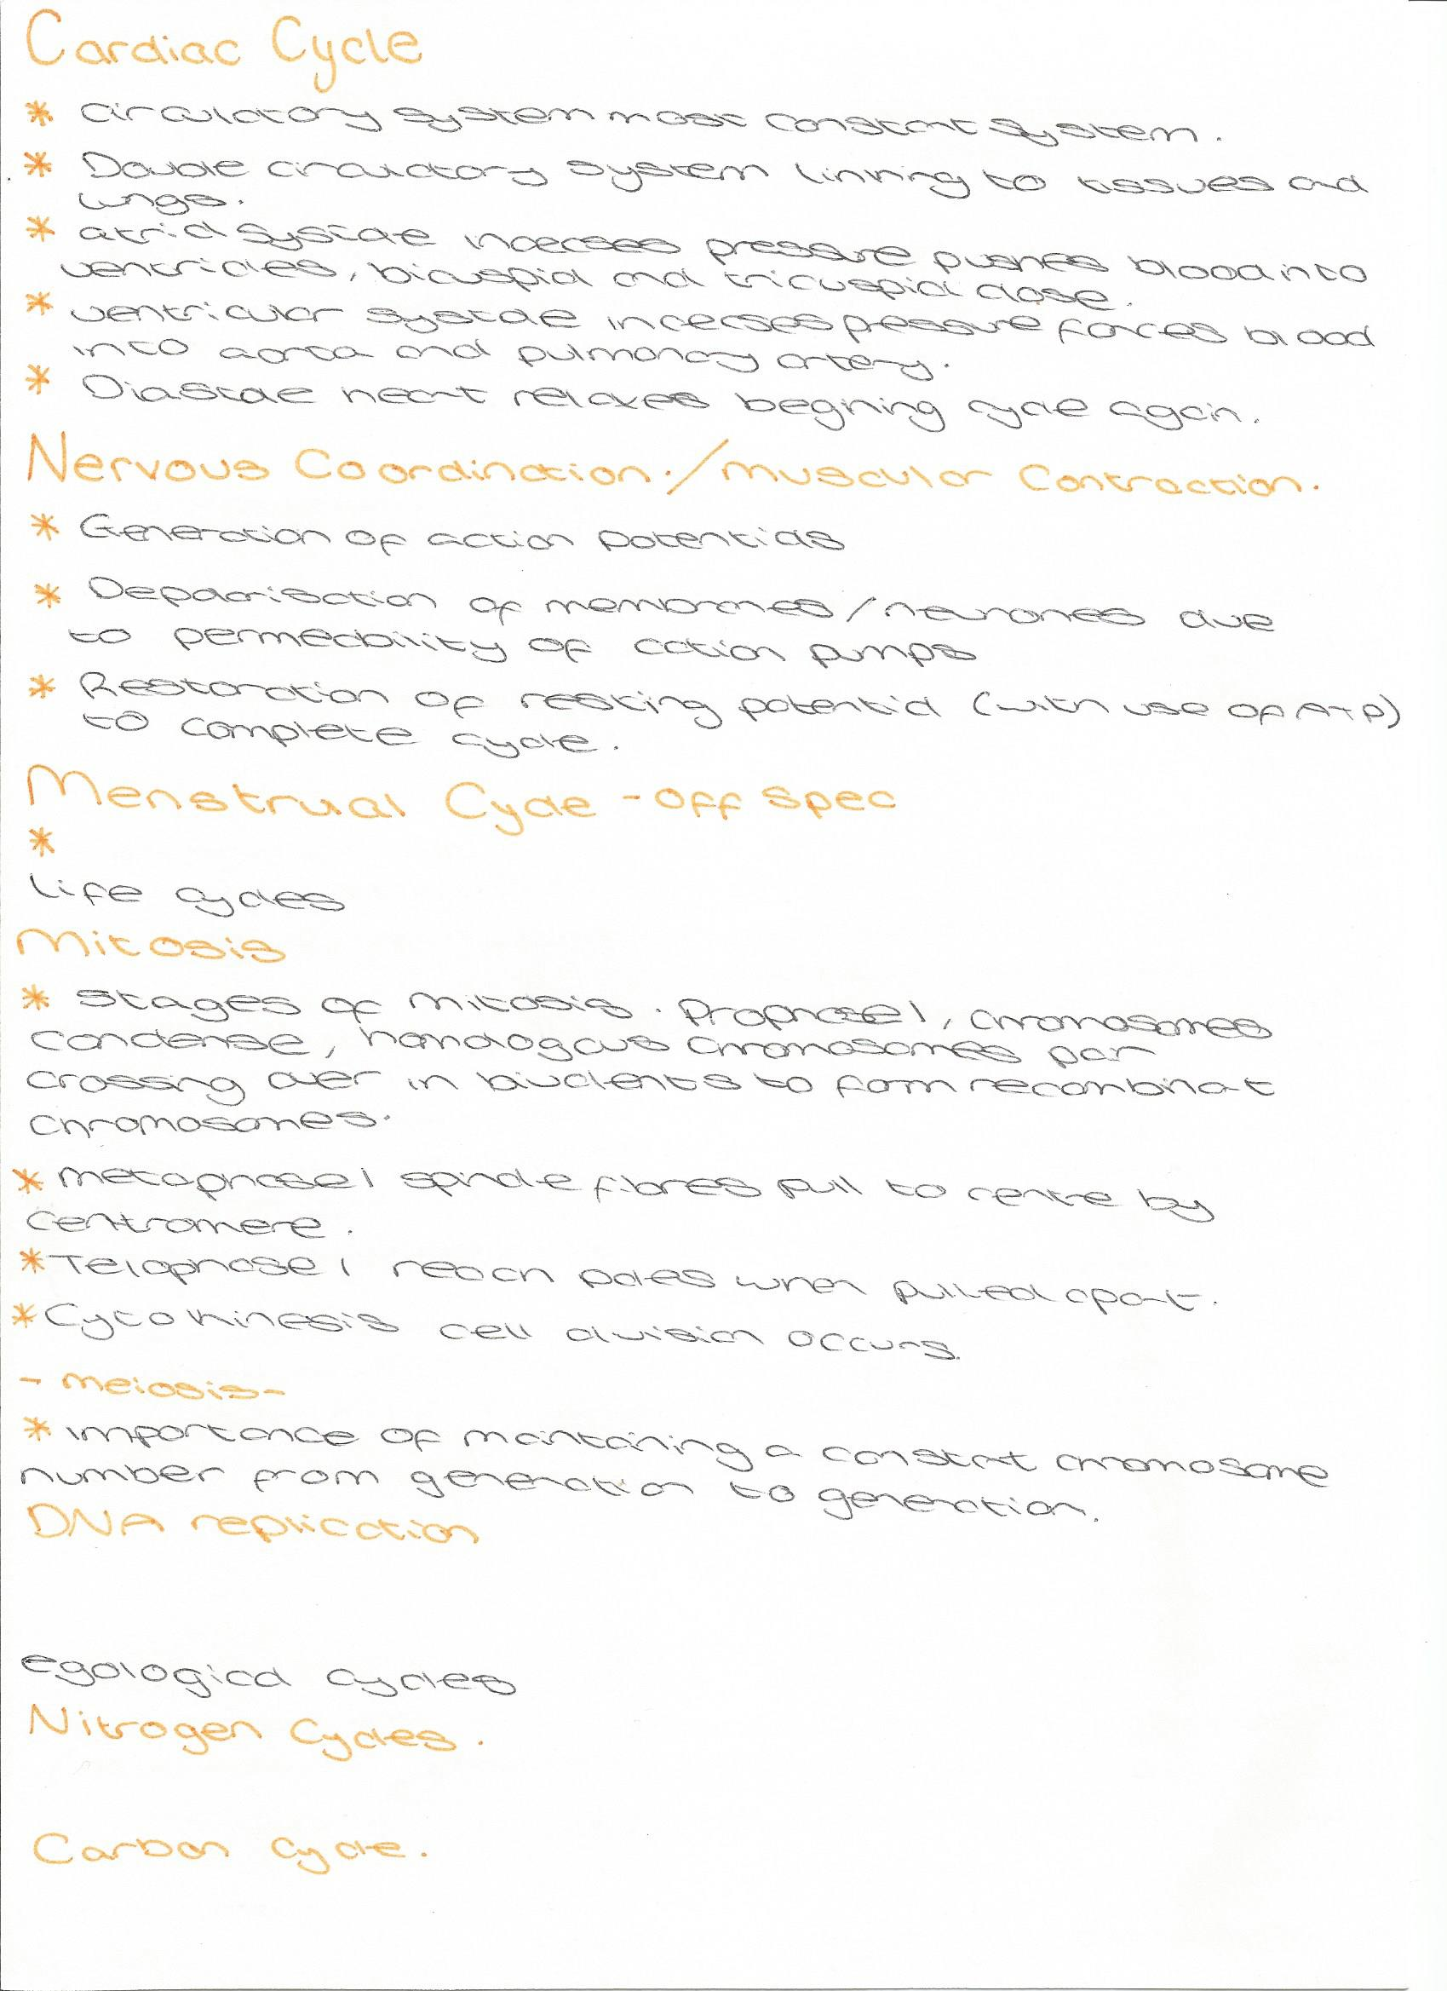
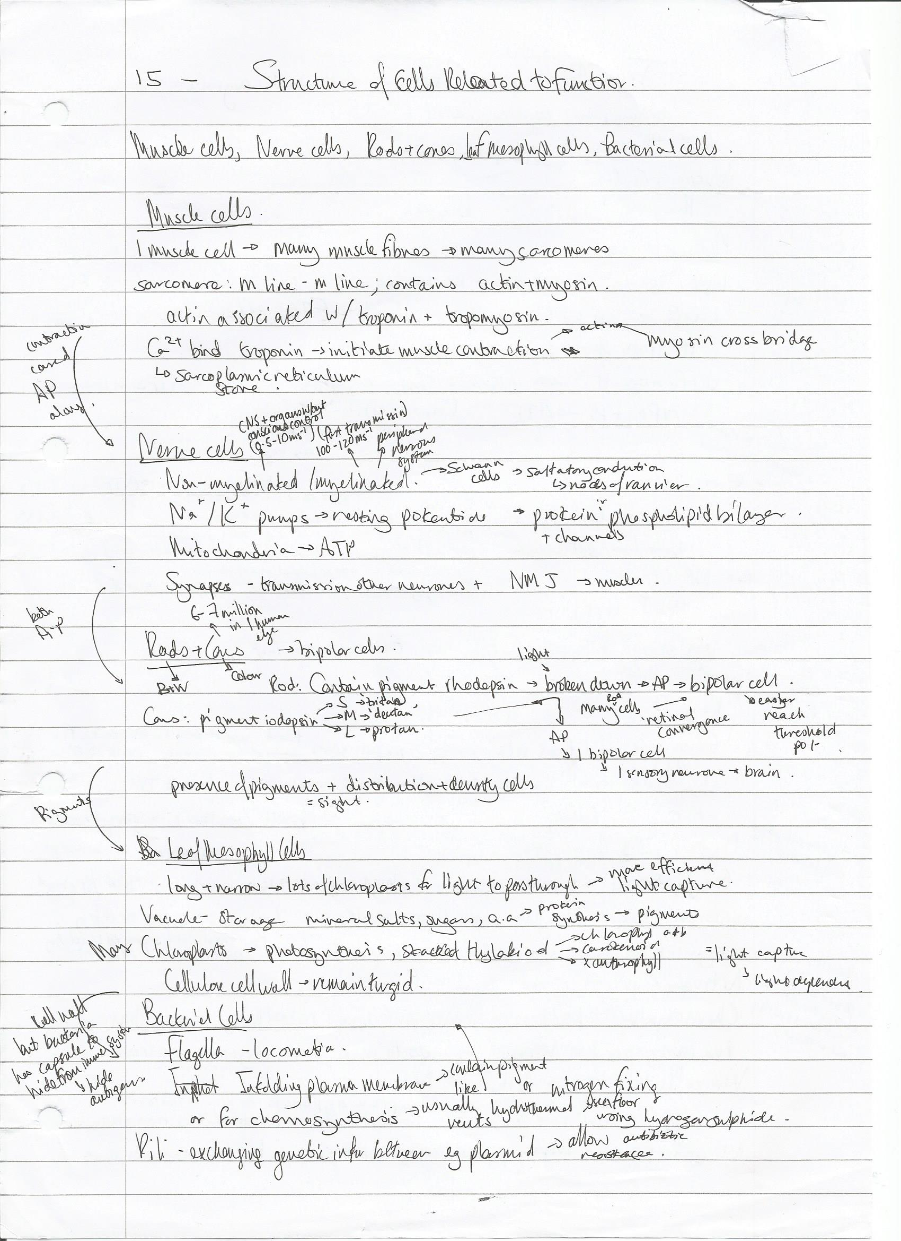
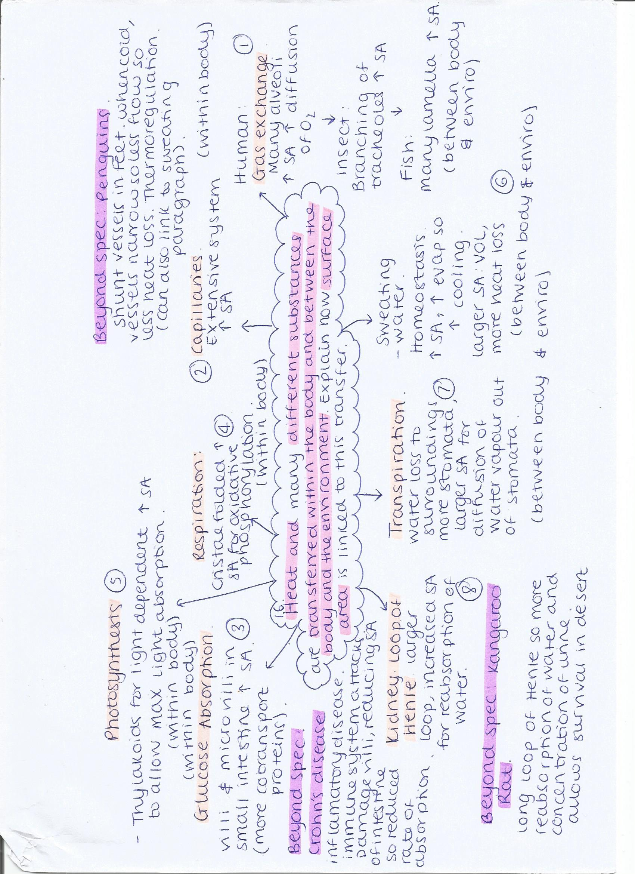
The different ways in which organisms use ATP
Essay checklist (make sure you have done all of the following!)
- 4-5 Topics that are relevant to the question  - Detailed A Level content for each topic  - 2-3 Points per topic  - Use of key words of phrases  - Links between topics | - State why the point is relevant to the question  - No waffle or scientific errors  - Introduction and conclusion  - Beyond the specification when aiming for A* grades

Topic | - ATP | - Respiration | - CALVIN CYCLE | - Phosphorylation | - muscles
Key Points | - Hydrolysis of ATP  - ATP structure  - First phosphodiester bond broken  - Adaptations for function | - Glycolysis, link reaction, krebs cycle, oxidative phosphorylation  - Production of ATP from glucose | - Provides energy for formation of triose phosphate  - Donates Pi for formation of ribulose bis phosphate | - ATP can donate Pi to compounds to make them more reactive  - Very important for protein function – particularly enzymes | - ATP is used for muscle contraction  - Movement of myosin head, reabsorption of Ca²⁺
Links | Links to topic as for organisms to use ATP it must be hydrolysed and the structure of ATP related to its function | Links to ATP as respiration is the process of forming ATP from glucose, respiration requires ATP | Links to respiration as sugars produced in photosynthesis are used in respiration and is also a cycle | Links to respiration and the calvin cycle as ATP phosphorylates compounds so that the reaction will continue in these reactions | Links to phosphorylation as enzymes are involved in muscle contraction and many enzymes are phosphorylation
Beyond the specification | - ATP is hydrolysed more rapidly at extreme pH’s | - Cellular respiration is an exothermic redox reaction which releases heat so is used to keep mammals warm |  | - Histones in DNA are undergo phosphorylation before translation
Key words | Adenosine tri phosphate, inorganic phosphate, adenosine di phosphate, adenosine mono phosphate, unstable | Catabolic reaction, donate Pi, provide energy | Cycle, light independent reaction, ribulose bis phosphate | Inorganic phosphate, donate, reactivity, enzymes | Myosin head, re-cock myosin head, power stroke, sarcoplasmic reticulum

Other topics: active transport, digestion, kidney function, nervous coordination
Why use a table? A table is a really good way or methodically planning out each paragraph and ensuring that you have included all the important points to get as many marks as possible.
Bacteria affect the lives of humans and other organisms in many ways. Apart from causing disease, describe how bacteria may affect the lives of humans and other organisms.
- Nitrogen cycle: use of saprobiontic microorganisms in each stage – nitrogen fixation (Rhizobium), nitrification (Nitrosomonas and Nitrobacter), denitrification (pseudomonas) and ammonification needed to convert nitrogen gas into nitrogen-containing compounds so that plants and animals can make proteins and nucleic acids

- Additional: nitrogen fixation also occurs in aquatic environments via Cyanobacteria and some bacteria are helpful in the sewage treatment. They are used to breakdown the organic material into methane gas

- Phosphorous cycle: plants and animals need phosphorous to make biological molecules such as phospholipids, DNA, and ATP – phosphate ions need to be released from organic compounds by saprobiontic microorganisms

- Digestion: bacteria aid in the breakdown and absorption of foods, such as Lactobacillus which helps ferment indigestible carbohydrates and support the breakdown of sugars in dairy products – used in the food industry for probiotics

- In the pharmaceutical industry, bacteria are used to produce antibiotics like streptomycin and tetracycline. Streptomyces are soil bacteria used in the commercial production of antibiotics
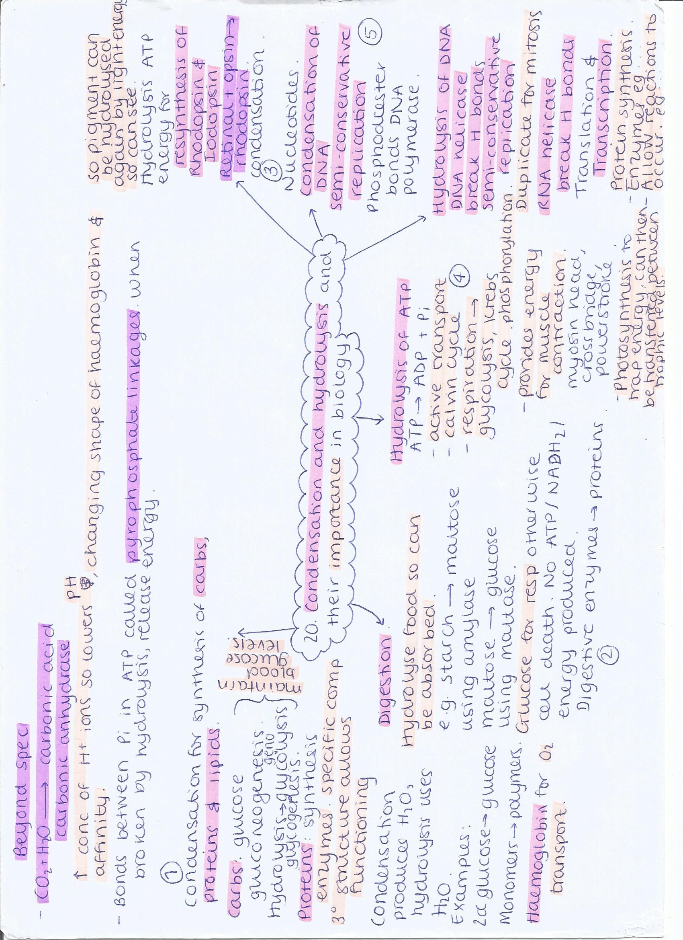
Negative feedback and its importance in biology.
- Maintaining blood glucose concentration: insulin/glucagon and their target cells, gluconeogenesis/glycolysis/glycogenolysis – to ensure that cells have adequate energy available for respiration/prevent BCG from becoming dangerously high (damaging blood vessels, kidneys…)

- Osmoregulation: receptors in the brain, ADH and the kidneys – prevent water potential of cells becoming too high and causing osmotic damage or too low (dehydration, water needed for metabolic processes including respiration)

- Body temperature: thermoreceptors detect change, physical responses such as sweating/vasodilation/hairs flattening vs. vasoconstriction/hairs raising – constant internal temperature required for enzymes etc

- Blood pressure: fluctuations in blood pressure send signals to the brain, response to slow heart rate and reduce pressure – to prevent damage to blood vessels from high blood pressures, other health problems with heart

- Plants: guard cells opening/closing in response to water, oxygen, or CO₂ levels – key to maintaining optimum levels within the plant for growth and respiration
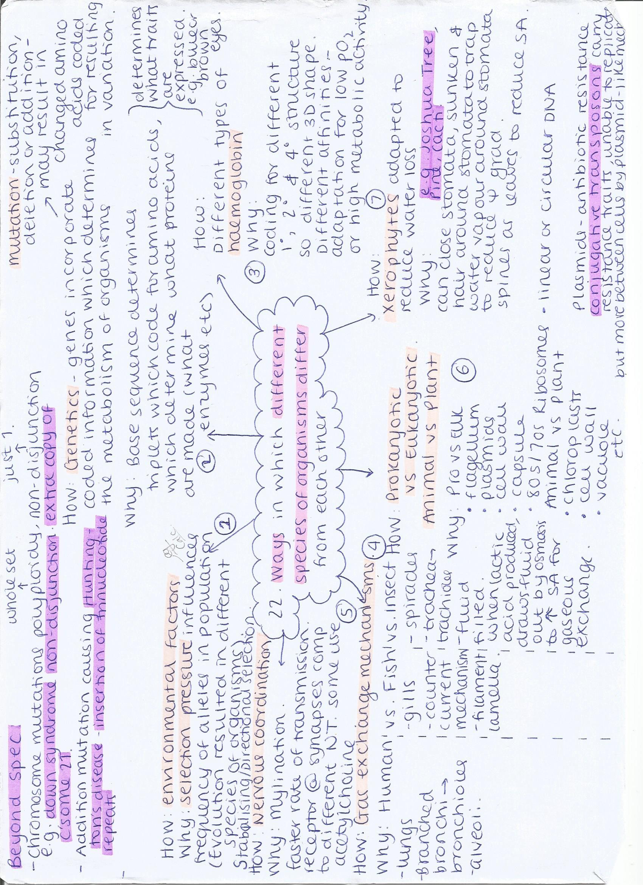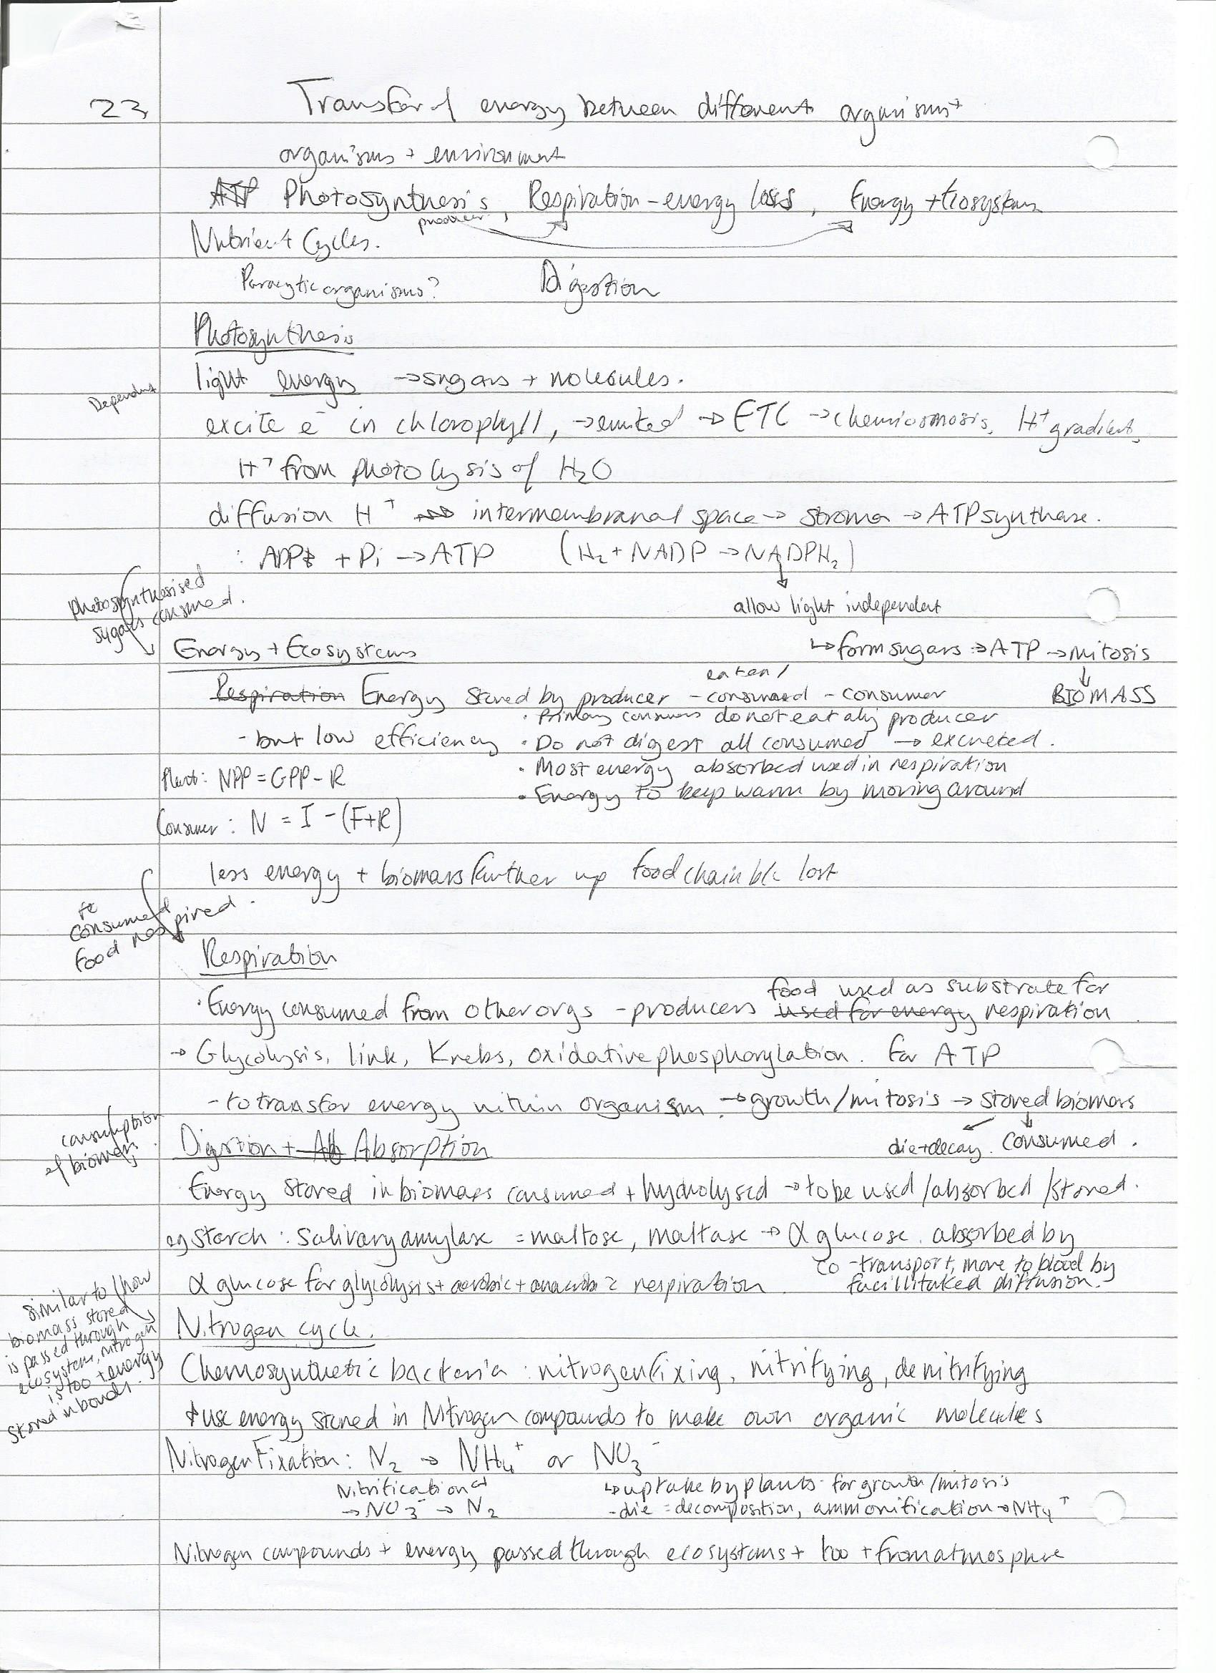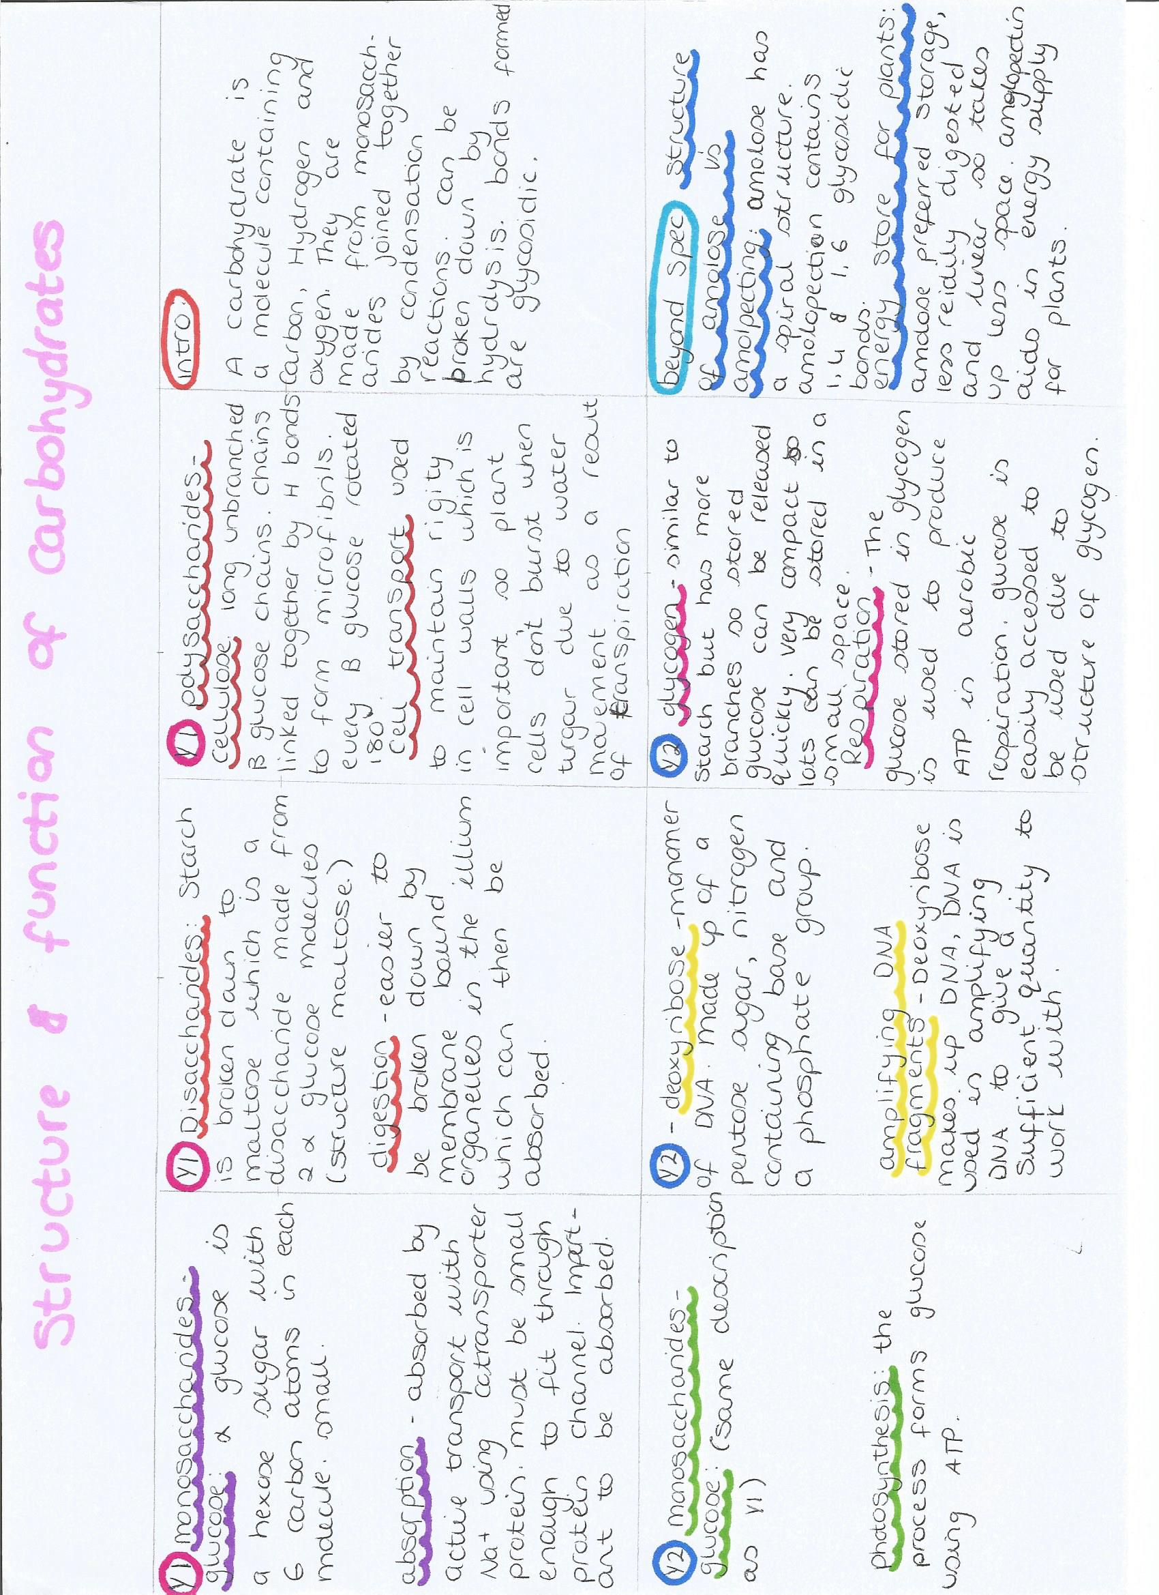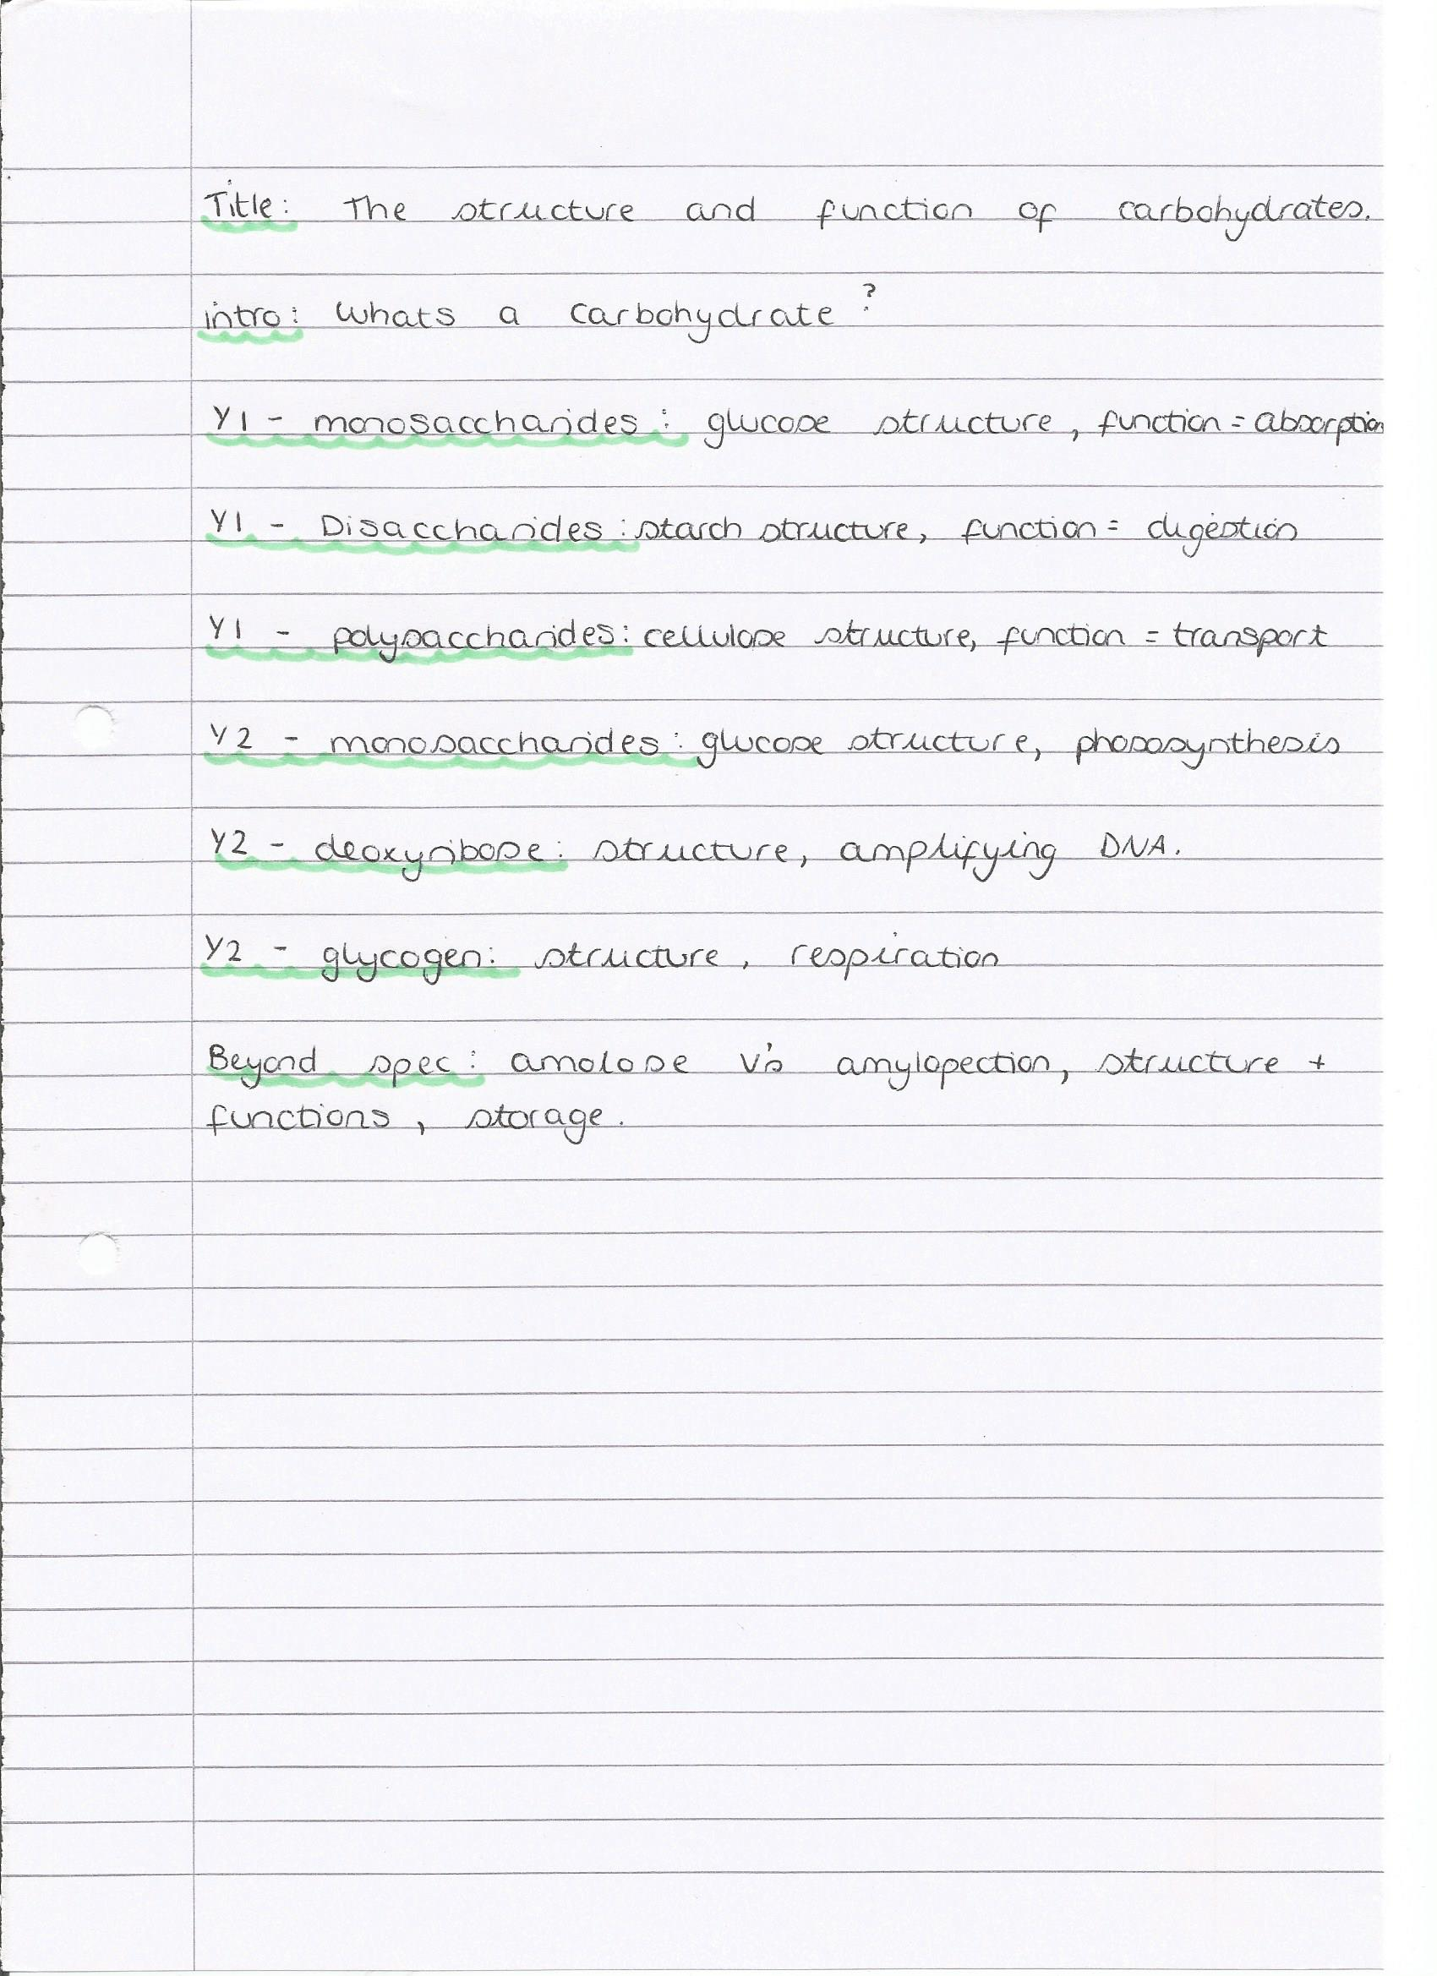
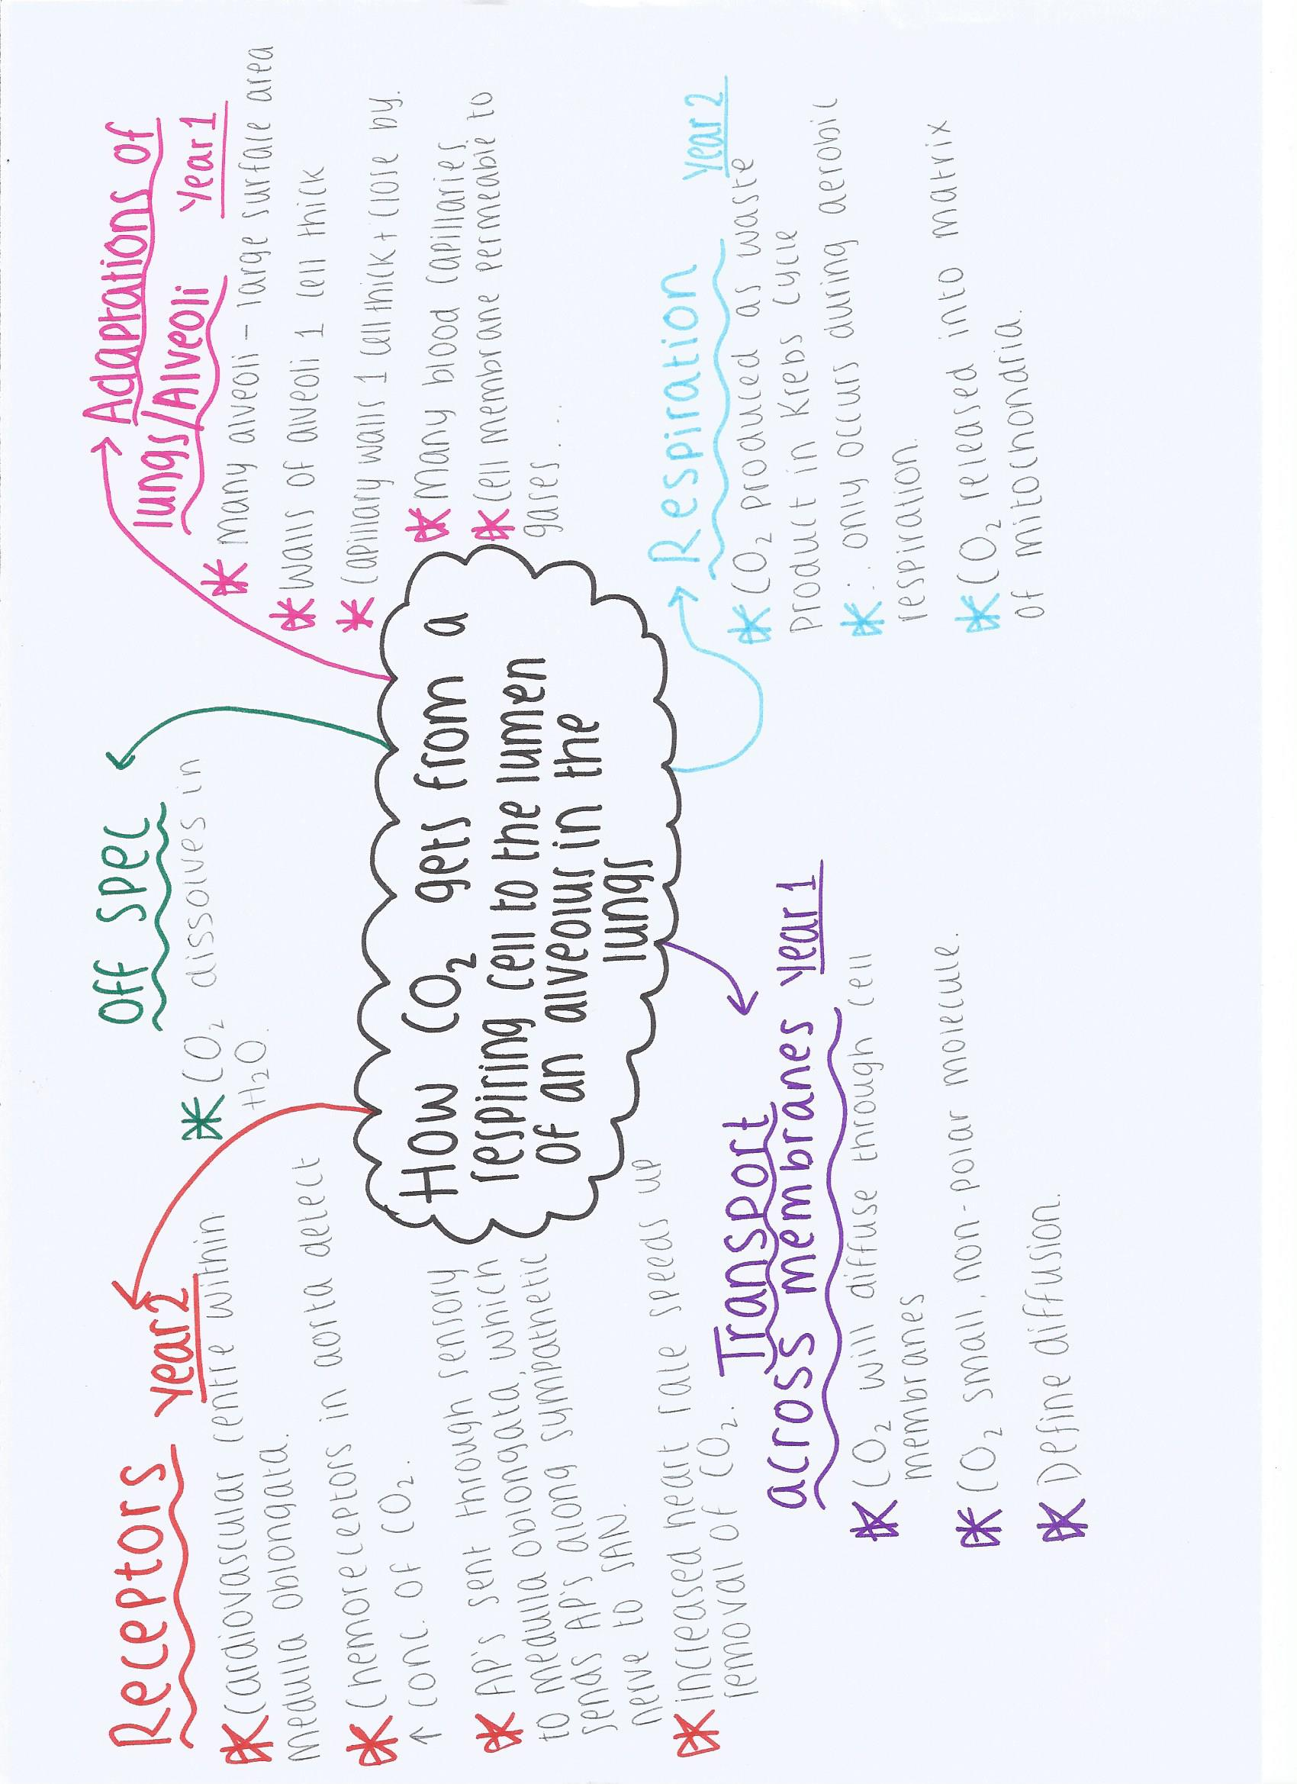

The biological importance of water.

- Important metabolite: use in hydrolysis reactions such as breaking down polymers to monomers in digestions to make them absorbable (starch to maltose, to glucose)

- High latent heat to vaporisation: a lot of energy required to convert liquid water to water vapour, useful in homeostasis – sweating keeps the body cool, prevents overheating. Additional: the large amounts of energy required to heat useful for aquatic organisms, water acts as a temperature buffer (only top layer of lake/pond/etc freezes, so organisms can survive cold seasons)

- Strong cohesion: due to covalent bonds between molecules, explain cohesion tension theory in plants (transpiration) and adhesion to xylem wall. Could also mention pond-skaters

- Dipolar molecule: can dissolve other hydrophobic, polar molecules due to opposing charged – allows for use in reactions or transport, give examples of where this is used e.g. blood

- Photosynthesis: used in photosynthesis during the light-dependent reaction to produce oxygen – can then be used in respiration
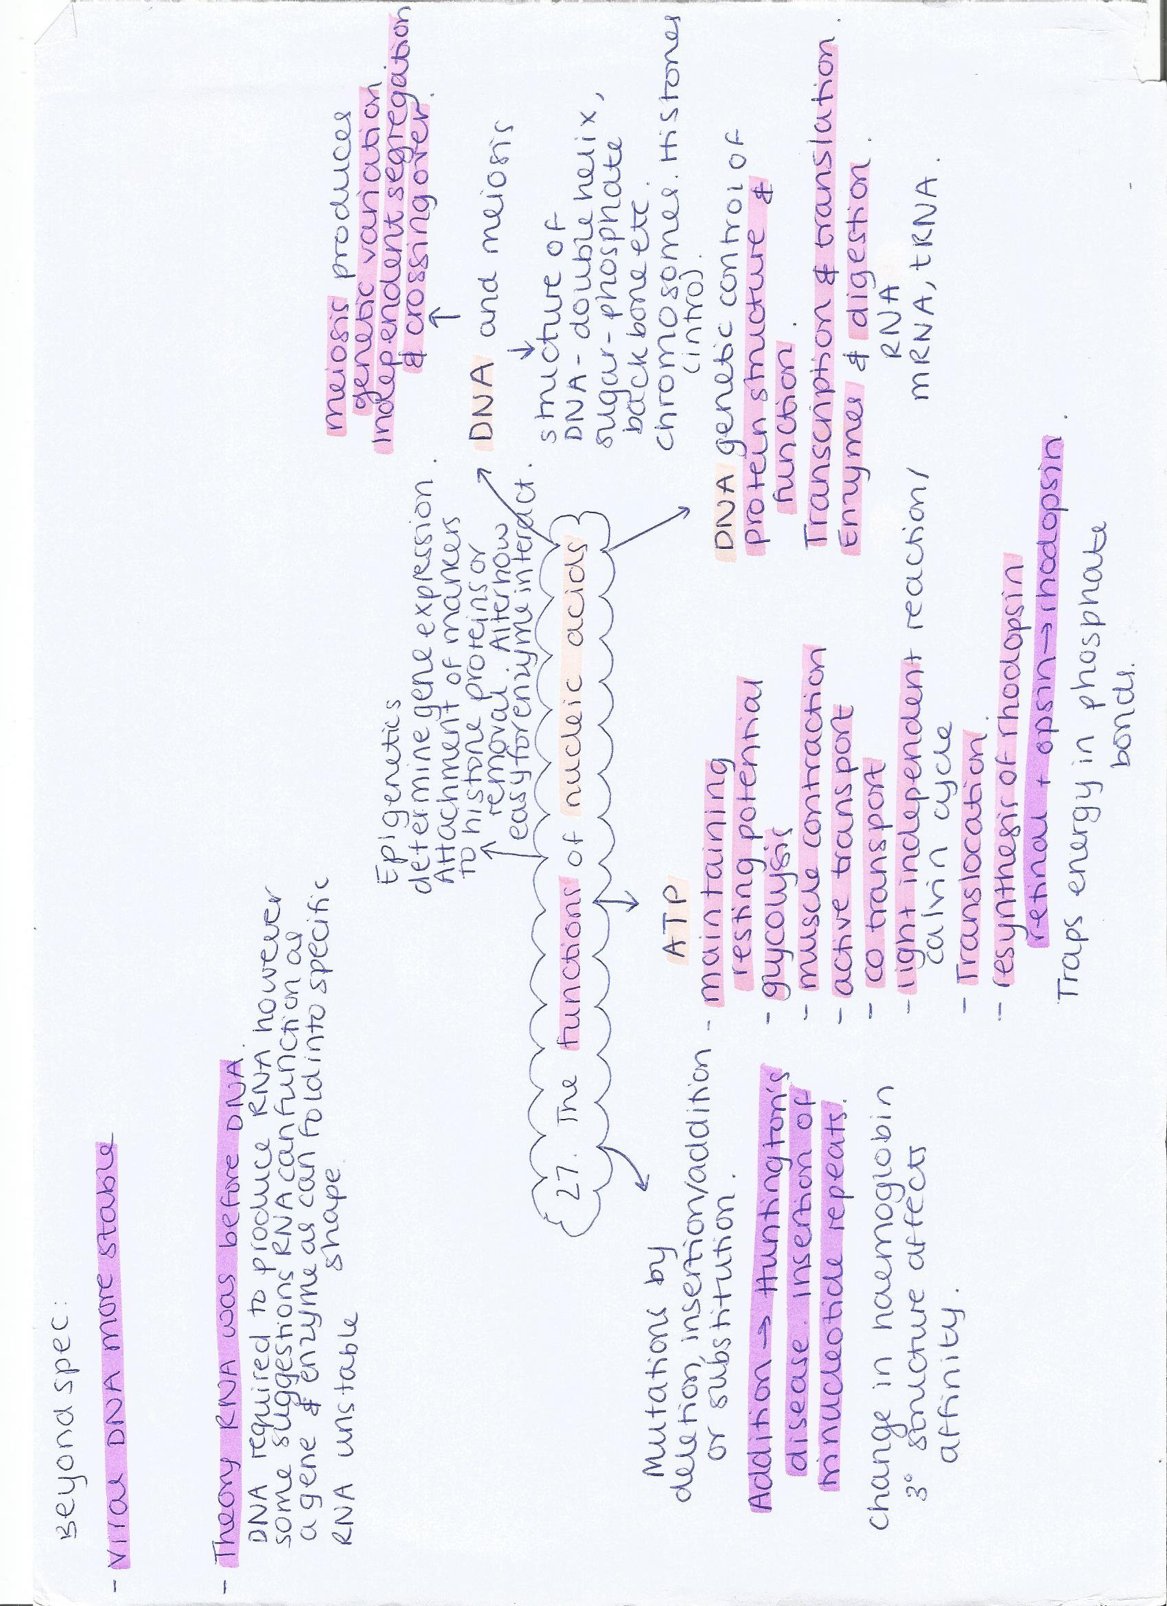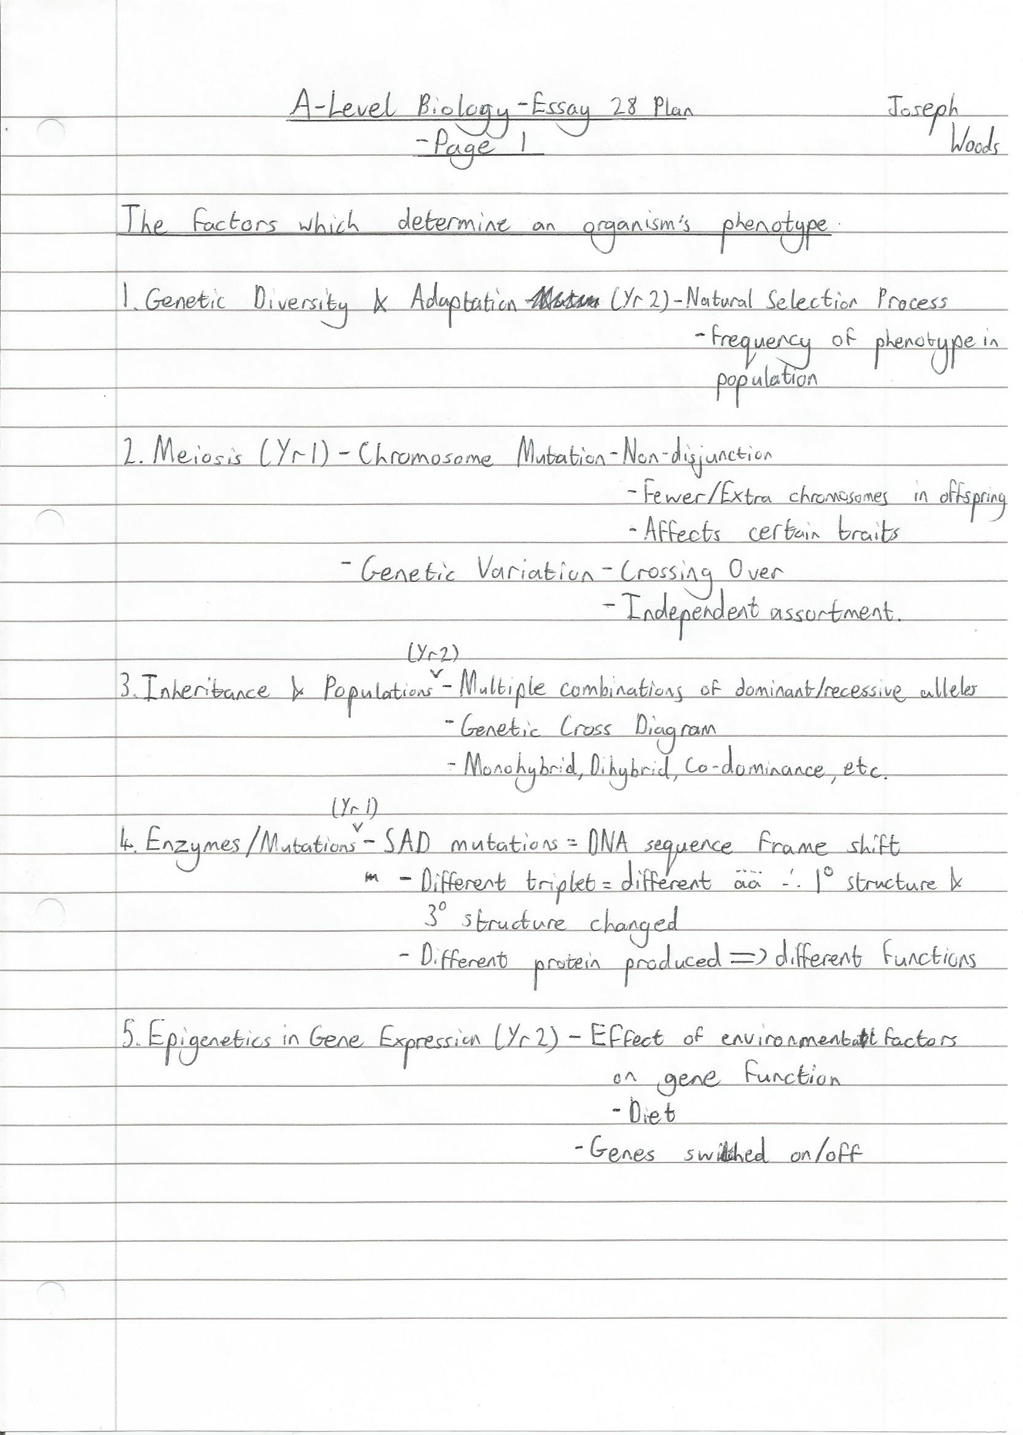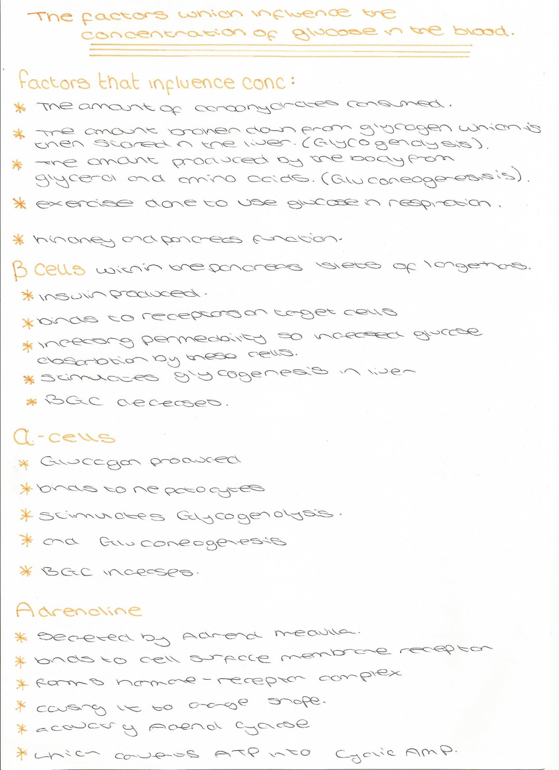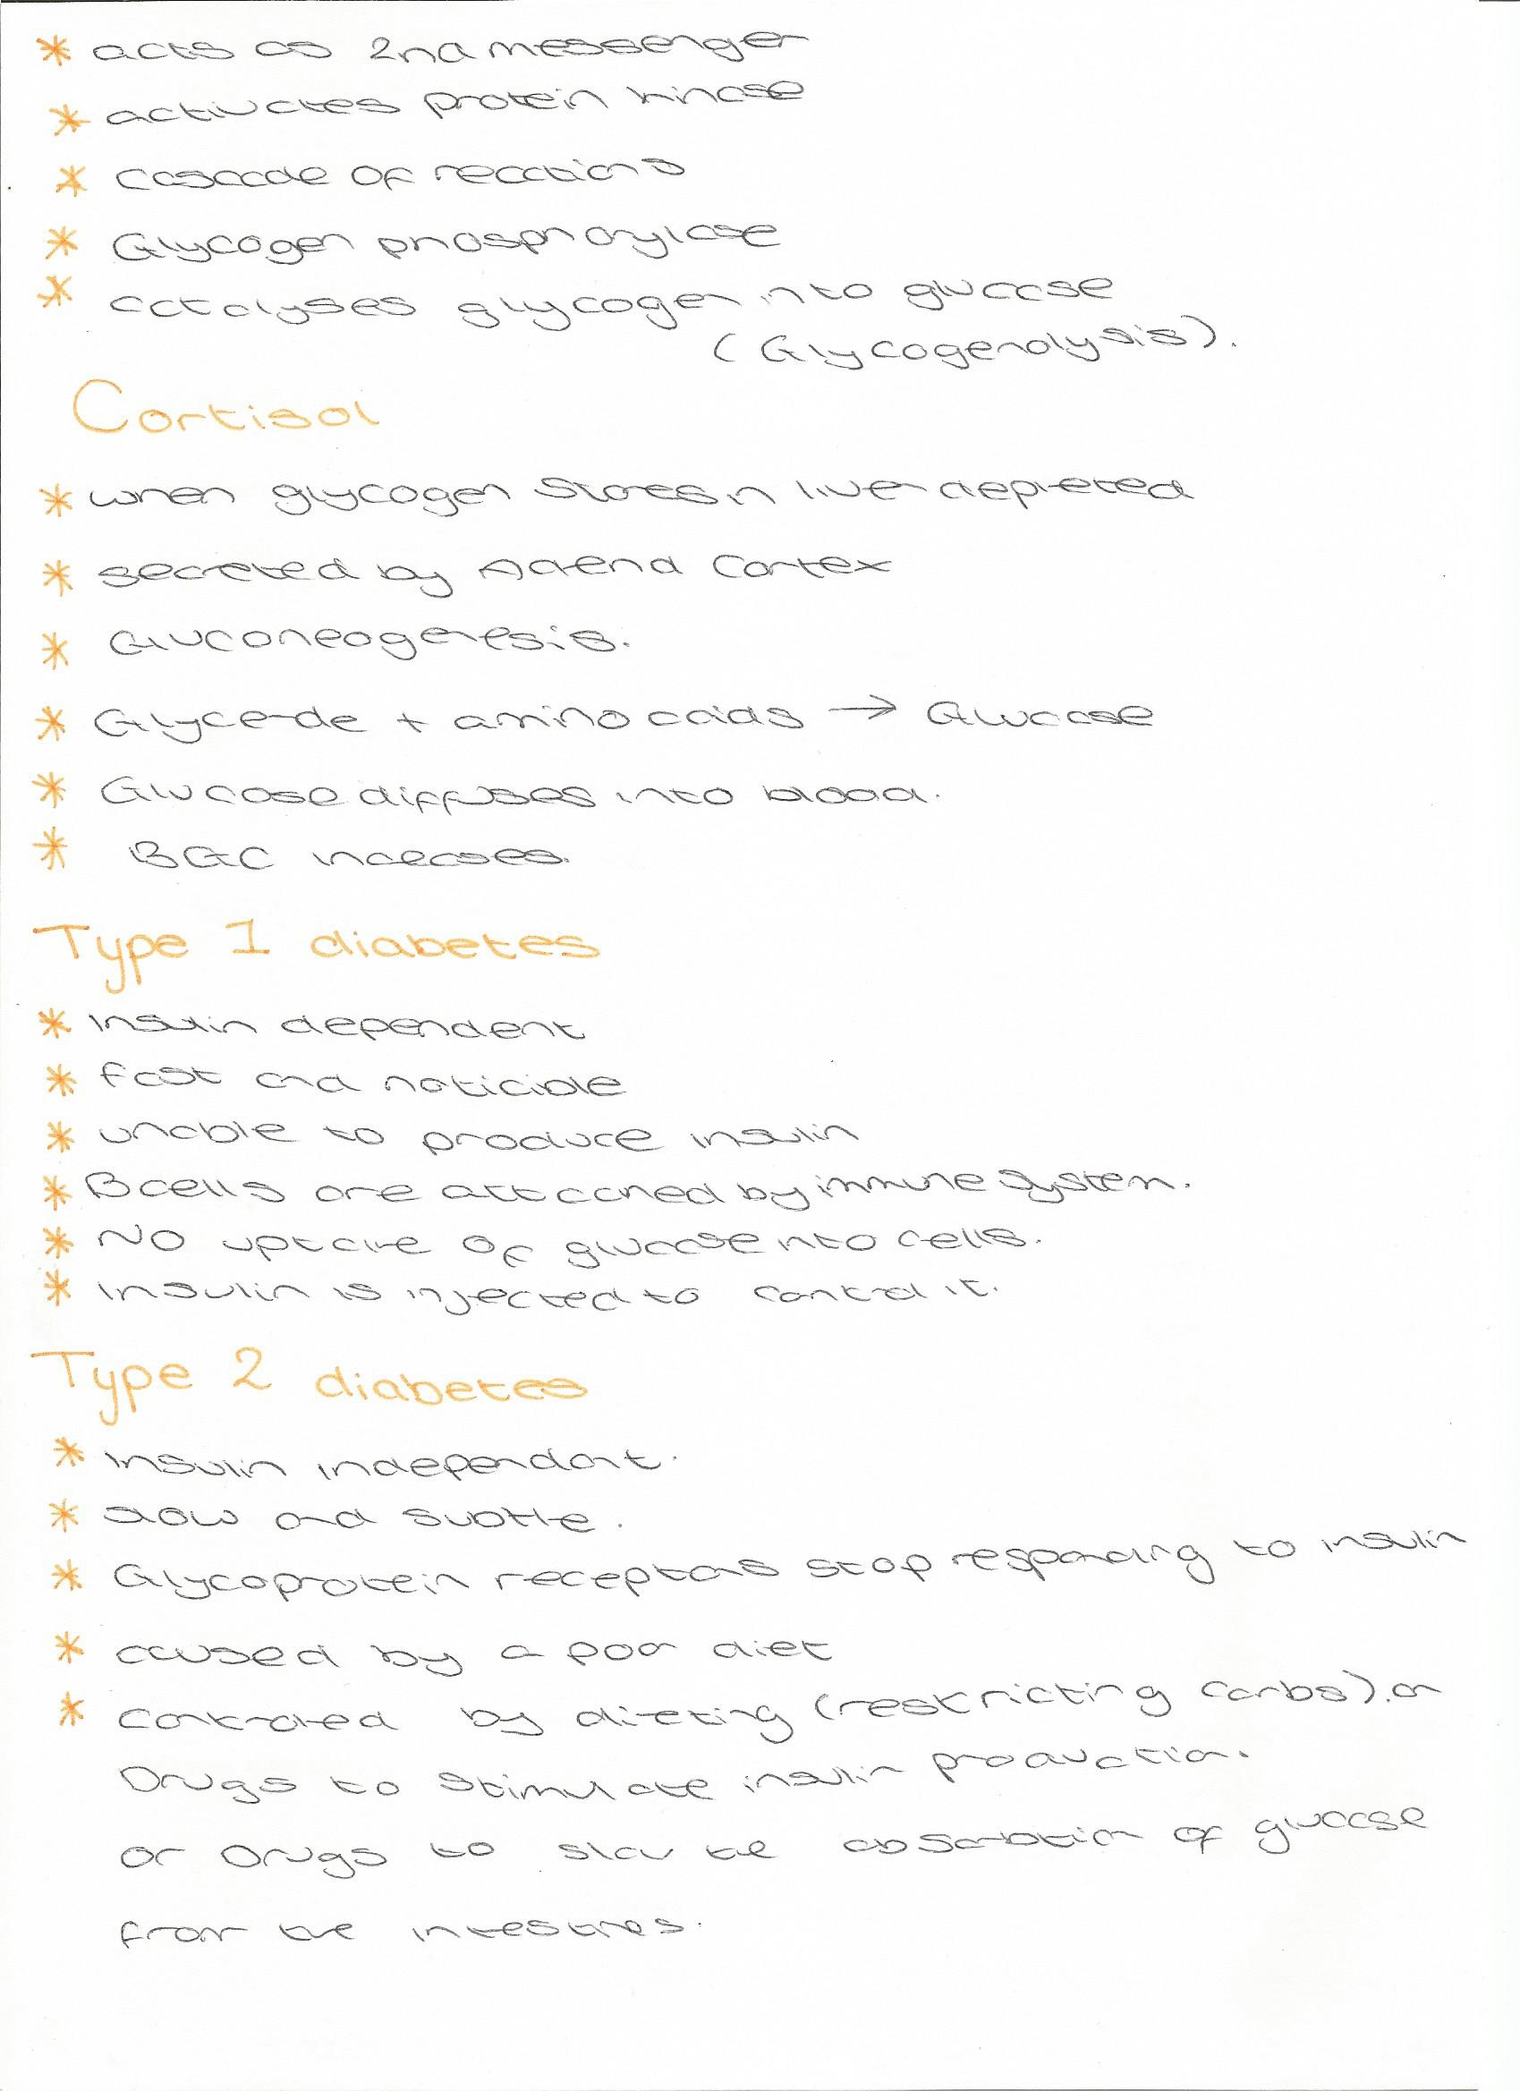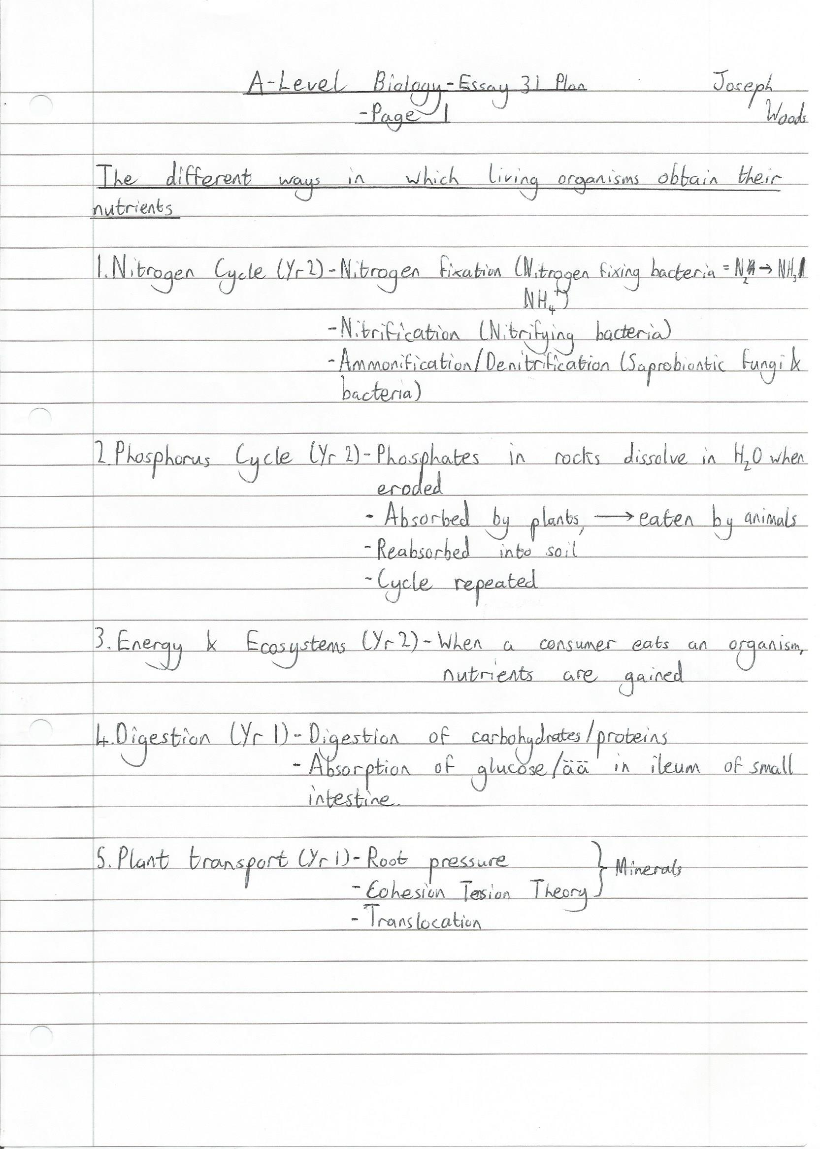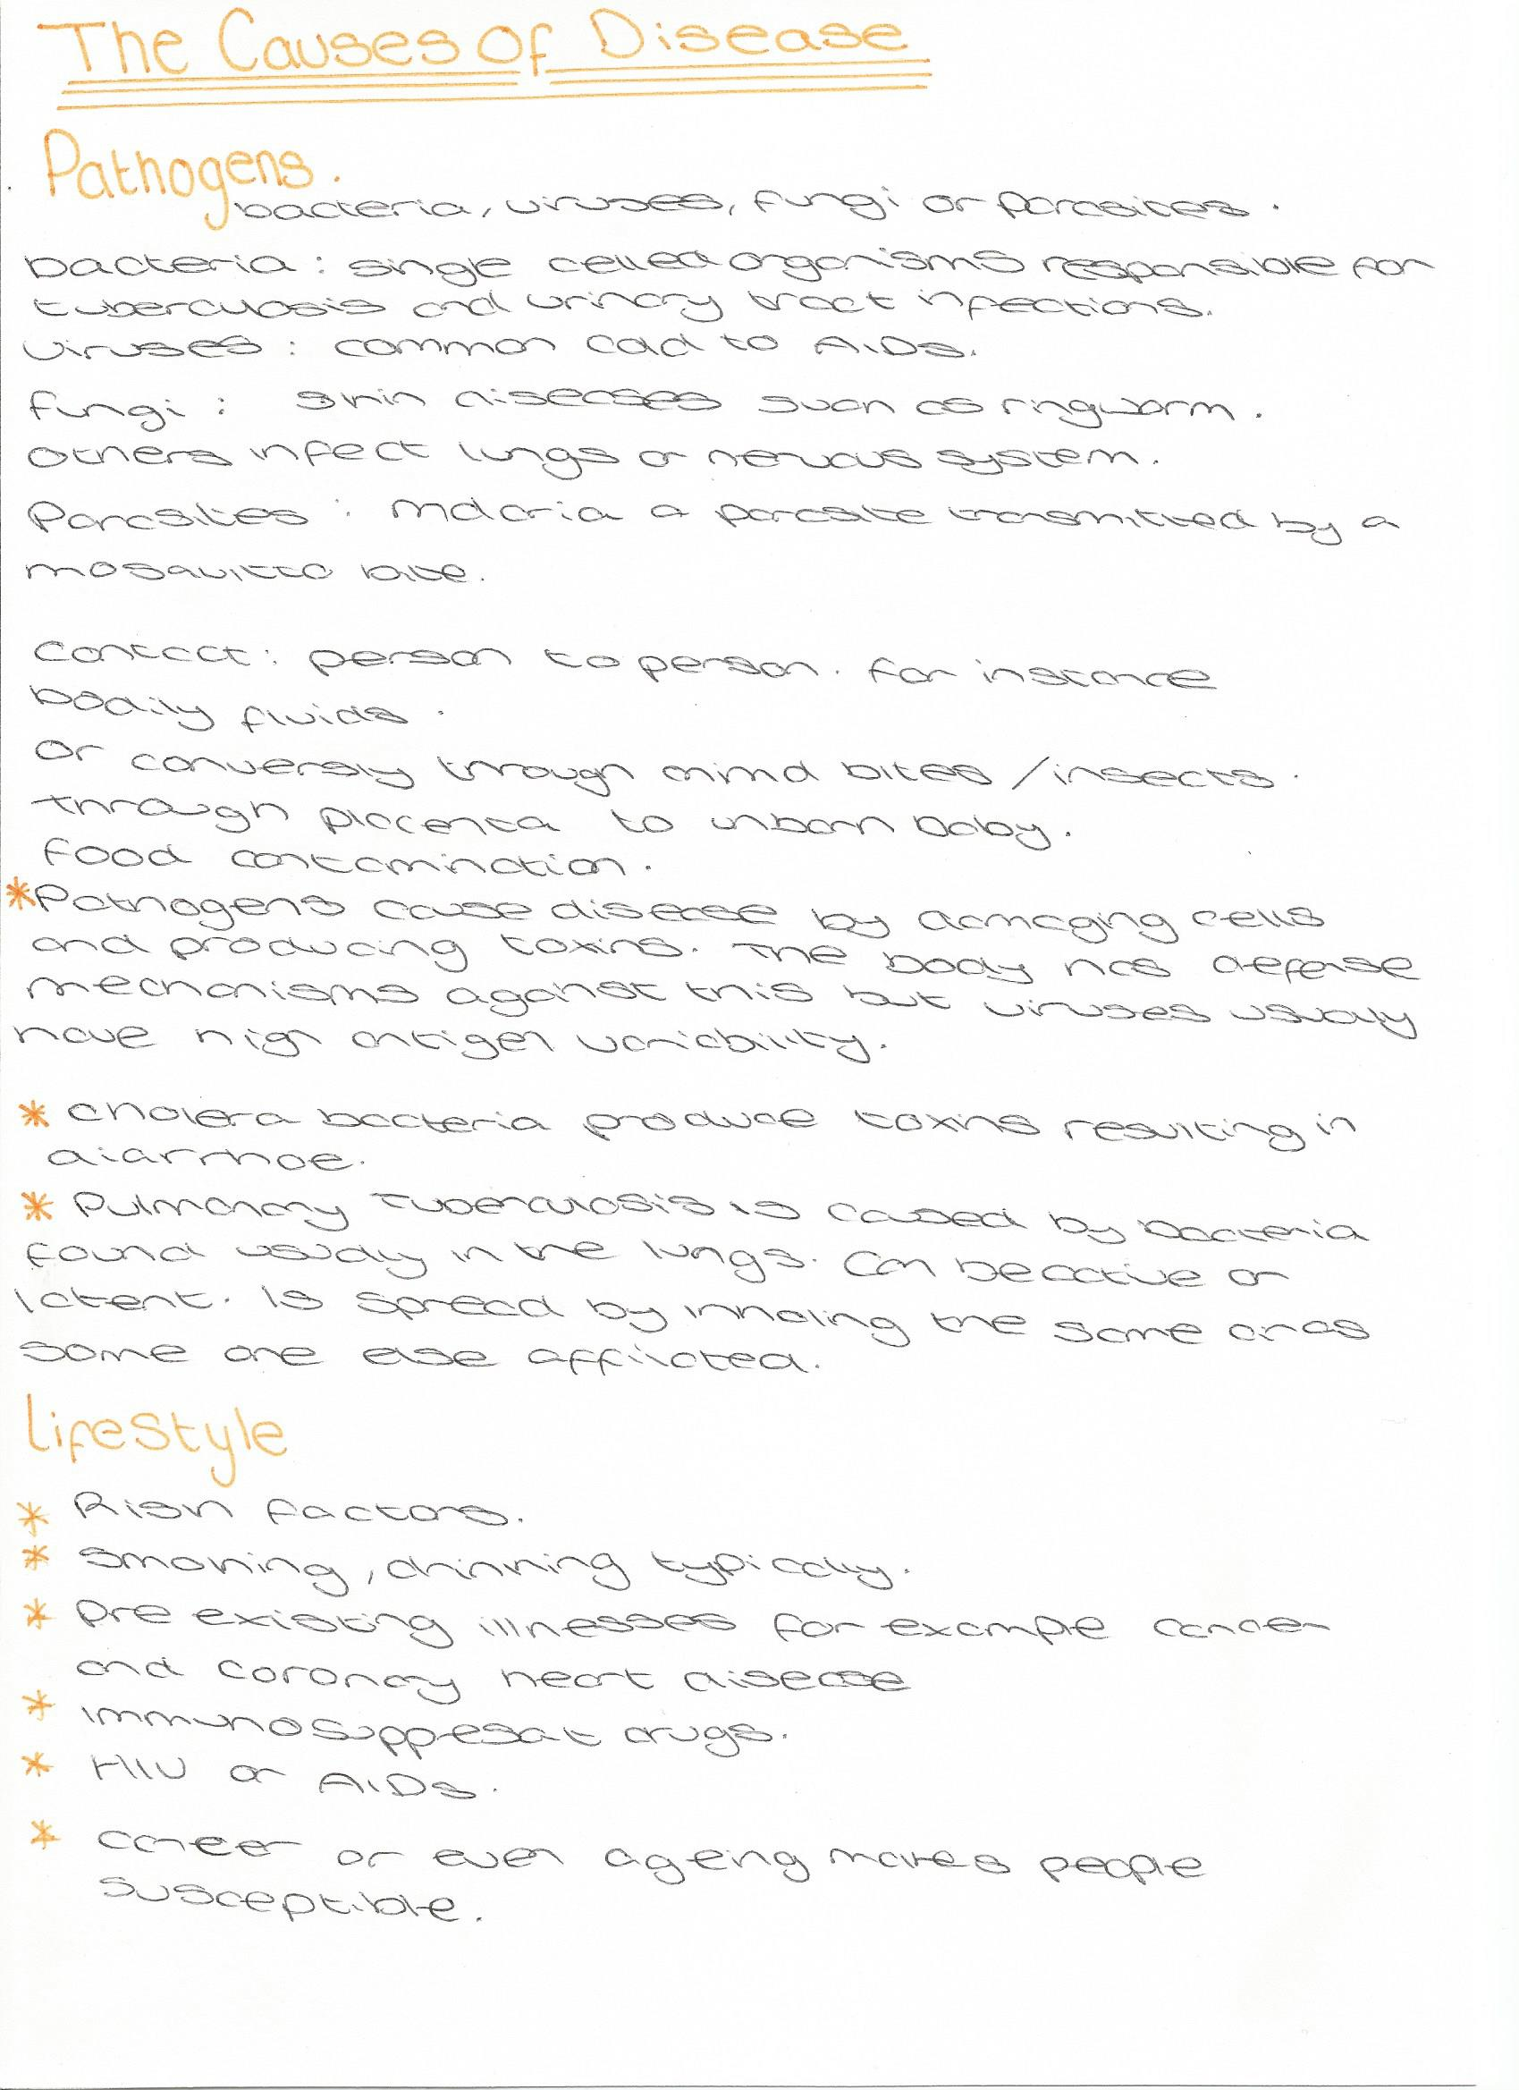

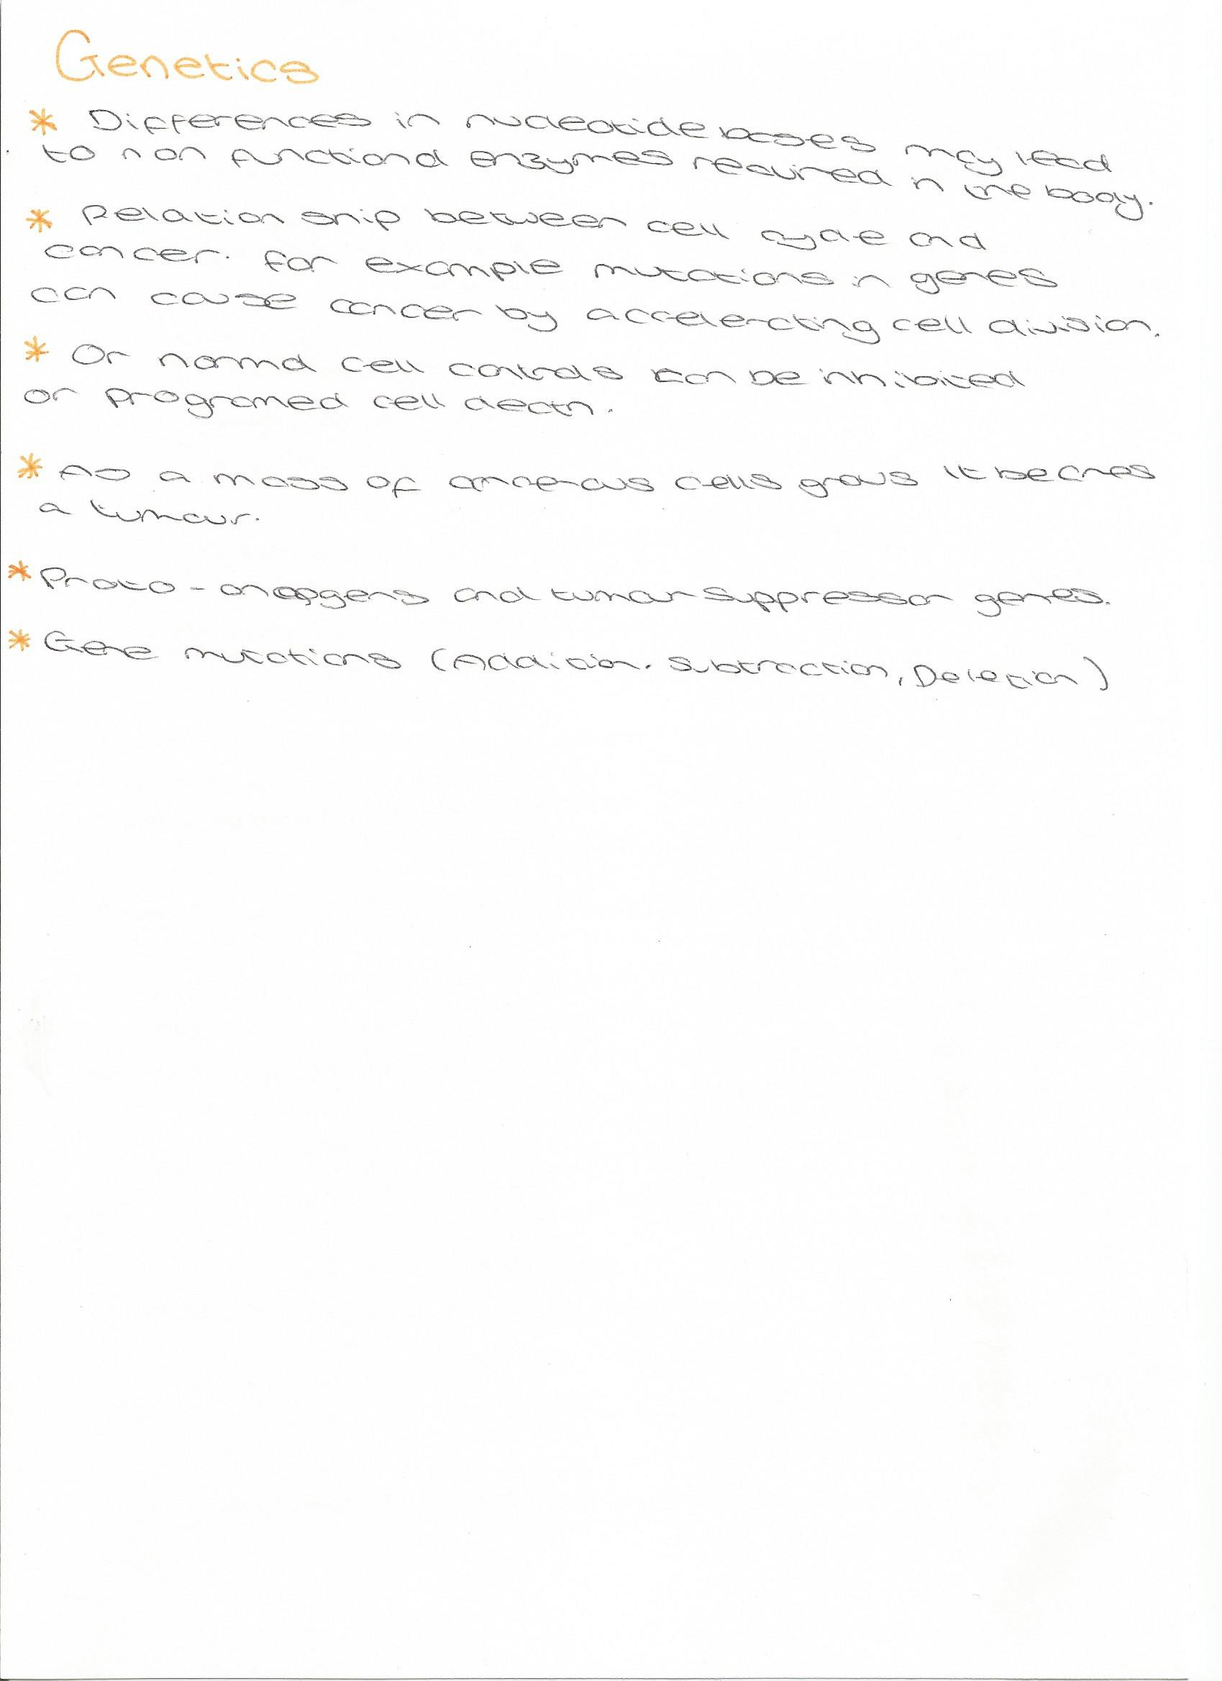
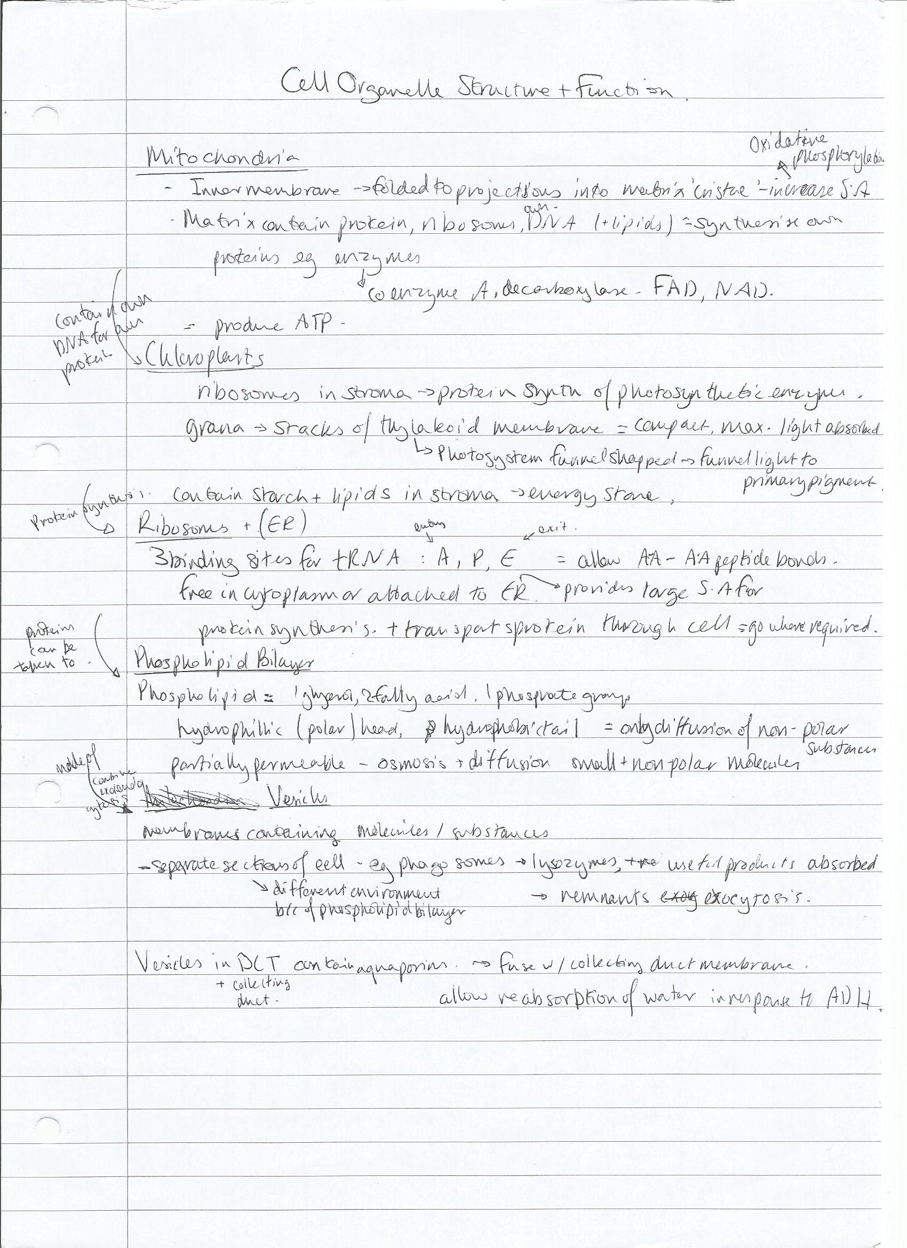

Maintaining constant conditions in the body
Essay checklist (make sure you have done all of the following!)
- 4-5 Topics that are relevant to the question  - Detailed A Level content for each topic  - 2-3 Points per topic  - Use of key words of phrases  - Links between topics | - State why the point is relevant to the question  - No waffle or scientific errors  - Introduction and conclusion  - Beyond the specification when aiming for A* grades

kidney, survival and response – reflex arc, digestion, animal and plant transport, adaptations,

Topic | - Homeostasis | - Kidney | - Controlling blood glucose | - survival and response | - adaptations
Key Points | - What is homeostasis?  - Definition  - Positive and negative feedback  - Why important? | - Kidney structure  - Ultrafiltration, selective reabsorption, reabsorption in loop of henle, osmoregulation | - Diabetes  - Insulin and glycogen  - Effects of changes in blood glucose concentration | - Medulla oblongata, blood pressure and pH  - Taxis and kinesis | - What do adaptations do?  - Natural selection  - Types of selection
Links | Links to topic as homeostasis maintains constant conditions in the body | Links to homeostasis as control of blood water potential is a homeostatic mechanism. | Links to homeostasis as control of blood glucose is a homeostatic mechanism. | Links to homeostasis as helps maintain constant conditions in the body | Links to controlling blood glucose as some organisms have adaptations to have longer or shorter loops of henle
Beyond the specification |  |  | - Likelihood of type 2 diabetes increases and may be caused by a build up of fat around skeletal muscles surrounding the spinal cord | - Medulla oblongata is located in the brain stem
Key words | Optimum point, stimulus, adrenalin | Hypothalamus, water potential, osmosis, aquaporins | Glycogenesis, glycogenolysis, gluconeogenesis, islets of Langerhans, pancreas | Stimulus, neurone, taxis, kinesis, reflex arc, | Directional or stabilising selection, selective advantage

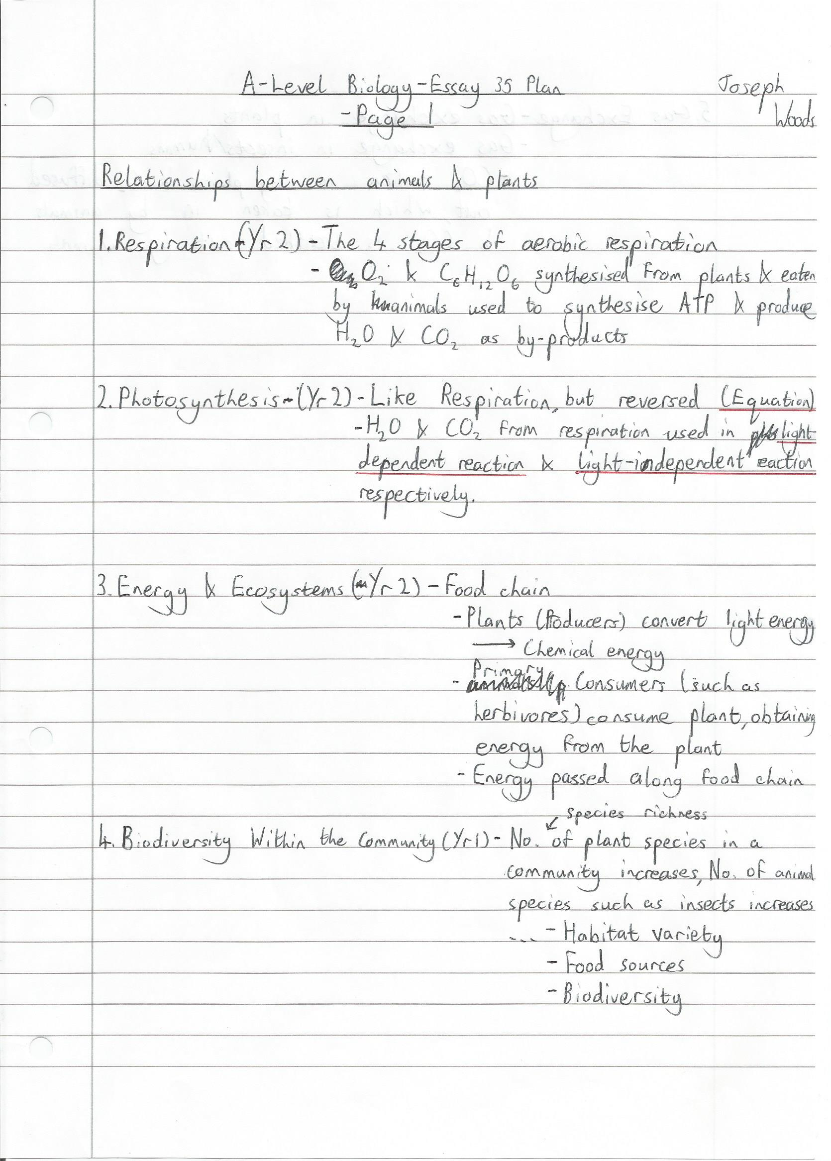


How the structure of proteins in relation to their functions.
- Explanation of protein structure: how primary/secondary/tertiary/quaternary structure is formed, the bonds involved – leading up to explanation of the importance of shape specificity

- Transport proteins: carrier/channel/cotransport proteins, examples of where they’re used (axon membrane, small intestine, NMJ)

- Enzymes: how ESC is formed (induced fit model), examples of enzyme’s role in digestion/respiration/other metabolic reactions

- Antibodies and antigens: brief explanation on immune response and how antibodies work (describe structure, and then functions i.e. agglutination)

- Hormones: such as adrenaline and insulin, what they do at target cells/roles in homeostasis

