Essay title: The importance of nitrogen containing substances in biological systems

Task 1
List biological molecules that contain nitrogen

Task 2
Think of some specific examples of these molecules – what year 1 and year 2 topics do they relate to

Task 3
Pick 5 topics areas (mix of year 12 and 13) to write about. Think about the order of your paragraphs so you can make sure your essay flows and is NOT just a series of biological facts

Task 4
Think about your biological language – pack in the information but concisely and to the point. The essay is about the IMPORTANCE of nitrogen containing substances i.e. what is their role/function? Why are they important?.What would be the problem is they did not perform this function?

Biological molecules that contain nitrogen:
- Amino acids/polypeptides/proteins
- DNA
- RNA
- ATP/ADP
What do they do?? Describe their function and then state why their function is important or what would be the problem is they didn’t do this function
- NAD/NADP
- cAMP
- chlorophyll

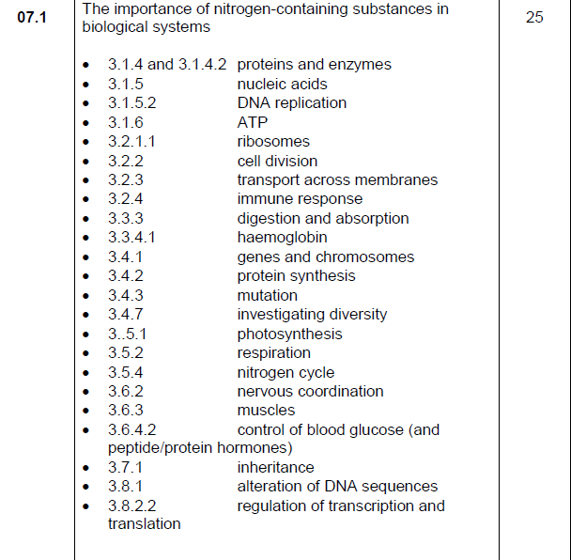
What is function of chlorophyll? Proteins in ETC/ATPase enzyme/stalked particle protein channel
Antibody – why protein importance in shape & function AND Reverse transcriptase/integrase in HIV infection
What about the recombinant DNA technology topic
- Roles of reverse transcriptase/DNA ligase/restriction enzymes – what do they do – why is this important?
Enzymes that add/remove methyl and actyl groups in epigenetics (e.g. methyl transferases) – what does this do to DNA/how does it affect transcription
Glucagon and insulin are peptides/cAMP/secondary messenger/role of enzymes glycogenesis/glycogenolysis
Na+/K+ pump/Na+ and K+ voltage gated channels – role?
Receptors at synapse/acetylcholinesterase enzyme at synapse
Tropomyosin/troponin/actin/myosin
Role of NAD/ETC proteins/ATP synthase/protein channel in stalked particle
mRNA/tRNA/ribosomes
Histone proteins
Spindle fibres are made of protein
What does it do – think about importance
Specific enzymes/what do they do/co transport proteins
Channel proteins/carrier proteins – function – used in what processes?
What is the role of ATP
made of RNA and protein – function?

