Precision and accuracy
Objective: To understand, explain and demonstrate the difference between precise and accurate data
Skill: Practical exam question techniques.

When taking scientific measurements, the goals are to measure accurately and with precision.

- Accuracy indicates the closeness of the measurements to the true or mean value. This means how close your repeated results are to the true or mean value.

- Precision is the closeness of the results to others obtained in exactly the same way. This means are your repeated results similar? This does not have anything to do with the true or mean value.

In this image, the bull’s-eye represents the accepted true or mean value. Each cross represents a repeated result.
- Activity: Descriptions.
2 of the descriptions have been completed for you, complete the other 2 descriptions to EXPLAIN the precision and accuracy of the results.

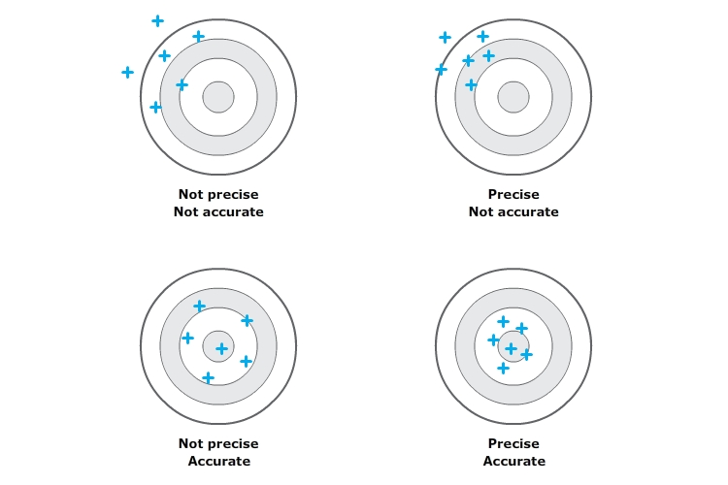
Accurate: Your results are close to the bulls eye (true/mean value)

Not precise: Your results are not close to each other.
Not accurate: Your results are not close to the bulls eye (true/mean value)

Not precise: Your results are not close to each other.
- Activity: Dart boards.
Jamal, David, Marie and Helen spent the afternoon playing darts. In the last round they set the target as the bulls eye. Each person was allowed seven throws. The results of their game are shown below.
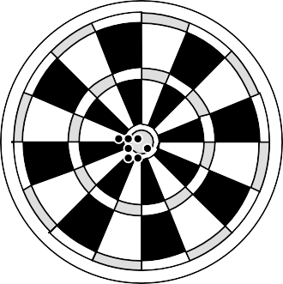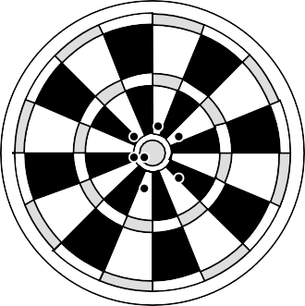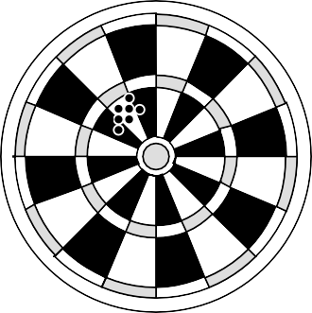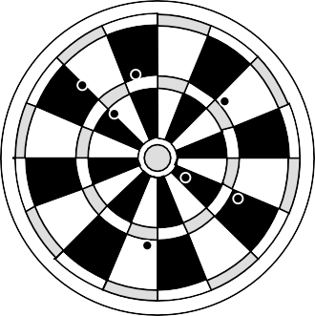
Jamal Helen David Marie
Whose game would you describe as (justify your answer):
- Precise but inaccurate

- Imprecise but accurate

- Precise and accurate

- Imprecise and inaccurate?

- Activity: Coin diameter

A gold coin has an ‘accepted/true’ diameter of 28.054 mm.

Two students are asked to measure the diameter of four gold coins. Student A uses a simple plastic ruler. Student B uses a precision measuring tool called a micrometer.

Student A – plastic ruler (mm) | Student B – micrometer
27.9  28.0  27.8  28.1 | 28.246  28.244  28.246  28.248

- Calculate the mean value for each set of measurements: A; ________ B:_____________

- Compare the mean value for each set with the accepted/true value:

- Which student’s data is more accurate?

- Which student’s data is more precise?

- Look closely at the table. Suggest why the micrometer is said to be a more “precise” measuring tool than the plastic ruler.

- Activity: Precision of equipment.

James has been asked to heat 30cm³ of water and measure the temperature at which it boils- this should be 100°C at a pressure of 1 atmosphere. James had a choice of different equipment he could use; different sized beakers, conical flasks, measuring cylinders and thermometers.

- Chose which pieces of equipment should be used. Under each piece of equipment give a reason for it NOT being used – this is how you JUSTIFY your answer.

Beaker to measure water Beaker for heating water
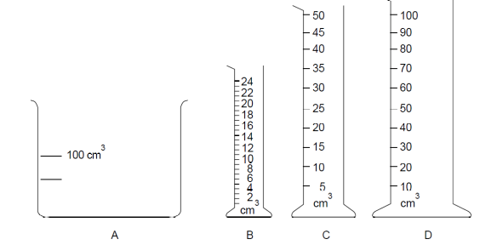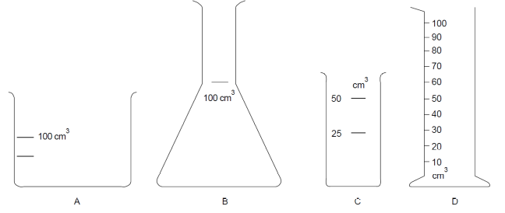

Thermometers for measuring temperature
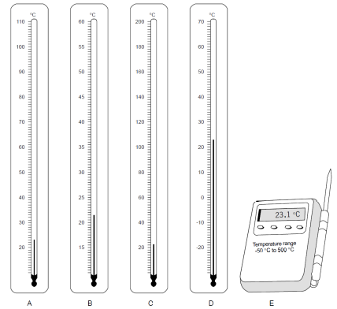

- Would choosing the right equipment make the results more accurate or more precise? Explain your answer.

These are the classes results including James’.
- Work out the mean for each groups results, fill into the table.
  - Which groups results are the most accurate?
  - Which groups results are the most precise?
  - Can you suggest why James’s results are not very good? Suggest how James could improve his results.
