
Key Stage 5 - Hypertrophic cardiomyopathy
Big-hearted briefing
Watch the video on the link below
https://www.stem.org.uk/resources/elibrary/resource/151846/big-hearted-briefing

Task sheet

Hypertrophic cardiomyopathy (HCM)

Around one in 500 people has HCM. The condition makes the heart use energy inefficiently. It is an inherited condition caused by genetic mutations.

Some people with HCM have no symptoms. Others feel breathless. They may have chest pains, blackouts, or palpitations. At its very worst, HCM causes chaotic heart rhythms leading to sudden death.

Your task
Your task is to create an information sheet on HCM for medical students.

Answer the following Q
- What is the genetic basis for HCM? How is it inherited?
- What impacts do HCM gene mutations have on the proteins they code for?
- How and why does HCM affect the structure and function of the heart?
- How does HCM affect how the heart uses ATP? How is this linked to a new treatment for the condition?

Finally, use what you have learnt to write an information sheet on HCM for medical students.

Key Stage 5 - Hypertrophic cardiomyopathy
Big-hearted briefing
Briefing sheet 1: The genetic basis of HCM.

Inheritance

HCM is an autosomal dominant condition. This means that only one mutated allele is required, from either parent, for a child to inherit this increased risk of developing HCM. The Punnett square shows that a child who has one parent who is heterozygous for HCM has a 50% probability of inheriting a mutation.
 |  | gametes from one parent
 |  | h | h | H = HCM  h = healthy
gametes from other parent | h | hh | hh
gametes from other parent | H | Hh | Hh

The example pedigree below shows the incidence of HCM in four generations of one family.
Affected female
Unaffected male
Affected male
Unaffected female
Genetic basis

There are 13 genes that code for the different proteins that make up normal heart muscle tissue. If any one of these genes has a mutation, the heart muscle may not form correctly. This may lead to HCM.

The severity of HCM varies greatly from person to person.
So far, scientists have found more than 1400 mutations in 13 genes that may cause HCM. The genes are located on several different chromosomes, including sex chromosomes.

Genetic tests for HCM

Oxford scientists have developed genetic tests for the mutations that cause HCM. They can be useful in helping to confirm diagnoses of the condition.

However, the genetic tests are not straightforward, and can be difficult to interpret. There is just a 50% probability of obtaining a positive genetic test for a patient whose phenotype is positive. Only the relatives of people with positive genetic tests can be given genetic tests themselves to find out if they are at risk of HCM.

Key Stage 5 - Hypertrophic cardiomyopathy
Big-hearted briefing
Briefing sheet 2: The impact of gene mutations on protein synthesis

Mutations and protein synthesis

The order of DNA bases in a gene determines the order of amino acids in the protein it encodes.

This means that, if a gene has a mutation, the order of amino acids in the protein it encodes could be changed. In other words, the primary structure of the protein is altered.

Changing the primary structure of a protein can alter its 3D shape. This may mean that it cannot fulfil its functions properly.

Mutations in people with HCM

Which genes?
So far, scientists have found more than 1400 mutations in 13 genes that may cause HCM. The genes are located on several different chromosomes, including sex chromosomes. All of the genes are expressed in the heart.

Many of the genes that are mutated code for or interact with the main contractile proteins of the sarcomere:
- myosin, which makes up thick myofilaments
- actin, which makes up thin myofilaments

Many HCM patients have mutations in one of two genes. Gene MYBPC3 codes for thick filament myosin-binding protein. This protein holds thick filaments together, like a barrel hoop. The other gene that is mutated in many HCM patients is MYH7, which codes for a myosin-heavy chain protein.

Research in Oxford shows that some genes associated with HCM do not encode contractile proteins. These include genes that code for the AMP-activated protein kinase, and calcium-handling proteins.
Which mutations?
Many pathogenic mutations involve changing just one nucleotide. These mutations result in codons that code for different amino acids. This type of mutation is a missense mutation. Missense mutations cause one amino acid to be exchanged for another in the synthesis of a protein. For example, a common mutation in the MYH7 gene causes glutamine to replace arginine in its protein.

Some mutations involve changes to more than one nucleotide. These affect a greater number of amino acids in the protein. For example, a frameshift mutation is a mutation caused by the insertion or deletion of a number of nucleotides that is not divisible by three. This changes the grouping of the codons, and leads to incorrect amino acids being incorporated into the protein that is produced on translation. After the mutation, the way in which all of the codons are read is affected by the insertion or deletion of these nucleotides. The earlier in the sequence the insertion or deletion occurs, the more different is the protein produced. Proteins produced as a result of frameshift mutations can be either longer or shorter than the normal protein.

Key Stage 5 - Hypertrophic cardiomyopathy
Big-hearted briefing
Briefing sheet 3: Heart structure and function

Cardiac muscle
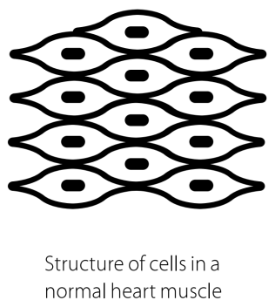
The heart must never stop beating, so its cells must never fatigue. Heart walls are made up of cardiac muscle. Cardiac muscle tissue consists of specially adapted cells, which have many mitochondria for continuous aerobic respiration.

Cardiac muscle tissue is a multinucleate syncytium. The cells are connected by intercalated discs, which have low electrical resistance. These adaptations mean that nerve impulses can move quickly from cell to cell.

Cardiac muscle is myogenic. This means it contracts and relaxes of its own accord. The muscle fibres are arranged in smooth straight lines, so they are aligned as the muscle contracts and relaxes.

Cardiac muscle and HCM
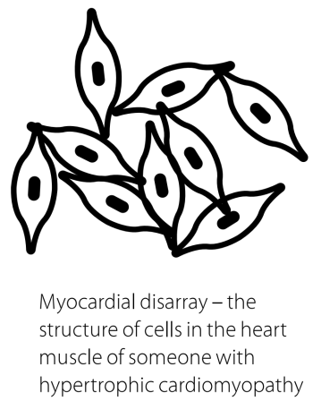
In people with HCM, the cardiac muscle cells are not arranged in smooth straight lines. Instead, they lie in disorganised layers. This is myocardial disarray.

Myocardial disarray seems to be associated with many symptoms of HCM. Scientists wanted to know why. They collected a great deal of evidence, but no one theory explained it all.

After much thought, Oxford scientists, lead by Professor Hugh Watkins, suggested a new explanation. The heart muscle of a person with HCM contracts inefficiently. It requires more energy than normal to produce the force needed to pump enough blood around the body.

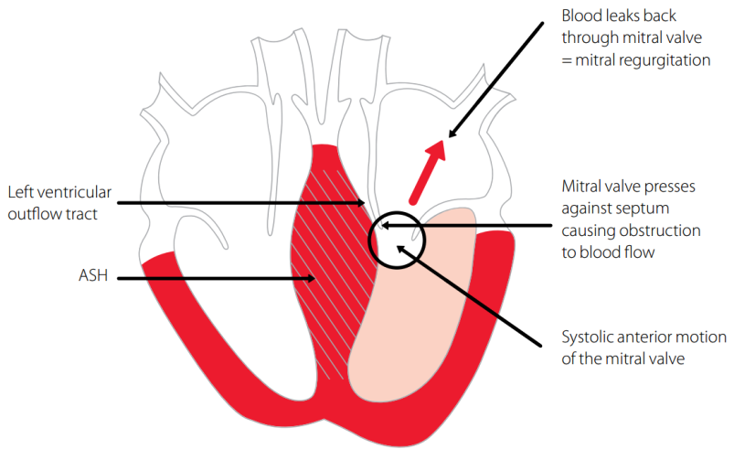
This inefficient use of energy makes the heart muscle thicken, to compensate. The diagram on the right shows a heart with a thickened septum.

The thickened septum causes a narrowing of the left ventricular outflow tract. The narrowing creates a Venturi effect, in which the pressure of the blood decreases as a result of flowing through the narrowed tract. The mitral valve (the valve between the left atrium and the left ventricle) is sucked towards the septum due to this decrease in pressure, further obstructing blood leaving the left ventricle through the aorta. This means that the heart cannot pump enough blood around the body.

There is also evidence to suggest that thickened heart muscle may change electrical signals in the lower chambers of the heart. This disruption contributes to abnormal heart rhythms.

The Oxford scientists have collected further evidence from HCM patients to test their new explanation. The evidence supports the explanation, making them confident that it is correct.

Acknowledgement Oxford Sparks would like to thank the British Heart Foundation for their permission to use images from their booklet Inherited heart conditions: hypertrophic cardiomyopathy. For more information see www.bhf.org.uk
Key Stage 5 - Hypertrophic cardiomyopathy
Big-hearted briefing
Briefing sheet 4: ATP and HCM

ATP as an energy source

A cell does not get its energy directly from glucose. Instead, cells use energy released by the breakdown of glucose or fatty acids to make another chemical, adenosine triphosphate, or ATP.

ATP is the perfect energy source for a cell. It breaks down easily in chemical reactions, releasing energy in the process. Its molecules are small and soluble, so diffuse easily to any part of the cell that needs energy. ATP molecules cannot pass out of their cell.

Heart muscle cells make ATP from two types of starting materials – glucose, and fatty acids. It is more efficient to make ATP from glucose, since less oxygen is required.

ATP and HCM

Scientists from Oxford, led by Professor Hugh Watkins, have developed an explanation linking ATP and HCM.

Mutations in genes that code for certain cardiac muscle proteins make the muscle contract inefficiently. The contractions need more energy than those in a healthy heart. This means that cardiac muscle cells in the heart of a person with HCM need more ATP.

Inefficient contractions make the heart muscle thicken. This makes the pumping chambers smaller. The heart cannot pump enough blood around the body, meaning that a person with HCM may be short of breath, or have chest pains.

If a heart with HCM is working harder than normal – perhaps during exercise – it may run out of ATP. The heart cannot pump properly. It beats very fast and chaotically. This is called ventricular fibrillation. A person suffering ventricular fibrillation will die unless their heart is restarted by an electrical current.

New treatment

Oxford scientists are developing a new treatment for HCM. The treatment is based on a drug that was used to treat angina (chest pain) in the 1980s.

The drug forces cardiac muscle cells to produce ATP from glucose, rather than from fatty acids. The production of ATP from glucose is more efficient, requiring less oxygen. This means that more ATP is produced for a certain amount of oxygen.

