BTEC Subsidiary Diploma

UNIT 48

Exploring Personal and

Professional Development in

Health and Social Care

Induction Tasks Booklet

c:\tempie\Content.IE5\PK2KVDLK\MC900332432[1].wmf

Your Journey to Success starts HERE!

**Where am I going?**

Before we start work for the course let’s think about what you want to achieve from it.

**Final Destination:** BTEC Subisdiary Diploma in Health & Social Care

**What do I want to have achieved in 12 months’ time?**

**…………………………………………………………………………………………………………………………………………………………………………………………………………………………………………………………………………………………………………………………………………………………………………………………………………………………………………………………………………………………………………………………………………………………………………………………………**

**What do I want to have achieved in 2 years’ time?**

**……………………………………………………………………………………………………………………………………………………………………………………………………………………………………………………………………………………………………………………………………………………………………………………………………………………………**

**What is your MEG? …………………………………**

**What grade do you aspire to achieve at the end of the BTEC Course? Please circle.**

**PASS MERIT**

**DISTINCTION DISTINCTION\***

**“The starting point of all achievement is desire”**

**Aim for the stars – be the best you can!**

**To achieve what you want to, how many BTEC Points do you need? ……………………**

**Preparation for the Work Related units**

**Starting Out **

**You should by now have obtained a file for these units which will be stored in college.**

1. Ensure your file is clearly labelled with your name.
2. Ensure each task is clearly **labelled with your name** and **the date** in the header or footer *(remember these units runs across the two years and you need to evidence your progression during the course*). Each task should be placed in a plastic wallet within your folder.
3. Create the major dividing pages for your portfolio of evidence.

|  |  |
| --- | --- |
| Dividing Page | Tick when completed |
| **Section 1The learning process** |  |
| **Section 2 Assessment of myself at the start of the course** |  |
| **Section 3 Action Plans** |  |
| **Section 4 Reflection of personal development and learning from college, placement experiences and helping others** |  |
| **Section 5 Work Placement time sheets** |  |
| **Section 6 Appendices** |  |

*****This task should be done by: ………………………………………………*

***Unit 48 tasks 1-10***

***The activities following are vital evidence for your unit 48 portfolio and will be undertaken either in class or as homework following relevant teaching and learning activities.***

***Task 1*** *is aimed at meeting the* ***P1*** *criteria for Unit 48*

***Tasks 2– 7 and 10*** *are aimed at meeting the P2 & M1 criteria for unit 48.*

***Task 8*** *is aimed at meeting the P2 criteria and will also go towards meeting P5 along with future reflection tasks and your reflective diaries from work placement Unit 48*

***Task 9*** *is aimed at meeting the P3 criteria. Unit 48*

**Task 1** **An explanation of the key influences on the personal learning processes of a person and the effects of these influences.**

This report will go in section 1 of your portfolio.

**Undertake the Unit 48 assignment 1 (P1)** using the answer frame work below. Don’t forget to put your name and the date in the header!

***Remember:***

***You must find and use resources to help you to complete the work for P1, your notes and pages 242 -247 (Stretch & Whitehouse 2010) are just a starting point.***

Don’t forget to record the sources that you use in your bibliography and reference these in your work.

**Task 1**: Main title: **An explanation of the key influences on the personal learning processes of a person and the effects of these influences.**

**Task 2** : Put a subtitle: **Introduction**

You now need to introduce the work – remember you a writing this to inform a student care worker.

Explain what is meant by learning

Give a basic example of learning

**Task 3:** Put a subtitle **Theories of learning and learning styles.**

Explain that you are going to describe two theories.

Explain the term theory

Now describe Kolb’s learning cycle

Now describe Honey & Mumford’s learning theory

***You may wish to include diagrams to help you explain the theories***

**Task 4:** Put a subtitle: **The Factors that affect and influence learning**

Start by explaining that some factors come from within and are known as intrinsic factors and others are external and environmental factors which are known as extrinsic factors.

You are now ready to start explaining the factors – remember there will be positive and negative effects of each factor.

**For each factor** you identify consider whether this has had any effect on your learning to date.

**For example:** At school if your friends and peers are eager to do well and achieve good results you are more likely to succeed and learn than if your friends don’t see the importance of education and mess about.

***To help you – here are the factors***

**Intrinsic Factors**

- Motivation, Attitude & self-discipline, Aspiration, Specific learning needs, Learning style

**Extrinsic Factors**

– Culture, Family, Lifestyle, Health, Informal learning, Funding for study, Access to books and learning materials, , Previous educational experience, Subject ‘blind spots’, Access to study support, Study Space, Friends & peers, Time, Care responsibilities, Employment Relationships.

When you have proof read and spell checked your work submit it along with your bibliography to Connect.

**To be completed by**: ………………………………………………………….

 **Assessing myself at the start of the course. P2 unit 6**

**Task 2** – **Learning Style questionnaires **

You should undertake both the Learning Styles questionnaire from Carmel Connect & the Honey & Mumford Learning style Questionnaire.

*These will identify your learning style and will assist you in writing task 2, your completed questionnaires will be placed in your portfolio.*

**To be completed by: ………………………………………………………….**

**Task 3** – **My learning styles** 

Produce a written piece about your learning styles – use the framework below to assist you.*Don’t forget to put your name & the date in the header or footer!*

**My Learning Style**

Explain briefly how you identified your learning style.

Identify what your learning styles are.

Explain about this type of learner. (The following website may help you in this [http://www.open2.net/survey/learning styles/](http://www.open2.net/survey/learning%20styles/) )

Do you think the information you have found out about this type of learner is valid (matches how you think you learn)?

Identify study tips for the type of learner you are.

What can this type of learner struggle with?

How might knowing the difficulties for this type of learner help you?

**To be completed by**: ………………………………………………………….

**Task 4** **An assessment of the key influences on my personal learning to date**.

This should be a typed A3 poster of a time line showing key influences on your personal learning. You must **assess** the effect the influence has had upon you. It is suggested you produce in landscape. *Don’t forget to put your name and the date in the header or footer!* **Remember your time line is likely to look different to everyone else’s and you do not need to share this information with anyone else if you do not wish to do so.**

Main title: **An assessment of the key influences on my personal learning to date**

1. Draw a line and indicate key ages on this line.

e.g. 0____________5______________10____11 __________ 14_____________16

2. You are now ready to start including things that have had effects on your learning (see example below)

Age 3 – uncle taught me the Lord’s Prayer; this informal learning could be the basis of my strong religious faith.

Age 5

While ill mum really encouraged my learning to read and my love of books. This was a combination of formal and informal learning but I think the informal influence of mum was important

Learned to knit after watching grandma which has given me good dexterity skills

Worked hard for my GCSE’s achieving nine A grades

History teacher Mrs Jones really

developed my love of history & encouraged me academically.

0____________5______________10____11 __________ 14_____________16

Age 5 –

Developed pneumonia and missed 3 months schooling, this may have led to me being shy but also enabled me to become an independent learner.

Bad experience in Physics has led to a subject blindness when it comes to Physics

**Looking at this time line I can see that both informal and formal learning have had key influences on my learning to date. It is possible that my early informal influences have had an impact on my success at the end of my formal education and my GCSE achievement.**

**To be completed**: ………………………………………………………….

**Task 5. Review of Skills for learning**

In this piece you are going to review your skills. For each skill you should consider what you are good at and what you could perhaps develop and improve during the course.

Copy the table below into a word document and complete it. This may be better done in landscape format. *Don’t forget to put your name and the date in the header or footer!*

|  |  |  |  |  |
| --- | --- | --- | --- | --- |
| **Skill** | **Review** | **Action I need to take to aid this skill.** | **Learning Opportunities to develop this skill** | **Support for my learning (Where can I get help in developing this skill?)** |
| **Literacy** |  |  |  |  |
| Composing documents |  |  |  |  |
| Writing emails |  |  |  |  |
| Writing letters |  |  |  |  |
| Planning an essay or report |  |  |  |  |
| Spelling & Grammar |  |  |  |  |
| Reading |  |  |  |  |
| **Numeracy** |  |  |  |  |
| Addition & subtraction |  |  |  |  |
| Multiplication |  |  |  |  |
| Mental arithmetic |  |  |  |  |
| Presenting data e.g. graphs |  |  |  |  |
| **IT** |  |  |  |  |
| Word processing |  |  |  |  |
| Databases |  |  |  |  |
| Spreadsheets |  |  |  |  |
| Sending emails with attachments |  |  |  |  |
| **Research Skills** |  |  |  |  |
| Using the library |  |  |  |  |
| Using the index of a book |  |  |  |  |
| Using a variety of sources for a topic. |  |  |  |  |
| Using the internet effectively |  |  |  |  |
| Referencing your sources |  |  |  |  |
| **Questioning** |  |  |  |  |
| Asking for help |  |  |  |  |
| clarifying tasks you have to undertake |  |  |  |  |
| **Using Feedback** |  |  |  |  |
| How good are you at using feedback |  |  |  |  |
| Do you see feedback as a positive or as a criticism |  |  |  |  |

**To Be completed:**………………………………………….

**Task 6. Employability skills. **

E**mployability skills** have been **defined** as: "A set of achievements, understandings and personal attributes that make individuals more likely to gain **employment** and to be successful in their chosen occupations". Peter Knight & Mantz Yorke (HEFCE/DfES ESECT group 2015).

Complete the employability skills table –this can also be accessed on Connect. *Don’t forget to put your name and the date in the header or footer!*

|  |  |  |
| --- | --- | --- |
| **Skill that employers are looking for** | **What this means** | **Skills I have at the beginning of my course** |
| **1 Communication & Interpersonal Skills** | The ability to explain what you mean in a clear and concise way through written & spoken communication.  To listen and relate to other people, and to act upon key/instructions. |  |
| **2 Problem solving skills** | The ability to understand a problem by breaking it down into smaller parts, and identifying key issues, implications and identifying solutions.  To apply your knowledge from many different areas to solving a task. |  |
| **3 Using your initiative and being self-motivated** | Having new ideas of your own which can be made into a reality. Showing a strong personal drive and not waiting to be told to do things. |  |
| **4 Working under pressure to deadlines** | Handling stress that comes with deadlines and ensuring that you meet them. |  |
| **5 Organisational Skills** | Being organised and methodical. Able to plan work to meet deadlines and targets. Monitoring progress of work to ensure you are on track to meeting a deadline. |  |
| **6 Team working** | Working well with other people from different disciplines, backgrounds, and expertise to accomplish a task or goal. |  |
| **7 Ability to learn and adapt** | To be` enthusiastic about your work, and to identify ways to learn from your mistakes for the benefit of both you and your employer. |  |
| **8 Numeracy** | The ability to use data and mathematics to support evidence or demonstrate a point. |  |
| **9 Valuing diversity & difference**  C:\Users\lesley\AppData\Local\Microsoft\Windows\Temporary Internet Files\Content.IE5\GBST1W45\MC900288988[1].wmf | Knowing the value of diversity and what it can bring. Understanding and being considerate of the different needs of different individuals. |  |
| **10 Negotiation skills** | To take on board other people’s feelings and express your own requirements in an un-emotional clear fashion to achieve a win-win outcome. |  |

**To be completed**: ………………………………………………………….

**Task 7.** ***Produce a CV at the start of the course.***

You should produce a CV which can be used when applying for part time work. This should show your qualifications, current skills and experience. It is good practice to update your CV regularly. *You have materials to assist you in producing a CV on Connect and there are many good websites to assist you in producing a professional CV.*

This pre-set format will assist you.

**Curriculum Vitae**

|  |  |
| --- | --- |
| **Name:** [Name] | **Address:** [First line]  [Second line]  [City]  [Post code] |
| **Telephone:** [Home or mobile] |
| **E-mail:** [E-mail] |

**Personal Profile**

[Enter your personal profile here – just a few brief sentences about yourself]

## Relevant Skills Profile (These are just some Examples of headings you can use use your employability skills document)

**Problem solving** [Two or three examples]

**IT skills** [Two or three examples]

**Communication** [Two or three examples]

**Teamwork** [Two or three examples]

**Education / Qualifications**

**[Dates]**  **[College Name]**

**[Courses being studied]**

[Important modules – these may link to the position you are applying for]

**[Dates]**  **[Other Schools]**

**[GCSE grades]**

**Employment/ Work Experience**

**[Dates] [Place of employment]**

* [Key Responsibilities]

**Hobbies and Interests**

* [A list of your key hobbies and interests]

**REFEREES**

**To be completed:………………………………………………..**

**Task 8. *Reflection*** 

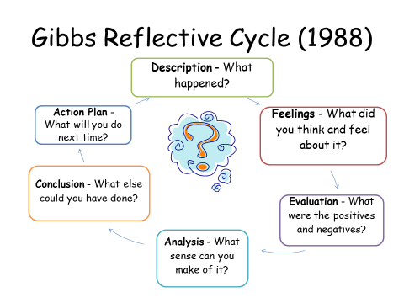

Reflection is a key aspect of monitoring your progress; it can be used to highlight your achievements as well as examining how you can improve for the future.

It is important that unit 6 and 44 contains evidence of ongoing reflection throughout the course.

Keeping a diary of your experiences during the course will assist you in writing a reflective account of your experience. *You can use direct quotes from your diary and reference this e.g. (Reflective diary page …..) Ensure each reflection has your name and the date in the header or footer.*

Write a reflection of your entry to the BTEC course and the positive and negative factors that affected your learning at school using Gibbs reflective cycle and the framework below.

Reflecting upon my educational achievements and learning to date.

What GCSE results did you get?

Did this mean you had the qualifications to study BTEC H&SC.

How did you feel about your GCSE results?

What were the positives and negatives of tht affected your learning at school?

What effects did these have on your success at GCSE?

What actions do you need to take to ensure success in your current studies?

Reflecting upon the start of the BTEC National Diploma in Health & Social Care.

Describe your first day at Carmel and your first Health & Social Care lesson.

How did you feel about starting Carmel? ( nervous /excited Why?)

How did you feel about your first H&SC lessons?

Describe your experience of Carmel & Health & Social Care to date?

How do you feel now about Carmel & H&SC compared with your first day?

What are the positive and negatives of H&SC so far?

What can you do to reduce any negatives and maximise your success in BTEC H&SC based on your experiences from school and your early experiences of H&SC?

**To be completed**:…………………………………………………………………..

**Task 9 *Produce an Action Plan.***



Using the information you have gathered from your employability skills audit, reflection of your entry to the BTEC Health & Social Care course and your review of your skills for learning table produce an action plan of areas you need to work on. Remember this should include both short term (up to six months) and long term goals. (Minimum of ten to eighteen months)

Your goals must be SMART - **S**pecific, **M**easurable, **A**ctionable, **R**elevant and **T**imed. See the example below (this is also available on Connect.)

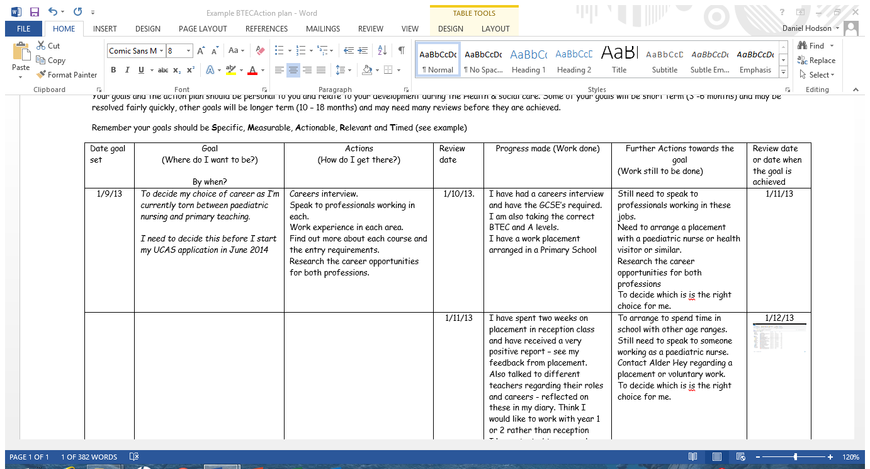

**You can find the pre-set format for the action plan on Connect.**

**It is suggested that you do a separate one for each goal and then these can be added to each time you review each goal.**

**To be completed**: ………………………………………………………………….

**Task 10. An assessment of my value and beliefs, knowledge, skills, practice and career aspirations.**

Using the heading and subheadings provided to structure your work produce a written piece using the framework below. *Don’t forget to put your name and the date in the header or footer!*

**An assessment of my value and beliefs, knowledge, skills, practice and career aspirations.**

**Introduction**

Start by explaining that you are undertaking a review of your values, beliefs, knowledge, skills, personal experience of practice and your career aspirations.

You may need to give a definition of each of the terms before you start covering each area.

**Values & beliefs.**

Write about your values – you might also want to undertake Activity 18 page 265 and read pages 264-265 (Stretch & Whitehouse 2010) before you start writing this as this will assist you. Do you think your values and beliefs fit with the area you are going to work in? How might you further develop your values and beliefs during the course? (e.g. work placement of units to be studied)

**Exploring my Knowledge.**

Write about your current knowledge and where you have developed this knowledge eg subjects studied, voluntary work, family experiences – reading pages 257 & 258 (Stretch & Whitehouse 2010) may assist you with this as may figure 6.11 page 270 (Walsh 2011) and pages 138 – 140 (Rasheed 2010)

**Skills**

Write about your current skills under the following headings - Communication skills, working with others, Technical skills, Research skills, Personal organisational & time management skills, Personal Presentation skills, Creative and craft skills, Literacy and Numeracy skills.

Where you have developed these skills? Which do you need to start to work on developing? Reading pages 258 - 262 (Stretch & Whitehouse 2010) may assist you with this. See also the skills review on pages 146-147 (Rasheed 2010)

**My experience of Practice**

Write about your past experience of helping others – you might also want to undertake Activity 17 page 264 (Stretch & Whitehouse 2010) before you do this and read pages 262-264 (Stretch & Whitehouse 2010) before you start writing this.

You could also include any volunteer work or work experience that you did at school in this section.

**My Career Aspirations**

Identify your career aim or possible career aims if you are still uncertain. Why have you chosen this? What qualifications do you need for this career? What skills do you possess that would be useful? What skills will you need to develop?

**To be completed**: …………………………………………………………………

**You have now completed your induction and have already completed tasks towards your qualification. WELL DONE.**