P3: Explain factors that may influence communication and interpersonal interactions in health & social care environments.
P4: Explain strategies used in health & social care environments to over barriers to effective communication and interpersonal interaction.

Environmental factors
Introduction
The effectiveness, or success, of communication and interaction in health and social care settings is influenced by a number of factors. Some of these factors promote interaction and effective communication, while others can limit interaction and be a barrier to effective communication. The environment refers to the external surroundings in which communication and interaction take place, and it is central to the effectiveness of communication.

Factor 1
Ty pe of Setting  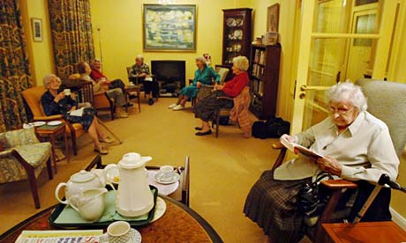 | Type of setting  Clients who use care services may interact and communicate with care professionals in a range of different settings such as their own homes, in community facilities, such as GP practices or day centres, in residential care settings or in institutional settings like hospitals – a ward, an Out Patient Department, Ante-natal clinic. Etc
Negative Effects on Communication | Where a setting is very busy and there is little privacy, communication may be inhibited. An individual client may not feel comfortable talking about themselves or aspects of their life or personal situation in a public environment. For example if a receptionist was asking the patient about their symptoms at the front reception desk of a busy GP waiting room. This lack of privacy could lead the patient feeling very embarrassed and may affect the patient wishing to return to the GP surgery in the future. This could have a negative effect on the Patients future health and well-being.
Strategies that may be used to reduce the effects and overcome the possible barriers create by this factor. | By enabling people to talk in private for example in the chemist when asking for advice regarding over the counter treatments, a person may be asked if they wish to discuss this in privacy.  Hospitals have tried to make their waiting areas in outpatients departments and ward settings more comfortable and less clinical, for example more comfortable seating, brighter paintwork and pictures which will make the person feel more relaxed and will therefore help reduce communication barriers.
Positive Effects on Communication | Where efforts are made to ensure the client can talk in private without being overheard, interaction and communication is likely to be more effective for both the carer and client.  For example: In a busy GP’s it is important that the patient and the GP has a private room for their consultation appointment. For the patient they will feel more comfortable and are more likely to open up and provide the GP with adequate information about their symptoms, particularly if they embarrassing eg a bowel problem if they think that they are not going to be overheard.  This will benefit the GP as they will be more likely to be able to make a more accurate diagnosis /order appropriate tests/investigations to aid diagnosis.

Factor 2
Noise levels
Negative Effects on Communication
Strategies that may be used to reduce the effects and overcome the possible barriers create by this factor.
Positive Effects on Communication

Factor 3
Space available
Negative Effects on Communication
Strategies that may be used to reduce the effects and overcome the possible barriers create by this factor.
Positive Effects on Communication

Factor 4
Seating
Negative Effects on Communication
Strategies that may be used to reduce the effects and overcome the possible barriers create by this factor.
Positive Effects on Communication

Factor 5
Quality of lighting
Negative Effects on Communication
Strategies that may be used to reduce the effects and overcome the possible barriers create by this factor.
Positive Effects on Communication

Factor 6
Time available
Negative Effects on Communication
Strategies that may be used to reduce the effects and overcome the possible barriers create by this factor.
Positive Effects on Communication

