**Carmel College**

BTEC National Diploma in Health & Social Care

Work Placement Unit 1.

November 7th 2018 – December 12th 2018

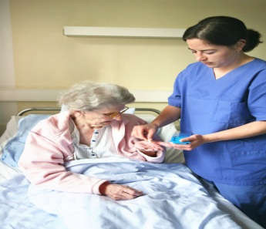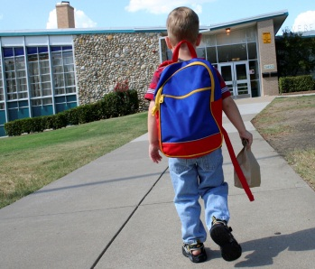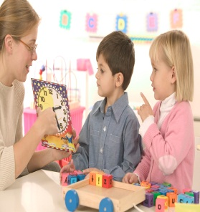

Name: ____________________________

Placement: __________________________________________________

**Log Book Unit 1 Guidance (Work placement evidence for M1, M2 & D1)**

* **M1 Assess the role of effective communication and interpersonal interaction in health and social care with reference to the theories of communication.**
* **M2, D1 Review and evaluate strategies used in health and social care environments to overcome barriers to effective communication and interpersonal interaction.**

|  |  |
| --- | --- |
| Assess | Give careful consideration to all the factors or events that apply and identify which are the most important or relevant. Make a judgement on the importance of something – similar to evaluate |
| Review | To look over, study, or examine again.  To consider retrospectively; look back on.  To examine with an eye to criticism or correction |
| Evaluate | Review the information then bring it together to form a conclusion. Give evidence for each of your views or statements |

You are required to complete the following work experience log book by recording examples of communication that you have observed in your work experience Placement 1 & 2 care settings. Record **8** interactions, one interaction per week, relating to a range of different situations for eg:

* Interactions between staff who work in your care setting (one to one and group interactions)
* Interactions between clients in your care setting eg residents in a care home, children interacting with their peer/s (one to one and group interactions)
* Interactions between clients and staff (one to one and group interactions)
* Interactions between clients, clients relatives, and staff

Your records of each of your recorded interactions should show:

* + Evidence of the use of Communication Theory in practice in the care setting
  + Evidence of what you consider to be effective and ineffective communication in the care setting
  + Evidence of barriers to communication that you come across in the care setting
  + Examples of how practitioners overcame these barriers to communication in the care setting
  + Cover both one to one and group interactions (4 of each)

**VERY IMPORTANT: When recording your observations please make sure that you maintain the clients and staff confidentiality ie do not identify the names of the client/s or staff. Replace with child X, resident A, Nursery Nurse X etc.**

**Preparation for gathering unit 1 evidence**

* In preparation for going out on placement revise the theory that we have covered in class for P1-P4:
  + Communication Theories in practice in the care setting
  + Effective and ineffective communication in the care settings
  + Barriers to communication that you come across in the care setting
  + How practitioners overcome these barriers to communication in care settings

* Re- read unit 1 chapter in your course text book .

**Example of a log book record:**

|  |
| --- |
| **M1** **Assess the role of effective communication and interpersonal interaction in health and social care with reference to the theories of communication.**  **M2, D1 Review and evaluate strategies used in health and social care environments to overcome barriers to effective communication and interpersonal interaction.** |
| **One to one interaction Care Worker and elderly resident A**  **Resident’s Room**  The one to one interaction took place in the resident’s own room. The care worker was asked to assist the elderly resident with washing and dressing. I noted that the care worker knocked on the elderly resident’s door and waited for the reply ‘come in’ from the resident before she walked in. **This was an example of good communication as the care worker showed the elderly client respect as this is the residents own space, like the front door to their home.** The care worker on entering the room greeted the resident in a cheerful voice, smiling and giving the resident eye contact, calling the resident by his preferred name. **This again is good communication as remembering the names of the clients that you look after shows respect and interest because…** **etc. The non-verbal communication with the resident was very effective. Eye contact with the resident was very good as….**  **(Evidence of what you consider to be effective and ineffective communication in the care setting)**  The resident’s room was gloomy, so to remove **this potential communication barrier the care worker asked the resident if she could turn on the bed-side light. This showed that the carer was aware that the environment, in this case light can be a barrier to effective communication.** The resident’s eyesight had deteriorated through ageing. The room was made lighter and as a result the resident and carer could see each other more clearly. **This helped the carer and resident to read each other’s body language more effectively.**  The carer then asked the resident if she could help her to put her glasses on. **Again, this is another example of how a barrier to communication was prevented as….. etc** (**Evidence of barriers to communication that you come across in the care setting; Examples of how practitioners overcame these barriers to communication in the care setting)**  **It was very clear that you could see Argyle’s Theory of Communication in practice during this one to one interaction communication is essentially a two-way process that involves people sending, receiving and responding to each other’s verbal and non-verbal messages. This was clear in the verbal and non-verbal messages that the resident and carer were sending to each other.** The carer asked if the resident had had a good night’s sleep. The resident responded by saying ‘ had a terrible night with pain in my hips’**.** The carer said’ ‘sorry to hear that Beryl (name changed) your hips have been painful in the night? (concerned look on carers face) Did you ring your bell for the night staff for some pain killers?’ **In this situation the carer showed empathy for the resident both verbally and non-verbally through her facial expression.** The nurse repeated back to the resident about the pain in her hips to check she had understood and received the message accurately. The carer then told the resident that she will make sure that the night staff checks that she has some pain killers before she goes to sleep and to make sure that she buzzes them in the night. **(Evidence of the use of Communication Theory and effective communication in practice in the care setting)**  **Tips on making log book entries:**   * Make a record of the basic content of each interaction. You can then review/assess and evaluate each interaction you have recorded at the end of each day on placement. **(this is in bold in the above example)** * In addition Make a record of any general communication barriers that you come across in your placement setting and record the strategies that you/staff put into place to overcome these.   **Communication Barriers**  Very noisy in the residents day room. Care worker asked a resident to go back to their own room to chat about their medication. This strategy ensured that the environmental barrier of noise was overcome. This enabled the care worker to discuss the residents medication |

**UNIT 1 DEVELOPING EFFECTIVE COMMUNICATION IN HEALTH & SOCIAL CARE LOG BOOK**

**STUDENT NAME: WORK PLACEMENT 1 DATES:**

**CARE SETTING : CLIENT GROUP:**

|  |
| --- |
| **M1** **Assess the role of effective communication and interpersonal interaction in health and social care with reference to the theories of communication.**  **M2, D1 Review and evaluate strategies used in health and social care environments to overcome barriers to effective communication and interpersonal interaction.** |
|  |

|  |
| --- |
| **M1** **Assess the role of effective communication and interpersonal interaction in health and social care with reference to the theories of communication.**  **M2, D1 Review and evaluate strategies used in health and social care environments to overcome barriers to effective communication and interpersonal interaction.** |
|  |
| **M1** **Assess the role of effective communication and interpersonal interaction in health and social care with reference to the theories of communication.**  **M2, D1 Review and evaluate strategies used in health and social care environments to overcome barriers to effective communication and interpersonal interaction.** |
|  |
| **M1** **Assess the role of effective communication and interpersonal interaction in health and social care with reference to the theories of communication.**  **M2, D1 Review and evaluate strategies used in health and social care environments to overcome barriers to effective communication and interpersonal interaction.** |
|  |
| **M1** **Assess the role of effective communication and interpersonal interaction in health and social care with reference to the theories of communication.**  **M2, D1 Review and evaluate strategies used in health and social care environments to overcome barriers to effective communication and interpersonal interaction.** |
|  |
| **M1** **Assess the role of effective communication and interpersonal interaction in health and social care with reference to the theories of communication.**  **M2, D1 Review and evaluate strategies used in health and social care environments to overcome barriers to effective communication and interpersonal interaction.** |
|  |
| **M1** **Assess the role of effective communication and interpersonal interaction in health and social care with reference to the theories of communication.**  **M2, D1 Review and evaluate strategies used in health and social care environments to overcome barriers to effective communication and interpersonal interaction.** |
|  |
| **M1** **Assess the role of effective communication and interpersonal interaction in health and social care with reference to the theories of communication.**  **M2, D1 Review and evaluate strategies used in health and social care environments to overcome barriers to effective communication and interpersonal interaction.** |
|  |

|  |
| --- |
| **M1** **Assess the role of effective communication and interpersonal interaction in health and social care with reference to the theories of communication.**  **M2, D1 Review and evaluate strategies used in health and social care environments to overcome barriers to effective communication and interpersonal interaction.** |
|  |

|  |
| --- |
| **M1** **Assess the role of effective communication and interpersonal interaction in health and social care with reference to the theories of communication.**  **M2, D1 Review and evaluate strategies used in health and social care environments to overcome barriers to effective communication and interpersonal interaction.** |
|  |