**BTEC Diploma Health & Social Care**

**BTEC– Unit 2 – Assignment 1**

**Submission date**…

***General Notes & Tips***

***Self- check: Tick the boxes when you have checked that have completed each task***

* **Font Style**: Comic Sans
* **Header**: Your name, date, unit number and criteria being covered eg Unit1, P1, M1.
* **Bold and underline the title it should be in the centre of the page.**
* **Have you completed all the necessary steps?**
* **Have you fully referenced your work and include a bibliography**
* **Proof read and spell check all of your work before submission for assessment.**
* **Save any work to the hard drive on your computer. Email copies of your work to yourself as an attachment. Backup your work. Remember you have links on Connect to**
* [**Office 365 (Email)**](https://outlook.office365.com/owa/?realm=carmel.ac.uk) **One drive**
* [**Remote desktop**](https://remote.carmel.ac.uk/) **Your College student F drive**

***On the computer create a folder Unit 2 BTEC H&SC coursework***

1. On your student user area
2. On your computer at home

This will help you to organise your work from the beginning and place relevant work in the appropriate unit folder and subfolders when it is produced.

**Reminder:** Organising IT folders has been covered during induction.

**Criteria to be covered by this assignment**

**P1:** Explain the concepts of equality, diversity and rights in relation to health and social care

Explain = Set out in detail the meaning of something, with reasons. It is often useful to give an example of what you mean. Start with the topic and then give reasons on how or why.

Watch the you tube video on writing an explanation to help you to develop your skills.

<https://www.youtube.com/watch?v=IIciCZFsBKO>

**Top Tip:**

**Ensure your work is referenced using a variety of sources. See page 9 of your specification Make sure you are putting information into your own words.**

**Task 1** - You are producing an information booklet for students and new members of staff with no experience to introduce them to Equality, Diversity and Rights. Remember to make it interesting, readable & informative

**Produce a title page:** An Introduction to the Concepts Equality, Diversity & Rights

**Subheading:** Introduction

Welcome your reader and explain the aim of the booklet.

Explain what is meant by equality

Explain what is meant by diversity

Explain what is meant by rights

Explain that there are many different terms that are used in Equality & diversity and you are going to provide a glossary of the terms that they may come across before going any further.

EXAMPLE:

Welcome to our organisation, this booklet on the Concepts of Equality, Diversity and Rights is designed to provide you with information and support as part the training that you are receiving.

Before we start let me define term Equality, which means ………………………………. Now we have looked at Equality let’s look at the term Diversity…………………………………………………………………………………….

There are many other terms that are used when considering Equality & diversity therefore a glossary of these terms has been produced to assist you. It may be useful to refer back these definitions during your work.

**Subheading**: Glossary of terms

Produce a glossary of terms for your reader. (A glossary is basically definitions of words or terms) See below for the terms you need to cover – make sure you put the information into your own words and reference the sources you have used.

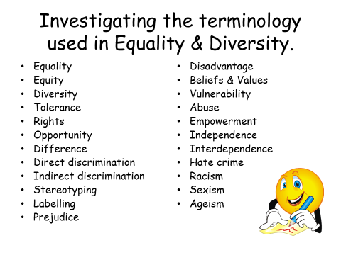

**Subheading:** Why is it important that we are aware of Equality, Diversity and Individual Rights?

Here you should identify that the organisation has service users who represent the diversity that we see in British society today.

Write a paragraph explaining how Britain is a multicultural society – you might want to include some information (facts & figures) from the latest census to support this view point.

You could now explain how diversity benefits today society. (Stretch & Whitehouse pages 50-52 & Rasheed et al pages 22-23 will help you with this)

**EXAMPLE:**

Our organisation has service users who represent the diversity of British Society and come from different social, cultural and religious backgrounds. Britain today is very much a multicultural society, the 2011 census confirmed this ………………………………………………………………………...

The introduction of this booklet introduced you to the term Rights and how these are set out in legislation such as the Human Rights Act 1998. We will now look at each of these individual rights in more detail.

**Subheading:** Individual Rights

Explain the principle of individual rights.

You should now provide a brief overview explaining each right. For each right you should put a subheading – *you can find information on each of these rights in Stretch & Whitehouse pages 62 -64 and Rasheed pages 28-29*

**Subheading:** The right to be respected

Summarise the information in your own words and provide references

**Subheading:** The right to be treated equally and not discriminated against

Summarise the information in your own words and provide references

**Subheading:** The right to be treated as an individual.

Summarise the information in your own words and provide references

**Subheading:** The right to be treated in a dignified way

Summarise the information in your own words and provide references

**Subheading:** The right to be allowed privacy,

Summarise the information in your own words and provide references.

**Subheading:** The right to be protected from danger and harm

Summarise the information in your own words and provide references.

**Subheading:** The right to be allowed access to information about themselves

Summarise the information in your own words and provide references.

**Subheading**: The right to be able to communicate using their preferred methods of communication and language,

Summarise the information in your own words and provide references.

**Subheading:** The right to be cared for in a way that meets their needs

Summarise the information in your own words and provide references.

**Subheading:** Conclusion

Write a concluding paragraph to pull your information together. *(Rasheed et al page21-22 may assist you here)*

**Task 2**

Produce a poster for the staff room to identify individual rights, This provides evidence towards P1

**Task 3**

Produce an eye catching A3 poster on the computer for the staff room to identify the benefits of diversity to society. Ensure you include references on this.