**STRENGTHEN**

**OUR**

**SOCIETY**

**STRENGTHEN**

**OUR**

**SOCIETY**

**Diversity**



**“Strength lies in differences, not in similarities.”**

[](https://www.google.com/url?sa=i&rct=j&q=&esrc=s&source=images&cd=&cad=rja&uact=8&ved=2ahUKEwjFuNC-t4XeAhURtRoKHdg2BacQjRx6BAgBEAU&url=https://www.nurole.com/news_and_guides/why-is-board-diversity-important&psig=AOvVaw2wk4xHH5V52oxKFENVQCqT&ust=1539589356897476)

**Economic Benefits**

Businesses, workplaces and employees may gain international connections which will benefit their business due to the international connections and customers from around the world. Employing people from different nationalities will help businesses and other work places to gain different ideas which will help them develop and gain more customers. Mostly engineers in the UK are from other nationalities and this shows how different thoughts from different types of people can help succeed. As well as this, different trades and plans can be brought by a people in a diverse society after mixing with different people and learning new things. This can help things develop and have a positive attitude towards the country, business/ workplaces and towards the people in society.

Benefits?

**Social Benefits**

Having a diverse society helps the public to identify different cultures and religions which lets people try out different things of what people from different countries bring with them. This can include things like arts, food, education, language, sports, cultural enrichment etc. seeing different opportunities and cultures may lead people to try out a variety of stuff like food, cultural activities after getting positive feedbacks from others. When liking them it will want people to explore the world more and engage with people around the world. This can also decrease racism and have positive benefits on people when emerging in a diverse society because it will be more likely that people will be talking and socialising with each other with interest to know more about each other and find it normal to have friends from different countries and backgrounds.

**Political Benefits**

There are many political benefits such as gaining different ideas and suggestions on how to improve the country and laws. By gaining different opinions from diverse people it will become debates after gaining all these suggestions which is an advance because there are lots of suggestions to pick and choose from and it is better than not having any. Therefore, this has led to employing people from different countries to be part of the parliament and government because it will help the country to develop and gain better improvements which can help the society.

[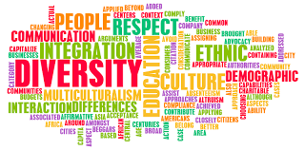](https://www.google.com/url?sa=i&rct=j&q=&esrc=s&source=images&cd=&cad=rja&uact=8&ved=2ahUKEwj_6qP1_oreAhVLneAKHRhIC_wQjRx6BAgBEAU&url=https://www.sheppard.af.mil/News/Article-Display/Article/1644085/new-diversity-and-inclusion-council-to-meet-sept-28/&psig=AOvVaw3tnJyP0GutsCKyFzFqKDMM&ust=1539780188967478)[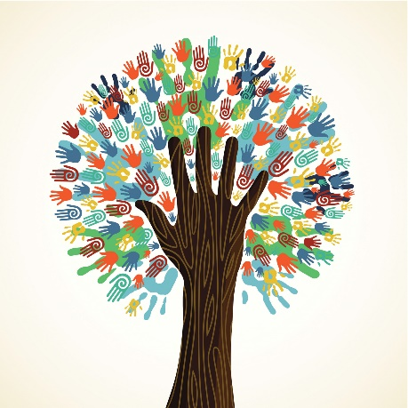](https://www.google.com/url?sa=i&rct=j&q=&esrc=s&source=images&cd=&cad=rja&uact=8&ved=2ahUKEwiKs5us_oreAhUlhOAKHdaaBSIQjRx6BAgBEAU&url=https://imgur.com/gallery/Ghqwl43&psig=AOvVaw3tnJyP0GutsCKyFzFqKDMM&ust=1539780188967478) [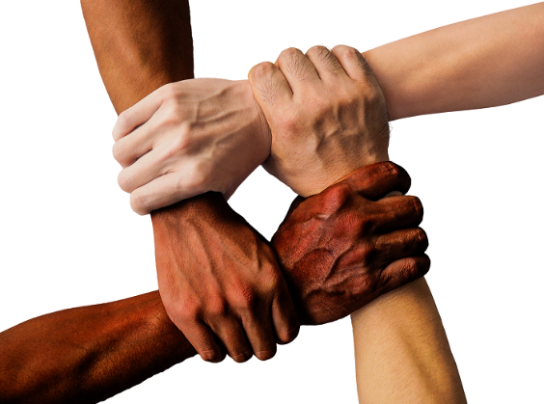](http://www.google.com/url?sa=i&rct=j&q=&esrc=s&source=images&cd=&cad=rja&uact=8&ved=2ahUKEwi1tP3wrYXeAhUIqxoKHXTzCzIQjRx6BAgBEAU&url=http://www.lse.ac.uk/News/Latest-news-from-LSE/2017/03-March-2017/No-quick-fix-to-managing-workplace-diversity&psig=AOvVaw0whDkdhsCY7pyFbo7DnnR4&ust=1539586767483648)

**Bibliography**

**Google 2018**

<https://nl.freepik.com/iconen-gratis/facebook-zoals-hand-symbool-overzicht_731004.htm> (13/10/18)

<https://creativemarket.com/AnnoUrbis/2499256-Check-mark-symbol-vector-black> (13/10/18)

Quote by *Stephen R. Covey-* [*http://www.wiseoldsayings.com/diversity-quotes/*](http://www.wiseoldsayings.com/diversity-quotes/) *(13/10/18)*

<https://www.nurole.com/news_and_guides/why-is-board-diversity-important> (13/10/18)

<http://www.lse.ac.uk/News/Latest-news-from-LSE/2017/03-March-2017/No-quick-fix-to-managing-workplace-diversity> (13/10/18)

<https://imgur.com/gallery/Ghqwl43> (16/10/18)

<https://www.sheppard.af.mil/News/Article-Display/Article/1644085/new-diversity-and-inclusion-council-to-meet-sept-28/> (16/10/18)