# The promotion of Anti-Discriminatory Practice.

[](http://www.google.co.uk/url?sa=i&rct=j&q=&esrc=s&source=images&cd=&cad=rja&uact=8&ved=0ahUKEwiKsvTe8N_RAhXlDMAKHTs0AFEQjRwIBw&url=http://www.dayjob.com/content/social-work-degree-703.htm&psig=AFQjCNFV-i0iiK2iUXVa-sVXgipCdxQMxQ&ust=1485522108085863)

Introduction

This booklet will explain how national initiatives promote anti-discriminatory practice in not only society but also in Health and Social Care settings.

‘Care practitioners must work within a legal and ethical framework.’

The quoted sentence above means that when workers are practising they must make sure they are **not** breaking the law. Whilst ensuring that they’re not breaking the law, they must make sure that they are working within an ethical framework. This means what society thinks is right and wrong.

Practitioners must follow and put into practice a range of laws, policies, codes of practice and charters in their work with the service users.

Legislation

Legislation refers to the Acts of parliament developed by the British Government.

The equality laws we have today have been developed as a results of the directives and regulations passed by the EU (European Union) and the decisions that are made in front of the European Court of Justice.

The European Union takes over UK legislation and case laws. These are decisions made within the UK courts. When a decision or directive on an equality issue is made within the EU, the UK has to accommodate for it by changing its laws. (**Walsh et al, 2000**)

There are legislations that are put in place towards discrimination. The Sex Discrimination Act of 1975 and the Race Relations Act of 1976 are just two examples of legislations that are put in place.

The Sex Discrimination Act of 1975 covers discrimination such as the pay gap between men and women. (<http://www.legislation.gov.uk>)

The Race Relations Act of 1976 (Amended in 2000) covers discrimination such as employment, education, housing, advertising and the provisions of goods and services. The act also covers someone’s rights to not be treated unfairly or less favourable because of someone’s race. (<http://www.inbrief.co.uk>)

These legislations have been incorporated in the Equality Act of 2010. Both the Sex Discrimination Act of 1975 and the Race Relations Act of 1976 are under chapter 2, part 2 in the 2010 Equality Act. The Race Relations Act of 1976 is number 10 and the Sex Discrimination Act is number 11. (<http://www.legislation.gov.uk>)

The Equality Act of 2010 is the most recent Act and most significant for discrimination. This Act consolidates the previous acts made for this into one. It provides protection against discrimination under the terms of age, disability, gender reassignment (trans genders), pregnancy and maternity, race, religion or belief, sex and sexual orientation. (**Walsh et al, 2000**) Not only this but it put in place a new public sector equality duty. This gives the public authorities a legal responsibility to provide this protection and make decisions which are fair and transparent, including the allocation of public money.

[](https://www.google.co.uk/url?sa=i&rct=j&q=&esrc=s&source=images&cd=&cad=rja&uact=8&ved=0ahUKEwjfy4qNjezRAhUKsBQKHVnLAfYQjRwIBw&url=https://www.courtley.com/equality-and-diversity/&psig=AFQjCNHEEJLpuXaBiWb9S-_vJmkdkEV95g&ust=1485942291367091)I think it was necessary to bring all the different legislations together under the Equality Act of 2010 because it shows that they want to treat everyone equally instead of singling for example; disability discrimination out from the others, they put it under one where all types of discrimination can be treated equally.

[](http://www.google.co.uk/url?sa=i&rct=j&q=&esrc=s&source=images&cd=&cad=rja&uact=8&ved=0ahUKEwio_q7ijezRAhWL1RQKHQMKCvMQjRwIBw&url=http://palliativecare.org.au/palliative-matters/six-things-to-know-during-national-carers-week/&bvm=bv.145822982,d.ZGg&psig=AFQjCNF7_CTgkM60kEdC-UCfpBnvrztCXw&ust=1485942591666496)How the Equality Act could be used to support someone caring for an elderly relative?

Using the pdf from (<https://www.gov.uk>) I will give some examples of how it can be used to support someone.

The Act has new rules that allow elderly people be treated fairly. For example; Some shops only allow elderly people to be served if they are accompanied by a younger individual.

This Act protects people who care for others from being treated unfairly.

*[](http://www.google.co.uk/url?sa=i&rct=j&q=&esrc=s&source=images&cd=&cad=rja&uact=8&ved=0ahUKEwiqg8mnjuzRAhUBXBoKHW93AlEQjRwIBw&url=http://www.clipartkid.com/senior-center-cliparts/&bvm=bv.145822982,d.ZGg&psig=AFQjCNHbFOd1sAEIb_Td3Jqg7E8DJSnHMw&ust=1485942679697404)Public bodies need to think about treating people of different ages (young and old) fairly and equally.* An example of this is; at the local park younger people take up the benches but also sit and stand around on other things. Because of this the elderly may not be able to enjoy the park. The council might put extra seats in the park so that they are able to enjoy it as well. This links in with someone looking after their relative as they might now be able to take them to a park rather than keeping them inside all day.

Another example could be; the council has a ‘meals on wheels’ service for people who are unable to cook for themselves or really move out of their home. A young child may be the only person available to look after the elderly man/woman and may not be able to cook. The council could send microwave meals to the house for them.

The law states that an employer cannot say that someone is too old or young for a job.

An example of young careers being treated unfairly;

* Some companies may make a younger individual pay more than an elderly person for no particular reason. This could make life more difficult if the young career has been sent out with the correct money to pick up something for the elderly person that they need and cannot now do so.

The role of the Equality & Human Rights commission is to enforce the equality legislations on age, disability, gender, race, religion or belief, sexual orientation or transgender status, and encourages people to accept the Human Rights Act. Not only this but they give advice and guidance to businesses, the voluntary and public sectors, and to individuals to help them in reducing inequality and discrimination, to strengthen good relations between people and promote and protect human rights. (<http://www.equalityhumanrights.com>)

Putting Legislation into practice

Charters & Standards

The Care Quality Commission is an **INDEPENDENT** regulator of ALL Health and Social Care services in England on the behalf of the government. Their role is to monitor, inspect and regulate all of the Health and Social Care services and then publish their findings to help people decide the best place for their need of care. (<http://www.cqc.org.uk/>)

Fundamental Care Standards cover every aspect of discriminatory practice. They promote anti-discriminatory practice as it sets a bar in which the standard of care you receive, cannot go below.

The Fundamental Care Standards cover person-centred care, dignity and respect, consent, safety, safeguarding from abuse, food and drink, premises and equipment, complaints, good governance, fit and proper staff, duty of candour and duty of ratings.

If care falls below these standards, then it can lead to you losing your job or being prosecuted if you put the individual at harm. (<http://www.carersuk.org>)

Codes of Practice and Codes of Conduct

The Codes of Conduct and Practice promote anti-discriminatory practice by ensuring that they treat everyone in an acceptable manor, so everyone feels secure and safe. Also, the staff’s knowledge and skills need to be kept up to date in case of the Code of Conduct and Practice ever changing. This also, promotes anti-discriminatory practice as the staff will always have to follow this and make sure everyone is treated with dignity and respect in order to feel good enough.

This Code of Conduct and Practice makes sure that no one is treated in a disrespectful way. Not only this but it ensures that the staff has the best interest of the service user at heart and provide a high quality service, which the public can continuously trust.

[](https://www.moneygeek.com/careers/nursing/)The nursing and midwifery council (NMC) are responsible for regulating nurses, midwives and health visitors. (<http://www.nmc-uk.org>)

The Health Care Professions Council (HPC) are responsible for regulating all other professionals within the Health and Social Care sectors. These are just a few examples of whom they regulate; Doctors, Radiologist, Occupational Therapists and many others. (<http://www.hpc-uk.org>)

There are adult social care workers and they usually are working with adults in residential care homes, in day centres and in someone’s home. Currently they are under no regulation. In February 2011, the Government published an article under the title of [**‘Enabling Excellence – Autonomy and Accountability for Healthcare Workers and Social Care Workers’**](http://www.dh.gov.uk/en/Publicationsandstatistics/Publications/PublicationsPolicyAndGuidance/DH_124359)

It speculated that the Department of Health would by the end of *2013*, explore the HCPC in establishing a voluntary register of Adult Social Care Workers in England.

However, a voluntary register means that it is not compulsory to become registered.

There is no regulation or register in England but there has been a code produced that employers may use. (<http://www.skillsforcare.org.uk/Standards-legislation/Code-of-Conduct/Code-of-Conduct.aspx>)



I personally believe that having a code of conduct and a voluntary registration would be beneficial to the care sector. This is because if there were no guidelines to follow then care would possibly become very poor.

Having a voluntary register is beneficial because the individual may not be registered officially it still shows that they are following their code of conduct and that you can trust them.

There may be a problem with voluntary registration as the people who are good at what they do might not have known about the official register and volunteered to go on it. This could potentially mean that the official register might have people who are poor at their job registered on it, instead of the excellent workers.

I think that skills for care have published a code of conduct because it will give the service user a sense of security and knowledge that the workers will give them high quality care. (<http://www.skillsforhealth.org.uk>)

There are many positives and negatives on the care sector by having a compulsory registration.

|  |  |
| --- | --- |
| Positives | Negatives |
| People who are providing the care in the care sector is registered. | The register could get long and have everyone on it. This could lead to an overload of staff. |
| They have a conduct to follow meaning their care should not go below those standards. | As it is compulsory, it implies that it’s too easy and because of this people may be unsure of whether the staff are all trustworthy. |
| Could have a legislation in place. | Continuing with the point above, there could be people who are registered yet are poor with their care. This means that they could be supplying people with poor care despite being registered. |

Organisational Policies and Procedures

A policy is ‘*a set of ideas or a plan of what to do in particular situations that has been agreed to officially, by a group of people, a business organisation, a government or a political party.*’ (<http://dictionary.cambridge.org>)

They are usually detailed statements of the approach that the organisation will follow upon a particular event. (Rules and guidelines).

A procedure is ‘*an established or official way of doing something*.’ (<https://en.oxforddictionaries.com>)

Written instructions about what must happen in a certain situation. (How to carry out rules and guidelines).

Organisational policies have a role of **making sure people follow** the anti-discriminatory rules. As of this, it ensures safety in a Health and Social Care setting. Example; A nurse signs an agreement that there will be no use if phones whilst caring for the residents. This protects individuals and gives them the sense of respect and protection that they need. In addition, policies give help and guidance on how to treat service users, so staff are fully aware what employers expect from them. It is alongside the law and informs what is right and wrong so that staff can apply this within their setting.

Organisational policies that *may* be developed:

* Confidentiality may be continuously developed as they may discover people who are asking for different types of confidentiality they require. For example; in a care home a resident may ask for one care worker to look at her file as she’s the one she trusts.
* Complaints Procedures may be continuously developed as an organisations complaints procedure may take too long and someone may need urgent changes. For example; in a care home a resident may be complaining about having a certain staff member do her personal care but violates her privacy. She may want another staff member to do her personal care.
* Harassment and Bullying may be continuously developed as people may be experiencing a different type of harassment or bullying not on the policy. This needs to be updated with any different types and what to do in this situation.
* Staff development and training may be continuously developed as the policy may say every staff member needs to be trained yearly. If hiring a new staff member, they will need training quite frequently until they improve meaning they will have to sort this out on their policy for future reference.
* Work practices – manual handling, infection control etc. This may need to be developed as if a service user catches a chest infection from a care worker then the chest infection will never leave the care home. This is due to the constant surroundings of it making it loop. If this was to happen their needs to be some way of getting rid of it and the policy would need to state what to do in the situation. This means that it needs to be updated regularly.

Failing to follow or breaching organisational policies can result in dismissal from employment and even prosecution. Not only is that the reason it is important to follow policies and procedures but the work they carry out could harm someone long term. When doing research on the failings in elderly care I found that there are short-term effects but the long term effects are the most worrying. It could harm someone physically, emotionally, intellectually, socially and psychologically.

[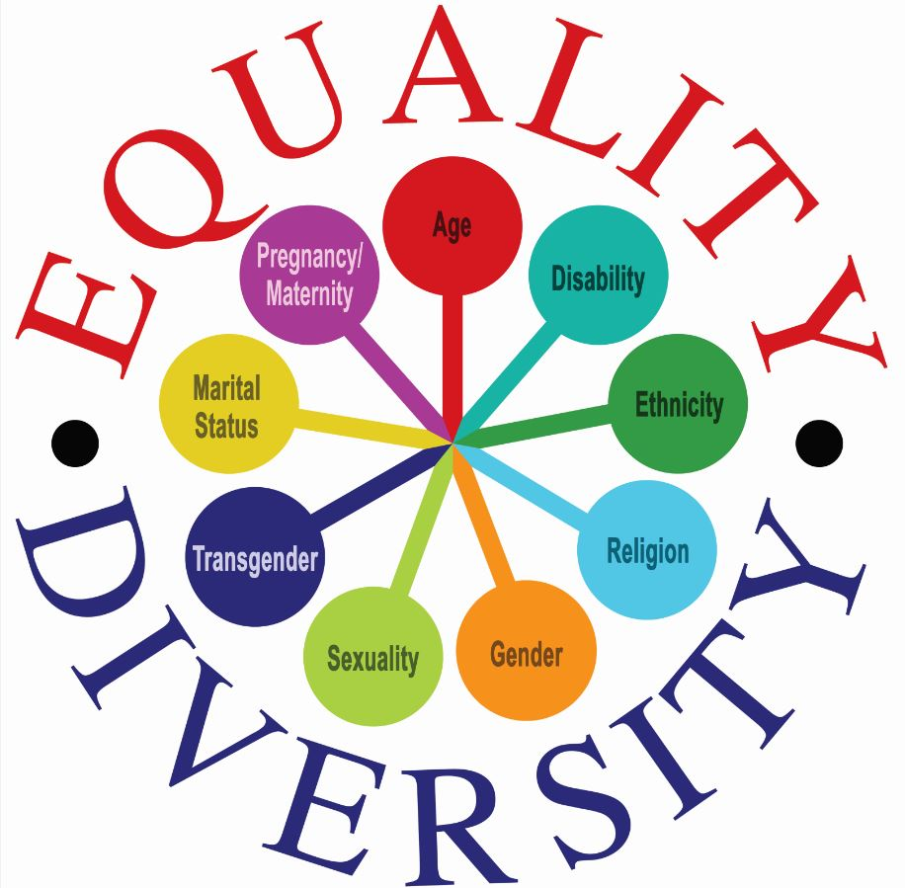](https://www.google.co.uk/url?sa=i&rct=j&q=&esrc=s&source=images&cd=&cad=rja&uact=8&ved=0ahUKEwj71OLGjOzRAhUGHxoKHW6kBPoQjRwIBw&url=https://www.durham.police.uk/About-Us/Pages/Equality%20and%20Diversity.aspx&psig=AFQjCNHEEJLpuXaBiWb9S-_vJmkdkEV95g&ust=1485942291367091)Thank you for reading my booklet on the National Initiatives for Equality and Diversity. I hope you found this useful and are able to look back on it when you need to.

Bibliography to the promotion of anti – discriminatory practice

Walsh et al (2000) Health & Social Care. Collins London page 28-29. Accessed on 25/01/2017 – 31/01/2017.

<http://www.legislation.gov.uk/ukpga/1975/65/pdfs/ukpga_19750065_en.pdf> Accessed on 25/01/2017.

<http://www.inbrief.co.uk/discrimination-law/race-discrimination/> Accessed on 26/01/2017.

<http://www.legislation.gov.uk/ukpga/2010/15/contents> Accessed on 26/01/2017.

<http://www.equalityhumanrights.com/about-us/> Accessed on 28/01/2017.

<http://www.cqc.org.uk/> Accessed on 27/01/2017.

<http://www.nmc-uk.org/Publications/Standards/The-code/Introduction/>

Accessed on 27/01/2017.

<http://www.hpc-uk.org/assets/documents/10003B6EStandardsofconduct,performanceandethics.pdf> Accessed on 28/01/2017.

[‘Enabling Excellence – Autonomy and Accountability for Healthcare Workers and Social Care Workers’](http://www.dh.gov.uk/en/Publicationsandstatistics/Publications/PublicationsPolicyAndGuidance/DH_124359) Accessed on 28/01/2017.

<http://www.skillsforcare.org.uk/Standards-legislation/Code-of-Conduct/Code-of-Conduct.aspx> Accessed on 29/01/2017.

<http://www.skillsforhealth.org.uk/standards/item/217-code-of-conduct> Accessed on 29/01/2017.

<http://www.skillsforhealth.org.uk/images/services/code-of-conduct/Code%20of%20Conduct%20Healthcare%20Support.pdf> Accessed on 30/01/2017.

<http://dictionary.cambridge.org/dictionary/english/policy> Accessed on 30/01/2017.

<https://en.oxforddictionaries.com/definition/procedure> Accessed on 30/01/2017.

<https://www.gov.uk/government/uploads/system/uploads/attachment_data/file/85012/easy-read.pdf> Accessed on 31/01/2017.

<http://www.carersuk.org/help-and-advice/practical-support/getting-care-and-support/care-standards-and-cqc?gclid=CJrf2Z-H7NECFa237Qod34kPJg> Accessed on 31/01/2017.