· · · - -···....

- -

. '

**Unit 6** - **Assignment 4 P7**



,lf1@ @@flu 8©00¥0@ @ @.

. @rr\ f @@Yl7B @w *@'tr .*

fkl@@ lfr;u @rr @ a@ *@fr*

- . . -- -

*( *

\

- ,

-,- - - ,- - •-· <•'!. °? - **·---,,;!!:.c_./:,,-** *::-*-,

• •.t,- ,.,. ------,:,,, .. - - - • - • "t·

-.:

-

;. ; _- '

. *,._·:i"-./ -- .....-.*·_-- -

* _:

-

--- - - ,.,., -

Unit 6 - Assignment 4 P7 

--

## Introduction

There are a variety of jobs available in the Health and Social care & early year's

sect ors . The sector itself is split into three main areas that all have a different roles and responsibilities of the care given. These areas include: ***(Stretch*** + ***Whitehouse 2010)***

* - Is not only about working and looking after the ill. It also involves creating new and better treatments as well as educating people (staff and clients) steps moving towards a healthy lifestyle

**if ll *.t* -:a J.**

* ***Socia( Care*** - This are of health and social care is very important as you will be working with vulnerable people (children, young people, and adults of working age also older adults). You may come across people who have broken the law, people who have physical or learning difficulties and also you may be working with people who have mental health problems. When working in this area of health and social care many people/clients seek help or advice for long or short periods of time in their lifetime.
* ***&mly eon$*** - Early Years is working and developing skills of children. This stage

could be split into different age gaps, you could be working with young children (aged 0-5 which is most commonly known as early year's foundation stage). In addition to this you could be working with adolescence in high school (aged 11- 16), or you could go onto third year teaching which could be working with children in college moving onto university. Just like the other two sections it is cover a wide range of job opportunities and a chance to learn new skills which could be use throughout you career path.

All of these sectors are multidisciplinary/ inter-professional care environments. This means that all professionals who are working in any of these settings are from different backgrounds and other sectors of health and social care and all of them will be working together to meet the needs of each of their clients when and where appropriate *(hee.nhs.uk).* This type of care is becoming more common in any type of health and social care setting as the government has set out for more intergraded health and social practices/care models. This is because it can make the quality of care given stronger as new skills and resources are being used to meet the specific needs of individuals in each care sector. In addition to multidisciplinary care it is it is very important you always consider the different care provisions in that specific setting and in health and social care settings; as each provision has a different role and responsibilities to ensuring the best quality of care given to clients ***(hee.nhs.uk).***

* **Direct Care Workers** - These types of practioners give care directly to the service user, this includes the professionals and clinical support staff who are there to assist the professionals providing the best quality of care for every ser vic _ user .

..'_-.-:'·---·1,·'· '

2

·:..•,..

o **Indirect Care Workers** - These are the support staff employed by the care organisation to support any work given by the direct care workers. They are probably one *of* the most important members *of* staff as they underpin the functioning of the organisation itself. For example, the technical support staff, laboratory staff, pathology, biochemistry etc. Other important members of staff include the receptionists, administive staff, domestic staff, cleaners, caretakers cooks etc.

It is very important that all care workers who are working in the health or social care sectors are expected to the meet the standards set by the Care Quality Commissions (CQC) who are the regulatory body of health and social care sectors. It is very important that all professionals are registered with the right body and are given the permission of the regulation to practice in the specific setting for example a hospital or social service job. In addition to the CQC if you are working in any early year's

sector it is important you follow the standards of care written and created by OFSTED

/

\ as they ensure the best ways of giving care and ensuring every individual is protected in

every way possible.

In England, each Health and Social care professional will be regulated to ensure the standards of care are met and the best quality of care is provided. The list below are some of the many regulators of health and social care professionals in England alone: ***(Stretch*** *+* ***Whitehouse 201 O)***

General Medical Council (GMC) - *Doctors*

Nursing and Midwifery Council (NMC) - *Nursing staff and midwives* Health and Care Professions Council (HCPC) - *biomedical scientists, social workers in England, dietitians*

General Chiropractic Council (GCC) - *Chiropractors*

General Dental Council (GDC) - *Dentists, dental hygienists, dental nurses, dental technicians*

General Osteopathic Council (GOsC) - *Osteopaths (mainly work and strengthen the musculoskeletal system)*

General Optical Council (GOC) - *Opticians (optometrists and dispensing opticians in training)*

General Pharmaceutical Council (GPhC) - *Pharmacist, pharmacy technicians also pharmacy premises in England, Scotland and Wales.*

In the next section below I will be taking a closer and more detailed look at three health and social care practioners. I will be taking a closer look into nursing specifically children's nursing, social work and an early year's stage teacher in a primary school.

. *.:.* :;.-/t\Y

**Practitioner 1- Children's Nurse**

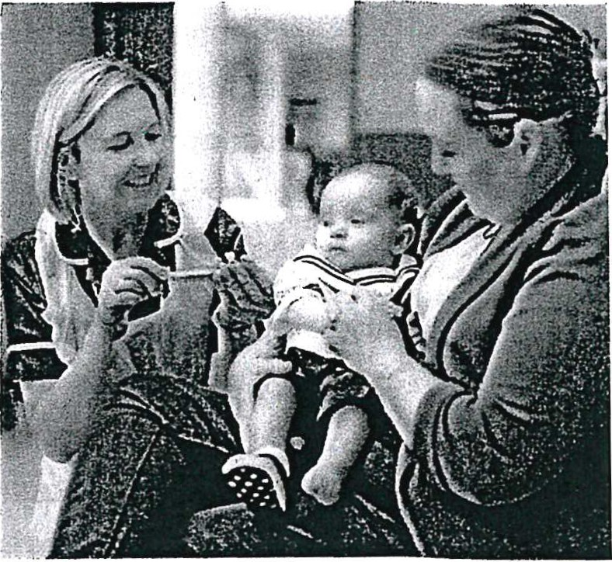A children's nurse job role involves working with a variety of children with different care needs. It is one of the biggest sections of health and social care as you could be nursing a new-born baby who is in the ICU or you could be helping an adolescent road accident victim who needs constant care and attention he next minute. In addition to taking care of the child themselves it is very important that the care professional is aware and able to support and care for the family members of each client in the appropriate manner. This includes parents, grandparents, siblings, guardians, or carers . As a part of

becoming/working as a children's nurse you will be working as part of a multidisciplinary team. You will be work with a variety of care professionals to ensure the best standard and quality of care is constantly being given. You will be working with other nurses, physicians and other health care professionals you have many responsibilities to ensure the best care is provided to all clients and family members. To show you some of these responsibilities I have created a list which highlights some of the roles/jobs you will be completing throughout your time as a children's nurse: ***(snagajob.com)***

}> Monitor the health conditions of clients when and where appropriate

}> Plan long term care needs and actions taken to ensure they are effective and implemented where appropriate

}> Administer Medicine

}> Use a variety of medical equipment

}> Perform minor medical operations

}> Advise and constantly update patient and families on the illness you are treating and the next steps of care you are going to take

}> Finally, some care that you provide will be given even after the child has eft the facility for example weekly, or monthly check-ups to see how they have developed or if they need to carry one any more treatment

To become a children's nurse on any ward or hospital there are entry requirements that must be met the care practitioner for them to start studying to become a children's nurse. Firstly, you will be expected to have a minimum of 6 GCSE'S grade C or above, possibly in either English language or English literature and at least one science subject ***(healthcareers.nhs.uk).*** In addition to this they are expected to have two A levels or an equivalent level 3 qualification, however some universities will asks for three A level or an equivalent. If you are worried that you will not be accepted onto the course at the university of your choice because you may not have any A levels it is very important that research further into the course as certain qualification may be accepted instead of an A level. These include: ***(healthcareers.nhs.uk)***

4

 Unit 6 - Assignment 4 P7 _;.--017

.

.

}> Scottish Highers/ Advanced Highers

}> Pearson BTEC Level 3 Diploma Qualifications

}> OCR CambridgeTechnicals

}> International Bachelorette (IB)

}> Access course for example Access nursing

You may be accessed to achieve a certain level within the alternative qualifications for example if it is a BTEC the university could ask for either a merit or a distinction for you to be able to study the course at that specific university. Along with the qualification needed to start the course of becoming a children's nurse it is very important that you have the right skills at the start that could be further developed the more experience you gain whilst completing the course. These skills are, listening and communication skills, ability to problem

solve, Good judgement where appropriate and

finally offering advice when and where it is

needed . It is very important that when you start to apply for new jobs you are aware of who the regulatory body is of the line of work you are going in. As a children's nurse you are working under the Nursing and Midwifery Council. This regulatory body is in charge of

Nursing & Midwifery Council

inspecting and improving all nurses and midwives in England. They ensure all policies, procedures and standard of care are constantly implemented and update for every single client they have to ensure the best quality of care they can provide ***(nmc.org.uk).***

As a children's nurse in the UK you are required to revalidate your license every three years . This is a mandatory requirement for all nurses as it gives you the legal right to work in any health and social care setting as a nurse. For you to be able to achieve your revalidation you must complete the following steps: ***(prospects.ac.uk)***

* 450 practice hours, which can be made up of providing direct care to patients, managing teams, teaching others around for example students or running a care service.
* 35 hours of CPD training this include 20 hours of participatory learning (involving observations and interaction with health care professionals)
  + Five pieces of practice related feedback from professionals observing your skills in the workplace and working with clients.
  + Five written reflective accounts
  + Reflective discussion between you and a health care professional on your skills and knowledge when in practice (clients and their families)
* Health and character declaration

_;_..• Unit 6 - Assignment 4 P7 

* + Pro f ess1onai''inde mn it y arrangement (pledge that they wish to carry on working in this specific profession).

There are a variety of career pathways that you could go through before getting to the right job for you. from leaving high school your future can change the more experiences you. for example, some people go straight from high school to college then to university and get your dream job straight away or sometimes it can differ and you need to go over more hurdles and gain more experience before finding your dream job. It all depends on who you are as a person whether you work better full academic or need hands on experience before making any decisions, however this is not always the case; you may not have the right quaIif ications you need so you may have to change your path to ensure your future career in nursing. To help you have a clearer understanding of the different career pathways leading to children's nursing I have left below an example of a children's nurse named Danielle who works at Whiston hospital. The example below shows her own experience of becoming a Children's Nurse and every step

she went through and her growing aspirations for her job and career in Nursing.

**Danielle's Career Pathway Start** -

1) In High school Danielle wanted to pick Health and Social care as an option. However at the time she could not as it was only an option for

people falling a foreign language

*,I*

3) Straight from college Danielle went to university to study Criminology. However she dropped out of this course after one year of studying and went to work at

a GP's surgery.

2) Danielle left high school with 11 GCSE's Grades A-C. She went straight to college where she studied

Psychology, Sociology and literature. Daniele had no intention of studying H&SC as she was unable in college. At the end college she left with 3 A levels Grade B.B & C.

!

4) Whilst in admin she studied an NVQ in business also completed safeguarding training and a Carers Campion training. At this point in her career she

decided to push herself and apply for Nursing.

!

7) This specific course was divided 50/50 (half being theory, the other half practical). The course included a

number of written assignments, anatomy and physiology exams and OSCE'S and a number of skills to be developed and passed in placements.

6) After an interview, a maths test and then a comprehension test Danielle was accepted to do

Children's nursing at Edge Hill University.

5) With vigorous amounts of research on nursing she came to the conclusion she would like to work with children. When searching for a university only a few of them offered this course at degree level the rest

where only master

8) After 3 full years of studying Danielle passed with a first Class Honours in a Bachelor of Science Degree. She

was able to successfully register as a nurse with the NMC. In addition to this she was granted with a 'pin'. This meant that she was able to gain employment in

9) From here she gained employment at a district general hospital on a general inpatient and HOU ward.



10) As part of keeping her registration she pay a fee of £120 and every three years she has to revalidate her license. She does this by sending off her nursing portfolio to the NMC to show she is still undertaking learning sessions reflecting on good practice and her

areas of improvements and finally completing practice hours in the ward in order to maintain her 'pin'.



11) In the future Danielle would like to look into doing a specialist public health certificate in school nursing. This will further her knowledge and enable her to work in specialist schools. She would like to

work with children with learning disabilities and complex needs. She found her passion whilst on her placements in her degree when she was placed in 3 different special needs schools.

## Practitioner 2 - Social Worker

As a social worker you could be working with a variety of people from many different backgrounds and with different care needs. The main job role of a social worker is provide support and help in every way possible in order to improve the lifestyle and life out comes of many different people. As a social worker the main service users are individuals or families who are in need of support through difficult/troubling times.

Alternatively you could also work with very vulnerable people for example adolescences or adults who are in need of safeguarding from type of harm for example physical, sexual or psychological and finally could be assisting a child or adult who is disabled. ***(prospects.ac.uk).*** When you take a closer look into social work each practitioner has many responsibilities to ensure the best and safest quality of car to every resident/client they see throughout their career. To help you have a deeper understanding of what some of these responsibilities I have composed a list below which highlights many of responsibilities of a social worker in health and social care: ***(truity.com)***

*>-"'* Main responsibility is ensure they can identify people who are in need of help or advice

*»* Assess the client's needs, situation, both strengths and weaknesses also will

start to research support networks to determine their goals for the future

*>-"'* Develop care-plans to help develop their clients well-being

*>-"'* Help the client adjust to any new changes and challenges in their lives for example illness, unemployment

*>-"'* Research and ref er their client to local community resources that will help them in their development

*>-"'* Able to respond to crisis situations whenever and where ever they arrive an example would be child abuse cases

7



}> Advocate (speak for) for clients to help them gain access to resources that would help their well being

}> Follow up with all of their clients to ensure they are developing and their situation have improved since the very first time meeting them

}> Evaluate the service you are providing to ensure they are effective towards all of the clients and their well-being

Before applying to a university or a job as a Social worker it is very important that you are aware that you will not be working alone. You will be working as part of a multidisciplinary team. In some cases you have you will be working with other social workers for example adoption agencies if working on a child protection case and it needs further action. You could also be working with carers of families, or certain individual for example people with serious illness or disability who are in need of more assistance or advice on their health and wellbeing. In some cases you could be working with an adult or teenager who has been in prison so you could be working with the public service like the police, There are many other health and social care practitioners that you will come across when working in social work as it is your job and there to ensure the development of individual or families health and wellbeing for example you could be assisting an individual who is starting from the very beginning, building them an entirely new and improved life. Which on its own can leave you with a tone of hurdles to jump over but since you are part of a multidisciplinary team you will work alongside of health care practitioners and develop methods to effectively assist every client you face ensuring the best quality of care in the safest way for both yourself and the client at hand. In addition to working in a multidisciplinary team it is very important that all health care practitioners are aware and registered with the correct regulatory body.

For social workers in the UK their regulatory body is known as the Health care professional's council. They are in charge of ensuring all policies and procedures are implemented in every way possible by all care practitioners to ensure the best quality of care is provided and has the best effective on the clients and their lifestyle and well-being.

Before you can start working as a social worker it is very important have registered with the Health and care practitioner's council. However, before this is made possible you need to have a full degree in social work. For this to be achieved you must have completed one of the courses below it should take three to four years full time for you to achieve your degree in social work. The course you could complete at degree level are as follows: ***(healthcareer.nhs.uk)***

* Law
* Ethic and Values
* Assessments and interventions
* Mental health, disability and other issues
* Practical work with clients and placements in social work settings

8

. Unit 6 - Assignment 4 *Pl *

for you to be able to get onto any of these degree courses you normally need two or three A levels, in addition you also need five GCSE's grades A-C this must include English and maths. Some universities on the other hand will except alternative qualifications these could include *(healthcareer.nhs.uk)*

* + BTEC, HND OR HNC
  + Relevant NVQ
  + Health or *social* care based success courses
  + Equivalent Scottish or Irish quaIif ications

Alternatively, if you have already got a degree in another subject but still want to become a social worker there are three more routes that you could take to ensure you dream career.

1. Take up a postgraduate qualification either a diploma or masters degree in social work (these course normally take 2 years full time to complete or *six* years part time you are free to choose which ever path suit you and your lifestyle better)
2. Train through a programmes called step up to social work which takes up to 14 months to complete and it combines study and work
3. Apply for frontline which *is* a two-year programme combining study with supervise practical work in children's protection.

Once you have received your degree in social work it is very important that you register with the HCPC, to make sure you are granted the chance to work in any social work setting. Once you have been registered with the HCPC, you are required to keep all training and learning constantly up to date through CPD *(continuing* professional development). This *is* a mandatory requirement for all care practitioners as it allows

you to re-register you licence to work. Once registered it will last for two years before it will need updating again. The types of CPD you as a social worker will be in health and social care alone there are many types of CPD that can be carried out but in social work particularly you will be learning new and improved skills. This could be by attending different conferences, new reading material such as policies it also requires you to attend any training session that *is* placed by your organisation or work place.

When you are considering becoming a social worker there are a lot of career pathways you could take before you get to the final job/career you are happy with. This could be with the job you have before or after university that could help you in the future when applying for jobs. No one in health and social care has the sae career pathway, in many cases they have ended up still doing the job they want but helping and assisted a different age group than they imagined. Below I have left an example of a women named Katherine and her journey to becoming a social worker and all of the hurdles she faced throughout her lifetime before she finally got the job she has always wanted.

## Katherine's Career Pathway

9



2) Whilst at night school Katherine completed voluntary work to gain experience working in health and social care . She worked at Lowa Johnson Ware in Wigan, she also volunteered on Ward 9 at Leigh hospital. The jobs that she completed where mainly bed making, passing papers to and fro1 departments for health professionals and also feeding son of the residents.

3) After high school she decide to apply for full time and part time jobs where ever she could at the time. However, the jobs that she found where not very good hours and she was very unpaid for the work she was completing so she took the leap and started attending night school so that she could gain more O levels and possibly apply for a nursing degree/course.



Unit 6 - Assignment 4 P7

-:,-. ·2· 0'

Jc h

11

**Start** -

1) In high school Katherine achieved O levels (GCSE'S) but only in specific subjects as at the time there where not a range of jobs or careers that you could go into. She left high school with a C in English language, she achieved a level 1 in RE (CFC) and her final subject and level was in typing also at a level 1. She did not pass her maths and didn't have option to retry it.

/

6) Sadly, Katherine could not apply for the nursing degree/course she had hoped for as she missed the dead line for the exams. To give her an extra chance she completed an exam in London that would guarantee her a place on the course. The pass grade was 51, Katherine received SO.

4) At the time when Katherine was completing night school to gain more qualifications so she could apply for a nursing degree she completed more O levels. Katherine went to Leigh college to study Geography as one of knew O levels. She also went to Newton college to study human Biology and complete a Sociology course. At the end of these courses she received three D grade's.

5) From here Katherine did another two courses at Wigan college to gain more qualifications. She did biology and got a D grade and a child care course in which she received an A*. Once she was happy with all of her qualifications she had received she applied and got a job working in the NHS. She worked and assisted adults with learning difficulties.

/

---

7) From this job opportunity Katherine decided to go back to education on a counselling course I which she become a qualified counsellor for adults. She created her own counselling office where she helped a wide range of adults but sadly t came to a point where she had less clients and gave up her counselling office.

8) From here Katherine took a year o, her education and got a job in the NHS working with adults who have learning difficulties. The company s worked for went private but she enjoyed it so much she stayed for another two years until she eft as th pay was not has she would have hoped.

9) Still wanting to work with adult she decided to start all training to become an adult social worker. This specific course had the opportunity for placement at which point she chose a children's placement in St Helens with 14-25 year olds.

10

10) Opened her eyes to children's work am she got a job at NACRO as a family support officer advising young people and families how to live by showing basic skills. From here she trained to be an education support worker with young children. In 2009 she became th, manager and still doing it now.

**115** z Unit 6 - Assignment 4 P7

Practitioner 3 - Teacher (KS3)

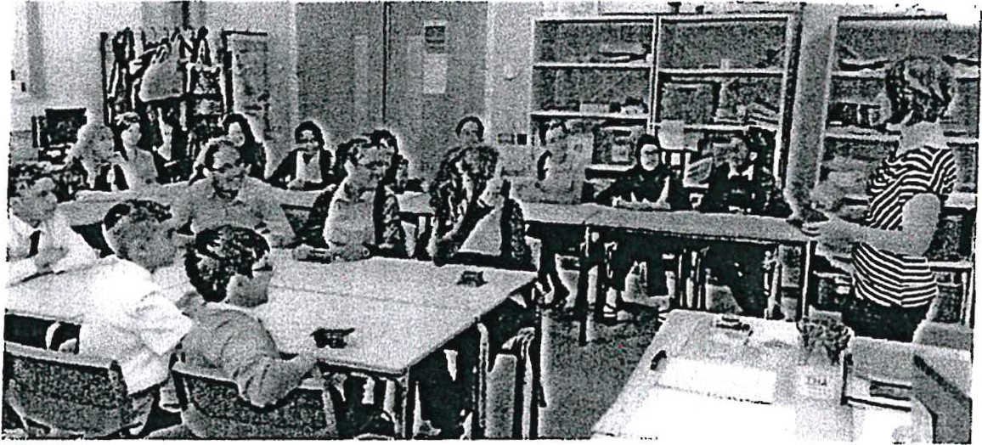When working in a high school you can be teaching a variety of children in one specific subject. A secondary school teacher's job role is to support, observe and record the progress for a number of pupils aged 11-16 but if the high school is a sixth form as well as a high school you could be teaching pupils 11-18 year olds.

Along with teaching the children it is also your job to keep up to date of any developments into your specific subject for example maths, english etc, also any resources that could be used to help develop skills also it is important as your role of a teacher to communicate with other professional, parent/carers about the development of any new skills you will be using to ensure a healthy culture of learning for all students you will come across. As a teacher you will be working with a number of children throughout the day, this means that to ensure the best possible learning in the easiest but most effective way possible you have a lot of responsibilities. The list below is made based upon the website ***(prospects.ac.uk)*** to highlight many responsibilities you will consider before and as you are teaching:

* Prepare and deliver lessons to a range of children all different ages and abilities
* Keep work up to date with marking whilst providing appropriate feedback and always maintain record of all pupils you work with and the progress they are making in your specific objects
* . Research any new subject/topics, keeping up to date on all knowledge of the subject you are working in and plan all lesson around the curriculum.
* Use a range of resources and equipment when teaching this can include podcasts and interactive whiteboard's
* Prepare all pupils for qualification and external examinations in every way possible
* Manage pupil behaviour in the classroom and on other parts of the premises appropriately and effectively whenever facing misbehaviour
* Undertake pastoral duties set by the school you are working in for example form tutor and supporting all pupils through academic and personal difficulties.
* Communicate with the parents or carers of all students to keep them updated on their progress, also you should attend departmental meetings, parents evening and any training session.
* Communicate with other professionals such as the learning support staff, career advisers education welfare officers etc.
* Supervise and support the work of all teaching assistant you will see in your department and any newly qualified teacher's (NQT)

11

Unit 6 - Assignment 4 P7 

* Participate in and o-rgatiise dny extracurricular activity that could help develop the skills your children will use for example trips, sports event
* Undergo regular observations and participate in regular in service training as part of CPD

As part of the multidisciplinary team you will be working with other members of staff from other departments/subjects around the school this is including all teaching assistant staff, you would also be working with the exam board if you are going to be marking them as you will need to be trained on how to mark them correctly to ensure the best grades possible for the students at the time of the exam. In many schools you may be partnered with other local high school or primary schools to help show and express new skills to broaden the teaching and understanding of the next generation of children. Finally as you work and cover such big area of health and social care you will be working alongside the governors and parents to ensure the safety of each pupil and more specifically the environment they are in and any

improvements that could be made to help further the education of the children. Alongside the multidisciplinary team you will also be under the supervision and guide line of the regulatory body. In this case it is Ofsted. This specific regulatory body monitors all policies procedures and standard that all teacher and teaching staff must implement when working in any school setting to make sure the standards of care for example health and safety are implemented to help develop the learning of children from throughout their time in education.



•

I

For you to become a qualified teacher there are many qualifications and training that you must complete before you can even apply for any job when teaching. Teacher training providers set their own entry requirements. In the majority of training provider they expect a minimum of a gcse grade c in maths and english and one degree. If you are yet to complete a degree you could complete a bachelor of education or a BA/BSc with a qualified teacher stat us . Alternatively if you have already completed a degree you will need to complete a postgraduate teacher training course which will lead to you have a QTS in England are will be allowed to practice teaching ***(prospect.ac.uk).*** Once you have become a qualified teacher and have received a job once you officially begin you will be completing a number of training session's throughout your time to work toward your CPD. To work toward your CPD all teachers is available to all teachers both in the location of the school and in personal time. All of the training topics include:

* Any curriculum issues
* Special needs and how to accommodate new skills and of learning
* Subject leadership

12

* + Pastoral care
  + New initiatives and how they will be implemented into everyday teaching
  + Technology- developments including child protections and online exploitation training

In all schools CPD is a mandatory requirement as it keeps all training policies and procedures up to date and is ensuring the development of any new skills will be implanted in every way possible and will be used to help further the education of children in high school time. As a high schoolteacher there is many pathways to success that you could follow to ensure you get to the job you want. Every care practitioner will be different. In the final section below I have placed an example of a career pathway of Kirsty who is an english teacher at a local school in newton. It shows the different stages she had taken to finally get to the job is working to improve more.

**Kirsty's Career Pathway**

/ **Start** -

1) Kirsty's career started when she was in high school, by the end of the five years

'

she achieved 9A* - 3A's. Straight from high school she went straight to further education at Winstanley College to study 5 A levels in English literature, Maths French, German and general studies.

/

1. Whilst she was studying in college she had a part time job at Tesco as a stock controller in October of her As year. She completed an extension project pilot scheme of all of her subjects she was studying in college to help her achieve a higher grade by the end. She left college with the highest grade in all of her subjects

--+

1. Straight from finishing Winstanley she went to Leeds University to study a degree in French and German. She started in September in 2008 but transferred to Edge Hill University after introduction week to study English

!

5) Kirsty graduated in July 2011 with a first class BA Honours degree in English literature.

6) One year later she then graduated with a master degree in English (still at edge Hill University).

!

4) Throughout her studies at edge hill she was still working at Tesco part time.

!

7) From here he went full time at Tesco from December 2012 - August 2013.

8) In September 2013 Kirsty went did her teacher

training through school direct programme at Liverpool hope university but was mainly based at Hope Academy

9) In September 2014 it was Kirsty's NQT year which she completed at hope academy

13

10) In September 2015 she was promoted to Assistant Head of English at Hope Academy and is responsible for all of KS4. She is till at Hope Academy and hopes to become part of the Senior Leadership Team at Hope academy



# Conclusion

I hope that this booklet has help€ftyou have a clearer understanding of some of the role and responsibilities that come with working in Social work, Teaching and finally Children's nursing.

*·e.:*

**14**

- Unit 6 - Assignment 4 P7 20th March 2017

# Bibliography

1. Stretch + Whitehouse 2010 BTEC Health and Social Care
2. https://hee.nhs.uk/our-work/planning-commissioning/delivering-nhs-five-year­ forward-view/supporting-new-care-models
3. htt ps :/ / www.he alt hcaree rs.nhs .uk/ exp lore-ro les / nurs ing/ chi ldre ns-nu rse/ ent ry- requirements-ch ildrens-nursi ng
4. ht t ps :/ / www .nmc.org.uk/
5. <http://www.snagajob.com/job-descriptions/pediatric-nurse/>
6. <http://combiboilersleeds.com/images/graduation/graduation-1.jpg>
7. <http://blogs.nottingham.ac.uk/publicsocialpolicy/files/2015/03/Word-cloud-> Health-and-Social-Care-Act-2012.jpg
8. https:// www.pros pe ct s.ac.uk/ job- profi les / s ocial- wor ke r
9. [https://www.truity.com/career-profile/social-worker](http://www.truity.com/career-profile/social-worker)
10. https:// me dia.glassdoor.co m/ s q ll/ 12873/ uk-n at ional- he alt h-se rvice-s quare logo- 143O93332956O.png
11. [http://www.homelesspeople.eu/wp-content*I*](http://www.homelesspeople.eu/wp-contentI) uploads/2O15/O8/social_services.jpg
12. [https://www.prospects.ac.uk/job-profiles/paediatric-nurse](http://www.prospects.ac.uk/job-profiles/paediatric-nurse)
13. https:/[/www.healthcareers.nhs.uk/](http://www.healthcareers.nhs.uk/)explore-roles/clinical-support-staff *I*social­ worker
14. https://upload.wikimedia.org/wikipedia/en/e/e7/NUT_logo.png
15. ht t p:/ / we llchi ld.s t age 2.reason.d igit a l/ wp­ content /uploads/2O15/O8/NNurseweb1.jpg
16. https:/*I* d18ocOdnkzxmg2.cloudfront.net*I* getasset*I* a6aOebd2-893b-410d-aa68-

16O535b663eb/

1. ht t ps :/ / s t at ic1.squares pace.com/ s t at ic/ 5 1fOfo a3e4 bO27aa8 O8 bb9 b2/ t / 52O0df 7c e4bO8f 2e358f 8da8/137613856 7546/of sted_O.png?format=15OOw
2. <http://starget.s3.amazonaws.com/media/teacher>_guide12015917122O48 . jp g

**15**