,------- Unit 44

l

# Continuing Professional

Development {CPD)

**Planned**

**I standard** =

**identified Un O d :a**

I

**c ion**

**lneedsi**

**assessment ::J**

**BY Stu Denty U6J**

Unit 44

This leaflet is designed to help you understand what your upcoming Continuing Professional Development is all about and why you need it. All professionals want to provide the best quality of care they can and this is exactly what this type of training helps with. So it's nothing to worry about. In fact, it's something exciting as it helps you become a better professional!

What is *Continuing Professional Development (CPD)?*

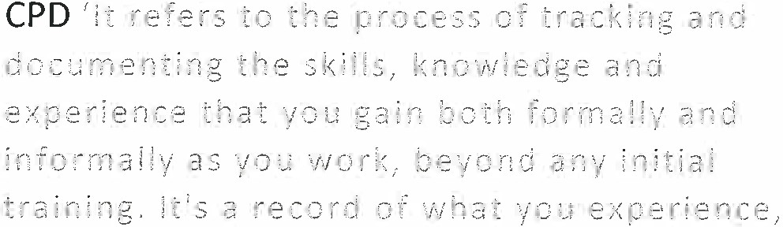

! 2.:t r 11 :1n d t h,:: n :1 o p { . The t i? r rn s gen e r a l ! \/



pr o f e s s i o n a .' (htt p:/ / [www.](http://www/) iobs.ac. uk)

Whv is CPD required for Health and Social Care practitioners?

Better meet service user's needs.

Develop effective communication skills with both the staff and the clients. To maintain and develop practical caring skills, life-saving and first aid skills. Respect diversity and equality of opportunity.

Refreshes knowledge and skills whilst also, providing opportunity to gain more knowledge and practical skills.

Recognises gaps and provides opportunity for a worker to consider their practice and what they need to work on the most.

CPD improves a workers mood and behaviour as they feel more confident with their work.

Assesses their learning and competence. (htt os:/ / www.healt hcareers. nhs.uk)

The practitioner needs to refresh knowledge and skills could be triggered bv:

A workers competence and they may be asked to stop performing until they're fully trained.

New legislation may be introduced so the practice needs to keep up to date with this.

Unfamiliar conditioners or care and support needs. This could be caused by a new client or an existing client with new additional needs.

A new risk is introduced for example; new equipment, change to the environment, policy, procedure, service delivery method or someone with additional needs.

Timeframes means that training could just be required within certain intervals so they need to refresh their skills at this time.





An individual often relies on the care that a practitioner is giving. This means that they need to be at the centre of care.

Professional development is important for the patients they care for as it helps the individual to be able to adapt and provide high quality personalised care . It also, demonstrates ambitiousness and dedication to self-improvement to the patient so they feel more confident and the patient has more trust. To further this, it means the skills are more relevant.

This is one of the most important benefits of CPD. If the patient is receiving centred care they're going to feel more comfortable and know they're getting the best quality care especially, if they've recently been trained. For example; if the staff in the hospital haven't been trained since they first started at the service, people are going to be wary of them and question their practice. However, if staff are trained every month ther e' s going to be a lot more trust in them. Staff will be more aware on how to use the specialist equipment meaning there will be no need for retesting a patient but also, they'll be able to comfort them if they feel uncomfortable. Staff will be friendlier to the patients making them feel more at ease and happier in that environment because they're confident with their work and their abilities.

(htt o:/ / cont inuingprofessi onaldevel opment.org ) Whv is CPD beneficial to others?

Aware of own process leading to a better service for the users.

Improved communication resulting from being in different situations and being able to understand them.

Ability to organise activities which are more beneficial for the needs of service users. Ability to teach others a new skill or talk about knowledge.

Experience of different situations and how to deal with them in the most appropriate way.

Effective communication with professionals and service users so information is clearer to others.

I believe that these are very effective and beneficial to others as staff are able to exchange knowledge they've learnt and enhance each other's skills. It also can build bonds between staff and create a much happier, friendlier and more approachable place. Being able to organise activities that are beneficial to the individual means they're demonstrating their knowledge and their expertise whilst enhances the individuals comfort and trust in the servi ce.

(ht tp:/ / contin uingprofession aldevel ooment.org ) How How is CPD delivered?

Depending on the service and the reason for the induced training there are many different ways that CPD can be delivered. These tend to be one of the following:

Unit 44

Classroom delivered training. One to one knowledge training. Workbooks.

E-Learning. Workshops. Research/Reading.

Team discussions/knowledge shari ng. Role-Play.

Observing/Shadowing. Mentoring/Coaching.

(htt ps:/ / coduk.co. uk)

How does CPD benefit the service overall?

Continuing professional development shows that the service is providing a safe, caring, effective and responsive service for the users. It assist with effective leading and management whilst those who are recruited have the right values and they're kept on. Not only does it improve workers skills but it helps to promote a positive culture and impression towards the community. CPD allows for the service to add new services and offer them to the public as the team will have the skills to do so ( ht tps:/ / cod uk.co.uk).

I hope you found this leaflet useful and helps you to understand Continuing Professional Development more. You can always come back to this and read over if you need to. Also, good luck with your CPD!

Bibliography

htt o:/ / [www.iob s.ac. uk/ careers-advice/ managing-vour-caree r/ 1318/ what-i s-contin uing-professio nal­](http://www.iobs.ac.uk/careers-advice/managing-vour-career/1318/what-is-continuing-professional) develooment-cod

htt os:/ / [www.he alt hcareers.nhs.uk/ career-olanning/ develooing-vour-health-ca reer/oersonal-and­](http://www.healthcareers.nhs.uk/career-olanning/develooing-vour-health-career/oersonal-and) professional-development/continuing-professional-develooment-cod

Ongoing and Learning Development Guide in Adult Care.

[http: / / continuingp rofessionaldevelooment.org/ whv-is-co d-imoortant /](http://continuingprofessionaldevelooment.org/whv-is-cod-imoortant/) httos://coduk.co.uk/exolained