Annotating texts
Annotating is when you add notes or comments to a text; this could also include underlining or circling individual words or phrases
Annotating is a useful way to keep a track of what you notice while you’re reading – the notes and marks you make can focus on particular details in the text. For example, if you were focusing on setting, you could circle all the words and phrases used to describe a place.
There are many ways to annotate texts. Try out different approaches to see what works best for you. Examples of common techniques include:
- circling or underlining words or phrases that are interesting or important and writing notes in the margin
- using different coloured highlighters to pick out different ideas, techniques or details
- using one margin to make a note of literary devices and the other margin to add your own responses
Closely annotating texts is an effective way to practise analysing a piece of fiction.
However, in exam conditions, annotations need to be brief and a quick way of responding to a new text. You can use your annotations to pick out details from the text and then develop your analysis of these details in your written response.

Tips for annotating quickly in exams
- Use abbreviations for longer words (eg allit for alliteration).
- Don’t worry about making it look pretty - make your marks and notes functional.
- Use marks that you understand, for example arrows or question marks to focus your attention on certain details.
- Don’t worry about annotating everything: be selective.

What to look for when annotating

Annotating structure
Read the text and look for patterns in the structure, for example:
- Sentence length and type - eg single or multi-clause sentences.
- Paragraph lengths and structure - eg focus on how the paragraph opens and closes.
- Repeated words and phrases.
- The order of ideas in the extract - eg where does the narrative start? Does the focus shift?

Annotating language and literary techniques
- Highlight any interesting language features in the text.
- Pick out examples of literary devices that stand out because they’re unusual, or because they link closely to the character, theme or setting.
- Highlight individual words to explore closely - those with particular connotations or ones that seem to relate to the theme of the text.

Annotating characterisation and voice
- Pick out key elements which show the development of characters.
- Look for phrases that reveal key details about characters. For example, you might highlight an example of where a character’s appearance is linked to a theme.
- Highlight points where narrative perspective is shown through the language.
- Is the author using the perspective for a particular effect? Pick out examples to support your ideas.

Annotating for themes and ideas
- Highlight any words or phrases that link to the main themes or a particular semantic field.

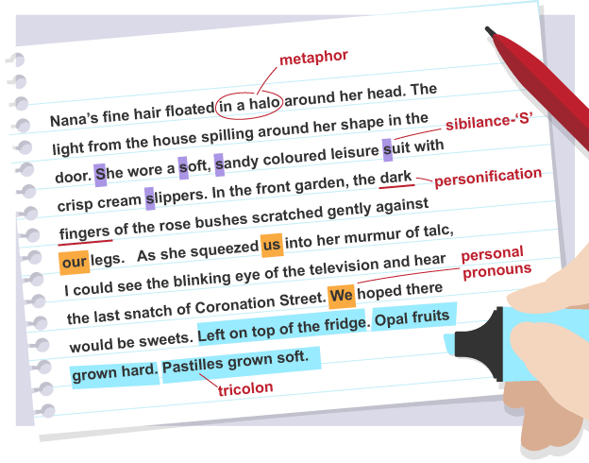
Example
Here is an example of some selective annotations. The student is focused on the language choices in this extract.
- metaphor - ‘Nana’s fine hair floated in a halo around her head’ – positive connotations
- sibilance – the repeated use of the letter 's' adds softness here
- personification – their ‘dark fingers’ is sinister, but then contrasts with the adverb ‘gently’
- personal pronouns – the use of ‘our’, ‘us’ and ‘we’ – sense of family
- tricolon of three single clause sentences – creates rhythm and interest for reader
Avoid making so many annotations that you can no longer read the text! Be selective, and pick out the details that interest you.
- metaphor - ‘Nana’s fine hair floated in a halo around her head’ – positive connotations
- sibilance – the repeated use of the letter 's' adds softness here
- personification – their ‘dark fingers’ is sinister, but then contrasts with the adverb ‘gently’
- personal pronouns – the use of ‘our’, ‘us’ and ‘we’ – sense of family
- tricolon of three single clause sentences – creates rhythm and interest for reader

- Avoid making so many annotations that you can no longer read the text! Be selective, and pick out the details that interest you.

