Characterisation and narrative voice

What is characterisation?
Characterisation is the way writers create characters and make them believable. When writing about texts, it is easy to treat characters as real people. Try to remember that the author is creating characters using language.
Think about the set of characters in a text:
- What are the characters like? How do you know this?
- What do the characters say (dialogue)?
- What do the characters do?
- How are they described?
- How are they seen by other characters?
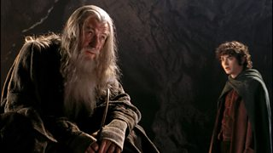
Fictional characters Gandalf and Frodo from the film version of The Lord of the Rings

Characterisation example
Character can be shown through the things characters do, what they say, what they look like, and what they own.
The following extracts describe two farmers from Bruce Chatwin’s On the Black Hill. What do we learn about these characters from the writer’s choice of language?
The brothers were identical twins.
As boys, only their mother could tell them apart: now age and accidents had weathered them in different ways.
Lewis was tall and stringy, with shoulders set square and a steady long-limbed stride. Even at eighty he could walk over the hills all day, or wield an axe all day, and not get tired.
He gave off a strong smell. His eyes – grey, dreamy and astigmatic – were set well back into the skull, and capped with thick round lenses in white metal frames. He bore the scar of a cycling accident on his nose and, ever since, its tip had curved downwards and turned purple in cold weather.
His head would wobble as he spoke: unless he was fumbling with his watch-chain, he had no idea what to do with his hands. In company, he always wore a puzzled look; and if anyone made a statement of fact, he’d say, ‘Thank you!’ or ‘Very kind of you!’ Everyone agreed he had a wonderful way with sheepdogs.
Benjamin was shorter, pinker, neater and sharp-tongued. His chin fell into his neck, but he still possessed the full stretch of his nose, which he would use in conversation as a weapon. He had less hair.
He did all the cooking, the darning and the ironing; and he kept the accounts. No one could be fiercer in a haggle over stock-prices and he would go on, arguing for hours, until the dealer threw up his hands and said, ‘Come off, you old skinflint!’ and he’d smile and say, ‘What can you mean by that?’
On the Black Hill, Bruce Chatwin
Analyse the use of language used here to differentiate the two boys.

Characters and contrasts
It’s important to think about how characters’ change and interact with each other, as this could suggest some important themes or ideas in the text. The writer may use language to encourage the reader to respond to a character in a certain way.
Look for contrasts or contradictions - not just between characters, but within each character. In real life, no one is simply good or bad. All effective characters have more than one side.

Typical contrasts between characters
- Characters who think versus characters who feel.
- Characters who talk versus characters who act.
- Sociable characters versus solitary characters.
- Predators who take advantage of people versus characters who are victims.
- Characters who want one thing versus those who want another.

Typical contrasts within a character
- A person who says one thing, and does another.
- A character who sacrifices something important to pursue a goal of their own.
- A character who wants two opposing things.

Example

This extract is a description of a character from Hilary Mantel’s historical novel Bring Up the Bodies. Thomas Cromwell is the King’s Secretary – an important role. What do we learn about Thomas Cromwell from this extract?
Thomas Cromwell is now about fifty years old. He has a labourer's body, stocky, useful, running to fat. He has black hair, greying now, and because of his pale impermeable skin, which seems designed to resist rain as well as sun, people sneer that his father was an Irishman, though really he was a brewer and a blacksmith at Putney, a shearsman too, a man with a finger in every pie, a scrapper and brawler, a drunk and a bully, a man often hauled before the justices for punching someone, for cheating someone. How the son of such a man has achieved his present eminence is a question all Europe asks. Some say he came up with the Boleyns, the queen's family. Some say it was wholly through the late Cardinal Wolsey, his patron; Cromwell was in his confidence and made money for him and knew his secrets. Others say he haunts the company of sorcerers. He was out of the realm from boyhood, a hired soldier, a wool trader, a banker. No one knows where he has been and who he has met, and he is in no hurry to tell them. Bring Up the Bodies, Hilary Mantel

Analysis – write down any features that Hilary Mantel uses here to define the character of Thomas Cromwell


When you are writing about characterisation, don't just describe what characters are like. Examine the language techniques used by the writer to create the character.

What is narrative voice?
Narrative voice is the perspective the story is told from. The writer chooses a narrative voice carefully, as it can have an important effect on the story and the reader’s response.
 | Different types of narrative voice | Example
First person | A character within the story is telling the story. Some of the main personal pronouns used are I, my, me, we. | I watched as the boat sank. I felt a mixture of relief and guilt. I turned to take the rudder, pushing away the thoughts that crawled like ants into my mind.
Second person | Not commonly used by writers. The personal pronouns you and your are used throughout. | You watch as the boat slowly sinks. You feel relief mixed with guilt. You turn and take the rudder, pushing away the thoughts that crawl like ants into your mind.
Third person | The story is being told by the voice of someone who is not a character in the story. The main personal pronouns used are she, he and they. | George watched as the boat slowly sank. He felt relief mixed with guilt. He turned to take the rudder, pushing away the thoughts that crawled like ants into his mind.
Third person omniscient | The story is being told by a voice who shows they know more than the characters in the story – the narrator is all knowing. The main personal pronouns used are she, he and they. | George watched as the boat sank. He felt relief mixed with guilt. Six miles away a group of fishermen watched the horizon, looking for signs of the storm they could feel in the air.
When thinking about narrative voice, think about the following:
- How does the reader feel about the narrator?
- Does the reader trust the narrator? Do they seem reliable?
- Is the voice of the narrator the author or someone else?
- How does the narrator choose to show us this fictional world?

Examples of narrative voice
Catcher in the Rye by J D Salinger is a first person narrative. The story is told from the perspective of a character called Holden, as if he were confiding in the reader. We get a sense of his character from the language he uses.
If you really want to hear about it, the first thing you'll probably want to know is where I was born, and what my lousy childhood was like, and how my parents were occupied and all before they had me, and all that David Copperfield kind of crap, but I don't feel like going into it, if you want to know the truth. In the first place, that stuff bores me, and in the second place, my parents would have about two haemorrhages a piece if I told anything pretty personal about them. They're quite touchy about anything like that, especially my father. They're nice and all I'm not saying that - but they're also touchy as hell. Besides, I'm not going to tell you my whole goddam autobiography or anything.
Catcher in the Rye, J D Salinger
In this next extract the writer uses a third person narrator. This narrator is not a character, but a voice that knows the thoughts and feelings of the characters in the story. In this extract we are presented with Harriet’s feelings.
It was mid-afternoon and Harriet judged that there were four or five hours of light remaining. Before the night stole up on her, she must busy herself with inspecting what remained and seeing what shelter she might be able to contrive. She told herself that at such a moment, it was best to move from simple task to simple task, going slowly and keeping watch, like a mariner who prepares his small boat for the coming storm. Yet the mile upon mile of emptiness around her made her more afraid than she had ever expected and she found it difficult to move from the spot where she stood. She looked down at her feet, shod in dusty black boots, with the laces beginning to fray, and was struck by how small they appeared.
The Colour, Rose Tremain

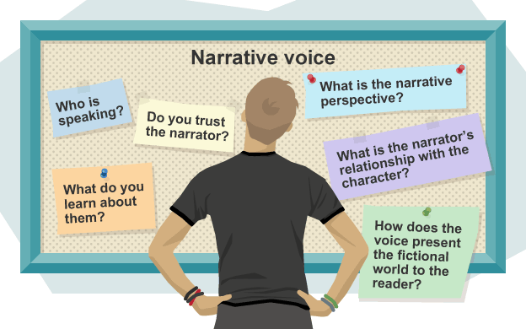
Analysing narrative voice in an extract

Example
This extract is the opening of D.H Lawrence’s Lady Chatterley’s Lover. What is the effect of the narrative voice in this extract?
Ours is essentially a tragic age, so we refuse to take it tragically. The cataclysm has happened, we are among the ruins, we start to build up new little habitats, to have new little hopes. It is rather hard work: there is now no smooth road into the future: but we go round, or scramble over the obstacles. We’ve got to live, no matter how many skies have fallen.
This was more or less Constance Chatterley’s position. The war has brought the roof down over her head. And she had realized that one must live and learn.
She married Clifford Chatterley in 1917, when he was home for a month on leave. They had a month’s honeymoon. Then he went back to Flanders: to be shipped over to England again six months later, more or less in bits. Constance, his wife, was then twenty-three years old, and he was twenty-nine.
His hold on life was marvellous. He didn’t die, and the bits seemed to grow together again. For two years he remained in the doctor’s hands. Then he was pronounced a cure, and could return to life again, with the lower half of his body, from the hips down, paralysed for ever.
Lady Chatterley’s Lover, D.H Lawrence
Analysis – write down your thoughts on the narrative voice in this extract.

Test – Circle the correct answer
Q1 - What is the name given to the process of creating a character in fiction?

