NARRATIVE WRITING (SHORT STORIES)
THE WORD COUNT IS 450-600 WORDS - AVERAGE HANDWRITING = 2 ½ - 3 PAGES.
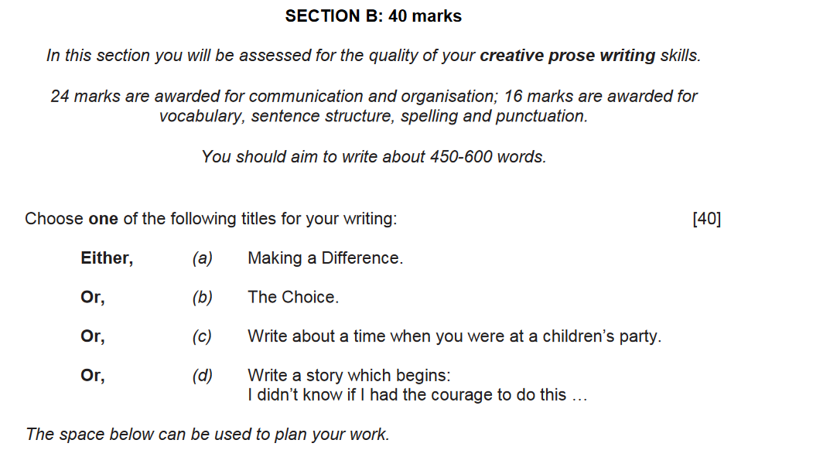
EXAMPLES:
I WALKED
I RAN
SHE SAID

TEACHER TIPS:
- USE THE FIRST PERSON – “I” AND “ME”
- WRITE IN THE PAST TENSE – “WALKED”, “SAID” ETC.
- SET YOUR STORY OVER A FEW MINUTES
YOUR STORY WILL TAKE PLACE IN THE PAST.

St
Stories to avoid!
- Fairy tales
- Wizards
- Going back in time
- Teenage pregnancy
- Drug abuse
- Murder / Blood
- DREAM ENDINGS!!!

Show , don’t tell

DO NOT WRITE SENTENCES LIKE THE FOLLOWING!
- THE MAN WAS TIRED.
- THE MAN WAS HAPPY.
- THE MAN WAS ANGRY.

WRITE THESE INSTEAD!
- THE MAN WAS YAWNED AS HE LOOKED AT HIS WATCH.
- THE MAN SMILED.
- THE BLOOD RUSHED TO THE MAN’S FACE AS HE SHOUTED LOUDLY.

YOUR PLOT IN YOUR STORY SHOULD BE SMALL AND INTERESTING.

Narrative Structure Chart
- Beginning: setting the scene and introducing the characters.
- Problem: something happens to complicate the lives of the characters
- Climax: a decisive moment is reached: matters come to a head; suspense is high.
- Ending: matters are resolved & some sort of satisfactory end is reached.

PLOT FOR ‘HOME ALONE’
BEGINNING:
Meeting the characters in the house as they pack for a holiday.
PROBLEM
Kevin is left home alone and the burglars are introduced.
CLIMAX
Kevin defeats the burglars.
ENDING
The family arrive home and are reunited.

Story Example
What the hell was I thinking? Just the thought of doing the awkward ‘hello’ made me want to cringe. I typed in my passcode and looked at his profile for the millionth time. He looked normal, I guess. The aroma of fatty fast food wafted over me as the speaker system screamed his train’s arrival. My pulse raced and my legs felt heavy. Slipping from my fingers, the balloon floated skyward rapidly towards the enormous clock. I knew what to blame for this: Tinder.
Joining in the summer, it was all swipe, swipe, and swipe. The time had come, my friends had told me, to find ‘the one.’ After scrolling through thousands of self-indulgent selfies, I picked him. His brown hair shone like glistening chocolate and he had kind, warm eyes. He also had a dog. So, he couldn’t be too bad could he? It was his idea to carry a pink balloon so we could recognise each other amid the clatter, chaos and commuters of Waterloo.
He should have been here by now. When was the next train home? My train app told me it was in five minutes. Checking my watch for the gazillionth time, my face drained of colour as the minute hand struck five. We had agreed to meet at noon. It was around that time when it went wrong. It all happened so quickly. It wasn’t really my fault, it was all just so weird. In the distance, towards the tickets machine, I could see a pink balloon bobbing along above the chattering crowd. Gulp.
‘You can do this,’ I told myself.
‘No, you can’t,’ came a voice from somewhere inside my head.
Limping along slowly, the body holding the balloon came into focus like a lion in a hunter’s gun. Slowly, very slowly, my eyes began to zoom in on a truly sick sight: it wasn’t the boy in the photo.
Did I just say boy? It was a man. An old man. An old, bearded, repulsive man. Suddenly, he picked up his pace and walked towards me. I felt like I was the balloon he was holding and that I was about to burst with a scream at any moment. I froze. The sensation of wanting to run away was so strong but I was a fly stuck in a gigantic cobweb. Moving closer, I noticed he sported a rat-like ponytail with food stained, sweaty clothes. What the hell was going on? Catfish, I thought. My head ached and my stomach rumbled loudly. For goodness sake Chloe, get a grip. I was just being melodramatic. He was probably nothing to do with me and just happened to have a balloon. It was probably for a cute little granddaughter. I needed to stop being so bloody stupid. Suddenly, I felt a tap on my shoulder.
“What happened to your balloon?” the old man asked looking up, “You can touch mine if you want.”
“Freak!” I screamed louder than I ever screamed in my life.
I pulled away from him and stumbled as I ran towards my platform. He shouted after me, but I didn’t look back. I just sprinted and sprinted. I crashed into some people, knocking a boy over. I didn’t care. Whistling loudly, the guard was closing the doors while ushering the final people on board. Swinging the door open with an extravagant flourish, like a cowboy about the swagger into a bar in a western, I leapt on board. As the train pulled away, I opened my emergency mini bottle of whisky from my handbag and took a huge swig.
“Chloe!”
I screeched so loudly the train jumped off the tracks. Tapping on the window, the boy I knocked over was waving at me from the platform and pointing towards his grazed hand. He was holding a balloon. A pink one. As the train picked up its pace, and he got smaller and smaller, I saw him shake his phone violently towards me. To be fair, unmatching me was the least I deserved.
That was the whole awful, horrible story and I knew what to blame: Tinder.
- Identify the use of sensory language in the story
- Identify the use of ‘show don’t tell’ in the story.

Sentence starters
TRY AND USE THESE TO START SOME OF YOUR SENTENCES
- Start with an adverb: “Carefully, John picked up the package.”
- Start with a verb+ing: “Moaning, the teenager walked off.”
- Start with an adjective: “Shocked, I couldn’t move.”
- SENTENCE LENGTH - TRY TO VARY THE LENGTH OF YOUR SENTENCES
- PARAGRAPH LENGTH - TRY TO MIX UP THE LENGTH OF YOUR PARAGRAPHS.
- OPENING PARAGRAPH - CREATE A SHOCKING / MEMORABLE OPENING LINE!
TEACHER TIP:
USE A RHETORICAL QUESTION!
EXAMPLE:
“What the hell was I thinking?”
- THE ENDING - THE ENDING IS THE FINAL IMPRESSION THE READER HAS OF YOUR WRITING.
CRAFT YOUR FINAL SENTENCE CAREFULLY – THIS IS THE LAST BIT OF YOUR WRITING AN EXAMINER WILL READ.
DO NOT SAY IT WAS A DREAM!!!

For a great grade, you will need to...
- Use ambitious vocabulary.
- Vary sentence structure and length.
- Use the 5 senses to describe.
- Show what characters are like using (A LITTLE) dialogue.
- WRITE AT LEAST 2 PAGES!

