**Unit 4 Development through the life stage**

1. **Understand physical and psychological changes of ageing** ·

Each person's experience of ageing is different. Some people develop serious problems associated with the ageing process in their fifties; other people have few problems even in their nineties. There is no simple process that affects everyone in the same way.

* 1. **Physical changes**

Some physical changes associated with ageing are summarised below.

Skin, bones, joints and muscles

* The skin becomes thinner, less elastic and more wrinkled.
* Bones can become less dense and more likely to fracture.
* Joints can become stiffer and may become painful as the cartilage on the bone ends becomes thinner.
* The ligaments which reinforce joints can become looser.
* A person can lose height because the cartilage that separates vertebrae in the backbone becomes compressed. The spine may also become more rounded .
* Muscles become weaker.

Senses

* The sense of balance can become impaired .
* The ability to taste and smell can deteriorate.
* Vision can deteriorate because of a range of problems and cataracts can d evelop .



Ivy attends a day centre for older people. She is 84 years old. She is talking about her experiences in the day centre.

*'The dinner here isn't very* good - *it's* a// *just tasteless* mush. You can't get *real food nowadays, not like we* used to *have.'*

'/ get *tired out on the days that I* come *here* - *there's* so *much activity* - *well it takes* me a *day* to get *over it. I do enjoy the keep fit activity but I* get *breathless doing it. I suppose it's all just my* age.'

* Hearing can deteriorate with a failure to hear high­ pitched sounds.
* A lack of skin sensitivity can lead to an increased risk of hypothermia.

Organs

* Muscles in the digestive tract can become weaker creating a risk of constipation.
* The heart is less efficient at pumping blood.
* Blood pressure can rise.
* Nutrients from food are not absorbed as well as in earlier life.
* Breathing can become less efficient because respiratory muscles are weaker.
* Gas exchange in the lungs becomes impaired as the elastic walls of the small air pockets called alveoli become damaged.
* Body metabolism is reduced due to lowered performance of the endocrine glands.

These physical changes do not come about just because we 'wear out' . If you take regular exercise, you may exp ect to live longer and stay healthier than people who do not. The physical changes associated with ageing may come about because there is a limit to how many times body cells can repair and renew them selv es, and because of damage that builds up over a lif etime . For more information, see the section on the final stage of life on page 139.

'/ *do* get *cold in here sometimes* - *all the* young ones - *I mean the staff- they always*

*complain it's* too *hot. But I feel the cold nowadays . It's never warm enough in here for* me .'

Using your understanding of physical changes of ageing answer the following questions: ·

1. Can you explain why Ivy might experience food as being tasteless nowadays?
2. Why might Ivy become tired and breathless following physical activity?
3. Why does Ivy feel cold all the time?





#### LI=C BTEC's own resources

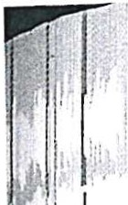

f I

**Hormones and the menopause**

Women usually experience a major decrease in the hormone oestrogen following the menopause. This decrease in oestrogen is associated with osteoporosis. Women are more at risk of osteoporosis than men because bone strength is influenced by the reduction of oestrogen. Some people may be more at risk of osteoporosis than others because osteoporosis may be influenced by genetic inheritance. The environment can make a difference as exercise is known to strengthen muscle and bone and may help to prevent osteoporosis.

## Cardiovascular system

The heart pumps blood around the body. Older people may develop a narrowing of the arteries and other blood vessels due to fats such as cholesterol being laid down in the walls of the blood vessels.

This process of 'clogging up' is called at herosclerosis. 'Athero' indicates fatty deposits and 'sclerosis' indicates the hardening of the arteries.

Atherosclerosis can result in higher blood pressure and high blood pressure puts the person at risk of stroke (where the blood supply to the brain is blocked) and heart attack.

The elasticity in the walls of the blood vessels can also decrease (sclerosis), causing the heart to work harder, increase in size and cause a rise in blood pressure. Fatty deposits can break away and cause a blockage in an artery . These blockages can result in coronary heart disease. If the coronary artery is partly blocked a person may experience the breathlessness and chest pains associated with angina. Where blood flow is seriously blocked a person may experience a heart attack.

## Respiratory system

When blood is not being pumped round the body efficiently, breathlessness may result . The strength of the chest muscles may reduce with ageing and the efficiency of the lungs may deteriorate. Chronic diseases such as bronchitis may develop. Bronchitis involves inflammation of the airways that connect

the windpipe to the lungs. Common disorders of the respiratory system include emphysema and chronic obstructive pulmonary disease.

Emphysema

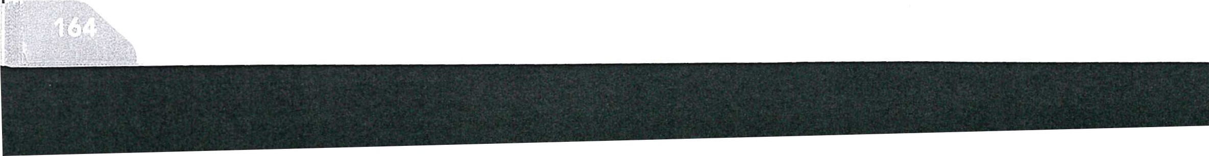Emphysema is a disease in which the air sacs in the lungs (alveoli) become damaged. This causes shortness of breath and can result in respiratory or heart failure.

Emphysema can be induced by smoking, which cau the lungs to produce chemicals that damage thew, of the air sacs. In time, this results in a drop in the amount of oxygen in the blood.

Chronic obstructive pulmonary disease (COPD)

When there is an airflow obstructio n, perhaps due tc emphysema or bronchitis, the resulting condition is described as chronic obstructive pulmonary disease (COPD). This condition can create a progressively worse disruption of airflow into the lungs . Some people with COPD increase their rate of breathing in order to cope, whereas others may have a bluish appearance or might look bloated because of a lack oxygen and a build-up of fluid in the b ody.

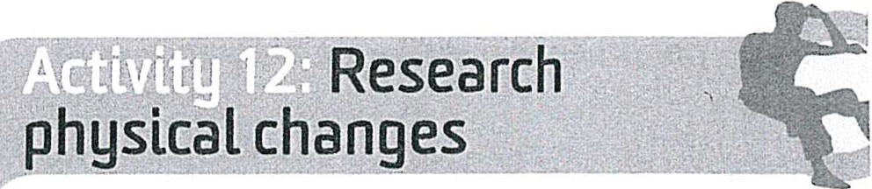

Get together with other course members and choose one topic each to look up using the NHS direct health encyclopaedia (www.nhs.uk). Present your topic in detail to the group. Make notes on other course members' presentations so that you have detailed information on the physical changes associated with ageing.



**ICT and English:** You can use your ICT skills to find 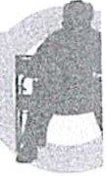 and select information regarding your chosen topic.

Presenting this information to the group allows you

, to practice your speaking skills. You can use writing

i

\ skills to make notes on the other presentations.

## Nervous system

Ageing may involve the loss of nerve cells that activate muscles. Neurotransmitters (the chemicals released

by the nerves in order to communicate and control muscles) may also function less effectively with age .

Motor neurone disease

Motor neurone disease is a rare disorder that is more common among people aged 50 to 70 than in other age groups. The disease causes nerves to degenerate, resulting in weakness and loss of muscle tissue . The causes of motor neurone disease are not understood but it is possible that genetic inheritance may play a role, or that exposure to toxic chemicals may increase a person's risk of developing the diseas e.

**Unit 4 Development through the life st,**

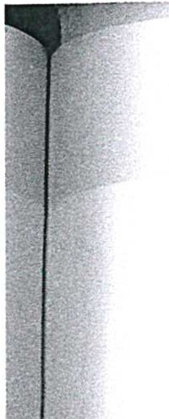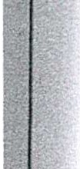

## Degeneration of the sense organs

###### Sight

After 45 years of age, the ability of the eye to focus begins to weaken and by 65 years there may be little focusing power left, making small print more difficult to read. Up to half of people over the age of 90 may have serious problems with vision .

Cataracts result from changes in the lens of the eye. As people grow older the lenses can become hard and cloudy. This process stops the lens of the eye from being able to change shape or transmit light appropriately. This process results in symptoms such as blurred vision . Cataracts may start to form between the ages of 50 and 60 years and often take time to

## . Jo e

Since retiring, Joe works as a volunteer in a day

' centre. At first he found it very difficult to hear what people were saying. When talking to a colleague he said,

*'It's strange that people here don't talk clearly­* even the staff group mumble all the time. It can't be a *problem with my hearing because I can* understand my family all right.'

Joe has since had a hearing check and now uses a hearing aid. He says,

*'It's funny how you don't notice change* - *I really* didn't believe I had a *hearing problem but* everything is much clearer now that I use a *hearing* aid.'



**Cognitive changes**

Ageing can involve a loss of nerve cells in the brain and a reduction in the ability of nerves to transmit electrical sig nals. But this does not mean that people lose their ability to think logically or reason. Many older people do report problems with memory recall, for example, 'where did I put my glasses?' Older people often report that it takes longer to do things; there may be a feeling ofslowing down. They may take longer

to respond to questions. Response times might also be slower, meaning that, for example, older people need to drive more carefully in order to compensate for slower response times. Slower response times and difficulty recalling recent memories are not symptoms of dementia. Senile dementia is not part of a general ageing process, although the disease is more common among people who are over 85.

develop. The majority of people over 75 years have some degree of cataract formation. Diabetes can also cause the development of cataracts.

Another problem that can affect eyesight in later life is glaucoma. Glaucoma involves an increase of fluid pressure within the eye.

**Hearing**

Many older people experience difficulty in hearing high frequency (or high-pitched) sounds. This can happen because the sensitivity of nerve cells in the inner ear may decrease. There may also be a loss of nerve cells, which results in hearing loss. Some older people experience an increase in wax in the outer ear and this can block the transmission of sound to the sensory nerves.



* 1. **Would you generally expect problems with vision and hearing associated with ageing to develop slowly over time or would they be sudden crises?**
  2. **Joe had a problem with hearing high-pitched sounds** - **he thought other people 'mumbled'. Would it have helped** if **other people had raised their voices and shouted at him or would it have caused more problems?**
  3. Why was Joe able to understand his family but not new people at the day centre? Why did he originally refuse to believe that he had a hearing loss?

**Key term**

**Cognitive changes** - changes to a person's thinking, memory or mental abilities that influence their behaviour.

## Musculoskeletal

Older people may experience the following:

* muscle thinning
* decline in mobility
* art hritis.

Ageing can result in a general reduction and shrinkage of skeletal muscles (the muscles we use to walk, lift things and move ab o ut). This loss of muscle tends to start after the age of 40 even in people who enjoy a healthy diet. Lack of exercise may contribute to muscle thinning in some people.



*:, , ,\ _*

#### BTEC's own resources

##### Absorption of nutrients

Absorption of food, including minerals and vitamins, becomes less efficient in older people, meaning that some people can experience malnourishment even though they continue to eat the same diet that was adequate in early adu lthood . Some older people are prescribed additional supplements of calcium and vitamin D in order to prevent osteoporosis as the body may not absorb sufficient calcium and vitamin D from the person's diet. Other major deficiencies in

the diets of older people often include insufficient iron and fibre.

##### Arthritis

Arthritis involves damage to joints within the body. A substance called cartilage covers the ends of our bones and helps to 'cushion' our bones as we move.

Cartilage can become thinner and less elastic with ag e. In osteoarthritis the bone ends can thicken and even form bony spurs which restrict movement of the joint . Many people with arthritis experience stiffness and pain when they move their hips or knees, especially after a period of immobility.

Osteoporosis is a major problem associated with ageing, affecting about 3 million people in the UK. Osteoporosis involves a thinning and weakening of bone, making it easier for bones to become fractured.

**Skin**

As people grow older the elasticity of the skin reduces . The amount of fat stored under the skin decreases, its appearance becomes looser and it develops wrinkles. Skin can also be damaged by excessive exposure to sunlight. Strong sunlight contains ultraviolet rays which can damage unprotected ski n. Ultraviolet rays may cause an increase in freckles, age spots, wrinkles and even rough and leathery skin. Using a sun cream with

a high ultraviolet protection factor can help to reduce this damage.

### The effects of smoking

Smoking exp oses the body to around 400 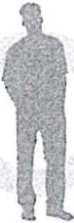 different toxic substances including nicotine, tar

and carbon monoxide.

Smoking is a major cause of a range of cancers including lung cancer. Some medical exp erts argue

that if no one smoked, lung cancer would be a rare disease . Smoking also causes cardiovascular disease associated with the hardening and narrowing of the arteries causing high blood pressure, heart att acks, strokes and lowered blood supply to extrem ities such as the feet. Smoking also causes chronic obstructive pulmonary disease (COPD) and emphysema. Smoking is an example of exp osure to toxic substances that may cause damage to DNA. Damage to cell DNA may result in skin developing a more aged appearance including what is sometimes described as a leathery or wrinkled app earance.

### Dementia - a disorder more common in ageLng

Dementia is more likely to occur in older p eop le.

Appro xim at ely 5 per cent of people over the age

of 65 years have dementia. The Alzheimer's Society , estimates that as many as 20 per cent of people over the age of 80 are affected by dementia. The majority of people who live to extreme old age will never develop dementia.

Dementia is a disorder that causes damage to the structure and chemistry of the brain. A person with dementia is likely to experience problems with understanding what is happening around them, communicating, reasoning, finding their way and remembering recent events . There are different kinds of dementia; two major types are Alzheimer's disease, and dementia caused by vascular disease, which involves problems with blood supply to the brain.

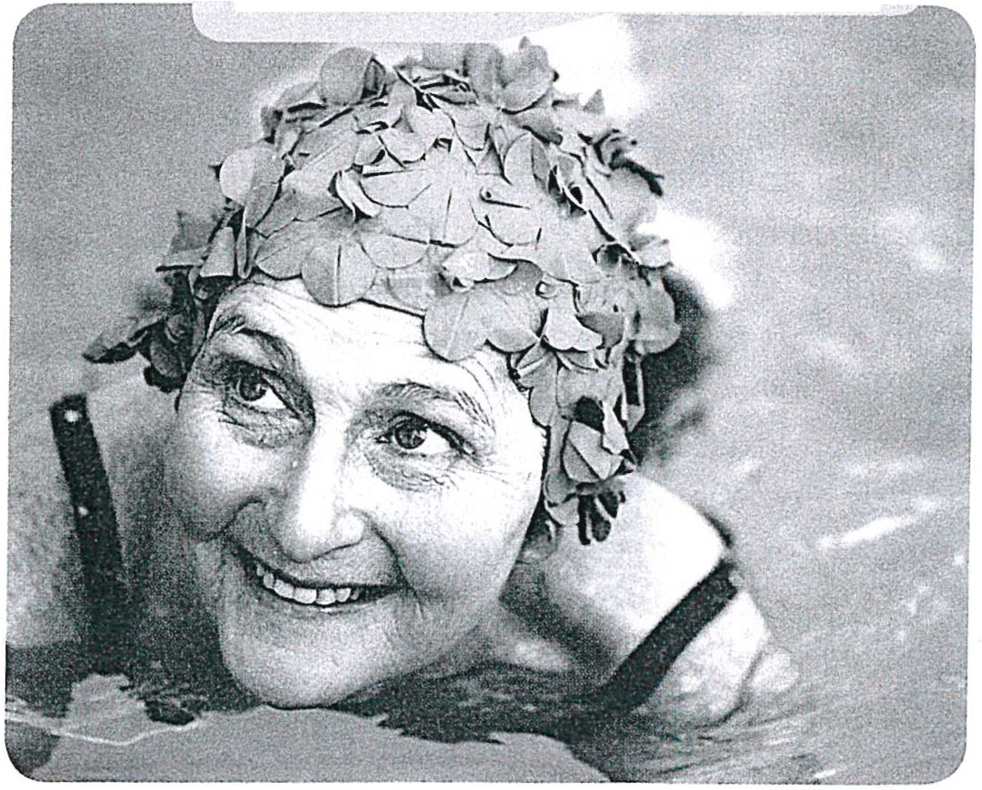Remember that many older people remain physically active well into later life

-



**Unit 4 Development through the life stag,**

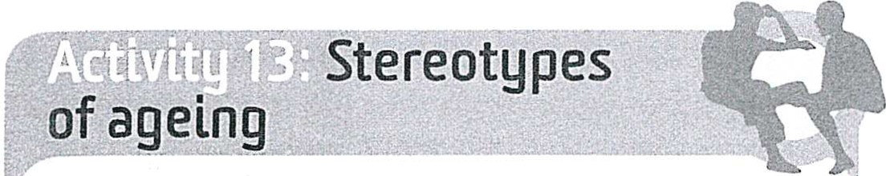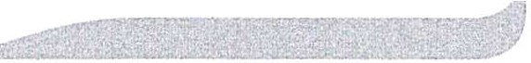

Ask some of your friends or family to name some major health problems they expect older people to have. Historically, many older people have been negatively stereotyped as suffering from disease and dementia. Can you find evidence that these stereotypes still exist?

**Creative thinkers:** This activity may help you to 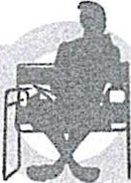 evidence the ability to question your own and

others' assumptions as part of your creative thinking skills.



* 1. **Psychological changes**

### The effects of ageing on personal confidence and self-esteem

As with physical ageing, each person's experience of psychological change is likely to be different.

Cumming (1975) argued that some people disengage from social activity as they get older (see page 170 for more information about Cumming's argument), but many people remain in close contact with friends and family. Another famous theorist, Erik Erikson, argued in 1963 that older people would need to develop a sense of 'ego integrity' if they were to avoid despair in later life. Ego integrity involves making sense of your life - holding on to a clear and meaningful sense of who you are . In part, ego integrity involves

holding on to your self-est eem. One theory is that older people need

to engage in telling their life story, reminiscing or reviewing their life in order to help create self-esteem and confidence. Coleman (1994) argued that some types of reminiscence work can be useful for most people, but that there are wide differences in individual needs. Joining a group to discuss past events may not be good for everybody .

Alice Heim (1990) was a psychologist who wrote a book about her own experiences of ageing and the

experiences of 160 of her friends and colleagues. Her study showed that even within a group of people with similar cultural and life experiences, there were wide variations in how people experienced later life. Some people reported an increase in social confidence; some people appeared to become more tolerant, while others became more irritable; some people appreciated the respect that they received from

other people, while others complained of a lack of respect. The study suggested that ageing is full of contradictions with no clear rules.

Heim suggested that confidence in undertaking practical tasks decreases in old age but that social confidence increases - and that this is one of the contradictions involved in the ageing process.

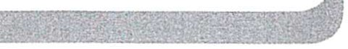

Imagine a fit, healthy 16-year-old and a frail 84-year- -=

old person with poor eyesight who both have to

cross a busy road. Which of these two people is likely to feel more confident in coping with the situation? Now imagine the same two people faced with the task of standing up at a wedding reception and making a speech. Imagine that the older person

has had a lifetime's experience of public speaking. Which of the two people is now likely to feel more confident?

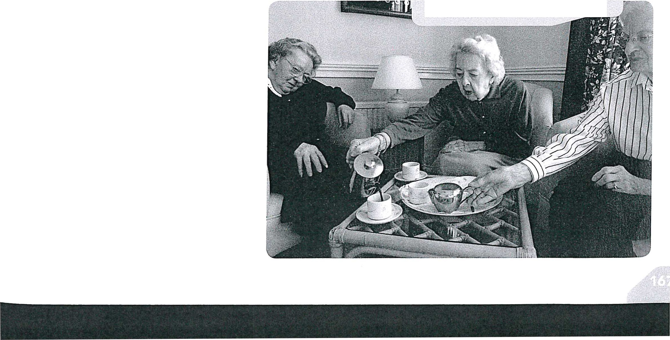Think about why some individuals may choose to take part in reminiscence sessions as an important social activity.

#### BTEC's own resources

 **Grace**

, Grace is 82 years old. She suffers from osteoporosis and recently fell and broke her hip . She made

the following statements in conversation with her physiotherapist who is helping her to learn to walk again using sticks to support herself while walking in

1 her bungalow .

*'Sometimes I have a little cry* because *I can't get* to the sho ps.'



*' I don't know when I'll have the strength and confidence* to go *shopping on my own again.'*

'/ *can still get on my mobility* scooter *and* go *down the club* - *that's easier because there are other people* to *help you there. '*

*I don't* know *what I' d do if I couldn't* get *down the club because there's other people with problems and you can talk to them .'*



*' M y old mum used to* say *that a problem*



*shared is a problem halved. It's a real help down the club* - *it lifts my feelings up when I'm down.'*

1. **Can you explain how osteoporosis has resulted in a problem that threatens Grace's confidence and self-esteem?**
2. **Can you explain what Grace does in order to keep her social confidence and self-esteem intact?**
3. **How far can services such as social clubs help to prevent older people from experiencing a loss of confidence and self-esteem despite physical changes?**

Physical illness may cause some people to lose confidence in doing certain activities but it would be wrong to assume that physical decline automatically removes everyone's general self-esteem and confid ence.

**Table 4.9:** General issues that may influence individual psychology

**Issue Explanation**

**Ageism** Older people are somet imes stereotyped as being useless, diseased, demented and unable to cope. Older people may experience prejudice from younger people who see them as 'having had their lives'. Many older people fear that they will not be treated with dignity in hospital or care settings .

**Role changes** , The majority of older people enjoy effective social networks with only one person in five experiencing a degree of isolati on. For many people retirement provides more opportunity for

'.' contact with grandchild ren and other relatives. Older people are more likely to vote than any other age group suggesting more involvement in politics, whereas younger people may be

1 more disengaged from polit ics. Loss of work role, loss of partner and loss of income may all

: result in major life changes th t are difficult to cope with .

' **Loss of a** Bereavement may result in a range of changes and losses including role changes . Bereavement

**partner** *!'* may cau temporary anxiety an_? d epression.

**The effects of**

' For many people retirement provides freedom. Retired people may be seen as 'time rich' and

1

**retirement** I free from work stress . But for some pe<;)ple retirement could result in a loss of income, contact with..work colleagues and the loss of interest in life.

-

**Increased** , Free time may enable many older people to engage in physical leisure activities such as walking

**leisure time** / and activity holidays. Gardening is very popular among people aged 50 to 70. Free time may enable many older people to engage in enjoyable social and mental activit ies such as taking new college courses, developing !CT skills etc. National Statistics Online (2006) reported that 51 per cent of people between _60 and 69 participafed in some form of learning.

**Financial** The majority of people aged 65 and over own their own home and people over 65 have higher **concerns** ;' leve,l s of savings in general than any other age group. Many older people enjoy a high standard ' of living . Only about one in five older people live in poverty. Most of these people will not have

, a pr ivate pension fund. These people may have concerns about paying for heating, shopping

1 and cop ing financially.

**-------------Unit 4-Dev-elopm-ent th-roughithe liafe st a1**



Other issues that may influence individual psychology

The majority of people over state retirement age experience reasonable health, a satisfactory social life and a reasonable standard of living. Only a minority of older people experience poor health, poverty and

isolati on. It is important to guard against the stereotype that old age is always a story of decline and isolation.

Old age is like any other life stage - whether or not you lead a happy and fulfilled life depends on a large range of individual issues.



Jake and Joshua are residents in a care home. Both have heart disease and serious mobility problems. In conversations with the care home staff, Jake has said:

*I'm finished with my li fe. I' m just a burden* to *my family* My *body has packed u p, there is nothing* to *live for, I can't walk, I can't get out, I'm no use* to *anyone* - *I wish I was dead.*

Joshua has said :

*I can't* get *around anymore but I still enjoy my li fe . It's a joy just* to *wake up in the morning,* to see *the sun,* to *see a smiling face . You should never give up on life* - *I learned that attitude from my family*

**Culture, religion and beliefs**

The way in which you react to physical changes in later life will depend on your attitudes and beliefs . Attitudes and beliefs are influenced by social issues such as culture and religion . Some people can maintain a happy and positive outlook on life despite having serious physical health problems. Other people may appear to be depressed or withdra wn despite being relatively fortunate in terms of physical health .



*I believe in a spiritual* 'me'. *If my body lets* me *down* - *well my spirit hasn't* altered- *why should I be* sad?

Jake believes that if you haven't got your health life is not worth living. Joshua thinks quite differently.

* 1. **Can you identify possible cultural and religious reasons for these different beliefs?**
  2. **Does physical health completely control and determine how much a person can enjoy life?**
  3. **Can you use Erikson's theory of 'ego integrity' in order to explain Joshua's positive attitude?**

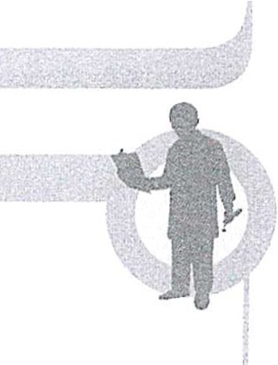**Interview with John continued**

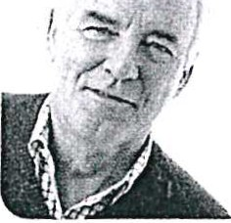***Interviewer:*** Do you think that the best time in life is when you are young and that you are less

confident now that you are older?

***John:*** No. The best time for my body was my early 20s, it is true. But I

think now is the best time in my life. When I think back I had a lot of problems in my 20s and 30s. I wasn't really settled, I kept changing job s. I got divorced twice. Looking back I pretended to be confident but I didn't really know who I was. I love the work that I'm doing now - I don't want to retire. I finally found a relationship that works so I've never been happier.

***Interviewer:*** But what about the aches and pains you mentioned? Don't they get you down?

***John:*** Yes. I've got arthritis and every time I try to do things, like decorate the house, my wrists and knees hurt. But I' ve got an answer - I don't decorate the house any more - I pay someone

else to do itl I'd love to be back in a 25-year-old

body but I wouldn't like to give up the life that I have now.

***Interviewer:*** Would you say you are more confident and your self-esteem has increased with age?

***John:*** Yes. I'm more confident in myself. I don't care what other people think - I know who I am and what I'm good at, so I have self-est eem. I know I don't look so good these days - but so what! You are what you are, and at my age I don't have to be attractive!

1. Can you describe some of the physical changes that John has experienced and how they have limited his life?
2. Can you explain why John still enjoys self­ confidence and high self-esteem even though he has experienced physical changes with ageing?
3. John might be said to have successfully adapted to physical ag eing. Can you explain why some people might adapt successfully while other people might experience of loss of self-esteem?

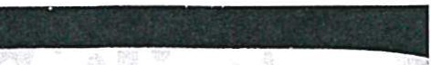

 **BTEC's own resources**

### Theories of ageing

Social disengagement

Engagement means being involved with people or activities. **Disengagement** means to withdraw from involvement. In 1961 two authors called Cumming and Henry put forward a disengagement theory that older people would naturally tend to withdraw from social involvement with others as they got older; older people would have restricted opportunities to interact with others. The issues that surround this are outlined in Table 4.10.

Cumming (1975) argued that older people would experience a reduction in social contact as they grew older and become increasingly 'individual' and less concerned with the expectations of others. He argued that it was appropriate and healthy for older people to withdraw from others - disengagement was a natural part of ageing .

The theory of disengagement was widely accepted in the past . For example, Bromley (1974) argued that 'although some individuals fight the process all the way, disengagement of some sort is bound to come,

**Table 4.10:** Issues that limit social interaction.

Problem Explanation

**Key term**

**Disengagement** - a theory that older people will need to withdraw from social contact with othe rs. Older people will disengage because of reduced physical health and loss of social oppo rtun ities .

simply because old people have neither the physical nor the mental resources they had when they were young.'

The theory of disengagement fits with the 'springboard' view of life (see page 133) and suggests that losing contact with other people is an inevitable consequence of biological decline and that withdrawing from other people is a natural and

appropriate response to ageing. However, there is little statistical evidence to suggest that this is a general rule for everyone.

Zimbardo (1992) argued that 'The disengagement view of social ageing has been largely discredited for a number of reasons' . The majority of older people do remain socially involved with family and friends and many older people become more involved with close

family as they become older. It may be that many older people choose to spend their time with people they

* + Ill-health

Geographical mobility -

Retireme..nt

Ill-health of friends and relatives

Travel and technology

·, Poor mobility or problems with

. hearing or vision may make interaction with other people more

: difficult.

Many people retire to areas away from friends and relatives. Family

. members may move away from

* older people in order to seek better ' housing or emp loyment.

·-- ..

Retiring from work may mean less contact with colleagues in a social setting.

- If friends or relatives have poor

* mobility or other disabilities they may ha e rec;luced social contact with you.

' Some older people do not have

: access to a car, the Internet or a mobile phone - this may limit opportunities for social contact.

feel close to, rather than seeking to make new friend s. If people only interact with close friends, does this mean that they are disengaged?

While many researchers today do not agree with disengagement theory, it is important to remember that when Cummings and Henry first proposed the theory in 1961 there was no Internet or text messaging; many olde r people did not have access to a car and quite a few would not even have had a phone in their home!

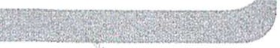

Imagine you have broken your legs . You have no access to a phone, text messages or the Internet and you cannot go out. Would you begin to disengage?

Now imagine the same situation but this time you have a mobile phone and an Internet connected

laptop . Would technology help? Do health problems automatically cause social withdrawal or might it be

more comp licated?



**Unit 4 Development through the life**

**Activit y theory**

Writing in 1966 Bromley argued that older people needed to disengage, but that they also needed to remain 'active' in order to prevent disengagement from going too far. Bromley said: 'It is not sufficient merely to provide facilities for elderly peop le. They need to be educated to make use of them and encouraged to abandon apathetic attitudes and fixed habits . ' Bromley argued that it was important to remain mentally active and maintain an interest in life and enjoy the company of other s. Too much

disengagement would lead to 'stagnation' and a loss of mental and physical ski lls.

##### Continuity theory

**Continuity theory** (Atchley, 1989) stresses the importance of continuing as the person you have always been. For many people this may involve continuing with interests, lifestyles and social contacts from the past. The important thing is that people can continue to develop an internal sense of self-esteem and self-concept. Memories of the past may be important because they can help a person to tell their life st ory.

Continuity theory suggests that people will have different needs when it comes to activity. Some people may wish to withdraw from social and physical activity because they see themselves as a person who is entitled to retire and adopt a disengaged lifestyle.

Other people may have lived with active involvement with family, friends or with hobbies and may not be able to cope without staying active. Some people can disengage without losing their sense of who they are. Some people need to stay actively involved

with people or hobbies in order to feel that life is worthwhile.

**Key terms**

**Activity theory** - a theory which argues that older people need to stay mentally and socially active in order to limit the risks associated with disengagement.

**Continuity theory** - a theory that older people will generalI maintain a continuous sense of who they are and continue tc adapt the self concept they developed earlier in life.

**AgeLng and health and social care provLSLo**

The majority of older people remain in their own horr in the community, where they may be supported by friends, family and health and social services. Some older people choose to move to sheltered housing. Sometimes people choose sheltered housing becaus< maintaining the family home has become too difficult Day care centres provide a social setting where peopl can meet and some health authorities provide day car to assist with physiotherapy and other health needs. A small proportion of older people choose residential care where 24-hour support is available.

All services for older people will aim to provide respec and choice for service users as part of their policy on quality assurance . Many day and residential services will provide a range of social and leisure activities

for service users. Older people should always have a choice as to how active they wish to be . Quality services will never attempt to force older people to be active and engaged, but they will provide

opportunities for individuals to maintain the continuity of their lives and remain as active as they wish.

In your role as a reporter for a magazine, you now need to write about the life of your chosen celebrity as they grow older. You must imagine some of the physical and psychological changes that could affect the person in the future. You will also need to explain two theories of ageing such as disengagement and activity theory.

Grading t3pS

**,P** To achieve P4 you could choose to explain disengagement and activity theory or you could research alternative theories such

as continuity theory.

To achieve PS it will be important to use creative thinking and consider different

p ossibilities. Some older people may no longer want to appear in public or be photograp hed. Other people will continue to develop their celebrity stat us. Some people are celebrities because they have overcome serious difficulties in their lives. These people might cope effectively with the challenges of later life. You can discuss the different possibilities that the future may hold within your fact file.

To achieve M2 you need to discuss the degree to which your celebrity might disengage or stay

""-- - - - - - - -- - - - -



#### BTEC's own resources

, i I .•••

actively involved with social activities as they become older. You might like to consider the role of continuity (how important it will be for your celebrity to keep their interests) when you discuss disengagement and activity theory.



***1M*** To achieve M3 you will need to discuss how these changes could affect your celebrity's self­ esteem and self -confidence .



# Resources and further reading

Atchley, R.C (1989) 'A continuity theory of normal agi ng', *The Gerontologist, 29,*183-190 Ainsworth, M.D.S., Blehar, M . C., Walter, E., Wall,

S. (1978) *Patterns of Attachment: A Psychological*

*Study of the Strange Situation* New Jersey : Lawrence Erlbaum Associates Inc.

Berrym an, J.C., Hargreaves, D., Herbert, M., Taylor,

A. (1991) *Developmental Psychology and You*

London: Routledge

Bowlby, J. (1953) *Childcare and the Growth of Love*

Harmondsworth : Pelican

Bromley, D.B. (1966) *The Psychology of Human Ageing* Harmondsworth : Penguin

Bromley, D.B. (1974) *The Psychology of Human Ageing,* second ed. Harmondsworth : Penguin Chomsky, N. (1959) Review of Skinner's *Verbal Behaviour, Language,* 35, 26- 58.

Coleman, P. (1994) 'Reminiscence within the study of ageing: the social significance of story', in Bornat, J. (1994) *Reminiscence Reviewed* Buckingham : OUP

Cumming, E. (1975) 'Engagement with an old theory' *International Journal of Ageing and Human Development,* 6, 187-191

Cumming, E., Henry, W.E. (1961) *Growing Old* New York: Basic Books

Erikson, E.H . (1963) *Childhood and Society,* second ed . New York: Norton .

Havighurst, R.J. (1972) *Developmental Tasks and Ed ucatio n,* third ed. New York: David McKay Heim, A. (1990) *Where Did I Put my Spectacles?* Cambridge: Allborough Press

To achieve D2 you should evaluat e how theories of ageing influence health and social care provision . If your celebrity was being supported at home or in care would they be supported

to maintain continuity with their past? Would they be expected to withdraw, or would they be encouraged to remain active in order to prevent excessive disengagement?

Levinson, D.J., Darrow, D.N., Klein, E.B., Levinson,

M.H., McKee, B. (1978) *The Seasons of* a Man's *Life*

New York: A. A. Knopf

Marris, P. (1996) *The Politics of Uncertainty* London: Routledge.

Paxton, W., Dixon, M. (2004) *The State of the Nation*

- *an Audit of Injustice in the UK* London: Institute for Policy Research

Pinker, S. (1994) *The Language Instinct* London: Penguin

Sugarman, L. (1986) *Life-Span Development* London

& New York : Methuen

Sugarman, L. (2001) *Life-Span Development* 2nd Edition Hove & New York: Psychology Press *Social Tre nd s,* Vol. 34 (2004) London : HMSO *Social Trends,* Vol. 39 (2009) London: HMSO

Unleashing Aspiration (July 2009) Report of the Panel on fair Access to the Professions Cabinet Office: London

www.cab inetoffice.gov.uk/accessprofessi ons Walters, R. (2009) *Crime is in the air: air pollution and regulation in the UK* Centre for Crime and Justice

Studies Kings College London . [www.crimeandjustice.org.uk.](http://www.crimeandjustice.org.uk/)

Zimbardo, P.G. (1992) *Psychology and Life* London : HarperCollins

# Useful websites

Institute for Public Policy Research www.ipp r.org National Statistics [www.statistics.gov](http://www.statistics.gov/) .uk

The Food Standards Agency www.eatwe ll.gov.uk The Poverty site [www.p overty.org.uk](http://www.poverty.org.uk/)