Complete the table identifying the tissue groups and the different types of tissue within this group.

Tissue Group | Types of Tissue within the group | Function | Where they are found in the body
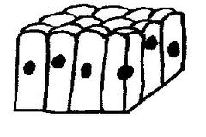 | 1  2  3  4

Complete the table identifying the tissue groups and the different types of tissue within this group.

Tissue Group | Types of Tissue within the group | Function | Where they are found in the body
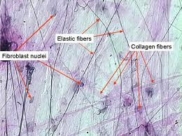 | 1  2  3  4  5
Complete the table identifying the tissue groups and the different types of tissue within this group.

Tissue Group | Types of Tissue within the group | Function | Where they are found in the body
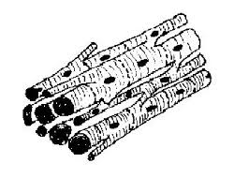 | 1  2  3

Complete the table identifying the tissue groups and the different types of tissue within this group.

Tissue Group | Types of Tissue within the group | Function | Where they are found in the body
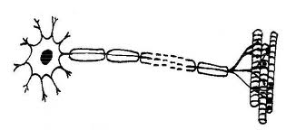 | 1  2

How Tissues make up and function in two different Body Organs.
Identify the body organ shown and outline the tissues that make up this organ.
ORGAN: | An outline of the tissues and their function in this organ
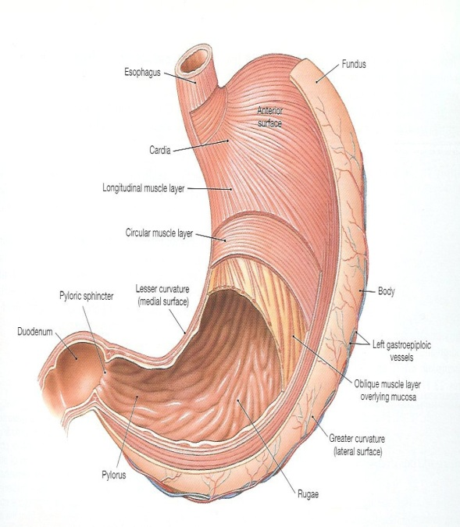
Identify the body organ shown and outline the tissues that make up this organ.
ORGAN: | An outline of the tissues and their function in this organ
