Name: _______________________________

Carmel College

BTEC National Diploma Health & Social Care

Unit 5

Anatomy & Physiology.

Tissues

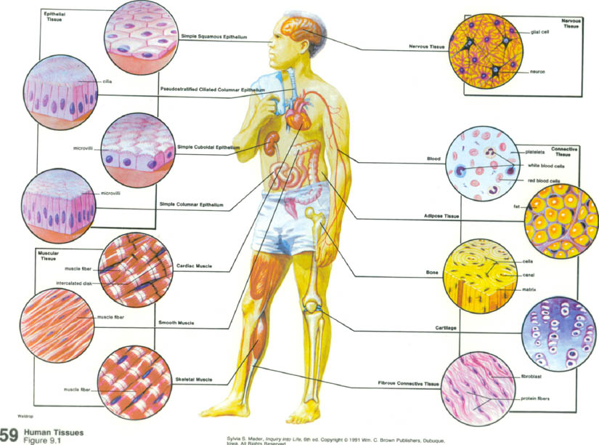

P2 Produce a booklet which **outlines** the **four main tissue types** and the role tissues play in **two named** organs.

**TISSUES**

*Explain what is meant by the term tissues.*

*What are tissues made up of? Explain about the intercellular matrix here.*

Identify the four main tissue groups

1.

2.

3.

4.

Draw the different types of Epithelial tissues on this page.

Draw the different types of Connective tissue

Draw the types of Muscle tissue on this page.

Draw the types of nervous tissue here.