Name: ________________________________

Carmel College

BTEC National Diploma Health & Social Care

Unit 5

Anatomy & Physiology.

Cells.

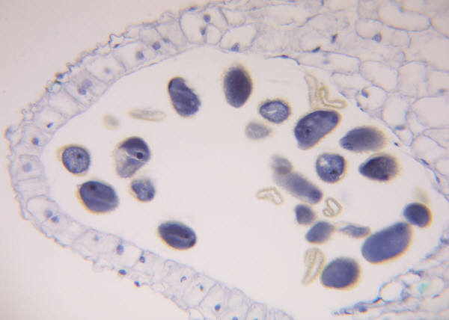

The activities within this booklet are designed to meet the following criteria.

**P1**: Outline the functions of the main cell components.

**THE MAIN CELL COMPONENTS**

*Draw and label a cell.*

*Complete the following table and find an image of or draw the structure.*

|  |  |  |
| --- | --- | --- |
| **Structure** | **Image** | **Description of the Structure** |
| Cell membrane |  |  |
| Cytoplasm |  |  |
| Golgi Apparatus |  |  |
| Lysosome |  |  |
| Mitochondria |  |  |
| Nucleus |  |  |
| Smooth Endoplasmic Reticulum |  |  |
| Rough Endoplasmic Reticulum |  |  |