Carmel College

BTEC National Diploma Health & Social Care

Unit 5

Anatomy & Physiology.

The Gross Body Structures

Name: __________________________

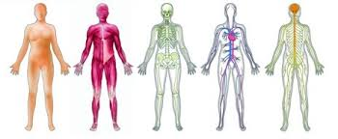

**P3: Outline** the **gross structure** of the **main systems** including the **main organs** within the systems and **their general functions**. For each system produce an **annotated diagram.**

***Don’t forget to include a bibliography of the sources used at the end of your booklet***

**THE CARDIOVASCULAR SYSTEM**

**Describe the functions of the system.**

|  |
| --- |
|  |

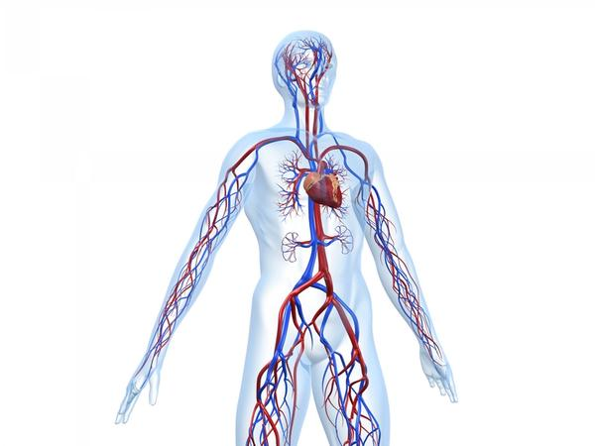

**Label the above diagram**

|  |  |
| --- | --- |
| **Structures** | **Functions** |
| **Heart** |  |
| **Arteries** |  |
| **Capillaries** |  |
| **Veins** |  |

**THE RESPIRATORY SYSTEM.**

**Describe the functions of the system.**

|  |
| --- |
|  |

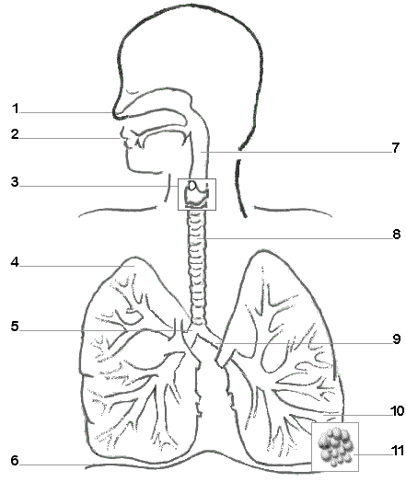

**Label the above diagram**

|  |  |
| --- | --- |
| **Structure** | **Functions** |
| **Nasal Cavity** |  |
| **Trachea** |  |
| **Bronchus** |  |
| **Bronchioles** |  |
| **Lungs** |  |
| **Diaphragm** |  |

**THE DIGESTIVE SYSTEM**

**Describe the functions of the system.**

|  |
| --- |
|  |

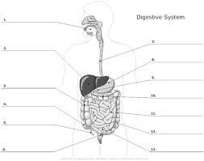

**Label the above diagram**

|  |  |
| --- | --- |
| **Structure** | **Function** |
| **Mouth** |  |
| **Salivary Glands** |  |
| **Oesophagus** |  |
| **Stomach** |  |
| **Duodenum,** |  |
| **Jejunum** |  |
| **Ileum** |  |
| **Structure** | **Function** |
| **Liver** |  |
| **Gall Bladder** |  |
| **Pancreas** |  |
| **Colon** |  |
| **Rectum** |  |
| **Anus** |  |

**THE RENAL SYSTEM**

Describe the functions of the system.

|  |
| --- |
|  |

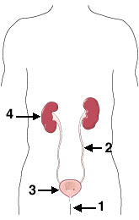

**Label the above diagram**

|  |  |
| --- | --- |
| **Structures** | **Functions** |
| **Kidneys** |  |
| **Ureters,** |  |
| **Bladder** |  |
| **Urethra** |  |

**THE NERVOUS SYSTEM**

**Describe the functions of the system.**

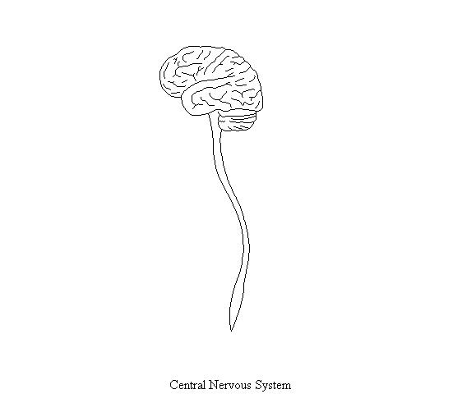

**Label the above diagram**

|  |  |
| --- | --- |
| **Structure** | **Function** |
| **Brain** |  |
| **Spinal Cord** |  |
| **Nerves** |  |

**THE ENDOCRINE SYSYTEM**

**Describe the functions of the system.**

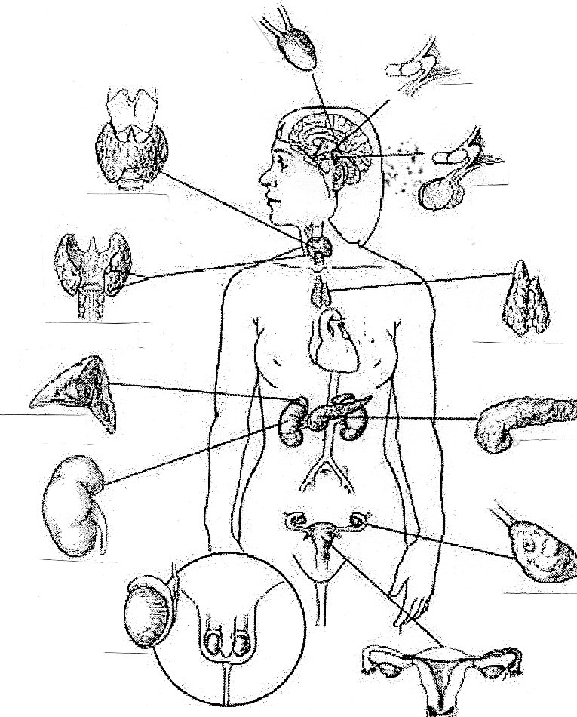

**Label the above diagram**

|  |  |
| --- | --- |
| **Structure** | **Functions** |
| **Pineal Gland** |  |
| **Hypothalamus** |  |
| **Pituitary Gland** |  |
| **Thyroid Gland** |  |
| **Parathyroid Glands** |  |
| **Adrenal Glands** |  |
| **Pancreas** |  |
| **Ovaries** |  |
| **Testes** |  |

**THE REPRODUCTIVE SYSTEM.**

**Describe the functions of the Reproductive system.**

|  |  |
| --- | --- |
| **Female Reproductive System** | **Male Reproductive System** |
|  |  |

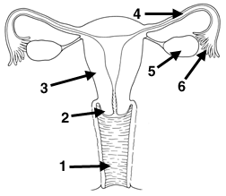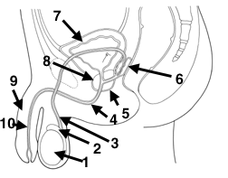

|  |  |
| --- | --- |
| **Structure** | **Functions** |
| **Ovaries** |  |
| **Fallopian Tubes** |  |
| **Uterus** |  |
| **Cervix** |  |
| **Vagina** |  |

|  |  |
| --- | --- |
| **Structure** | **Functions** |
| **Scrotum** |  |
| **Testes** |  |
| **Vas Deferens** |  |
| **Seminal vesicle** |  |
| **Prostate Gland** |  |
| **Penis** |  |
| **Urethra** |  |

**THE LYMPHATIC SYSTEM**

**Describe the functions of the system.**

|  |
| --- |
|  |

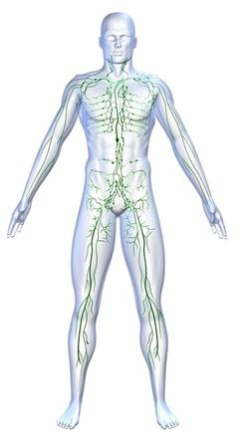

**Label the diagram**

|  |  |
| --- | --- |
| **Structure** | **Functions** |
| **Lymphatic Vessels** |  |
| **Lymph Nodes** |  |
| **Tonsils** |  |
| **Thymus gland** |  |
| **Spleen.** |  |

**THE MUSCULO-SKELETAL SYSTEM**

**Describe the functions of the system.**

|  |
| --- |
|  |

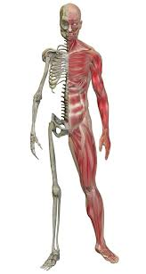

**Label the Diagram.**

|  |  |
| --- | --- |
| **Structure** | **Function** |
| Bones |  |
| Tendons |  |
| Ligaments |  |
| Muscles. |  |

THE IMMUNE SYSTEM

Describe the functions of the system.

|  |
| --- |
|  |

Label your diagram

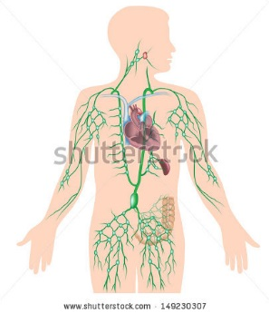

|  |  |
| --- | --- |
| Structures | Functions |
| Lymphatic Vessels |  |
| Lymph Nodes |  |
| Tonsils |  |
| Thymus gland |  |
| Spleen |  |
| Bone Marrow |  |

**Bibliography of sources used:**