**Information on hypothermia from** **http://www.mountain-training.org/blog/hypothermia**

As humans we operate most effectively with a body temperature of around 37C.  
  
When heat is allowed to leave our bodies without being replaced the temperature will drop. A very small loss is all it takes for the early stages of Hypothermia to start to take hold. This is something we will all have experienced at one time or other and is characterised by the shivering that we all recognise as our bodies’ way of telling us to put on an extra fleece, eat something sugary or drink something warm. However shivering whilst running is not reliable as it is hard to shiver AND run, thus while running and losing heat the runner may lower their core temp significantly and only start shivering when they stop. Feeling cold, poor decision making, poor concentration (e.g. navigation errors), fatigue, and irritable mood are also all early signs. The body’s energy needs also increase in mild hypothermia because the sugars are used to create heat, and by the muscular effort of shivering. Heart rate and breathing initially increase to help with the increased demand, but then reduce as shivering stops. Shivering cannot be absolutely relied upon as an indicator of cold as pain from an injury may prevent it so making sure an injured person is kept warm is important both in terms of preventing shock and hypothermia.   
  
**Once the body is down to 35C it is now suffering from Mild Hypothermia.** As your temperature drops the body decides that it is fighting a losing battle in trying to raise the temperature of the whole so concentrates its efforts purely on survival. As the body cools further, shivering will stop. The body is now becoming severely hypothermic. You will stop shivering but not because you are getting warm. Blood will be drawn into the core. Heart rate and breathing will slow down. As blood cools it becomes more viscous, takes more effort to pump round and is less able to carry oxygen. Without sufficient oxygen the body cannot metabolise sugars so energy levels drop further creating a vicious cycle. Being dehydrated will exacerbate the problems.   
  
As the cooling continues the victim may become incoherent and display ‘the Umbles’: grumbling, mumbling, stumbling, fumbling, apathetic or irrational. Skin will become pale and clammy (remember to check under clothing as well as the exposed bits). It may sound like a parody but lips and fingers really do turn blue. Blood should usually take 2 seconds to return to the skin on a fleshy extremity after pressure is applied with finger and thumb. If it takes longer than this it is an indication circulation is slowing down.   
  
Below 32C, consciousness is often lost and the heart beat can become irregular. The body no longer has the energy to make the muscles work to generate heat so stops trying and releases the blood it has managed to keep warm into the full circulatory system. It is this that results in the phenomenon of a hypothermic person sometimes taking off all their clothes and complaining of being too hot. At 28C a cardiac arrest is almost a certainty.

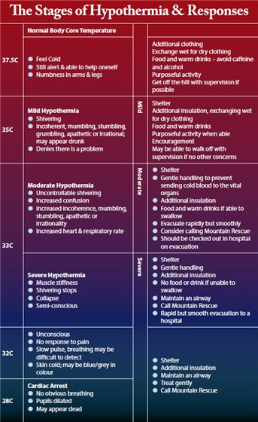

**So, how should we respond to a Hypothermia victim?**  
  
Well first, remember you are the most important person there. Helping others is all very commendable but creating a second victim by getting cold yourself will help no one. Prevent further heat loss by putting on dry clothing, find shelter, insulate from the ground and rewarm the body slowly. Don’t forget to remove wet clothing; the body cools much quicker when wet. Get off the hill if possible. Do not apply direct heat (eg heat pads, standing in front of a fire, sitting on a radiator).   
  
Warm, sweet drinks, high energy food and gels will help replace lost energy and warm from the inside out **if the casualty is able to swallow.** Do not give alcohol or caffeine. Treatment and movements should be gentle as rough handling, rapid movements and vigorous rubbing can cause cold blood to rush to heart and brain. This is likely to cause Ventricular Fibrillation (VF arrest) – otherwise known as a cardiac arrest. If the casualty is unconscious check the air way but if you cannot find a pulse do not attempt resuscitation unless you can keep up CPR until you can get to a hospital. There is a Mountain Rescue adage that a Hypothermic victim is not dead until they are warm and dead. Survival rates from Hypothermia can still be quite high even for those found with no apparent signs of life.   
  
Finally, never underestimate the value of encouragement and a good hug; a positive attitude and shared body heat can make a massive difference to recovery.   
  
**Of course prevention is better than cure.**  
  
Basic physics states that energy can be conserved and converted. In fell running terms that is wearing the right clothes and eating the right foods. Make sure you take on enough food before & during a run. Recognising when you need to take in more food and water, when energy levels are dropping and you are in danger of pushing yourself too far is key, not only to improving performance but, preventing Hypothermia. It’s worth bearing in mind that if you are recovering from an illness particularly cold or flu you are much more susceptible.   
  
Make sure you understand the gradual effects of cold and make allowances for wind chill. Warm, dry clothing is important in staving off both Immersion and Exhaustion Hypothermia. Pay particular attention to the extremities, especially head, neck and hands. When checking for a pulse, it is particularly important to keep these “Arterial” areas warm. They have a high volume of blood, close to the surface of the skin. Think how we instinctively tuck our chins on to our chests and hide in a high collar when it’s cold, but “expose” our necks when it’s warm. These are examples of the body instinctively doing the right thing. 