3.4.6 Biodiversity &
3.7.4 Populations in an Ecosystem
Part 2
Name: _________________________________________
Reflection on Learning outcomes | or | Target
Explain how some common abiotic factors could be measured
Explain what is meant by the carrying capacity of a population, and the biotic and abiotic factors which determine population size
Explain why no two species have exactly the same niche, interpret and analyse experimentally derived data to identify a species niche
Explain how interspecific competition influences population size
Explain what succession is and how succession causes changes to ecosystems over time
Explain how farming techniques impact on biodiversity, and the reason why these techniques are used
Evaluate conservation techniques, and why these must be balanced with farming then use your knowledge and understanding to present scientific
arguments and ideas relating to the conservation of species and habitats
Explain the impact of environmental changes on biodiversity



Outcome:
- Explain how some common abiotic factors could be measured
- Explain what is meant by the carrying capacity of a population, and the biotic and abiotic factors which determine population size
Biodiversity in an ecosystem
Definitions:
Population: ____________________________________________________________________________________
______________________________________________________________________________________________
Abiotic factor: __________________________________________________________________________________
Biotic factor: ___________________________________________________________________________________
Carrying capacity: _______________________________________________________________________________
______________________________________________________________________________________________
Limiting factor: Factor(s) which limit the growth of a population or organism.
Complete the table below to describe the influence of abiotic factors on population size
Abiotic factor | How does it influence population size? (CC = carrying capacity)
Temperature | ______________________________________  Temperature below  Enzyme activity reduced  Metabolic rate reduced  CC is reduced  More energy used to maintain body temp so less energy for growth/reproduction  ______________________________________  ______________________________________  ______________________________________  ______________________________________  _______________________________________
Light intensity (LI) | _____________________________________________________________________________  Light intensity above  Photosynthesis increases  Faster plant growth/reproduction  Greater population size  CC is increased  More food available for other organisms.  _____________________________________________________________________________  _____________________________________________________________________________  _____________________________________________________________________________  _____________________________________________________________________________  _____________________________________________________________________________
pH | _____________________________________________________________________________  pH below  Enzyme activity reduced  Metabolic rate reduced  CC is reduced  Enzymes denatured.  _____________________________________________________________________________  _____________________________________________________________________________  _____________________________________________________________________________  _____________________________________________________________________________  _____________________________________________________________________________
Water and humidity | Water availability reduced.  Populations are reduced, only specially adapted species can live there.  Low Humidity  Increased transpiration rates in plants & evaporation of water from animal’s bodies.

Outcome:
- Explain why no two species have exactly the same niche, interpret and analyse experimentally derived data to identify a species niche
Niche
Definition:
Niche: _________________________________________________________________________________________
Explain a Niche
Organism is adapted to biotic and abiotic factors in the habitat in order to survive, reproduce and maintain population. Some species may appear very similar, but may differ in:
- nesting habits
- behaviour
- tolerance to environmental factors (pollutant, shortage of oxygen or nitrates)
Explain why 2 species never occupy exactly same niche:
- Interspecific competition for factors
- Give example of factor
- One species becomes extinct

Explain what happens when a niche overlap:
- Interspecific competition
- One species/population more successful
- Species extinct/ species separation/ loss of niche/ loss of habitat – Apply to exam question specifics.

Exam questions:
Q1.(a) (i) What is meant by an abiotic factor?
______________________________________________________________(1)
(ii) Do abiotic factors exert a density-dependent or a density-independent effect on a population? Using an example, explain your answer.
Effect ______________________ Explanation ____________________________________________________
______________________________________________________________(1)
(b) Describe how you would collect the necessary data to estimate the size of a population by the mark-release-recapture technique.
___________________________________________________________________
___________________________________________________________________
___________________________________________________________________ (3)
Q2. The vegetation on a large heap of waste from an old mine was investigated. The table shows the results of the measurements of certain factors in 1m² frame quadrats placed on the south-facing slope.
Quadrat | Angle of  slope / ° | Vegetation  cover / % | Moisture  content of  soil / % | pH of  soil
1  2  3  4  5  6 | 45  30  25  12  7  1 | 60  70  68  100  85  100 | 17.2  14.6  20.3  23.5  21.0  21.2 | 5.6  4.2  5.2  7.1  5.4  6.8
(a) Which of the factors measured are abiotic?
___________________________________________________________________(1)
(b) Describe how the investigators could obtain the value for vegetation cover in each quadrat.
___________________________________________________________________
___________________________________________________________________ (2)
(c) The correlation between vegetation cover and soil moisture content was tested statistically. These two factors were found to be positively correlated, and p < 0.05. Explain what this result means.
___________________________________________________________________
___________________________________________________________________(2)
(d) At first the waste heap had no plants growing on it. Some of the first plants to colonise it were small herbaceous plants. Explain one way in which colonisation by herbaceous plants could change the physical environment.
___________________________________________________________________
___________________________________________________________________
___________________________________________________________________(2)
Q3.(a) What term is used to describe populations of different species living in the same habitat?
___________________________________________________________________(1)
(b) Different species occupy different ecological niches. Explain the advantage of species occupying different niches.
___________________________________________________________________(1)
Scientists recorded the number of water beetle species in 30 lakes. In each lake, they measured the pH of the water and recorded whether there were any fish present. The graph shows their results.
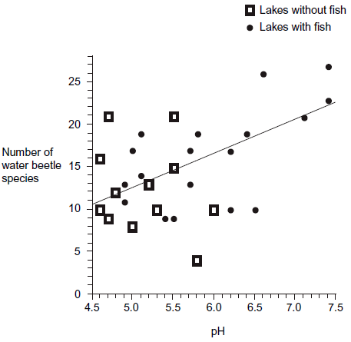
(c) A student concluded that a decrease in acidity caused an increase in the number of water beetle species. Evaluate this conclusion.
___________________________________________________________________
___________________________________________________________________
___________________________________________________________________
___________________________________________________________________ (3)
(d) Explain how the presence of fish in a lake could cause an increase in the number of water beetle species.
___________________________________________________________________
___________________________________________________________________ (1)

Q4. (a) Explain what is meant by the ecological term community
___________________________________________________________________
___________________________________________________________________(1)
(b) Scientists investigated the distribution of three species of fish in a lake. They recorded the range of depths where each species was found. The table shows their results.

Species of fish | Range of depths /m
White bass | 0 to 8.4
Walleye | 6.8 to 10.0
Sauger | 7.2 to 14.6
(i) Use information from the table to give the range of depths at which all three species of fish may be found living together.
Answer ____________________ m (1)
(ii) Suggest and explain one advantage to the fish of occupying different depths in the lake.
______________________________________________________________
______________________________________________________________
______________________________________________________________ (2)
(c) The graph shows the relationship between the depth and the temperature of the water in the lake.
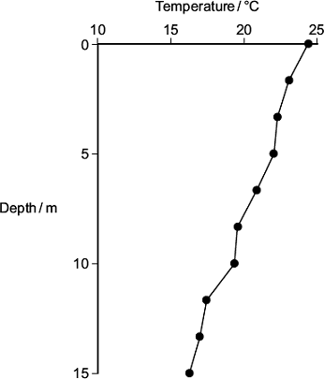
A student concluded that the temperature of the water in the lake determined the depth at which the species of fish were found. Use the table and the graph to evaluate this conclusion.
___________________________________________________________________
___________________________________________________________________(3)
Q5.Mayflies are insects which lay their eggs in streams and rivers. The nymphs which hatch from the eggs live in the water for several years. Mayfly nymphs were collected by disturbing the gravel of a stream bed. A net placed immediately downstream caught any animals which were washed out of the gravel. Eight samples were collected from shallow, fast-flowing parts of the stream and eight from deeper, slow-flowing parts. Nymphs from two different families of mayfly were found. The results are given in the table.
 | Family Caenidae |  | Family Baetidae
 | Shallow water | Deep water | Shallow water | Deep water
Mean number of nymphs | 2.38 | 12.88 | 24.50 | 6.00
Standard deviation | 1.51 | 7.92 | 6.72 | 1.51
(a) Describe how you would have collected the samples in order to ensure they were representative of the habitats being investigated and could be compared with each other.
___________________________________________________________________
___________________________________________________________________
___________________________________________________________________
___________________________________________________________________ (3)
(b) Which one of the four samples showed the greatest variation within the sample? Give evidence from the table for your answer.
___________________________________________________________________
___________________________________________________________________(1)
(c) The two families of mayfly nymph occupy different ecological niches. (i) What is meant by the term ecological niche?
______________________________________________________________
______________________________________________________________(1)
(ii) Describe the evidence in the table which suggests that the two families of mayflies occupy different ecological niches.
______________________________________________________________
______________________________________________________________(1)
(iii) Explain the advantage to these two families of mayflies of occupying different ecological niches.
______________________________________________________________
______________________________________________________________ (2)

Outcome:
- Explain how interspecific competition influences population size
Predator- Prey relationship
Definitions:
Intraspecific competition: _________________________________________________________________________
_______________________________________________________________________________________________
Interspecific competition: _________________________________________________________________________
_______________________________________________________________________________________________

Predator-prey relationships are examples of INTERSPECIFIC competition, with one organism directly affecting the population size of another organism.
https://www.youtube.com/watch?v=rNjPI84sApQ – Video showing an example of predator-prey relationships and how this affects population size.
Exam note: What do you need to remember when describing information/trends/data from a graph/table?
________________________________________________________________________________________________________________________________________________________________
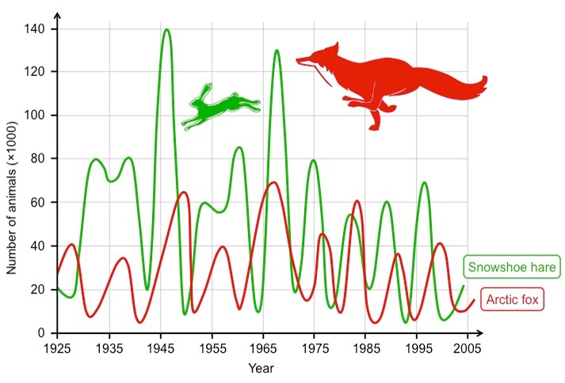
Describe the graph for the snow shoe hare between Explain the changes in population size.
1975 to 1985
____________________________________________________________________________________________________________________________________________________________________________________________________________________________________________________________________________________________________________________________________________________________________________________________
______________________________________________________________________________________________________________________________________________________________________________________________

Exam questions:
Q1.(a) In an investigation, carrot seeds were planted at different densities. After 120 days, the dry mass of the carrot plants was measured. The results are shown in the graph.
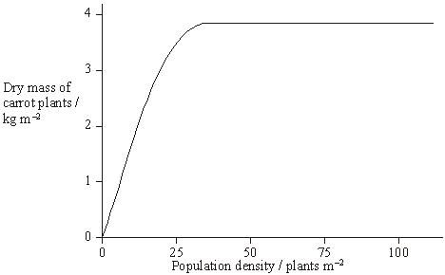
(i) What is the advantage of measuring the dry mass rather than the total mass of the carrot plants?
______________________________________________________________(1)
(ii) What type of competition is shown in this investigation?
______________________________________________________________(1)
(iii) Explain the shape of the curve.
______________________________________________________________
______________________________________________________________
______________________________________________________________(2)
(b) Commercial growers want all the carrots to be the same size when harvested. Suggest two ways in which they can try to ensure this.
1. _________________________________________________________________
___________________________________________________________________
2. _________________________________________________________________
___________________________________________________________________(2)

Q2.Lemmings are small mammals which live in the Arctic. Their main predator is the stoat, a small carnivorous mammal, which feeds almost entirely on lemmings. The graph shows the changes in the numbers of lemmings and stoats from 1988 to 2000.
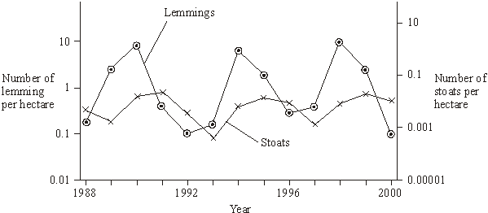
(a) Describe and explain the changes which occur in the lemming and stoat populations.
___________________________________________________________________
___________________________________________________________________
___________________________________________________________________
___________________________________________________________________
___________________________________________________________________
___________________________________________________________________
___________________________________________________________________
___________________________________________________________________
___________________________________________________________________(6)
(b) Lemmings often live in isolated populations. From time to time some lemmings move and join other populations. Explain how this movement is important in maintaining genetic variability in lemming populations which have large fluctuations in size.
___________________________________________________________________
___________________________________________________________________
___________________________________________________________________(2)
(c) James Bay is a large ocean bay in northern Canada. It was formed by the melting of glaciers. One species of lemming inhabits the eastern side of James Bay and another species of lemming inhabits the western side. Before the glaciers melted there was only one species of lemming present. Explain how two species of lemming evolved from the original species.
___________________________________________________________________
___________________________________________________________________
___________________________________________________________________
___________________________________________________________________(4)
Outcome:
- Explain what succession is and how succession causes changes to ecosystems over time
Succession
Ecosystems are dynamic systems so are constantly changing, so Biodiversity is also constantly changing.
Succession is the gradual change in the communities in a particular place. The final community is called the climax community.
Primary succession occurs from bare uncolonized land by pioneer species to climax community. At each stage in succession, new species change the environment becoming less suitable for the previous species.
Secondary succession has been colonised previously but communities have been destroyed
Changes that organisms produce in their abiotic environment can result in a less hostile environment and change biodiversity. Conservation of habitats frequently involves management of succession.
Pioneer species
Role:
- Increases humus/organic content of the soil
- Increases water retention/minerals of soil
- Increases habitats/shelter
- Decreases soil erosion
Features:
- A-sexual reproduction so single organisms can rapidly multiply
- Rapid germination
- Have increased photosynthesis- as no other food available

Primary succession. Stage 1: Pioneer species.

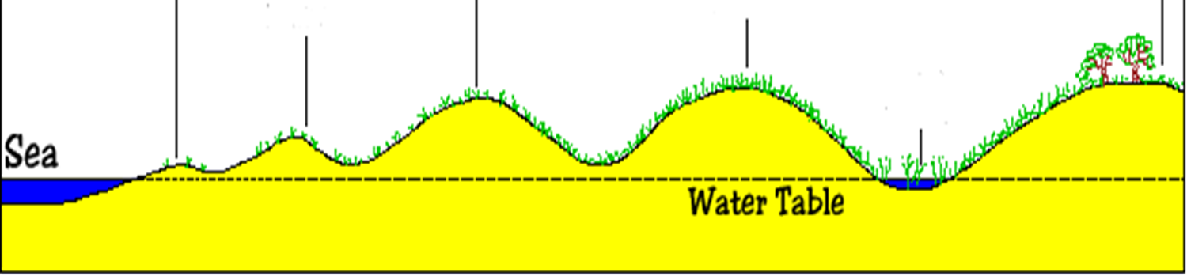
Stage 2:
Stage 3:

Stage 4: Climax community

Exam Questions:
Q1. Ecologists studied a stream community before and after a flood. The flood reduced animal populations in the stream by 98%.The table shows how the populations of six animal species found in the stream changed following the flooding.
Animal species | Number of days after flooding
Animal species | 1 | 5 | 13 | 22 | 35 | 49 | 63
Animal species | Mean number of organisms / thousands m⁻³
Baetis quilleri | 0.03 | 0.85 | 2.6 | 9.3 | 6.4 | 0.9 | 0.3
Leptohyphes packeri | 0.0 | 0.0 | 0.25 | 2.5 | 17.3 | 18.0 | 29.5
Helicopsyche mexicana | 0.0 | 0.02 | 0.2 | 0.1 | 0.07 | 0.03 | 0.01
Cryptolabis paradoxa | 0.0 | 13.3 | 21.3 | 55.8 | 62.9 | 168.7 | 182.6
Pentaneurini guttipennis | 0.1 | 0.5 | 0.6 | 1.8 | 1.0 | 0.6 | 0.25
Micropsectra klinki | 0.0 | 0.0 | 0.0 | 0.0 | 0.0 | 0.2 | 5.6
(a) Explain how the data in the table provides evidence of succession.
___________________________________________________________________
___________________________________________________________________
___________________________________________________________________
___________________________________________________________________
___________________________________________________________________
___________________________________________________________________
___________________________________________________________________(5)
(b) The populations of Cryptolabis paradoxa and Leptohyphes packeri both increased between days 13 and 63. Calculate how many times the population growth per day of Cryptolabis paradoxa is greater than that of Leptohyphes packeri between these days.
Answer = _____________________(2)
(c) The stream eventually recovered to reach a climax community. Give two features of a climax community.
1. _________________________________________________________________
___________________________________________________________________
2. _________________________________________________________________
___________________________________________________________________(2)
Q2.The diagram shows the dominant plants in communities formed during a succession from bare soil to pine forest.
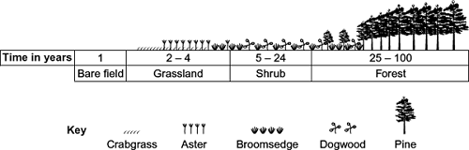
(a) Name the pioneer species shown in the diagram.
___________________________________________________________________(1)
(b) The species that are present change during succession. Explain why.
___________________________________________________________________
___________________________________________________________________
___________________________________________________________________
___________________________________________________________________(2)
(c) The pine trees in the forest have leaves all year. Explain how this results in a low species diversity of plants in the forest.
___________________________________________________________________
___________________________________________________________________(1)

Q3.(a) The diagram shows a number of stages in an ecological succession in a lake.
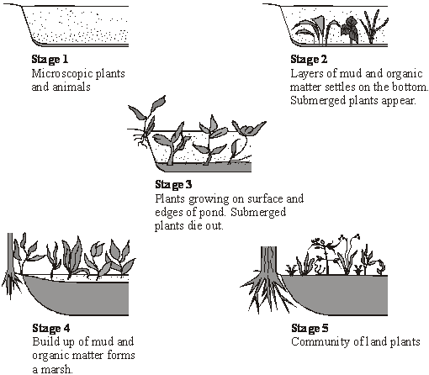
Explain how the diagrams illustrate the features of an ecological succession.
___________________________________________________________________
___________________________________________________________________
___________________________________________________________________
___________________________________________________________________
___________________________________________________________________
___________________________________________________________________
___________________________________________________________________
___________________________________________________________________
___________________________________________________________________(6)
(b) Several small rivers flow into this lake. These rivers flow through forested areas.
Explain how deforestation might affect the process of succession in the lake.
___________________________________________________________________
___________________________________________________________________
___________________________________________________________________(2)
(c) Stage 5 illustrates the final stage of succession which is known as the climax community. During this stage the number of different species in the habitat and the size of each population remain fairly constant. Explain what limits the size of populations in a climax community.
___________________________________________________________________
___________________________________________________________________
___________________________________________________________________
___________________________________________________________________
___________________________________________________________________
___________________________________________________________________
___________________________________________________________________
___________________________________________________________________
___________________________________________________________________ (5)

Outcome:
- Explain how farming techniques impact on biodiversity, and the reasons why these techniques are used.
- Evaluate conservation techniques, and why these must be balanced with farming then use your knowledge and understanding to present scientific arguments and ideas relating to the conservation of species and habitats
- Explain the impact of environmental changes on biodiversity
Conservation, Agriculture and human impacts on Biodiversity
These exam questions are always application questions in the exam, you will need to read the information carefully then draw conclusions from the information/table/graph/data.
Read pages 246-247 and 488 in the Toole and Toole textbook, complete the questions below. These questions are quite open so make sure you fill as much detail as you can.
Human activities can do great damage to the environment. We cut down forests to provide us with wood for building and fuel to burn, or clear the land for housing and agriculture. We pollute the land, air and water, making it impossible for some species to live there.
- Conservation attempts to maintain biodiversity.
- This involves maintaining a variety of different habitats, which between them can support a wider range of species than a single type of habitat could do.
- Conservation frequently involves preventing succession from occurring, or careful management of succession. There is generally more diversity in the stages leading up to the climax community than there is in the final stage.

- Describe the effect of mankind’s desire for low cost food.
________________________________________________________________________________________________________________________________________________________________________________
- Complete the table below
Natural Ecosystem | Agricultural Ecosystem
Longer time to develop
 | Larger number of individuals
 | Smaller number of species
 | Lower Index of Diversity
Controlled by nature
Heavily affected by climate
Higher level of genetic diversity
Many different alleles
 | Pesticides/herbicides/insecticides used to reduce competition.
- Suggest what is meant by biomass? Think back to Energy and Ecosystems booklet
________________________________________________________________________________________________________________________________________________________________________________
- Suggest why “food production in the UK has doubled over the last 40 years”
________________________________________________________________________________________________________________________________________________________________________________
- List 2 practices that have directly reduced species diversity.
________________________________________________________________________________________________________________________________________________________________________________
________________________________________________________________________________________________________________________________________________________________________________
- Suggest what is meant by monoculture
________________________________________________________________________________________________________________________________________________________________________________
- Explain 2 advantages of monocultures to farmers. You must ALWAYS directly reference how the farmer will benefit in your answer, these are NOT general advantages.
________________________________________________________________________________________________________________________________________________________________________________
________________________________________________________________________________________________________________________________________________________________________________
- Suggest 2 disadvantages of monocultures for a natural ecosystem, this is not included in the textbook so you will need to apply your knowledge.
________________________________________________________________________________________________________________________________________________________________________________
________________________________________________________________________________________________________________________________________________________________________________
- List 8 conservation techniques.
________________________________________________________________________________________________________________________________________________________________________________
________________________________________________________________________________________________________________________________________________________________________________
________________________________________________________________________________________________________________________________________________________________________________
- Conservation of all species is important but especially of plant species. Suggest why you think the conservation of different plant species is so important to the plant and the human race. This is your opinion not in the textbook.
________________________________________________________________________________________________________________________________________________________________________________
________________________________________________________________________________________________________________________________________________________________________________

- List the 4 reasons for conservation:-
________________________________________________________________________________________________________________________________________________________________________________
________________________________________________________________________________________________________________________________________________________________________________
- Suggest why conservation often involves managing succession
________________________________________________________________________________________________________________________________________________________________________________
________________________________________________________________________________________
Complete the “conflicting interests” activity on page 489 in the Toole and toole textbook. Once you have completed the activity, check your answers on page 644 at the back of the textbook. Make a note of any important points in your answers above.
Exam questions:
Q1.(a) There are ethical and economic arguments for maintaining biodiversity.
(i) Suggest one ethical argument for maintaining biodiversity.
______________________________________________________________
______________________________________________________________(1)
(ii) Suggest one economic argument for maintaining biodiversity.
______________________________________________________________
______________________________________________________________(1)
Ecologists calculated the percentage of bird species that have become extinct on six islands in the last one hundred years. They also calculated the percentage of original forest area remaining on each island after the same time period. The graph shows their results.
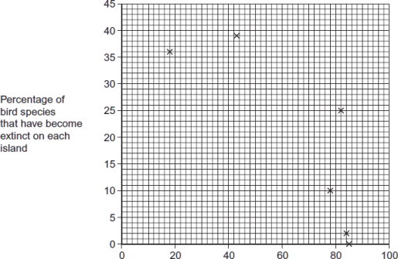
Percentage of original forest area remaining on each island
(b) Explain the relationship between the percentage of original forest area remaining and the percentage of bird species that have become extinct.
___________________________________________________________________
___________________________________________________________________
___________________________________________________________________
___________________________________________________________________(2)
(c) What two measurements would the ecologists have needed to obtain to calculate the index of diversity of birds on each island?
1. _________________________________________________________________
2. _________________________________________________________________(2)
(d) The ecologists noted that the species of birds surviving on the coldest islands had a larger body size than those surviving on warmer islands. Explain how a larger body size is an adaptation to a colder climate
___________________________________________________________________
___________________________________________________________________
___________________________________________________________________(2)
Q2. Woods can be coppiced to provide a continuous supply of useful logs and poles. Coppicing involves cutting down some trees in a wood to leave stumps. New shoots grow from the stumps. After about 15 years, these trees can be coppiced again. Because coppicing produces a wood with patches of light and shade, the diversity of plants and animals in a coppiced wood is high. Ecologists investigated the effect of coppicing on the flowering of wild daffodils growing in a wood in Cumbria. Some areas of the wood were coppiced and some areas were not. The graph shows some results from this investigation.
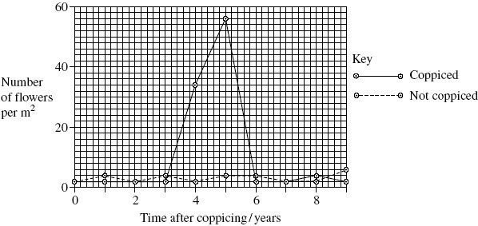
- You could collect data for the coppiced plots by using quadrats.

(i) Describe how you would place the quadrats at random.
______________________________________________________________
______________________________________________________________
______________________________________________________________(2)
(ii) Describe how you would decide the number of quadrats to use in order to collect representative data.
______________________________________________________________
______________________________________________________________
______________________________________________________________(2)
(b) Members of the public visit this wood to see wild daffodils in flower. Explain how the information in the graph could help the owners to manage the wood so that there were many wild daffodils in flower every year.
___________________________________________________________________
___________________________________________________________________
___________________________________________________________________
___________________________________________________________________(2)
(c) The ecologists analysed the relationship between the number of daffodils in flower in the whole wood and data collected from a nearby weather station for the previous year. They used the Spearman rank correlation test. The table shows their results.
Month | Climatic factor | Correlation coefficient | Statistical significance
July | Total rainfall | + 0.65 | significant
August | Total rainfall | + 0.74 | significant
July | Monthly mean temperature | – 0.78 | significant
August | Monthly mean temperature | – 0.65 | significant
The ecologists concluded that a wet, cool summer produces good flowering the following spring. Do you support this conclusion? Use the data in the table to explain your answer.
___________________________________________________________________
___________________________________________________________________
___________________________________________________________________
___________________________________________________________________
___________________________________________________________________(2)

Q3.A hedgerow is a line of shrubs and trees bordering a field, together with the herbaceous plants at their base. In the last 50 years farmers have removed many hedgerows.
(a) Explain two advantages for a farmer of removing hedgerows.
1. _________________________________________________________________
___________________________________________________________________
2. _________________________________________________________________
___________________________________________________________________(2)
(b) In recent years some hedgerows have been replanted. Ground beetles, which are unable to fly, are predators of crop pests. The beetles overwinter in the shelter of grasses at the base of the hedgerow. In some large fields, a permanent strip of grass is left as shown in the diagram.
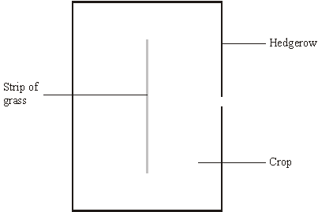
Suggest and explain the advantage of leaving the strip of grass in the middle of the field.
___________________________________________________________________
___________________________________________________________________
___________________________________________________________________
___________________________________________________________________(2)
(c) Apart from providing a habitat for predators of crop pests, give two biological benefits of replanting hedgerows.
1. _________________________________________________________________
___________________________________________________________________
2. _________________________________________________________________
___________________________________________________________________(2)

