3.4.6 Biodiversity &
3.7.4 Populations in an Ecosystem
Part 1 and 2
Name: __TEACHER
Reflection on Learning outcomes | or | Target
Define what is meant by the terms population, community, biotic, abiotic, ecosystem and niche
Explain how some common abiotic factors could be measured
Explain why no two species have exactly the same niche, interpret and analyse experimentally derived data to identify a species niche
Explain what is meant by the terms biodiversity, species richness and index of diversity
Explain what is meant by the carrying capacity of a population, and the biotic and abiotic factors which determine population size
Calculate the index of diversity when supplied with relevant information
Interpret information and draw conclusions from the index of diversity for different habitats
Explain how farming techniques impact on biodiversity, and the reason why these techniques are used
Evaluate conservation techniques, and why these must be balanced with farming then use your knowledge and understanding to present scientific
arguments and ideas relating to the conservation of species and habitats
Explain the techniques of random sampling using quadrats, and systematic sampling using transects and why it is appropriate to use these
Explain how random sampling can be done to avoid bias
Explain what standard deviation is and how it is calculated
Interpret data in terms of means and the overlap of standard deviation bars and apply knowledge of, to draw and explain conclusions
Evaluate the quality of results and reliability of conclusions. Explain how to ensure that estimates and conclusions are reliable.
Describe the different measures of abundance that can be measured
Explain the technique of mark-release-recapture and when it would be appropriate to use this technique
Use given data to calculate the size of a population estimated using the mark-release-recapture method
Explain the assumptions which must be made during mark-release-recapture and why careful consideration must be given to the method used to mark animals
Explain what succession is and how succession causes changes to ecosystems over time
Explain the impact of environmental changes on biodiversity
Outcome:
- Define what is meant by the terms population, community, biotic, abiotic, ecosystem and niche
- Understand the concepts of biodiversity, species richness and index of diversity.

Complete the sort card activity to complete the table below with examples for each definition

Definitions:
Term | Definition | Example
Population | Total number of organisms of one species that occupy the same ecosystem at the same time. | A group of flamingos
Community | All the organisms of all species living and interacting together in the same ecosystem at the same time. | In an oak woodland, there will be oak trees, shrubs, bluebells, nettles, sparrowhawks, ladybirds, woodlice, fungi, bacteria
Abiotic Factors | Non-living factors in a particular area | Temperature, rainfall, pH, soil conditions
Biotic Factors | Living factors in a particular area | Competition, predation, food availability, disease
Ecosystem | All the Abiotic and Biotic factors in a habitat. | Freshwater pond or lake, oak woodland
Niche | Role/position of a species within a habitat | Foxes eat duckling born on the pond.
Biodiversity | The variety of organisms living in an environment | All the different species of animals and plants in a pond ecosystem.
Carrying capacity | The size of population of a species that an ecosystem can support | Every spring, there are many ducklings born on the pond, but the population never increases.
Habitat | Place where an organism lives | Bluetits live in a leaf canopy in a woodland, woodlice live n a decaying log

Biodiversity
There are 3 different types of diversity that you need to understand:
Species Diversity: Number of different species and the number of individuals of each species within any one community
Genetic Diversity: Variety of genes possessed by individuals that make up a population of a species
Ecosystem diversity: Range of different habitats from a small local habitat to the whole of the Earth
Example | Term
Coral reef, lake shore, rock pools, your back garden | Ecosystem
A deer lives in wooden areas | Habitat
The pH of a seashore is very low, it is acidic | Abiotic factor
Daffodils can be white, yellow or orange | Genetic Diversity
There are approximately 10 million different species of animal and plant life in the amazon rainforest | Species Diversity
The pH of wooden areas is very high, it is alkaline | Abiotic.
Scientist need to be able to measure the Biodiversity to check the “health” of an ecosystem/habitat/population.
This can be done by measuring the Species richness or calculating the Index of Diversity.
Definition:
Species richness: Number of different species in a particular area at a given time, in a particular community.
What is the issue with using species richness as a measure of biodiversity?
Species richness is a measure of the number of species not taking into account of number of individuals in the population/community or their abundance.
Calculating Index of DIVERSITY – KEY MATHS COMPONENT
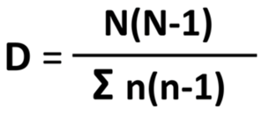
Index of Diversity (D):

N means: Total number of organisms of all species
n means: Total number of organisms of each species/population
∑ means: the sum of.
Why do you think the Index of diversity is a better measure of Biodiversity?
Takes into account the total number of organisms for each different species/population.
Outcome:
- Calculate the index of diversity when supplied with relevant information
- Interpret information and draw conclusions from the index of diversity for different habitats
Follow this procedure – learn HOW to do this equation
- Calculate N. Add up the total number of individuals in the table eg. 100
- Calculate (N-1). Take 1 away from the value eg. 100-1 = 99
- Calculate N (N-1). Multiply those numbers together eg. 100 X 99 =
This is the top half of the equation (value 1)
- Calculate n-1. Look at the numbers for each species in the rows
- Calculate n(n-1).
- Calculate ∑n(n-1). Add up the n(n-1) column.
This value is the bottom half of the equation. (Value 2)
- Finally divide Value 1 by Value 2. The answer must be greater than 1.
Habitat 1: Complete to 3 SF
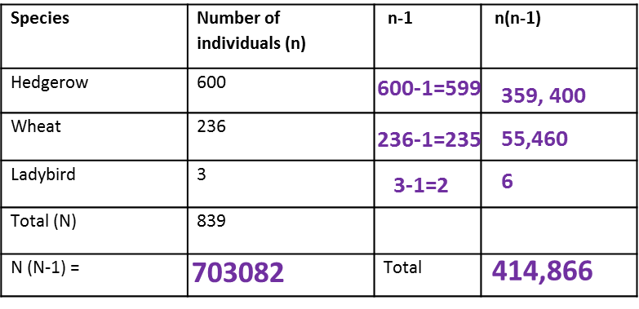
Habitat _1_: D= 1.69

Habitat 2: Complete by applying your knowledge to 3 SF
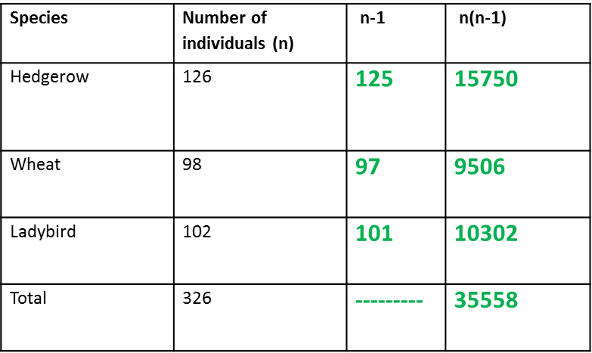
Habitat _2_: D= 2.98

What does this value mean?
The HIGHER the value of D the MORE diverse the habitat. The LOWER the value of D the LESS diverse the habitat.
- Biodiversity reflects how well an ecosystem can survive change in Environmental conditions.
- Stable ecosystems have a high index of diversity
- Stable ecosystems will be less affected by change
- Stable ecosystems are more likely to have at least 1 species that will survive the change in conditions.
What a stable ecosystem, an ecosystem with a high index of diversity, looks like?
- A large variety of different plant and/or animal species.

- No monoculture, all the population sizes are roughly the same
- A large variety of habitats and niches for nesting and feeding
- Large variety of different food sources available

A low/decrease in Index of Diversity would result in a decrease in the factors listed above.
Using your calculated values for habitat 1 and 2 complete the sentences below then apply your knowledge to the exam question.
Terms: A B Larger More Less Smaller
- Habitat _B__ has the highest value and habitat __A_ has the lowest value.
- Habitat __B_ has the most stable ecosystem so will be _Less_____ effected by change in the environmental conditions. Has a ___Larger_______ variety of different plant/animal species, and ___LArger_______ variety of habitats and niches so a ____Larger_________ variety of different food sources available.
- Habitat _A__ has the least stable ecosystem so will be More______ effected by change in the environmental conditions. Has a _smaller_________ variety of different plant/animal species, and _Smaller_________ variety of habitats and niches so a ___Smaller__________ variety of different food sources available.
Exam questions:
Q1.(a) What is meant by species diversity?
(a) Number of species in a community/habitat/area/ecosystem
Accept: species richness
Reject: in a population
(b) Give two pieces of information needed to calculate an index of diversity for a community.
(b) 1. Number of/population of (organisms of) each species;. Accept: ‘species richness’
2. Total number of organisms (of all species) / Total number of species; Idea of grand total of all organisms, not just number of different species

(c) A scientist investigated the effect sewage entering a river had on the distribution of organisms living in the river. Where sewage entered the river, he found a high density of organisms but a low index of diversity. Suggest how sewage entering the river could explain the scientist’s findings.
(c) 1. Described effect of sewage (eg oxygen depletion/is toxic/kills); Accept: eutrophication/description of eutrophication
2. Prevents some/many species colonising/ reproducing/remaining; Accept: only a few species survive
3. Sewage is food source for (individuals of) some/a few/species;
4. (So) increase only in their numbers;
(d) A second scientist repeated the investigation of the first scientist at the same place. The second scientist obtained a high index of diversity. (i) Explain how the second set of results affects the ability of the scientists to make any conclusions about the effect of sewage on the index of diversity.
(d) (i) 1. Results are not repeatable / are not representative / unreliable / conflict / contradict;
Accept: different / don’t agree
Ignore: not valid/not reproducible/inaccurate
2. Can’t make any conclusions;
(ii) Suggest the additional steps that should be taken by the scientists before they are able to make any conclusions about the effect of sewage entering this river.
(ii) Do repeats to find a pattern/distribution/mean (of index of diversity); Need idea of more than one repeat
Accept: use a different technique to obtain more reliable evidence;

Q2.A student investigated the species richness and index of diversity of insects in three different habitats, a barley field, a wheat field and a hedge. Her results are shown in the table below.
 | Number of individuals of each insect species in each habitat
Insect species | Barley field | Wheat field | Hedge
a | 32 | 4 | 34
b | 78 | 0 | 12
c | 0 | 126 | 22
d | 0 | 5 | 12
e | 0 | 0 | 8
f | 0 | 0 | 42
g | 0 | 25 | 13
h | 0 | 10 | 12
i | 0 | 0 | 12
j | 42 | 41 | 0
Species richness | 3 | 6 | 9
Total number of insects (N) | 152 | 211 | 167
(a) Complete the table for species richness and the total number of insects of each habitat. (2)
(b) Calculate the index of diversity of the wheat field.
Use the following formula:
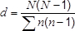
where N = total number of organisms
and n = total number of organisms of each species.

(b) 2.45

Use of the correct denominator = 1 mark

2
(c) The index of diversity of the insects was higher in the hedge than in the barley field. Suggest why.

(c) 1. More plant species;

2. More food sources / variety of food;

3. More habitats / niches;

Allow converse for barley field

More food = neutral
Q3.A student investigated the distribution of plants in a heathland. The table below shows the number of plants he found in a sample area of 1 m².
Species of plant | Number counted in  1 m²
Common heather | 2
Red fescue | 14
Vetch | 2
White clover | 8

(a) | What is the species richness of this sample? 4:

(b) Calculate the index of diversity of this sample. Show your working.
Use the following formula to calculate the index of diversity.
d = 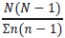
where N is the total number of organisms of all species
and n is the total number of organisms of each species

2.68(6).

If answer incorrect:
Σn(n-1) = 242 = 1 mark

N(N-1) = 650 = 1 mark
(c) Suggest how this student would obtain data to give a more precise value for the index of diversity of this habitat.

1. Take more samples and find mean;

2. Method for randomised samples described.

Allow larger area = 1 mark

Q4. The UK government pays farmers to leave grassy strips around the edges of fields of crops. These grassy strips contain a variety of plant species. Leaving the strips is an attempt to encourage biodiversity of animals.
(a) Give two reasons why the grassy strips increase the biodiversity of animals.

(a) Any two valid reasons; e.g.

1. Increase in plant diversity leads to more types of food for animals;

2. Increase in variety of animals leads to increase in predator species;

3. Increase in niche / habitat
A group of scientists investigated the effect of grassy strips on the biodiversity of soil animals.
  - They divided a field into plots measuring 25 m × 5 m, with a 5-metre-wide grassy strip of land between each plot.
  - Each year, they planted wheat in each of the plots.
  - In the fifth year, they removed samples of soil from each plot where wheat was growing and from the grassy strips around them.
  - They sorted each soil sample by hand for 40 minutes to collect the soil animals within the sample.
(c) The table below shows how the scientists published their results. They calculated mean values and two times the standard deviation (SD) of the mean. Two standard deviations above and below the mean includes 95.4% of the data.

Group of animals | Mean number of animals per m²  (± 2 × SD) |  | Mean number of species per m²  (± 2 × SD)
Group of animals | Soil under wheat crop | Soil under grassy strips | Soil under wheat crop | Soil under grassy strips
Beetles | 41.2 (± 6.4) | 80.1 (± 10.1) | 10.0 (± 1.6) | 17.3 (± 1.0)
Centipedes | 18.4 (± 3.6) | 13.5 (± 1.0) | 1.8 (± 0.3) | 2.1 (± 0.2)
Earthworms | 244.5 (± 27.1) | 281.2 (± 39.4) | 3.8 (± 0.3) | 5.1 (± 0.2)
Millipedes | 38.4 (± 12.2) | 36.2 (± 2.9) | 3.5 (± 0.3) | 3.2 (± 0.2)
Woodlice | 0.0 | 73.9 (± 8.5) | 0.0 | 2.8 (± 0.2)
It would not be possible to calculate an index of diversity from the results in the table. Explain why.

(c) 1. No data on number of individuals in each

species / diversity index 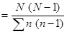

1
(d) A summary of this research was published in a farming magazine. The journalist concluded that creating grassy strips around fields had little effect on the diversity of soil animals. Do you agree with this conclusion? Use evidence from the table to justify your answer.

(d) Principle:

1. Overlap of 2 × SD shows probability of differences (in means) being due to chance is greater than 0.95;

Allow converse of MP1

Credit MP1 wherever it appears

Agree:

2. No difference in number of earthworms and millipedes (per m²)

3. No difference in number of species of centipedes or millipedes.

Disagree:

4. More beetles and woodlice in grassy strips;
5. More species of beetles, earthworms, woodlice in grassy strips

Key points to use when answering conclusion questions in the exam:

Outcome:
- Explain the techniques of random sampling using quadrats, and systematic sampling using transects and why it is appropriate to use these
- Explain how random sampling can be done to avoid bias
- Describe the different measures of abundance that can be measured
- Explain the technique of mark-release-recapture and when it would be appropriate to use this technique
- Use given data to calculate the size of a population estimated using the mark-release-recapture method
- Explain the assumptions which must be made during mark-release-recapture and why careful consideration must be given to the method used to mark animals
The data above is used to make conclusions about different habitats, it informs ecologists of the stability of ecosystems throughout the world and allows ecologists to track how ecosystems are changing over time. This is quite a difficult task for ecologists though as living organisms are so different and can often move/change with the change of the seasons or an ecosystem can be very large and uniform eg the oceans. To try to make data collected comparable ecologists collect data by sampling.
Definition:
Random Sampling: Reduced human bias, results are representative of whole area
Sampling bias: The selector may be influencing the area/organisms within the habitat that are being sampled. Random sampling aims to reduce this

Chance: How likely an event can occur. Humans can influence chance by introducing bias to results.

How to carry out random sampling:
If the area is large and uniform with no clear pattern/species you would use random sampling because it is important that your results are unbiased and representative of the whole area. This is an explain question.
Method:
- Set up a grid axis using 2 tape measures at right angles to each other,
- each metre is a marker.
- Using a random number generator select two numbers at random and use these numbers as co-ordinates.
- At these co-ordinates place a frame quadrat.
- Organisms are identified using a key, animals can be counted/collected to give information on abundance, absence or presence of species.
- Repeat procedure at different times of the day, seasons, month etc.
- Collect data on % cover using a frame quadrat

Why is it best to carry out random sampling?
It is difficult to eliminate human bias altogether but we can put steps into place which include: (these are also advantages of carrying out random sampling)
- Use a large sample size. This will reduce the influence of chance and anomalies and allow you to calculate a mean which makes your results more precise

- Analyse the data collected to determine the influence of chance on the data collected. Carry out statistical tests to make your results more valid.

- Use random sampling instead of systematic sampling. Random sampling reduces human bias .

How to carry out Systematic Sampling
This is used where there is a gradual change in the communities of plants and animals takes place e.g. it may be apparent that the species growing in the meadow gradually change as you move from a dry part to a wetter part, or from the meadow into the edge of adjoining woodland. Sampling is done along a LINE that runs through these changing areas to identify change in species present.
Method:
- To monitor change along a habitat/area (environmental gradient).
- Place a line or belt transect across length of area,
- Quadrat is placed at regular intervals eg every metre.
- Organisms are identified using a key, animals can be counted/collected to give information on abundance, absence or presence of species.
- Repeat procedure at different times of the day, seasons, month etc.
How to work out percentage cover when randomly sampling plants.
- Split quadrat into equal number of squares,
- Work out % represented by each square by dividing 100% by the number of squares into the quadrat eg 25 squares would be 100/25 = 4% for each square,
- If a plant covers a whole square = 4%, if the plant covers half the square = 2%, if the plant covers a quarter of the square = 1%.
- Then add all the squares together to work out the total % cover of the plant within the whole quadrat
This is one method for working out the abundance of a plant species.
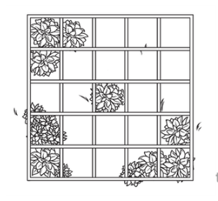

ACFOR scale when randomly sampling plants
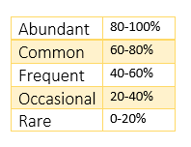
Draw out the method for Random sampling, systematic sampling, % cover and the ACFOR scale. Remember to add labels.

Mark Release recapture method when randomly sampling animals
Method:
- Catch a sample of animals and count them
- Mark each one
- Release back into habitat
- Leave for 1-2 days so they can mix
- Catch a second sample
- Count the total, and the number which are marked
- Then use the following equation
Total numbers of animals in a population = Number in sample 1 x Number in sample 2
Number of marked animals in sample 2
Worked example: Gypsy moth populations soar every few years in North Eastern deciduous forests, causing great damage to the trees their larvae ear. In order to determine the population of gypsy moths in a forest, 200 were trapped, marked and released. The next night, more moths were collected. Of the 150 that were collected, 15 were already marked. What is the population of gypsy moths in the forest?
Sample size 1: 200
Sample size 2: 150
Marked in 2nd sample: 15
Calculations:
200 x 150 / 15 2000
- In order to determine snail populations, 340 snails were captured tagged and released. Later, 420 snails were captured. Of the 420 snails, 16 were already marked. What is the size of the snail population? Show your working
340 x 420 = 8925
16
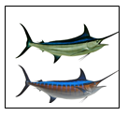
- 150 Marlin were captured, tagged and returned to the deep ocean, where they live. Later, when 140 Marlin were captured, 7 of the Marlin has tags. What is the size of the Marlin population? Show your working.
150 x 140 = 3000
7
6 assumptions must be correctly followed for the Mark release recapture calculation to be accurate
- Marked individuals between sample 1 and 2 are proportional
- Marked individuals from sample 1 distribute evenly
- No immigration or emigration
- Few births/death in population
- Marking not toxic or conspicuous
- Marking not lost/damaged
Exam questions:
Q1.Ecologists investigated the size of an insect population on a small island. They used a mark-release-recapture method. To mark the insects they used a fluorescent powder. This powder glows bright red when exposed to ultraviolet (UV) light.
(a) The ecologists captured insects from a number of sites on the island. Suggest how they decided where to take their samples.
1. Draw grid over (map of) area;
2. Select squares / coordinates at random.

(b) Give two assumptions made when using the mark-release-recapture method.
1. No emigration / immigration;
2. No losses to predation;
3. Marking does not affect survival;
4. Birth rate and death rate equal;
5. (In this case) all belong to one population.

(c) Suggest the advantage of using the fluorescent powder in this experiment.
1. Only glows brightly with UV, so doesn’t make insects more visible;
2. So doesn’t affect / increase predation;
OR
1. Glows brightly with UV marking visible;
2. So makes it easy to pick out labelled insects.
The ecologists did not release any of the insects they captured 1–5 days after release of the marked insects.The table below shows the ecologists’ results.

Days after  release | Number of marked  insects remaining  in population | Number of insects  captured | Number of  captured insects  that were marked
1 | 1508 | 524 | 78
2 | 1430 | 421 | 30
3 | 1400 | 418 | 18
4 | 1382 | 284 | 2
5 | 1380 | 232 | 9
(d) Calculate the number of insects on this island 1 day after release of the marked insects. Show your working.
10 130.
Tolerance of ±1
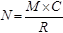 = 1 marks
(e) The ecologists expected to obtain the same result from their calculations of the number of insects on this island on each day during the period 1–5 days after release. In fact, their estimated number increased after day 1. During the same period, the number of insects they caught decreased.
The method used by the ecologists might have caused these changes. Use the information provided to suggest one way in which the method used by the ecologists might have caused the increase in their estimates of the size of the insect population.
1. Scientists removed large numbers of insects (which were not returned) from same area / same population;
2. Affecting ratio of marked to unmarked.

Q2.(a) A student investigated the diversity of plants at several sites on a golf course. At each site she took a large number of random samples.
(i) Explain the importance of taking a large number of samples at each site.
(a) (i) Produces a more reliable mean / average / makes sure sample was representative / reduce effect of extreme values / identify anomalies;
Ignore references to chance
1
(ii) Explain the importance of taking samples at random.
Removes bias
The student collected data from one part of the golf course and calculated an index of diversity. The table shows her data.

Species | Number of  plants per m²
Sheep’s fescue | 11
Creeping buttercup | 6
Clover | 5
Dandelion | 2
Sheep’s sorrel | 1
Lady’s bedstraw | 7
Stemless thistle | 4
The index of diversity can be calculated from the formula
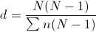
where
d = index of diversity
N = total number of organisms of all species
n = total number of organisms of each species
(b) Use the formula to calculate the index of diversity for the plants on this part of the golf course. Show your working.
Two marks for correct answer of 5.8;
One mark for incorrect answer that clearly shows denominator as 216;
2

(c) The golf course was surrounded by undeveloped grassland from which it had been produced.
The golf course had
• some areas of very short grass which was cut frequently
• some areas of longer grass which was cut less frequently
• some areas of long grass and shrubs which were never cut.
The index of diversity for the insects on the golf course was higher than that for the surrounding undeveloped grassland. Explain the effect of developing this golf course on the index of diversity of insects.
(c) 1. Increase in variety of plants / shrubs / grass;
2. More habitats / niches;
3. Greater variety of food sources / more food sources;
3
Q3. Dengue is a serious disease that is caused by a virus. The virus is carried from one person to another by a mosquito, Aedes aegypti. One method used to try to reduce transmission of this disease is the Sterile Insect Technique (SIT). This involves releasing large numbers of sterile (infertile) male A. aegypti into the habitat. These males have been made infertile by using radiation.
(a) Explain how using the SIT could reduce transmission of dengue.
1. Compete (with fertile males) to mate / for food / resources
OR
intraspecific competition;
2. Do not reproduce / breed
OR
Reduces population (of mosquitoes);
1. Must convey idea of competition.
2. Accept: ‘fewer mosquitoes’ / ‘fewer offspring’.
(b) Describe how the mark-release-recapture method could be used to determine the population of A. aegypti at the start of the investigation.
(b) 1. Capture / collect / sample, mark and release;
2. Leave time for mosquitoes / Aedes to disperse before second sampling / collection;
3. (Population =) number in first sample × number in second sample divided by number of marked in second sample / number recaptured;
3. Accept: correct equation.
(c) The release of radiation-sterilised A. aegypti has not been very successful in controlling the transmission of dengue. Suggest one reason why.
(c) (Radiation) affects their ‘attractiveness’ / courtship / survival / life span;
Accept: ‘die / less likely to survive due to radiation’.
Accept: ‘disease can be transmitted by other means’ (other than mosquitoes).

(d) Recently a new method was developed to control A. aegypti. Scientists produced transgenic males carrying a ‘lethal gene’ which kills their offspring before they can reproduce. The scientists released transgenic males every week in one area of a city in Brazil. At regular intervals they determined the number of A. aegypti per km² in the area where transgenic males were released and in a control area where no transgenic males were released.
The graph shows their results.
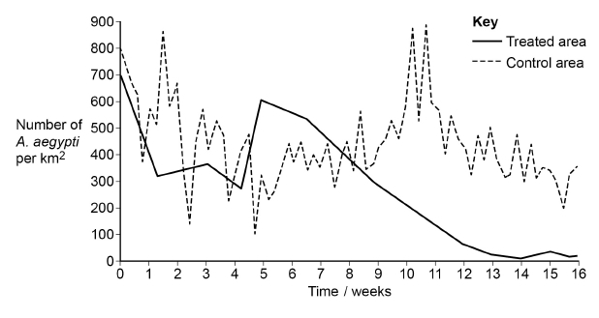
Suggest why the scientists released more transgenic males every week.
To maintain number / competition as they die / have a short life span;
Accept: to replace mosquitoes that have died.
(e) The release of transgenic males proved successful in reducing the number of A. aegypti.
Describe how the results in the diagram above support this conclusion.
1. Number (of mosquitoes in treated area) is low / lower at / after 12/13/14/15/16 weeks = 2 marks;
2. For one mark accept number (of mosquitoes in treated area) is low/lower without reference to relevant week;
Accept: amount for number.
Accept: comparison of numbers (of mosquitoes) for lower/low.
2

Outcome:
- Explain how some common abiotic factors could be measured
- Explain what is meant by the carrying capacity of a population, and the biotic and abiotic factors which determine population size
Biodiversity in an ecosystem
Definitions:
Population: Total number of organisms of one species that occupy the same ecosystem at the same time

Abiotic factor: Non-living factors in a particular area
Biotic factor: Living factors in a particular area
Carrying capacity: The size of population of a species that an ecosystem can support

Limiting factor: Factor(s) which limit the growth of a population or organism.

Complete the table below to describe the influence of abiotic factors on population size
Abiotic factor | How does it influence population size? (CC = carrying capacity)
Temperature | ______________________________________  Temperature above  Enzyme activity increased  Metabolic rate increased  CC is increased  More energy for growth/reproduction  If temp too high causes denaturation and death  Temperature below  Enzyme activity reduced  Metabolic rate reduced  CC is reduced  More energy used to maintain body temp so less energy for growth/reproduction  ______________________________________  ______________________________________  ______________________________________  ______________________________________  _______________________________________
Light intensity (LI) | _____________________________________________________________________________  Light intensity below  Photosynthesis decreases  slower plant growth/reproduction  smaller population size  CC is decreased  less food available for other organisms.  Light intensity above  Photosynthesis increases  Faster plant growth/reproduction  Greater population size  CC is increased  More food available for other organisms.  _____________________________________________________________________________  _____________________________________________________________________________  _____________________________________________________________________________  _____________________________________________________________________________  _____________________________________________________________________________
pH | _____________________________________________________________________________  pH below  Enzyme activity reduced  Metabolic rate reduced  CC is reduced  Enzymes denatured.  pH below  Enzyme activity reduced  Metabolic rate reduced  CC is reduced  Enzymes denatured.  _____________________________________________________________________________  _____________________________________________________________________________  _____________________________________________________________________________  _____________________________________________________________________________  _____________________________________________________________________________
Water and humidity | Water availability reduced.  Populations are reduced, only specially adapted species can live there.  Low Humidity  Increased transpiration rates in plants & evaporation of water from animal’s bodies.
Outcome:
- Explain why no two species have exactly the same niche, interpret and analyse experimentally derived data to identify a species niche
Niche
Definition:
Niche: Role/position of an organism in the habitat
Explain a Niche
Organism is adapted to biotic and abiotic factors in the habitat in order to survive, reproduce and maintain population. Some species may appear very similar, but may differ in:
- nesting habits
- behaviour
- tolerance to environmental factors (pollutant, shortage of oxygen or nitrates)
Explain why 2 species never occupy exactly same niche:
- Interspecific competition for factors
- Give example of factor
- One species becomes extinct

Explain what happens when a niche overlap:

- Interspecific competition
- One species/population more successful
- Species extinct/ species separation/ loss of niche/ loss of habitat – Apply to exam question specifics.

Exam questions:
Q1.(a) (i) What is meant by an abiotic factor?
the non-living / physical part (of an ecosystem / environment);__ _(1)
(ii) Do abiotic factors exert a density-dependent or a density-independent effect on a population? Using an example, explain your answer.
Effect __ Explanation density-independent, with named abiotic factor and a specific effect

(b) Describe how you would collect the necessary data to estimate the size of a population by the mark-release-recapture technique.
capture, count and release;
carefully mark to avoid detection;
recapture, count marked and unmarked
Q2. The vegetation on a large heap of waste from an old mine was investigated. The table shows the results of the measurements of certain factors in 1m² frame quadrats placed on the south-facing slope.
Quadrat | Angle of  slope / ° | Vegetation  cover / % | Moisture  content of  soil / % | pH of  soil
1  2  3  4  5  6 | 45  30  25  12  7  1 | 60  70  68  100  85  100 | 17.2  14.6  20.3  23.5  21.0  21.2 | 5.6  4.2  5.2  7.1  5.4  6.8
(a) Which of the factors measured are abiotic?
(b) Describe how the investigators could obtain the value for vegetation cover in each quadrat.
system for subdividing quadrat into, e.g. many squares;
method of estimating cover in small squares, e.g. counting those where cover over 50%, or cover at points (of intersection);
(not just ‘count squares with vegetation’ unless very small)
(c) The correlation between vegetation cover and soil moisture content was tested statistically. These two factors were found to be positively correlated, and p < 0.05. Explain what this result means.
increasing vegetation cover is related to increasing moisture content
(allow ‘affects‘ moisture content or vice versa, not ‘causes);
correlation is significant / not due to chance / can reject null hypothesis
/ only 1 in 20 / 5% probability that the correlation is due to chance;
(d) At first the waste heap had no plants growing on it. Some of the first plants to colonise it were small herbaceous plants. Explain one way in which colonisation by herbaceous plants could change the physical environment.
factor; and linked effect e.g.
wind-blown particles trapped;
accumulation of soil;
OR
accumulation of organic / dead / decomposed matter / humus;
increase in mineral ions / improved water retention / improved
soil structure;
Q3.(a) What term is used to describe populations of different species living in the same habitat?
Community
(b) Different species occupy different ecological niches. Explain the advantage of species occupying different niches.
(Less) competition for food/resource;
Ignore: competition for niche/habitat.
Accept: space/named resource.
Reject: intraspecific competition.
Scientists recorded the number of water beetle species in 30 lakes. In each lake, they measured the pH of the water and recorded whether there were any fish present. The graph shows their results.
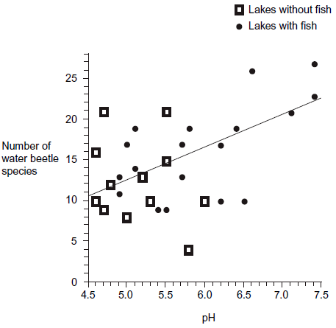
(c) A student concluded that a decrease in acidity caused an increase in the number of water beetle species. Evaluate this conclusion.
1. Correlation but does not mean a causal effect;
Ignore: positive/ negative (correlation).
2. Other abiotic/biotic/named factor involved;
Accept: due to presence/absence of fish.
Reject: ‘other factors’ unless further qualified.
3. Variation in numbers of beetles species at same/similar particular pH;
Accept: same number of beetles at different pHs.
Accept: ‘scattered results’ / ‘anomalies’ / ‘spread of results’.
4. Large sample;
(d) Explain how the presence of fish in a lake could cause an increase in the number of water beetle species.
Fish feed on predator/consumer of water beetle;
Accept: beetles feed on fish/faeces.
Q4. (a) Explain what is meant by the ecological term community
(a) All / group of species / all / group of populations / all the organisms;
Accept equivalent terms for group. Answers which only refer to organisms must have idea of all the organisms not just a group of organisms
Reject answers which include ‘environment’ or abiotic factors as part of the definition
(b) Scientists investigated the distribution of three species of fish in a lake. They recorded the range of depths where each species was found. The table shows their results.
Species of fish | Range of depths /m
White bass | 0 to 8.4
Walleye | 6.8 to 10.0
Sauger | 7.2 to 14.6
(i) Use information from the table to give the range of depths at which all three species of fish may be found living together.
Answer 7.2 - 8.4 (metres);
Accept answer of 1.2
(ii) Suggest and explain one advantage to the fish of occupying different depths in the lake.
1. Food / prey / oxygen;
Do not accept ‘resource’ for mark point 1 unless this is qualified as food / prey / oxygen
2. Less / no competition;
Reference to light and CO₂ as a resource negates mark point 2
Ignore intraspecific / interspecific for mark point 2
(c) The graph shows the relationship between the depth and the temperature of the water in the lake.
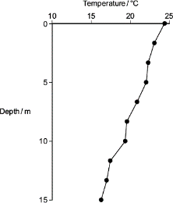A student concluded that the temperature of the water in the lake determined the depth at which the species of fish were found. Use the table and the graph to evaluate this conclusion.
1. Increase in depth linked to decrease in temperature / decrease in depth linked to increase in temperature;
Accept increase or decrease in temperature is related to ‘higher depth’ or ‘lower depth’ due to ambiguity of these terms
2. Correlation / relationship between temperature and fish distribution does not indicate a causal effect;
Ignore any reference to correlation unless it is clearly in context of temperature and fish distribution
3. Overlap in ranges / different fish / species occupy same depth;
Temperature does not determine fish distribution is not sufficient for idea of causal effect
4. Other abiotic / biotic / named factor involved;
Reject: ‘casual’ for mark point 2
Reject ‘other factors’ for mark point 4 unless further qualified
Q5.Mayflies are insects which lay their eggs in streams and rivers. The nymphs which hatch from the eggs live in the water for several years. Mayfly nymphs were collected by disturbing the gravel of a stream bed. A net placed immediately downstream caught any animals which were washed out of the gravel. Eight samples were collected from shallow, fast-flowing parts of the stream and eight from deeper, slow-flowing parts. Nymphs from two different families of mayfly were found. The results are given in the table.
 | Family Caenidae |  | Family Baetidae
 | Shallow water | Deep water | Shallow water | Deep water
Mean number of nymphs | 2.38 | 12.88 | 24.50 | 6.00
Standard deviation | 1.51 | 7.92 | 6.72 | 1.51
(a) Describe how you would have collected the samples in order to ensure they were representative of the habitats being investigated and could be compared with each other.
Samples collected at random;
Method for choosing random sites – random coordinates / position from tables / calculator / other suitable means;
Other named factor constant e.g.:
Same size of net / same width of opening of net / use of one quadrat / Quadrats of same size / of stated size / same area disturbed / collect each Sample for same time;
(b) Which one of the four samples showed the greatest variation within the sample? Give evidence from the table for your answer.
Caenidae in deep water – because highest standard deviation / ‘S.D.= 7.92’
(c) The two families of mayfly nymph occupy different ecological niches. (i) What is meant by the term ecological niche?
An organism’s role / in the ecosystem / community; [ALLOW refs. To trophic levels / named]
(IGNORE refs. To habitat)
(ii) Describe the evidence in the table which suggests that the two families of mayflies occupy different ecological niches.
Caenidae found mainly in deep water AND Baetidae in shallow water / one family mainly in deep water AND the
other in shallow water;
(iii) Explain the advantage to these two families of mayflies of occupying different ecological niches.
Reduces competition for named factor – e.g. food / shelter / O₂ ;
To ensure both types survive / otherwise better adapted type displaces other type;
OR
Ref. to ‘Competitive exclusion principle’ = 2 marks
Outcome:
- Explain how interspecific competition influences population size
Predator- Prey relationship
Definitions:
Intraspecific competition: Between organisms of the same species for the same resource
Interspecific competition: Between organisms of different species for the same resource

Predator-prey relationships are examples of INTERSPECIFIC competition, with one organism directly affecting the population size of another organism.
https://www.youtube.com/watch?v=rNjPI84sApQ – Video showing an example of predator-prey relationships and how this affects population size.
Exam note: What do you need to remember when describing information/trends/data from a graph/table?
- Quote the title of BOTH axis
- Comment on all GRADIENTS
- Quote data from beginning to end of the gradient

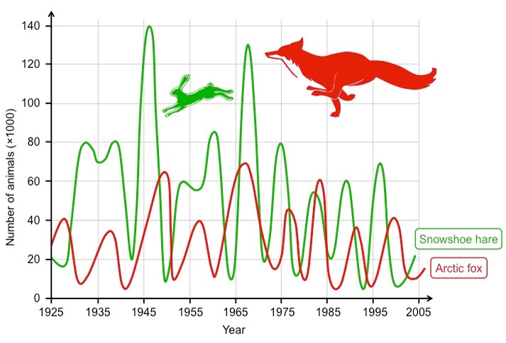

Describe the graph. Explain how the graphs shows the affect on populations
The decrease in snowshoe hare population is due to an increase in artic fox population.
The predator population has increased so will need more food to sustain the population growth.
Increase in predation and a decrease in prey causes the predator population to also decrease in the following years.
A decrease in the predator population means a decrease in predation so an increase in prey population.

Between 1975 to 1977 the snowshoe hare population decreases in a steep gradient from 80,000 to 10,000.
Between 1977-1981 the population increases in a steep gradient from 10,000 to 55,000
From 1981 onwards the population decreases to 20,000.

____________________________________________________________________________________________________________________________________________________________________________________________________________________________________________________________________________________________________________________________________________________________________________________________
______________________________________________________________________________________________________________________________________________________________________________________________

Exam questions:
Q1.(a) In an investigation, carrot seeds were planted at different densities. After 120 days, the dry mass of the carrot plants was measured. The results are shown in the graph.
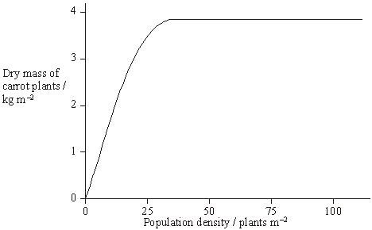
(i) What is the advantage of measuring the dry mass rather than the total mass of the carrot plants?
true indication of growth / water mass may vary
(ii) What type of competition is shown in this investigation?
intraspecific
(iii) Explain the shape of the curve.
the denser the planting the greater the yield;
above a planting density of approx 30 competition for named resource / named limiting factor / population density
not limiting
(accept nutrients / space reject food)
(b) Commercial growers want all the carrots to be the same size when harvested. Suggest two ways in which they can try to ensure this.
)use genetically identical plants / clones / asexual reproduction / tissue culture;
maintain identical environmental conditions / named condition;
reference to density of planting;1
2 max

Q2.Lemmings are small mammals which live in the Arctic. Their main predator is the stoat, a small carnivorous mammal, which feeds almost entirely on lemmings. The graph shows the changes in the numbers of lemmings and stoats from 1988 to 2000.

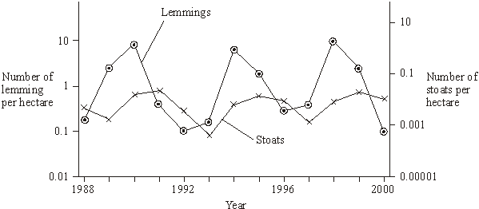
(a) Describe and explain the changes which occur in the lemming and stoat populations.
(a) 1 4 year cycles;
2 predator / stoat peaks after prey / lemming;
3 lemmings increase due to low numbers of stoats / available food;
4 more food for stoats so numbers increase;
5 increased predation reduces number of lemmings;
6 number of stoats decreases due to lack of food / starvation;
6
(b) Lemmings often live in isolated populations. From time to time some lemmings move and join other populations. Explain how this movement is important in maintaining genetic variability in lemming populations which have large fluctuations in size.
(b) smaller populations have fewer different alleles / more homozygosity / less
heterozygosity / smaller gene pool / lower genetic variability;
migrants bring in new alleles / increase gene pool;
(c) James Bay is a large ocean bay in northern Canada. It was formed by the melting of glaciers. One species of lemming inhabits the eastern side of James Bay and another species of lemming inhabits the western side. Before the glaciers melted there was only one species of lemming present. Explain how two species of lemming evolved from the original species.
(c) geographical isolation of populations;
variation present in population(s);
different environmental conditions / different selection pressures / different
phenotypes selected;
change in genetic constitution of populations / gene pools / allele frequency;

Outcome:
- Explain what succession is and how succession causes changes to ecosystems over time
Succession
Ecosystems are dynamic systems so are constantly changing, so Biodiversity is also constantly changing.
Succession is the gradual change in the communities in a particular place. The final community is called the climax community.
Primary succession occurs from bare uncolonized land by pioneer species to climax community. At each stage in succession, new species change the environment becoming less suitable for the previous species.
Secondary succession has been colonised previously but communities have been destroyed
Changes that organisms produce in their abiotic environment can result in a less hostile environment and change biodiversity. Conservation of habitats frequently involves management of succession.
Pioneer species
Role:
- Increases humus/organic content of the soil
- Increases water retention/minerals of soil
- Increases habitats/shelter
- Decreases soil erosion
Features:
- A-sexual reproduction so single organisms can rapidly multiply
- Rapid germination
- Have increased photosynthesis- as no other food available

Primary succession. Stage 1: Pioneer species.
Hostile-More alkaline

Less organic matter
Less habitat variety
Less food soucrs
Low species richness/diversity
Hostile, abiotic factors
Pioneer species
Adapted to hostile enviro

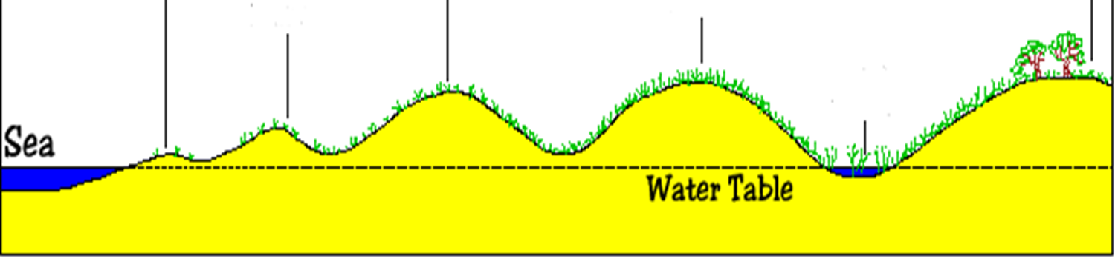
Stage 2:
Increases humus/organic content of the soil
Increases water retention/minerals of soil
Increases habitats/shelter
Decreases soil erosion

Low species richness/diversity
More organic content due to decomp plant/animals
More habitat variety
More food sources
Increased species diversity
Outcompete pioneer species so more likely to survive

Less Hostile
Stage 3:
N fixing bacteria
Greater water retention
More stable
More humus

Stage 4: Climax community
Greater biodiversity
Greater biomass

Exam Questions:
Q1. Ecologists studied a stream community before and after a flood. The flood reduced animal populations in the stream by 98%.The table shows how the populations of six animal species found in the stream changed following the flooding.
Animal species | Number of days after flooding
Animal species | 1 | 5 | 13 | 22 | 35 | 49 | 63
Animal species | Mean number of organisms / thousands m⁻³
Baetis quilleri | 0.03 | 0.85 | 2.6 | 9.3 | 6.4 | 0.9 | 0.3
Leptohyphes packeri | 0.0 | 0.0 | 0.25 | 2.5 | 17.3 | 18.0 | 29.5
Helicopsyche mexicana | 0.0 | 0.02 | 0.2 | 0.1 | 0.07 | 0.03 | 0.01
Cryptolabis paradoxa | 0.0 | 13.3 | 21.3 | 55.8 | 62.9 | 168.7 | 182.6
Pentaneurini guttipennis | 0.1 | 0.5 | 0.6 | 1.8 | 1.0 | 0.6 | 0.25
Micropsectra klinki | 0.0 | 0.0 | 0.0 | 0.0 | 0.0 | 0.2 | 5.6
(a) Explain how the data in the table provides evidence of succession.
(a) 1. (Overall, data show an) increase in species richness / increase in species diversity / increase in total number of living organisms;
2. Baetis quilleri and / or Pentaneurini guttipennis are pioneers;
3. (Pioneers cause) named change of environment e.g. provide food for other species;
4. New species / example from data colonise once there is a change;
5. Baetis quilleri / Pentaneurini guttipennis / Helicopsyche mexicana decline / outcompeted / eaten as succession continues.
5
(b) The populations of Cryptolabis paradoxa and Leptohyphes packeri both increased between days 13 and 63. Calculate how many times the population growth per day of Cryptolabis paradoxa is greater than that of Leptohyphes packeri between these days.
Correct answer 5.5 = 2 marks;
Allow 1 mark for correct calculation of mean population growth rate per day for each species, i.e:
Cryptolabis paradoxa = 3.226, Leptohyphes packeri = 0.585
(c) The stream eventually recovered to reach a climax community. Give two features of a climax community.
(c) 1. Same species present (over long time) / stable community (over long time);
2. Abiotic factors (more or less) constant (over time)
3. Populations stable (around carrying capacity)

Q2.The diagram shows the dominant plants in communities formed during a succession from bare soil to pine forest.
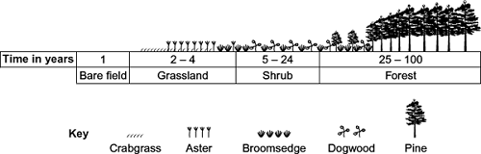
(a) Name the pioneer species shown in the diagram.
(a) Crabgrass;
Reject: grass or grassland
Reject: crabgrass if another organism is also included
1
(b) The species that are present change during succession. Explain why.
1. Species / plants / animals change the environment / conditions / add humus / nutrients etc. / less hostile (habitat);
Accept ‘they’ for species / plants in mark points 1 and 2
2. Species / plants better competitors;
(c) The pine trees in the forest have leaves all year. Explain how this results in a low species diversity of plants in the forest.
(Only) plants which can photosynthesise with less light (remain);
Accept converse but do not award mark for idea that plants cannot photosynthesise and die because there is no light
Answers must be in context of being or not being able to photosynthesise with less light
Q3.(a) The diagram shows a number of stages in an ecological succession in a lake.
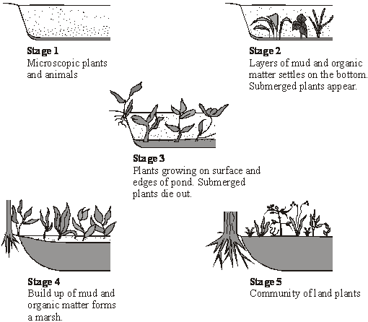
Explain how the diagrams illustrate the features of an ecological succession.
(a) 1. colonisation / pioneering;
2. microscopic plants at start;
3. death / decomposition;
4. named change in environment e.g. increase in organic matter / stabilisation;
5. new species colonise once there is a change;
6. increase in number of species / diversity / increase in total amount of living material / biomass / more niches / increase in nutrient availability / change from more extreme conditions / more stability;
(b) Several small rivers flow into this lake. These rivers flow through forested areas.
Explain how deforestation might affect the process of succession in the lake.
marking principles:
one mark – direct result of removing forest cover;
e.g. soil erosion / leaching
one mark – specific effect on organisms in lake;
e.g. more sediment / nutrients (for plants to grow
(c) Stage 5 illustrates the final stage of succession which is known as the climax community. During this stage the number of different species in the habitat and the size of each population remain fairly constant. Explain what limits the size of populations in a climax community.
) 1. named nutrient availability;
2. numbers of producers providing energy (for a food chain) / light intensity affecting the rate of photosynthesis;
3. disease killing (weaker) members of species / predation described;
4. space for nest building / niches;
5. competition for a named limited resource / (intra and interspecific) competition explained;

Outcome:
- Explain how farming techniques impact on biodiversity, and the reasons why these techniques are used.
- Evaluate conservation techniques, and why these must be balanced with farming then use your knowledge and understanding to present scientific arguments and ideas relating to the conservation of species and habitats
- Explain the impact of environmental changes on biodiversity
Conservation, Agriculture and human impacts on Biodiversity
These exam questions are always application questions in the exam, you will need to read the information carefully then draw conclusions from the information/table/graph/data.
Read pages 246-247 and 488 in the Toole and Toole textbook, complete the questions below. These questions are quite open so make sure you fill as much detail as you can.
Human activities can do great damage to the environment. We cut down forests to provide us with wood for building and fuel to burn, or clear the land for housing and agriculture. We pollute the land, air and water, making it impossible for some species to live there.
- Conservation attempts to maintain biodiversity.
- This involves maintaining a variety of different habitats, which between them can support a wider range of species than a single type of habitat could do.
- Conservation frequently involves preventing succession from occurring, or careful management of succession. There is generally more diversity in the stages leading up to the climax community than there is in the final stage.

- Describe the effect of mankind’s desire for low cost food.
Reduction in Biodiversity , low species diversity.
- Complete the table below
Natural Ecosystem | Agricultural Ecosystem
Longer time to develop | Shorter time to develop
Large number of individuals | Large number of individuals
Larger number of species | Smaller number of species
Higher index of diversity | Lower Index of Diversity
Controlled by nature | Controlled by humans
Heavily affected by climate | Less affected by climate
Higher level of genetic diversity | Lower level of genetic diversity
Many different alleles | Few different alleles
None | Pesticides/herbicides/insecticides used to reduce competition.
- Suggest what is meant by biomass? Think back to Energy and Ecosystems booklet
Total mass of living materials in a specific area at a specific time
- Suggest why “food production in the UK has doubled over the last 40 years”
Meet demands of expanding human population by improved genetic varieties of plants/animal species, greater use of chemical pesticide/herbicide/insecticide, changing in farming practices.
- List 2 practices that have directly reduced species diversity.
Removal of hedgerow,
Creating monocultures
Filling in ponds/wetlands or draining marshes
Over grazing of lands
- Suggest what is meant by monoculture
Only growing one species of plants in an area/field
- Explain 2 advantages of monocultures to farmers. You must ALWAYS directly reference how the farmer will benefit in your answer, these are NOT general advantages. Examples of answers:
Advantage: Crop adapted to environment, Farmer: Bigger yield so more profit
Advantage: Only growing one crop so bigger crop, Farmer: More profit
Advantage: Grow pesticide/herbicide resistant crops so reduces competition from other species, Farmer: crop will be bigger yield so more profit.
- Suggest 2 disadvantages of monocultures for a natural ecosystem, this is not included in the textbook so you will need to apply your knowledge. Examples of answers
Less predation so prey species will not be controlled, these may be pests
Less prey so predators die out due to lack of food
Less variety of food sources so species becoming more reliant on other food sources
Less nesting/breeding sites so less reproduction
- List 8 conservation techniques.
Maintain existing hedgerows
Plant hedges not fences
Leave wet corner of fields
Plant native species in low diversity areas
Reduce use of pesticide
Use organic fertiliser
Crop rotation including N fixing crops
Use intercropping instead of herbicides to control weeds
Natural meadows
Leave cuttings on verges
- Conservation of all species is important but especially of plant species. Suggest why you think the conservation of different plant species is so important to the plant and the human race. This is your opinion not in the textbook. Examples of answers
Loss of habitat for species so will die/not be able to reproduce
Loss of variety of food sources so will have to change food source increasing competition
Loss of genetic diversity which might provide future medicines/drugs/vaccines
Loss of shelter for species causing death.

- List the 4 reasons for conservation:-
Personal: maintain our planet
Ethical: other species also deserve to live /coexist
Economic: Gene pool which has a lot of potential
Cultural and Aesthetic: Enrich our lives
- Suggest why conservation often involves managing succession
Stages up to climax community have high species diversity so want these stages
Climax community often has lower species diversity so don’t want to reach this stage,
Complete the “conflicting interests” activity on page 489 in the Toole and toole textbook. Once you have completed the activity, check your answers on page 644 at the back of the textbook. Make a note of any important points in your answers above.
Exam questions:
Q1.(a) There are ethical and economic arguments for maintaining biodiversity.
(i) Suggest one ethical argument for maintaining biodiversity.
(We should maintain biodiversity to)
Prevent extinction / loss of populations / reduction in populations / loss of habitats / save organisms for future generations (idea of);
Neutral: references to ‘playing God’ / animal rights
(ii) Suggest one economic argument for maintaining biodiversity.
A suitable example of how some species may be important financially e.g.
1. medical / pharmaceutical uses;
2. commercial products / example given;
3. tourism;
4. agriculture;
5. saving local forest communities;
Ecologists calculated the percentage of bird species that have become extinct on six islands in the last one hundred years. They also calculated the percentage of original forest area remaining on each island after the same time period. The graph shows their results.
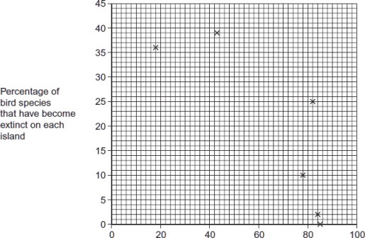
(b) Explain the relationship between the percentage of original forest area remaining and the percentage of bird species that have become extinct.
1. Fewer plant species / decrease in plant diversity;
Accept: converse arguments for islands with a high percentage of forest remaining
1. Neutral: fewer plants
2. Fewer habitats nesting sites / niches / food sources / varieties / less protection from predators / hunters / environment;
2. Neutral: fewer homes
2. Neutral: less food
(c) What two measurements would the ecologists have needed to obtain to calculate the index of diversity of birds on each island?
1. Number of (individuals / birds of) each species;
1. Neutral: number of species
2. Total number of individuals / birds of all species;
2. Accept: ‘total number of birds’ as given context for ‘all species’ in the investigation
(d) The ecologists noted that the species of birds surviving on the coldest islands had a larger body size than those surviving on warmer islands. Explain how a larger body size is an adaptation to a colder climate
1. (Larger birds have) a low(er) SA:VOL;
Neutral: reference to fat / feathers
2. (So) less heat loss / more heat retained;
MP2 is independent of MP1
Q2. Woods can be coppiced to provide a continuous supply of useful logs and poles. Coppicing involves cutting down some trees in a wood to leave stumps. New shoots grow from the stumps. After about 15 years, these trees can be coppiced again. Because coppicing produces a wood with patches of light and shade, the diversity of plants and animals in a coppiced wood is high. Ecologists investigated the effect of coppicing on the flowering of wild daffodils growing in a wood in Cumbria. Some areas of the wood were coppiced and some areas were not. The graph shows some results from this investigation.
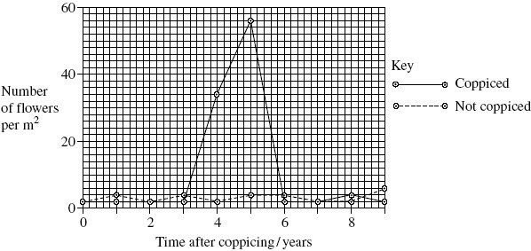
- You could collect data for the coppiced plots by using quadrats.

(i) Describe how you would place the quadrats at random.
(a) (i) Method of positioning quadrats,
E.g. Find direction and distance from specified point / find coordinates on a grid / split area into squares;
Method of generating random numbers;
E.g. From calculator / telephone directory / numbers drawn from a hat;
Last point represents minimum answer
Q Do not credit any method that relies on throwing a quadrat
2
(ii) Describe how you would decide the number of quadrats to use in order to collect representative data.
Calculate running mean / description of running mean;
When enough quadrats, this shows little change / levels out (if plotted as a graph);
Enough to carry out a statistical test;
A large number to make sure results are reliable;
Ignore terms that are not incorrect
Regards large numbers as 10 / 10% +
Need to make sure work can be carried out in the time available;
(b) Members of the public visit this wood to see wild daffodils in flower. Explain how the information in the graph could help the owners to manage the wood so that there were many wild daffodils in flower every year.
Coppice different parts of the wood at different times;
As data show many daffodils flowering 4 / 5 years after coppicing;
Q Second point needs specific reference to the graph, numbers and time after coppicing. Accept any correct answer that does this.
(c) The ecologists analysed the relationship between the number of daffodils in flower in the whole wood and data collected from a nearby weather station for the previous year. They used the Spearman rank correlation test. The table shows their results.
Month | Climatic factor | Correlation coefficient | Statistical significance
July | Total rainfall | + 0.65 | significant
August | Total rainfall | + 0.74 | significant
July | Monthly mean temperature | – 0.78 | significant
August | Monthly mean temperature | – 0.65 | significant
The ecologists concluded that a wet, cool summer produces good flowering the following spring. Do you support this conclusion? Use the data in the table to explain your answer.
Positive correlation between rainfall and flowering / the higher the rainfall, the more daffodil flowers;
Negative correlation / the higher the temperature the fewer daffodils in flower;
All statistically significant so not likely to be / not due to chance;

Q3.A hedgerow is a line of shrubs and trees bordering a field, together with the herbaceous plants at their base. In the last 50 years farmers have removed many hedgerows.
(a) Explain two advantages for a farmer of removing hedgerows.
source of pests / animals, and effect on crop;
source of weeds / no longer taking nutrients, hence competition / reduced yield; creation of larger fields / leaving room,
hence more efficient use of machinery / grow more crops;
hedgerows have to be maintained, so removal saves time / money;1.
(b) In recent years some hedgerows have been replanted. Ground beetles, which are unable to fly, are predators of crop pests. The beetles overwinter in the shelter of grasses at the base of the hedgerow. In some large fields, a permanent strip of grass is left as shown in the diagram.
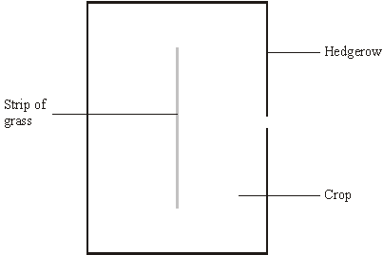
Suggest and explain the advantage of leaving the strip of grass in the middle of the field.
source of pests / animals, and effect on crop;
source of weeds / no longer taking nutrients, hence competition / reduced yield; creation of larger fields / leaving room,
hence more efficient use of machinery / grow more crops;
hedgerows have to be maintained, so removal saves time / money
(c) Apart from providing a habitat for predators of crop pests, give two biological benefits of replanting hedgerows.
increases biodiversity;
source of food for animals;
habitat / nest for animals;
reduce need for insecticides / attracts insects away from crop;
windbreaks / prevent erosion / run-off / leaching;
migratory corridors;

