Outcomes:
- Explain what standard deviation is and how it is calculated
- Interpret data in terms of means and the overlap of standard deviation bars and apply knowledge of, to draw and explain conclusions
- Evaluate the quality of results and reliability of conclusions. Explain how to ensure that estimates and conclusions are reliable.
This lesson will focus on the maths skills that are relevant to your Biology course. These maths skills are also very common in Biodiversity and Population questions.
Definition:
Mean: Average calculate by taking the sum of all values and dividing by the total number of values
Mode: Most frequent value in the set of data
Median: Middle value when set of data is placed in numerical order
Standard deviations: A measure that is used to quantify the amount of variation in a set of data

Mean, modes and medians
Exam note: NEVER use the word “average” in your exam, this will lose you the mark.
Apply the definitions to the questions below.
Family | No. of kids  - Work out the mean (show your working):  33/11= 3  - Work out the mode:  1  - Work out the median (show your working):  2
A | 0
B | 1
C | 1
D | 1
E | 2
F | 2
G | 3
H | 4
I | 6
J | 6
K | 7

Cow Name | Weight (kg)
Daisy | 62
Dot | 77
Fleur | 67
Dandelion | 71
Buttercup | 63
Cowslip | 92
- Work out the mean (show your working):
432/6=72

- Work out the mode:
There is no mode

- Work out the median (show your working):
67 and 71 are the median values
Standard deviation
What is it and how should it be used?
It takes into account ALL the values, not just the two most extreme ones - which is the range. E.g. If one of the extreme values is an outlier, then the range will be misleading.
This means standard deviation is less influenced by anomalies.
Standard deviation is a statistical test allows you to compare the means of 2 sets of data to see if the difference between the data sets is significant or not.
A standard deviation close to 0 indicates that the data points tend to be very close to the mean of the set, while a high standard deviation indicates that the data points are spread out over a wider range of values.
The smaller the standard deviation the more accurate the mean, the more reliable the results.
If the standard deviations of the 2 sets of data DO overlap then the DIFFERENCE between the 2 DATA SETS is NOT significant so NO conclusion can be formed from the data.
If the standard deviations of the 2 sets of data DON’T overlap then the DIFFERENCE between the 2 DATA SETS IS significant so A conclusion can be formed from the data.
Worked example:
The St. Kilda field mouse lives only on one island off the coast of Scotland. It is very similar in appearance to the long-tailed field mouse but is larger and has lighter coloured fur. Biologists wanted to find out if the St. Kilda field mouse and the long-tailed field mouse populations belonged to different species. They measured the length of the same features of a large number of individuals from the two populations. The results are shown in Table 2.
Population | Mean length (±SD) / mm
Population | Head and body | Values | Tail | Values
St. Kilda field mouse | 112.3 (±9.3) | 103.0  121.6 | 105.5 (±8.4)
Long-tailed field mouse | 95.2 (±8.2) | 87.0  103.4 | 90.2 (±7.3)
(a) Do the data in Table 2 provide evidence that the two populations belong to different species? Use calculations of ratios to support your answer.
1. (No) SDs of means of body sizes / sizes of parts of bodies overlap;
2. Calculation of correct head and body: tail ratios;
3. Almost identical, so same body shape / proportions;
Exam Questions:
Q1. (a) Define each of the following terms.
Species (a) 1. Species = (A group of) organisms that are able to produce fertile offspring;
Scientists investigated the species richness of fish caught at various depths in the Pacific Ocean close to the western coast of Chile. The graph shows the scientists’ results. 68% of all the fish caught in this investigation came from sample A.
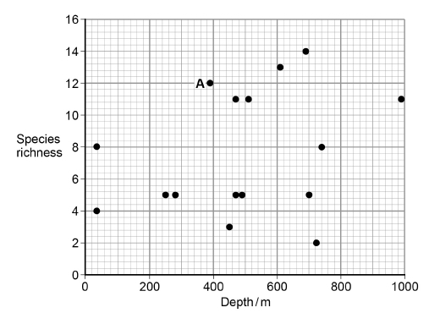
(b) What is the modal value of species richness?
5

Q2. Mayflies are insects which lay their eggs in streams and rivers. The nymphs which hatch from the eggs live in the water for several years. Mayfly nymphs were collected by disturbing the gravel of a stream bed. A net placed immediately downstream caught any animals which were washed out of the gravel. Eight samples were collected from shallow, fast-flowing parts of the stream and eight from deeper, slow-flowing parts. Nymphs from two different families of mayfly were found. The results are given in the table.

 | Family Caenidae |  | Family Baetidae
 | Shallow water | Deep water | Shallow water | Deep water
Mean number of nymphs | 2.38 | 12.88 | 24.50 | 6.00
Standard deviation | 1.51 | 7.92 | 6.72 | 1.51
(a) Which one of the four samples showed the greatest variation within the sample? Give evidence from the table for your answer.
(b) Caenidae in deep water – because highest standard
deviation / ‘S.D.= 7.92’

Exam note: You do not need to have studied the topic yet to be able to comment on the standard deviations.
Q3. The scientists’ results are shown in the table below.
Heat treating the fungus kills it so means the fungus can have no effect on the results.
Treatment | Mean dry mass / g per plant  ( standard deviation)
Treatment | Root | Shoot
A – heat-treated fungus and nitrate fertiliser | 0.40  (±0.05) | 1.01  (±0.12)
B – fungus and nitrate  fertiliser | 1.61  (±0.28) | 9.81  (±0.33)
C – heat-treated fungus and ammonium fertiliser | 0.34  (±0.03) | 0.96  (±0.26)
D – fungus and ammonium fertiliser | 0.96  (±0.18) | 4.01  (±0.47)
(e) What conclusions can be drawn from the data in the table about the following?
The effects of the fungus on growth of the pea plants.
With live fungus – showing effects of the fungus:
1. Fungus increases growth of roots and shoots in both;
2. Produces greater growth with nitrate.

The effects of nitrate fertiliser and ammonium fertiliser on growth of the pea plants.
With heat-treated fungus – showing effects of fertiliser:
3. Similar dry masses for roots and shoots;
4. (Probably) no significant difference because SDs overlap.

Q4. Scientists investigated how the concentration of protein in blood plasma changes in people between the ages of 60 and 95. The graph shows the scientists’ results. The bars show ±1 standard deviation.
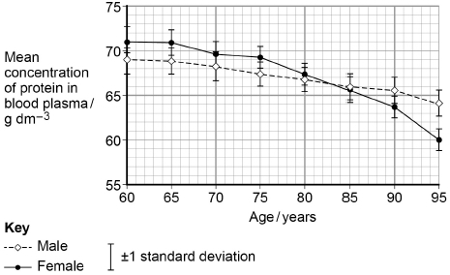
- What is the difference between males and females in the fall in mean concentration of protein in blood plasma between 60 and 95 years?

(a) 6 (g dm⁻³); (females fall from 71 to 60= fall of 11, males fall from 69-64= fall of 5)

Answer = ___________ g dm⁻³ (1)
(b) Use the graph above to calculate the rate of change of the mean concentration of protein in the blood plasma of males between the ages of 60 and 95. Show your working.
(b) Correct answer of (−)0.14;
1 mark for correct difference in concentration (5) divided by 35 / (69 − 64) ÷ 35 / 1 ÷ 7
Ignore +/- sign
Accept 0.31(4) for 1 mark if female data used
Answer = ___________ g dm⁻³ year⁻¹
(2)
(c) What can you conclude from the graph above about the effect of ageing on the mean concentration of protein in the blood plasma in males and females?
1. Protein content decreases with age and decreases more in females;
2. Difference (between sexes) only significant at 95 years because SDs do not overlap;
OR
Differences not significant because 2 × SD would overlap;
Probability and chance:
Definitions
Chi-squared test: Used to compared expected and observed data

Student t- test: Used to compare means from 2 sets of data

Correlation co-efficient: Used to compare data from 2 different variables that have been sampled

What do statistical tests do? Test the probability of the differences in the values is due to chance or if the difference in the values is statistically significant
If the p-value given in the question is less than 0.05 or 5%:
“The probability that the difference in the values is due to chance is less than 5%/0.05
The difference in the values is significant”
If the p-value given in the question is more than 0.05 or 5%:
“The probability that the difference in the values is due to chance is more than 5% or 0.05
The difference in the values is not significant so is due to chance”

If the p-value in a student t-test is more than 0.05 or 5%:
“The probability that the difference in the means is due to chance is more than 5% or 0.05
The difference in the means is not significant so is due to chance”

Common mistake, write notes for yourself.:
_______________________________________________________________________________________________
_______________________________________________________________________________________________

Probability and chance- Example:
- Identify the statistical test.
- Check the p-values
- Identify which are more or less than 0.05 or 5%
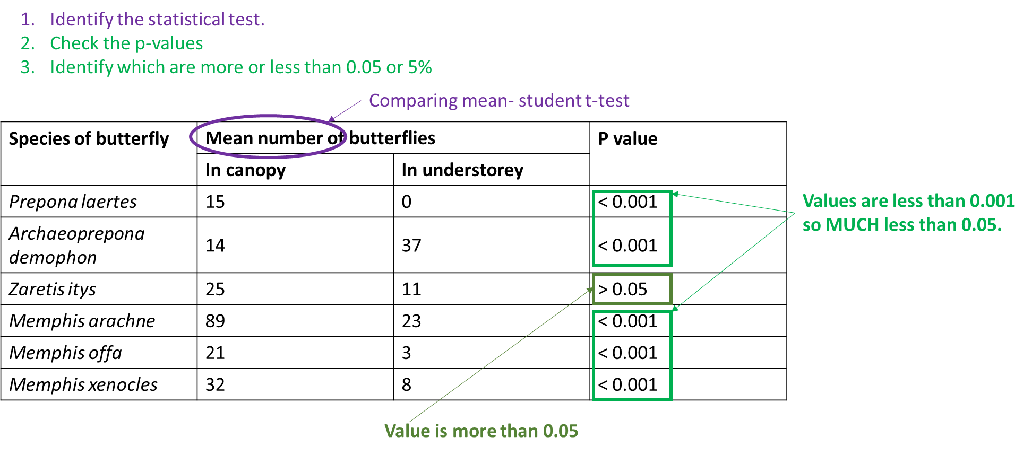

(a) The scientists carried out a statistical test to see if the difference in the distribution of each species between the canopy and understorey was due to chance. The P values obtained are shown in the table. Explain what the results of these statistical tests show.
1. For Zaretis itys, difference in distribution is probably due to chance / probability of being due to chance is more than 5%;
2. For all species other than Zaretis itys, difference in distribution is (highly) unlikely to be due to chance;
3. Because P < 0.001 which is highly significant / is much lower than 5%.
Exam questions:

Q1. A student investigated the duration of afterimages using red squares and purple squares. His results are shown in the table.

Colour of square | Cone cell(s) stimulated | Colour of afterimage | Mean duration of afterimage / seconds
Red | Red | Blue-green | 15
Purple | Red and blue | Green | 12

(a) Suggest a statistical test that would be appropriate for this investigation. Give a reason for your answer.

Statistical test: student t test

Reason for choice: because looking for differences between means / measurements (from different samples Test and reason required for the marking point

Q2. The scientists then calculated the mean mass of each species of alga eaten by the consumers. They used a statistical test to determine the P value. Table 2 shows some of the results they obtained.

Species of alga | Mean mass eaten / g |  | P value
Species of alga | Sea slug | Shore crab | P value
Laurencia pacifica | 4.42 | 0.22 | <0.01
Egregia leavigata | 0.12 | 0.08 | >0.05
Microcystis pyrifera | 0.19 | 0.14 | >0.05
Cystoseira osmondacea | 0.17 | 0.04 | <0.05

(a) Suggest what conclusions the scientists could have made from this investigation when using the probability values in Table 2.

1. For Laurencia pacifica and Cystoseira osmondacea (difference in results) significant /reject null hypothesis / not due to chance / less than 5%/0.05 probability due to chance;

Accept: for Laurencia pacifica ‘less than 1%/0.01 probability’.

2. For Egregia leavigata and Microcystis pyrifera no significant (difference in results)/accept null hypothesis / is due to chance/more than 5%/0.05 probability due to chance;

Accept: ‘insignificant’ for ‘no significant difference’.

3. (Difference in results) for Laurencia pacifica is the most significant;

Note: reference to probabilities on their own is not sufficient.

1, 2 and 3. Accept: abbreviations for all species.

Q3. Several years later, scientists repeated their study on this population. They found that the frequency of the recessive allele had decreased. A statistical test showed that the difference between the two frequencies of the t allele was significant at the P = 0.05 level. Use the terms probability and chance to help explain what this means.

1. There is a probability of 5% / 0.05;

2. That difference in frequencies / difference in results are due to chance;

Accept 95% probability changes in frequencies not different as a result of chance

Q4. Scientists measured the mean amino acid concentration in white wines made from grapes grown organically and white wines made from grapes that were not grown organically.

(a) Which test could the scientists have used to identify that there are amino acids in white wine?

Biuret;

(b) All amino acids have the same general structure. The image below shows the structure of the amino acid isoleucine. Draw a box around the part of the molecule that would be the same in all amino acids.

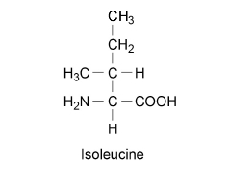

(1)

(c) Name the chemical element found in all amino acids that is not found in triglycerides.

Nitrogen;

(d) The scientists used a statistical test to determine whether there was a significant difference in the amino acid concentration in the two types of white wine. They obtained a value for P of 0.04. Name the statistical test the scientists used and give a reason for your answer.

Was the difference significant? Give a reason for your answer.

Name of statistical test (Student’s) t-test

Reason for choice Looking for differences between two means

Explanation of test result :Difference is significant / not due to chance because the P value is 0.04 / is less than 0.05;

Explanation: Assume ‘it’ means difference

Explanation: Reject result / data is significant / not due to chance

Explanation: do not accept P value is less than 0.04

