3.1 Biological Molecules

Name: ________________________________________________
Reflection on Outcomes | or | Target
Explain what a monomer and polymer are

Explain the concept of condensation and hydrolysis reactions in forming/breaking down polymers.
Identify common monosaccharides and describe the monosaccharides from which lactose, maltose and sucrose are made.
Present the structure of α -glucose and β –glucose diagrammatically

Explain what is meant by a glycosidic bond and how they form through condensation
Describe and explain how polymerisation of α-glucose can form starch or glycogen and how this relates to their function and properties.
Explain why glycosidic bonds between β –glucose form cellulose and how this relates to its function and properties.
Describe the structure of triglycerides and explain how triglycerides form
Recognise, from diagrams, saturated and unsaturated fatty acids.

Describe the structure of phospholipids and explain their properties.

Contrast the different properties of triglycerides and phospholipids.

Describe the general structure of an amino acid and how dipeptides form.
Explain the variety of functions that proteins have and why they are so important to the body.
Explain how dipeptides and polypeptides form

Explain the hierarchical organisation of protein structure

Describe the types of bonds involved in protein structure and the weakness of H bonds
Describe the Biuret test, the emulsion test, reducing and non-reducing sugar and starch test and how they can be interpreted.
Explain what is meant by qualitative testing and quantitative data.

Describe how the Benedict’s test can be adapted to provide quantitative data
Explain the usefulness of calibration curves or standards.

Describe the properties that are important in water

Explain the properties of water linked to the polar nature of the molecule
Explain the significance of these properties to living organisms and processes

Monomers and Polymers

Outcome:
- Explain what a monomer and polymer are

Definitions:
Monomer: ____________________________________________________________________________________
Polymer: _____________________________________________________________________________________
Polymerisation: _______________________________________________________________________________
Condensation: ________________________________________________________________________________
Hydrolysis: ___________________________________________________________________________________
Metabolism: __________________________________________________________________________________

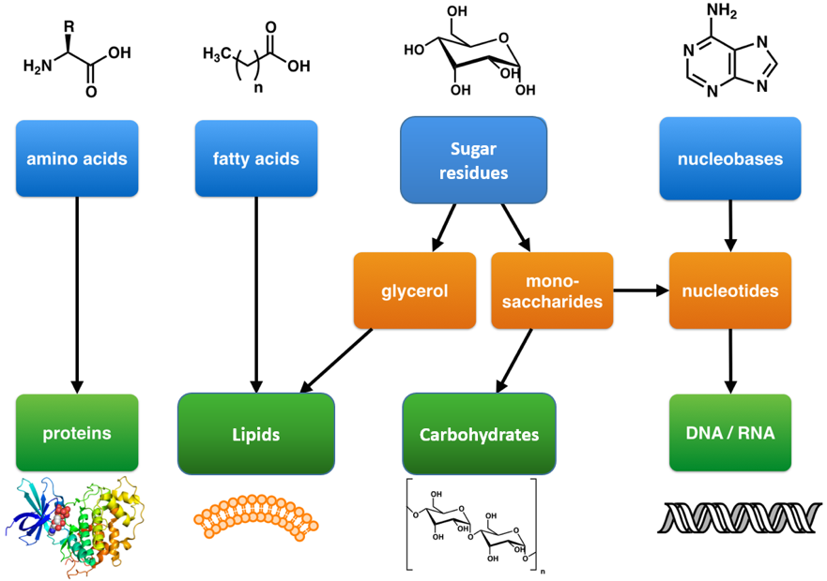

Biological molecule | Scientific name | Monomer | Polymer
Carbohydrate | Saccharides | Monosaccharide
Proteins | Peptides | Amino acids
Nucleic acids | Nucleotides | Nucleotides

Explain why are Lipids missing from the table?
______________________________________________________________________________________________________________________________________________________________________________________________

Outcome
- Explain the concept of condensation and hydrolysis reactions in forming/breaking down polymers.
- Identify common monosaccharides and describe the monosaccharides from which lactose, maltose and sucrose are made.
- Present the structure of α -glucose and β –glucose diagrammatically
- Explain what is meant by a glycosidic bond and how they form through condensation
Carbohydrates
- Contain the elements C, H and O.
- General formula (CH₂O)_{n}
Carbohydrate name | No. of C’s
Triose
Pentose
Hexose

Monosaccharides

Definition
Isomer: ________________________________________________________________________________________

Properties
- Dissolve in water and are reducing sugars

- They all have the same chemical formula C6H12O6 and are therefore isomers.

- You need to know – Alpha glucose, beta glucose, fructose and galactose.

Structure:
Exam tip: Can you write yourself a method to remember how to draw these hexose sugars?
Diagram of Alpha glucose Diagram of Beta glucose

State the structural difference between alpha and beta glucose.
_______________________________________________________________________________________________
Disaccharides
Properties:
- Dissolve in water and can be reducing or non-reducing sugars
- Made from two monomers joined by a condensation reaction
- Forming a covalent bond called a glycosidic bond.

Condensation reaction: Rules for drawing
- Always show the groups involved
- Always show water is released
- Always circle and label the bond formed

Structure:
Formation of the disaccharide Maltose (a reducing sugar):
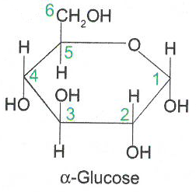
+

Formation of the disaccharide Sucrose (a non-reducing sugar):
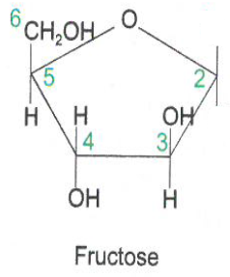
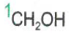
+

Draw out the formation of lactose (a reducing sugar) using α-glucose and galactose.
Exam tip: You do not need to remember this one for your exam but you might be asked to apply your knowledge to this example.

Hydrolysis reactions: Rules for drawing
- Always show the groups involved
- Always show where water is added
- Always circle and label the bond broken
- Name the monomers formed.
Disaccharides can be broken down by a hydrolysis reaction.
In the space below draw out the hydrolysis reaction of Maltose.

How does the structure of alpha and beta glucose change the bonding?
______________________________________________________________________________________________________________________________________________________________________________________________

Exam questions:
Q1.(a) What is a monomer?
___________________________________________________________________
___________________________________________________________________(1)
(b) Lactulose is a disaccharide formed from one molecule of galactose and one molecule of fructose. Other than both being disaccharides, give one similarity and one difference between the structures of lactulose and lactose.
Similarity ___________________________________________________________
___________________________________________________________________
___________________________________________________________________
Difference __________________________________________________________
___________________________________________________________________
___________________________________________________________________(2)
Q2.Lactose is a disaccharide found in milk. In the human small intestine, the enzyme lactase catalyses the hydrolysis of lactose to the monosaccharides, galactose and glucose. These monosaccharides are then absorbed into the blood. Complete the diagram to show the hydrolysis of lactose to galactose and glucose.
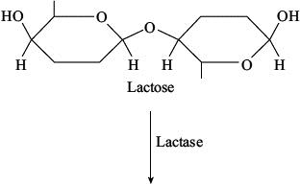

(Total 2 marks)

Q3.(a) Name the monosaccharides of which the following disaccharides are composed.
(i) Sucrose
monosaccharides___________________and___________________(1)
(ii) Lactose
monosaccharides___________________and___________________(1)

Outcomes:
- Describe and explain how polymerisation of α-glucose can form starch or glycogen and how this relates to their function and properties.
- Explain why glycosidic bonds between β –glucose form cellulose and how this relates to its function and properties.

Polysaccharides
1.Starch Structure:
- Polysaccharide of a-glucose
- 1-4 and 1-6 glycosidic bonds
- Branches and coiled shape held by H bonds

2.Glycogen Structure:
- Polysaccharide of a-glucose
- 1-4 and 1-6 glycosidic bonds
- Branched and coiled shape held by H bonds

Function/property of Starch and Glycogen:
Main role is as energy storage compound. Starch is in plants only, glycogen is in animals only.
Describe | Explain
Insoluble | Doesn’t affect WP
Branched | Compact/Can fit many in a small space
Polymer of a-glucose | Provides glucose for respiration
Branched | Many ends for enzymes to attach and hydrolyse
Large | Cannot leave cell.

Contrast Starch and Glycogen structure:
Starch structure | Glycogen structure

3.Cellulose Structure:
- Polysaccharide of B-glucose
- Every other B--glucose upside down
- 1-4 glycosidic bonds only
- Straight chains
- Many H bonds between chains forming microfibrils.

Function/property of cellulose:
Describe | Explain
Long straight chains | Provides rigidity/strength to plant cell wall
Many H bonds forming microfibrils | Provides rigidity/strength to plant cell wall

Exam tip: Most polysaccharide exam question asking you to compare and contrast the functions or structures of the 3 polysaccharides. Compare and contrast questions should ALWAYS be done as a table.

Complete the revision poster below using the information about polysaccharides. Add information from your memory first to see what you can remember. Change colour and add information that you had forgotten,

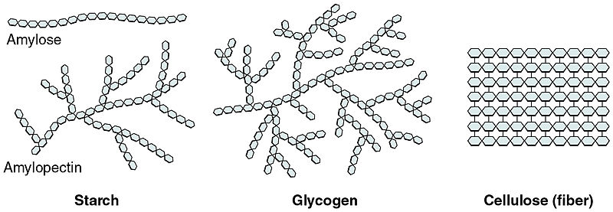

Exam questions:
Q1. Starch and cellulose are two important plant polysaccharides. The following diagram shows part of a starch molecule and part of a cellulose molecule.
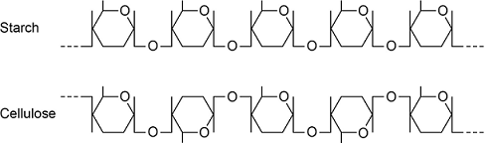
(a) Explain the difference in the structure of the starch molecule and the cellulose molecule shown in the diagram above.
___________________________________________________________________
___________________________________________________________________
___________________________________________________________________(2)
(b) Starch molecules and cellulose molecules have different functions in plant cells. Each molecule is adapted for its function. Explain one way in which starch molecules are adapted for their function in plant cells.
___________________________________________________________________
___________________________________________________________________
___________________________________________________________________(2)
(c) Explain how cellulose molecules are adapted for their function in plant cells.
___________________________________________________________________
___________________________________________________________________
___________________________________________________________________
___________________________________________________________________(3)
These are more challenging application and skills questions.
Q2.Scientists investigated the hydrolysis of sucrose in growing plant cells by an enzyme called SPS.
(a) Name the products of the hydrolysis of sucrose.
1. _________________________________________________________________
2. _________________________________________________________________(2)
(b) The scientists grew plant cells in a culture for 12 days. At the start, there were only a few cells in the culture. Each day, they determined the mass of sucrose hydrolysed by SPS in the plant cells in 1 hour. The following table shows their results.
Day | Mass of sucrose hydrolysed by SPS in 1 hour / μg | Rate of hydrolysis of sucrose  by SPS
0 | 0.07
2 | 0.09
4 | 0.11
6 | 0.15
8 | 0.20
10 | 0.24
12 | 0.24
For each day, calculate the rate per minute of the reaction catalysed by SPS. Record the rates in standard form and plot a suitable graph of your processed data.

(3)
(c) What can you conclude about the growth of the plant cells from these data?
Explain how you reached your conclusions.
___________________________________________________________________
___________________________________________________________________
___________________________________________________________________
___________________________________________________________________
___________________________________________________________________(3)
Q3.In mammals, in the early stages of pregnancy, a developing embryo exchanges substances with its mother via cells in the lining of the uterus. At this stage, there is a high concentration of glycogen in cells lining the uterus.
(a) Describe the structure of glycogen.
___________________________________________________________________
___________________________________________________________________
___________________________________________________________________
___________________________________________________________________
___________________________________________________________________(2)
(b) During early pregnancy, the glycogen in the cells lining the uterus is an important energy source for the embryo.Suggest how glycogen acts as a source of energy. Do not include transport across membranes in your answer.
___________________________________________________________________
___________________________________________________________________
___________________________________________________________________(2)
(c) Suggest and explain two ways the cell-surface membranes of the cells lining the uterus may be adapted to allow rapid transport of nutrients.
1. _________________________________________________________________
___________________________________________________________________
2. _________________________________________________________________
___________________________________________________________________(2)
(d) In humans, after the gametes join at fertilisation, every cell of the developing embryo undergoes mitotic divisions before the embryo attaches to the uterus lining.
• The first cell division takes 24 hours.
• The subsequent divisions each take 8 hours.
After 3 days, the embryo has a total volume of 4.2 × 10⁻³ mm³. What is the mean volume of each cell after 3 days? Express your answer in standard form.
Show your working.
Answer = ____________________ mm³ (2)

Outcomes:
- Describe the structure of triglycerides and explain how triglycerides form.
- Recognise, from diagrams, saturated and unsaturated fatty acids.

Property:
- Contain C, H, O
- Insoluble in water/non-polar
- Main groups of lipids are:
- Triglycerides - also known as fats (solid at room temperature) and oils (liquid at room temperature).
- Phospholipids – main component of plasma membranes.

Triglyceride Structure
Draw a molecule of glycerol and a fatty acid.

Draw the condensation of a triglyceride.

Saturated and unsaturated Fatty acids
Definition:
Saturated: ______________________________________________________________________________________
Unsaturated: ____________________________________________________________________________________

Saturated – Unsaturated-
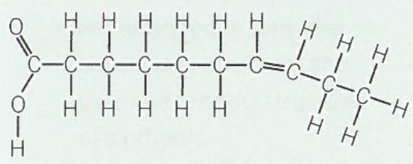
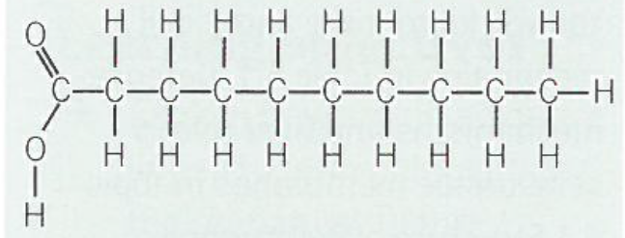

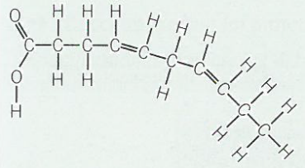

Circle and label the carboxyl group.
Circle and label the double C bonds.

Triglyceride Function:
Property | Function/Explanation
Energy store
Large, insoluble and non-polar molecules
Storage below dermis of the skin in adipose tissue
Metabolic source of water
Buoyancy

Exam questions:
- The figure below shows a phospholipid.
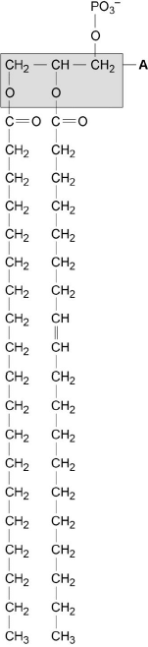
X Y
(b) The part of the phospholipid labelled A is formed from a particular molecule. Name this molecule.
___________________________________________________________________(1)
(c) Name the type of bond between A and fatty acid X.
__________________________________________________________________(1)
(d) Which of the fatty acids, X or Y, in the figure above is unsaturated? Explain your answer.
___________________________________________________________________
___________________________________________________________________(1)
Scientists investigated the percentages of different types of lipid in plasma membranes from different types of cell. The table shows some of their results.

Type of lipid | Percentage of lipid in plasma membrane by mass
Type of lipid | Cell lining ileum of  mammal | Red blood cell of  mammal | The bacterium  Escherichia coli
Cholesterol | 17 | 23 | 0
Glycolipid | 7 | 3 | 0
Phospholipid | 54 | 60 | 70
Others | 22 | 14 | 30
(e) The scientists expressed their results as Percentage of lipid in plasma membrane by mass. Explain how they would find these values.
___________________________________________________________________
___________________________________________________________________
___________________________________________________________________(2)
Q2.(a) A triglyceride is one type of lipid. The diagram shows the structure of a triglyceride molecule.
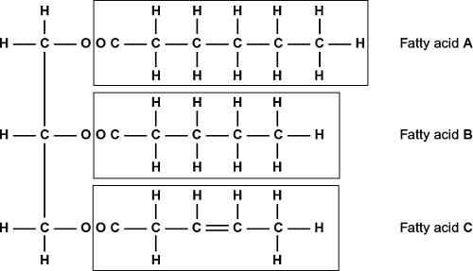
(i) A triglyceride molecule is formed by condensation. From how many molecules is this triglyceride formed?
 (1)
(ii) Use the diagram to explain what is meant by an unsaturated fatty acid.
______________________________________________________________
______________________________________________________________
______________________________________________________________(2)
Q3.(a) Omega-3 fatty acids are unsaturated. What is an unsaturated fatty acid?
___________________________________________________________________
___________________________________________________________________
___________________________________________________________________
___________________________________________________________________(2)
(b) Scientists investigated the relationship between the amount of omega-3 fatty acids eaten per day and the risk of coronary heart disease. The graph shows their results.
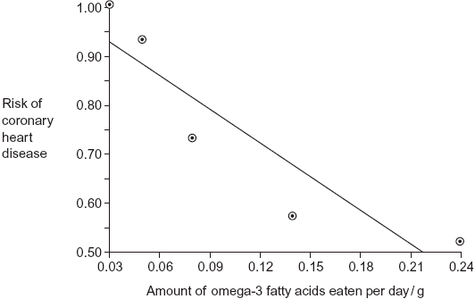
Do the data show that eating omega-3 fatty acids prevents coronary heart disease? Explain your answer.
___________________________________________________________________
___________________________________________________________________
___________________________________________________________________
___________________________________________________________________
__________________________________________________________________(3)
(c) Olestra is an artificial lipid. It is made by attaching fatty acids, by condensation, to a sucrose molecule. The diagram shows the structure of olestra. The letter R shows where a fatty acid molecule has attached.
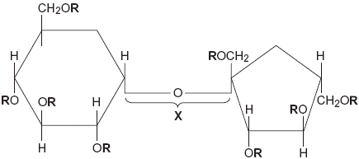
(i) Name bond X.
_____________________________________________________________(1)
(ii) A triglyceride does not contain sucrose or bond X. Give one other way in which the structure of a triglyceride is different to olestra.
______________________________________________________________
______________________________________________________________(1)
(iii) Starting with separate molecules of glucose, fructose and fatty acids, how many molecules of water would be produced when one molecule of olestra is formed?
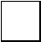(1)
Q4.Omega-3 fatty acids are found in cows’ milk. Scientists investigated changes in the concentration of omega-3 fatty acids in milk when cows were moved from eating grass in fields to eating corn in cattle sheds. The following figure shows the results of one investigation.
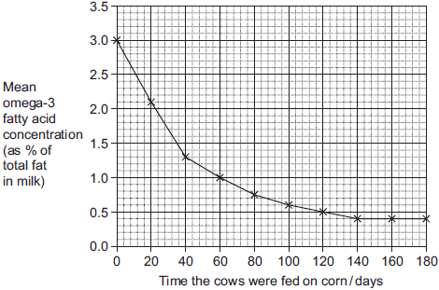
(a) The concentration of omega-3 fatty acids in milk changed when cows were fed on corn instead of grass. Describe how.
___________________________________________________________________
___________________________________________________________________
___________________________________________________________________(2)
(b) (i) Calculate the rate of decrease in the mean omega-3 fatty acid concentration between 0 and 40 days.Show your working.

Answer____________________% per day(2)
Outcome:
- Describe the structure of phospholipids and explain their properties.
- Contrast the different properties of triglycerides and phospholipids.
Phospholipids Structure
Definition:
Amphipathic: Have polar and non-polar regions
Property:
- Fatty acids repel water and are referred to as being hydrophobic
- Phosphate group is attracted to water and is referred to as being hydrophilic
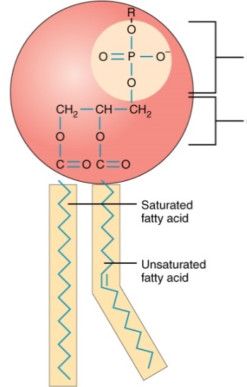
On the diagram label the hydrophilic phosphate head, the hydrophobic fatty acid tail and circle the C=C double bond.

Add details to the diagrams below showing how phospholipids arrange themselves when interacting with water.
When placed in water the phospholipid molecules arrange themselves either:

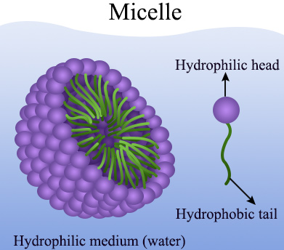
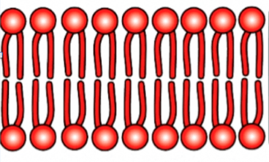

Phospholipid function:

Form a bilayer within a cell surface membrane so hydrophobic barrier formed between the inside and outside of cell
Forms membranes inside the cell e.g. mitochondria, to isolate metabolic reactions.
Controls exchange of substances
Compare and contrast triglycerides and phospholipids
 | Triglyceride | Phospholipid
Ester Bonds
Glycerol
Fatty acid structure
Fatty acid number
Elements
Solubility
Bilayer

Exam tip: ALWAYS do contrast questions as a table to get fully marks. Examiners notes always say “must be directly comparative statements, on the same line/same sentence”.

Exam questions:

(b) Mucus produced by epithelial cells in the human gas exchange system contains triglycerides and phospholipids.

Compare and contrast the structure and properties of triglycerides and phospholipids.

___________________________________________________________________

___________________________________________________________________

___________________________________________________________________

___________________________________________________________________

___________________________________________________________________

___________________________________________________________________

___________________________________________________________________(5)
Outcome:
- Describe the general structure of an amino acid and how dipeptides form.
- Explain the variety of functions that proteins have and why they are so important to the body.
- Explain how dipeptides and polypeptides form

Proteins
Property:
- Contains C, H, O, N and sometimes S
Amino Acids
- 20 naturally occurring amino acids
- Same 20 amino acids found in almost all living organisms.
- Proteins can be:
  - Globular - spherical and soluble. Have a metabolic function e.g. haemoglobin, insulin, enzymes.
  - Fibrous – long, thin and insoluble. Have structural function e.g. collagen, keratin

Structure:
All amino acids have:
- An amine group = -NH₂
- A carboxyl group = -COOH
- A hydrogen atom = -H
- R group (side chain) = differs in all amino acids
Draw and label General Amino Acid

Dipeptides Structure:
- Polypeptides formed by condensation reactions
- Bond formed is called a peptide bond
- Forms between amine group of one amino acid and carboxyl group of the other
Draw and label General Dipeptide here.

Outcome:
- Explain the hierarchical organisation of protein structure
- Describe the types of bonds involved in protein structure and the weakness of H bonds

Hierarchical protein structure
- Proteins can consist of a single polypeptide chain e.g. most enzymes, or 2 or more polypeptides e.g. haemoglobin, collagen.
Primary Structure
Definition:
____________________________________________________________________________________
Bond:
Peptide

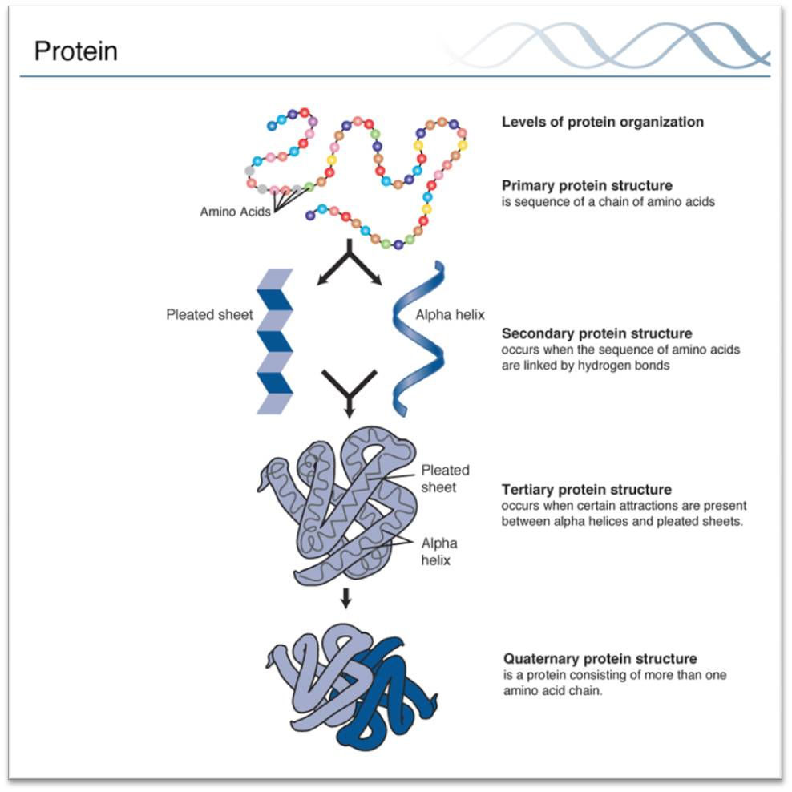
Tertiary Structure
Definition:
_________________________________________________
Bonds:
H bonds – ________________________________________
_________________________________________________
Ionic bonds – _____________________________________
________________________________________________
Disulphide bridges – _______________________________
_________________________________________________

Tertiary structure is determined by where these bonds form which is determined by sequence of amino acids.
Tertiary structure determines 3D shape and function of the protein.

Secondary Structure
Definition:
________________________________________________________________________________________
Bond:
H bonds
Quaternary Structure
Definition:
_________________________________________________

Bonds:
_________________________________________________
Exam questions:
Q1. (a) Draw the general structure of an amino acid.

(1)
Q2. (a) Glycine, an amino acid. In the space below, draw a diagram to show the dipeptide produced when two molecules of glycine are joined together.

(2)

(b) Name the other molecule formed when two molecules of glycine are joined together.
___________________________________________________________________(1)

Q3. the structure of proteins.
___________________________________________________________________
___________________________________________________________________
___________________________________________________________________
___________________________________________________________________
___________________________________________________________________
___________________________________________________________________
___________________________________________________________________
___________________________________________________________________
___________________________________________________________________
___________________________________________________________________(5)

Outcomes:
- Describe the Biuret test, the emulsion test, reducing and non-reducing sugar and starch test and how they can be interpreted.
- Explain what is meant by qualitative testing and quantitative data.
- Describe how the Benedict’s test can be adapted to provide quantitative data
- Explain the usefulness of calibration curves or standards.

Testing for Biological Molecules

Biological molecule | Method | Result
Protein | Add Biuret | Blue to Lilac
Carbohydrates- Reducing sugar | Heat to 80c with Benedict’s | Blue to Brick red precipitate
Carbohydrates- Non-reducing sugar | Follow Benedict method but solution stays blue.  Fresh sample  Boil with acid then neutralise with alkali  Heat to 80c with Benedict’s | Blue to Brick red precipitate
Lipids | Shake with ethanol  Then add water | White/milky emulsion
Starch | Add iodine | Yellow to blue black

Testing for carbohydrates
Give an example of an acid and an alkali you would use in the non-reducing test.
_______________________________________________________________________________________________

Explain why an acid is added in the non-reducing test
_______________________________________________________________________________________________

Explain why an alkali is added after the acid in the non-reducing test.
_______________________________________________________________________________________________
Definition:
Quantitive data: Numerical measurement of a variable, can be statically analysed
Qualitative data: Judgement, cannot be statically analysed

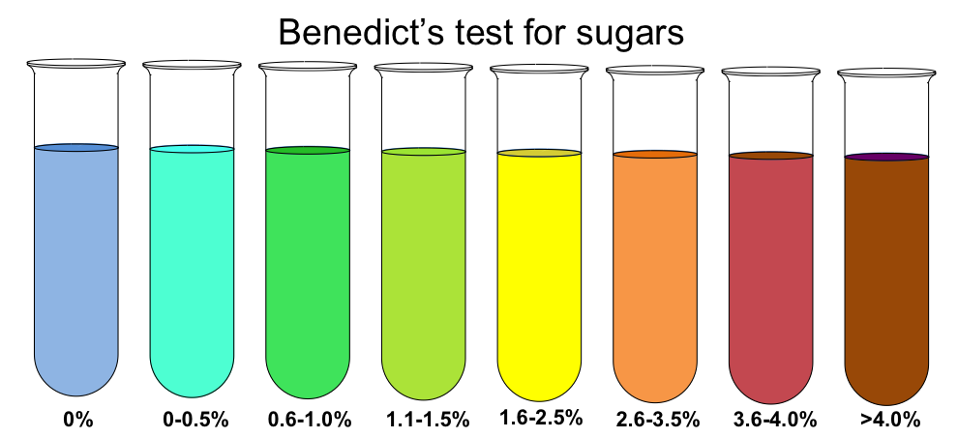
Describe the qualitative data
______________________________________________________________________________________________________________________________
Describe the method for quantitative Benedict’s test:
_______________________________________________________________________________________________
_______________________________________________________________________________________________
_______________________________________________________________________________________________
_______________________________________________________________________________________________
_______________________________________________________________________________________________
_______________________________________________________________________________________________
______________________________________________________________________________________________
_______________________________________________________________________________________________
Sketch a graph showing the % absorption using a colorimeter

Describe how you could use this calibration curve to work out the glucose concentration of an unknown solution
_______________________________________________________________________________________________
_______________________________________________________________________________________________
_______________________________________________________________________________________________
Outline:
- Describe the properties that are important in water
- Explain the properties of water linked to the polar nature of the molecule
- Explain the significance of these properties to living organisms and processes

Water Structure
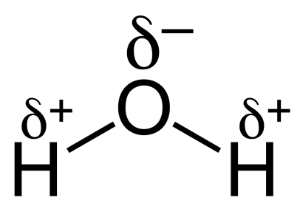
- Major component of cells
- Made up of 2 atoms of hydrogen and 1 atom of oxygen
- Hydrogens joined to oxygen by covalent bonds.

- Electrons are not shared equally – oxygen atom has
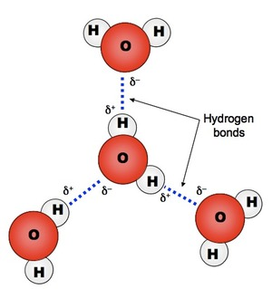
slight negative charge, hydrogen atoms have slight positive charge – polar- dipolar

- Each water molecule is attracted to each other
- Attractions called hydrogen bonds

Property | Explanation | Advantage to organisms
Polar molecule | Universal solvent | Transport ions around the body for faster reaction
Universal solvent | Water is polar allowing ions to dissolve for transport | Transport ions around the body for faster reaction
Reactive/Metabolite | Involved in hydrolysis/condensation reactions | Allows metabolic reactions to occur
High heat capacity | Takes a lot of heat energy to break H bonds  Energy is used instead of changing temperature  Act as a buffer | External: Stable environment for organisms eg fish  Internal: Maintains stable temperature for enzymes and reactions.
Large latent heat of vaporisation | Takes a lot of heat energy to break H bonds.  Energy is used to change liquid to gas when it evaporates carrying away the heat energy | Heat energy is lost through evaporation allowing animal to cool down.
Cohesion | Attraction between water molecules  Water forms a column for support  Water has a high surface tension when in contact with air | Column: Transport ions in plants  Surface tension: Habitat for insects.
Exam questions

a) State and explain the property of water that can help to buffer changes in temperature.

___________________________________________________________________

___________________________________________________________________

___________________________________________________________________

___________________________________________________________________

___________________________________________________________________

___________________________________________________________________

__________________________________________________________________(2)

Water and inorganic ions have important biological functions within cells.

(a) Give two properties of water that are important in the cytoplasm of cells.

For each property of water, explain its importance in the cytoplasm.

Property 1__________________________________________________________

Biological importance within cells________________________________________

___________________________________________________________________

___________________________________________________________________

Property 2__________________________________________________________

Biological importance within cells________________________________________

___________________________________________________________________

___________________________________________________________________(4)

Polysaccharides Summary Sheet
Name of Polysaccharide | Found in | Found as | Function/ Role | Monomer | Type of bond between monomer | Type of chain formed | Extra Notes
Starch

Glycogen

Cellulose |  | Fibres

