3.4.5 Species and Taxonomy

Name __Teacher

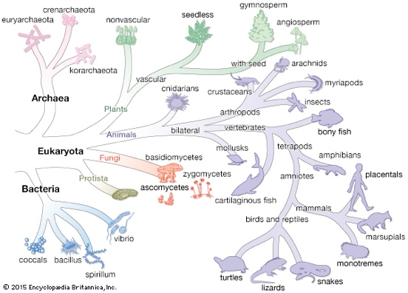

Reflection on learning outcomes | or | Target
Explain what a species is

Appreciate the difficulties in defining the term species

Explain the role of courtship and why it is necessary

Interpret information and data relating to courtship displays

Outline how a Species is named

Explain the hierarchical taxonomic ranks used in the classification of species

Interpret phylogenetic trees

Apply knowledge to identify different taxonomic ranks from information provided

Appreciate the difficulties in constructing valid phylogenetic classifications

Explain how genetic sequencing and immunology can help us to update our understanding of evolutionary relationships

Interpret results from genetic and immunological analysis, to draw valid conclusions as to evolutionary relationships between organisms.

Outcome:
- Explain what a species is

Definitions:
Classification: The organisation of living organisms into groups.

Taxonomy: The study of classification.

Species: A group of similar organisms that can breed together to produce fertile offspring.

Outcome:
- Appreciate the difficulties in defining the term species

Species
These “Happy face spiders” look different, but since they can interbreed, they are considered the same species: Theridion grallator.

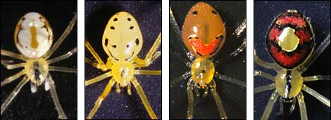

Scenario: An organism is discovered by Taxonomists in Asia. They suspect from observing the characteristics of the organism that it is an example of a Species already classified in Europe. To be certain they would need to mate this individual with the European Species to determine if they are capable of producing fertile offspring.

Exam question:
The St. Kilda field mouse lives only on one island off the coast of Scotland. It is very similar in appearance to the long-tailed field mouse but is larger and has lighter coloured fur.
Biologists wanted to find out if the St. Kilda field mouse and the long-tailed field mouse populations belonged to different species. They measured the length of the same features of a large number of individuals from the two populations.
The results are shown in Table 2.
Population | Mean length (±SD) / mm
Population | Head and body | Tail
St. Kilda field mouse | 112.3 (±9.3) | 105.5 (±8.4)
Long-tailed field mouse | 95.2 (±8.2) | 90.2 (±7.3)

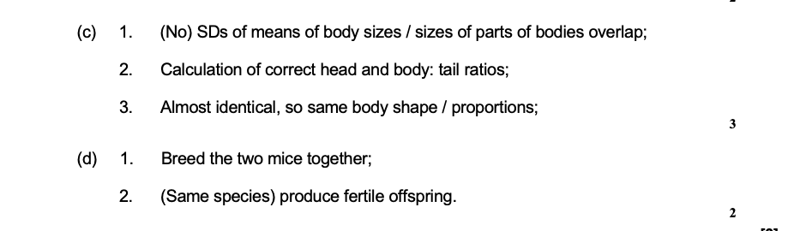

Outcome:
- Explain the role of courtship and why it is necessary
- Interpret information and data relating to courtship displays

Courtship
Members of the same species have the same genes and will share many of the same alleles of these genes, therefore they resemble one another physically and biochemically.

This helps them to distinguish members of their own species from those of other species. The same is true of behaviour.
The behaviour of members of the same species is more alike than that of members of different species.
Courtship ensures mating is successful and the offspring have the maximum chance of survival.

Courtship behaviour helps to achieve this by enabling individuals to:
- Recognise members of their own species
- Recognise opposite gender
- Identify a mate capable of breeding – both partners need to be sexually mature, fertile and receptive to mating.
- Form a pair bond
- Synchronise mating (similar to number 3)
- Stimulates release of gametes.

There is usually a chain of actions that is the same for all members of that species, acting as a stimulus so they can recognise they are of the same species and may be prepared to mate.

Exam question:

1. The diagram shows a seahorse. A seahorse is a fish. Mating in seahorses begins with courtship behaviour. After this, the female transfers her unfertilised eggs to the male’s pouch. Most male fish fertilise eggs that have been released into the sea. However, a male seahorse fertilises the eggs while they are inside his pouch. The fertilised eggs stay in the pouch where they develop into young seahorses.

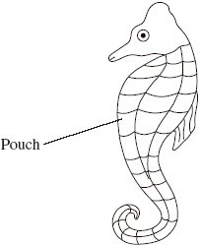

(a) Give two ways in which courtship behaviour increases the probability of successful mating.

Recognition of same species;

Stimulates release of gametes;

Recognition of mate / opposite gender;

Indication of sexual maturity / fertility

(b) Give one way in which reproduction in seahorses increases the probability of

(i) fertilisation

Internal fertilisation / fertilisation occurs in pouch / limited area;

Q The term fertilisation is not required in the answer but must be implied.

(ii) survival of young seahorses.
Protection from predators (developing in pouch);
2. Drosophila fruit flies display courtship behaviour. One of the stages of courtship is singing by males. Normally a male will produce a ‘sine song’, in which continual noise is made, and a ‘pulse song’, in which there is continual noise with some louder peaks.
Scientists showed fruit flies a visual stimulus that made them sing. They made recordings of these songs.
Figure 2 shows the recordings of the songs of three flies over the same time period.
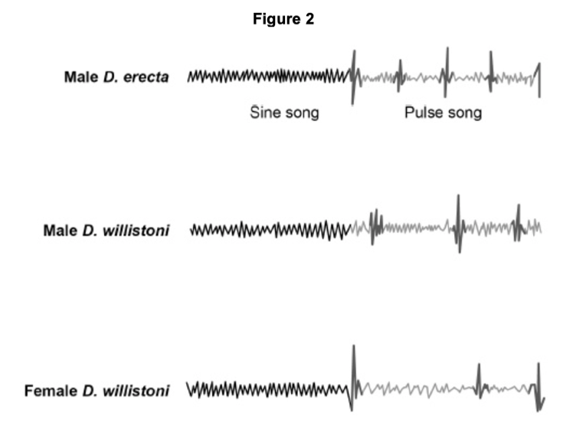

(c) 1. Sine song is (very) similar / same length (for both, so closely related).

2. (But) have different peaks / pulses (in pulse song);

Must give a difference, not just state they are different

Accept suitable differences eg number / length / amplitude / interval

2

(d) 1. (Three) peaks (in pulse song) occur at the same time (since both female) / songs identical / male peaks are different;

Accept suitable differences in male peaks eg number / length / amplitude / interval

2. (Therefore) no male (song) to stimulate / cause mating;

OR

Nothing to stimulate / cause mating;

Q3. Courtship and mating in fruitflies can occur equally well in the light or dark. The diagrams show the courtship sequence of males from two closely related species of fruitfly (species A and species B). The numbers show the probability of one courtship element following from another.

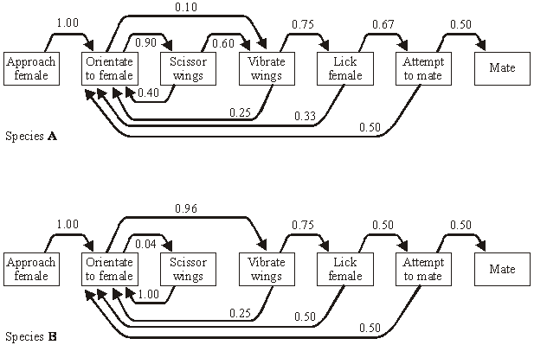

(a) Once a male of species A has orientated to the female, what is the probability that he will perform each courtship element once only and then attempt to mate?
Show your working.

principle of sequential multiplication (0.9×0.6×0.75×0.67);
0.27;

(correct answer 2 marks)

2

(b) Suggest how the courtship sequences provide evidence to support the claim that the two species are

(i) closely related;

similar sequence / actions / sign stimuli

(ii) separate species.

additional action in sequence(species A) / scissor wings blocks
sequence in B

(c) During courtship, vibration of the wings creates a sound. The sound is different in the two species of fruitfly. Explain how this prevents mating between members of different species.

(acts as) sign stimulus;
responds only to species-specific sound

Outcome:

- Outline how Species are named

Binomial System
At one time scientists often gave new organisms a name that described their features, for example blackbird. rainbow trout. This practice resulted in the same names being used in different parts of the world for very different species. Therefore, it was difficult for scientists to be sure they were referring to the same organism. Over 200 years ago the Swedish botanist Linnaeus overcame this problem by devising a common system of naming organisms. This system is still in use today. Organisms are identified by two names and hence the system is called
the binomial system.

Two names come from the genus and the species names e.g. Homo sapiens
  - Homo = genus name (always has a capital letter)
  - sapiens = species name

Can be abbreviated to H. sapiens

The binomial name is always printed in Italics or underlined if handwritten
Can you write out the scientific name for the following organisms:
Ovis Aries
Balaenoptera musculus
Sequoiadendron giganteum
Spongiforma squarepantsii
Parastratiosphecomyia stratiosphecomyioides
Ba humbug
Homo Spaiens
- Sheep _________________________________
- Blue whale _________________________________ (largest animal on the planet)
- Giant Redwood _________________________________ (Some of the largest tress on the planet)
- Malaysian spongy fungi _________________________________
- Near solider wasp fly _________________________________ (longest species name)
- Viti Levu snail _________________________________
- Humans _________________________________

Using the information below can you write out the binomial name for a tiger
Taxon | Tiger (Name of Taxon)
Kingdom | Animalia
Phylum | Chordata
Class | Mammalia
Order | Carnivora
Family | Felidae
Genus | Felix
Species | tigris

Felix tigris_
Research your favourite animal. Write out the common name for this animal then write out the binomial name

Outcome:

- Explain the hierarchical taxonomic ranks used in the classification of species
- Interpret phylogenetic trees
- Apply knowledge to identify different taxonomic ranks from information provided

Organisms are classified according to how closely they are related.

The phylogenetic classification system is made up of groups (taxon) in a hierarchy

The large groups (taxon) are subdivided into smaller groups (taxon) that show closer similarities between organisms.

Smaller groups still are then subdivided further based on sharing the most similar features.

Definitions:
Hierarchy: Groups within groups, no overlap.

Taxonomy is the study of these groups and their positions in a hierarchical order, where they are known as taxonomic ranks. These are based upon the evolutionary line of descent of the group members – link to Natural selection booklet.
A domain is the highest taxonomic rank and three are recognised: Bacteria, Archaea (a group of prokaryotes) and Eukarya.
A useful mnemonic for remembering the order of the taxonomic ranks is
'Delicious King Prawn Curry Or Fat Greasy Sausages'.
Come up with your own Mnemonic in the table below
Taxon (Group) | Mnemonic
Domain
Kingdom
Phylum
Class
Order
Family
Genus
Species
Note: You DO NOT need to know any specific organisms taxonomy but you will need to remember the name of the ranking.

Exam question:
The long-tailed field mouse, Apodemus sylvaticus, is a small mammal common in mainland Britain.
Complete Table 1 to show the classification of the long-tailed field mouse.

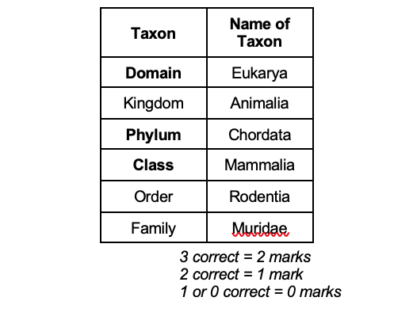

Q2. Table 1 shows how a bird called the bluethroat (Luscinia svecica) is classified by biologists.

Complete Table 1 by filling the seven blank spaces with the correct terms. (2)

(a) 1. Kingdom, Phylum, Class, Order, Family;

2. Luscinia svecica.

1 mark for each correct column

Allow Genus and Species if both placed in box for species but not if both placed in genus box

Q3. In 2002, biologists identified a new group of insects. They called these insects gladiators.

(a) (i) Mantophasma zephyra is one species of gladiator. Complete the table to show how this species is classified.

(a) (i) Phylum, Class, Order, Genus;

Mantophasma (M) / (Mantophasma) zephyra;

2

(ii) This system of classification consists of a hierarchy. Explain what is meant by a hierarchy.

Groups within (larger) groups;

No overlap;

2

(b) In 2002, very few gladiators were available for identification. Scientists around the world used photographs to establish the relationship of gladiators to other insects.

Explain how.

Comparison of / look for similar features / structures / appearance

Sometimes the taxa can be presented in different ways, for examples as circles. Annotate the diagram below

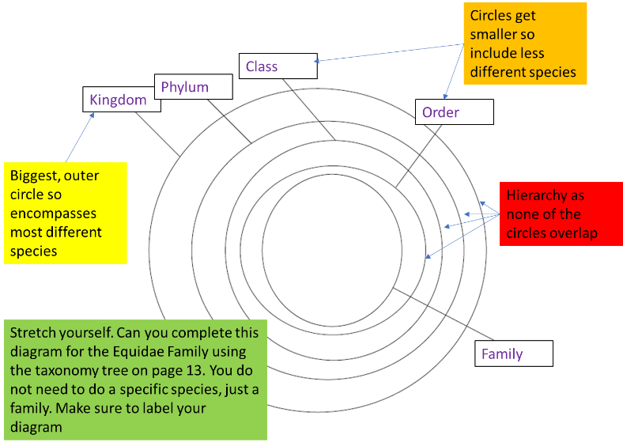

Stretch yourself. Can you complete this diagram for the Equidae Family using the taxonomy tree on page 13. You do not need to do a specific species, just a family. Make sure to label your diagram

Exam question:

Q1. Figure 1 represents the phylogenetic classification of four different species of fruit fly.

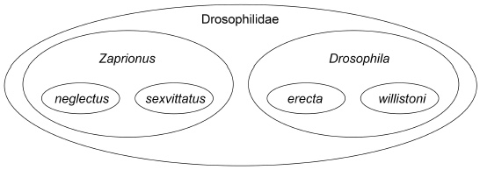

(a) Figure 1 shows a hierarchy. Explain how.
(a) 1. (It shows) smaller groups within larger groups / larger groups containing smaller groups;
Accept groups within groups
2. With no overlap (between groups);

(b) Name the taxon to which Drosophilidae belongs.
(b) Family;
Accept phonetic spellings

Outcome:
- Interpret phylogenetic trees

Definitions:

Phylogeny: The study of the evolutionary relationships between species.

Phylogenetic Group: (Grouped according to) evolutionary links / history / relationships / common ancestry;

Phylogenetic Classification

Based on evolutionary relationships between organisms and their ancestors
Classifies organisms into groups using shared features derived from shared ancestors
Arranges the groups into a hierarchy.
Evolutionary trees can be created.
An evolutionary tree is used to see how closely species are related, or if
Any 2 species living today have had a common ancestor at some time in the past.
The more closely 2 species are related, the closer they appear together on the evolutionary tree.

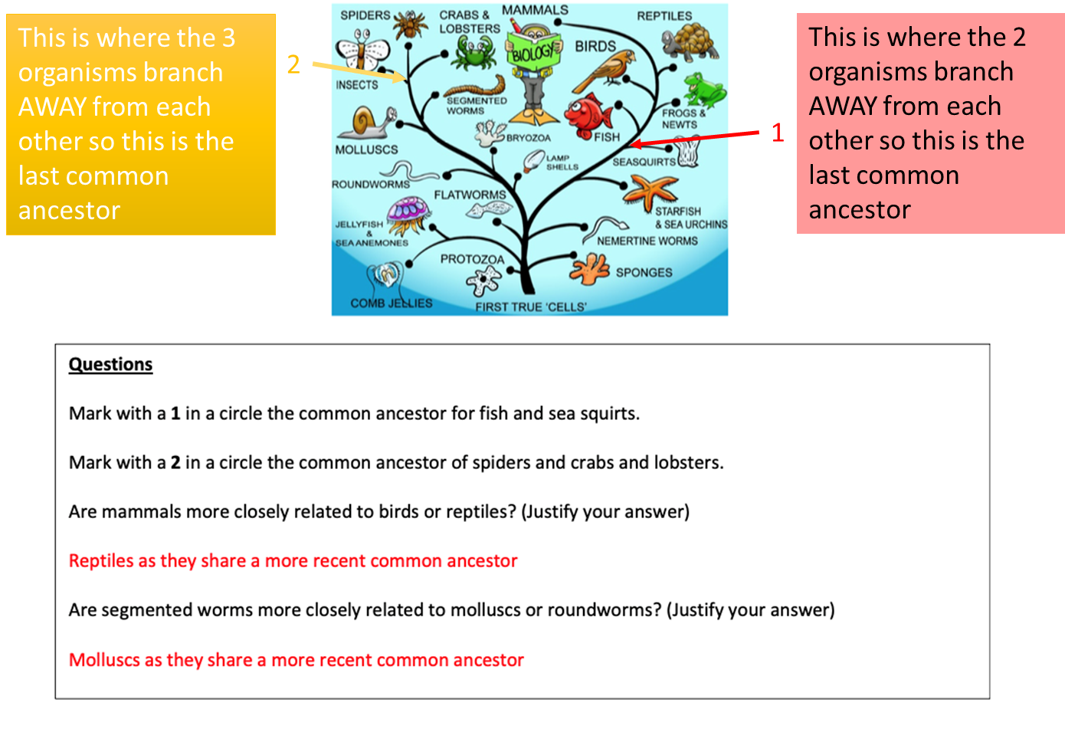

Have you completed the extra phylogenetic activity about dinosaurs?

Exam question:

Q1. The following figure shows how some animals with hooves are classified.

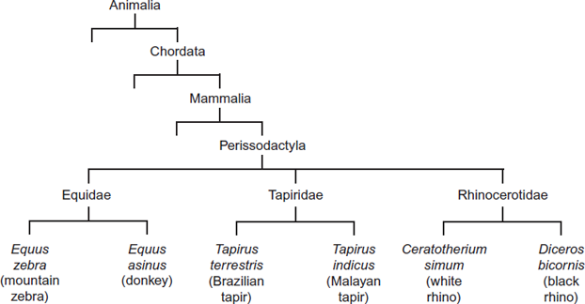

(a) This type of classification can be described as a phylogenetic hierarchy.(i) What is meant by a hierarchy?

1. Groups within groups;

Accept: idea of larger groups at the top or smaller groups at the bottom

2. No overlap (between groups);

(ii) How many different families are shown in the figure?

3; (1)

(iii) To which phylum does the white rhino belong?

Chordata;

Accept: if phonetically correct eg ‘Cordata’

(b) (i) Explain the role of independent segregation in meiosis.

1. (To provide) genetic variation;

Genetic variation must be directly stated and not implied

2. (Allows) different combinations of maternal and paternal chromosomes / alleles;

Accept: any allele of one gene can combine with any allele of another gene

(ii) A zedonk is the offspring produced from breeding a mountain zebra with a donkey.

• The body cells of a mountain zebra contain 32 chromosomes.

• The body cells of a donkey contain 62 chromosomes.

Use this information to suggest why zedonks are usually infertile.

1. (Zedonk has) 47 / odd / uneven number of chromosomes;

Accept: diploid number would be odd

Reject: if wrong number of chromosomes is given

2. Chromosomes cannot pair / are not homologous / chromosome number cannot be halved / meiosis cannot occur / sex cells / haploid cells are not produced;

Accept: cannot have half a chromosome

Q Reject: meiosis cannot occur in sex cells

Q2. The diagram shows two different ways of classifying the same three species of snake.

• Classification X is based on the frequency of observable characteristics

• Classification Y is based on other comparisons of genetic characteristics.

All three species of snake belong to the Python family.

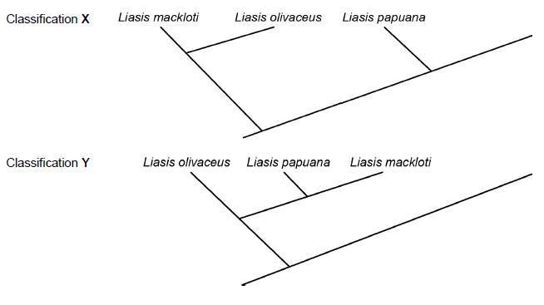
- What do these classifications suggest about the evolutionary relationships between these species of snake?

Classification X 1. (Without genetic analysis / X) mackloti and olivaceus have a more recent common ancestor with each other (than with papuana

Classification Y (Genetic analysis indicates / Y) papuana and mackloti have a more recent common ancestor with one another (than with olivaceus

Accept ‘more closely related to’ for ‘more recent common ancestor’

(b) Complete the table below to show the missing names of the taxa when classifying these snakes. (1)

Domain | Eukaryote
Kingdom | Animal
Phylum | Chordata
Class | Reptilia
Order | Squamata
Family | Python

(c) There is a debate about the name of one of these species of snake. Some scientists name it Liasis papuana and other scientists name it Apodora papuana.Give the name of the taxon about which the scientists disagree.

Genus / genera;If the response has two answers no mark is awarded.

Outcome:

- Explain how genetic sequencing and immunology can help us to update our understanding of evolutionary relationships
- Interpret results from genetic and immunological analysis, to draw valid conclusions as to evolutionary relationships between organisms.

How can we determine the Evolutionary relationships of Species?

- Comparing the frequency of observable characteristics.

- Comparing the base sequence of DNA - the more similar the DNA sequence, the more closely related the 2 species are, the more difference in the DNA sequence the less closely related the 2 species are.
Species accumulate mutations over time, so the less closely related they are, the more mutations they will have and therefore the more different the sequences of bases.

- Comparing the base sequence of mRNA.

- Amino acid sequences of certain proteins can be compared between different species- the more similar the amino-acid sequence, the more closely related the 2 species are, the more difference in the amino-acid sequence the less closely related the 2 species are.

Application- You will learn more about this in the evolution booklet

DNA Hybridisation: pair two strands for the same gene from two different organisms together. If they are closely related, the sequence of bases will be very similar so more complementary pairing so more H bonds will form. Therefore takes a higher temperature to break these extra bonds.

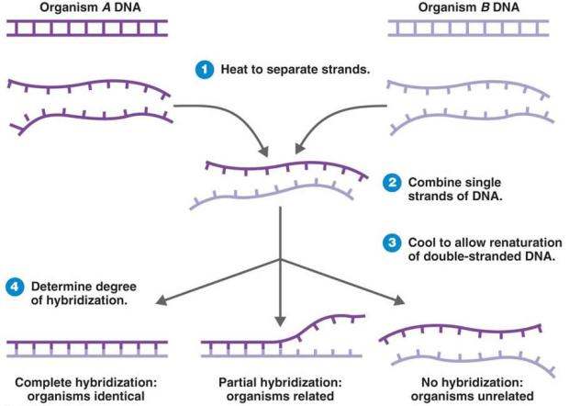

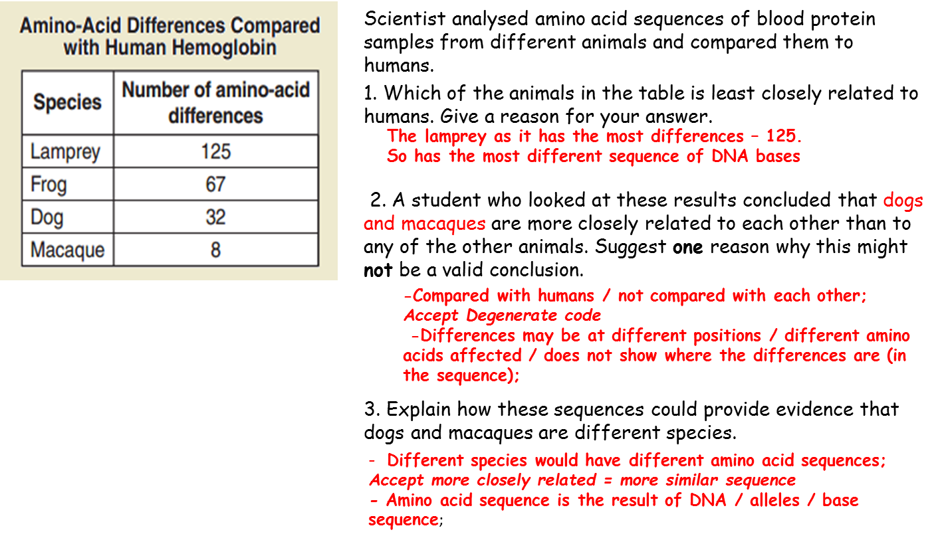

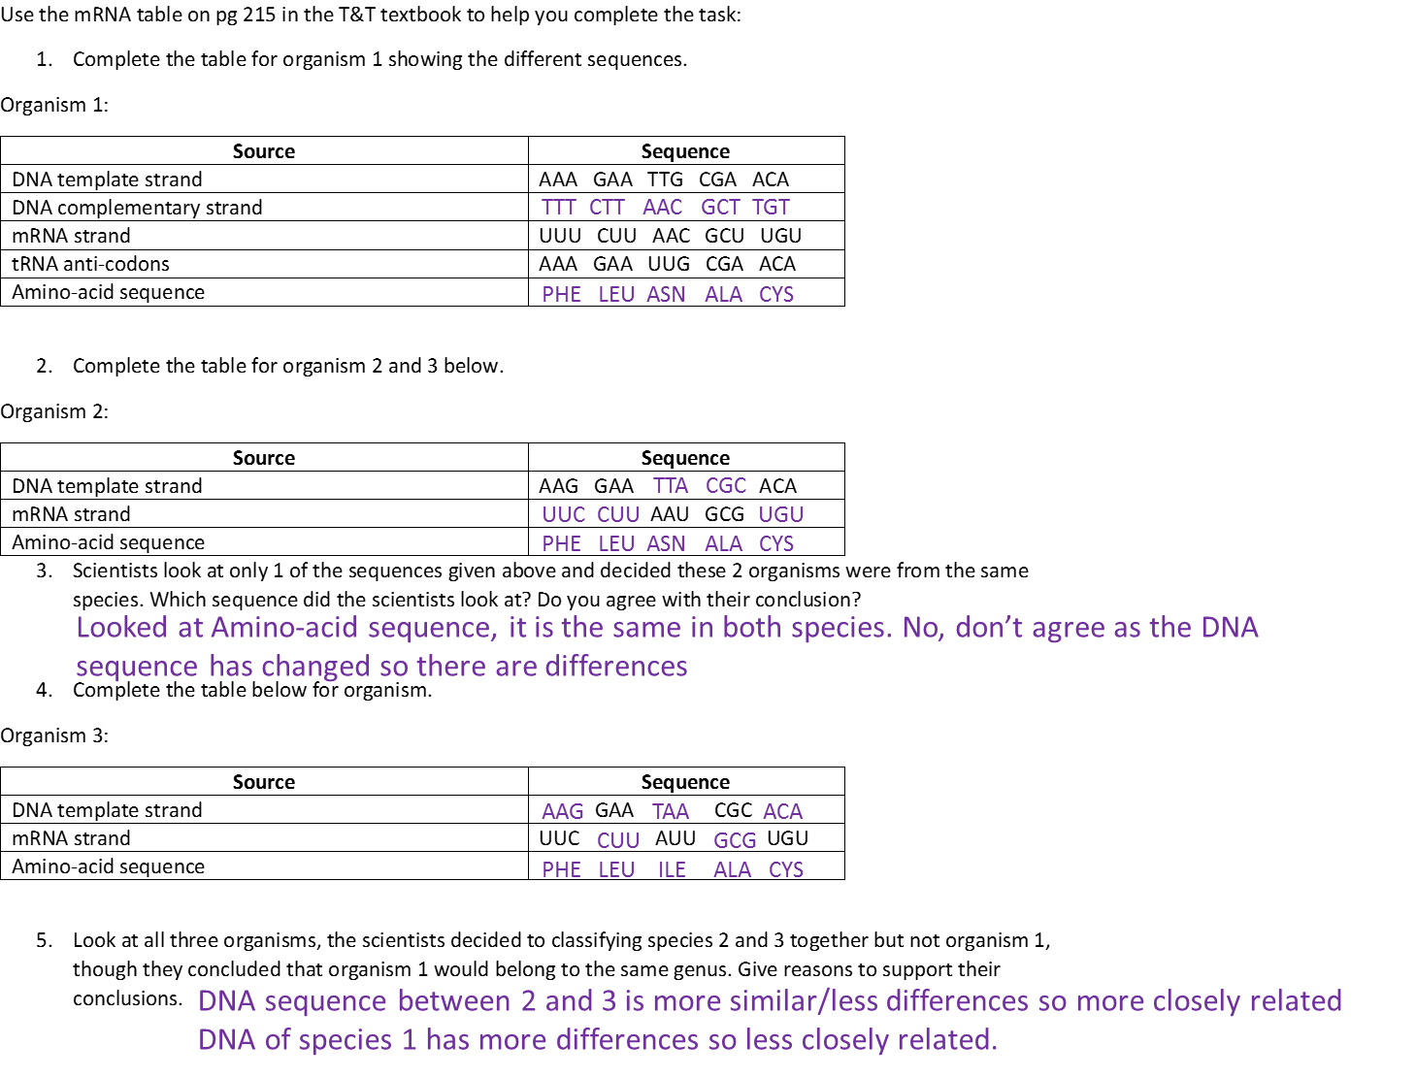

Exam question:

A group of scientists investigated genetic diversity in different species of bird. For each species, the scientists:

• collected feathers from a large number of birds

• extracted DNA from cells attached to each feather

• analysed the samples of DNA to find genetic diversity.

Table 2 summarises their results.

Table 2

Species of bird | Number of genes  examined | Number of genes  examined that showed  genetic diversity
Willow flycatcher | 708 | 197
House finch | 269 | 80
Bluethroat | 232 | 81

(b) In this investigation, what is meant by genetic diversity?

Number of different alleles of each gene.

Accept number of different base sequences (found) in each gene

(1)

(c) The scientists concluded that the bluethroat showed greater genetic diversity than the willow flycatcher. Explain why they reached this conclusion. Use calculations to support your answer.

1. Has greater proportion of genes / percentage of genes showing diversity;

2. Percentage is 35% compared with 28% / proportion is 0.35 compared with 0.28.

Allow correct figures that are not rounded up, i.e., 34.9% / 0.349 and 27.8% / 0.278

(2)

