Species and Taxonomy Assessment
Name: ______________________________________________________________________
Q1.(a) The cheetah, Acinonyx jubatus, and other cat species belong to the family Felidae. Complete the table to show the classification of the cheetah.

Kingdom | Animalia
 | Chordata
 | Mammalia
 | Carnivora
Family | Felidae
Genus
(2)
(b) This system of classification is described as hierarchical. Explain what is meant by a hierarchical classification.
___________________________________________________________________
___________________________________________________________________
(1)
(c) Despite differences in form, leopards, tigers and lions are classified as different species of the same genus. Cheetahs, although similar in form to leopards, are classified in a different genus.
(i) Describe one way by which different species may be distinguished.
______________________________________________________________
______________________________________________________________
(1)
(ii) Suggest two other sources of evidence which scientists may have used to classify cheetahs and leopards in different genera.
1. ____________________________________________________________
______________________________________________________________
2. ____________________________________________________________
______________________________________________________________
(2)
(Total 6 marks)
Q2.(a) An order is a taxonomic group. All seals belong to the same order. Name one other taxonomic group to which all seals belong.
___________________________________________________________________
(1)
(b) The diagram shows how some species of seal are classified.
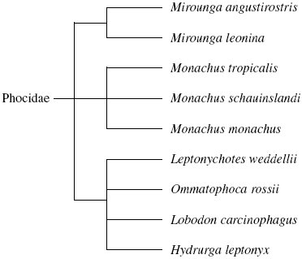
(i) How many different genera are shown in this diagram?
_____________________________________________________________
(1)
(ii) All the seals shown in the diagram are members of the Phocidae. Phocidae is an example of a taxonomic group. Of which taxonomic group is it an example?
______________________________________________________________
(1)
(iii) The diagram is based on the evolutionary history of the seals. What does the information in the diagram suggest about the common ancestors of Mirounga angustirostris, Mirounga leonina and Monachus tropicalis?
______________________________________________________________
______________________________________________________________
______________________________________________________________
(1)
(c) A species of seal shows genetic diversity. Explain what is meant by genetic diversity.
___________________________________________________________________
___________________________________________________________________
(1)
(Total 5 marks)
Q3.(a) The mammals form a class called the Mammalia within the animal kingdom. The grey wolf is a species of mammal. Figure 1 shows the groups within the Mammalia to which the wolf (labelled W) belongs.
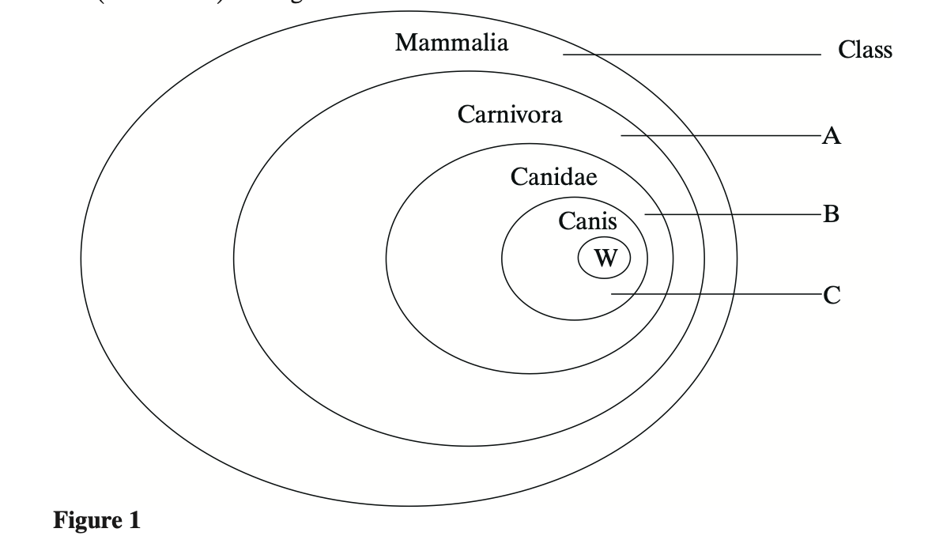
(i) Label Figure 1 to show the names of the groups.
(2)
(ii) The lion, Panthera leo, belongs to another group in the Carnivora, called the Felidae. Add this information to Figure 1, using the letter L to represent the lion species.
(1)
(b) The diagrams show two systems of classification of mammals. Figure 2 shows a simple hierarchy. Figure 3 shows a phylogenetic system.
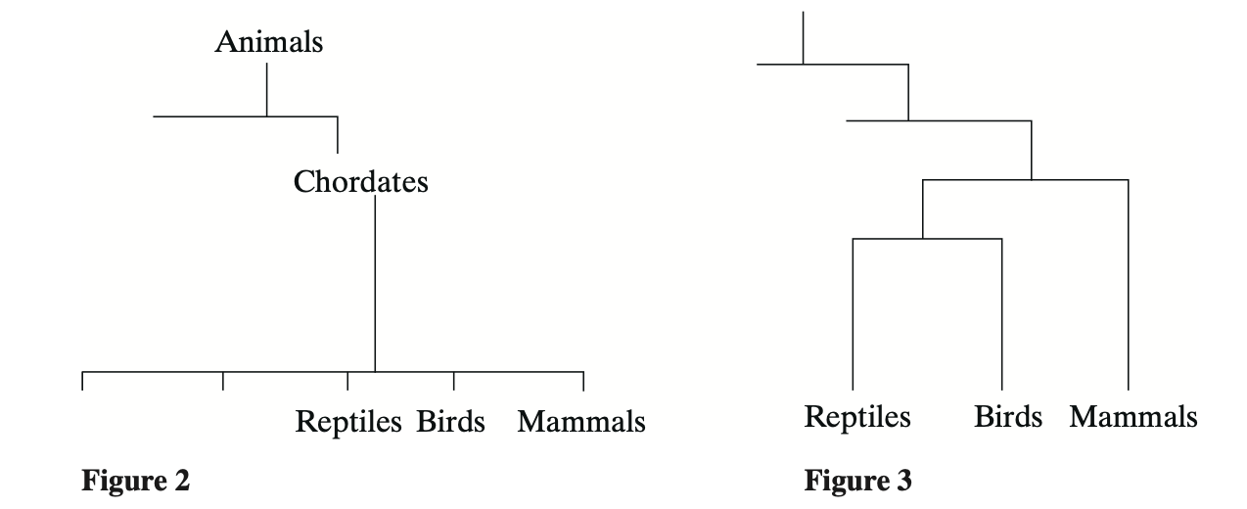
(i) What is meant by a hierarchy?
______________________________________________________________
______________________________________________________________
(1)
(ii) By reference to Figures 2 and 3, explain how a phylogenetic system differs from a simple hierarchy.
______________________________________________________________
______________________________________________________________
______________________________________________________________
______________________________________________________________ (3)

Q4. (a) Use your knowledge of classification to arrange class, phylum, genus and family in order of decreasing number of species.
largest number of smallest number of species species
___________ ___________ ___________ ___________
(1)
(b) Cytochrome c is a protein involved in one of the reactions of aerobic respiration in a mitochondrion. The molecular structure of cytochrome c from different species has been analysed. More similarities are present in the structure of cytochrome c in closely related species than in distantly related species.
(i) Explain what is meant when two species are described as being closely related.
______________________________________________________________
______________________________________________________________
(1)
(ii) A difference in the molecular structure of cytochrome c may arise in a small population that becomes geographically isolated. Explain how the difference may arise and how it may spread in the population.
______________________________________________________________
______________________________________________________________
______________________________________________________________
______________________________________________________________
______________________________________________________________
______________________________________________________________
(4)
Q5.Micronesia is a group of islands in the Pacific Ocean. The white-fronted ground dove is a bird found on these islands.The diagram below shows how the white-fronted ground dove is classified.
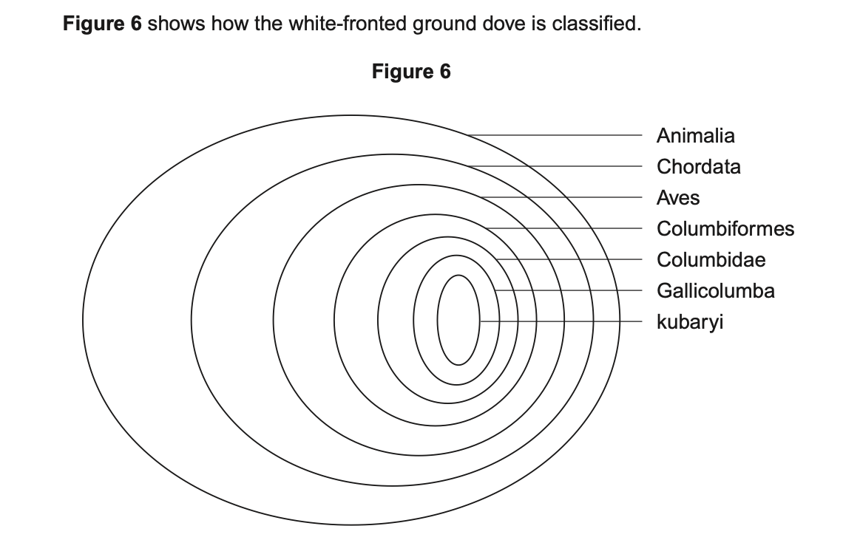
(a) To which class does the white-fronted ground dove belong?
______________________________________________________________
(1)
(b) Give the scientific name for the white-fronted ground dove.
______________________________________________________________
(1)
(c) This classification system consists of a hierarchy as there are small groups within larger groups.
Give one other feature of a hierarchy that is shown in the diagram.
______________________________________________________________
______________________________________________________________
(1)

Q6. Figure 1 shows one way in which the kingdom Fungi can be classified.

Figure 1

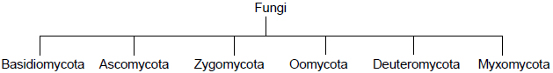

(a) Name the taxon represented by Zygomycota.

___________________________________________________________________

(1)

Rhizopus is a member of the Zygomycota. It has thread-like hyphae that form a mass, called a mycelium, across its food source. Vertical hyphae form spore-carrying sporangia. A new hypha grows from each spore.

Figure 2 shows the life cycle of Rhizopus.

Figure 2

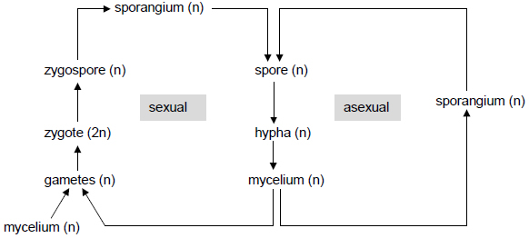

(b) Write the letter M on Figure 2 to show where meiosis occurs.

(1)

(c) Figure 2 shows that Rhizopus is able to reproduce both asexually and sexually. Suggest and explain one advantage of asexual reproduction and one advantage of sexual reproduction in this life cycle.

Asexual ____________________________________________________________

___________________________________________________________________

Sexual _____________________________________________________________

___________________________________________________________________

(2)

Figure 3 shows one spore-carrying sporangium from Rhizopus. The magnification of Figure 3 is × 700.

Figure 3

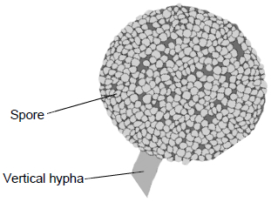

(d) The hypha supporting the spore-carrying sporangium is vertical.

Suggest one advantage of the hypha being vertical.

___________________________________________________________________

___________________________________________________________________

(1)

(e) A scientist wanted to calculate the mean volume of Rhizopus spores.

Describe how she could use Figure 3 do this.

You may assume the spores are perfectly spherical.

___________________________________________________________________

___________________________________________________________________

___________________________________________________________________

___________________________________________________________________

___________________________________________________________________

___________________________________________________________________

___________________________________________________________________

(3)

