3.1 Molecules - 3.1.4.2 Enzymes
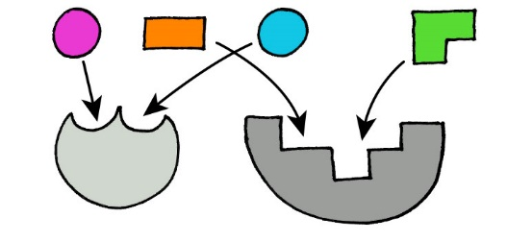

NAME: TEACHER BOOKLET

Reflection on outcomes | or | Target
Interpret energy level diagrams and identify the activation energy

Explain the induced fit model of enzyme action

Evaluate the strengths of the induced fit model against the lock and key theory

Apply knowledge of tertiary structure to explain enzyme specificity and the formation of enzyme-substrate complexes.

Explain how temperature, pH, substrate concentration, enzyme concentration, and the presence of inhibitors affect enzyme catalysis

Describe and explain trends within graphs, relating this back to the tertiary structure of active sites and the effect of these variables

Calculate rate of reaction from graphs and raw data, and explain the advantage of using initial rate

Interpret graphs of enzyme catalysed reactions and apply knowledge to explain them.

Outcome
- Interpret energy level diagrams and identify the activation energy
- Explain the induced fit model of enzyme action
- Evaluate the strengths of the induced fit model against the lock and key theory
- Apply knowledge of tertiary structure to explain enzyme specificity and the formation of enzyme-substrate complexes.

Definition:
Enzymes are globular proteins with a specific tertiary structure which act as biological catalysts and increase the rate of reaction by lowering the activation energy.
Enzyme Action

Almost all reactions in living organisms (metabolism) are catalysed by enzymes. Anabolic reactions build up complex molecules from simple ones e.g. making a disaccharide. Catabolic reactions break down complex molecules into smaller ones e.g. breaking down a disaccharide.

Enzymes are:
- Catalysts which speed up chemical reactions but remain unchanged at the end and can be reused
- Globular proteins with a specific primary structure of amino acids
- Coiled into a precise 3D shape determined by tertiary structure
- Are soluble in water because they have hydrophilic R groups on the outside and hydrophobic R groups on the inside
- Enzymes have an ACTIVE SITE formed from tertiary structure
- The active site is a depression on the surface of an enzyme to which a specific substrate binds
- The shape of the active site is COMPLEMENTARY to the shape of the substrate

Exam note: In your Exams talk about the ACTIVE SITE rather than the enzyme
Use these words to fill in the diagram below

Active Site, Enzyme Substrate Complex, Products, Enzyme, Substrate, Active site changes shape, Enzyme, Enzyme product complex
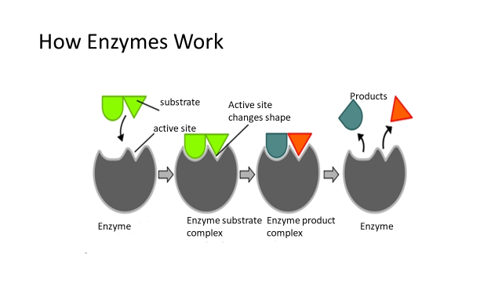

Activation Energy
- For a reaction to occur there needs to be enough energy available. The minimum amount of energy required for a reaction to start is known as the Activation energy.
- Enzymes lower the activation energy required to start a reaction. This speeds up the rate of reaction.
- Enzymes do this by bending the bonds between molecules this means that less energy is required for the bonds to be broken when the reaction occurs.

The graph below shows the activation energy required for a reaction to occur without enzymes.

Task:
- On the graph draw what you think the graph would look like for a reaction with enzymes.
- Then label your graph using these words: Energy, Progress of reaction, Substrate, Products, Activation energy, With enzymes, Without enzymes
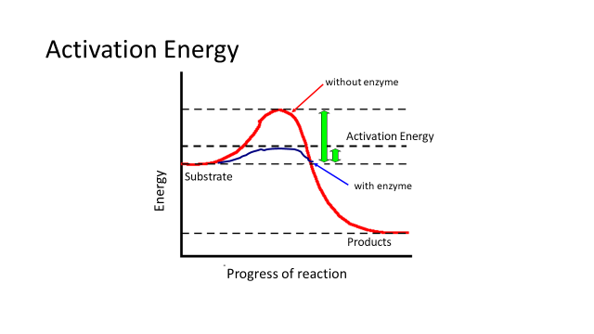

Exam Question

Q1. Formation of an enzyme-substrate complex increases the rate of reaction.
Explain how.
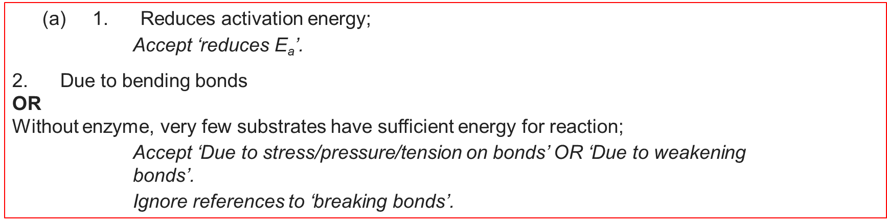
(2)

Q2. The graph shows the energy changes which take place during the reaction in which hydrogen peroxide is converted to water and oxygen.
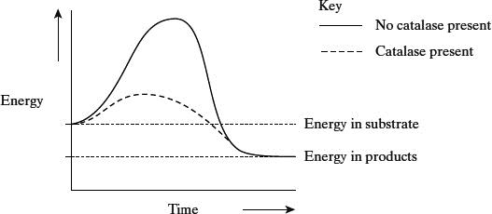
Use the graph to explain why
(i) hydrogen peroxide breaks down at a lower temperature when catalase is present than when it is not present;
______________________________________________________________
______________________________________________________________
(1)
(ii) test tubes A and B became warmer when the reaction was taking place.
______________________________________________________________
______________________________________________________________
______________________________________________________________
______________________________________________________________
(2)

(c) (i) Lower activation energy / less energy required to bring about reaction;

1

(ii) Energy in products / water and oxygen less than energy in substrate / reactants / hydrogen peroxide;
(Difference) given out as heat / exothermic;

Models of Enzyme Action

Lock and Key
- This is the older model and not as widely accepted as the induced fit theory.
- Lock and key states that the active sites do not change shape they are already fully complementary to the substrate.

Induced Fit Hypothesis
- Before the reaction the active site is not complementary to/does not fit the substrate
- The shape of active site changes as substrate binds forming a enzyme-substrate complex
- The substrate forms temporary bonds with the R groups of amino acids lining the active site
- This stresses/bends the bonds in substrate
- Lowers the activation energy leading to the reaction

Task
In the space below Illustrate the two models of enzyme action then annotate your diagrams with comparisons and differences between the two theories.
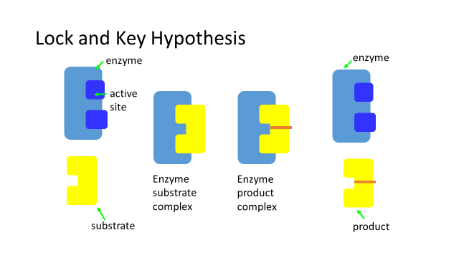

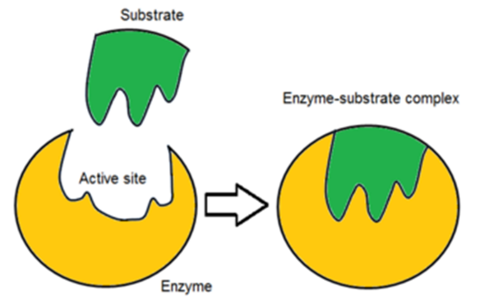

Exam Questions

Q1)
(a) Induced fit and lock and key are two models used to explain the action of enzymes.
(i) Describe the induced fit model of enzyme action. (2)
________________________________________________________________________________________________________________________________________________________________________________________________________________________________________________________________________________________
- Active site not complementary
- Active site changes shape
- Allows substrate to fit/ESC to form
(ii) Describe one way that the lock and key model is different from the induced fit model. (1)
__________________________________________________________________________________________________________________________________________________________________________________________________________________
- Active site does not change shape/is already complementary
(b) Explain how the shape of an enzyme molecule is related to its function. (2)
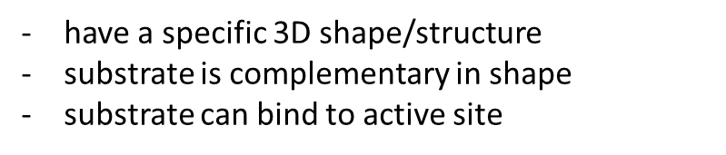
________________________________________________________________________________________________________________________________________________________________________________________________________________________________________________________________________________________
Q2)

- Explain the importance of tertiary structure to the functioning of an enzyme [4]
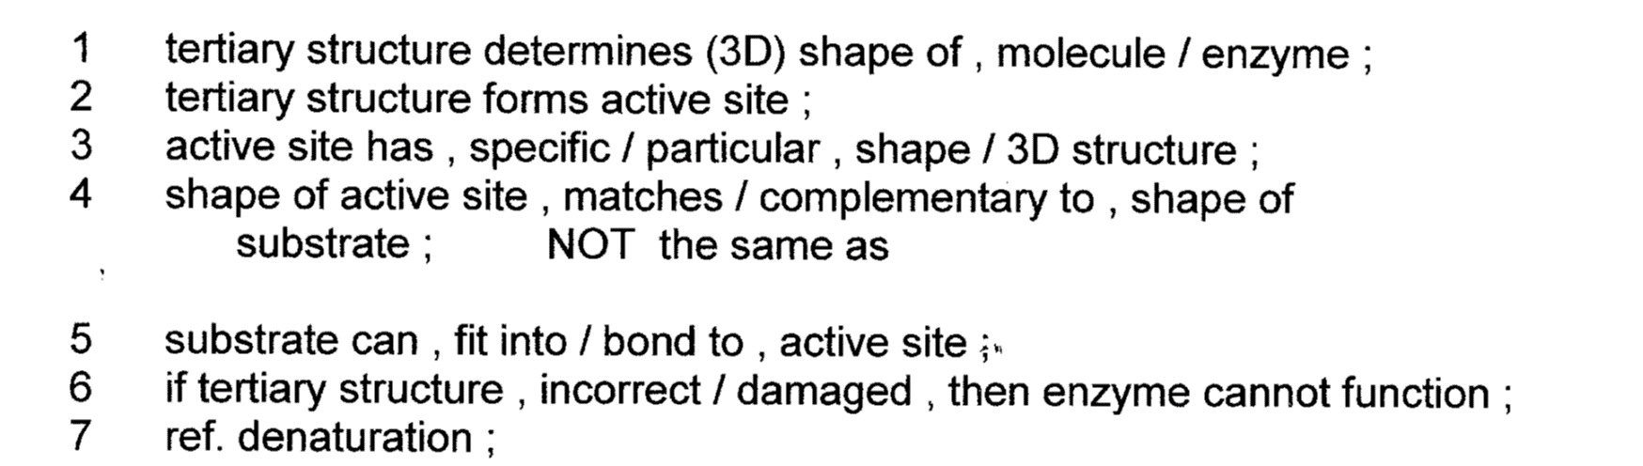
__________________________________________________________________________________________________________________________________________________________________________________________________________________________________________________________________________________________________________________________________________________________________________________________________________________________________________________________________________________________________________
- With reference to the functioning of an enzyme, explain what is meant by the term active site [4]
1. depression / cleft / groove / AW ; (A) on a labelled diagram.
2. on (surface of) enzyme ;
3. site where catalysis occurs / AW ;
4. specific shape ;
5. to take / complementary to , substrate ;

6. R groups / side chains , line active site ;
7. bonds with substrate ;
8. puts strain on substrate / AW ;
9. ref. “lock & key” ;
10. induced fit ;
11. detail of induced fit ;

- Biological washing powders make use of enzymes such as lipases and proteases to help remove stains. Explain how biological washing powders help to remove protein stains from clothes [4]
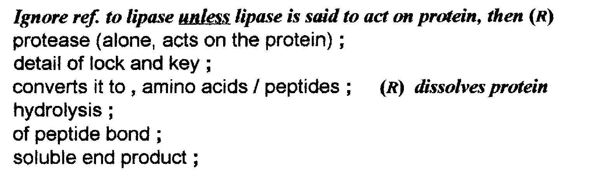
____________________________________________________________________________________________________________________________________________________________________________________________________________________________________________________________________________________________________________________________________________________________________________________________________________________________________

- Explain why an enzyme which catalyses the conversion of starch to maltose is unable to catalyse the conversion of a protein into amino acids [2]
Specificity ;
Active site certain shape ;
Complementary to starch / starch causes induced fit ;
A substrate protein will not , enter active site / fit active site / form ESC ;

Q3. Maltose is hydrolysed by the enzyme maltase. Explain why maltase catalyses only this reaction.
___________________________________________________________________

1. Active site (of enzyme) has (specific) shape / tertiary structure / active site complementary to substrate / maltose;

Reject active site on substrate.
Must have idea of shape

Assume “it” = maltase

Accept (specific) 3D active site

Reject has same shape

2. (Only) maltose can bind / fit;

Accept “substrate” for “maltose”

3. To form enzyme substrate complex.

Accept E−S complex

___________________________________________________________________
___________________________________________________________________
___________________________________________________________________(

Outcome
- Describe and explain trends within graphs, relating this back to the tertiary structure of active sites and the effect of these variables
- Calculate rate of reaction from graphs and raw data, and explain the advantage of using initial rate.

Following the Course of an enzyme controlled reaction.

This can be done by measuring the formation of the product or the conversion of a substrate.
Remember- never use the word amount- always be specific with what it being measured i.e. concentration, mass, volume etc.

Example of measuring product formation:
Catalase
2H₂O₂ O₂ + 2H₂0

The substrate is hydrogen peroxide. The products are water and oxygen. The enzyme is catalase

- What Type of reaction is occurring? _________________________________________
Hydrolysis

- How could you Qualitatively measure the rate of this reaction?
_________________________________________________________________________________________________________________________________________________________________________________________________________________________________
How quickly bubbles are produced.

- How could you Quantitatively measure the rate of this reaction?
_________________________________________________________________________________________________________________________________________________________________________________________________________________________________
Collect and measure the volume of oxygen produced over a set period of time.

The following Data was collected from a similar experiment.
Plot the data on a graph on the next page. Remember to put your axis in the correct place, label them correctly and give them units separated by () or /
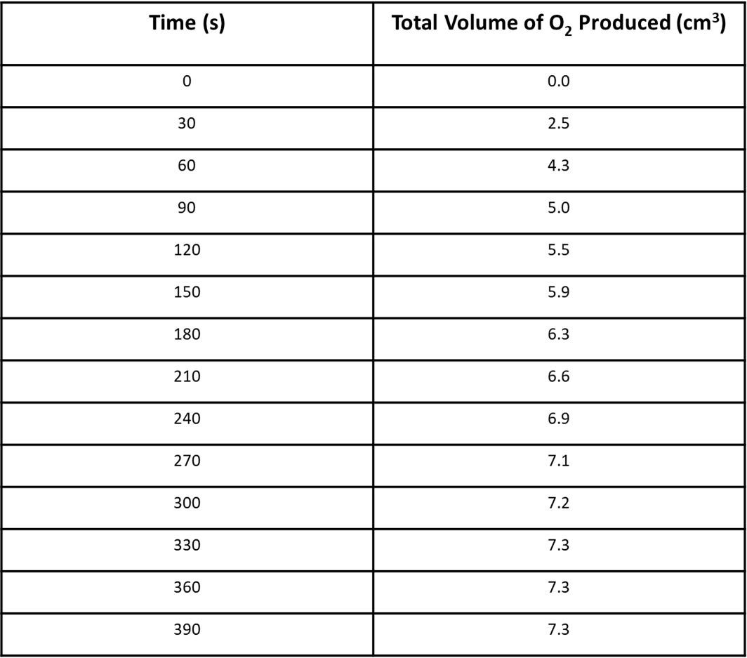

Drawing a Graph
Task:

- Plot the data on a graph on the next page. Remember to put your axis in the correct place, label them correctly and give them units separated by () or /
- You must be able to describe and explain what a graph shows.
C
B
  - Describe – Say what you see. Use both the axis labels in your answer. Comment on all changes in gradients. Quote figures with units.
  - Explain – Use your biological knowledge – state why it looks the way it does.
- There should be 3 sections to your graph:
- the initial increase
- the middle section where the rate slows
- the final part of the graph where it levels out
- Label these parts on your graph.
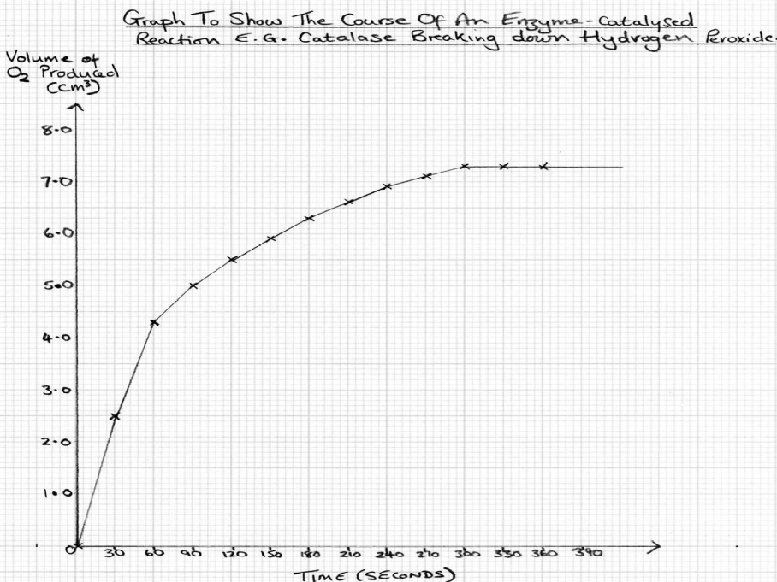

Task: Complete the table below to DESCRIBE and then EXPLAIN what is happening in each section of the graph.
Letter | Describe | Explain
A | As time increases, the volume of O₂ produced increases rapidly. There is a fast initial rate of reaction. | This is because when the enzyme & substrate are first mixed, there are many substrate molecules, so every enzyme’s active site has a substrate molecule bound to it. The substrate is rapidly broken down into its products.
B | As time increases, the volume of O₂ produced increases but not as rapidly | More and more substrate is converted into product, so there are fewer & fewer substrate molecules to bind with the active site. Therefore some enzymes active sites are unoccupied & the rate of reaction becomes slower
C | There is a plateau – no more O₂ is produced. | There are fewer & fewer substrate molecules (as turned into product).  Therefore reaction slows down & eventually stops when all the substrate has been converted to product.
Task: Using the information above and your own knowledge…

- When is the rate of an enzyme catalysed reaction the fastest?
______________________________________________________________________________________________________________________________________________________
At the start of the reaction.

- What is this rate called?
The initial rate of reaction.
___________________________________________________________________________

- Suggest why it may be better to use this section of the curve rather than simply measuring the rate after a certain period of time?
At the start of the curve there are minimal limiting factors. Factors like substrate concentration can slow the rate of reaction when not in excess.

Maths Skill – Calculating the rate of reaction

Sometimes you may be asked to calculate the rate of reaction from a graph. You will be asked to either calculate the initial rate of reaction or the rate of reaction at a specific point.

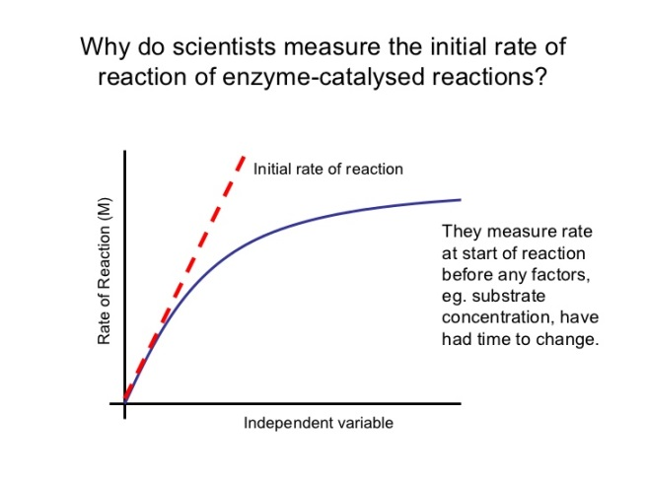
To calculate the initial rate of reaction
Volume of product
Step 1. Draw a tangent (using a pencil!) to calculate the initial rate of reaction. Your tangent must go through the intercept at 0.

Step 2. Draw a triangle from this

Step 3. Read off the change in product (Y) and the change in time (X).

Step 4. We now calculate the gradient of this line using the equation

Rate of reaction = change in y
change in x

Now, using your graph on page 8 calculate the initial rate of reaction. Make sure to include the correct units in your answer. Show your working below.
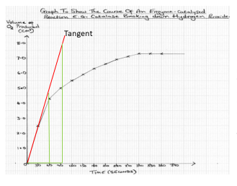

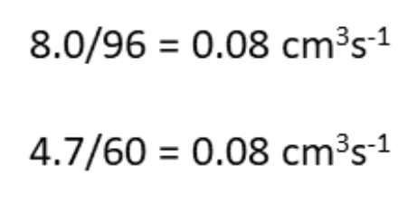

Calculating rate from specific times.

This is a very similar process, for example calculating the rate of reaction at 30 seconds or 2 mins etc.
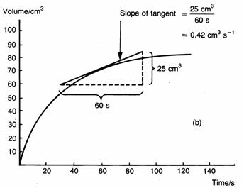
Rate of reaction = change in y
change in x

Step 1. Draw a tangent – a straight line that only touches the curve at one point (the point that you are working out the rate of reaction for).
Step 2. Draw a triangle from this (as below).
Step 3. Read off the change in product (Y) and the change in time (X).
Step 4. We now calculate the gradient of this line using the equation above.
e.g.
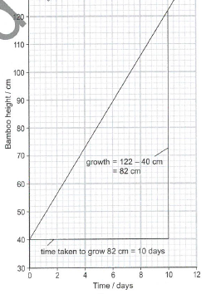

Example 1: the triangle has been drawn for you and the change in y and change in x have been calculated. Work out the rate of reaction and include the correct units!

1a. 82/10 = 8.2 cm/day

Example 2:
- Work out the rate of reaction at 60 seconds for the reaction with the enzyme present.

2a. With enzyme 1.2/36 = 0.03 mol per second (unit: mol/s)
(36 – each little square on the x axis is worth 6 seconds

2b. Without enzyme 4/240 = 0.017 mol/s

2c. 0.03 / 0.017 = 1.76 times faster

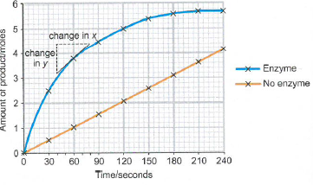
- Now work out the rate of reaction without the enzyme at 60 seconds.

- How many times faster is the rate of reaction when the enzyme is present?

Exam Question

(a) A scientist investigated the hydrolysis of starch.
He added amylase to a suspension of starch and measured the concentration of maltose in the reaction mixture at regular intervals.
His results are shown in the graph below. (2)
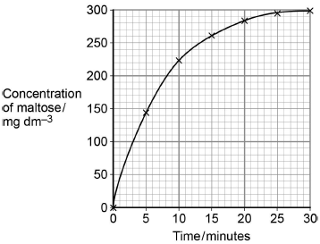

Determine the rate of the reaction at 10 minutes. Show how you obtained your answer.
(a) 1. Tangent to curve drawn;
Tangent drawn at about 10 minutes
2. Value in range of 8 to 11;
1 mark only for correct answer

Rate of reaction ____________________ mg dm⁻³ min⁻¹

(b) Explain the results shown in the graph.
(b) 1. (Rate of) increase in concentration of maltose slows as substrate/starch is used up
OR
High initial rate as plenty of starch/substrate/more E-S complexes;
Reject ref. to amylase being used up
2. No increase after 25 minutes/at end/levels off because no substrate/starch left;
Accept ‘little’
Ignore references to substrate a limiting factor
___________________________________________________________________
___________________________________________________________________
___________________________________________________________________
___________________________________________________________________
___________________________________________________________________

EXAM TIP
It is very important that you look closely at the y axis, if the axis is showing a measurement of the products or reactants you need to draw a tangent. If the Y axis shows rate of reaction you do not need to draw a tangent and can just read off the graph.

Q2) The scientists set up two experiments, C and L.
Experiment C used: the enzyme and different concentrations of ATP.
Experiment L used: the enzyme, different concentrations of ATP and a sugar called lyxose.

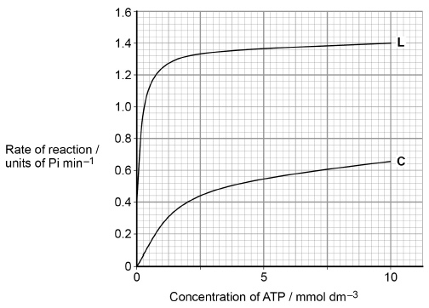
The scientists measured the rate of reaction in each experiment. Their results are shown in the graph

(c) Calculate the rate of reaction of the enzyme activity with no lyxose at 2.5 mmol dm^{–3} of ATP as a percentage of the maximum rate shown with lyxose.
(c) 31.4;;
Allow 1 max for
0.44 and 1.4
32.8
33.1
30
29.3

Outcome
- Explain how temperature, pH, substrate concentration, enzyme concentration, and the presence of inhibitors affect enzyme catalysis
- Describe and explain trends within graphs, relating this back to the tertiary structure of active sites and the effect of these variables
- Interpret graphs of enzyme catalysed reactions and apply knowledge to explain them.

Factors Affecting Enzyme Action
There are 5 factors we need to focus on when considering enzyme controlled reactions
- Temperature
- pH
- Substrate concentration
- Enzyme concentration
- The presence of Inhibitors
You need to be able to describe and explain and interpret graphs showing how each of these factors can affect enzyme controlled reactions and relate this back to the tertiary structure of active sites
1.Temperature
Complete the graph to show how temperature effects enzyme controlled reactions.
Fully annotate your graph including
- Label the point with the maximum rate of activity.
- Label the point at which all enzymes are denatured.
- Label a point where there is not very much kinetic energy.
1
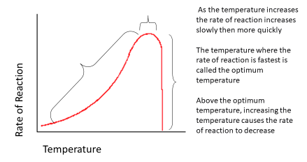
3
2

Describe | Explain
As the temperature increases the rate of reaction increases slowly then more quickly | - At low temperatures - less kinetic energy so less collisions between the substrate and enzyme active site - rate is low.  - As the temperature increases – more kinetic energy of the substrates and enzymes.  - Frequency of collisions between substrate and active sites increase so more enzyme-substrate complexes form, so more product form - rate increases.
The temperature where the rate of reaction is fastest is called the optimum temperature | Optimum temperature is when collisions between substrate and active sites are at their fastest - rate is fastest.
Above the optimum temperature, increasing the temperature causes the rate of reaction to decrease rapidly | Above the optimum temperature the enzyme vibrates more until the H bonds maintaining the tertiary structure break.  The shape of the active site changes – enzyme is denatured.  The active site and substrate are no longer complementary in shape.  Less ESC, EPC and product form – rate decreases rapidly.

Questions
- What is meant by the term denatured?
______________________________________________________________________________________________________________________________________________________
Shape of the active site changes and is no longer complimentary to the substrate

- Name the bond that is broken by high temperatures to denature an enzyme.
______________________________________________________________________________________________________________________________________________________
Hydrogen bonds

- Suggest the optimum temperature that enzymes work at in mammals.
______________________________________________________________________________________________________________________________________________________
37.5ºC ( Body Temperature)

- Suggest why enzymes in biological washing powders are taken from bacteria living in thermal vents.
______________________________________________________________________________________________________________________________________________________
So the enzymes do not denature
in the hot water used to wash clothes ( ie 40 degrees +)

Exam Question

A technician investigated the effect of temperature on the rate of an enzyme-controlled reaction. At each temperature, he started the reaction using the same volume of substrate solution and the same volume of enzyme solution.

The figure below shows his results.

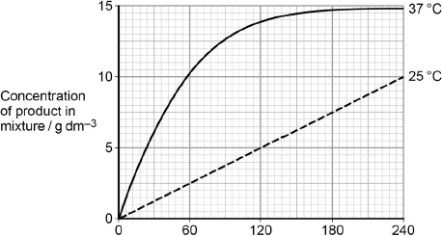
Time after start of reaction / s

(a) Give one other factor the technician would have controlled.

_____________________________________________________________

_____________________________________________________________
(a) Concentration of substrate solution / of enzyme solution / pH.

(1)

(b) Calculate the rate of reaction at 25 °C.
1. 2.5 / 0.04;
1 mark for correct value
2. g dm^{–3} minute^{–1} / g dm^{–3} s^{–1};
1 mark for related unit

Answer ____________________

(2)

(c) Describe and explain the differences between the two curves.

_____________________________________________________________
1. Initial rate of reaction faster at 37 °C;
2. Because more kinetic energy;
3. So more E–S collisions / more E–S complexes formed;
4. Graph reaches plateau at 37 °C;
5. Because all substrate used up.
Allow converse for correct descriptions and explanations for curve at 25 °C

_____________________________________________________________

_____________________________________________________________

_____________________________________________________________

Exam tip: Read the axis of your graph carefully!
The three graphs below all represent the same reaction- They look different because each Y axis shows a different measuring factor.
Add the correct axis title to each graph including suitable units.
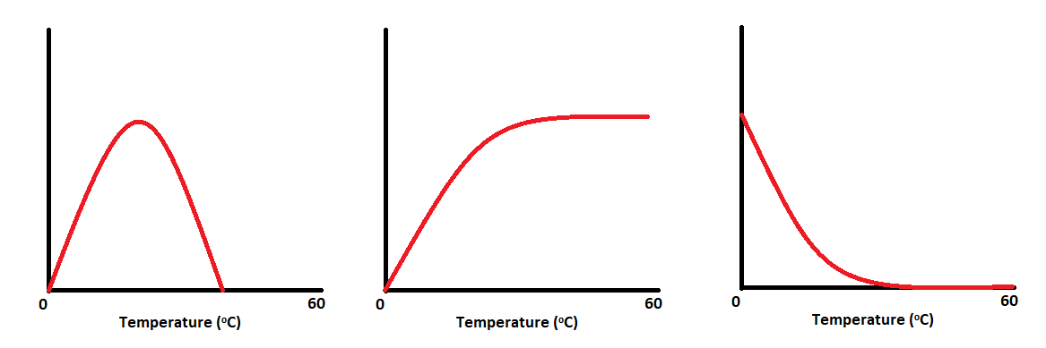
Rate of Reaction, Substrate Concentration, Mass of product released
Rate of Reaction
Mass of product
Substrate concentration

The enzyme graphs usually plateaux’s (levels off) because one of the other factors is limiting i.e. all of the substrate has been used up or all of the active sites are occupied.

2. pH
Each enzyme has a pH value that it works at with maximum efficiency called the optimal pH. If the pH is lower or higher than the optimal pH, the enzyme activity decreases until it stops working.
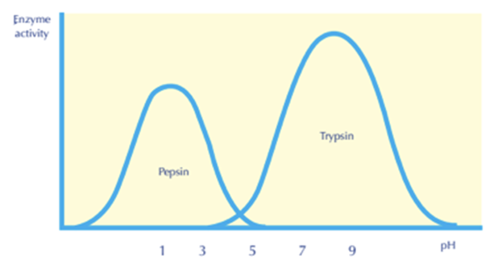
For example, pepsin works at a low pH, i.e, it is highly acidic, while trypsin works at a high pH, i.e, it is basic. Most enzymes work at neutral pH 7.4.

1

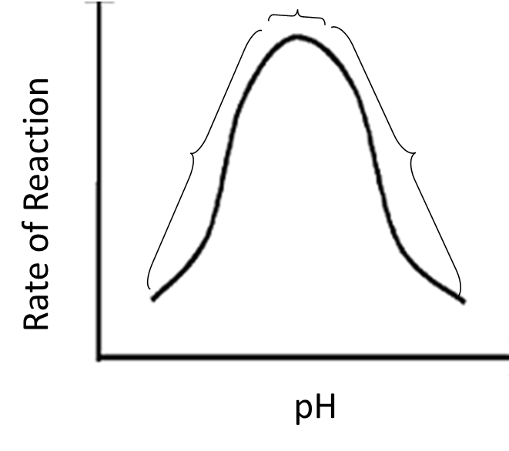
Complete the graph showing how pH affects enzyme activity

- Label where enzymes have become denatured.

- Label on the x axis where the optimum pH is.

2
2

Describe | Explain
The pH where the rate of of reaction is fastest is called the optimum pH | - At an optimum pH - tertiary structure/shape of the active site is complementary to the substrate.  - ESC form - rate is at its highest
Reducing or increasing the pH away from the optimum decreases the rate of reaction | - pH is a measure of H⁺ concentration  - Change in H⁺ concertation can:  - Disrupts/break hydrogen bonds and ionic bonds  - Change charge of amino acids in the active site  - Change tertiary structure and shape of the active site - enzyme is denatured  - The active site and substrate are no longer complementary in shape.  - Less ESC form – rate decreases

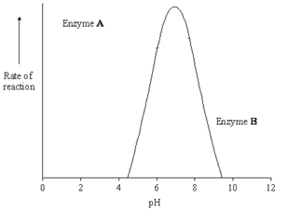
Question - Enzymes A and B digest protein. The graph shows the effect of pH on the rates of reaction of these enzymes.

Enzyme A, Pepsin, is a protein-digesting enzyme found in the stomach. It has an optimum pH of 2 and is fully denatured at pH 6.

Sketch a curve on the graph to show the effect of pH on the rate of reaction of pepsin.

Explain why the rate of reaction of enzyme B is low at pH 5.

____________________________________________________________________________________________________________________________________________________________________________________________________________________________________________________________________________________________________________
- (change in H ion concentration /pH) leads to breaking of ionic and hydrogen bonds holding tertiary structure/changes charge on amino acids;
- enzyme/protein/active site loses shape/denatured;
- substrate will not bind with/fit active site;
- fewer/no ES complexes formed;
Rising to a peak at pH2 and falling to 0 by pH 6.

Exam Question

- Students investigated the effect of pH on the activity of the protease.
•The students used agar plates containing protein. The protein made the agar cloudy.
•They made four wells of equal size in the agar of each plate.
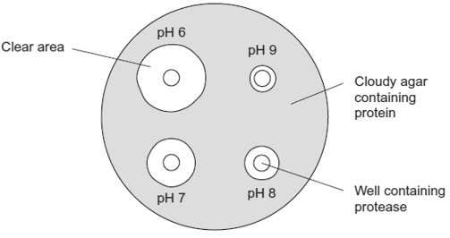
•They added a drop of protease solution to each of the wells. The protease solution in each well was at a different pH.
•The students incubated the agar plates for 4 hours at a constant temperature.
The diagram shows the agar plates after they were incubated and the pH of the protease solution in each well.

(i) How should the students make sure that the pH of the protease solution did not change?
______________________________________________________________
Use a buffer solution
(1)
(ii) Use the diagram to describe the effect of pH on the activity of this protease.
______________________________________________________________
______________________________________________________________
______________________________________________________________
Works best at pH 6 / at higher pH activity decreases;
Accept converse
Insufficient: pH 6 had largest clear area
(1)

Investigation into the effects of pH on Amylase Action
- What substrate does amylase act on?
starch
- What is the product of this reaction?
maltose
- What will be the independent variable? pH
- How does the enzyme increase the rate of reaction?
lower the activation energy

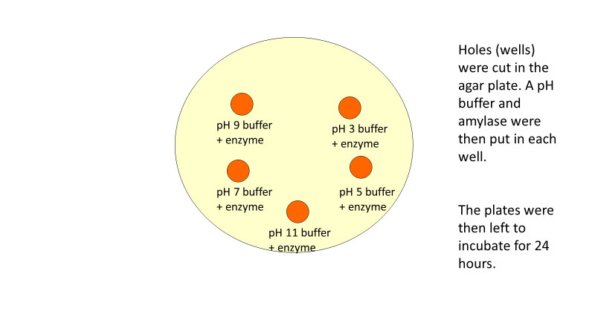
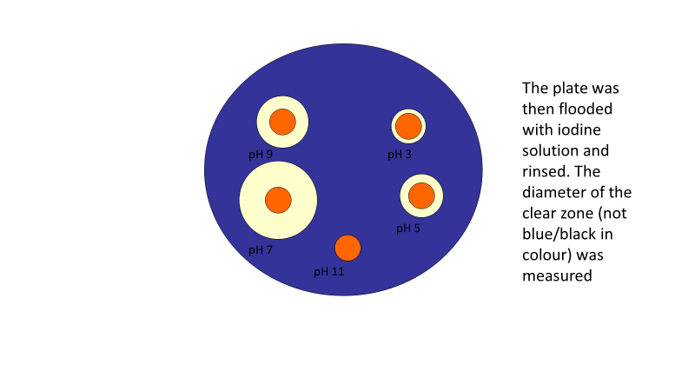
Amylase hydrolyses starch to maltose. You can investigate the effect of pH on the activity of amylase with a simple assay technique.
Figure 1 Holes cut in the starch form wells. pH buffer and enzyme are placed in each well
Figure 2 After 24 hours incubation the plate is flooded with iodine solution and rinsed. The diameter of the clear zone ( non-blue/black) is measured.
- Cut wells into the agar plate using a cork borer
- Place the same volume of a range of pH buffers in each well
- Place identical volumes of amylase solution into each well except one
- To the empty well add an equal volume of distilled water as a control.
- Incubate for 24h in a dry oven at 35°C
- Flood the plate with iodine solution and rinse with water
- Measure the diameter of the cleared zone – this would give a measure of how much substrate had been turned into product.

- What are the positive and negative results for the presence of starch using iodine solution?
Blue-black - positive brown/yellow -negative
- If amylase hydrolyses starch to maltose what result would you see?
Negative
- If amylase does not hydrolyse starch to maltose what result would you see?
Positive
You have been provided with 3 sets of results

pH | Diameter of Clear Zone (mm)
pH | Replicate 1 | Replicate 2 | Replicate 3 | Mean
3 | 17.0 | 17.0 | 17.0 | 17.0
5 | 21.0 | 20.0 | 24.0 | 21.7
7 | 38.0 | 20.0 | 42.5 | 33.3
9 | 25.0 | 30.0 | 30.0 | 28.3
11 | 0.0 | 0.0 | 11.5 | 3.8

- Calculate the mean diameter for each pH
- Sketch a graph to show the results.
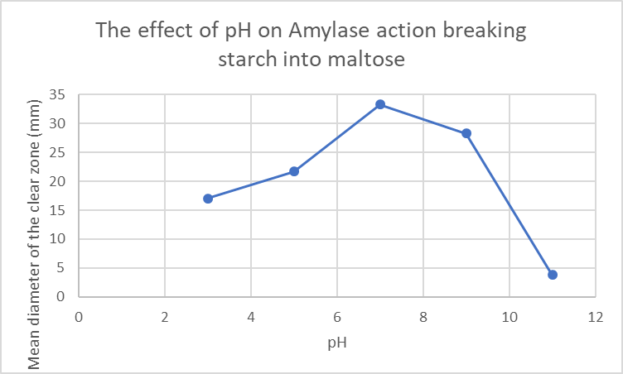

- Identify which pH provides the optimum condition for amylase to work in.
pH 7
- In which pH did amylase not work at all? pH11

- What would be the importance of repeats in the investigation? How many repeats were done here? More repeats increases the reliability of results. 3 repeats have been done here but >10 would be more acceptable
- Identify the anomalous result or outlier in the data.
Repeat 3 for pH 11.
- Why leave the plates for 24 hours rather than 1 hour
To make sure the amylase has had enough time to interact with the substrate
- What would you do as a control and why?
The concentration of starch, the concentration of enzyme and the temperature as they can all affect the rate of reaction

3.Substrate Concentration

In the presence of a given amount of enzyme, the rate of reaction increases as the substrate concentration increases until a limiting rate is reached.
Further increase in the substrate concentration produces no significant change in the reaction rate.
At this point, so much substrate is present that essentially all of the enzyme active sites have substrate bound to them. The enzyme molecules are saturated with substrate. The excess substrate molecules cannot react until the substrate already bound to the enzymes has reacted and been released

Complete the graph to show how Substrate concentration affects enzyme controlled reactions.
Fully annotate your graph including
- Axis titles
- Label on the V_{max}.
- Label on the part of the graph where the rate of reaction is directly proportional to the substrate concentration.
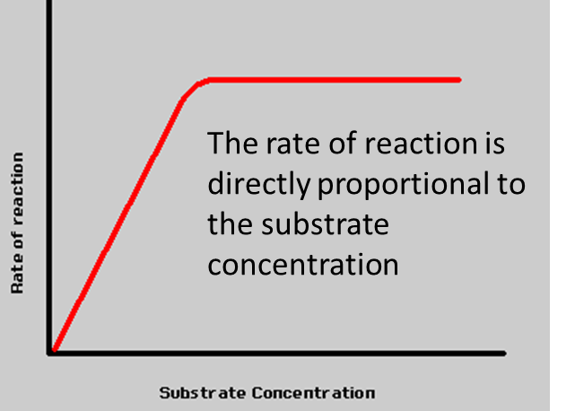
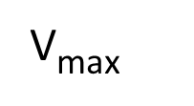

Describe | Explain
As the substrate concentration increases the rate of reaction increases | - As the concentration of substrate molecules increases, collisions between substrates and active sites occur more often.  - More ESC form so more products form which increases the rate of reaction
Until a certain point when increasing the substrate concentration will not further increase the rate | - Until a point is reached when all the active sites are occupied with substrates  - Further increases in substrate concentration has no effect on increasing the rate  - The enzymes are working at their fastest rate V_{max}

4.Enzyme Concentration

Complete the graph showing how enzyme concentration affects the rate of reaction
There are two scenarios so you are going to need to draw and label two lines on your graph.
- Add axis titles with suitable units
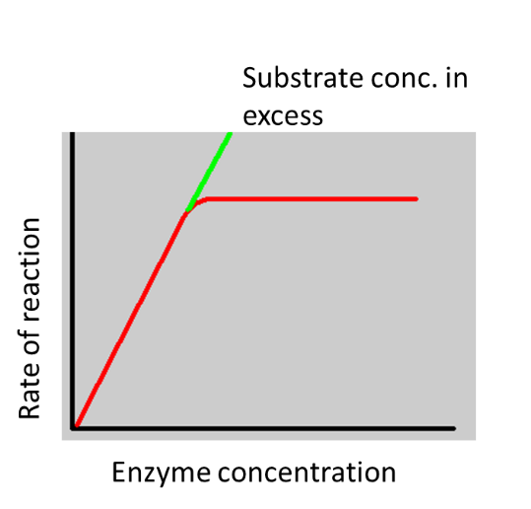
- Draw a line representing the rate of reaction as enzyme concentration increases if you have a fixed quantity of substrate.

Suggest why the graph levels off

The concentration of substrate is now the limiting factor

- Add a line to the graph showing the rate of reaction if the substrate concentration was in excess
- Label both lines correctly

Describe | Explain
When substrate is in excess  As the enzyme concentration increases the rate of reaction increases  The rate of reaction is directly proportional to enzyme concentration | When substrate is in excess  - As the enzyme concentration increases the number of active sites increases  - More substrate molecules can bind to the active sites to form ESC  - So more products form which increases the rate of reaction
When substrate is limiting  Until a certain point when increasing the enzyme concentration has no further effect on the rate | When substrate is limiting  - Until a certain point when there are more active sites than available substrate molecules to bind to them and the maximum rate is reached

Exam Questions
A student investigated the effect of lipase concentration on the hydrolysis of lipids.
He took a beaker containing a suspension of lipids. He placed a pH probe attached to a data logger into the beaker. After 5 minutes, he added the lipase solution. The data logger recorded the pH. The apparatus used is shown in the diagram below.
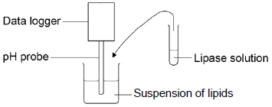
(a) The student did not add a buffer to the lipase solution.
Explain why.
(a) Student was measuring change in pH
OR
Buffer would maintain a constant pH.
___________________________________________________________________
___________________________________________________________________
___________________________________________________________________
(1)
(b) Give two variables the student would have controlled in this investigation.
1. _________________________________________________________________
2. _________________________________________________________________
1. Volume of suspension of lipids;
2. Concentration of suspension of lipids;
3. Volume of lipase solution;
4. Temperature;

(2)
(c) Give the suitable control for this investigation.
Boiled lipase solution
___________________________________________________________________
___________________________________________________________________
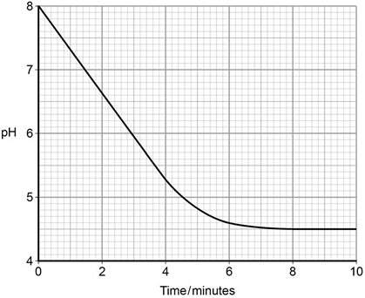
(1)
The data logger recorded the pH. The graph below shows what happened after he added the lipase solution.

(d) Draw a tangent on the graph and use it to calculate the rate of change at 5 minutes.
Rate of change at 5 minutes = _________________ pH minute⁻¹
–0.34 = 2 marks
0.34 = 1 mark
(2)
(e) Explain the results shown in the graph.
1. Fatty acids produced;
2. Curve levels off as all substrate used up.
accept the lower pH inactivates / denatures the enzyme
___________________________________________________________________
___________________________________________________________________
___________________________________________________________________
___________________________________________________________________
(2)
(f) The student repeated the experiment with a higher concentration of lipase solution.
Describe and explain the results you would expect him to get.
___________________________________________________________________
1. Faster fall in pH and levels off at same point;
2. More enzyme = substrate complexes formed;
3. Same amount of fatty acids produced / product
___________________________________________________________________

- Effect of Inhibitors on the Rate of Enzyme Reactions

Enzyme inhibitors are substances which reduce the rate or stop enzyme catalysed reactions because they have some effect on the enzyme molecule. They can be temporary or permanent.
Inhibitors can be Competitive or Non-Competitive

Competitive Inhibitors
- Competitive inhibitors have similar shape to the substrate.
- They compete with the substrate for the active site.
- They can occupy the active site.
- This prevents the substrate binding, so prevents the formation of the ESC.
- This reduces the rate of reaction.
- Increasing the concentration of substrate reduces the effect of the inhibitor

Task: In the space below draw and annotate a diagram illustrating the action of competitive inhibitors highlighting the key marks scheme points
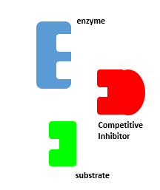
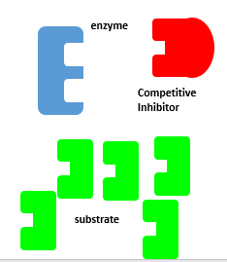

Complete the graph showing 3 lines.
- Rate with competitive inhibitors
- Rate with just enzyme
- Rate when lots of substrate and inhibitor

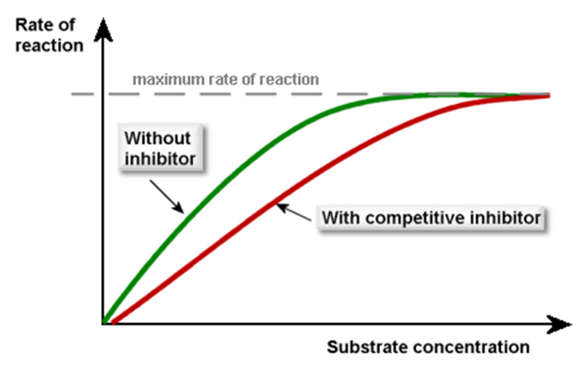

Non-competitive inhibitor
Rate, Substrate concentration, ESC, Reaction, Reduce, Tertiary, Inhibitor, Active site, Away, Allosteric, Complementary.

- Non competitive inhibitors bind to the enzyme AWAY from the active site at the ALLOSTERIC SITE
- Binding of the non competitive inhibitor disrupts the3D TERTIARY structure of the Active site
- This changes the shape of the ACTIVE SITE so the substrate is no longer COMPLEMENTORY and cant bind. The ESC cannot form.
- The addition of Non-Competitive inhibitors REDUCES the rate of REACTION
- Increasing the SUBSTRATE CONCENTRATION will not REDUCE the effect of the INHIBITOR.

Task: Draw and annotate a diagram illustrating the action of Non-competitive inhibitors highlighting the key marks scheme points.

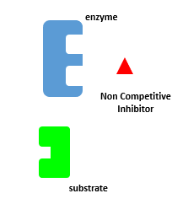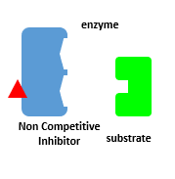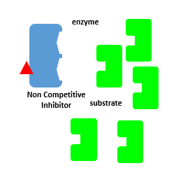

Task: Complete the graph showing the effect of inhibitors in a limited supply of substrate on the rate of an enzyme-controlled reaction.

You must include:

- Axis titles and suitable units.
- A line showing rate of just the enzyme with no inhibitors
- A line showing the effect of competitive inhibitors
- A line showing the effect of non-competitive inhibitors
- Make sure to label your lines

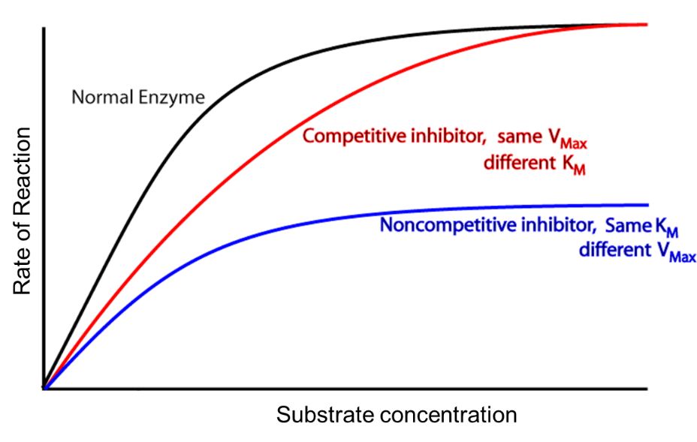

Exam Questions

Q1) The diagrams represent an enzyme, its substrate and two other molecules, A and B.
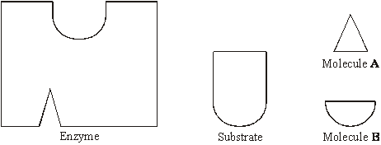

The addition of a non-competitive inhibitor will prevent the formation of an enzyme-substrate complex. Draw a labelled diagram based on relevant molecules selected from the diagram above to explain how this occurs.
Diagram showing molecule A fitting in inhibition site;
Distortion of active site;

(2)
Q2) In an investigation, the rate at which phenol was broken down by the enzyme phenol oxidase was measured in solutions with different concentrations of phenol. The experiment was then repeated with a non-competitive inhibitor added to the phenol solutions. The graph shows the results.
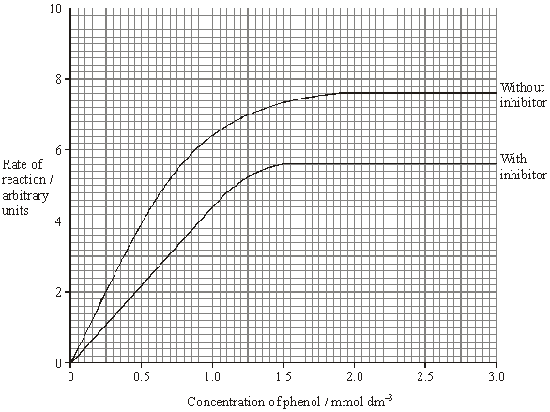

- Explain why an increase in concentration of phenol solution from 2.0 to 2.5 mmol dm^{–3} has no effect on the rate of the reaction without inhibitor.
__________________________________________________________________________________________________________________________________________ (2)
- Max rate at which enzyme can combine with substrate/form ESC/substrate no longer limiting/enzyme is limiting;
- Active site of enzyme saturated with substrate;

- Explain the effect of the non-competitive inhibitor.
- Inhibitor attaches to enzyme away from active site;
- Changes shape of active site;
- Prevents formation of ESC;

- Calculate the percentage decrease in the maximum rate of the reaction when the inhibitor was added. Show your working
.
7.6 -5.6 = 2
(2/7.6)100 = 26.3 %

(2)
- Draw a curve on the graph to show the results expected if a competitive inhibitor instead of a non-competitive inhibitor had been used.
(1)

Q3) Uric acid is produced in the body. One of the reactions involved in the production of uric acid is catalysed by xanthine oxidase.
xanthine
oxidase
xanthine uric acid
- Explain why xanthine oxidase is able to catalyse this reaction but it is not able to catalyse other reactions.
________________________________________________________________________________________________________________________________________________________________________________________________________________________________________________________________________________________________________________________________________________________________________
- Substrate has specific shape;
- Allows binding/forms ESC with active site; OR
- Active site has specific shape;
- Allows binding/forms ESC with substrate; accept structure = shape
(2)

- Gout is a painful condition caused by uric acid crystals in the joints. It is often treated with a drug that inhibits xanthine oxidase. The diagram shows a molecule of xanthine and a molecule of this drug.

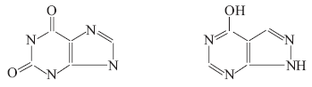
Xanthine Drug used to treat gout
Use the diagram to explain why this drug is effective in the treatment of gout.
________________________________________________________________________________________________________________________________________________________________________________________________________________________________________________________________________________________________________________________________________________________________________
- Xanthine similar shape to drug;
- Drug fits active site/competes for active site/is a competitive inhibitor;
- Less/no uric acid formed;
(3)

