Outcomes |  | Targets
Explain why individuals within a population of a species may show a wide range of variation in phenotype.
Describe variation and continuous or discontinuous based on trends in graphs, and link this to the causes of variation.
Explain what is meant by genetic diversity and allele frequency.
Explain the concept of reproductive success.
Explain the principles of natural selection, and how selection and adaptation are major factors in evolution and species diversity
Explain what is meant by a selection pressure, and which factors can act as selection pressures.
Apply knowledge to unfamiliar information to explain how selection produces changes within a population of a species.
Explain what is meant by directional and stabilising selection and disruptive in the context of the effect that each has on allele frequencies.
Identify types of selection from distribution curves
Interpret data relating to the effect of selection in producing change within populations
Apply knowledge of types of selection to explain antibiotic resistance and human birth weights.
Explain what is meant by allopatric and sympatric speciation
Explain how natural selection and isolation may result in change in the allele and phenotype frequency and lead to the formation of a new species by allopatric speciation and sympatric speciation
Explain possible mechanisms for reproductive isolation resulting in sympatric speciation and apply knowledge to unfamiliar contexts
Explain the process of genetic drift and its impact on allele frequencies.
Explain how genetic drift differs from natural selection.
Explain why genetic drift is important only in small populations.
Explain how DNA hybridisation and biochemical analysis can be used to suggest relationships between different organisms within/between species
Interpret data relating to DNA hybridisation or biochemical analysis
Explain how gene technology has changed the way in which relationships between organisms are worked out
Evaluate direct DNA/protein sequencing against methods of measuring the frequency
Insert Title
Name ____________________________ MEG ________________________

Outcome:
- Explain why individuals within a population of a species may show a wide range of variation in phenotype.
- Describe variation and continuous or discontinuous based on trends in graphs, and link this to the causes of variation.
- Explain what is meant by genetic diversity and allele frequency.

Key terms: use the words below to match the definitions

TERM | DEFINITON
 | The observable characteristics of an organism, resulting from its genotype and interaction with the environment
 | A length of DNA which codes for a protein or polypeptide
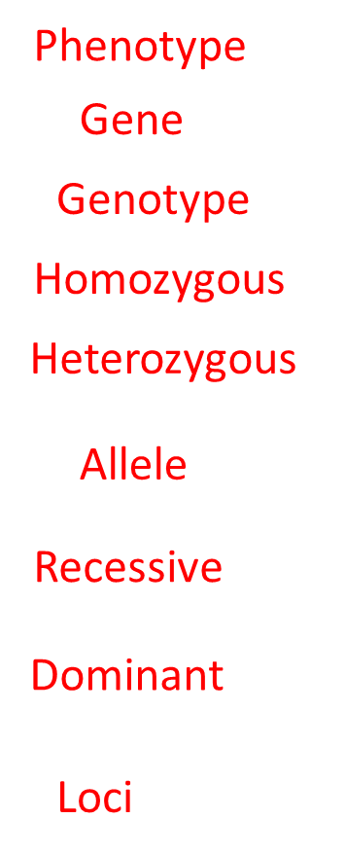 | The genetic constitution of an organism
 | The two alleles of a gene are the same
 | The two alleles of a gene are different
 | Different forms of a gene
 | The allele which is only expressed in the phenotype, in absence of a dominant allele
 | The allele is always expressed in the phenotype, even if a different allele for the same gene is present
 | The position of a gene on a chromosome
Gene, Allele, Genotype, Phenptype, Homozygous, Heterozygous, Dominant, Recessive, Loci

Multiple alleles can also exist for a characteristic, but only two will be present in the organism e.g. blood groups.
Look at the diagram showing different possible pairings of dominant and recessive alleles. Choose suitable letters to label each pair of homologous chromosomes with:
Homozygous dominant, Homozygous recessive, Heterozygous
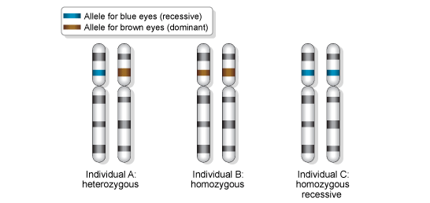
Variation
Within any population of a species there will be genetic diversity which means there will be phenotypic variation within a population
What two types of factors do you think can cause variation?
1Genetic
2.Environmental
The main source of genetic variation is mutations, which can produce different alleles of genes.
Further sources of genetic variation include meiosis (independent assortment and crossing over) and the random fertilisation of gametes during sexual reproduction to create new allele combinations.

The environment can influence the way an organism’s genes are expressed. This can be because of biological factors such as predators or non-biological factors such as sunlight.
Definitions
Genetic diversity: The number of different alleles of the same gene
Allele Frequency: The number of times a specific allele appears in a population

Explain what is meant by the term allele
Different forms of a gene__(1)
Therefore the more alleles in a population the Greater the genetic diversity.

Types of Variation
Individuals in a population show variation due to:
- Genetic factors
- Mutations – primary source of variation.
- Meiosis – e.g. forming bivalents, independent assortment of chromosomes in meiosis 1, separation of chromatids in meiosis 2, crossing over.
- Random fertilisation of gametes.

- Environmental factors (always give named examples)

There are two types of variation use these words to fill in the gaps below:
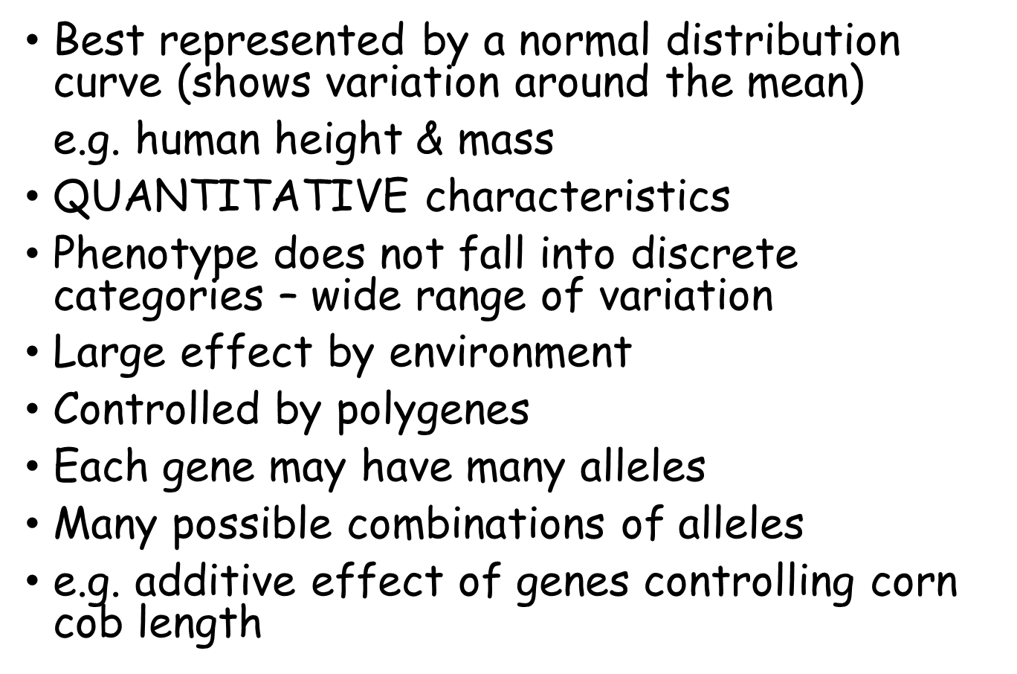
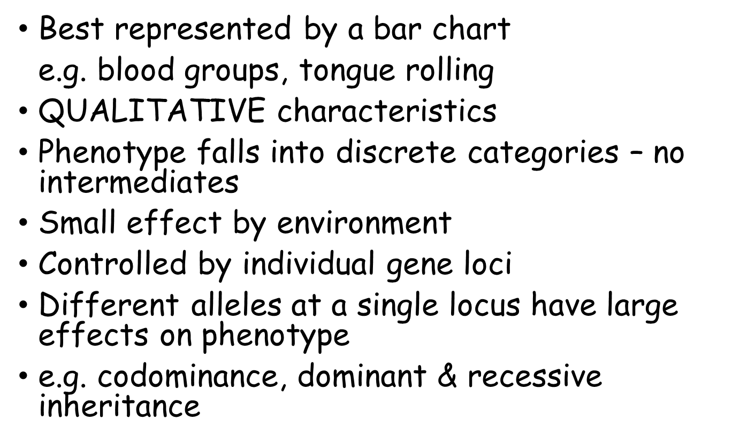
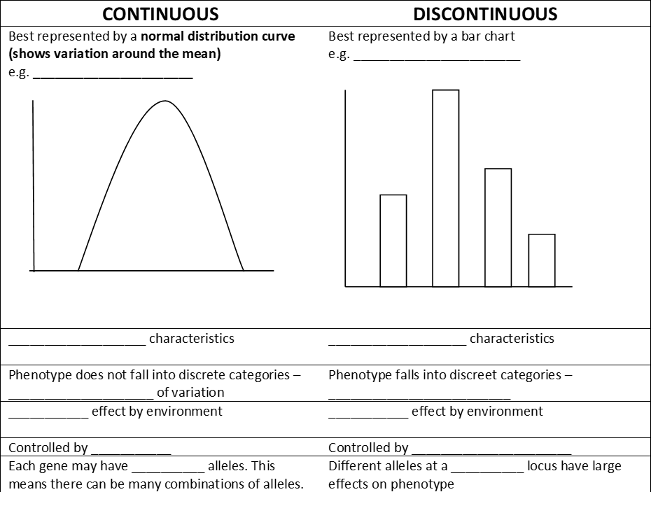
Small, Human height & Mass, Quantitative, Single, Blood groups & tongue rolling, Large, Discrete, Polygenes, Qualitative, Many, No Intermediates, Individual gene loci.

Outcome:
- Explain the concept of reproductive success.
- Explain the principles of natural selection, and how selection and adaptation are major factors in evolution and contributing to species diversity linked to adaptation and inheritance of alleles by the next generation.
- Explain what is meant by a selection pressure, and which factors can act as selection pressures.
- Apply knowledge to unfamiliar information to explain how selection produces changes within a population of a species.

Natural Selection
Random mutation can result in new alleles of a gene, many mutations are harmful but, in certain environments, the new allele of a gene might benefit its possessor, leading to increased reproductive success.
Definition
Reproductive success: The ability of an organism to pass on its genes to the next generation.
An organism that is very healthy, and fit will survive and be able to have more offspring which means its genes will be passed on to the next generation.

Predation, disease and competition means that not all individuals within a population survive to get a chance to reproduce. This differential survival and reproduction is the process by which natural selection acts.
The organisms with phenotypes that provides a selective advantage are more likely to reproduce and thus pass on their favourable alleles to the next generation. This means that the proportional of individuals with the favourable allele will
Increase in the next generation (increase the allele frequency) within the population. The population evolves.
Evolution is the change in allele frequencies in a population over time.
The process of natural selection (you need to learn this and apply it to different organisms)

- New allele arises due to random mutation
- Leads to variation in a population
- Populations may be geographically isolated so no interbreeding
- Different selection pressures ( state selection pressure)
- Competition for resources– intraspecific competition (new!)
- New alleles gives a selective advantage so organisms survives and reproduces
- Pass on advantageous alleles to the next generation
- This happens over many generations
- Frequency of allele in population increases
- Frequency of the phenotype (characteristic) increases

The three main selection pressures are predation, disease and competition e.g. for food.
Tip – always state what the selection pressure is in an exam question. Are the populations geographically isolated? (always state this – usually a mark!)

Definition
Selection pressure: Any Factor which alters the behaviour and fitness (ability to reproduce) of living organisms within a given environment. It is the driving force of evolution and natural selection, and it can be divided into two types of pressure: biotic or abiotic
.

In the space below come up with 3 abiotic factors and 3 biotic factors that may affect an organism’s reproductive success.

Exam Question
In an investigation, the tolerance to copper ions of the grass Agrostis tenuis was determined. Samples were taken of plants growing in waste from a copper mine and from nearby areas just outside the mine. The mean copper tolerance of plants from the mine waste was found to be four times higher than that of plants in the surrounding area.
(a) Explain how natural selection could produce a copper-tolerant population in the mine waste.
_________________ __________________________________________________
___________________________________________________________________
___________________________________________________________________
Answers on Powerpoint
___________________________________________________________________
___________________________________________________________________
___________________________________________________________________
___________________________________________________________________
___________________________________________________________________
(4)
Remember you will need to apply your knowledge to unfamiliar situations. Read through the peppered moth example on page 230 of the toole and toole textbook.
Identify the selection pressure and then apply your knowledge to suggest an explanation that accounts for the change from the light to dark variety in moths.
______________________________________________________________________________________________________________________________________________________ (1)
Explain how natural selection could produce dark coloured moth population in Manchester.
___________________________________________________________________
___________________________________________________________________
Answers on Powerpoint
___________________________________________________________________
___________________________________________________________________
___________________________________________________________________
___________________________________________________________________
___________________________________________________________________ (4)
Outcome:
- Explain what is meant by directional and stabilising selection and disruptive in the context of the effect that each has on allele frequencies.
- Identify types of selection from distribution curves
- Interpret data relating to the effect of selection in producing change within populations
- Apply knowledge of types of selection to explain antibiotic resistance and human birth weights.

Types of Selection
Those organisms with phenotypes providing a selective advantage are likely to produce offspring and pass on their favourable alleles to the next generation.
The gene pool decreases because the numbers of different alleles are decreasing as a result of the favourable alleles increasing and the less favourable alleles decreasing.
Natural selection can have different effects on the gene pool as to which alleles survive and pass on.
Definition
Gene pool: All of the alleles in a population

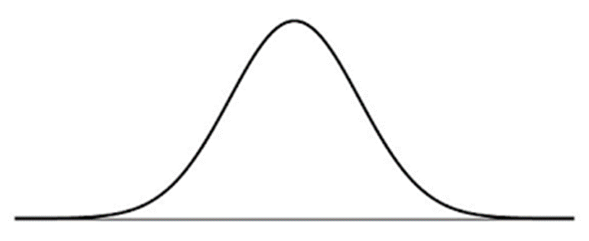

What causes variation?
Most characteristics are influenced by more than one gene – polygenes.
These characteristics are more influenced by the environment than characteristics determined by a single gene.
You can plot this variation on a graph – normal distribution curve, as it shows variation about a mean.
There are 3 types of selection that you need to know
Definitions
- Stabilising selection: is where organisms with phenotypes in the middle are more favourable than the two extremes maintaining genetic polymorphisms in the population
- Directional selection: results in the increase of a favoured allele over time
- Disruptive selection: is where the two extreme phenotypes are favoured more than the middle alleles:

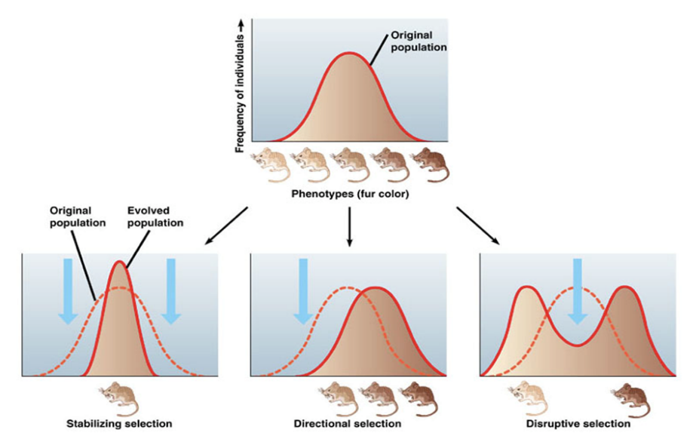

Stabilising selection
EXAMPLE: Mass of babies at birth can be small, large or in the middle.
Stabilizing selection is a selective force that favours the phenotypes closest to the mean value of a trait. E.g. Human birth weight. Babies that tend to the extremes of birth weight have higher mortality rates.
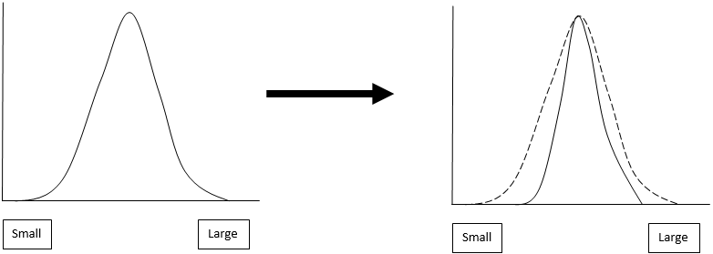

Directional Selection
EXAMPLE: Cheetahs are the fastest animals on land. It is likely that this characteristic was inherited by directional selection as individuals that are the fastest are more likely to catch their prey. Directional selection is a selective force that favours individuals with an extreme form of a trait and selects against phenotypes at the other extreme.
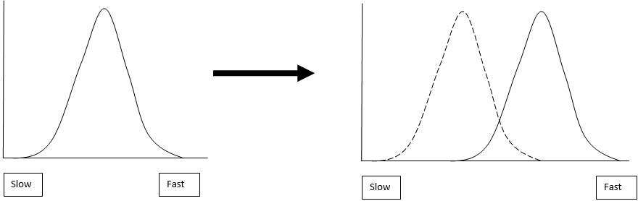

Disruptive Selection
EXAMPLE: Birds’ beaks can either be big or small depending on the appetite they have. Birds that have beaks that are in the middle cannot really eat anything as their beaks will always have a problem.
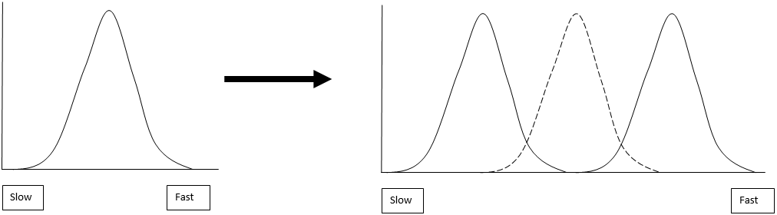
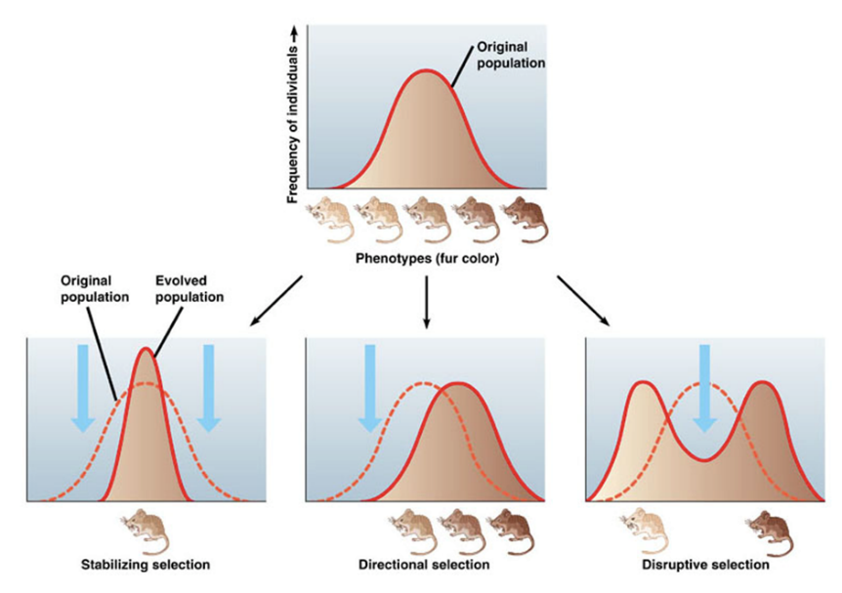

Occurs in a stable environment.

Selection for individuals around a mean/selection against the extremes.

The range is reduced.

The population’s characteristics are being preserved.

An increasing proportion of the population becomes well adapted.

- The opposite of stabilising selection.
- The extremes of the phenotype are selected.
- Occurs when an environmental factor e.g. temperature, takes two or more distinct forms.
e.g. 5ºC in winter and 15ºc in summer favouring long or short fur, not in between, leading to two separate species of mammal.
- Occurs if a change in the environment takes place.
- Favours the organisms at one of the extremes of phenotype.
- Overtime, the mean will move in the direction of these individuals.

Using the Toole and Toole textbook on page 459 answer the summary questions to check your understanding.
1) State which form of selection each statement best relates to:
a) ________Stabilising__________________________
b) ________Stabilising__________________________
c)_________Directional__________________________
d)_________Disruptive__________________________
e)_________Disruptive__________________________
f)_________Directional__________________________
g)_________Stabilising__________________________
2) Suggest which form of the peppered moth is now most common in cities like Manchester and explain why in terms of selection pressure. (4)
________________________________________________________________________________________________________________________________________________________________________________________________________________________________________________________________________________________________________________________________________________________________________________________________________________________________________________________________________________________________________________________________________________________________________________________________________________________
Answers on Powerpoint
Exam question
Lactose is the main sugar in milk and is hydrolysed by the enzyme lactase. Lactase is essential to newborn mammals as milk is their only source of food. Most mammals stop producing lactase when they start feeding on other food sources. Humans are an exception to this because some continue to produce lactase as adults. The ability to continue producing lactase is known as lactase persistence (LP) and is controlled by a dominant allele. A number of hypotheses based on different selection pressures have been put forward to explain LP in humans.
(a) One hypothesis for LP in humans suggests that the selective pressure was related to some human populations farming cattle as a source of milk.
Describe how farming cattle as a source of milk could have led to an increase in LP.
___________________________________________________________________
___________________________________________________________________
___________________________________________________________________
Answers on Powerpoint
___________________________________________________________________
___________________________________________________________________
___________________________________________________________________
___________________________________________________________________
(4)
Antibiotic resistance in Bacteria
Now apply your knowledge to complete the diagram explaining how natural selection can lead to antibiotic resistance in a bacterial population. Use the following words.
Binary, Random, Increases, Advantage, Resistance, Allele, Penicillinase
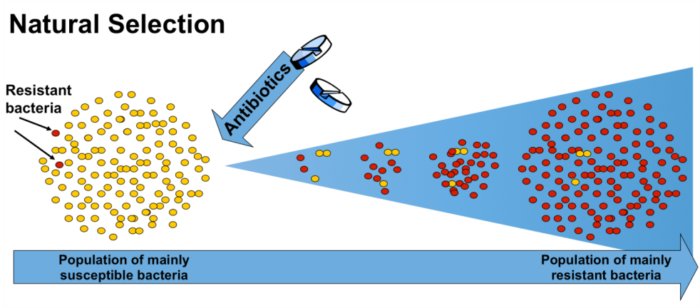
1. Random mutation in a bacterium, allowed it to make an enzyme (Penicillinase) to break down penicillin.
2. Gave the bacteria a selective Advantage if penicillin was in the environment.
3. These bacterium survived and reproduced by Binary fission to develop a small population.
4. These bacterium survived and so the population of resistant bacterium increased.
5. The frequency of the Allele that allowed production of penicillinase Increased.
6. The population’s normal distribution curve shifted in the direction of a population having greater Resistance to penicillin.

Exam question
Q1.
(a) A student used a dilution series to investigate the number of cells present in a liquid culture of bacteria.
Describe how he made a 1 in 10 dilution and then used this to make a 1 in 1000 dilution of the original liquid culture of bacteria.
___________________________________________________________________
___________________________________________________________________
___________________________________________________________________
___________________________________________________________________
___________________________________________________________________
Answers on Powerpoint
___________________________________________________________________
___________________________________________________________________
___________________________________________________________________
___________________________________________________________________
___________________________________________________________________
___________________________________________________________________
___________________________________________________________________
(3)
(b) Using an optical microscope, the student determined there were 15 cells in 0.004 mm³ of the 1 in 1000 dilution of the culture.
Calculate the number of cells in 1 cm³ of undiluted liquid culture.
15 in 0.004 mm- how many in 1 mm ? ----- 1/0.004 x 15 = 3750 cells in 1 mm cubed
2) How many cells in 1 cm cubed? – 1 cm cubed = 1000 mm cubed so 3750 x 1000 = 3,750,000
3) This is in a 1 in 1000 dilution so there are 1000 times less cells. So in an undiluted solution there would be 1000 times more cells. So 3,750,000 x 1000= 3,750,000,000 or 3.75 x10⁹

Answer = ____________________ Number of cells
(2)

(c) The student looked at cells in the 1 in 10 dilution during his preliminary work. He decided not to use this dilution to determine the number of cells in the undiluted liquid culture.
Suggest an explanation for the student’s decision.
___________________________________________________________________
___________________________________________________________________
___________________________________________________________________
Answers on Powerpoint
___________________________________________________________________
___________________________________________________________________
___________________________________________________________________
___________________________________________________________________
(2)
(d) On some farms, animals are routinely given antibiotics in their food.
Scientists investigated whether these farm animals had antibiotic-resistant bacteria in their intestines. They tested the bacteria for resistance to two antibiotics, tetracycline and streptomycin.
Their results are shown in the table.
Antibiotic | Percentage of antibiotic-resistant bacteria
Tetracycline | 29
Streptomycin | 13

Suggest and explain one reason why bacteria resistant to tetracycline are more common than bacteria resistant to streptomycin in these farm animals.
___________________________________________________________________
___________________________________________________________________
___________________________________________________________________
___________________________________________________________________
Answers on Powerpoint
___________________________________________________________________
___________________________________________________________________
___________________________________________________________________
___________________________________________________________________
(2)
(e) In recent years, these farm animals have not been given tetracycline in their food. Despite this, the percentage of bacteria resistant to tetracycline has remained constant.
Suggest one reason why.
___________________________________________________________________
___________________________________________________________________
Answers on Powerpoint
___________________________________________________________________
___________________________________________________________________
___________________________________________________________________
(1)
(Total 10 marks)
Outcome:
- Explain what is meant by allopatric and sympatric speciation
- Explain how natural selection and isolation may result in change in the allele and phenotype frequency and lead to the formation of a new species by allopatric speciation and sympatric speciation
- Explain possible mechanisms for reproductive isolation resulting in sympatric speciation and apply knowledge to unfamiliar contexts

Speciation
Definitions
Evolution is the change in allele frequencies in a population over time.
Speciation is the evolution of new species from existing ones.

Speciation is the process by which new species arise after a population becomes separated and cannot interbreed. This reproductive isolation followed by accumulation of genetic changes through natural selection can result in the formation of a new species.
This is because the populations become genetically distinct with different allele combinations, making them unable to breed to produce fertile offspring.

There are two mechanisms of speciation that you need to know for your exams;
- Allopatric speciation
- Sympatric speciation

Allopatric speciation
Allopatric speciation is caused by a physical barrier. Such as geographical isolation due to natural disasters.
As the two groups become separated and reproductively isolated the result is that the gene flow is reduced. Each group experiences a different selection pressure as the environment they live in is different. Over time, the frequency of alleles changes through natural selection and the two parts of the population can no longer interbreed and become separate species.
Sympatric Speciation
Sympatric speciation is where new species evolve from a single ancestral species when inhabiting the same geographic region.
For example a chromosomal error during cell division which leads to reproductive isolation (members of a population can no longer interbreed forming two separate populations). Other reasons include mutations that mean courtship behaviour isn’t recognised and anatomical changes that mean mating cannot physically occur.
There are two types of sympatric speciation
- Pre-zygotic isolation mechanisms: These are things that stop two individuals coming together to mate. There are six types of pre-zygotic isolation mechanisms:
- Post-zygotic isolation mechanisms: This when the zygote is prevented from further reproduction after it has formed. There are two types:
Pre-zygotic

- Temporal isolation: This is where organisms mate at different times of the year or at different time of the day.
- Gametic isolation: The gametes of each population are different so that they cannot fuse.
- Behavioural isolation: Difference in the mating rituals leads to different courtships or reproduction.
- Ecological isolation: Different habitats mean less interaction.
- Polyploidy: Some organisms may have more than two copies of chromosomes (called polyploid instead of diploid). This means that organisms that are polyploid cannot mate with organisms that are diploid. This is more common in plants.
- Mechanical isolation: Different anatomy of the genitalia means cross-mating cannot occur.

Post-zygotic

- Inviable zygote: Two organisms are able to produce a zygote but it develops incorrectly. The offspring dies later.
- Hybrid sterility: An offspring is produced but is sterile meaning that it cannot produce fertile offspring.

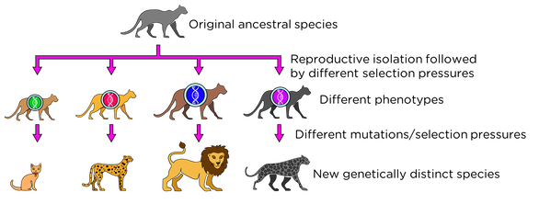

Exam question
(a) What is a gene pool?
___________________________________________________________________
___________________________________________________________________
(1)
(b) Lord Howe Island in the Tasman Sea possesses two species of palm tree which have arisen via sympatric speciation. The two species diverged from each other after the island was formed 6.5 million years ago. The flowering times of the two species are different.
Using this information, suggest how these two species of palm tree arose by sympatric speciation.
___________________________________________________________________
___________________________________________________________________
___________________________________________________________________
___________________________________________________________________
Answers on Powerpoint
___________________________________________________________________
___________________________________________________________________
___________________________________________________________________
___________________________________________________________________
___________________________________________________________________
(5)
(c) Individuals in a population show phenotypic variation.
Give the two types of factor that cause this variation.
1. _________________________________________________________________
2. _________________________________________________________________
(2)
(d) What is allopatric speciation?
___________________________________________________________________
___________________________________________________________________
___________________________________________________________________
___________________________________________________________________
(2)
(Total 10 marks)
Outcome:
- Explain the process of genetic drift and its impact on allele frequencies.
- Explain how genetic drift differs from natural selection.
- Explain why genetic drift is important only in small populations.

Genetic Drift
Evolution and speciation can occur via natural selection in which a selection pressure results in the increased frequency of an advantageous allele within a population or it can happen due to genetic drift.
Individuals within a population show variation in their genotypes e.g. genotype H and I
By chance, the allele for one genotype (I) is passed on to the offspring more than others
So the number of individuals with this allele increases
Change in the allele frequency in two isolated populations could lead to reproductive isolation and speciation
- Genetic drift describes change in allele frequencies in the gene pool of a population (evolution) due purely to chance events and not selection pressures.

- Due to the random nature of gamete production and fertilisation, certain alleles may increase in the population due to chance.

- The effect of genetic drift is more prominent within small populations because chance has a greater influence, whereas in larger populations the random fluctuations even out across the whole population.

In the space below read through pages 460 – 463 and answer the questions on page 463 of the Toole and Toole textbook.
1.____________________________________________________________________________________________________________________________________________________
2.____________________________________________________________________________________________________________________________________________________
3.__________________________________________________________________________________________________________________________________________________________________________________________________________________________________________________________________________________________________________
Answers on Powerpoint
4._______________________________________________________________________________________________________________________________________________________________________________________________________________________________
5.___________________________________________________________________________________________________________________________________________________
Outcome:
- Explain how DNA hybridisation and biochemical analysis can be used to suggest relationships between different organisms within/between species
- Interpret data relating to DNA hybridisation or biochemical analysis
- Explain how gene technology has changed the way in which relationships between organisms are worked out
- Evaluate direct DNA/protein sequencing against methods of measuring the frequency

Genetic Diversity
We can determine how closely related two species are by analysing their genetic diversity.
Genetic diversity within or between species can be made by comparing:
- the frequency of measurable or observable characteristics
- base sequence of DNA
- base sequence of mRNA
- amino acid sequence made in protein synthesis

DNA can be extracted from different organisms, sequenced, and the base sequence compared to that of other organisms. This comparison can tell us about relationships between living organisms, because it is the DNA that is actually passed down the generations. Over time, DNA slowly accumulates mutations, so closely related species have similar DNA sequences, while more distantly related species have accumulated more mutations so will have more different sequences.
DNA hybridisation

Although the complete genomes of a few species have been sequenced (including humans), DNA sequencing is slow and expensive. Furthermore it is usually only practical to compare the sequences of few genes and this can give unreliable evidence. A simpler and quicker technique, which can also compare large amounts of DNA at a time, is DNA hybridisation. The method is:
- Extract DNA from 2 species and remove non-coding regions.
- Heat DNA to break Hydrogen bonds and separate the strands.
- Mix DNA from both species in one tube and put DNA from just one species in another tube.
- Cool to allow base pairs to form between strands.DNA with complementary sequences will base pair whilst mismatched sequences will not.
- Warm slowly to separate the strands again and measure the amount of single stranded DNA every 2 degrees.
- Determine the temperature at which 50% of the DNA has separated into Single strands.

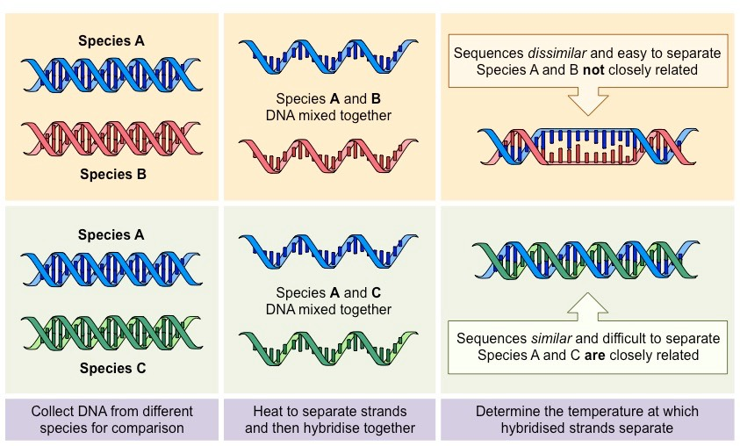

The difference between the two T₅₀H temperatures tells us how similar the DNA sequences are. As a general rule, a difference in T₅₀H of 1°C is equivalent to a 1% difference in the base sequences. DNA hybridisation has been used to investigate the relationship between humans and other apes:

Species whose DNA is being compared Difference in T₅₀H (°C)
Human + chimpanzee 1.6
Human + gorilla 2.3
Human + orang-utan 3.6

These results have led to a new phylogeny for humans. It used to be thought that humans were separate from all other apes, but we now know that humans are closely related to chimpanzees.

Using Proteins to Identify Genetic Diversity.
Animal Species | No. of a.a. differences
Human | 0
Gorilla | 1
Gibbon | 2
Rhesus monkey | 8
Dog | 15
Horse | 25
Mouse | 27
Gray Kangaroo | 38
Chicken | 45
Frog | 67
Since proteins sequences are determined by DNA sequences we can also use the amino acid sequence in proteins to investigate genetic diversity.
The typical protein used is haemoglobin as it is found in all animals. The β-chain of haemoglobin usually contains 146 amino acids the table below shows the number of differences in the amino acid sequence of different species compared to humans.
Use the table to work out which organism is;

- most closely related to humans
Gorilla

- Least closely related to humans
Frog

- A scientist concluded that humans were more closely related to dogs than a horse is to a frog. Evaluate their conclusion.
There are 15 differences between a human and a dog
You cannot see how many differences there are between the horse and the frog as the table is only comparing other species to human DNA. His conclusion is incorrect.
(2)

Exam question
There are nine subspecies of giraffe. These subspecies evolved when populations of giraffe were separated for long time periods. Each subspecies has distinct coloured skin markings. Some biologists have suggested that up to six of these subspecies should be classified as different species.
(a) Explain how different subspecies of giraffe may have evolved from a common ancestor.
Use information from the passage in your answer.
___________________________________________________________________
___________________________________________________________________
___________________________________________________________________
___________________________________________________________________
___________________________________________________________________
Answers on Powerpoint
___________________________________________________________________
___________________________________________________________________
___________________________________________________________________
___________________________________________________________________
___________________________________________________________________
___________________________________________________________________
(5)
(b) Biologists compared the mitochondrial DNA of the different subspecies of giraffe. They used the results from comparing this DNA to conclude that six of the nine subspecies are separate species.
Suggest how they came to this conclusion.
___________________________________________________________________
___________________________________________________________________
___________________________________________________________________
___________________________________________________________________
___________________________________________________________________
(2)
(Total 7 marks)
Q2
Lemmings are small mammals which live in the Arctic. Their main predator is the stoat, a small carnivorous mammal, which feeds almost entirely on lemmings. The graph shows the changes in the numbers of lemmings and stoats from 1988 to 2000.
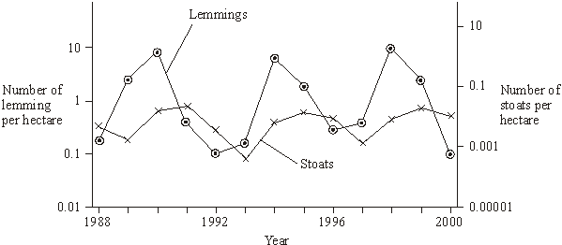

(a) Describe and explain the changes which occur in the lemming and stoat populations.
___________________________________________________________________
___________________________________________________________________
___________________________________________________________________
___________________________________________________________________
___________________________________________________________________
Answers on Powerpoint
___________________________________________________________________
___________________________________________________________________
___________________________________________________________________
___________________________________________________________________
___________________________________________________________________
___________________________________________________________________
___________________________________________________________________
(6)
(b) Lemmings often live in isolated populations. From time to time some lemmings move and join other populations. Explain how this movement is important in maintaining genetic variability in lemming populations which have large fluctuations in size.
___________________________________________________________________
___________________________________________________________________
___________________________________________________________________
___________________________________________________________________
(2)
(c) James Bay is a large ocean bay in northern Canada. It was formed by the melting of glaciers. One species of lemming inhabits the eastern side of James Bay and another species of lemming inhabits the western side. Before the glaciers melted there was only one species of lemming present. Explain how two species of lemming evolved from the original species.
___________________________________________________________________
___________________________________________________________________
___________________________________________________________________
___________________________________________________________________
Answers on Powerpoint
___________________________________________________________________
___________________________________________________________________
___________________________________________________________________
(4)
(Total 12 marks)

