ANIMAL TRANSPORT 3.3.4.1
Oxygen Dissociation

Name___________________________________________

Reflection on learning outcomes | or | Target
Relate knowledge of protein structure to the structure of haemoglobin.

Explain what is meant by the term “partial pressure”

Explain how the binding of one oxygen molecule changes the shape of haemoglobin, and how this affects the binding of further oxygen molecules

Explain the effect of carbon dioxide concentration on oxygen dissociation, relate this knowledge to explain oxygen loading and unloading in different tissues.

Explain differences between the dissociation curves of different species and relate these differences to the environment in which the organisms with to explain how these adaptations allow organisms to survive

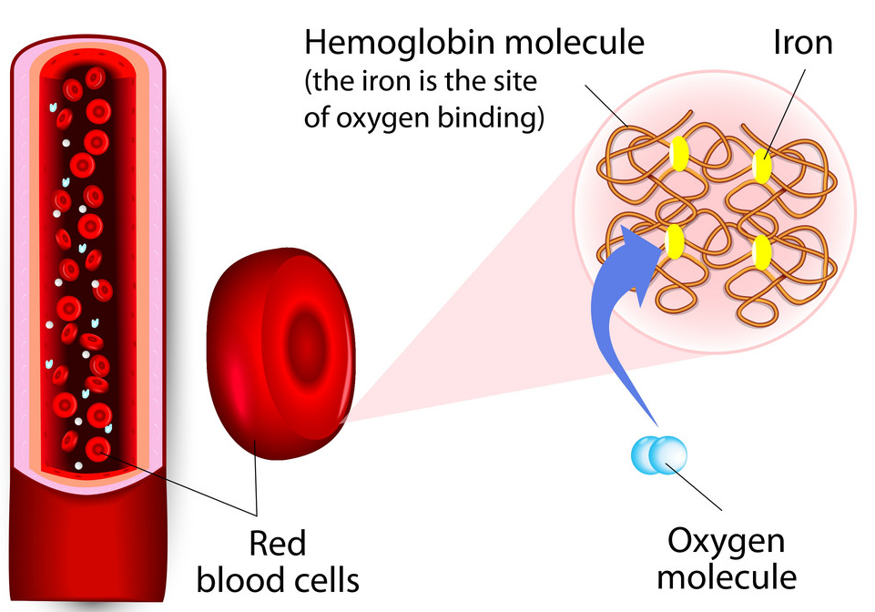

Oxygen Transport in Mammals
Outcome:
- Relate knowledge of protein structure to the structure of haemoglobin
- Explain what is meant by the term “partial pressure”
- Explain how the binding of one oxygen molecule changes the shape of haemoglobin, and how this affects the binding of further oxygen molecules

Blood
Consists of a liquid called plasma, containing RBC (oxygen transport), WBC (immune system), and platelets (blood clotting).
Haemoglobin Structure
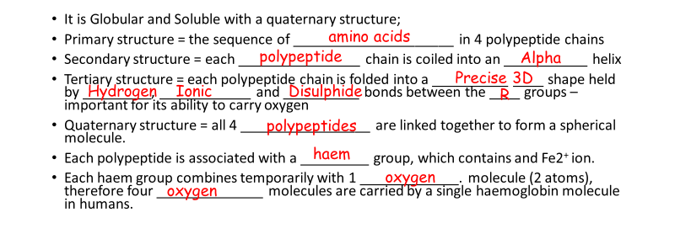
It is Globular and Soluble with a quaternary structure;
- Primary structure = the sequence of _____________________ in 4 polypeptide chains
- Secondary structure = each ________________ chain is coiled into an ___________ helix
- Tertiary structure = each polypeptide chain is folded into a __________ ____ shape held by _________, ____________ and __________ bonds between the ____ groups – important for its ability to carry oxygen
- Quaternary structure = all 4 _________________ are linked together to form a spherical molecule.
- Each polypeptide is associated with a _________ group, which contains and Fe2⁺ ion.
- Each haem group combines temporarily with 1 _____________. molecule (2 atoms), therefore four ______________ molecules are carried by a single haemoglobin molecule in humans.
Words for gap fill:
Polypeptide | Polypeptide | Amino-Acids | Ionic | 3D
Specific | Hydrogen | R | Alpha | Haem
Disulphide | Oxygen | Oxygen

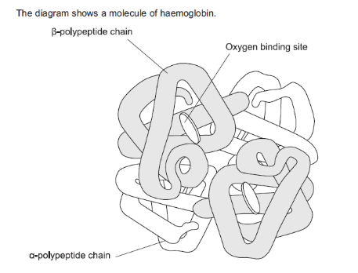
What is the evidence from diagram that haemoglobin has a quaternary structure?

Multiple Polypeptide chains joined together

Haemoglobin Role
- To LOAD oxygen in a high O₂ concentration, where it has a high affinity for oxygen, to form oxyhaemoglobin
- This occurs in lungs
- UNLOAD oxygen in a low pO₂ conditions and high pCO_{2,} where it has a low affinity for oxygen
- This occurs in the respiring cells / tissues
Use this information to complete the table
Affinity of haemoglobin for oxygen under different conditions
Region of Body | Oxygen concentration  (high/low) | Carbon dioxide concentration  (high/low) | Affinity of haemoglobin for oxygen (high/low) | Result  (oxygen is associated/dissociated)
Gas exchange surface | High | low | high | Associated
Respiring tissues | low | high | low | dissociated

Oxygen Dissociation Curves
When haemoglobin is exposed to different partial pressures (concentrations) of oxygen (pO₂), it does not bind oxygen evenly, giving a sigmoid shape to the curve.
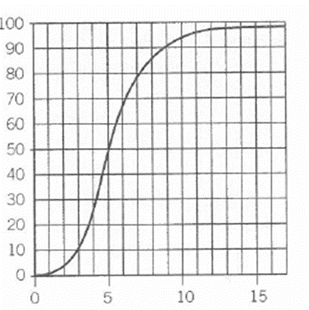
When every molecule of Hb is combined with 8 atoms of oxygen, then it is 100% saturated, etc.
The graph shows the relationship between the saturation of haemoglobin with oxygen and the partial pressure of oxygen (pO₂), and is called the OXYGEN DISSOCIATION CURVE
What is % saturation of Hb with O₂ at:
- 6 kPa- 65%
- 8 kPa- 85%
- 15 kPa- 98 %

Why is the curve sigmoid?
Starting from the bottom
- Describe: Bigger increase in pO₂ smaller increases in % sat (quote values from graph)
Curve is shallower
Explain: The shape of the Hb molecule makes it difficult for 1st oxygen molecule to bind

- Describe: Smaller increase in pO₂ bigger increases in % sat (quote values from graph)
Steeper gradient.
Explain: Binding of the first oxygen changes the quaternary structure shape of Hb molecule which makes it much easier for other oxygen molecules to bind.

- Describe: Bigger increase in pO₂ smaller increases in % sat (quote values from graph)
% saturation flattens out
Explain: Binding of 4th is harder because it is less likely that a single oxygen molecule will find an empty binding site

In reverse – loss of one oxygen makes it easier for the next one to be lost, and so on

What is the Relevance?
- In the lungs
√ Blood leaving the lungs is almost always completely saturated with oxygen.
√ Even if pO₂ in lungs drops a bit below normal, Hb can still pick up a lot of oxygen

- In the body tissues, respiration in the cells is using up the oxygen
√ A slight decrease in pO₂ of tissues produces a large increase in oxygen release from Hb.
√ O₂ is very effectively delivered to the tissues that need it
______________________________________________________________________________________________

Exam Questions
Q9.(a) Binding of one molecule of oxygen to haemoglobin makes it easier for a second oxygen molecule to bind. Explain why.
___________________________________________________________________
___________________________________________________________________
___________________________________________________________________
Answers on powerpoint
___________________________________________________________________
___________________________________________________________________
__________________________________________________________________ (2)
A haemocytometer is a special microscope slide which can be used to count the numbers of blood cells in a sample of blood.
• The surface of the slide has many small, equal-sized squares marked on it.
• The depth of the liquid under each square is 0.1 mm
• When counting, cells that touch top or left lines are counted but cells that touch right or bottom lines are not counted.
A doctor used a haemocytometer to determine the number of red blood cells per mm³ in a blood sample. He diluted the original blood sample by a factor of 200 times before putting some on a haemocytometer. The diagram shows the distribution of cells in a typical small square.
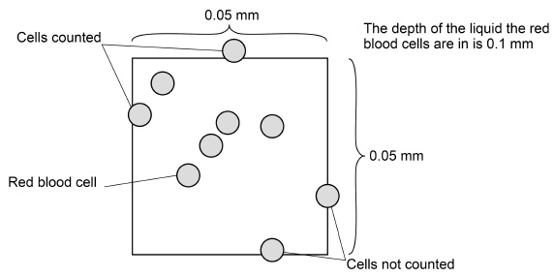
(b) The doctor counted the red blood cells in many small squares. The mean number of red blood cells per small square was 7. The original blood sample was diluted by a factor of 200 times.
Calculate the number of red blood cells per mm³ in the original blood sample. Give your answer in standard form.
Answers on powerpoint

Answer = ____________________ red blood cells per mm³ (2)
(c) When counting, cells that touch top or left lines are counted but cells that touch right or bottom lines are not counted. Suggest two reasons for this rule.
1. _________________________________________________________________
___________________________________________________________________
Answers on powerpoint
___________________________________________________________________
2. _________________________________________________________________
___________________________________________________________________
___________________________________________________________________ (2)
The doctor also wanted to know how many white blood cells per mm³ there were in a different sample of blood. To do this he first diluted the sample by a factor of 20 times. He then made the white blood cells clearly visible by using a stain that makes nuclei appear dark blue.
(d) When counting white blood cells, the doctor only diluted the blood sample by a factor of 20 times, instead of 200 times when counting red blood cells. Suggest why he only diluted the sample by a factor of 20 times.
___________________________________________________________________
Answers on powerpoint
___________________________________________________________________ (1)
(e) Explain how the stain allowed the doctor to count the white blood cells amongst all the red blood cells.
___________________________________________________________________
___________________________________________________________________
Answers on powerpoint
__________________________________________________________________(1)

The BOHR SHIFT
Outcome:
- Explain the effect of carbon dioxide concentration on oxygen dissociation
- Relate this knowledge to explain oxygen loading and unloading in different tissues.

Effect of Carbon Dioxide concentration on Oxygen Transport:
pCO₂ is the concentration of carbon dioxide.
In respiring body tissues CO₂ is produced
When we exercise, more CO₂ is produced; therefore the pCO₂ in the tissues increases
Write out equation for aerobic respiration: Oxygen + Glucose Carbon Dioxide + Water +ATP
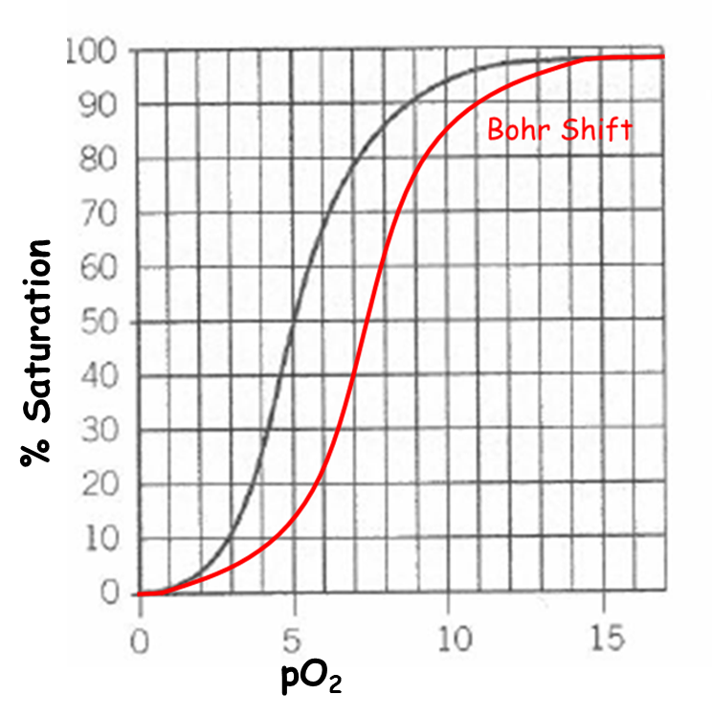
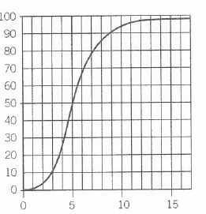
Exam tip: When you are asked to draw a curve:
- Make sure it begins and ends at the SAME point as the one given
- Then draw to the left or right, as appropriate
- The higher the pCO₂, the more readily the oxygen is unloaded from Hb
- So more oxygen is released for cells during activity.
- So, the dissociation curve shifts to the RIGHT
- Hb has a LOWER AFFINITY for O₂
= the BOHR SHIFT

Draw the curve for the Bohr Shift, and label “high pCO₂ “

What causes the Bohr Shift?
- In the tissues, CO₂ is released by respiring cells
- Forms Carbonic acid which dissociates into H+ lowering pH
- Acidity changes shape of Hb so now has a lower affinity for oxygen
- O₂ is more readily released to respiring tissues.
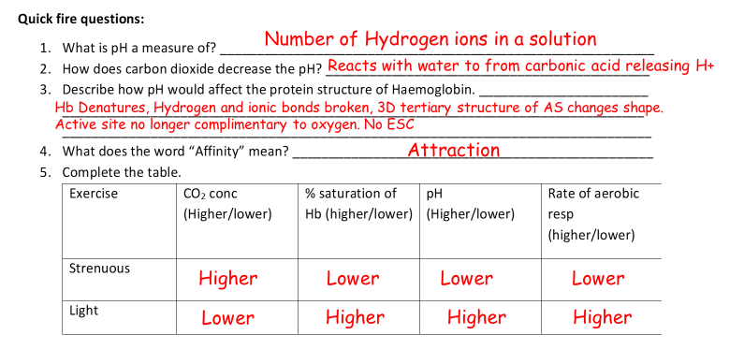
Quick fire questions:
- What is pH a measure of? ___________________________________________________________
- How does carbon dioxide decrease the pH? ____________________________________________
- Describe how pH would affect the protein structure of Haemoglobin. _______________________
_______________________________________________________________________________
________________________________________________________________________________
- What does the word “Affinity” mean? _________________________________________________
- Complete the table.
Exercise | CO₂ conc  (Higher/lower) | % saturation of Hb (higher/lower) | pH  (Higher/lower) | Rate of aerobic resp (higher/lower)
Strenuous
Light

Different Species-
Outcome:
- Explain differences between the dissociation curves of different species
- Relate these differences to the environment in which the organisms with to explain how these adaptations allow organisms to survive

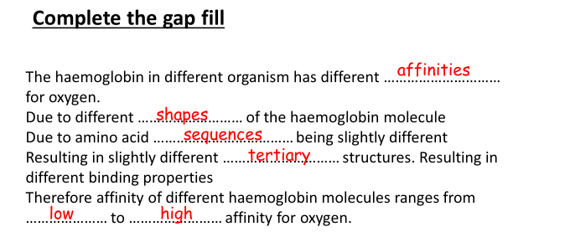
Why are there different haemoglobins?
- The haemoglobin in different organisms have different _______________ for oxygen.
- Due to different______________ of the haemoglobin molecule.
- Due to amino acid ________________ being slightly different.
- Resulting in slightly different tertiary and ___________________ structures
- Resulting in different binding properties
- Therefore, affinity of different haemoglobin molecules ranges from ____________ to __________ affinity for oxygen.
Words for gap fill:
Higher | Quaternary | Lower | Oxygen
Sequences | Affinities | Shapes

1. Low oxygen environments, low pO₂
- pO₂ is lower where they live
- So the Hb has a higher affinity for O₂
- So it can load more of the available oxygen,
- Be saturated at a lower pO₂
- Dissociation curve is shifted to the LEFT
Examples:
- foetus
- In uterus, low pO2
- So needs to be able to load more O₂ than mother at same pO₂.
- Enables oxygen to move from mother to foetus.

- lugworms
- Live in burrows beneath the sand - low pO₂.
- So need to load as much oxygen as possible

- llama
- Lives at high altitudes, low atmospheric pO₂
- So has to be able to load with more oxygen

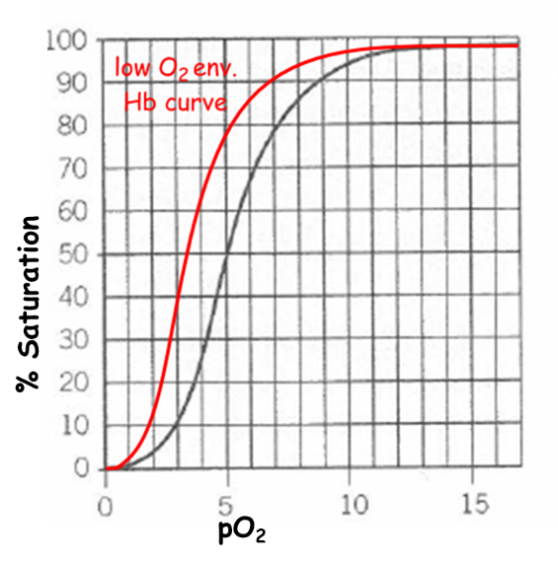

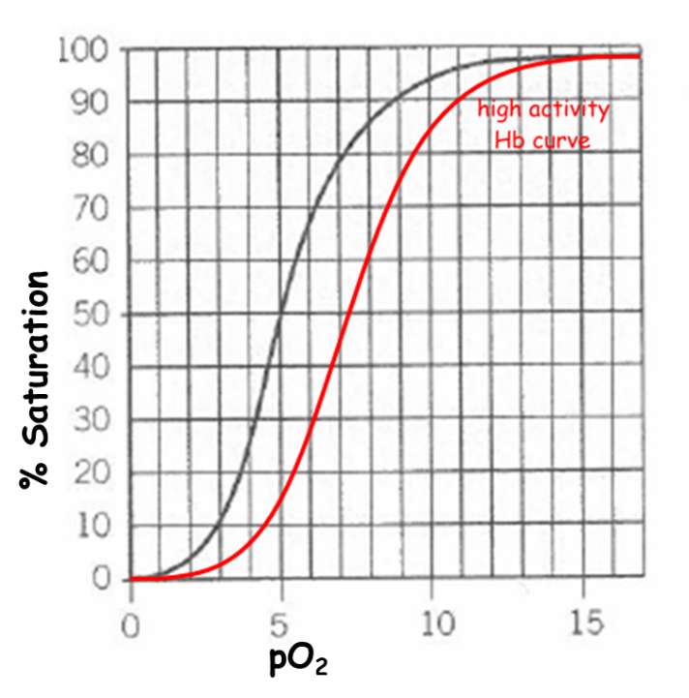
2. Different Activity levels & Size
- Organisms that are very active and small, have a higher O₂ demand
- They need their Hb to unload oxygen more readily
- To supply more oxygen to tissues
- For a faster respiration
- Therefore have a Hb with a lower affinity
- In all these cases, the dissociation curve is shifted to the RIGHT
Examples:
- Hawk
- Very high respiratory rate
- Lives where there is plenty of oxygen

Small mammals
- Have a higher SA:VOL ratio
- Therefore lose heat more quickly,
- So have a higher metabolic rate to keep warm.
- Therefore have a higher oxygen demand
- So need the Hb to unload oxygen more easily.

Exam questions answer The larger the animal:
- The more to the Left the curve is,
- The Steeper the curve is,
- The higher the affinity for oxygen.

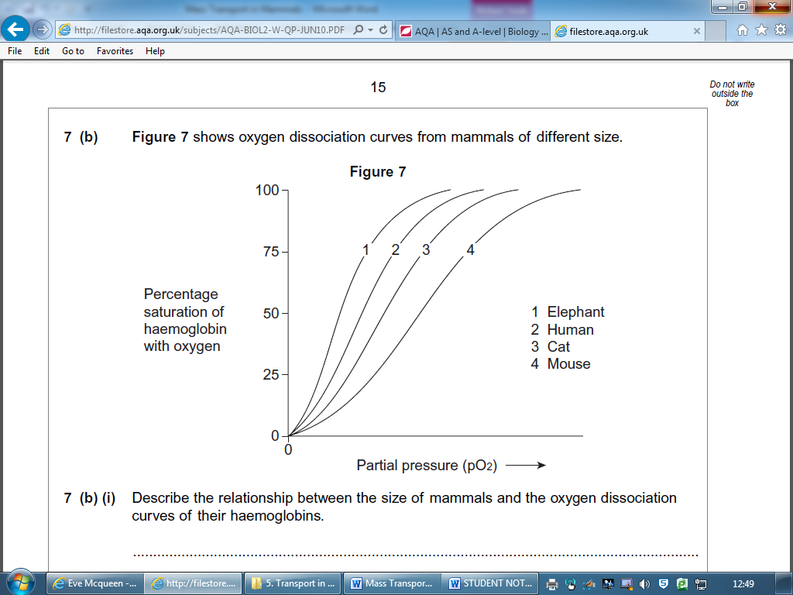

Q: Why does the Hb of smaller mammals have a lower affinity for oxygen?

- SA:VOL ratio is Higher
- Heat loss is quicker
- Rate of respiration greater (if SA:Vol is greater)
- Requirement of O2 for respiration higher
- Haemoglobin has a lower affinity for oxygen / it releases O2 more readily

Exam Questions
Q10. The graph shows the oxyhaemoglobin dissociation curves for fetal haemoglobin (HbF) and adult haemoglobin (HbA).

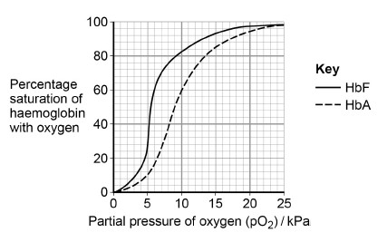
(a) Explain how changes in the shape of haemoglobin result in the S-shaped (sigmoid) oxyhaemoglobin dissociation curve for HbA.

_________________________________________________________________

_________________________________________________________________
Answers on powerpoint

________________________________________________________________

_________________________________________________________________

__________________________________________________________________(2)
(b) At birth 98% of the haemoglobin is HbF. By the age of 6 months, the HbF has usually completely disappeared from the baby’s blood and been replaced by HbA. Use the graph above to explain why this change is an advantage for the baby.

_________________________________________________________________

_________________________________________________________________

_________________________________________________________________
Answers on powerpoint

_________________________________________________________________

_______________________________________________________________(2)

(c) Sickle cell disease (SCD) is caused by production of faulty HbA. This results in a reduced ability to transport oxygen to tissues. Scientists investigated the use of a substance called hydroxyurea to treat babies with SCD. Hydroxyurea changes the concentration of HbF in the blood.
The scientists carried out an investigation with 122 babies who had SCD. Each baby was given hydroxyurea for 41 months. The scientists then found the mean change in the concentration of HbF in the babies’ blood. Their results are shown in the table.

Mean concentration of HbF in the babies’ blood / arbitrary units
Before treatment with hydroxyurea (± 1 standard deviation) | After treatment with hydroxyurea (± 1 standard deviation)
7.6  (± 4.5) | 19.1  (± 6.5)
The scientists concluded that treatment with hydroxyurea would increase the concentration of oxygen in the blood of babies with SCD. Suggest how the graph and table above support this conclusion.

________________________________________________________________

________________________________________________________________

_______________________________________________________________
Answers on powerpoint

_________________________________________________________________

_________________________________________________________________

______________________________________________________________(3)

Q 11 a) The haemoglobin in one organism may have a different chemical structure from the haemoglobin in another organism. Describe how.
Answers on powerpoint
_________________________________________________________________
_______________________________________________________________(1)
(b) The graph shows oxygen dissociation curves for horse haemoglobin and for llama haemoglobin. Horses are adapted to live at sea level and llamas are adapted to live in high mountains.
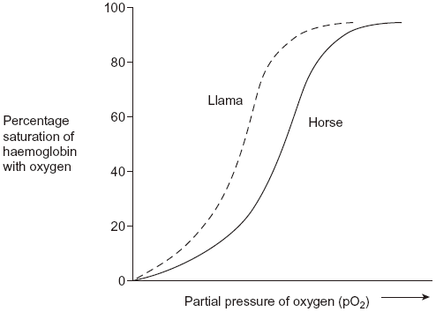
Answers on powerpoint
Use the graph to explain why llamas are better adapted to live in high mountains than horses.
________________________________________________________________
______________________________________________________________(3)
Outcomes
- Apply knowledge of circulation to draw and explain conclusions
- Evaluate the quality of results and reliability of conclusions.
- Explain the causes and consequences of cardiovascular disease
- Analyse and interpret data associated with specific risk factors and the incidence of cardiovascular disease and recognise correlations and causal relationships

Causes and Consequences of Cardiovascular disease (CVD)
Definition:
Cardiovascular disease covers a range of different problems that can develop in the blood vessels and the heart, usually when the vessels become blocked

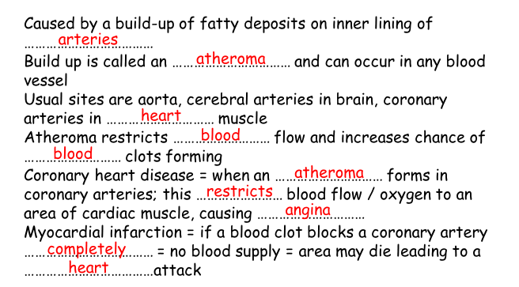
Atherosclerosis

Research activity:
In pairs, choose one cardiovascular disease e.g. stroke, heart disease, research the causes, risk factors and consequences, then prepare a short presentation to be given to the class.
Plan your presentation.

Application Exam Questions
Q1. The graph shows dissociation curves for human oxyhaemoglobin at rest and during exercise. Table 1 gives information about conditions in the body at rest and during exercise.
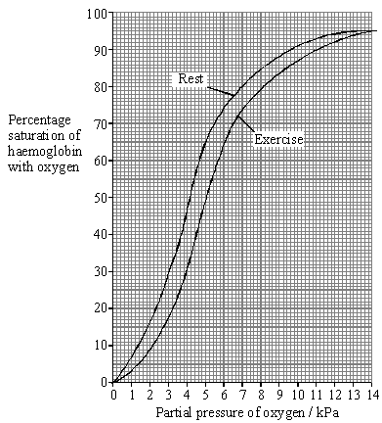

 | Rest | Exercise
Plasma pH | 7.4 | 7.2
Blood temperature / °C | 37.0 | 39.0
Alveolar partial pressure of oxygen / kPa | 13.3 | 13.3
Tissue partial pressure of oxygen / kPa | 5.0 | 4.0

(a) What is meant by the term partial pressure?
Answers on powerpoint
___________________________________________________________________
___________________________________________________________________(1)

(b) Use Table 1 and the graph to calculate the difference in the percentage saturation of haemoglobin in the tissues between rest and exercise.

Answer ____________________ %(1)
Answers on powerpoint

(c) Explain the differences between the figures shown in Table 1 for rest and exercise.
___________________________________________________________________
Answers on powerpoint
___________________________________________________________________
___________________________________________________________________
___________________________________________________________________
___________________________________________________________________
___________________________________________________________________
___________________________________________________________________
__________________________________________________________________(4)

(d) Explain the advantage of the difference in position of the dissociation curve during exercise.
___________________________________________________________________
Answers on powerpoint
___________________________________________________________________
___________________________________________________________________
___________________________________________________________________(2)

Table 2 shows how the oxygen concentration in the blood going to and from a muscle changes from rest to heavy exercise.

Oxygen concentration / cm³ per 100 cm³
blood
 |  | Blood in arteries | Blood in veins
At rest | In solution | 0.3 | 0.2
At rest | As oxyhaemoglobin | 19.5 | 15.0
At rest | Total oxygen | 19.8 | 15.2
During heavy exercise | In solution | 0.3 | 0.1
During heavy exercise | As oxyhaemoglobin | 20.9 | 5.3
During heavy exercise | Total oxygen | 21.2 | 5.4

(e) By how many times is the volume of oxygen removed from the blood by the muscle in Table 2 during heavy exercise greater than the volume removed at rest? Show your working.
Answers on powerpoint
Answer ____________________ times (2)

(f) Does enriching inspired air with oxygen have any effect on the amount of oxygen reaching the tissues? Support your answer with evidence from the graph and Table 2.
___________________________________________________________________
Answers on powerpoint
___________________________________________________________________
___________________________________________________________________
_________________________________________________________________ (3)

(g) The change to the dissociation curve is one of a number of ways in which the total oxygen supplied to muscles is increased during exercise. Give two other ways in which the total oxygen supplied to muscles during exercise is increased.
Answers on powerpoint
1. _________________________________________________________________
___________________________________________________________________
2. ________________________________________________________________ (2)
Q2. Some people have a form of heart failure where their heart is not pumping blood as well as it used to. Some people with heart failure are given an artificial heart to improve circulation of blood from the left ventricle. Figure 1 shows where this type of artificial heart is connected.
Figure 1
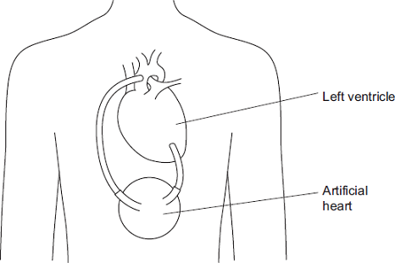
(a) Name the blood vessel to which the artificial heart is connected.
___________________________________________________________________(1)

(b) In these patients, the right ventricle still produces sufficient blood flow to keep the patient alive. Suggest why the left ventricle requires the help of the artificial heart but the right ventricle does not.
___________________________________________________________________
Answers on powerpoint
___________________________________________________________________
___________________________________________________________________
___________________________________________________________________(2)

(c) Figure 2 shows the internal structure of this type of artificial heart.
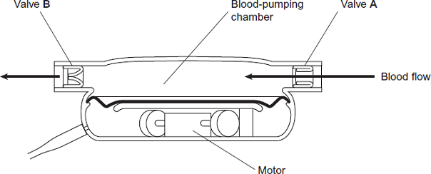

Valves A and B have the same functions as heart valves involved in the cardiac cycle. Name the heart valve that has the same function as:
valve A ____________________________________________________________
valve B ___________________________________________________________(2)
Answers on powerpoint

(d) There are different designs of artificial heart. Doctors compared results for patients who received two different types of artificial heart, X and Y. They recorded information 2 years after the artificial hearts were implanted. Their results are shown in Figure 3.

 | Information recorded 2 years after artificial heart implanted
Type of artificial heart | Number of patients surviving without replacement of artificial heart | Number of patients surviving but who required repair or replacement of artificial heart | Number of patients who died
X  (119 patients) | 62 | 13 | 44
Y  (58 patients) | 7 | 24 | 27

Which type of artificial heart was the more successful? Use calculations to support your answer.
___________________________________________________________________
Answers on powerpoint
___________________________________________________________________
___________________________________________________________________
___________________________________________________________________
___________________________________________________________________
___________________________________________________________________
__________________________________________________________________ (3)
Q3. (a) Describe and explain four ways in which the structure of a capillary adapts it for the exchange of substances between blood and the surrounding tissue.
___________________________________________________________________
Answers on powerpoint
___________________________________________________________________
___________________________________________________________________
___________________________________________________________________
___________________________________________________________________
___________________________________________________________________
___________________________________________________________________
__________________________________________________________________(4)

(b) Explain how tissue fluid is formed and how it may be returned to the circulatory system.
___________________________________________________________________
___________________________________________________________________
Answers on powerpoint
___________________________________________________________________
___________________________________________________________________
___________________________________________________________________
___________________________________________________________________
___________________________________________________________________
___________________________________________________________________
___________________________________________________________________
______________________________________________________ (6)

