ANIMAL TRANSPORT 3.3.4.1
Name___________________________________________
Reflection on learning outcomes | or | Target
explain what is meant by a double circulatory system

describe the structure of the circulatory system, with particular reference to the blood vessels entering/leaving the heart, lungs and kidneys

link the structure of the circulatory system to its role in exchanging and transporting materials.

relate knowledge of protein structure to the structure of haemoglobin

explain what is meant by the term “partial pressure”

explain how the binding of one oxygen molecule changes the shape of haemoglobin, and how this affects the binding of further oxygen molecules

relate knowledge to explain the shape of an oxygen dissociation curve

explain the effect of carbon dioxide concentration on oxygen dissociation
relate this knowledge to explain oxygen loading and unloading in different tissues.

explain differences between the dissociation curves of different species
relate these differences to the environment in which the organisms with to explain how these adaptations allow organisms to survive
describe and label the structure of the heart

explain differences in the thickness of cardiac muscle between the atria and ventricles, and between different sides of the heart

explain the purpose of the atrio-ventricular and semilunar valves

explain the role of the coronary artery.

explain the cardiac cycle in terms of atrial systole, ventricular systole and diastole
explain the opening and closing of AV and semi-lunar valves in terms of differences in pressure at different stages of the cardiac cycle
analyse and interpret data relating to pressure and volume changes during the cardiac cycle.
describe the structure of arteries, arterioles, veins and capillaries
relate the structure of arteries, arterioles, veins and capillaries to their functions
compare and contrast the structure and function of different blood vessels
explain what tissue fluid is and which substances it contains
explain the formation of tissue fluid in terms of hydrostatic pressure
explain the reabsorption of some tissue fluid back into the capillaries, in terms of hydrostatic pressure and water potential

explain the role of the lymph system.
explain the features of good experimental design

process data to calculate rates

represent raw and processed data clearly using tables and graphs
apply knowledge of circulation to draw and explain conclusions

evaluate the quality of results and reliability of conclusions.
explain the causes and consequences of cardiovascular disease
analyse and interpret data associated with specific risk factors and the incidence of cardiovascular disease
recognise correlations and causal relationships
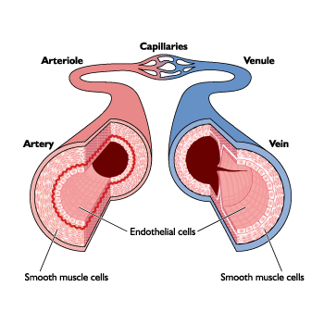

Outcome:
- Explain what is meant by a double circulatory system
- Describe and label the structure of the heart

All organisms exchange materials between themselves & the Environment.. – Diffusion. is fast enough for transport over short distances, so can be used in small organisms.
However, as size increases, SA:VOL ratio Decreases. and specialised Exchange surfaces are required to Absorb nutrients and respiratory gases and Remove excretory products and a Transport system is required to take materials from cells to exchange surfaces, from the exchange surfaces to cells, and between different parts of the organism. Whether or not there is a specialised transport medium and whether or not it is circulated by a pump depends on
- The SA:VOL ratio
- How active the organism is

External structure of The Heart
Add labels using p.171 T & Toole

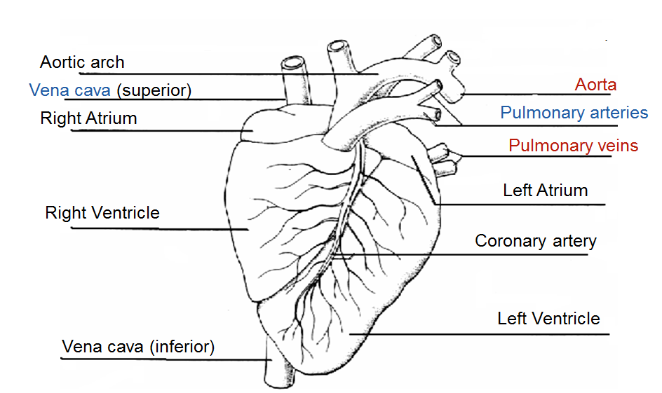
Internal Structure of the Heart
Add labels using p.171 T & Toole
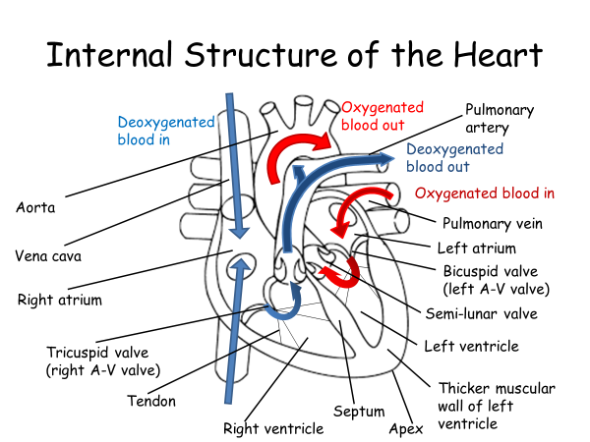

Mammals have a closed (blood is in vessels), double circulatory system (blood passes through heart twice for each circuit of the body); the 2 systems are:-
[use following words: oxygenated, deoxygenated, blood, heart, heart, increases, release, tissues in your answers]

- Pulmonary circulation – carries deoxygenated blood to the lungs, to take up oxygen & then returned to heart.
- Systemic circulation – carries oxygenated blood to the rest of the body, to release oxygen & then returned to heart.
- The main advantage of a double circulatory system for mammals is that it increases– blood pressure and therefore increases the rate of blood flow to the tissues.

Double circulatory system
Outcome:
- describe the structure of the circulatory system, with particular reference to the blood vessels entering/leaving the heart, lungs and kidneys

- Label all blood vessels and heart chambers in the diagram below
- Add colour to show oxygenated (red) and deoxygenated (blue) blood.

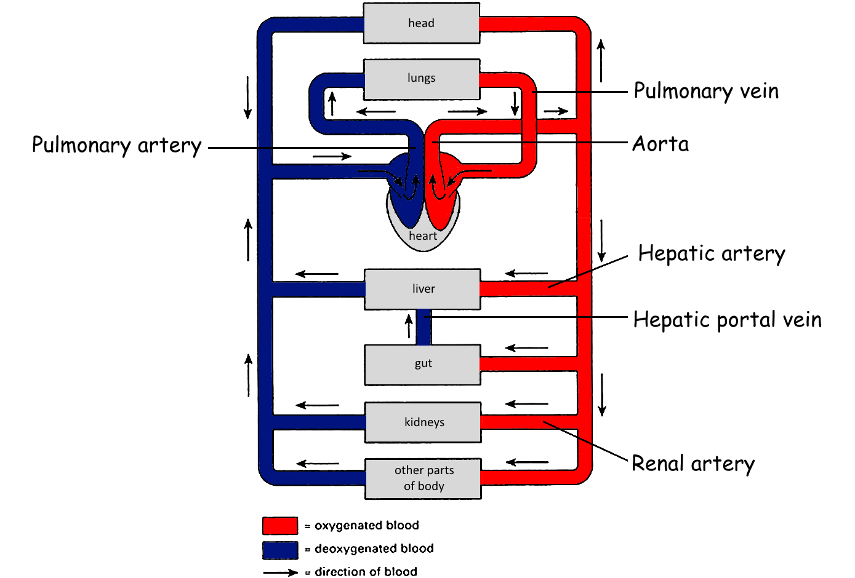

Outcome:
- explain the role of the coronary artery.

Blood supply to heart
- Heart muscle needs its own blood supply
- Therefore arteries branch off from aorta to form the coronary arteries which run through heart muscle, close to outer surface.
Q- Explain the role of coronary arteries, and why a blockage in one of these causes a heart attack (Myocardial infarction) (4)
- Coronary arteries carry oxygen to the heart muscle
- A blockage such as a blood clot or build up of fatty acids can restrict the flow of blood/ oxygen to the heart muscle.
- If the clot blocks the coronary artery completely no oxygen is reaching the heart.
- The heart muscle can no longer respire so muscle cells may die.
- Resulting in a heart attack.
_______________________________________________________________________________________
Exam Questions:
Answers on powerpoint
Q1.
(a) Figure 1 shows part of the blood circulation in a mammal.
Figure 1
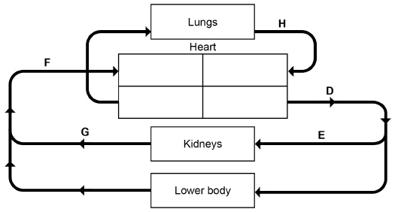
Use Figure 1 to give the letter that represents each of these blood vessels.

Aorta | 
Renal vein
Vena cava
(3)
(b) Name the blood vessels that carry blood to the heart muscle.
___________________________________________________________________
(1)

Outcome:
- Explain the purpose of the atrio-ventricular and semilunar valves
- Explain differences in the thickness of cardiac muscle between the atria and ventricles, and between different sides of the heart


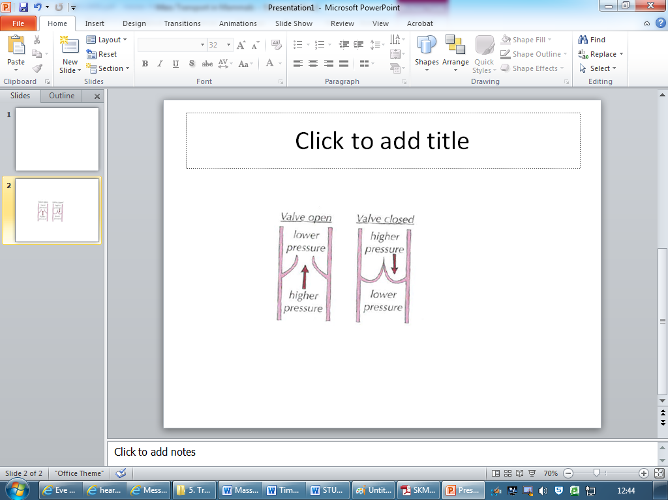
Heart valves
- They only open one way
- They prevent backflow of blood

Muscle and Valves
Task: Fill in the blanks using given words, and then use the information to annotate the diagram below
[direction, pressure, contract, relax, greater, higher, A-V, S-L, atria, ventricles, ventricles, ventricles, ventricles, stronger, stronger]
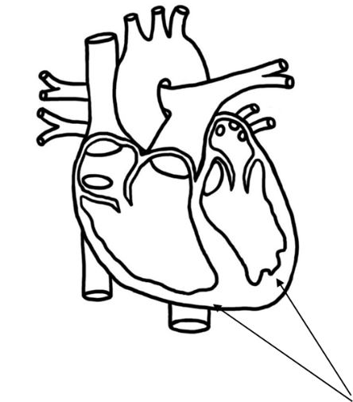
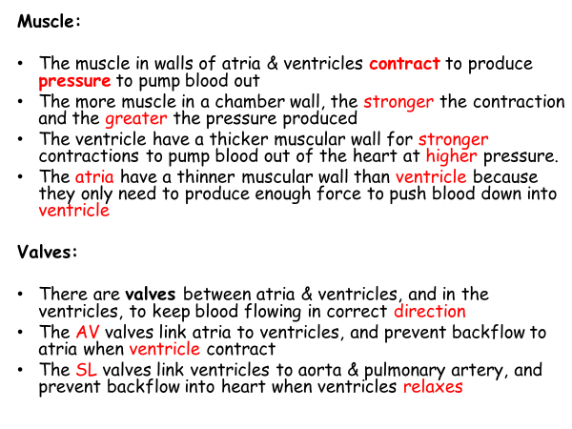

_______________________________________________________________________________________
Exam Questions:
Answers on powerpoint

Q2.
In a healthy person, blood moves in one direction as it passes through the heart. Give two ways in which this is achieved.
1. _____________________________________________________________________
_______________________________________________________________________
_______________________________________________________________________
2. _____________________________________________________________________
_______________________________________________________________________
_______________________________________________________________________
(Total 2 marks)
Q3.
The diagram shows a section through the heart. The main blood vessels are labelled A, B, C and D.
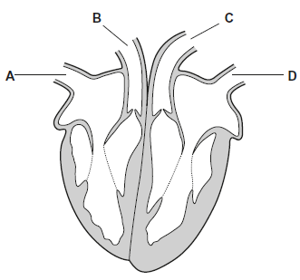
(a) Write a letter, A, B, C or D, in the box to represent the correct blood vessel.
(i) Which blood vessel carries oxygenated blood away from the heart?

(1)
(ii) Which blood vessel carries deoxygenated blood to the heart?
(1)
(b) Explain how the highest blood pressure is produced in the left ventricle.
___________________________________________________________________
___________________________________________________________________
___________________________________________________________________
(1)
(c) Some babies are born with a hole between the right and the left ventricles.
These babies are unable to get enough oxygen to their tissues.
Suggest why.
___________________________________________________________________
___________________________________________________________________
___________________________________________________________________
___________________________________________________________________
___________________________________________________________________
(2)
(Total 5 marks)

_______________________________________________________________________________________
Outcome:
- Explain the opening and closing of AV and SL valves in terms of the pressure differences at different stages of the cardiac cycle.
- Explain the cardiac cycle in terms of atrial systole, ventricular systole and diastole
- Analyse and interpret data relating to pressure changes during the cardiac cycle

- The cardiac cycle is the ongoing sequence of contraction & relaxation of the atria and ventricles
- The 2 phases are contraction (SYSTOLE) and relaxation (DIASTOLE).
- Contraction occurs separately in the atria & ventricles

Note the pressure and volume changes throughout the cycle

“SYSTOLE”: Contraction of the heart muscle
“DIASTOLE”: Relaxation of the heart muscle

(Use these prompts to fill in the blanks: Muscle, Pressure, Valve, Direction – My Parents are Very Delightful)
1. DIASTOLE
- Muscle is relaxed
- Pressure increases in atria
- Valves: bicuspid and tricuspid valves open slightly
- Direction: blood starts to enter ventricles
2. ATRIAL SYSTOLE
- Muscles in atrial walls contract
- Pressure in atria increases
- Valves: A-V valves are forced open when the pressure in atria is higher than in ventricles
- Direction: blood flows into ventricles
3. VENTRICULAR SYSTOLE
- Muscles in ventricle walls contract
- Pressure in ventricles increases
- Valves: A-V valves are forced closed when the pressure in ventricles is higher than in atria,
- Direction: valves prevent blood flowing back into atria
- Pressure in ventricles is also greater than in arteries
- Valves: S-L valves are therefore forced open
- Direction: blood flows out of arteries
4. DIASTOLE
- Muscle relaxes
- Pressure in all chambers decreases
- Pressure in arteries is now greater than in ventricles
- Valves: S-L valves are therefore forced closed
- Direction valves prevent blood flowing back into ventricles
- Direction: Blood enters L & R atria from veins

Use red and blue to show oxy and deoxy blood, label first heart, fill in each box with name of the phase
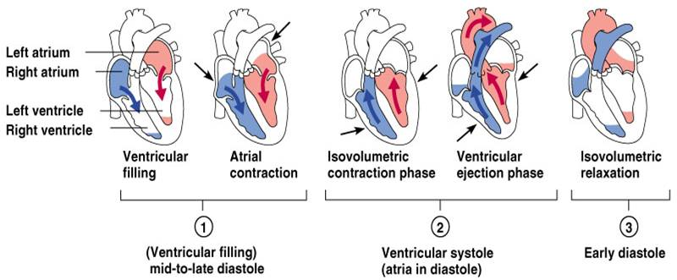

Diastole
Ventricular systole
Atrial Systole
Diastole

Outcome:
- process data to calculate rates

Calculations:

Heart rate = the number of beats per minute (bpm)
HR = 60 (s)
time taken for one heart beat (1 cardiac cycle = 1 heart beat)
Q: If your cardiac cycle is 0.9 seconds long, what is your heart rate?
………………………………66.67………………………………………………………
- Stroke volume = cardiac output ÷ heart rate
- Cardiac output = stroke volume x heart rate

Mark scheme answer: Why does training lower the resting heart rate of an athlete?
- Size of the heart / ventricles increases
- Muscle size in the walls increases
- Strength of contractionincreases
- Stroke volumeincreases
- Cardiac output is the same

_______________________________________________________________________________________
Exam Questions:
Answers on powerpoint

Q4.
(a) (i) The human heart has four chambers.
In which one of the four chambers of the human heart does pressure reach the highest value?
______________________________________________________________
(1)
(ii) Explain how the structure of this chamber causes this high pressure.
______________________________________________________________
______________________________________________________________
______________________________________________________________
(1)

The table shows the volume of blood in a man's right ventricle at different times during one cardiac cycle.

Time / s | Volume of blood / cm³
0.0 | 125
0.1 | 148
0.2 | 103
0.3 | 70
0.4 | 56
0.5 | 55
0.6 | 98
0.7 | 125
(b) (i) Use the data in the table to calculate the man’s heart rate.
Heart rate = ____________________ beats per minute
(ii) Use the data in the table and your answer to part (b) (i) to calculate the man’s cardiac output. Show your working.
Cardiac output = ____________________ cm³ per minute
(3)
(c) Use information from the table to complete the table below to show whether the valves are open or closed at each of the times shown. Write open or closed in the appropriate boxes.

Time / s | Valve between right  atrium and right  ventricle | Valve between right  ventricle and pulmonary  artery
0.2
0.6
(2)
(Total 7 marks)

Answers on powerpoint

Q5.
An electrocardiogram is made by attaching recording electrodes to a person’s chest. It shows the electrical changes that take place in a person’s heart each time it beats. A sports physiologist produced electrocardiograms for a fit adult male.
Chart X shows an electrocardiogram from this man after 10 minutes of complete rest.
A cardiac cycle consists of the filling time and the contraction time. The filling time and the contraction time for one cardiac cycle are shown on this chart.
Chart X
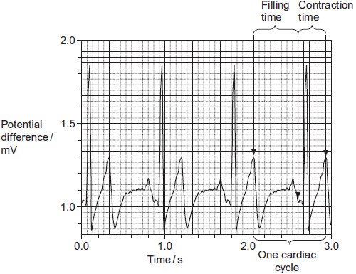
Chart Y shows an electrocardiogram from the same man immediately after a period of exercise.
Chart Y
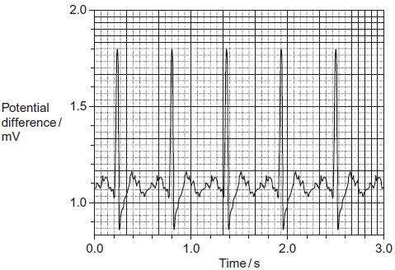
Answers on powerpoint

(a) Give one way in which an electrocardiogram could have produced more reliable results than counting the pulse.
Answers on powerpoint
___________________________________________________________________
___________________________________________________________________
___________________________________________________________________
(1)
(b) (i) Chart X shows that the man’s resting heart rate was 67 beats per minute. What was his pulse rate? Explain your answer.
______________________________________________________________
______________________________________________________________
______________________________________________________________
(2)
(ii) Use chart Y to calculate the man’s heart rate after the period of exercise.
Show your working.

Answer ____________________ beats per minute
(2)
(c) Use charts X and Y to describe how exercise affected filling time.
___________________________________________________________________
___________________________________________________________________
___________________________________________________________________
___________________________________________________________________
___________________________________________________________________
(2)
(d) The physiologist used electrocardiograms to investigate the effect of increasing heart rate on filling time.
Describe how she could have modified the method of exercising you used to produce a range of increases in heart rate.
___________________________________________________________________
___________________________________________________________________
___________________________________________________________________
___________________________________________________________________
___________________________________________________________________
(2)
(Total 9 marks)

Outcome:
- Analyse and interpret data relating to pressure changes during the cardiac cycle

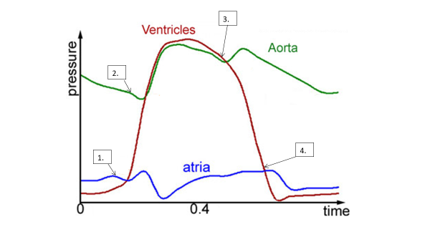
Pressure changes in left side of the heart during the cardiac cycle

- Ventricular systole increase in pressure in ventricle so it is higher than the pressure in atrium which pushes the A-V valve shut

- Ventricular systole increase in pressure in ventricles so it is higher than in arteries, which pushes the S-L valves open

- Ventricular diastole decrease in pressure in Ventricle, so it is lower than in the arteries which pushes the S-L valves shut

- Ventricular diastole decrease in pressure in ventricle, so it is lower than in the arteries which pushes the S-L valves open

- You do not need to learn this because once you understand why valves open and close, you can then just work it out

______________________________________________________________________________________
Exam Questions:
Answers on powerpoint

Q6. Relaxation of heart muscle is called diastole. Contraction is called systole. The diagram shows the periods of diastole and systole when the heart is beating.
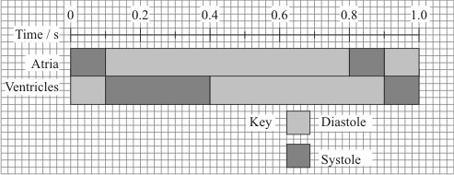
(a) At what time is the volume of blood in the ventricle at a maximum?
___________________________________________________________________ (1)
(b) Calculate the heart rate in beats per minute. Show your working.

Heart rate = ____________________ beats per minute(2)
(c) The valves between the atria and the ventricles are closed between 0.1 s and 0.4 s.
(i) Explain how pressure causes these valves to be shut.
______________________________________________________________
______________________________________________________________
(1)
(ii) Explain how closure of these valves is essential to the functioning of the heart.
______________________________________________________________
______________________________________________________________(1)

The graph shows the effect of the pressure of blood in the veins on the stroke volume of the heart.
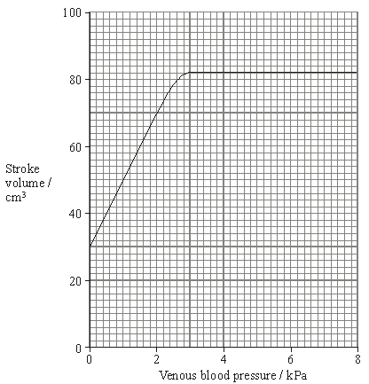
(d) Describe how venous blood pressure affects stroke volume.
___________________________________________________________________
___________________________________________________________________
___________________________________________________________________
___________________________________________________________________(2)
(e) At a venous pressure of 2 kPa, the cardiac output is 5600 cm³ per minute. Calculate the number of times the ventricle contracts in one minute. Show your working.

Answer ____________________(2)

Answers on powerpoint

(f) Explain how blood in a vein in the leg is returned to the heart.
___________________________________________________________________
___________________________________________________________________
___________________________________________________________________
___________________________________________________________________
___________________________________________________________________
___________________________________________________________________
___________________________________________________________________
___________________________________________________________________
___________________________________________________________________
___________________________________________________________________
___________________________________________________________________
Blood Vessel | Role
Capillaries | tiny vessels that link arterioles to veins; site of exchange between blood and cells
Arteries | carry blood away from heart, at high pressure, and into arterioles; blood travels in pulses
Veins | carry blood, at low pressure, from capillaries back to heart.
Arterioles | smaller arteries that control blood flow from arteries to capillaries
___________________________________________________________________
___________________________________________________________________
___________________________________________________________________
___________________________________________________________________
(6)
Answers on powerpoint
(Total 15 marks)

Outcome:
- Describe the structure of arteries, arterioles, veins and capillaries
- Relate the structure of arteries, arterioles, veins and capillaries to their functions
- Compare and contrast the structure and function of different blood vessels

Blood Vessels
Match up the blood vessel with role: Arteries, Arterioles, Capillaries, Veins

Blood vessels all have;
- Lumen = central cavity
- Endothelium = thin, smooth inner lining
- Wall = made of muscle, elastic tissue and collagen
- BUT… the relative proportions of each layer differ, and links to their different functions.

Diagram of the different vessels: colour in muscle, elastic layer:-

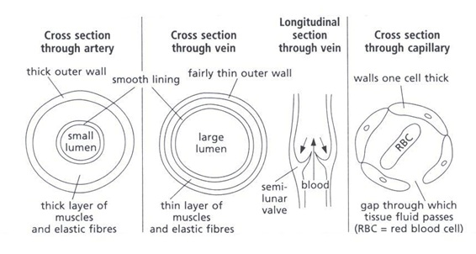

Capillary:
- Very thin wall, only 1 cell think
- Made of flattened Endothelium
- Spaces between the endothelial cells allow WBC to escape to get to site of tissue infection
Artery:
- Thicker muscular layer
- TThicker elastic tissue layer
- Wall Thicker overall
- Lumen is relatively narrow
Vein:
- Thinner muscular layer
- Thinner elastic tissue layer
- Wall Thinner overall
- Lumen is relatively Wider

Which type of blood vessel is the aorta?Artery
How is the structure of the aorta is adapted to its function?
- Elastic tissue allows stretch and recoil to maintain blood pressure
- Elastic tissue stretches when ventricles contract
- Muscle allows contraction, vasoconstriction
- Thick walls stop bursting
- Smooth endothelium reduces friction
- Semi-lunar valves prevent backflow

Stretch and challenge: Calculate ratio of lumen to total diameter for artery and vein

Complete the comparison of blood vessels table below.
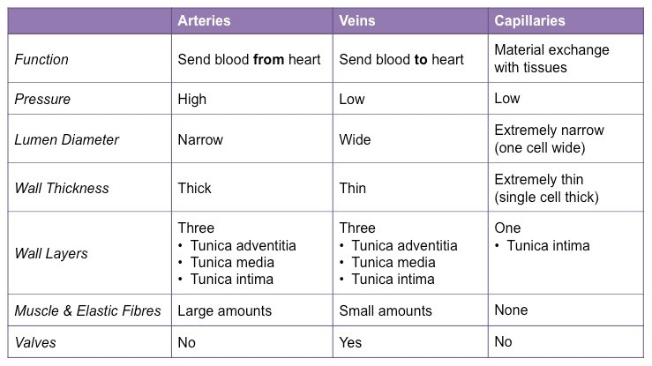
Three Three one
Smooth Endothelium Smooth Endothelium 1 cell thick Muscle and elastic Muscle and elastic Endothelium Epithelium Epithelium

Outcome:
- Explain what tissue fluid is and which substances it contains
- Explain the formation of tissue fluid in terms of hydrostatic pressure
- Explain the reabsorption of some tissue fluid back into the capillaries, in terms of hydrostatic pressure and water potential
- Explain the role of the lymph system.

Tissue Fluid and lymphatic system

What is it?
- It is the environment of the cells
- Substances move out of the capillaries to form tissue fluid
- It bathes the body cells in the tissues, supplying all required substances
- Tissue fluid then receives carbon dioxide and other waste materials
- And is returned to the circulatory system
- Tissue fluid is how exchange of gases & nutrients between blood and cells occurs

Stretch and Challenge: Transport of oxygen, carbon dioxide, glucose, amino acids, urea & proteins

Tissue | From Capillaries to tissue | To capillaries from tissue
Alveoli | 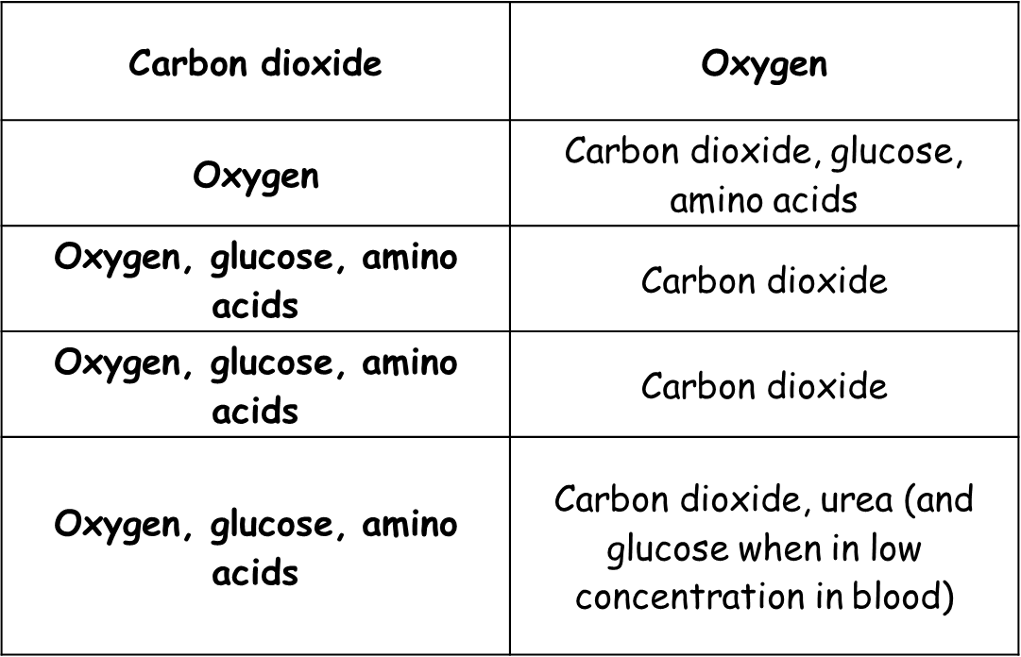
Intestinal villi

Brain

Leg muscles

Liver

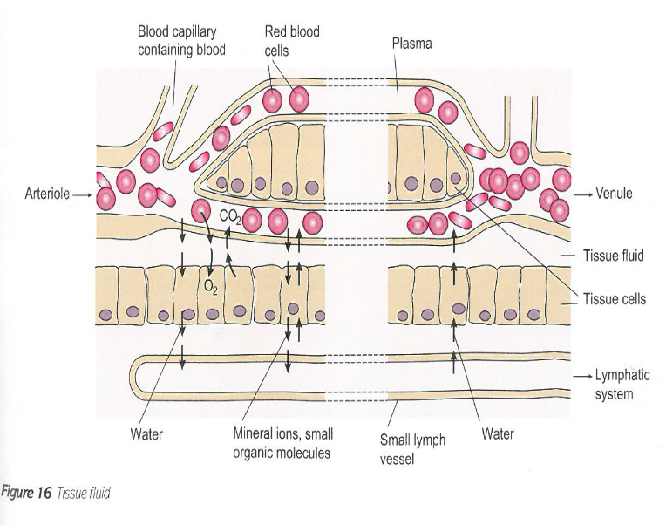

Annotate the diagram with all the notes below
At venule end:
- The loss of water from the capillaries reduces the HP inside
- So the HP is now lower than the issue fluid outside
- The water potential is lower inside the capillary than outside in the TF due to the water loss and the larger proteins still in the capillary
- Therefore water re-enters the capillaries from the tissue fluid by osmosis down a water potential gradient.

At arteriole end:
- There is a high hydrostatic pressure (HP) in the capillaries created by contraction of the ventricles.
- This is greater than the HP of tissue fluid outside the capillaries
- Therefore water to move OUT of capillaries and into the spaces around cells, forming the tissue fluid (TF)
- Small molecules are also forced out
- Cells and the larger plasma proteins, are too large to cross the membrane = ultrafiltration.

Lymphatic System
- Not all 100% of the tissue fluid can return to the capillaries.
- The remaining fluid (10%) enters the lymphatic system, into a lymph vessel, and is now called lymph
- Eventually the vessels drain back into the bloodstream

Q7. The diagram shows a cross-section of a blood vessel.
Answers on powerpoint
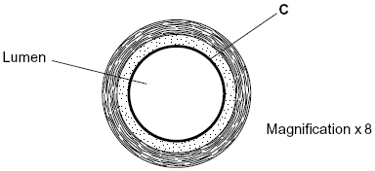
(a) Name layer C.
___________________________________________________________________ (1)
(b) Calculate the actual diameter of the lumen of this blood vessel in millimetres. Show your working.

Answer ____________________ mm(2)
(c) The aorta has many elastic fibres in its wall. An arteriole has many muscle fibres in its wall.
(i) Explain the importance of elastic fibres in the wall of the aorta.
______________________________________________________________
______________________________________________________________
______________________________________________________________
______________________________________________________________(2)
(ii) Explain the importance of muscle fibres in the wall of an arteriole.
______________________________________________________________
______________________________________________________________
______________________________________________________________
______________________________________________________________(2)

(d) The graph shows the rate of blood flow in different blood vessels. It also shows the total cross-sectional area of these blood vessels.
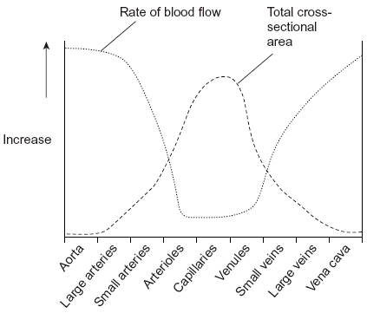
(i) The rate of blood flow decreases from the aorta to the capillaries. Use information from the graph to explain why.
______________________________________________________________
______________________________________________________________
______________________________________________________________
(1)
(ii) Efficient exchange of substances in the capillaries is linked to the rate of blood flow. Explain how.
______________________________________________________________
______________________________________________________________
______________________________________________________________
(1)
(Total 9 marks)
Q8. (a) (i) An arteriole is described as an organ. Explain why.
______________________________________________________________
______________________________________________________________
______________________________________________________________
(1)
Answers on powerpoint

(ii) An arteriole contains muscle fibres. Explain how these muscle fibres reduce blood flow to capillaries.
______________________________________________________________
______________________________________________________________
______________________________________________________________
______________________________________________________________
______________________________________________________________
(2)
(b) (i) A capillary has a thin wall. This leads to rapid exchange of substances between the blood and tissue fluid. Explain why.
______________________________________________________________
______________________________________________________________
______________________________________________________________
(1)
(ii) Blood flow in capillaries is slow. Give the advantage of this.
______________________________________________________________
______________________________________________________________
______________________________________________________________
(1)
(c) Kwashiorkor is a disease caused by a lack of protein in the blood. This leads to a swollen abdomen due to a build up of tissue fluid.
Explain why a lack of protein in the blood causes a build up of tissue fluid.
___________________________________________________________________
___________________________________________________________________
___________________________________________________________________
___________________________________________________________________
___________________________________________________________________
___________________________________________________________________
(3)

