3.2.3 Transport Across Cell Membranes

Name __________________________________

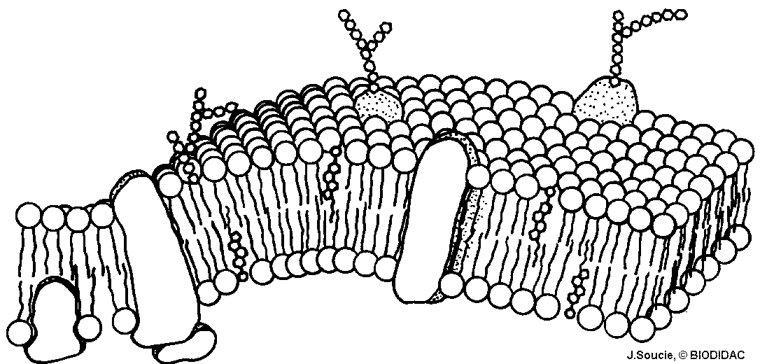

Reflection on learning outcomes | or | Target
Describe, explain and relate the arrangement of proteins, glycoproteins, glycolipids, phospholipids and cholesterol in the fluid mosaic model of membrane to roles around/inside cells.
Explain how surface area, number of channel or carrier proteins and differences in gradients of concentration or water potential affect the rate of movement across cell membranes.
Define and explain what is meant by diffusion and facilitated diffusion and their processes.
Identify which substances rely on facilitated diffusion and why they cannot enter/leave cells by diffusion.
Define and explain osmosis in terms of water potential and the movement of water due to osmosis into or out of cells.
Define and explain what is meant by active transport and its process.
Compare and contrast active transport and facilitated diffusion.
Interpret data to identify when a substance is being moved by diffusion, facilitated diffusion or active transport.
Explain the adaptations of specialised cells, including small intestine epithelial cells, maximising the rate of transport across their internal and external membranes.
Define and explain what is meant by co-transport in the context of absorption of glucose.

Outcome:
- Describe, explain and relate the arrangement of proteins, glycoproteins, glycolipids, phospholipids and cholesterol in the fluid mosaic model of membrane to roles around/inside cells.

All membranes around and within all cells (including those around and within cell organelles) have the same basic structure and are known as plasma membranes.
The cell-surface membrane is the name specifically given to the plasma membrane that surrounds cells and forms the boundary between the cell cytoplasm and the environment.

Structure of a phospholipid (Biological molecules)
Recap questions:

- Name A and B, stating how many of each. Label on the diagram below.
A = ________________________
A

B = ________________________
B

- What property does A have?
________________________________________________________________

- What property does B have?
________________________________________________________________

- Two layers of phospholipids form a _____________.

- What type of molecule do phospholipids allow to pass through?
_________________________________________________________________
- What type of molecule do they not allow through?
_________________________________________________________________
“Property”: A trait a molecule has which can be used to identify it or measurable
“Component”: The different parts that make up a structure
Fluid Mosaic Model
In the boxes write fluid or mosaic to produce a definition:

Molecule can move relative to one another, allowing flexibility

Made of both phospholipids and proteins

Membrane components
All membranes diagrams looks different. You will need to APPLY your knowledge to diagrams.
Label structures A to F. Use text book page 86 to help.
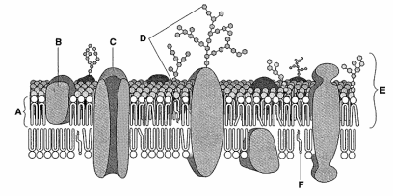

Component | Role/Function
Phospholipid | - Forms bilayer  - Selectively permeable; only allowing non-polar molecules through into cell.  - Compartmentalisation; maintain different concentrations either side of the membrane  - Flexible shape  WITHIN CELLS:  - Selectively permeable; only allowing non-polar molecules through into organelle  - Separates metabolic reaction and enzymes inside organelle  - Surface for reactions
Cholesterol | - Regulates fluidity  - Hydrophobic
Proteins | - Stability to membrane  - Can be extrinsic (surface) or intrinsic (though bilayer)  - Channel proteins for polar molecules in facilitated diffusion  - Carrier proteins for active transport of polar molecules
Glycoprotein/  Glycolipid | - Receptor site for hormones  - Act as recognition sites for molecules and cells  - Helps cells to attach to each other to form tissue

T/F Quiz:
If statement is false then you need to correct it, space on previous page.
- Glycolipids help form tissues

- Without proteins membranes would dissolve

- Oestrogen is a lipid-based hormones so is able to pass through the bilayer

- Insulin is a protein-based hormones so is able to pass through the bilayer

- The membrane of the mitochondria is impermeable to glucose which means only small amounts of glucose can pass through the membrane

- Intrinsic proteins span the bilayer so allow the membrane to be flexible and change shape

- Channel proteins are used in both facilitated diffusion and active transport.

- Cholesterol is soluble in water

- Phospholipid heads are hydrophilic so point in towards the bilayer

- Compartmentalisation means the concentration of glucose inside the vacuole can be higher than in the cytoplasm of the plant cell.
_______________________________________________________________________________________
Exam question:
- The diagram shows part of a cell surface membrane.

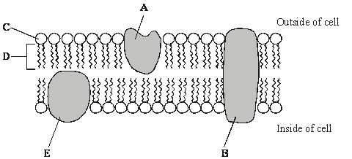

(a) Complete the table by writing the letter from the diagram which refers to each part of the membrane. (2)

Part of membrane | Letter
Channel protein
Contains only the elements carbon and hydrogen

(b) Explain why the structure of a membrane is described as fluid-mosaic.

___________________________________________________________________

_________________________________________________________________ (2)
Q2.(a) The diagram shows the fluid-mosaic model of a cell surface membrane.
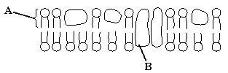
(i) Name the molecules labelled A and B.
A ________________________________________________________
B ________________________________________________________(1)
(ii) How does the bilayer formed by substance A affect entry and exit of substances into and out of a cell?
________________________________________________________
________________________________________________________
________________________________________________________
________________________________________________________(2)

_______________________________________________________________________________________

Membrane and permeability- Assessed practical 4

Temperature
A higher temperature gives molecules (phospholipids) in the membranes more kinetic energy, so they move faster.
The bilayer is more fluid. This makes the membrane leaky, increasing permeability.

Ethanol
Ethanol dissolves lipids (phospholipids and cholesterol) causing holes in the membrane allowing molecules to move freely.

Transport through cell membranes
There are 5 different transport methods. You will need to be able to define, describe, explain and compare the different methods using application questions.
Passive –  Does not require energy | Active -  Requires energy

Outcome:
- Explain how surface area, number of channel or carrier proteins and differences in gradients of concentration or water potential affect the rate of movement across cell membranes

Factors affecting rate of transport.

Factor | Description | Explanation
 | The greater the difference in concentration between the two sides of the membrane the faster the rate of transport
 | The greater the surface area (e.g. microvilli present) the faster the rate of transport | This is because more molecules or ions can cross the membrane at any one moment.
 | A larger number of channel and carrier proteins in the membrane the faster the rate of transport | This is because more molecules or ions can cross the membrane at any one moment.
 | Higher temperatures give molecules or ions more kinetic energy so the faster the rate of transport | Molecules move around faster.

*Always specify the type of transport the exam question is asking about- Diffusion, Facilitated diffusion, active transport or osmosis

Words to use can be found in the outcome

Outcome:
- Define and explain what is meant by diffusion and facilitated diffusion and their processes
- Identify which substances rely on facilitated diffusion and why they cannot enter/leave cells by diffusion.

- Diffusion
Definition:
Net movement of molecules or ions from a higher concentration to lower concentration
Down a concentration gradient until equilibrium
Passively

Non-polar molecule diffuse quickly but small polar molecules can also diffuse through membrane as their size means it doesn’t matter that the molecules are polar.

Add to the diagram to show diffusion definition.
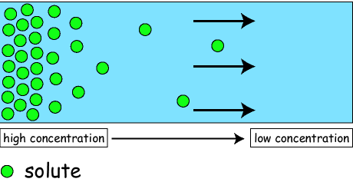

- Facilitated Diffusion
Definition:
Net movement of molecules or ions from a higher concentration to lower concentration
Down a concentration gradient until equilibrium
Passively
Using channel and carrier proteins

Charged ions and polar molecules do not easily diffuse because of the hydrophobic fatty-acid tails of the phospholipids. They use protein channels and carrier proteins instead, which are specific to one molecule/ion, to help. The no. of channel/carrier proteins can limit the rate of transport.

Label the diagram below.
Labels – phospholipid, phosphate hydrophilic heads, fatty acid hydrophobic tail, hydrophilic channel, high concentration, low concentration.

_______________________________________________________________________________________
Exam Questions:
Q1. The diagram shows part of a plasma membrane. The arrows show the path taken by sodium ions and by substance X when they diffuse through the membrane into a cell.
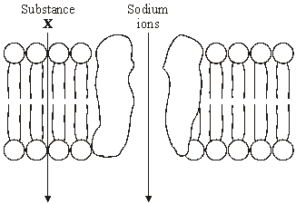
(a) An optical microscope cannot be used to see a plasma membrane. Explain why.
____________________________________________________________
____________________________________________________________
____________________________________________________________
____________________________________________________________(2)
(b) Give one property of the molecules of substance X which allows them to diffuse through the membrane at the position shown.
____________________________________________________________
____________________________________________________________(1)

The most common type of exam questions for transport are application questions. You will have to use/understand the definitions and apply this to graphs.
Tips:
- Identify the ion/molecule that is being moved.
- Use this to identify the type(s) of transport that can be used.
- Apply the transport definitions.
(c) The effect of the concentration of sodium ions in the surrounding solution on their rate of diffusion across the membrane was investigated. The graph shows the results.
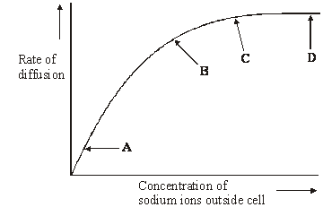
- Na⁺ so polar molecule
- FD, AT
- A-B: As conc increase so does rate = FD/AT
C-D: increasing conc rate plateau so must be limiting factor, no mention of ATP so must be FD

(i) What limits the diffusion of sodium ions across the membrane between
A and B on the graph? Give the evidence for your answer.
Limiting factor __________________________________________________
Evidence ______________________________________________________
____________________________________________________________(2)
(ii) Explain the shape of the curve between C and D.
________________________________________________________
________________________________________________________
________________________________________________________(2)

Outcome:
- Define and explain osmosis in terms of water potential and the movement of water due to osmosis into or out of cells

- Osmosis

Definition:
The diffusion of water molecules from a higher water potential to a lower water potential
Down a water potential gradient until equilibrium
Passively across membrane or through aquaporins

Add to the diagram below to explain osmosis:
B
A

- Lower water potential
- Higher concentration of solute molecules
- Higher water potential
- Lower concentration of solute molecules

Solute:
Ion/molecule that dissolves in a solvent
e.g sodium ions (solute) dissolve in water (solvent)
Solvent:
Substance solute dissolves in
e.g sodium ions (solute) dissolve in water (solvent)

Use the text book page 89 + 90 to answer the questions below to help you understand osmosis better:

- What is the water potential of pure water? ________

- What affect do solutes have on water potential? _______________________________________

- Why is there a net movement of water molecules from A to B? ___________________________

- Equilibrium is when there is no net movement of water molecules. In what situation will this occur? _________________________________________________________________________________

- Place the cells in the correct order for water to pass from one to the next:
A = -200 kPa
B = -250 kPa
C = -100 kPa
D = -150 kPa.
Fill in the term for the definition below, these are terms used in the exam that you need to know but won’t need to define yourself.

Term | Definition
 | The protoplast no longer presses on the cell wall
 | Consists of outer cell-surface membrane, nucleus, cytoplasm, and inner vacuole membrane
 | The protoplast and cell contents pull away from the cell wall
 | The protoplast is pushed against the cell wall

Term:
Incipient plasmolysis Plasmolysed Turgid Protoplast

You may be shown diagrams or be given descriptions of what is happening around cells, you will then have to explain what is/has happened.

Animal cell

Water potential of external solution compared to cell solution | Higher  (less negative) | Equal | Lower  (more negative)
Net movement of water
State of cell

Diagram
Plant cell

Water potential of external solution compared to cell solution | Higher  (less negative) | Equal | Lower  (more negative)
Net movement of water

Protoplast

Condition of cell

Diagram

_____________________________________________________________________________
Exam questions:
All of these are application style questions.
Q1.(a) The water potential of a plant cell is –400 kPa. The cell is put in a solution with a water potential of –650 kPa. Describe and explain what will happen to the cell.
____________________________________________________________
____________________________________________________________
____________________________________________________________(3)
(b) A group of students investigated the effect of sucrose concentration on the change in length of cylinders of tissue cut from a young carrot. They measured the initial lengths of the carrot cylinders, then placed one in each of a number of sucrose solutions. After 18 hours, they removed the carrot cylinders and measured their final lengths. Some of the results are shown in the table.

Concentration of sucrose /  mol dm^{–3} | Percentage decrease in length of carrot cylinder
0.4 | 4.2
0.5 | 8.7
0.6 | 13.0
0.7 | 16.8
0.8 | 18.1
0.9 | 18.1
1.0 | 18.1
(i) The carrot cylinders were left for 18 hours in the sucrose solutions. Explain why they were left for a long time.
________________________________________________________(1)
(ii) Explain how you would use a graph to predict the concentration of sucrose that would result in no change in length of the carrot cylinders.
________________________________________________________
________________________________________________________ (2)
(iii) Young carrots store sugars in their tissues but, in older carrots, some of this is converted to starch. How would using cylinders of tissue from older carrots affect the results obtained for a sucrose solution of 0.6 mol dm^{–3}? Give a reason for your answer.
________________________________________________________
________________________________________________________(2)

Q2. Six cylinders of a standard size were cut from a single large potato. One cylinder was placed in distilled water and the others were placed in sucrose solutions of different concentrations. The length of each cylinder was measured every 5 minutes for the next 50 minutes. The graph shows the changes in length at each sucrose concentration.

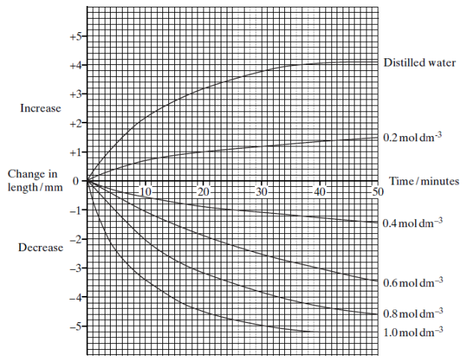

(a) Explain why

(i) the potato cylinder in distilled water increased in length;

______________________________________________________________

______________________________________________________________ (2)

(ii) the potato cylinder in the 1.0 mol dm^{–3} sucrose solution showed no further
decrease in length after 40 minutes.

______________________________________________________________

______________________________________________________________ (2)

(b) (i) Describe the difference in the rate of decrease in length during the first 10 minutes between the cylinder in the 0.4 mol dm^{–3} and the cylinder in
the 0.8 mol dm^{–3} solution.

______________________________________________________________

______________________________________________________________(1)

(ii) Use your knowledge of water potential to explain this difference.

______________________________________________________________

______________________________________________________________(1)

Outcome:
- Define and explain what is meant by active transport and its process
- Compare and contrast active transport and facilitated diffusion.
- Interpret data to identify when a substance is being moved by diffusion, facilitated diffusion or active transport

- Active transport

Definition:
The movement of ions or molecules from a lower concentration to a higher concentration
Against a concentration gradient
Using ATP
And carrier proteins.

Can be used to transport ions/molecules directly or as part of a process like co-transport (more about this later). In the exam you will usually have to interpret graphs or compare active transport to other methods of transport.
Complete the contrast table, then annotate the diagram below

Transport | Diffusion | Facilitated diffusion | Osmosis | Active transport
Molecules moved
Concentrations

Gradient

ATP?

Transport proteins?
Limiting factors?

_____________________________________________________________________________________
Exam questions:
Q1.(a) Contrast the processes of facilitated diffusion and active transport. TABLE!
____________________________________________________________
____________________________________________________________
____________________________________________________________
________________________________________________________ (3)
1.

c.
b.
a.
Q2. A scientist investigated the uptake of sodium ions by animal tissue. To do this, he:
• used two flasks, F and G
• put equal masses of animal tissue into each flask
• added equal volumes of a solution containing sodium ions to each flask
• added to flask F a solution of a substance that prevents the formation of ATP by cells
• measured the concentration of sodium ions remaining in the solution in each flask.
The graph below shows his results.
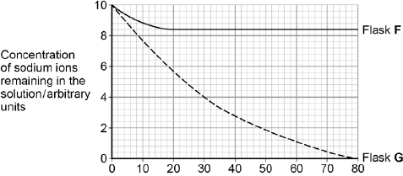
Time / minutes
Go back to exam tips on page 9 to help you figure out the graph
(a) Calculate the rate of uptake of sodium ions by the tissue in flask G during the first 20 minutes of this investigation.
Answer = ____________________ arbitrary units per minute (1)
(b) The scientist concluded that the cells in flask G took up sodium ions by active transport. Explain how the information given supports this conclusion.
______________________________________________________
_____________________________________________________
______________________________________________________
_____________________________________________________ (4)
(c) The curve for flask F levelled off after 20 minutes. Explain why.
______________________________________________________
______________________________________________________
______________________________________________________ (2)

Q3. A scientist placed plant cells in solutions containing different concentrations of calcium ions. She measured the rate of uptake of calcium ions by plant cells.

The graph below shows her results.

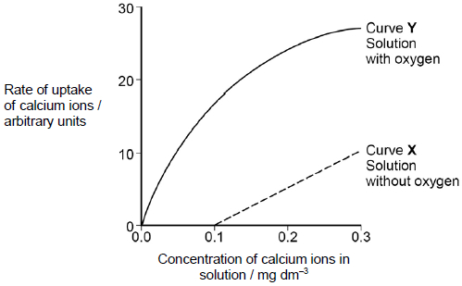

(a) What can you conclude from the graph about the processes involved in the uptake of calcium ions by these plant cells? Use evidence from the graph to support your answer.

___________________________________________________________________

___________________________________________________________________

___________________________________________________________________

___________________________________________________________________

___________________________________________________________________

___________________________________________________________________

___________________________________________________________________

___________________________________________________________________

___________________________________________________________________

___________________________________________________________________

___________________________________________________________________

___________________________________________________________________(5)

Outcome:
- Explain the adaptations of specialised cells, including small intestine epithelial cells, maximising the rate of transport across their internal and external membranes
- Define and explain what is meant by co-transport in the context of absorption of glucose

- Co-transport and absorption of glucose in the ileum

Recap questions: The two images here show microvilli on epithelial cells from the small intestine.
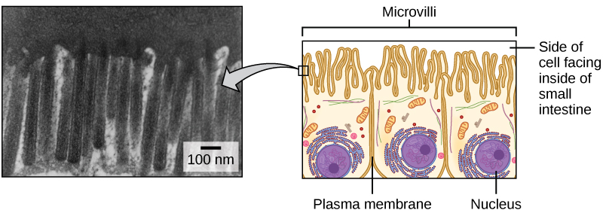
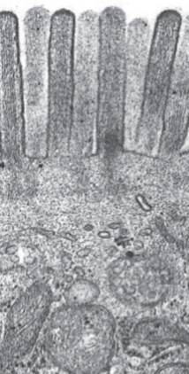

Can you identify and explain how the epithelial cell is specialised to increase the rate of transport?

- _________________________________________________________________________
_________________________________________________________________________

- _________________________________________________________________________
_________________________________________________________________________

What organelle can you see in the photo on the left that indicate this photo was taken with a TEM?
_________________________________________________________________________

Explain why these cells would need a large number of these organelles.
__________________________________________________________________________

__________________________________________________________________________
Name 2 polysaccharides that we are able to digest in our diet.
__________________________________________________________________________
Give the monomer(s) for the saccharides below:
Lactose: ___________________________________________________________________
Maltose: __________________________________________________________________
We eat polysaccharides and digest them into monosaccharides in our digestive system. These monosaccharides are then absorbed from the lumen of the ileum (the small intestine) into our epithelial cells lining the ileum and then into our blood.

Diffusion only results in the concentration of glucose in the blood and in the small intestine becoming equal. The reason why all the glucose and amino acids are absorbed from the ileum is due to active transport taking place as well, using co-transport.

Glucose or amino acids are drawn into the cells lining the small intestine along with sodium ions that have been actively transported out by the sodium-potassium pump.

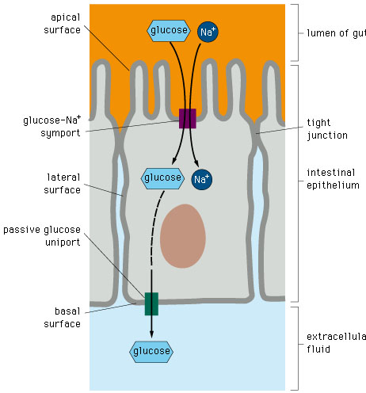
6.

4.

9.

11.

1.

2.

Use these words to finish labelling the structure on your diagram.

Microvilli Blood capillary Co-transport protein
Lumen of ileum Epithelial cells Protein carrier
8.Sodium potassium pump

10. Plasma membrane

5. Plasma membrane

3. Plasma membrane

Na⁺

7. Extra cellular fluid

Use the words below to fill in the gaps, then add the numbers to the diagram.

Epithelial Epithelial Epithelial Na⁺ Na⁺
Active Facilitated Glucose Glucose
Down Against Blood

Na+ leave the e____________ cell into the blood
By a___________ transport using the Na⁺/K⁺ pump
So, N____ concentration inside e_________________ cell is lower than lumen of Ileum
N_____ moves from the lumen of the ileum into the e_____________ cell by f______________ diffusion d________ a concentration gradient
G_______________ absorbed with Na+ a_______________ glucose concentration gradient
G______________ moves into b______________ from epithelial cell by f________________ diffusion
T/F quiz.
If statement is false then you need to correct it.
- Na+ is actively transported from the lumen of the Ileum to epithelial cells
- Glucose is actively transported from the lumen of the Ileum to epithelial cells
- ATP is used to move Na+
- The steeper the concentration gradient the faster the rate of movement
- ATP is used to move glucose
- Glucose diffuses into the epithelial cell
- If the temperature increased Co-transport would happen faster.
- Glucose uses proteins to move into the blood from the epithelial cell
- ATP is used to maintain a steep concentration gradient for Na+ between the lumen of the Ileum and the blood
- Amino-acids are actively transported from the lumen of the Ileum to the epithelial cell.

_____________________________________________________________________________________
Exam Questions:
Q1. The diagram shows one method by which amino acids are absorbed from the small intestine into the blood. They are co-transported into the epithelial cell with sodium ions (Na⁺) at point X on the diagram. Normally, the concentration of sodium ions inside the epithelial cell is low.
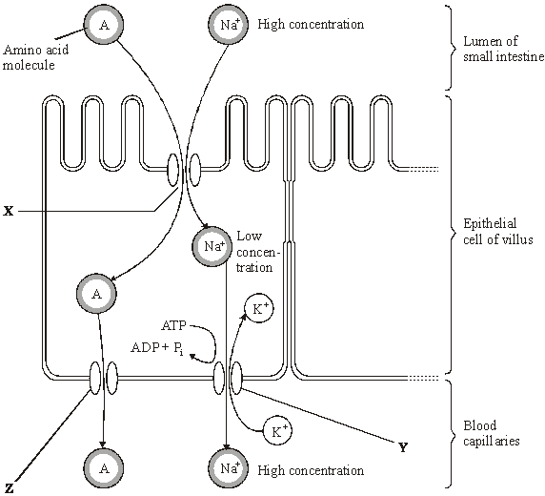
Dinitrophenol (DNP) prevents oxidative phosphorylation. When treated with DNP, the sodium-potassium pump at Y no longer works. As a result, the concentration of sodium ions in the cell rises and amino acid absorption stops.
(i) Explain why pump Y will not work in the presence of DNP.
____________________________________________________________
____________________________________________________________
____________________________________________________________
____________________________________________________________(2)

(ii) Explain why sodium ions and amino acids are not absorbed from the lumen of the small intestine in the presence of DNP.
____________________________________________________________
____________________________________________________________
____________________________________________________________(2)
(iii) By what mechanism would amino acids leave the epithelial cell at point Z?
____________________________________________________________(1)
Q2.(a) The letters P, Q, R, S and T represent ways substances can move across membranes.
• P – diffusion through the phospholipid bilayer
• Q – facilitated diffusion
• R – active transport
• S – co-transport
• T – osmosis
For each of the following examples of transport across membranes, select the letter that represents the way in which the substance moves across the membrane.
Write the appropriate letter in each box provided.

Transport through a channel protein | 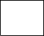
Transport of small, non-polar molecules
Transport of glucose with sodium ions
Q3.(a) Cells lining the ileum of mammals absorb the monosaccharide glucose by co-transport with sodium ions. Explain how.
____________________________________________________________
____________________________________________________________
____________________________________________________________
____________________________________________________________
____________________________________________________________(3)

Q4. (a) Many different substances enter and leave a cell by crossing its cell surface membrane. Describe how substances can cross a cell surface membrane.
____________________________________________________________
____________________________________________________________
____________________________________________________________
____________________________________________________________
____________________________________________________________
____________________________________________________________
____________________________________________________________
____________________________________________________________
____________________________________________________________
____________________________________________________________(5)

