3.2.3 Transport Across Cell Membranes

Starter work! – what do you know from GCSE??

- Go to google, type in GCSE bitesize membranes and go to the first link - http://www.bbc.co.uk/education/guides/zc9tyrd/revision

- Read through the revision pages.

- Print the glossary to go in your notes.

- Watch the activity video.

- Do the quiz below. You can check if your answers are correct on the website. Put it in you file with the glossary.
1. What is diffusion?
The movement of particles from low concentration to high concentration
The movement of particles from high concentration to low concentration
Active movement of particles, requiring energy from respiration
2. Which of these three liquids has the highest water potential?
Pure water
10% sucrose solution
20% sucrose solution
3. Which process is responsible for gas exchange in the lungs?
Diffusion
Osmosis
Active transport
4. What will happen to cut fruit pieces sprinkled with sugar?
They will gain water by osmosis
They will not change
They will lose water by osmosis

- What is osmosis?
The overall movement of water, through a partially permeable membrane, from a region of low solute concentration to a region of high solute concentration
The overall movement of water, through a partially permeable membrane, from a region of high solute concentration to a region of low solute concentration
The overall movement of water, through a partially permeable membrane, from a region of low water concentration to a region of high water concentration
- What happens to red blood cells when they are put into water?
They lose water and shrink, becoming wrinkled
Their size and shape does not change
They gain water and swell
- Why do plant cells become flaccid in concentrated sugar solution?
They gain water by osmosis
They lose water by osmosis
They lose water by active transport

- Which process needs carrier proteins in the cell membrane?
Diffusion
Osmosis
Active transport
- Which process happens against a concentration gradient?
Diffusion
Osmosis
Active transport
- What happens to the rate of diffusion as the temperature increases?
It decreases
It increases
It stays the same
Articles:
It is important step to A-level to read around the subject, this can also help you understand a topic or area you are interested in. The link below is about phospholipids and triglycerides, read the information carefully then add details to the picture below describing the difference in STRUCTURE between phospholipids and triglycerides and describe how these STRUCTRUAL DIFFERENCE affect the FUCNTIONAL differences.

https://www.livestrong.com/article/201557-what-is-the-difference-between-phospholipids-triglycerides/

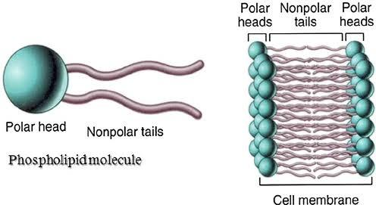
PHOSPHOLIPID FUNCTION
PHOSPHOLIPID STRUCTURE
TRIGLYCERIDE FUNCTION
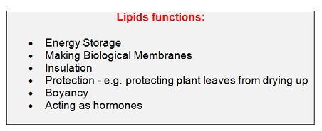
TRIGLYCERIDE STRUCTURE
