3.2.3 Transport Across Cell Membranes

Name _TEACHER_____________________________

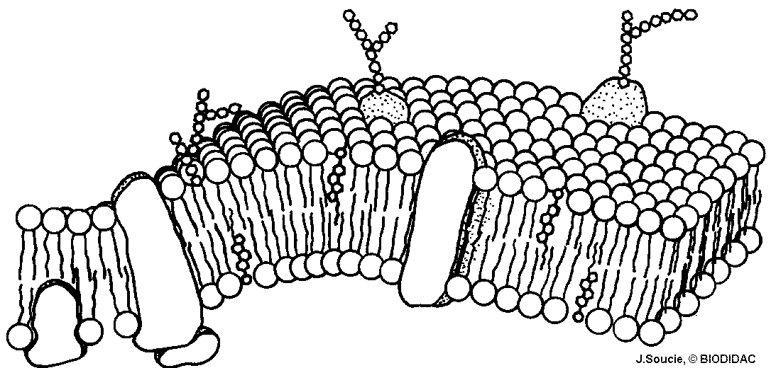

Reflection on learning outcomes | or | Target
Describe, explain and relate the arrangement of proteins, glycoproteins, glycolipids, phospholipids and cholesterol in the fluid mosaic model of membrane to roles around/inside cells.
Explain how surface area, number of channel or carrier proteins and differences in gradients of concentration or water potential affect the rate of movement across cell membrane
Define and explain what is meant by diffusion and facilitated diffusion and their processes
Identify which substances rely on facilitated diffusion and why they cannot enter/leave cells by diffusion.
Define and explain osmosis in terms of water potential and the movement of water due to osmosis into or out of cells
Define and explain what is meant by active transport and its process
Compare and contrast active transport and facilitated diffusion.
Interpret data to identify when a substance is being moved by diffusion, facilitated diffusion or active transport
Explain the adaptations of specialised cells, including small intestine epithelial cells, maximising the rate of transport across their internal and external membranes
Define and explain what is meant by co-transport in the context of absorption of glucose

Outcome:
- Describe, explain and relate the arrangement of proteins, glycoproteins, glycolipids, phospholipids and cholesterol in the fluid mosaic model of membrane to roles around/inside cells.

All membranes around and within all cells (including those around and within cell organelles) have the same basic structure and are known as plasma membranes.
The cell-surface membrane is the name specifically given to the plasma membrane that surrounds cells and forms the boundary between the cell cytoplasm and the environment.

Structure of a phospholipid (Biological molecules)
Recap questions:

- Name A and B, stating how many of each. Label on the diagram below.
A = Hydropillic Phosphate head
A
B = Hydrophobic lipid tail

B

- What property does A have?
Hydrophillic- soluble in water

- What property does B have?
Hydrophobic- repels/insoluble in water

- Two layers of phospholipids form a bilayer_.

- What type of molecule do phospholipids allow to pass through?
non-polar/lipid-soluble/small
- What type of molecule do they not allow through?
Large/polar/soluble in water
“Property”: A trait a molecule has which can be used to identify it or measurable
“Component”: The different parts that make up a structure
Fluid Mosaic Model
In the boxes write fluid or mosaic to produce a definition:
Fluid
Molecule can move relative to one another, allowing flexibility
Mosaic
Made of both phospholipids and proteins

Membrane components
All membranes diagram looks different. You will need to APPLY your knowledge to diagrams.
Label structures A to F. Use page 86 to help.
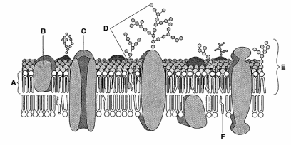

A: Phospholipid
B: Protein (extrinsic)
C: Channel protein
D: Glycoprotein
E: Glycolipid
F: Choleterol

Component | Role/Function
Phospholipid | - Forms bilayer  - Selectively permeable; only allowing non-polar molecules through into cell.  - Compartmentalisation; maintain different concentrations either side of the membrane  - Flexible shape  WITHIN CELLS:  - Selectively permeable; only allowing non-polar molecules through into organelle  - Separates metabolic reaction and enzymes inside organelle  - Surface for reactions
Cholesterol | - Regulates fluidity  - Hydrophobic
Proteins | - Stability to membrane  - Can be extrinsic (surface) or intrinsic (though bilayer)  - Channel proteins for polar molecules in facilitated diffusion  - Carrier proteins for active transport of polar molecules.
Glycoprotein/  Glycolipid | - Receptor site for hormones  - Act as recognition sites for molecules and cells  - Helps cells to attach to each other to form tissue

BLANK FOR STUDENT ANSWER TO T/F QUIZ

T/F Quiz:
If statement is false then you need to correct it.
- Glycolipids help form tissues - T

- Without proteins membranes would dissolve – F. Provides stability,lipids repel water

- Oestrogen is a lipid-based hormones so is able to pass through the bilayer. T

- Insulin is a protein-based hormones so is able to pass through the bilayer. F- polar so repelled by hydrophobic tails

- The membrane of the mitochondria is impermeable to glucose which means only small amounts of glucose can pass through the membrane. F- imperm means not able to pass through at all

- Intrinsic proteins span the bilayer so allow the membrane to be flexible and change shape. F- provide stability, cholesterol control fluidity/flexibility

- Channel proteins are used in both facilitated diffusion and active transport. F- only FD

- Cholesterol is soluble in water. F- lipid based, non-polar so repels

- Phospholipid heads are hydrophilic so point in towards the bilayer. F- point out towards solutions

- Compartmentalisation means the concentration of glucose inside the vacuole can be higher than in the cytoplasm of the plant cell. T
_______________________________________________________________________________________
Exam question:
- The diagram shows part of a cell surface membrane.

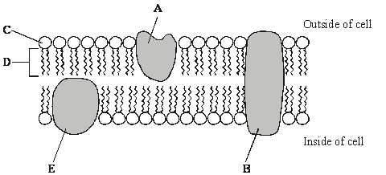

(a) Complete the table by writing the letter from the diagram which refers to each part of the membrane. (2)

Part of membrane | Letter
Channel protein | B
Contains only the elements carbon and hydrogen | D

(b) Explain why the structure of a membrane is described as fluid-mosaic. (2)
idea of molecules / named molecules moving = Fluid;
idea of both proteins and phospholipids = Mosaic;
Q2.(a) The diagram shows the fluid-mosaic model of a cell surface membrane.
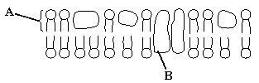
(i) Name the molecules labelled A and B.
A _phospholipid_
B __Protein __(1)
(ii) How does the bilayer formed by substance A affect entry and exit of substances into and out of a cell? (2)

allows movement of lipid soluble / non-polar molecules / named e.g. water / gases;
prevents movement of water soluble / polar molecules / named e.g. ions / amino acids;
idea of selection / membrane partially / differentially permeable /large molecules do not move through, small molecules do;

(accept semi-permeable)

_______________________________________________________________________________________

Membrane and permeability- Assessed practical 4

Temperature
A higher temperature gives molecules (phospholipids) in the membranes more kinetic energy, so they move faster.
The bilayer is more fluid. This makes the membrane leaky, increasing permeability.

Ethanol
Ethanol dissolves lipids (phospholipids and cholesterol) causing holes in the membrane allowing molecules to move freely.

Transport through cell membranes
There are 5 different transport methods you will need to be able to define, describe, explain and compare the different methods using application questions.
Passive –  Does not require energy | Active -  Requires energy
Osmosis  Diffusion  Facilitated diffusion | Active transport  Co-transport

Outcome:
- Explain how surface area, number of channel or carrier proteins and differences in gradients of concentration or water potential affect the rate of movement across cell membrane

Factors affecting rate of transport

Factor | Description | Explanation
 | The greater the difference in concentration between the two sides of the membrane the faster the rate of transport
 | The greater the surface area (e.g. microvilli present) the faster the rate of transport | This is because more molecules or ions can cross the membrane at any one moment.
 | A larger number of channel and carrier proteins in the membrane the faster the rate of transport | This is because more molecules or ions can cross the membrane at any one moment.
 | Higher temperatures give molecules or ions more kinetic energy so the faster the rate of transport | Molecules move around faster.

*Always specify the type of transport the exam question is asking about- Diffusion, Facilitated diffusion, active transport or osmosis

Outcome:
- Define and explain what is meant by diffusion and facilitated diffusion and their processes
- Identify which substances rely on facilitated diffusion and why they cannot enter/leave cells by diffusion.

- Diffusion
Definition:
Net movement of molecules or ions from a higher concentration to lower concentration
Down a concentration gradient until equilibrium
Passively

Non-polar molecule diffuse quickly but small polar molecules can also diffuse through membrane as their size means it doesn’t matter that the molecules are polar.

Annotate the diagram to show diffusion.

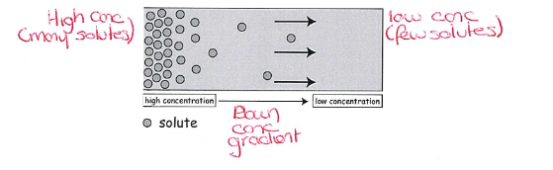

- Facilitated Diffusion
Definition:
Net movement of molecules or ions from a higher concentration to lower concentration
Down a concentration gradient until equilibrium
Passively
Using channel and carrier proteins

Charged ions and polar molecules do not easily diffuse because of the hydrophobic fatty-acid tails of the phospholipids. They use protein channels and carrier proteins instead, which are specific to 1 molecule/ion, to help. The no. of channel/carrier proteins can limit the rate of transport.

Label the diagram below.
Labels – phospholipid, phosphate hydrophilic heads, fatty acid hydrophobic tail, hydrophilic channel, high concentration, low concentration.
High conc
Low conc
Hydrophilic channel
Fatty acid tail
Phosphate head
Phospholipid
_______________________________________________________________________________________
Exam Questions:
Q1. The diagram shows part of a plasma membrane. The arrows show the path taken by sodium ions and by substance X when they diffuse through the membrane into a cell.
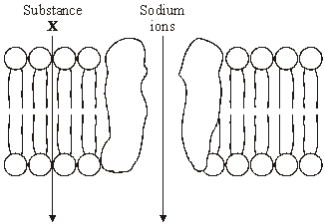
(a) An optical microscope cannot be used to see a plasma membrane. Explain why. (2)
Does not have the resolution / cannot distinguish between points this close together;
As light has longer wavelength;
The key ideas in marking this part of the question are resolution and wavelength
(b) Give one property of the molecules of substance X which allows them to diffuse through the membrane at the position shown. (1)

Lipid soluble / small / non-polar / not charged;

The most common type of exam questions for transport are application questions, you will have to use/understand the definitions and apply this to graphs.
Tips:
- Identify the ion/molecule that is being moved.
- Use this to identify the type(s) of transport that can be used.
- Apply the transport definitions.
(c) The effect of the concentration of sodium ions in the surrounding solution on their rate of diffusion across the membrane was investigated. The graph shows the results.
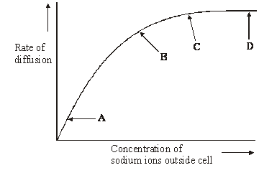
- Na+ so polar molecule
- FD, AT
- A-B: As conc increase so does rate = FD/AT
C-D: increasing conc rate plateau so must be limiting factor, no mention of ATP so must be FD

(i) What limits the diffusion of sodium ions across the membrane between
A and B on the graph? Give the evidence for your answer.
Limiting factor _ Concentration of sodium ions (outside cell);__
Evidence As concentration increases so does the rate of diffusion;

(ii) Explain the shape of the curve between C and D.
Sodium ions are passing through the channels at their maximum rate;
Rate is limited by the number of sodium channels / another limiting factor;

Outcome:
- Define and explain osmosis in terms of water potential and the movement of water due to osmosis into or out of cells

- Osmosis

Definition:
The diffusion of water molecules from a higher water potential to a lower water potential
Down a water potential gradient until equilibrium
Passively across membrane or through aquaporins

Annotate the diagram below to explain osmosis:
B
A

- Lower water potential
- Higher concentration of solute molecules
- Higher water potential
- Lower concentration of solute molecules

Solute:
Ion/molecule that dissolves in a solvent
Eg sodium ions (solute) dissolve in water (solvent)
Solvent:
Substance solute dissolves in
Eg sodium ions (solute) dissolve in water (solvent)

Use the text book page 89 + 90 to answer the questions below to help you understand osmosis better:

- What is the water potential of pure water? 0

- What affect do solutes have on water potential? Lower WP

- Why is there a net movement of water molecules from A to B? A higher WP than B, down WP gradient to reach equilibrium of WP NOT water molecules (definition)

- Equilibrium is when there is no net movement of water molecules. In what situation will this occur? Same WP

- Place the cells in the correct order for water to pass from one to the next:
-100kPA -150kPa. -200kPA. -250kPa

Fill in the term for the definition below, these are terms used in the exam that you need to know but won’t need to define yourself.

Term | Definition
Incipient plasmolysis | The protoplast no longer presses on the cell wall
Protoplast | Consists of outer cell-surface membrane, nucleus, cytoplasm, and inner vacuole membrane
Plasmolysed | The protoplast and cell contents pull away from the cell wall
Turgid | The protoplast is pushed against the cell wall

Term:
Incipient plasmolysis Plasmolysed Turgid Protoplast

You may be shown diagrams or be given descriptions of what is happening around cells, you will then have to explain what is/has happened.

Animal cell

Water potential of external solution compared to cell solution | Higher  (less negative) | Equal | Lower  (more negative)
Net movement of water | Into cell | No net movement, movement both in and out | Out of cell
State of cell | Haemolysed/burst | Normal | Crenated/shrunk
Diagram | 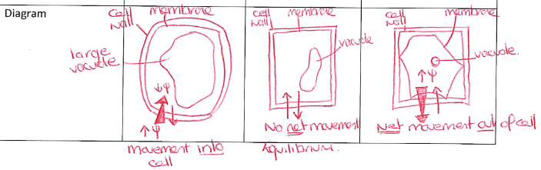
Plant cell

Water potential of external solution compared to cell solution | Higher  (less negative) | Equal | Lower  (more negative)
Net movement of water | Into cell | No net movement, same in/out of cell | Out of less
Protoplast | Enlarged | Normal | Shrunk
Condition of cell | Turgid | Normal | Flaccid
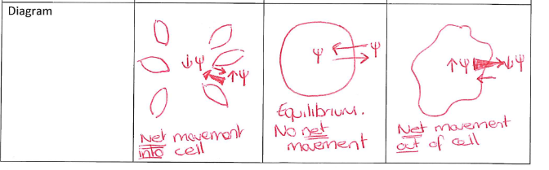
Diagram

_____________________________________________________________________________
Exam questions:
All of these are application style questions.
Q1.(a) The water potential of a plant cell is –400 kPa. The cell is put in a solution with a water potential of –650 kPa. Describe and explain what will happen to the cell.

Membrane / cytoplasm shrinks away from cell wall / cell plasmolysed / goes flaccid;

Water moves down water potential gradient / to lower water potential;

By osmosis;

(b) A group of students investigated the effect of sucrose concentration on the change in length of cylinders of tissue cut from a young carrot. They measured the initial lengths of the carrot cylinders, then placed one in each of a number of sucrose solutions. After 18 hours, they removed the carrot cylinders and measured their final lengths. Some of the results are shown in the table.

Concentration of sucrose /  mol dm^{–3} | Percentage decrease in length of carrot cylinder
0.4 | 4.2
0.5 | 8.7
0.6 | 13.0
0.7 | 16.8
0.8 | 18.1
0.9 | 18.1
1.0 | 18.1
(i) The carrot cylinders were left for 18 hours in the sucrose solutions. Explain why they were left for a long time.

Reaches equilibrium / no further change in length;

Reject osmosis takes time
(ii) Explain how you would use a graph to predict the concentration of sucrose that would result in no change in length of the carrot cylinders.

Line / curve of best fit;

Extrapolate (and read off) / find where it crosses x-axis;
(iii) Young carrots store sugars in their tissues but, in older carrots, some of this is converted to starch. How would using cylinders of tissue from older carrots affect the results obtained for a sucrose solution of 0.6 mol dm^{–3}? Give a reason for your answer.

Greater decrease / length smaller;

More water removed;

Greater difference in water potential / cell with higher / less negative water potential; Starch is insoluble / has no effect on osmosis

Q2. Six cylinders of a standard size were cut from a single large potato. One cylinder was placed in distilled water and the others were placed in sucrose solutions of different concentrations. The length of each cylinder was measured every 5 minutes for the next 50 minutes. The graph shows the changes in length at each sucrose concentration.

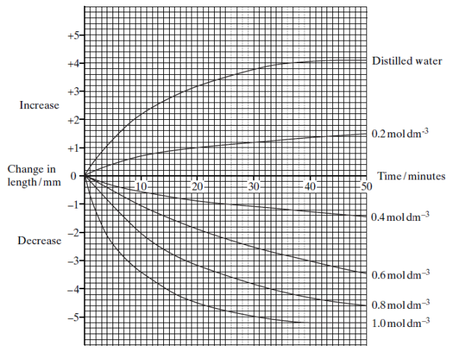

(a) Explain why

(i) the potato cylinder in distilled water increased in length;

potato more negative water potential; (accept more concentrated)

water enters by osmosis causing cells to extend / become turgid;

(ii) the potato cylinder in the 1.0 mol dm^{–3} sucrose solution showed no further
decrease in length after 40 minutes.

little / no water remaining in potato / fully plasmolysed /all water moved out;
cell wall prevents further shrinkage / sucrose solution moves in;

or,

water potentials are equal / equilibrium;
no net movement of water / no further osmosis;

(b) (i) Describe the difference in the rate of decrease in length during the first 10 minutes between the cylinder in the 0.4 mol dm^{–3} and the cylinder in
the 0.8 mol dm^{–3} solution.

faster rate (of decrease) in 0.8 mol dm^{–3};

(ii) Use your knowledge of water potential to explain this difference.

bigger water potential gradient / greater difference in water potentials

(between potato and surrounding solution);

Outcome:
- Define and explain what is meant by active transport and its process
- Compare and contrast active transport and facilitated diffusion.
- Interpret data to identify when a substance is being moved by diffusion, facilitated diffusion or active transport

- Active transport

Definition:
The movement of ions or molecules from a lower concentration to a higher concentration
Against a concentration gradient
Using ATP
And carrier proteins.

Can be used to transport ions/molecules directly or as part of a process like co-transport (more about this later). In the exam you will usually have to interpret graphs or compare active transport to other methods of transport.
Complete the contrast table, then annotate the diagram below

Transport | Diffusion | Facilitated diffusion | Osmosis | Active transport
Molecules moved | Small, non polar | Large, polar | Water | Polar
Concentrations | High to low | High to low | High WP to low WP | Low to High
Gradient | Down | Down | Down WP | Against
ATP? | No | No | No | Yes
Transport proteins? | No | Channel, carrier | Aquaporins | Carrier
Limiting factors? | Conc gradient | Proteins, conc gradient | WP gradient, proteins | ATP, proteins
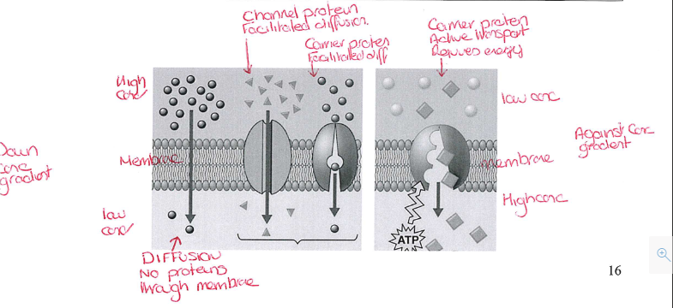
_____________________________________________________________________________________
Exam questions:
Q1.(a) Contrast the processes of facilitated diffusion and active transport. TABLE!

1. Facilitated diffusion involves channel/carrier proteins whereas active transport only involves carrier proteins;

2. Facilitated diffusion does not use ATP / is passive whereas active transport uses ATP;

3. Facilitated diffusion takes place down a concentration gradient whereas active transport can occur against a concentration gradient.

Since ‘contrast’, both sides of the differences needed
1.

c.
b.
a.
Q2. A scientist investigated the uptake of sodium ions by animal tissue. To do this, he:
• used two flasks, F and G
• put equal masses of animal tissue into each flask
• added equal volumes of a solution containing sodium ions to each flask
• added to flask F a solution of a substance that prevents the formation of ATP by cells
• measured the concentration of sodium ions remaining in the solution in each flask.
The graph below shows his results.
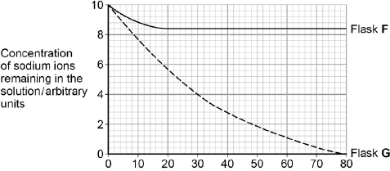
Time / minutes
Go back to exam tips on page 9 to help you figure out the graph
(a) Calculate the rate of uptake of sodium ions by the tissue in flask G during the first 20 minutes of this investigation.
Answer = _0.22;arbitrary units per minute (1)
(b) The scientist concluded that the cells in flask G took up sodium ions by active transport. Explain how the information given supports this conclusion.

1. Uptake in flask G much greater than in flask F;

2. Showing use of ATP in flask G;

3. Sodium ion concentration in flask G falls to zero;

4. Showing uptake against a concentration gradient.

(c) The curve for flask F levelled off after 20 minutes. Explain why.

_1. (Uptake of sodium ions occurring by) facilitated diffusion;

2. Equilibrium reached / sodium ion concentrations in solution and in cells the same.
Q3. A scientist placed plant cells in solutions containing different concentrations of calcium ions. She measured the rate of uptake of calcium ions by plant cells.

The graph below shows her results.

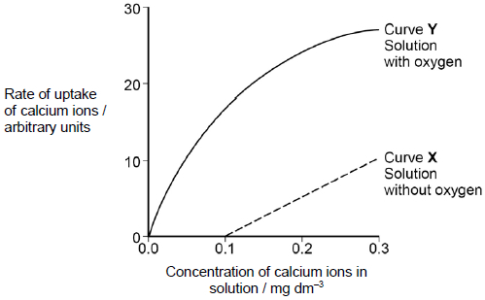

(a) What can you conclude from the graph about the processes involved in the uptake of calcium ions by these plant cells? Use evidence from the graph to support your answer.
1. Between 0 and 0.1 calcium (ions) cannot enter by facilitated diffusion

OR

No diffusion gradient for entry into the cell.

2. Between 0.1 and 0.3 calcium (ions) enter by facilitated diffusion;

3. As calcium (ions) enter without oxygen

OR

Oxygen is not required for facilitated diffusion;

4. Between 0 and 0.1 calcium (ions) enter by active transport;

5. Movement is against the concentration gradient;

6. As calcium (ions) only enter in presence of oxygen / oxygen is required for active transport.

Accept ‘they’ refers to calcium ions

5 max
1.

c.
b.
a.

Outcome:
- Explain the adaptations of specialised cells, including small intestine epithelial cells, maximising the rate of transport across their internal and external membranes
- Define and explain what is meant by co-transport in the context of absorption of glucose

- Co-transport and absorption of glucose in the ileum

Recap questions: The two images here show microvilli on epithelial cells from the small intestine.
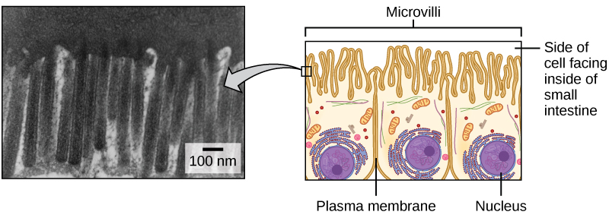
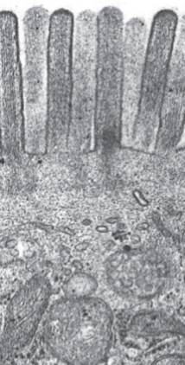

Can you identify and explain how the epithelial cell is specialised to increase the rate of transport?
Identify: Increased surface area- microvilli
Explain: More channel/carrier proteins so more mols through at once

Identify: Large RER
Explain: More protein synthesis eg channel/carrier proteins

Identify: Large no. of mitochondria
Explain: More ATP for AT

What organelle can you see in the photo on the left that indicate this photo was taken with a TEM?
Mito- can see THROUGHT inside the organelle

Explain why these cells would need a large number of these organelles.
Aerobic respiration
Produce ATP
More AT/Co-transport

Name 2 polysaccharides that we are able to digest in our diet.
Starch and glycogen (Reject cellulose, don’t have the enzyme)
Give the monomer(s) for the saccharides below:
Lactose: glucose and galactose
Maltose: glucose and glucose

We eat polysaccharides and digest them into monosaccharides in our digestive system. These monosaccharides are then absorbed from the lumen of the ileum (the small intestine) into our epithelial cells lining the ileum and then into our blood.

Diffusion only results in the concentration of glucose in the blood and in the small intestine becoming equal. The reason why all the glucose and amino acids are absorbed from the ileum is due to active transport taking place as well, using co-transport.

Glucose or amino acids are drawn into the cells lining the small intestine along with sodium ions that have been actively transported out by the sodium-potassium pump.

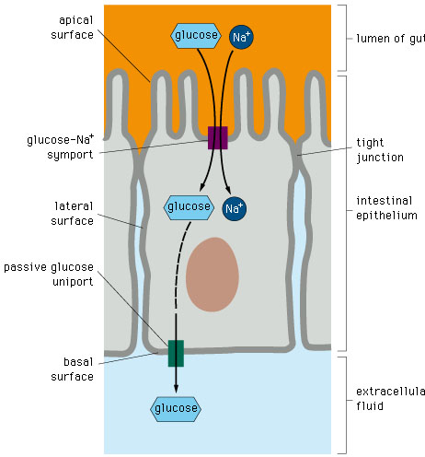
6.
Blood capillary
11.
Lumen of Ileum
4.
Protein carrier
2. co-transport proteins
Use these words to finish labelling the structure on your diagram.

Microvilli Blood capillary Co-transport protein
Lumen of ileum Epithelial cells Protein carrier
8.Sodium potassium pump

10. Plasma membrane

5. Plasma membrane

3. Plasma membrane

Na⁺

7. Extra cellular fluid

9.
Epithelial cell
1.Microvilli
Use the words below to fill in the gaps, then add the numbers to the diagram.

Epithelial Epithelial Epithelial Na+ Na+
Active Facilitated Glucose Glucose
Down Against Blood

Na+ leave the epithelial cell into the blood
By active transport using the Na+/K+ pump
So, Na+ concentration inside epithelial cell is lower than lumen of Ileum
Na+moves from the lumen of the ileum into the epithelial cell by facilitated diffusion down a concentration gradient
Glucose absorbed with Na+ against glucose concentration gradient
Glucose moves into blood from epithelial cell by facilitated diffusion
T/F quiz.
If statement is false then you need to correct it.
- Na+ is actively transported from the lumen of the Ileum to epithelial cells. F- from epithelial to blood
- Glucose is actively transported from the lumen of the Ileum to epithelial cells. F- isn’t AT
- ATP is used to move Na+- T
- The steeper the concentration gradient the faster the rate of movement. T
- ATP is used to move glucose- F- moves Na+ to create/maintain conc grad
- Glucose diffuses into the epithelial cell. F- Facc diff
- If the temperature increased Co-transport would happen faster. T, until proteins denature
- Glucose uses proteins to move into the blood from the epithelial cell T
- ATP is used to maintain a steep concentration gradient for Na+ between the lumen of the Ileum and the blood. F- between blood and epithelial cell
- Amino-acids are actively transported from the lumen of the Ileum to the epithelial cell. F- by facc diff like glucose.

_____________________________________________________________________________________
Exam Questions:
Q1. The diagram shows one method by which amino acids are absorbed from the small intestine into the blood. They are co-transported into the epithelial cell with sodium ions (Na⁺) at point X on the diagram. Normally, the concentration of sodium ions inside the epithelial cell is low.
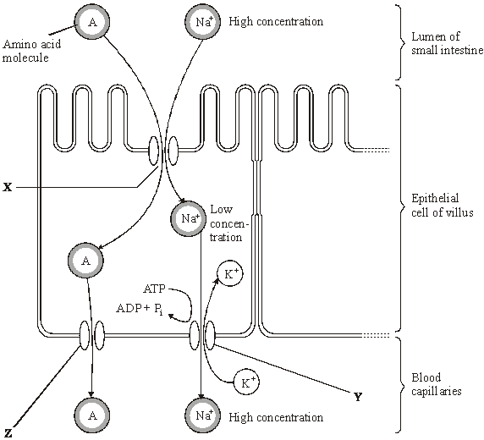
Dinitrophenol (DNP) prevents oxidative phosphorylation. When treated with DNP, the sodium-potassium pump at Y no longer works. As a result, the concentration of sodium ions in the cell rises and amino acid absorption stops.
- Explain why pump Y will not work in the presence of DNP.
Lack of ATP;
Pump = active transport / requires energy / ATP provides energy /transport is against
concentration gradient;

2
- Explain why sodium ions and amino acids are not absorbed from the lumen of the small intestine in the presence of DNP.
Concentration of Na⁺ inside cell no longer less than concentration in gut lumen / no longer a concentration gradient;
No (facilitated) diffusion of Na⁺ ions possible / amino acid absorption requires diffusion of Na⁺ ions into cell;

2
- By what mechanism would amino acids leave the epithelial cell at point Z?
Diffusion / facilitated diffusion;

1
Q2. The letters P, Q, R, S and T represent ways substances can move across membranes.
• P – diffusion through the phospholipid bilayer
• Q – facilitated diffusion
• R – active transport
• S – co-transport
• T – osmosis
For each of the following examples of transport across membranes, select the letter that represents the way in which the substance moves across the membrane.
Write the appropriate letter in each box provided.

Transport through a channel protein | 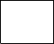  Q
Transport of small, non-polar molecules | P
Transport of glucose with sodium ions | S
Q3.(a) Cells lining the ileum of mammals absorb the monosaccharide glucose by co-transport with sodium ions. Explain how.

1. Sodium ions actively transported from ileum cell to blood;

2. Maintains / forms diffusion gradient for sodium to enter cells from gut (and with it, glucose);

3. Glucose enters by facilitated diffusion with sodium ions;

3

Q4. (a) Many different substances enter and leave a cell by crossing its cell surface membrane. Describe how substances can cross a cell surface membrane.
1. (Simple / facilitated) diffusion from high to low concentration / down concentration gradient;

Q Do not allow across / along / with concentration gradient

2. Small / non-polar / lipid-soluble molecules pass via phospholipids / bilayer;

Reject: named molecule passing through membrane by an incorrect route

Accept: diagrams if annotated

OR

Large / polar / water-soluble molecules go through proteins;

3. Water moves by osmosis / from high water potential to low water potential / from less to more negative water potential;

4. Active transport is movement from low to high concentration / against concentration gradient;

Only penalise once if active transport is not named
e.g. ‘movement against the concentration gradient involves proteins and requires ATP’ = 2 marks

5. Active transport / facilitated diffusion involves proteins / carriers;

Accept: facilitated diffusion involves channels

Reject: active transport involves channels

6. Active transport requires energy / ATP;

7. Ref. to Na⁺ / glucose co-transport;

Credit ref. to endo / exocytosis as an alternative

5 max

