Nucleic Acids Bridging Work
Go to the following website
http://www.bbc.co.uk/education/guides/zvb7hyc/revision
What is the role of DNA and what does it determine?

What is a gene?

What are chromosomes and where are they found?

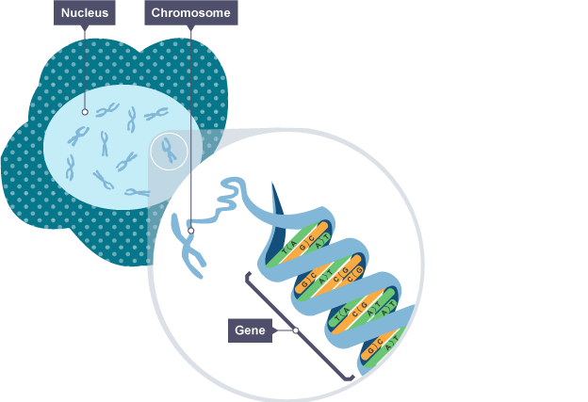
Add the labels nucleus, chromosome and gene to this diagram

What two scientists are credited with working out the structure of DNA. What did they find out about the structure of DNA?

Name the four types of nitrogen containing base found in DNA & which complementary base pair?

What is an allele? Give an example.

What is the difference between dominant and recessive alleles?

Looking at the diagram showing two alleles for eye colour. What do you think heterozygous and homozygous means?

State three roles for new cells produced by mitosis

Label the diagrams to show how mitosis & meiosis takes place
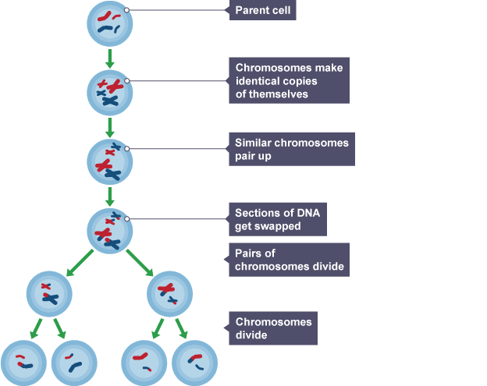

Mitosis produces two …………………… identical cells which contain the ………………. number of chromosomes as the original cell
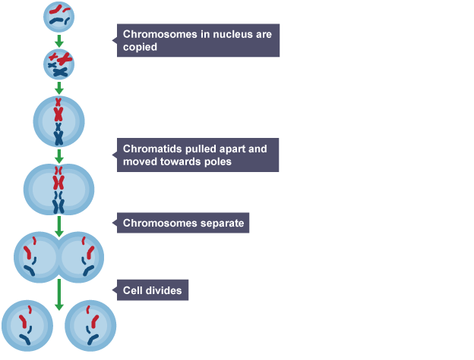
What type of cell division produces gametes? What are gametes in humans?

How many chromosomes are found in a human body cell and how are they arranged?

What does haploid mean?

How many cells are produced after a cell divides by meiosis and why is it described as reduction division?

Draw a table to show the differences between mitosis and meiosis
Click on the “activity tab” and watch the animation then complete the test

