3.5.3 Energy and Ecosystems
Name: _________________________________________

Reflection on Learning objectives | or | Target
Explain how plants utilise the sugars from photosynthesis
Explain what is meant by biomass and how it can be measured
Suggest units for biomass
Explain the process of calorimetry
Evaluate the accuracy of results from simple calorimetry.
Explain the concepts of Gross primary production and Net primary production
Explain the concept of net production in consumers, linked to how energy losses along food chains
Understand the mathematical relationship between the two and use it to calculate values when supplied with data
Explain the reduction in energy/biomass along a food chain
Apply knowledge to the context of exam questions.
Explain the ways in which productivity is affected by simplifying food webs
Explain the ways in which farmers are reducing respiratory losses within a human food chain
Interpret and calculate data on efficiency when provided with appropriate information
Evaluate the ethics of some of these farming practices.

Learning Outcomes
- Explain how plants utilise the sugars from photosynthesis
- Explain what is meant by biomass, how it can be measured and suggest units for biomass
- Explain the process of calorimetry and evaluate the accuracy of results from simple calorimetry

How energy enters an ecosystem

Photosynthesis is the main route by which energy enters an ecosystem.
Definition: An ecosystem is formed from a community and the non-living (abiotic) components of its environment.

- In any ecosystem plants synthesise organic compounds from either atmospheric CO₂ (for land-based plants) or aquatic CO₂ (for aquatic plants and algae).
- The light energy is transferred to chemical energy in the organic compounds made in photosynthesis. Most of the sugars made in photosynthesis, such as glucose, are immediately used as respiratory substrates.
- The rest are used to make other carbohydrates such as starch and cellulose or other biological molecules such as lipids and amino acids.
- These biological molecules form the biomass (mass of living material in the plant) of the plants.

Q: Explain the relationship between photosynthesis, respiration and biomass by answering the question “Where does an oak tree get the materials it needs to grow from?”
Words: glucose, proteins, ATP, growth, biomass, fats, sugars, mitosis 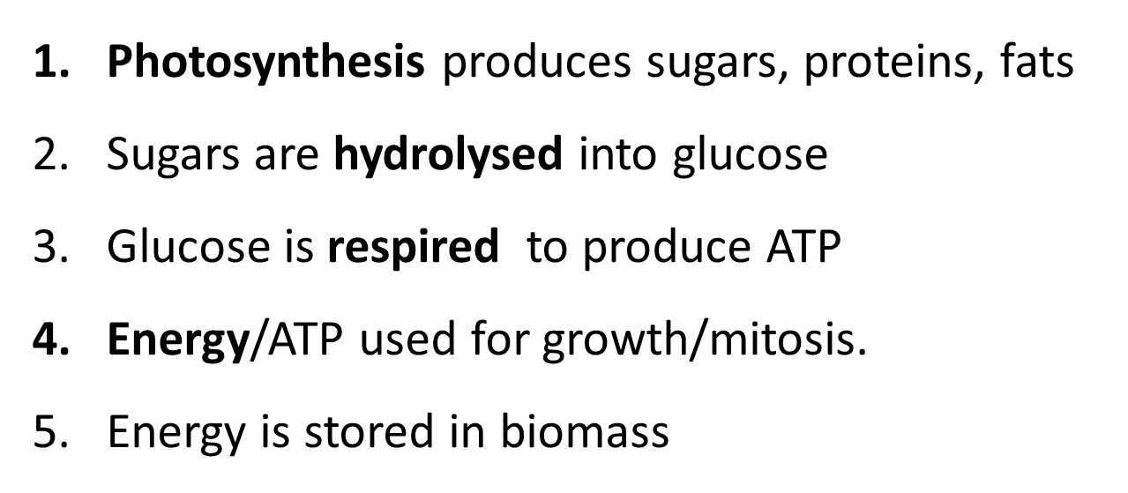

Measurement of biomass

Biomass is a measurement of
- the mass of carbon, per unit area
OR
- the dry mass of tissue produced per unit area, per unit time (more commonly used)

Dry mass gives you a measure of the productivity of an ecosystem. The higher the productivity the higher the biomass.
Measuring Dry mass
- The sample of organism is dried in an oven (normally around 100ºC).
- The sample is weighed after a certain amount of time e.g. 24 hours.
- The sample is dried again in the oven and re-weighed over and over until the mass remains constant, which means all the water has been removed.

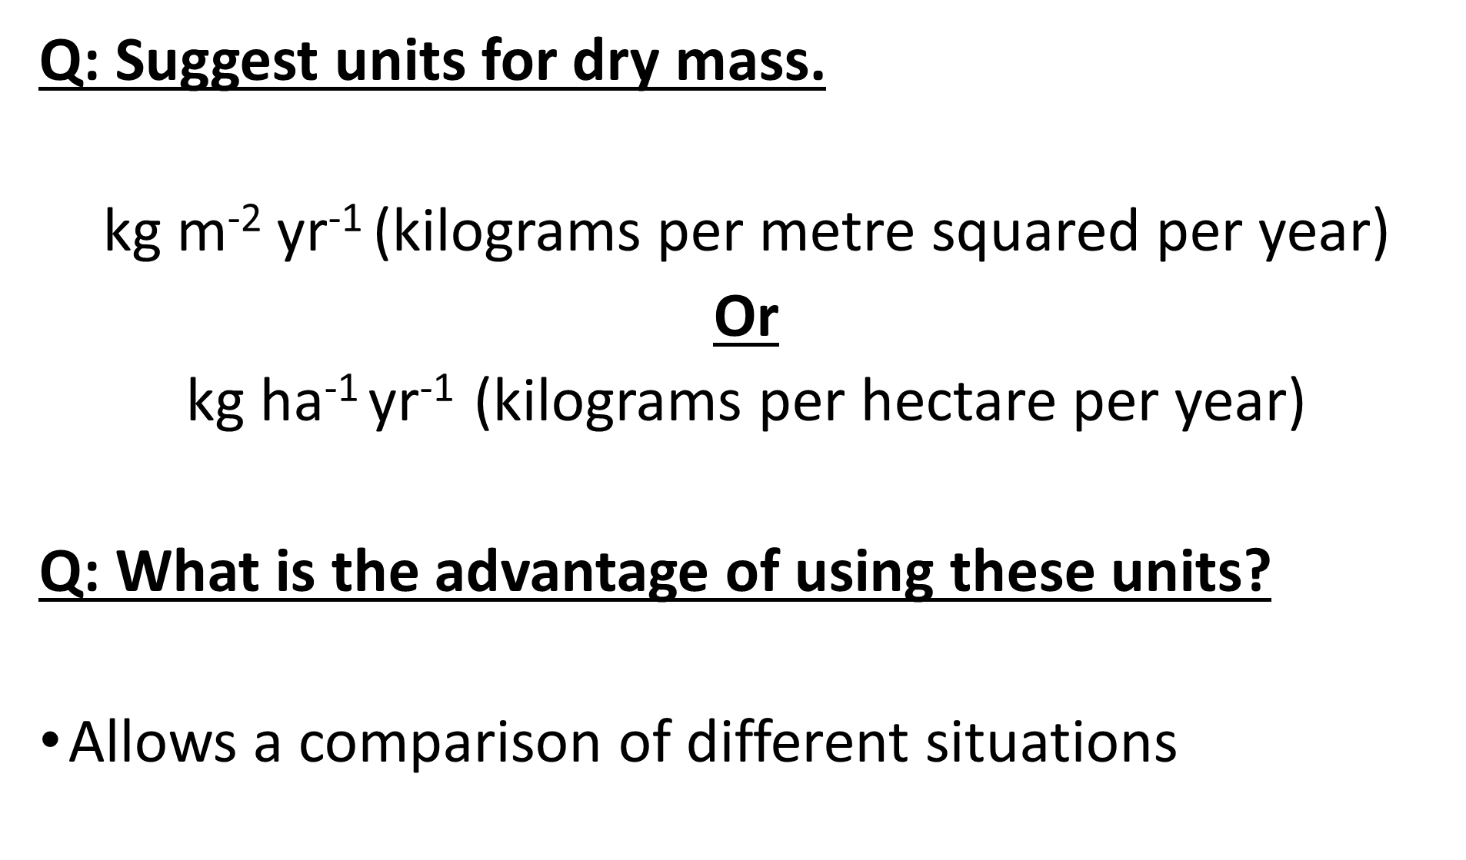
Exam question and Mark scheme perfect answer

Collect all wheat in 1 metre², dry them at 80ºc, weigh them, and repeat process until no further change in weight. Then multiply answer by number of square metres in the field.

Why does this method help to provide a reliable measurement of the biomass? [2]
- Removes water
- Water content may vary in a plant

Why is this method not usually used in practice? [1]
- Destroys the sample

Calorimetry
Method for calorimetry
- This is used to measure the chemical energy stored in organic material (biomass)
- Organic material dried out
- Burnt in oxygen in a combustion chamber.
- The energy given off is used to heat a known volume of water.
- Increase in temperature of water indicated energy contained in material.
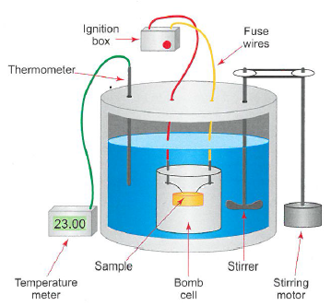
- The units are Joules / kiloJoules (J/kJ)

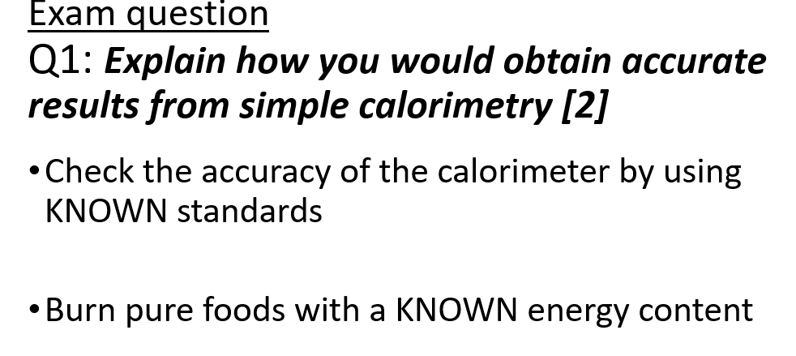
Exam Questions

Q1. Explain how you would obtain accurate results from simple calorimetry
_______________________________________________________________
_______________________________________________________________
_______________________________________________________________
_______________________________________________________________
______________________________________________________________(2)
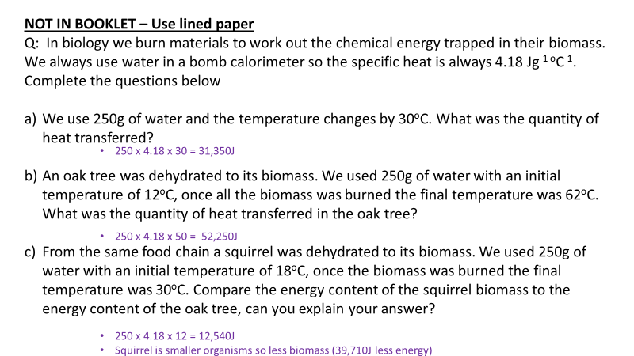

Q2. Yield can be determined by measuring the dry mass of plants

a) Suggest how you could determine the dry mass of a sample of plant material.
_________________________________________________________________________________________________________________________________________________________________________________________________________________________________________________________________________________________________________________________________________________________________________________________(2)
b) What is the advantage of using the dry mass and not the fresh mass to compare the yield of plants?
______________________________________________________________________________________________________________________________________________________________________________________________________________________________________________________________________________________________________________________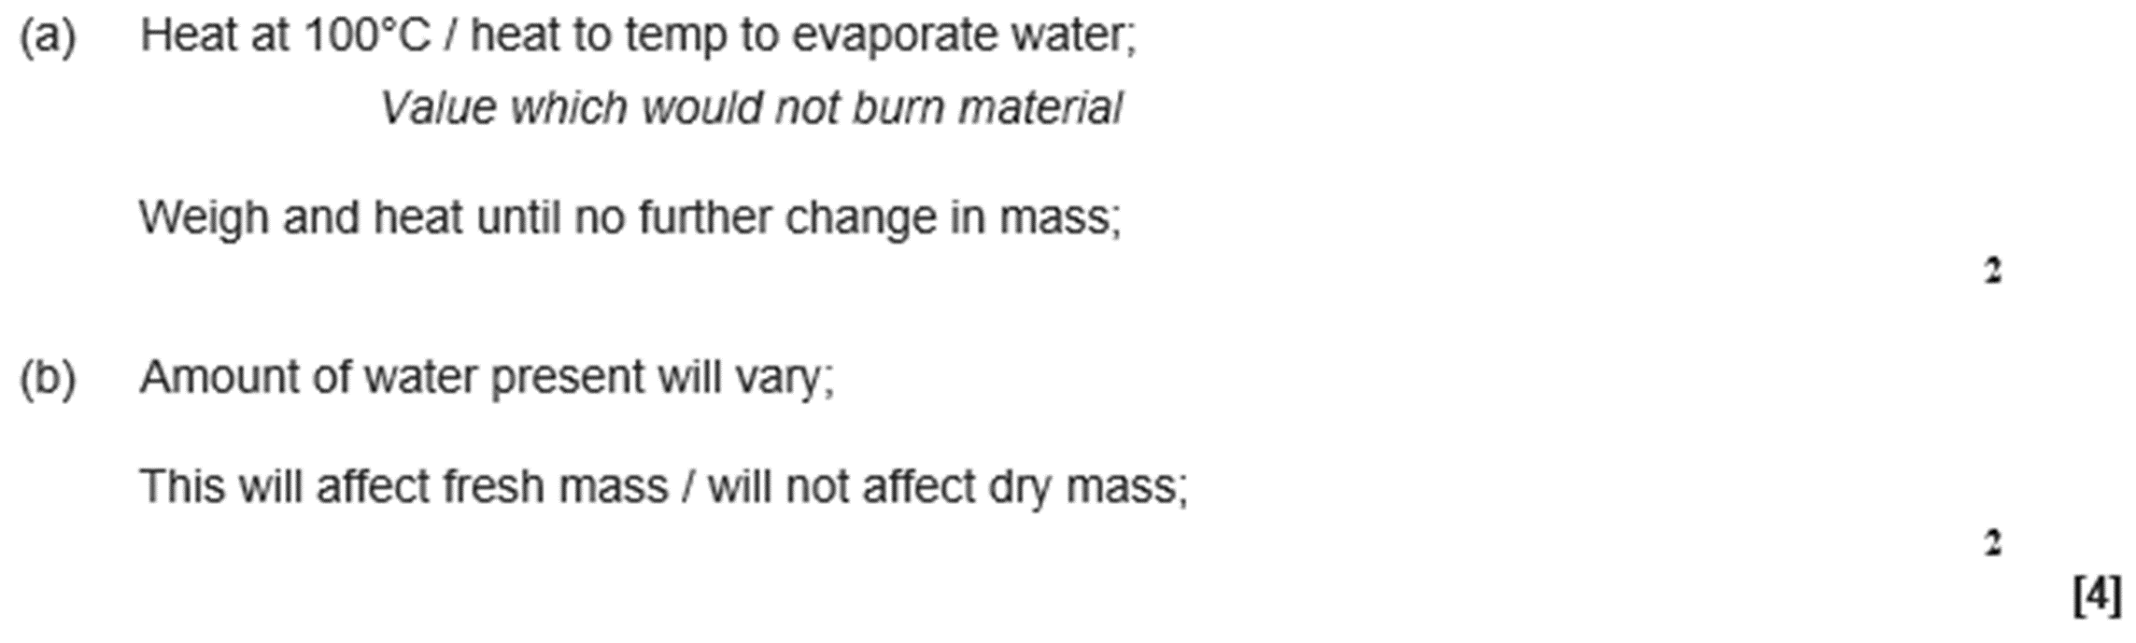__________________________________________________________________ (2)
Q3. Ecologists developed a method for estimating the biomass of trees in a plantation. The plantation consisted of trees of the same species. They collected samples of wood from trees. For each sample they:

- determined the density of the freshly cut wood
- dried the wood in an oven at 103 °C for 24 hours
- determined the volume of the dried wood sample
- determined the density of the dried wood.
The table below shows data about one wood sample.

Volume of freshly cut wood sample  / dm³ | Density of freshly cut wood  / g per dm³ | Volume of dried wood sample  / dm³ | Density of dried wood sample  / g per dm³
1.345 | 993.0 | 1.125 | 769.0
(a) The loss of mass of the wood sample was due to loss of water. Water has a density of 1 g per cm³.
Use the data in the table to calculate the percentage of water in the freshly cut wood sample. Show your working.
Percentage of water = __________________________________
(2)
(b) The ecologists dried the samples in an oven at 103 °C for 24 hours. Describe how the ecologists could have determined whether or not this drying removed all the water from a sample of wood.
___________________________________________________________________
___________________________________________________________________
___________________________________________________________________
___________________________________________________________________
___________________________________________________________________
(2)
(c) Ecologists then investigated the relationship between the diameter of the trunk of the trees and their biomass.
The graph below shows their results. Each point is the result for one tree.
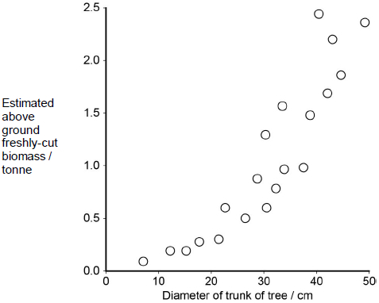
What does the graph show about the relationship between the diameter of the trunk of the trees and their biomass?
___________________________________________________________________
___________________________________________________________________
___________________________________________________________________
(2)
(d) Plantations of trees are often created to remove carbon dioxide from the atmosphere, to help to balance the carbon dioxide released by burning fossil fuels.
For different species of tree, information is available for:
• the relationship between diameter of trunk and freshly cut biomass
• the percentage of water in fresh-cut wood
• the mean dried density of wood.
Using only the information provided in part (c), suggest how the mass of carbon in the wood of a plantation of trees of a particular species could be estimated.
Start with measuring the diameter of a large number of trees.
Assume that the dry biomass of a tree consists of biological molecules that contain carbon.
___________________________________________________________________
___________________________________________________________________
___________________________________________________________________
___________________________________________________________________
___________________________________________________________________
___________________________________________________________________
(4)
(Total 10 marks)
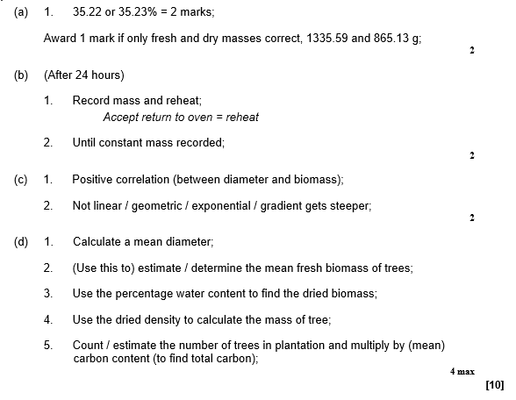Energy flow through ecosystems
Learning Outcome
- Explain the concepts of Gross Primary Production (GPP) and Net Primary Production (NPP)
- Understand the mathematical relationship between the two, and use it to calculate values when supplied with data

Definition:
Gross Primary Production (GPP) is the chemical energy store in plant biomass, in a given area, in a given time.

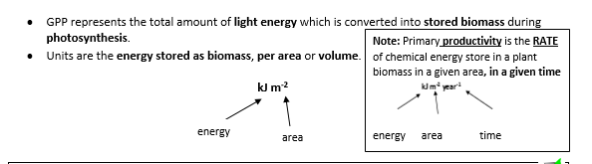
Definition:
Net Primary Production (NPP) is the chemical energy store in plant biomass after respiratory losses (R) have been subtracted.

- Plants respire to release energy from the biological molecules which make up the biomass made in photosynthesis, such as glucose.
- We therefore have to minus these respiratory losses of energy from the GPP.
- NPP is what is left after the plant has taken what it requires.
- NPP represents the potential food available to consumers.

NPP can be calculated using the formula: NPP = GPP - R
Net primary production
Gross primary production
Respiratory losses to the environment

- This net primary production is available for plant growth and reproduction.
- It is also available for other trophic levels in the ecosystem such as herbivores and decomposers.
Exam tip: If an exam questions asks you about NPP or GPP, always write out the equation above. It is likely to get you one mark!
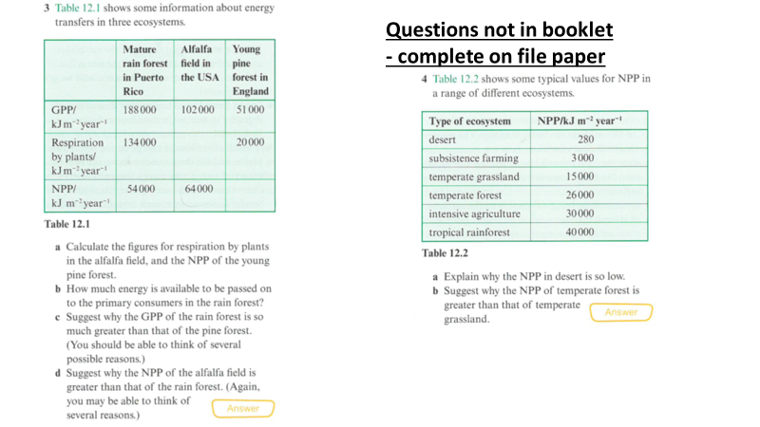
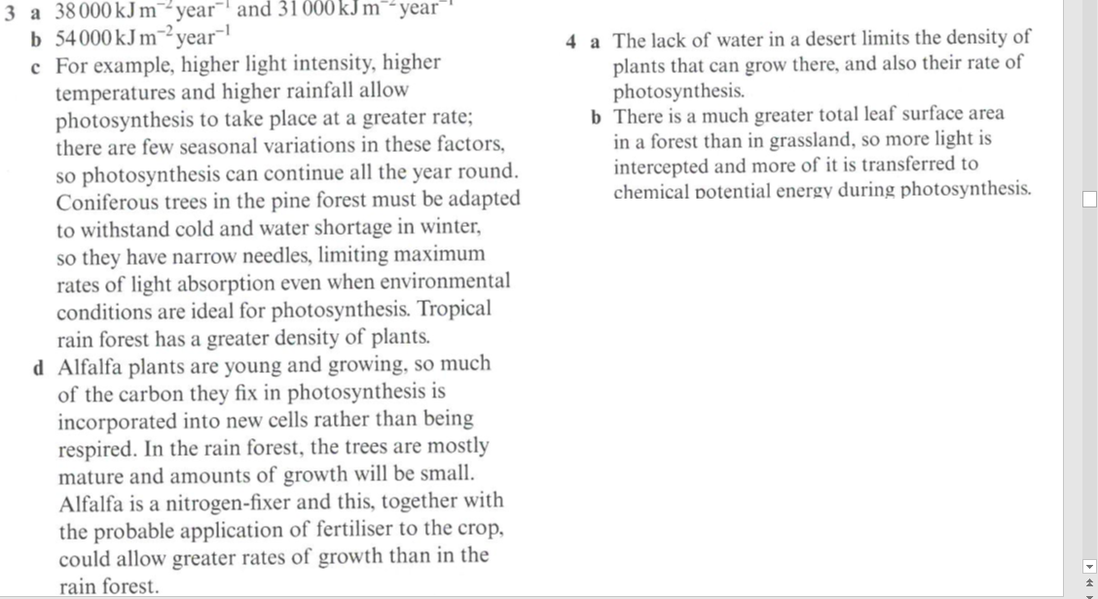

Learning outcomes:
- Explain the reduction in energy/biomass along a food chain

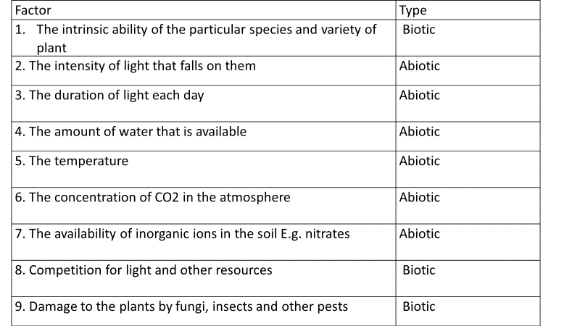Factors affecting primary production
Production is related directly to the rate of photosynthesis, and so is affected by a wide range of biotic and abiotic factors.
Energy flow
What are the energy losses?
- The sun is the source of energy for ecosystems.
- However, only 1 % of this light energy is captured by green plants and converted to organic compounds, and so is available to organisms in the food chain.
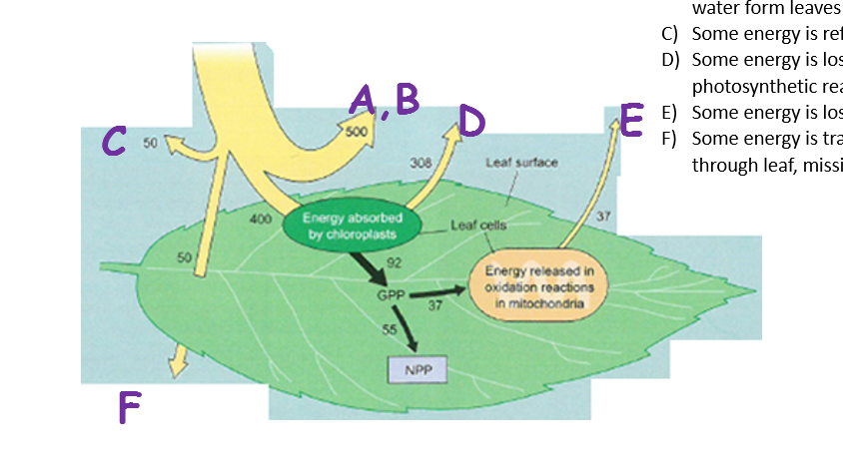
Add the letters below to the correct places on the leaf to show the energy losses
- Some is the wrong wavelength to be absorbed by chlorophyll.
- Some energy is used ins evaporating water form leaves
- Some energy is reflected
- Some energy is lost during photosynthetic reactions
- Some energy is lost in respiration
- Some energy is transmitted straight through leaf, missing the chloroplasts.
Food chains

- A food chain shows the flow of energy between organisms. Each organism represents a trophic level. Decomposers are often not represented on a food chain.
- Producers start the food chain. They are photosynthetic organisms such as plants and form their own organic molecules (autotrophic).
- Consumers rely on an external source of organic compounds (heterotrophic) that they have to feed on. Animals are consumers.
- Primary consumers eat producers. Secondary consumers eat primary consumers. Tertiary consumers eat secondary consumers

Example of food chain with three trophic levels
Water lily (producer) Water boatmen (Primary consumer) Roach (fish) (Secondary consumer)

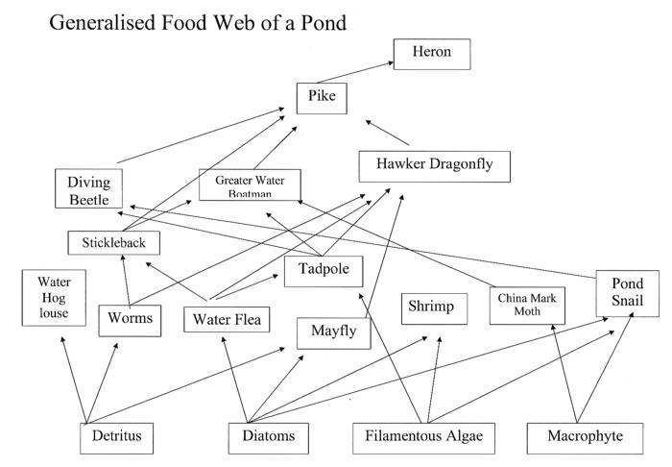
Food webs

- In a particular habitat many food chains can be linked together to form a food web.
- The more complex the food web means that any one change in a population will have less of an effect on the other populations, making it more stable.

Net Primary Production (NPP) in food chains
Exam tip: If an exam question mentions net primary production then you must write
NPP = GGP – R
This may get you a mark!
The NPP is the energy available to:
- producers for growth and reproduction.
- primary consumers when they eat the producers.
- decomposers when they feed on the dead producers/consumers.

Only about 10% of the NPP is transferred to the consumer. 90% is lost because…
- Some of the organism is indigestible and the energy is egested as faeces.
- Some of the energy is excreted in urine.
- Some of the biological molecules taken in are respired and not incorporated into consumer biomass, this respired energy is lost as heat.
Sun
Producer
Primary
consumer
Decomposers (feeding on faeces, urine and dead organisms
2%
5-10%
15-20%
Light energy lost
15-20 %
Energy lost in egestion (faeces), excretion (urine) and as heat during respiration
Tertiary
consumer
Secondary
consumer

The % of energy transferred between the producer and primary consumer is less (5-10% compared to 15-20% between consumers) due to more indigestible matter in producers, such as cellulose, lost in faeces.

Exam Questions

Q4. Arbuscular mycorrhiza fungi (AMF) are fungi which grow on, and into, the roots of plants. AMF can increase the uptake of inorganic ions such as phosphate.

(a) Suggest one way in which an increase in the uptake of phosphate could increase plant growth.

___________________________________________________________________

___________________________________________________________________

(1)

(b) Suggest one way in which AMF may benefit from their association with plants.

___________________________________________________________________

___________________________________________________________________

(1)

(c) Scientists investigated the effects of different AMF species on the productivity of the plant community of a prairie grassland ecosystem when growing in/on soil containing different phosphate concentrations.

The scientists set up identical plots of prairie grassland soil containing seeds of the plant species found in the ecosystem. The scientists added different AMF species and different concentrations of phosphate to particular plots. Control plots without AMF species were also set up. After 20 weeks the scientists determined the shoot biomass for each plot.

The results the scientists obtained are shown in the graph.

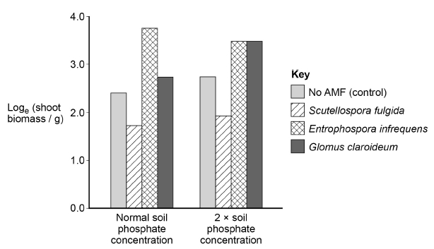

Explain why an increase in shoot biomass can be taken as a measurement of net primary productivity.

___________________________________________________________________

___________________________________________________________________

___________________________________________________________________

___________________________________________________________________

(2)

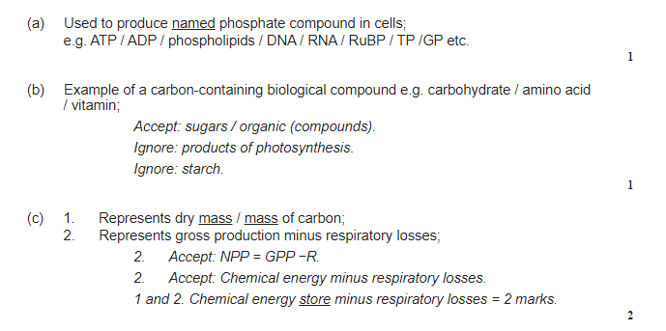

(d) Using the data from the graph in part (c), evaluate the effect on plant productivity of adding AMF species and adding phosphate to the soil.

___________________________________________________________________

___________________________________________________________________

___________________________________________________________________

___________________________________________________________________

___________________________________________________________________

___________________________________________________________________

(4)

(e) Using the e^{x} button on your calculator, determine the rate of shoot biomass production in grams per day for the control plot in soil with normal phosphate concentration.

Answer = ____________________ g day⁻¹

(2)

(Total 10 marks)

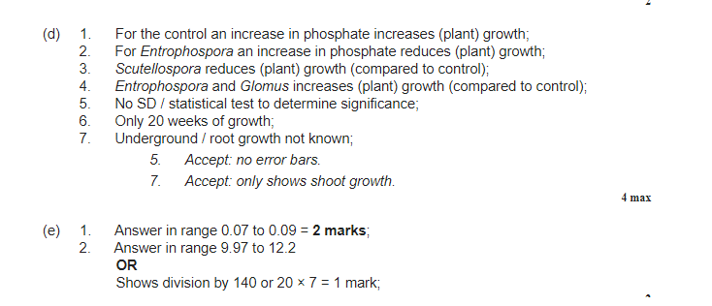

Net production
Learning outcomes:
- Explain the concept of net production in consumers, linked to how energy losses along food chains

Net production (N) in a consumer is the energy available to the next trophic level. The N reduces as you go from one tropic level to the next due to the energy loss at each level. N can be measured in a consumer as:

N = I – (F + R)
Energy lost through respiration
Chemical energy in ingested food
Net production
Chemical energy lost in faeces and urine

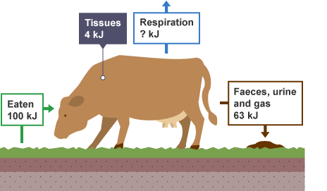
N
I
R
F

Reminder:
NPP refers to the net primary production in a producer,
N refers to the net production in a consumers (higher trophic level)

Primary and secondary productivity

Secondary production refers to the net quantity of energy transferred and stored in the tissues of consumers (heterotrophs) (i.e. it is net production)
Definitions:
Primary productivity: The rate of primary production. It is measured as biomass in a given area at a given time e.g. in kJ ha⁻¹ year⁻¹
Secondary productivity: The rate of secondary production. It is measured It is measured as biomass in a given area at a given time e.g. kJ ha⁻¹ year⁻¹

Exam Tip:
- ha⁻¹ year⁻¹ means per hectare per year
- 1 hectare is equivalent to 10,000m²

Efficiency of energy transfer

To calculate the efficiency of energy transfer between trophic levels:

% efficiency of energy transfer = net production of trophic level x100
net production of previous tropic level

e.g. The available energy, N, in a trout is 250 kJ m⁻² year⁻¹ and the energy available to a human after eating it is 50 kJ m⁻² year⁻¹. What is the efficiency of the energy transfer?

% efficiency of energy transfer = 50 = 0.2 x 100 = 20%
250

Increasing efficiency in food chains
Learning outcomes:
- Explain the ways in which productivity is affected by simplifying food webs

Productivity is affected by farming practices designed to increase the efficiency of energy transfer to humans by:
- Simplifying food webs to reduce energy losses to non-human food chains
- Reducing respiratory losses within a human food chain

Simplifying food webs involves getting rid of food chains which do not include humans. This can increase the proportion of energy transferred to humans as less is eaten by other organisms.

e.g. Weed aphid ladybird

Wheat human

In this example by removing the aphids, there is less competition between the aphids and the humans for the wheat as the aphids reduce the biomass of the wheat by eating it. The aphids can be removed in 3 ways:
- By using chemical control
  - Using an insecticide to kill the aphids directly.
  - Using an herbicide to kill the weeds which in turn removes interspecific competition for the crop for abiotic factors such as light and also removes a food source for the aphids reducing their numbers.
- By using biological control, such as adding ladybirds to the ecosystem which in turn eat the aphids.

Reducing respiratory losses

By reducing rate of respiration in livestock this will reduce R in the equation, increasing N. Less energy is lost through respiration and more is used for growth and biomass.

- Movement can be restricted by keeping animals in pens so less respiration occurs to release energy for muscle contraction.
- Animals can be kept indoors or heated rooms so less respiration occurs to generate heat to maintain body temperature.

Task: Use the words below to fill in the blanks on the mark scheme perfect answers
higher; respiration ; eat; consume; moving around; excretory; roots; herbivores; faeces; faeces; digest; digest; warm; hooves, horns, hair; respiration; energy; reflected; body temperature; chloroplast; respiration; wavelength; excretion; misses; faeces; eaten; heat; food;

Exam question: Describe reasons for the low efficiency of energy transfer from producer to primary cons.
- The primary consumers herbivores / cattle, do not eat all the grass (e.g. roots).
- They do not digest all the grass consumed (produce lots of faeces.
- Most of the energy they DO absorb is used in respiration.
- A lot of the energy is used to keep themselves warm by moving around.

Exam question: Describe reasons for the low efficiency of energy transfer between consumers.
- Secondary consumers (us) don’t eat all the cow (e.g. hooves, horns, hair).
- We can’t digest everything we consume (produce faeces)
- There are losses in excretory materials – urine
- Some is lost as heat from respiration to the environment – the higher the body temp., the higher the energy needed to maintain it

Exam question: Describe reasons for the low efficiency of energy transfer through ecosystems-
- Some light is reflected / not of the appropriate wavelength
- Some light misses leaves / does not strike chloroplasts
- There is heat loss / energy is used to maintain body temperature
- There is energy loss via respiration
- There is energy loss via faeces / undigested food / some parts of organism are not eaten
- There is loss via excretion / urine

Farming practices Read Toole and Toole, p.303-304.
Learning outcomes:
- Explain the ways in which farmers are reducing respiratory losses within a human food chain
- Interpret and calculate data on efficiency when provided with appropriate information
- Evaluate the ethics of some of these farming practices
Action to improve productivity | Reason
  Add fertilisers to soil | e.g. nitrates for protein synthesis; phosphate for ATP & DNA synthesis
pesticides are added | to prevent damage or consumption of crop
weed killers/herbicides, are added | to remove competition
Crops are selectively bred or genetically modified | For high productivity
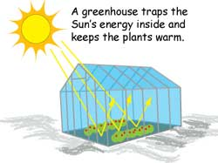  Use of greenhouses increase temperature, CO₂ conc and light intensity | To increase rate of photosynthesis / remove limiting factors
Ploughing | aerates soil so improves drainage
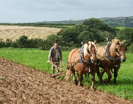  Ploughing/ aeration | allows nitrification (decreases denitrification)
Crops are protected by birds / pests / frost, by use of netting, covers | To prevent loss of crop / increase yield
  Watering | So it is not a limiting factor
Crop rotation | to improve soil nutrients
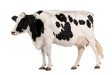  Livestock is slaughtered when still growing | more energy is transferred into biomass
  Livestock is fed on concentrate / a controlled diet | a higher proportion of food is digested, absorbed and used for biomass / less is lost in faeces
Their movement is restricted | Less heat / energy, is lost - there is less respiratory loss
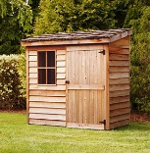  They are kept warm | less energy is used to maintain body temperature
There is selective breeding | for high productivity

Use of greenhouses and polytunnels
Limiting factor | Management in glasshouse.
CO2 conc | Increased by burning propane in generator
Light | Light through glass  Lights in the dark
Temp | Glass traps lights’ heat  Heating and cooling systems incl circulating systems.

The efficiency of a grazing animal
Scientists investigated the efficiency of an individual herbivore. They chose a bullock, because its energy transfer is not complicated by the milk producing process. Firstly, they needed to estimate the energy contained in the food eaten by the animal, which they did by taking samples of grass from a field. The plot selected was one hectare. One hectare measures 100m by 100m. It’s about the size of a football or rugby pitch.
- How many square meters in a hectare? [1]

- The scientists selected 20 different plots of area 1m²m and collected all of the grass by mowing.
- What percentage of the total plot was sampled? [1]

- Suggest why mowing was selected as collection method [1]

- The selected plots were chosen at random. Explain why this was important [1]

- Suggest how these plots could have been chosen. [1]

- The grass collected from the plots was first heated in an oven at 105ºC until the weight was constant. Explain why this was [2]

- Scientists obtained these results:
Mean mass of grass before drying/kg | Mean mass of grass after drying/kg
1.25 | 0.46

Calculate the percentage water content of grass. [2]

- 100g of the dry plant material was placed into a bomb calorimeter which produced a mean value of 85Kj. Outline how a bomb calorimeter works. [3]

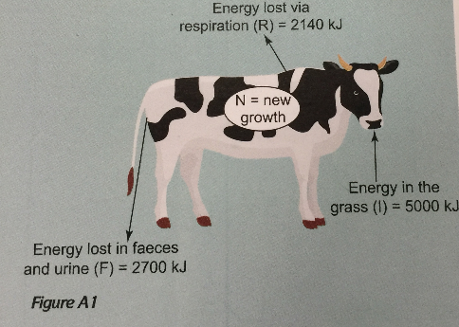
- Look at figure A1. Use the equation N= I – (F+R) to calculate the net production of the bullock in KJ [2]

- Calculate the overall efficiency of the energy transfer from producer to primary consumer. [2]

- The energy transfer from primary to secondary consumer is general higher. Suggest a reason for this. [2]

Answers
1. 10 000
2.
a. 0.2%
b. It mimics grazing. It just removes the upper parts/leaves, leaving the roots.
3. To avoid bias / the conscious choice of the scientist.
4. Give each square metre a number. Select 20 using a random number generator.
5. To make sure all the water was removed.
6. 38.3% (Calculated as 0.46 ÷ 1.25 × 100) Isn’t this a calculation of dry mass, not the water content?
7. Sample is burnt in oxygen. The energy given off heats up the surrounding water.
8. N = 160 kJ
9. 160 as a % of 5000 is 3.2%.
10. Meat is much more digestible than plant material. Less is wasted in faeces (in un-digestible cellulose, etc.).

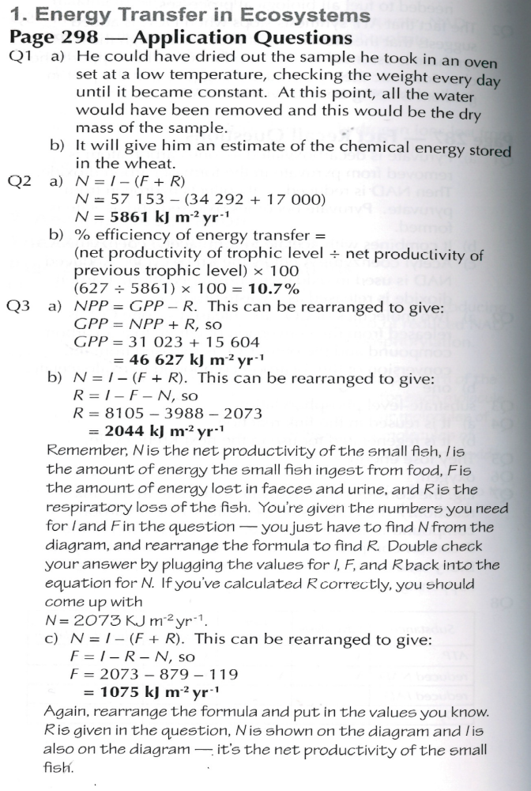
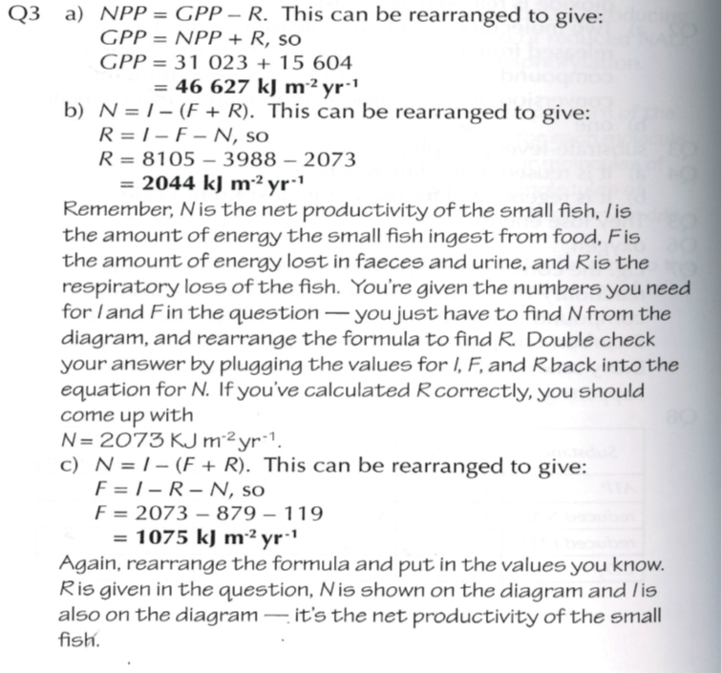
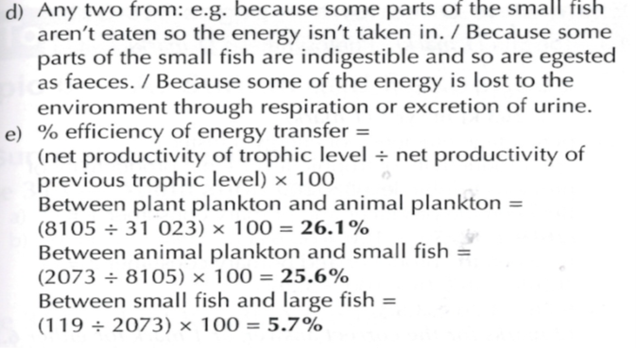

Exam Questions
Q5. This is a food web from a pond ecosystem: single-celled algae pond snail fish
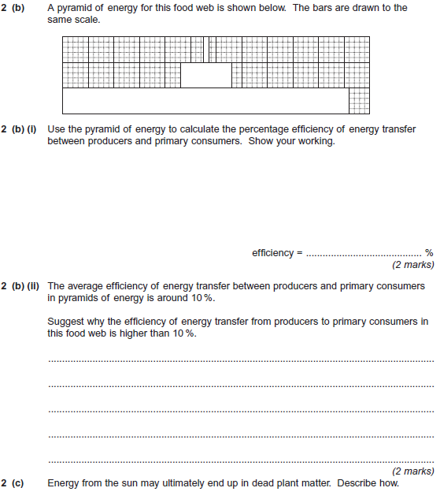[2]
________________________________________________________________________________________________________________________________________________________________________________________________________________________________________________________________________________________________________________________________

