Assessment – Energy and Ecosystems
Q1.
Mycorrhiza are fungi which grow on, and into, the roots of plants. Scientists investigated the effect of a mycorrhizal fungus on the growth of pea plants with a nitrate fertiliser or an ammonium fertiliser. The fertilisers were identical, except for nitrate or ammonium.
The scientists took pea seeds and sterilised their surfaces. They planted the seeds in soil that had been heated to 85 °C for 2 days before use. The soil was sand that contained no mineral ions useful to the plants.
(a) Explain why the scientists sterilised the surfaces of the seeds and grew them in soil that had been heated to 85 °C for 2 days.
___________________________________________________________________
___________________________________________________________________
___________________________________________________________________
___________________________________________________________________
(2)
(b) Explain why it was important that the soil contained no mineral ions useful to the plants.
___________________________________________________________________
___________________________________________________________________
(1)
The pea plants were divided into four groups, A, B, C and D.
• Group A – heat-treated mycorrhizal fungus added, nitrate fertiliser
• Group B – mycorrhizal fungus added, nitrate fertiliser
• Group C – heat-treated mycorrhizal fungus added, ammonium fertiliser
• Group D – mycorrhizal fungus added, ammonium fertiliser
The heat-treated fungus had been heated to 120 °C for 1 hour.
(c) Explain how groups A and C act as controls.
___________________________________________________________________
___________________________________________________________________
___________________________________________________________________
___________________________________________________________________
(2)
After 6 weeks, the scientists removed the plants from the soil and cut the roots from the shoots. They dried the plant material in an oven at 90 °C for 3 days. They then determined the mean dry masses of the roots and shoots of each group of pea plants.
(d) Suggest what the scientists should have done during the drying process to be sure that all of the water had been removed from the plant samples.
___________________________________________________________________
___________________________________________________________________
___________________________________________________________________
___________________________________________________________________
(2)
The scientists’ results are shown in the table below.

Treatment | Mean dry mass / g per plant  ( standard deviation)
Treatment | Root | Shoot
A – heat-treated fungus and nitrate fertiliser | 0.40  (±0.05) | 1.01  (±0.12)
B – fungus and nitrate fertiliser | 1.61  (±0.28) | 9.81  (±0.33)
C – heat-treated fungus and ammonium fertiliser | 0.34  (±0.03) | 0.96  (±0.26)
D – fungus and ammonium fertiliser | 0.96  (±0.18) | 4.01  (±0.47)
(e) What conclusions can be drawn from the data in the table about the following?
The effects of the fungus on growth of the pea plants.
___________________________________________________________________
___________________________________________________________________
___________________________________________________________________
___________________________________________________________________
The effects of nitrate fertiliser and ammonium fertiliser on growth of the pea plants.
___________________________________________________________________
___________________________________________________________________
___________________________________________________________________
___________________________________________________________________
(4)

The scientists determined the dry mass of the roots and shoots separately. The reason for this was they were interested in the ratio of shoot to root growth of pea plants. It is the shoot of the pea plant that is harvested for commercial purposes.
(f) Explain why determination of dry mass was an appropriate method to use in this investigation.
___________________________________________________________________
___________________________________________________________________
___________________________________________________________________
___________________________________________________________________
(2)
(g) Which treatment gave the best result in commercial terms? Justify your answer.
___________________________________________________________________
___________________________________________________________________
___________________________________________________________________
___________________________________________________________________
(2)
(Total 15 marks)
Q2.
In some countries, pigs are reared in intensive units in which the temperature is controlled. Agricultural scientists investigated the effect of temperature on pig growth and on the efficiency with which the pigs converted food to biomass.
(a) (i) In the investigation, the scientists used pigs of the same breed, with similar genotypes.
Explain why.
______________________________________________________________
______________________________________________________________
______________________________________________________________
______________________________________________________________
______________________________________________________________
(2)
(ii) The pigs were allowed to eat as much food as they wanted.
How could this have decreased the reliability of any conclusions drawn from the investigation?
______________________________________________________________
______________________________________________________________
(2)
The table shows the results of this investigation.

Temperature / °C | Mean growth rate /  kg per day | Efficiency of conversion of  food to biomass /%
0 | 0.54 | 19
10 | 0.80 | 42
20 | 0.85 | 48
30 | 0.45 | 37
35 | 0.31 | 37
(b) (i) Describe the effect of temperature on mean growth rate.
______________________________________________________________
______________________________________________________________
(1)
(ii) A student concluded from these data that the mean growth rate of the pigs was fastest at 20 °C.
Do you agree with this conclusion? Explain your answer.
______________________________________________________________
______________________________________________________________
______________________________________________________________
______________________________________________________________
______________________________________________________________
(2)
(c) (i) Pigs can survive at temperatures above 35 °C. Use the data to suggest why scientists did not carry out any investigations at temperatures higher than 35 °C.
______________________________________________________________
______________________________________________________________
______________________________________________________________
______________________________________________________________
______________________________________________________________
(2)
(ii) The efficiency of conversion of food to biomass is lower at 0 °C than it is at 20 °C.
Suggest an explanation for the lower efficiency.
______________________________________________________________
______________________________________________________________
______________________________________________________________
______________________________________________________________
(2)
(d) Pigs require a mixture of fibre and protein in their food. The greater the ratio of fibre to protein, the less the food costs.
Scientists took five large groups of pigs. They fed each group a different high-fibre food. Each of the foods contained fibre from different plant species, but they all had the same energy content. The scientists fed a control group of pigs a low-fibre food with the same energy content. After 10 days, the scientists compared the masses of the pigs fed on high-fibre food to those fed on low-fibre food.
The graph shows the results of the investigation. The bars represent ±2 standard errors of the mean.
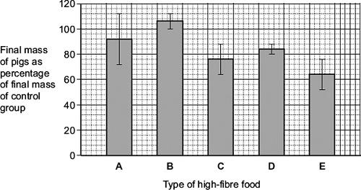
A farmer saw these results and concluded that he should replace his pigs’ usual food with food B.
Evaluate this conclusion.
___________________________________________________________________
___________________________________________________________________
___________________________________________________________________
___________________________________________________________________
___________________________________________________________________
___________________________________________________________________
___________________________________________________________________
___________________________________________________________________
(4)
(Total 15 marks)
Q3.
Yield can be determined by measuring the dry mass of plants.
(a) Suggest how you could determine the dry mass of a sample of plant material.
___________________________________________________________________
___________________________________________________________________
___________________________________________________________________
___________________________________________________________________
(2)
(b) What is the advantage of using dry mass and not fresh mass to compare the yield of plants?
___________________________________________________________________
___________________________________________________________________
___________________________________________________________________
___________________________________________________________________
(2)
(Total 4 marks)

Q4.
- An area of vegetation 10m x 6m produces 12 x10⁴ kJ of potential energy per year. Calculate the gross primary production of this area.
___________________________________________________________________
___________________________________________________________________
___________________________________________________________________
___________________________________________________________________
(2)
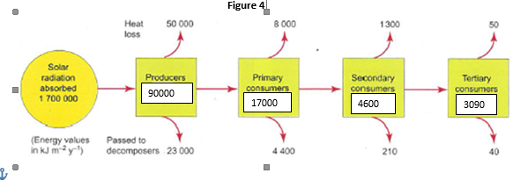

- Using Figure 4, calculate the percent transferred (the % efficiency) between each trophic level

(3)
(Total 5 marks)

Q5. Describe the process of calorimetry.

___________________________________________________________________
___________________________________________________________________
___________________________________________________________________
___________________________________________________________________
___________________________________________________________________
___________________________________________________________________
___________________________________________________________________
___________________________________________________________________
___________________________________________________________________
___________________________________________________________________
___________________________________________________________________
___________________________________________________________________ (5)
(Total 5 marks)

