Recombinant DNA technology

Name: _____________________________________________________________
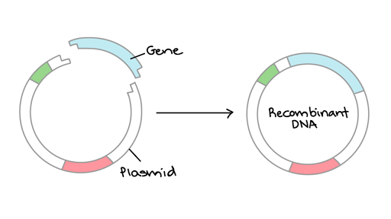
Reflection on learning outcomes | or | Target
Explain what is meant by recombinant DNA technology.

Explain the methods which could be used to isolate a gene and produce a DNA fragments including:

- conversion of mRNA to cDNA, using reverse transcriptase

- using restriction enzymes to cut a fragment containing the desired gene from DNA

- creating the gene in a ‘gene machine’.

Explain what is meant by a restriction endonuclease and how they work to leave sticky ends.

Explain the importance of the use of restriction enzymes and sticky ends

Describe the stages involved in in vivo gene cloning.
Explain the importance of the addition of promoter and terminator regions

Explain the methods used for transformation.
Explain the use of marker genes and replica plating.
Interpret information provided in exam questions, to interpret which colonies have been successfully transformed with recombinant DNA.

Outcome:
- Explain what is meant by recombinant DNA technology.

Definition:
Recombinant DNA: DNA from two different sources joined together (The 2 sources do not need to be from the same species).
In vivo: Experiments performed within the living organism.
In vitro: Experiments performed test tubes/petri dishes outside of the living organism.

The process of making a protein using DNA technology of gene transfer and cloning involves a number of stages:
OVERVIEW of Recombinant DNA Technology
Donor DNA | Restriction site | Gene probe | Same | Sticky ends
Vector | Plasmid | Sugar-phosphate | Bacterial | Recombinant
Recombinant | Transgenic | Protein synthesis | Product

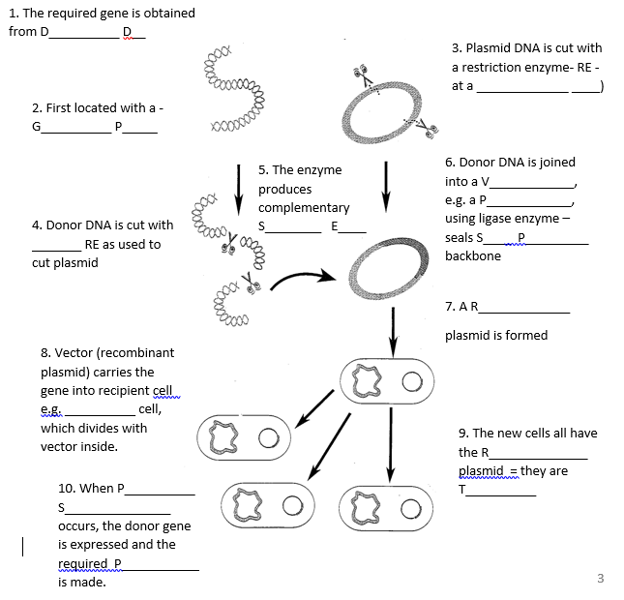
Use the two links below to help you consolidate your understanding of the process if needed.
Video 1: http://highered.mcgraw-hill.com/sites/0072437316/student_view0/chapter16/animations.html#
Video 2: http://m.youtube.com/watch?v=8Dd7M9PGhgQ
We most commonly use bacteria for this form of cloning but in modern labs there is a steady increase in the use of viruses and liposomes.

Now you need to look at the different stages in more detail.
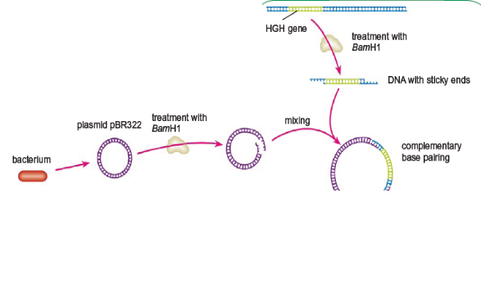
- Isolation
- Insertion
- Transformation
- Identification
- Growth/Cloning

Outcome:
- Explain the methods which could be used to isolate a gene and produce a DNA fragments including; conversion of mRNA to cDNA, using reverse transcriptase, using restriction enzymes to cut a fragment containing the desired gene from DNA, creating the gene in a ‘gene machine’.
- Explain what is meant by a restriction endonuclease and how they work to leave sticky ends.
- Explain the importance of the use of restriction enzymes and sticky ends.

Step 1: Isolation.
The gene may be a few hundred bases amongst many millions in the human genome. There a number of methods used to isolate the gene:
- Method 1: conversion of mRNA to cDNA, using reverse transcriptase
- Method 2: using restriction enzymes to cut a fragment containing the desired gene from DNA
- Method 3: creating the gene in a ‘gene machine’.
Method 1: conversion of mRNA to cDNA, using reverse transcriptase
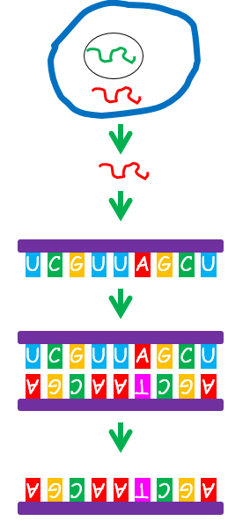
Example – Isolating human insulin gene
1.

2.

3.

4.

5.

6.

7.

8.

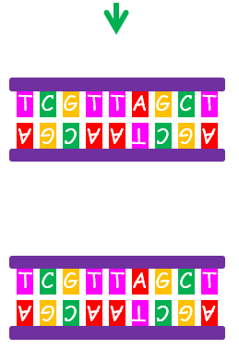

Why do scientists have to use mRNA to produce insulin, why can’t the scientists use the DNA instead?
___________________________________________________________________________________________________________________________________________________________________________________________________________________________________________________________________________________________________________________________
Match the complementary base pairs:
a) mRNA strand for insulin: A U G C C U C G C C U G U U C U U G
Reverse transcriptase
b) Single strand of DNA _______________________________
DNA Polymerase
c) Double stand of DNA _______________________________
Write out the gene for insulin: ________________________________

T/F quiz. If you think the statement is false, can you correct it?
- There are 2 H bonds between C and G
- There are 3 H+ bonds between A and T
- T in DNA is replaced by U in RNA
- The sugar in DNA is deoxyribose
- DNA nucleotides are joined by phospho bonds
- DNA polymerase makes peptide bonds
- Reverse transcriptase forms a DNA chain from an mRNA template.
Advantages of using reverse transcriptase
- mRNA is easy to obtain as it can be found outside of the nucleus.
- Using mRNA isolated from cytoplasm means introns have been removed.

Method 2: using restriction enzymes to cut a fragment containing the desired gene from DNA
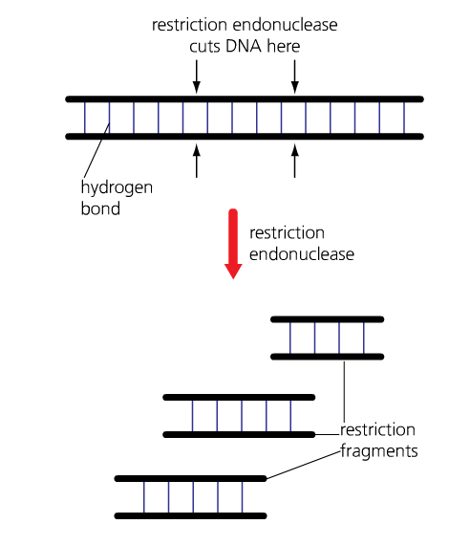
Restriction enzymes are also known as restriction endonucleases.
Restriction endonucleases are enzymes which cut (hydrolyse) DNA at specific base sequences (recognition sequences).
Different restriction endonucleases cut DNA at different specific sequence of bases (recognition sites) because the shape of the recognition site is complementary to the enzymes active site.
These recognition sites occur in the DNA of all species of organisms- but not in the same places!
These recognition sequences are palindromic - base pair read the same in opposite directions.
If recognition sequences for these enzymes are present at either side of the DNA fragment you want, you can use restriction endonucleases to separate it from the rest of the DNA. The DNA sample is incubated with the specific restriction endonuclease, which cut DNA fragment out of DNA.

NOTE: It is important that the recognition sequence for the selected restriction endonuclease does not occur within the gene you want to isolate.
Restriction enzymes are made by bacteria to cut out viral DNA sequences from the bacterial DNA.

The cut made at the recognition site is either straight (giving a blunt end) or staggered (producing a 'sticky end').
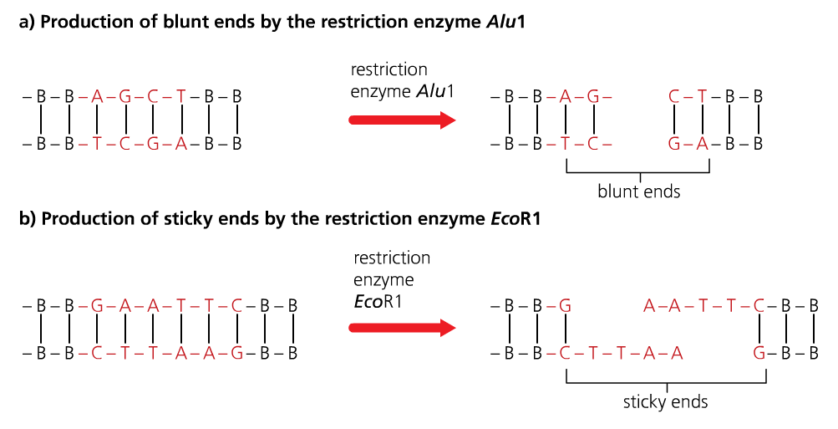
Definition:
Sticky end: Short, single stranded section at the end of a DNA molecule, the result of staggered cutting with a restriction endonuclease.
Sticky ends can be used to bind (anneal) DNA fragments together, if other DNA molecule has complementary 'sticky' end.
Sticky ends are important as they allow the DNA fragment to be inserted into another organism / species DNA, if the other organism’s DNA is cut using the same restriction enzyme.

Below are 5 identical bacterial DNA sequences and 5 different restriction endonucleases. On each DNA strand:
- Highlight the recognition sequence
- The enzyme reads the top chain of the recognition site first from left to right. On the top line draw a vertical line between the 2 bases the enzymes cuts
- The enzyme reads the bottom chain of the recognition site second from right to left. On the bottom line draw a vertical line between 2 bases the enzyme cuts
- Connect the 2 vertical lines with a horizontal line.
The first two have been done for you. Complete the rest of the activity.
Bacterial sequence 1:
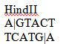
A│G T A C T G C A G T A T A C T A T C G C G T T A A C G C T A G
T C A T G│A C G T C A T A T G A T A G C G C A A T T G C G A T C
Bacterial sequence 2:

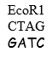
A G T A C T G C A G T A T A C T A T C G C G T T A A C G C T│A G
T C A T G A C G T C A T A T G A T A G C G C A A T T G C G A│T C
Bacterial sequence 3:
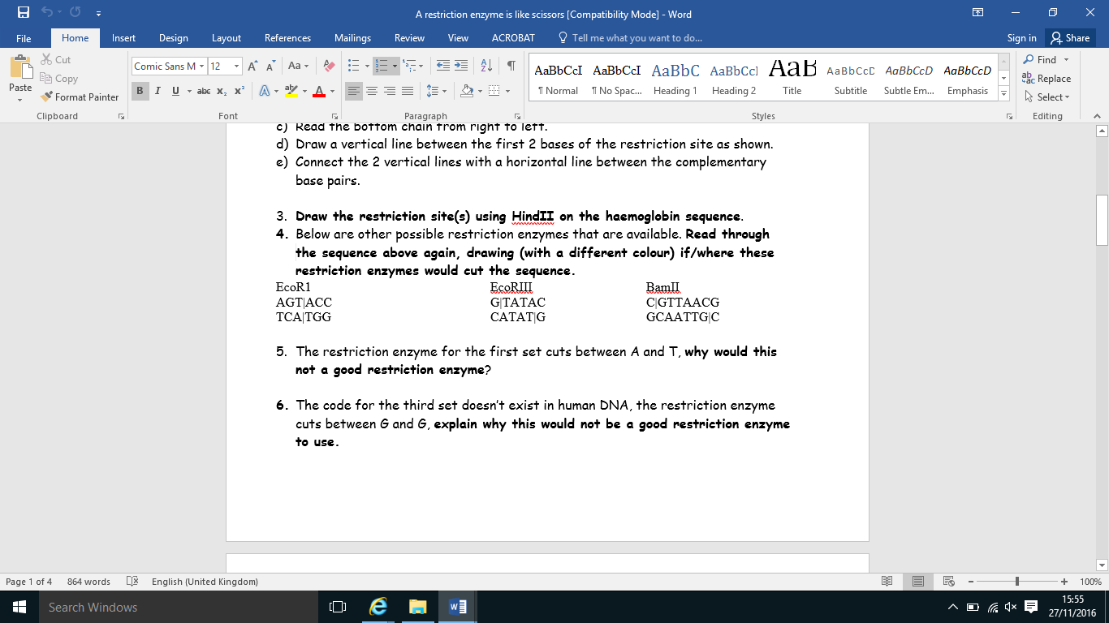
A G T A C T G C A G T A T A C T A T C G C G T T A A C G C T A G
T C A T G A C G T C A T A T G A T A G C G C A A T T G C G A T C
Bacterial sequence 4:

A G T A C T G C A G T A T A C T A T C G C G T T A A C G C T A G
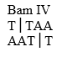
T C A T G A C G T C A T A T G A T A G C G C A A T T G C G A T C
Bacterial sequence 5:

A G T A C T G C A G T A T A C T A T C G C G T T A A C G C T A G
T C A T G A C G T C A T A T G A T A G C G C A A T T G C G A T C

Complete the definitions table using page 5
Term | Definition
Restriction endonuclease/enzyme
Recognition site
Palindrome
Blunt sticky end
Staggered sticky end

Method 3: creating the gene in a ‘gene machine’.
- Protein sequence analysed
- Amino-acid sequence worked out (determined)
- mRNA sequence worked out
- DNA nucleotide base sequence worked out
- DNA nucleotide base sequence is uploaded into the computer
- Computer produces DNA base sequence by producing overlapping single strands of nucleotides called Oligonucleotides which can then be assembled into the gene.
Advantages of using the gene machine:
- Faster to use the gene machine rather than using reverse transcriptase or restriction endonucleases
- There are more steps involved in isolating the gene/mRNA as well as the enzyme catalysed reactions.
- Highly accurate.
Complete the table below:
Amino-acid sequence | GLY | ILE | VAL | GLU | GLN | CYS | CYS
mRNA sequence | _ _ U | _ _ A | _ _ U | _ _ A | _ _ A | _ _ C | _ _ U
DNA sequence

Maths question. The DNA sequence for insulin is normally 237 base pairs long, the mRNA chain is only 153 base pairs long. What is the % decrease in base pair length? Show your working.

How long is the amino-acid sequence that the mRNA codes for. Show your working?

Extension: Can you give a suggestion for the difference in base pair length?
_____________________________________________________________________________________________________________________________________________________________________________________________________________________________________________________________________________________________

REMEMBER: Gene cloning involves fragments of DNA being amplified by in vitro and in vivo techniques.
- In vitro – Polymerase chain reaction (PCR) - DNA techniques booklet
- In vivo – Culture of transformed host cells - This booklet!
Outcome:
- Describe the stages involved in in vivo gene cloning,
- Explain the addition of promoter and terminator regions
Step 2: Insertion of the desired gene into a suitable vector.
Before a gene can be copied it has to be inserted into a suitable vector so the transgenic organism will be able to read and use the inserted genetic information to produce the protein we want.
Step 2(a): Preparing the DNA fragment for insertion.
Promotor region:
RNA Polymerase:

Transcription factors:

Terminator region:

Preparing the DNA fragment. Identify the promotor region by colouring it RED, add a label to this region and give its definition. Identify the enzyme RNA polymerase by colouring it BLUE, add a label and give its definition. Identify the terminator region by colouring it in YELLOW, add a label and give its definition. Identify the sticky ends by colouring them in ORANGE, add a label and give their definition.

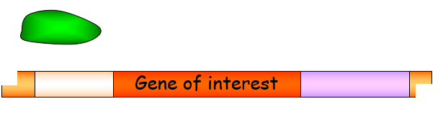

Answer the questions below, use and apply your knowledge.
- Explain why each of steps are important in preparing the gene of interest for insertion into a vector. (Can you remember what explain means in your exam?)
  - A specific promotor region is added in front of the gene of interest
__________________________________________________________________________________________________________________________________________________________________________________________________________________
  - A terminator region is added at the end of the gene of interest
__________________________________________________________________________________________________________________________________________________________________________________________________________________

  - Sticky ends are added at the beginning of the promotor region and at the end of the terminator region.
__________________________________________________________________________________________________________________________________________________________________________________________________________________
  - Extension: The promotor region is complementary to RNA polymerase but not DNA polymerase.
__________________________________________________________________________________________________________________________________________________________________________________________________________________
Step 2(b): Inserting the gene of interest into a vector.
Definition:
Vector: A DNA carrier (i.e. bacterial plasmid or virus) used to transfer DNA into cells.
- The most common type of vector is a PLASMID which can be inserted into a bacterial cell.
- To prepare the vector for the gene of interest the vector has to be opened by using the SAME restriction enzyme
- So the sticky ends are complementary
- DNA Ligase is then used to recombine the 2 pieces of DNA
- This is known as RECOMBINANT DNA
- https://www.youtube.com/watch?v=8rXizmLjegI
Draw A diagram below to repreent the information above to help remember this information.

Outcome:
- Explain the methods used for transformation
Step 3: Transformation.
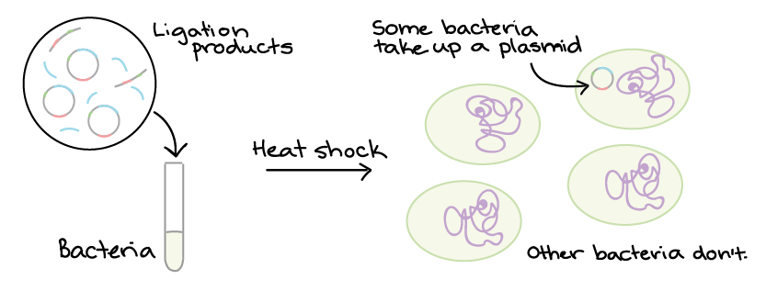
Now we have our vector which carries the gene of interest we need to get the recombinant DNA into our microorganisms so the microorganisms can get on with producing the gene that we require.

Step 1: Chemical transformation
__________________________________________________________________________________________________________________________________________________________________________________________________________________
__________________________________________________________________________________________________________________________________________________________________________________________________________________
Step 2: Heat shock
__________________________________________________________________________________________________________________________________________________________________________________________________________________
__________________________________________________________________________________________________________________________________________________________________________________________________________________
Draw a diagram to represent the 2 steps above.

Outcomes:
- Explain the use of marker genes and replica plating,
- Interpret information provided in exam questions, to interpret which colonies have been successfully transformed with recombinant DNA
Step 4: Identification of the transformed bacteria.
Only 1% of the bacteria that we try to transform actually take up the vector. The other 99% of the bacteria are useless to us. There is no point wasting time and money allowing all 100% of the bacteria to reproduce if we only want 1%. So, how do we identify the correct bacteria and what’s happened to the other 99%?
Firstly, we need to consider what might happen to the bacteria as shown below:
- Some of the plasmids will have resealed without becoming recombinant- we don’t want this.
- Some of the gene of interest will have resealed without becoming recombinant – we don’t want this.
- There will be some recombinant DNA – this is what we want.
- Some of the bacteria will not have transformed at all- we don’t want this.
In the boxes labelled below draw what this might look like. (Plasmid = blue, gene of interest = red, bacteria = green.)
Bacteria with resealed plasmid | Bacteria with resealed gene of interest | Bacteria with recombinant DNA | Bacteria that has not transformed.

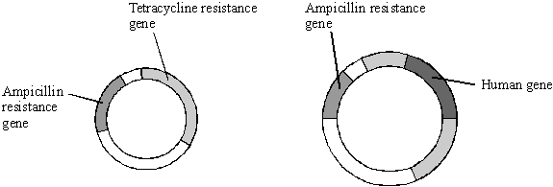
To help us identify the recombinant DNA in the transformed bacteria we use specialised plasmids as the one shown below- known as an R-plasmid.

Definition:
Antibiotic resistance:_______________________________________________________________________________________
________________________________________________________________________________________________________
Genetic markers: _________________________________________________________________________________________
________________________________________________________________________________________________________

Our R plasmid has two antibiotic resistant gene: 1) Resistant to ampicillin known as the AMP gene. 2) Resistance to tetracycline known as the TET gene.
Activity:
- If we use the BamIV restriction enzyme draw below what the recombinant plasmid would look like (AMP gene= red, TET gene= blue, gene of interest= green) using the gene of interest (e.g. Insulin gene) TAC GGA GCG GAC AAG AAC

- To your drawing add if the AMP gene would work (provide the bacteria with resistance) and if the TET gene would work (provide the bacteria with resistance). Justify your answer.
__________________________________________________________________________________________________________________________________________________________________________________________________________________________________________________________________________________________________________________________________________________________________________________________________
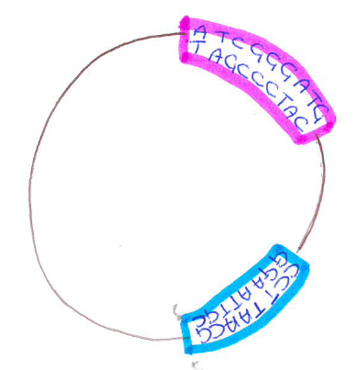
R – plasmid Recombinant plasmid

Complete the table below:
Drawing
Bacteria | Bacteria with resealed plasmid | Bacteria with resealed gene of interest | Bacteria with recombinant DNA | Bacteria that has not transformed.
Resistance to AMP (/ or x)
Resistance to TET (/ or x)

Activity: Read the method below and complete the diagram to show how we use the R plasmid to identify the bacteria that have transformed and carry the recombinant DNA.
Replica plating: Method used to Identification of the transformed bacteria.
Master plate
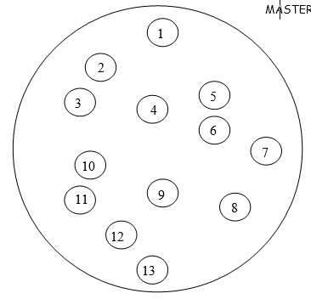
- On the MASTER plate ALL the bacterial colonies are grown.

- The colonies on the MASTER plate are transferred onto a plate containing antibiotics. This is called replica plating.
NOTE: The colonies must be transferred in exactly the same position

1st replica plate
3. The first REPLICA PLATE medium contain the antibiotic AMPLICILLIN.
4. The REPLICA PLATE is incubated.
5. On the diagram identify which bacterial colonies have died and describe these bacteria.
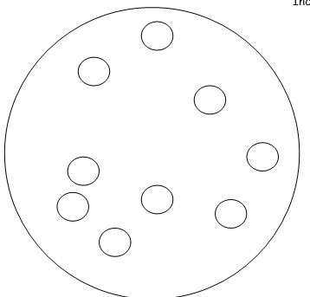

2nd replica plate
6. The surviving colonies are transferred onto a second replica plate.
NOTE: The colonies must be transferred in exactly the same position
7. The second REPLICA PLATE medium contains the antibiotic TETRACYCLINE.
8. The REPLICA PLATE is incubated.
9. On the diagram identify which bacterial colonies have died and describe these bacteria.
10. Now we go back to the master plate and can identify which is the recombinant bacteria. These were the colonies that survived the ampicillin plate but NOT the tetracycline plate.
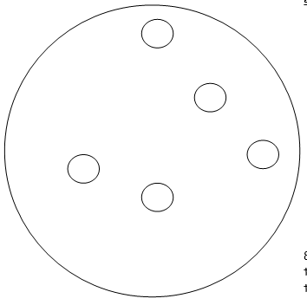

Exam questions: Enzymes
Q1. Scientists are working to produce a genetically modified bacterium to treat patients suffering from a disease of the digestive system. They plan to collect mRNA from human cells. This will be used to produce the DNA of the gene for the protein interleukin. They will then transfer this human gene into the bacterium Lactococcus. The scientists intend patients to swallow the genetically modified bacteria. These bacteria will release interleukin inside the digestive system to treat the disease.
(a) (i) Name the type of enzyme which will be used to produce the DNA from the mRNA.
._________________________________________________________________________________________(1)
(ii) It is easier to obtain the interleukin gene from mRNA rather than directly from the DNA removed from human cells. Explain why
._________________________________________________________________________________________
._________________________________________________________________________________________(1)
(b) The scientists propose to put the gene directly into the DNA of Lactococcus.
Describe the role of the enzyme ligase in this process.
._________________________________________________________________________________________
.________________________________________________________________________________________(1)
Forming recombinant DNA
Q2. Plasmids can be used as vectors to insert lengths of foreign DNA into bacteria. The diagram shows how this is achieved.
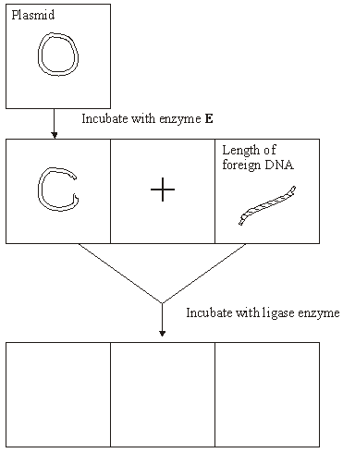
(a) Name enzyme E.
._________________________________________________________________________________________(1)
(b) Cut plasmids and lengths of foreign DNA can join. What features of their ends allows them to join?
._________________________________________________________________________________________
.________________________________________________________________________________________(2)
(c) Draw three different structures that could be formed by incubating cut plasmids and lengths of foreign DNA with ligase. Use the spaces provided on the diagram. (3)
Questions on Vectors and identification
Q3. (a) (i) Some human DNA was cut into separate pieces using a restriction enzyme which produced a staggered cut. A scientist wanted to insert these pieces of DNA into plasmids and used the same restriction enzyme to cut the plasmids. Explain why the pieces of human DNA would be able to join to the cut DNA of the plasmids.
._________________________________________________________________________________________
.________________________________________________________________________________________
._________________________________________________________________________________________
.________________________________________________________________________________________(2)
(ii) Which other enzyme must the scientist have added to the mixture to form recombinant plasmids?
._________________________________________________________________________________________
.________________________________________________________________________________________(1)

(b) A plasmid may be used as a vector. Explain what is meant by a vector in this context.
._________________________________________________________________________________________
.________________________________________________________________________________________(2)
(c) Molecular biologists often use plasmids which contain antibiotic resistance genes. Explain the reason for this.
._________________________________________________________________________________________
.________________________________________________________________________________________(2)
(Total 7 marks)
Q4.Haemophilia is a genetic condition in which blood fails to clot. Factor IX is a protein used to treat haemophilia. Sheep can be genetically engineered to produce Factor IX in the milk produced by their mammary glands. The diagram shows the stages involved in this process.

 | Stage 1 | 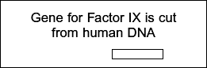
 | Stage 2 | 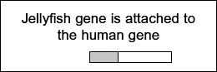
 | Stage 3 | 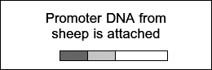
 | Stage 4 | 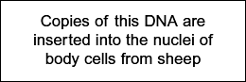
 | Stage 5 | 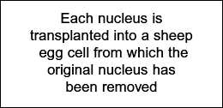
 | Stage 6 | 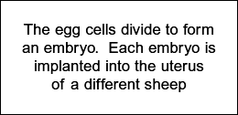

(a) Name the type of enzyme that is used to cut the gene for Factor IX from human DNA (Stage 1) .
._________________________________________________________________________________________
.________________________________________________________________________________________(1)
(b) (i) The jellyfish gene attached to the human Factor IX gene (Stage 2) codes for a protein that glows green under fluorescent light. Explain the purpose of attaching this gene.
._________________________________________________________________________________________
.________________________________________________________________________________________(2)

(ii) The promoter DNA from sheep (Stage 3) causes transcription of genes coding for proteins found in sheep milk.
Suggest the advantage of using this promoter DNA.
._________________________________________________________________________________________
.________________________________________________________________________________________(2)
Q5.Silkworms secrete silk fibres, which are harvested and used to manufacture silk fabric. Scientists have produced genetically modified (GM) silkworms that contain a gene from a spider. The GM silkworms secrete fibres made of spider web protein (spider silk), which is stronger than normal silk fibre protein.
The method the scientists used is shown in the figure below.
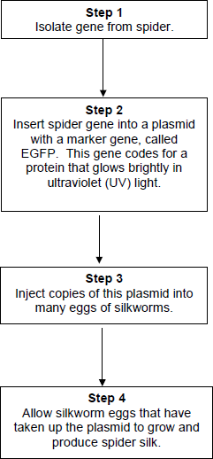
(a) Suggest why the plasmids were injected into the eggs of silkworms, rather than into the silkworms.
._________________________________________________________________________________________
.________________________________________________________________________________________(2)
(b) Suggest why the scientists used a marker gene and why they used the EGFP gene.
._________________________________________________________________________________________
.________________________________________________________________________________________(2)
The scientists ensured the spider gene was expressed only in cells within the silk glands.
(c) What would the scientists have inserted into the plasmid along with the spider gene to ensure that the spider gene was only expressed in the silk glands of the silkworms?
._________________________________________________________________________________________
.________________________________________________________________________________________(1)

(d) Suggest two reasons why it was important that the spider gene was expressed only in the silk glands of the silkworms.
1 ._________________________________________________________________________________________
.________________________________________________________________________________________
2 ._________________________________________________________________________________________
.________________________________________________________________________________________(2)

