3.8.3 Using genome projects

3.8.4 Applications and implication of gene technologies
Name __________________________________
Reflection on Learning outcome | or | Target
Explain the principles of gel electrophoresis in separating DNA fragment
Explain how sequencing techniques have become automated and faster
Explain why it is harder to translate genomic sequences into the proteome for complex organisms than for simpler organisms.
Describe the process of PCR in amplifying DNA fragments
Explain the role of primers and Taq polymerase in PCR
Explain the processes of strand separation, primer annealing, and strand synthesis
Evaluate the pros and cons of using PCR to clone DNA fragments over in vivo methods.
Describe the methodology involved in producing a genetic fingerprint
Explain what variable number tandem repeats are, and how these allow the production of a virtually unique genetic fingerprint
Explain the applications of genetic fingerprinting.
Interpret genetic fingerprint patterns and draw conclusions
Explain how DNA probes and hybridisation are used to locate specific alleles.
Explain the benefits of screening for genetic diseases.
Explain some of the issues raised by screening, and the role of genetic counsellors.
Evaluate information relating to screening individuals for genetically determined conditions and drug responses.
Interpret information relating to the use of recombinant DNA technology.
Evaluate the ethical, financial and social issues associated with the use and ownership of recombinant DNA technology in agriculture, in industry and in medicine.
Balance the humanitarian aspects of recombinant DNA technology with the opposition from environmentalists and anti-globalisation activists
(NB the three italicized learning outcomes are not required AO1 specification knowledge but used to develop ideas)
Explain the principles of gene therapy.
Explain the use of liposomes and viruses in delivering genes into cells.
Explain the difference between somatic and germ line therapy, and why germ line therapy is prohibited.
Evaluate the effectiveness and risks of gene therapy

Learning outcome:
- Explain the principles of gel electrophoresis in separating DNA fragment

Gel electrophoresis
This technique is used to separate DNA fragments based on their SIZE so they can then be identified and analysed. It is based on the fact that the rate at which a particular fragment of DNA moves is proportional to its mass (length).
Separating fragments according to size using gel electrophoresis:
DNA is hydrolysed by restriction endonucleases before it can be separated. The hydrolysed DNA sample is placed within the well at one end of an agarose gel. The gel is placed in a buffer so that the negative electrode is next to the well and an electrical current is passed through the gel. 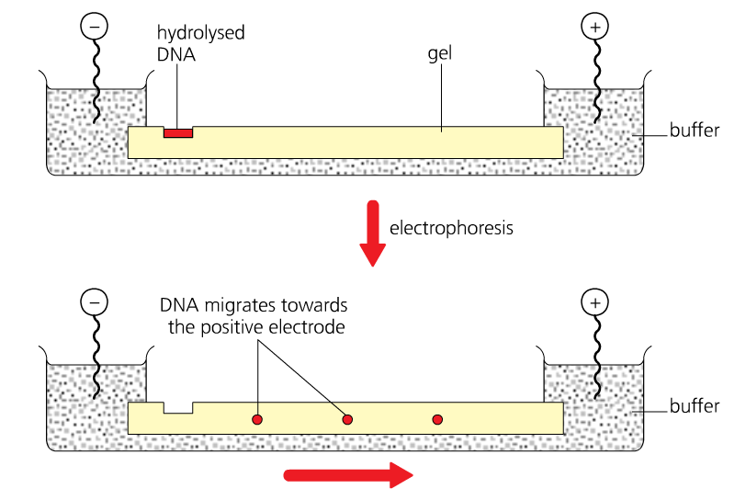
As DNA is negatively charged (due to the phosphate group), DNA fragments migrate toward the positively charged end of the gel/electrode.
Smaller DNA fragments migrate through the gel more quickly than larger fragments. So smaller fragments move further through the gel in the same time period, this process separates fragments according to their size across the gel.

Visualising the DNA fragments: Southern blotting and autoradiography
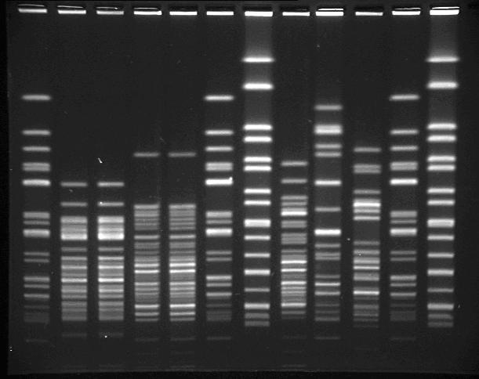
An alkali is added to make the DNA single stranded. The DNA is transferred to a nylon membrane by Southern blotting.
Radioactively/fluorescently labelled DNA probes with complementary base sequences to the DNA fragments are added to the DNA and bind due to hydrogen bonding.
The DNA can be visualised using autoradiography (the radioactively labelled probes expose X ray film so bands can be visualised – see image on right)

Task: Virtual Gel Electrophoresis
- Visit website: http://learn.genetics.utah.edu/
- Click on the virtual lab, ‘GEL ELECTROPHORESIS’.
- Read the instructions carefully to carry out your own electrophoresis.
- Repeat and note down your answers to the following questions.

Questions
- What is the purpose of gel electrophoresis?
Sort DNA strands according to length. Can also be used to separate other molecules like proteins by mass
- What acts as a filter?
The gel- like a sponge with many small holes in it​
- How is the agarose different to jell-o?
Dried powder similar to gelatine but made from seaweed​
- What is the electric current for?
To split the DNA fragments by size ​
- Why are DNA fragments drawn towards the positive pole?
DNA is negatively charged​
- What is the purpose of the loading buffer?
Conducts electricity from one end of the gel to the other ​
- What is the name of the holes left in the gel as it cools in which the DNA is loaded?
Wells
- What does the ‘DNA size standard’ contain? What is its purpose?
DNA of known lengths for reference ​
- How do you know when the current is running?
Bubbles produced at the electrodes ​
- Why do the longer DNA strands migrate the least?
Take longer to move through the holes in the gel​
- Why is ethidium bromide used to stain DNA? (2 reasons)
Binds to DNA and shows under fluorescent light ​
- Why is it necessary to avoid contact with ethidium bromide?
Binds to DNA and shows under fluorescent light ​
- Type in your estimates of base pair length.
Binds to DNA and shows under fluorescent light ​

Learning outcomes:
- Explain how sequencing techniques have become automated and faster
- Explain why it is harder to translate genomic sequences into the proteome for complex organisms than for simpler organisms.

DNA sequencing
Task:
- Watch the video yourgenome.org/teachers/speed.shtml
- You do not need to know the process of DNA sequencing but you should be able to apply your knowledge if you are given a question which may refer to the process.
- The key thing is to highlight points which have allowed sequencing methods to become faster and more automated.
Notes:
___________________________________________________________________________________________________________________________________________________________________________________________________________________________________________________________________________________________________________________________________________________________________________________________________________________________________________________

The proteome: simple vs complex
Definition:
All the proteins produced in a given type of cell or organism at a given time. 

Your potential proteome (how many proteins can be coded for by your genes) is not the same as your actual proteome (the proteins actually being produced inside a cell).

Suggest why: (Hint: Think about epigenetics, cell specialisation, mitosis, mutations)

Some genes are expressed due to factors like methylation/acetylation so not all proteins produced in a particular cell.
When cells specialised, they make produce more of certain proteins but not other.
When DNA replicated DNA have mutations. Certain proteins may no longer be coded for. When cell dived it may lack these proteins.

Simple organisms (e.g. prokaryotes) just have one circular piece of DNA that is not associated with histones with very little non-coding DNA. It is easier to determine their proteome.

Complex organisms have more DNA and lots (95%) does not code for proteins so it is difficult to determine their proteome. One mystery is that the human body is capable of making more than 100 000 proteins even though we only have 25000 genes

Exam Tip:
The exam board’s focus for comparative genomics is “which genes would you choose to compare to draw evolutionary trees?”.
When comparing closely related species look at fast evolving genes which are unique to those species. Good examples are genes coding for the specific antigens on their cells.
When comparing distantly related species you need to look at genes which are fundamental to life processes which rarely change and all organisms have in their genome. Good examples are genes coding for ribosomes and tRNA.

Task:
- Watch this video: https://www.youtube.com/watch?v=mU9ROpm6d70
- Answer the questions below describing the importance of comparative genomics- a big growth area in biology and medicinal research.

Questions
- How many species genomes can we now sequence?
1000+ (this will be even more now since the video was made)
- Describe what is meant by “Comparative genomics”
Compare genes that are conserved between simple and complex organisms allowing to check for similarities and differences in DNA sequences
- What is meant when a gene is “conserved”? What does this tell us about this protein/gene?
Compare genes that are conserved between simple and complex organisms allowing to check for similarities and differences in DNA sequences
- Suggest the advantage of using computers to compare genes?
Faster and more accurate.
- Explain why scientists used the 2 plant species to compare again the human genome to identify the potential genes for cilia/flagella formation.
1st plant lives in water and has 2 flagella (elongated cilia) to move around. 2nd plant was land based so had no need for flagella or cilia at all. 2nd plant wouldn’t carry the genes needs to make flagella/cilia/basal body.
- Describe the steps the scientists took to reduce the number of genes to look at from 25,000 human genes to the 1 gene required.
Compare genes between 1st plant, 2nd plant and humans. Genes shared by humans and 1st plant but not by second plant could potentially be basal body genes.
- There are 25,000 genes in the human genome, we share 4348 genes with the Chlamydomonas. What % of our genes do we share with this plant species?
17.4%
- Using the method you have described, the scientists were able to reduce the number of potential genes from 25,000 to 600. Calculate the percentage decrease.
97.6% (pretty impressive reduction)
- Suggest why further studies were carried out on the Chlamydomonas instead of the second plant species.
Reduces the need to test on other organism which may cause damage/pain. Illegal to test on humans.
- Suggest why further studies were carried out on the Chlamydomonas instead of humans.
Remove flagella from 1 st organism causing the plant to upregulate the flagella genes. Start knocking these genes out to see the effect on the plant, till you find the basal body gene.

Polymerase Chain Reaction (PCR) - an in vitro method of cloning Procedure for PCR
Definitions:
PCR: To amplify (make may copies) of fragments of DNA in an automated process.
In Vitro: Experiments/processes carried out outside living cells in test tubes
Primers: Short sequence of nucleotides that have a complementary base sequence to one end of the DNA strand to be copied. They allow the DNA polymerase to attach and start addition of
nucleotides. They prevents strands re-joining.

Learning outcomes:
- Describe the process of PCR in amplifying DNA fragments
- Explain the role of primers and Taq polymerase in PCR
- Explain the processes of strand separation, primer annealing, and strand synthesis
Separation of DNA strand
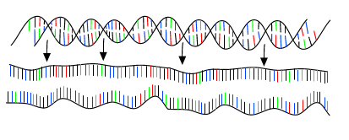
1.The mixture is heated to 95ºC which breaks the hydrogen bonds between the bases, therefore separates the strands and produces single - stranded DNA molecules = denatured

- Addition of the primers
Complementary base-pairing
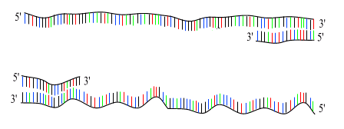
2. The mixture is heated to 95ºC which breaks the hydrogen bonds between the bases, therefore separates the strands and produces single - stranded DNA molecules = denatured

- Synthesis of DNA
3. The temperature is increased to 72ºC This enables the free DNA nucleotides to attach by complementary base-pairing (A to T, C to G). The new DNA strands are built up using the enzyme Taq polymerase which joins the phosphodiester bonds = extension.
The first cycle is complete.

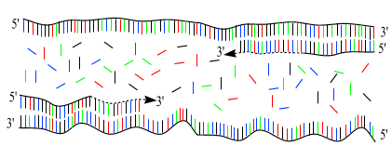

4. The cycle is repeated
5. The 2 resulting DNA molecules make up the template DNA for the next cycle, thus amplifying the amount of DNA duplicated for each new cycle.
.

Questions:
Maths practice
- How many cycles will it take to produce 512 DNA molecules? [1 DNA molecule = 2 DNA strands] (2⁹)
log₂(512) = 9 cycles
- How many cycles will it take produce one million molecules?
log₂(1000000) = 20 cycles
- How many DNA strands will there be after 7 cycles?
2⁷ = 128 DNA molecules 128 x2 = 256 strands
- How many DNA molecules will there be after 5 cycles?
2⁵ = 32 DNA molecules
Use Toole and Toole, p.540-541 to answer these questions:
- i) Why is Taq polymerase specifically used?
Comes from a bacterium in hot springs, therefore is tolerant to heat so does not denature at the high temps used in PCR

ii) Why is it important that the DNA used is not contaminated with any biological material?
Biological contaminants may contain DNA which would ALSO be copied

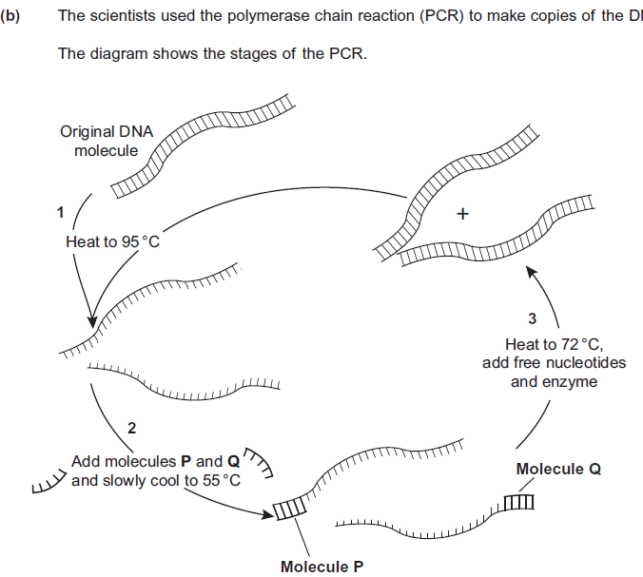
- P and Q are short lengths of single-stranded DNA. What are they called? [1] Primers
- Explain why the mixture is cooled from 95^{O} to 55^{O} in step 2. [1] Explain the functions of P and Q [2]
To allow H bonds reformation/to allow joining of primers to DNA; To mark region of DNA to be copied /to show enzyme where to start; needs starting strand onto which to attach nucleotides;

- How many copies of each original DNA molecule would be present after 5 cycles of PCR? [1] 32

- Now identify the differences between PCR and DNA replication

 | Replication method
 | In vivo | In vitro / PCR
Length of DNA replicated | long sequences | short sequences because they has been cut
Method of strand separation | DNA helicase | heating to 95ºC
Are Primers required? Why? | No | yes, too allow replication to start.

Exam Question:

Q1. Describe how PCR is carried out.
1 DNA heated to 90 to 95°C;
2 strands separate;
3 cooled / to temperature 55-60 °C
4 primers bind;
5 nucleotides attach;
6 by complementary base pairing;
7 temperature raised to 70 - 75°C;
8 Taq polymerase joins nucleotides together;
9 cycle repeated;
(6 marks)
Comparison of in vivo and in vitro cloning: Pros and Cons
Learning outcomes:
- Evaluate the pros and cons of using PCR to clone DNA fragments over in vivo methods.

Task: Add P or C, to show if it is a pro or a con.

In vivo | P/C? | In vitro | P/C?
It takes many days or weeks to produce enough DNA | C | Extremely rapid: a billion copies of a gene can be made in a few hours | P
Very useful when we wish to introduce a gene into another organism therefore can be used in gene therapy * | P | No valuable time is lost before forensic analysis and matching can take place | P
It uses vectors and plasmids which means the gene can be delivered into another organism | P | Any contaminating DNA found at a crime scene will be massively increased | C
Produces transformed bacteria which can be used to produce large quantities of gene products e.g. insulin | P | Does not require living cells; it can copy DNA which has been partly broken down * | P
Almost no risk of contamination due to the use of restriction endonucleases and creation of sticky ends * | P | Requires a very pure sample to prevent contaminant DNA being multiplied | C
It is very accurate; the copied DNA has very few errors as mutations are very rare * | P | Any errors in copying DNA will also be copied in subsequent cycles * | C
It can be used to copy genes which have not been studied before * | P | It cannot be used to copy genes which have not been studied before* | C
Cannot be copied unless isolated from other material | C | DNA embedded in other material can be copied | P
Reliably copies genes up to about 2 million base pairs long | P | Unreliable when copying fragments longer than 1000 bp | C

Task: EXPLAIN the statements shown with * and then check your answers.
- Gene therapy: The treatment of genetic diseases by giving patients healthy copies of defective genes.
- Could use to amplify small fragments of DNA from crimes scenes/ancient DNA etc.
- RE and SE means very specific joins between DNA from different sources.
- Mutation- change in the base/DNA sequence
- Each new DNA molecule will have error. Error amplified.
- You don’t need to know DNA sequence to copy gene.
- Need primers with known base sequence therefore you need to know the DNA sequence.
Learning outcomes:
- Describe the methodology involved in producing a genetic fingerprint
- Explain what variable number tandem repeats are, and how these allow the production of a virtually unique genetic fingerprint
- Explain the applications of genetic fingerprinting.
- Interpret genetic fingerprint patterns and draw conclusions

Genetic fingerprinting and VNTR’s

Genomes contains the same repetitive sequences (satellite DNA) of non-coding DNA. The number of bases in the repeat sequence varies (ATG or AGCTTCA) and the length of the repeat sequences (the number of times it repeats), and it is the length of the repeats that are unique to each person.

This can happen in non-coding DNA as mutations will arise and be retained as this has no functional impact
These repeating core sequences are called VNTRs (variable number tandem repeats) if the sequence is between 10-80 bases.

The VNTRs can be cut using restriction endonucleases. These will cut at recognition sequences either side of the VNTR, so it will cut the same section for all people, but the number of repeats and thus the distance between the recognition sites will vary and should be unique to each person, this will produce different sized fragments.
ATGATGATGATG
ATGATGATGATGATGATGATGATGATGATGATGATGATG
12 bases long
39 bases long

Producing genetic fingerprints:
- Extract the DNA: e.g. from crime scene/individual/ cells/tissue
- Amplify the DNA: PCR
- Digestion of DNA: Restriction endonucleases
- Separation: Gel electrophoresis
- Southern blotting: Transfer to nylon sheet
- Hybridisation: Add radioactive or fluorescently labelled probes
- Development: Place nylon layer under UV light or expose to X - ray
- Interpretation: Make comparisons between bands/ locate specific genes using a DNA ladder
Exam question:
Task: Compare the two mark schemes – Highlight the similarities and key terms used.
 Describe how the technique of genetic fingerprinting is carried (6 marks)

1. DNA is cut;  2. Using restriction enzyme;  3. Electrophoresis;  4. Separates according to length/mass/size;  5. DNA made single-stranded;  6. Transfer to membrane/ Southern blotting;  7. Apply probe;  8. Radioactive/ single stranded/ detected on film/ fluorescent;  9. Reference to tandem repeats/VNTRs/minisatellites;  10. Pattern unique to every individual; | - DNA extracted from sample;  - DNA cut/hydrolysed into segments using restriction endonucleases;  - must leave minisatellites/required core sequences intact;  - DNA fragments separated using electrophoresis;  - detail of process e.g. mixture put into wells on gel and electric current passed through  - immerse gel in alkaline solution / two strands of DNA separated;  - Southern blotting / cover with nylon/absorbent paper (to absorb DNA);  - DNA fixed to nylon/membrane using uv light  - radioactive marker/probe added (which is picked up by required fragments)/complementary to minisatellites;  - (areas with probe) identified using X-ray film/autoradiography;

Uses of genetic fingerprinting

- Forensic science
- Determine genetic relationships
- Medical diagnosis
- Determining genetic variability in a population
- Animal and plant breeding
Learning outcomes:
- Explain how DNA probes and hybridisation are used to locate specific alleles.
- Explain the benefits of screening for genetic diseases.
- Explain some of the issues raised by screening, and the role of genetic counsellors.
- Evaluate information relating to screening individuals for genetically determined conditions and drug responses.

DNA probes and hybridisation:
Definitions:
DNA hybridisation: Annealing/joining/binding of two strands of DNA/RNA from two different sources (e.g. different species or two different organism). Technique is used to identify complementary genes/alleles or how similar species are.
DNA probe: 
- short single stranded sequence of DNA with a specific base sequence
- which has been fluorescently labelled/produces light
- complementary to an allele/gene

Proliferation: means more cell division (mitosis).
Assay: means to test the activity of a biological molecule, e.g. testing the transcription rate/activity for a protein.

Task:
- Watch the video and complete the tasks below.
- https://www.youtube.com/watch?v=xoxUWGl8WFs – Khan academy microarray- 8 minute video.

- What does it mean if a gene is upregulated? What type of gene will gene A be if being upregulated means it causes cancer?
More proteins are produced. Protoncogens to oncogenes.
- What does it mean if a gene is downregulated? What type of gene will gene B be if being downregulated means it causes cancer?
Less proteins are produced. TSG
- What happens to gene C?
Nothing happened to gene C
- What is meant by the term MICROARRAY?
Testing the transcription activity of multiple genes in a small space e.g. a chip
Microarray from the top:
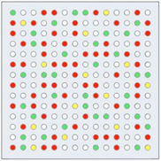
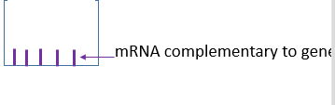
- Draw a well below as seen from the side. Make this quite large as you are going to add detail to it. To your well in PURPLE add what is already inside the well, label your diagram. Complementary mRNA to a specific gene you are testing for.

- Put the statements below in order.
- mRNA (or biological molecule we are testing for) inside cell is located
- mRNA from inside cells are fluorescently labelled different colours. Eg cancer = yellow, normal = blue.
- Cancer and normal cell are broken apart
- Add content of both cells to the same well.
- The well will light up.
- Computer is used to scan microarray to detect colours.
- For the example on the video- if the well was to light up yellow what would this mean about gene A?
If yellow means DNA is from cancer cell, gene has been upregulated/expressed more.
- How will a well for gene B be different?
Gene B is down regulated/not expressed in cancer cell so well would be blue not yellow
- How is a microarray useful in cancer treatment?
See if gene is up or down regulated/not expressed.
Genetic screening: How are DNA probes used to identify alleles or genes?
Types of DNA probes:

- Radioactive probes - made up of nucleotides containing ³²P.
- Fluorescently labelled probes - emit light.
Method:
- The DNA being analysed is amplified using PCR to make many copies.
- The DNA is cut into fragments using restriction enzyme.
- The DNA fragments are separated out by size using gel electrophoresis.
- An alkali is added to break the hydrogen bonds between complementary bases. This creates single strands.
- A nylon membrane is placed on top of the gel. The DNA transfers onto the nylon. This is Southern blotting. The DNA is fixed on using UV light.
- Radioactively/fluorescently labelled DNA probes with a complementary base sequence to the allele/gene of interest are added and bind to the allele if present. This is DNA hybridisation.
- Excess probes are washed away.
- If a radioactive probe is applied, radioactivity exposes x-ray film, producing an autoradiograph so the DNA can be visualised
- If a fluorescent probe is applied, exposure to UV light allows the DNA to be visualized

Example: Phenylketonuria (PKU) is a rare inherited disorder. People with PKU can't break down the amino acid phenylalanine, which then builds up in the blood and brain causing death. At 5 days old, babies are given blood spot screening to check if they have it.

Answer the questions below:
- What must be done to the DNA before the gene probe can be used? From the PCR process, describe how this would be achieved?
Make DNA single stranded. Use heat to denature strands (could also use enzymes/alkaline solution)
- The temperature is dropped. What happens and explain the importance of dropping the temperature.
Allow primers/probe to bind
- Which section of the target gene will the probe bind to?
Complementary DNA sequence
- Once the location of the gene has been identified by the probe, how can scientists detect it?
If probe is fluorescent use UV light, if radioactive use X-ray film and produce autoradiograph.
- Why might a scientist want to screen a patients DNA?
Identify alleles for disease, identify mutations in genes, identify suspects in crime e.t.c.
- How might probes be used in personalised medicine to develop bespoke treatments for patients?
Some drugs may be more effective in treating people with particular alleles.

How are DNA probes used to determine how a patient responds to a specific drug.

Herceptin is a drug which only works on specific receptors for 1 type of breast cancer.

Question: How could a DNA probe be used to test if Herceptin should be prescribed?
- Use radioactively/fluorescently labelled DNA probe with a complementary sequence to part of the allele which codes for specific receptor
- If probe binds to DNA and this is identified on a autoradiograph/under UV light the allele is present.
- This allele would be transcribed and translated into receptor and be present in CSM of breast cancer cells.
- Treat these individuals with Herceptin.

Genetic counselling

If a couple have been identified as being at risk of having a child with a genetic disorder a counsellor confidentially provides advice before or after screening about:
- Being a carrier for a disease
- Most appropriate type of screening test and the risks of screening
- Result of screening test the type of allele discovered
- Most effective treatment
- Quality of life with condition and life expectancy
- Possibly of termination
- Chance of it occurring in future pregnancies using pedigree diagram
- Use of donor/ IVF with screening

Advice need to be given in light of beliefs and culture

Example: A woman with a family history of breast cancer may have genetic counselling to help her decide whether or not to be screened for known mutations that can lead to breast cancer, e.g. a mutation in the BRCA1 TSG. If she is screened and the results is positive, genetic counsellors might explain to the woman what her lifetime chance of developing breast cancer is. Counselling could also help the woman to decide if, for example, she wants to take surgical steps to reduce the risk of breast cancer developing.

Exam questions:
Fully ANNOTATE the information.

Q1. (a) Cystic fibrosis can be caused by any one of several mutant alleles of the cystic fibrosis gene. The most common of these mutant alleles accounts for about 70% of cases of cystic fibrosis. The use of gene probes can identify individuals carrying this allele. Gene probes are single strands of DNA which are radioactively labelled. They have a base sequence that is complementary to a mutant allele. The main stages in using a gene probe are shown in the diagram.
Using the information given, explain how the use of a gene probe could enable the presence of a mutant allele of the cystic fibrosis gene to be detected. (4)
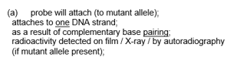
Sample of DNA extracted from a person’s tissue and heated to separate the strands

Radioactive gene probe added
to the DNA

Excess probe washed away

Sample tested for radioactivity
(b) Sheep have been genetically engineered to produce alpha-1-antitrypsin which is used to treat cystic fibrosis. Use your knowledge of this process to explain one argument for and one against using sheep in this way.
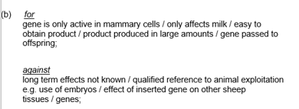(2)
Q2. Mycobacterium tuberculosis causes tuberculosis. The DNA of M. tuberculosis contains a direct repeat (DR) region. The DR region consists of 43 different, non-coding base sequences called spacers. Each spacer is found in a specific place in the DR region. In different strains of M. tuberculosis, some of these spacers have been lost.
(a) (i) The DR region consists of non-coding base sequences. What is meant by a non-coding base sequence?
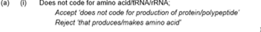(1)
(ii) Name the process by which the base sequence of a spacer is lost from a DR region.
(1)
Scientists investigated the DR regions of different strains of M. tuberculosis. They produced a DNA probe for each of the 43 spacer sequences. Each probe was:
• labelled with a fluorescent marker that gave off light if the probe attached to its complementary spacer
• attached to a particular square on a slide.
They obtained samples of the DR region from each strain. These were cut into small single-stranded DNA fragments. The fragments from each strain were added to a slide with the DNA probes attached. The diagram below shows their results for one strain of M. tuberculosis with 20 of the probes.
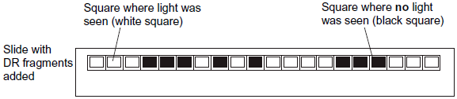
(b) The scientists cloned the DR region DNA in vitro before testing for the presence of spacers. Give the name of the method they used to clone the DNA in vitro.
 (1)
(c) Explain how the use of DNA probes produced the results in the diagram.
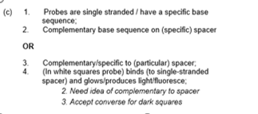 (3)
(d) Doctors can use the method with DNA probes to identify the specific strain of M. tuberculosis infecting a patient. This is very important when there is an outbreak of a number of cases of tuberculosis in a city. Suggest and explain why it is important to be able to identify the specific strain of M. tuberculosis infecting a patient.
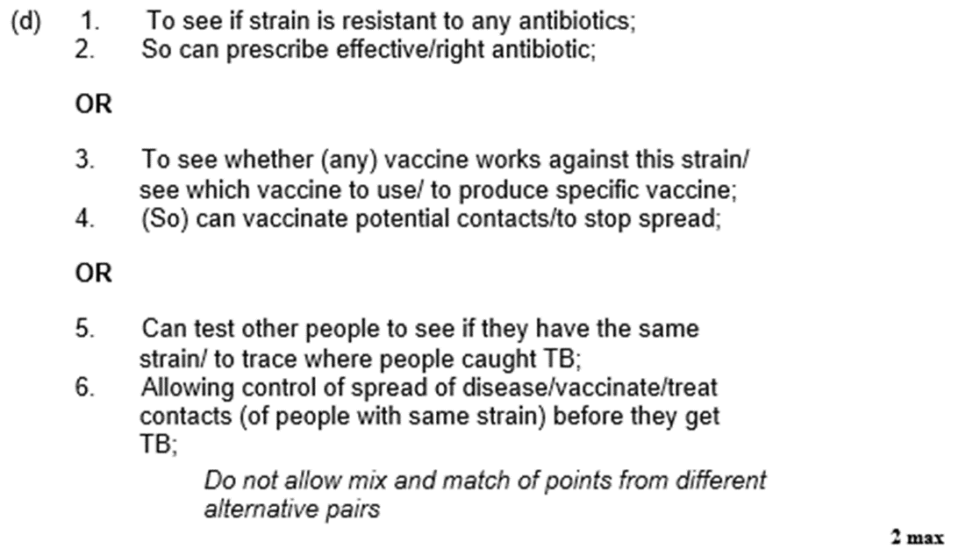2)
Q3. A husband and wife wanted to know whether they were carriers of the mutated form of a gene. This mutation is a deletion that causes a serious inherited genetic disorder in people who are homozygous. A geneticist took samples of DNA from the husband and the wife. He used a DNA probe to look for the deletion mutation. The DNA probe was specific to a particular base sequence in an exon in the gene. Exons are the coding sequences in a gene. The geneticist compared the couple’s DNA with that of a person known not to carry this mutation. The chart shows the geneticist’s results.
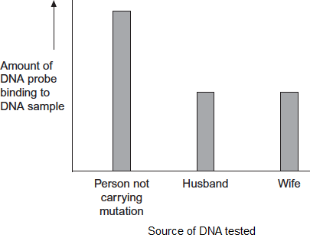

(a) The geneticist told the couple they were both carriers of the mutated gene.
Explain how he reached this conclusion.
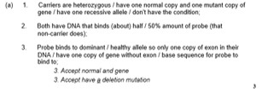 (3)
(b) The DNA probe the geneticist used was for an exon in the DNA, not an intron. Explain why.
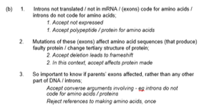(3)
(c) To make the DNA probe, the geneticist had to find the base sequence of the normal gene. Once he had copies of the gene, what methods would he use to find the base sequence of the gene?
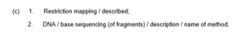(2)

Q4.Scientists wanted to measure how much mRNA was transcribed from allele A of a gene in a sample of cells. This gene exists in two forms, A and a.The scientists isolated mRNA from the cells. They added an enzyme to mRNA to produce cDNA.
(a) Name the type of enzyme used to produce the cDNA.
(1)
The scientists used the polymerase chain reaction (PCR) to produce copies of the cDNA. They added a DNA probe for allele A to the cDNA copies. This DNA probe had a dye attached to it. This dye glows with a green light only when the DNA probe is attached to its target cDNA.
(b) Explain why this DNA probe will only detect allele A.
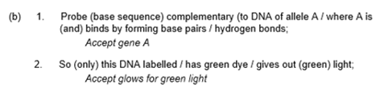(2)
(c) The scientists used this method with cells from two people, H and G.
One person was homozygous, AA, and the other was heterozygous, Aa.
The scientists used the PCR and the DNA probe specific for allele A on the cDNA from both people.The figure shows the scientists’ results.
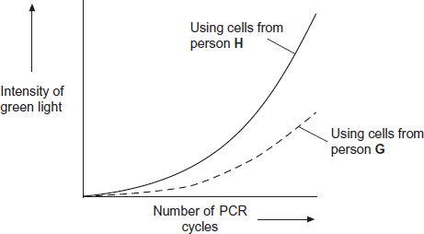
(i) Explain the curve for person H.
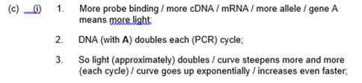 (3)
(ii) Which person, H or G, was heterozygous, Aa? Explain your answer.
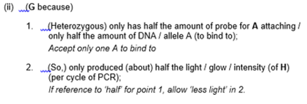 (2)

Applications of Recombinant DNA (gene) technology in agriculture, industry and medicine
Learning outcomes
- Interpret information relating to the use of recombinant DNA technology.
- Evaluate the ethical, financial and social issues associated with the use and ownership of recombinant DNA technology in agriculture, in industry and in medicine.
- Balance the humanitarian aspects of recombinant DNA technology with the opposition from environmentalists and anti-globalisation activists
(Note: these learning outcomes are not required AO1 specification knowledge but used to develop ideas)

Task:
- Read the laminated pages.
- CONDENSE this information into the boxes below. You DO NOT need to learn specific examples but you will be given specific examples which you with have to ethically discuss.
AGRICULTURE:
Benefit to humans with example | Concerns with example
INDUSTRY:
Benefit to humans with example | Concerns with example
MEDICINE:
Benefit to humans with example | Concerns with example

Exam questions:
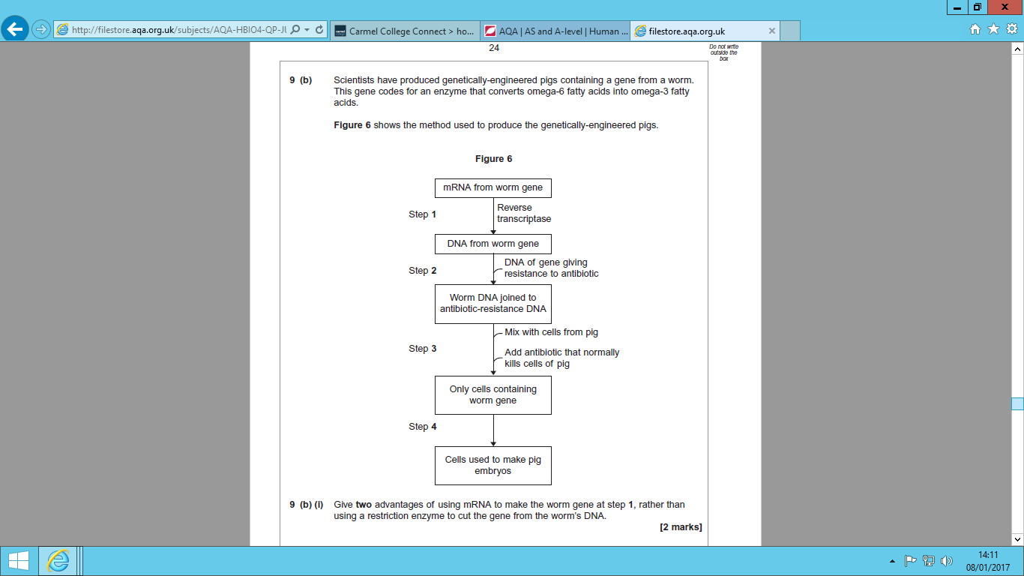

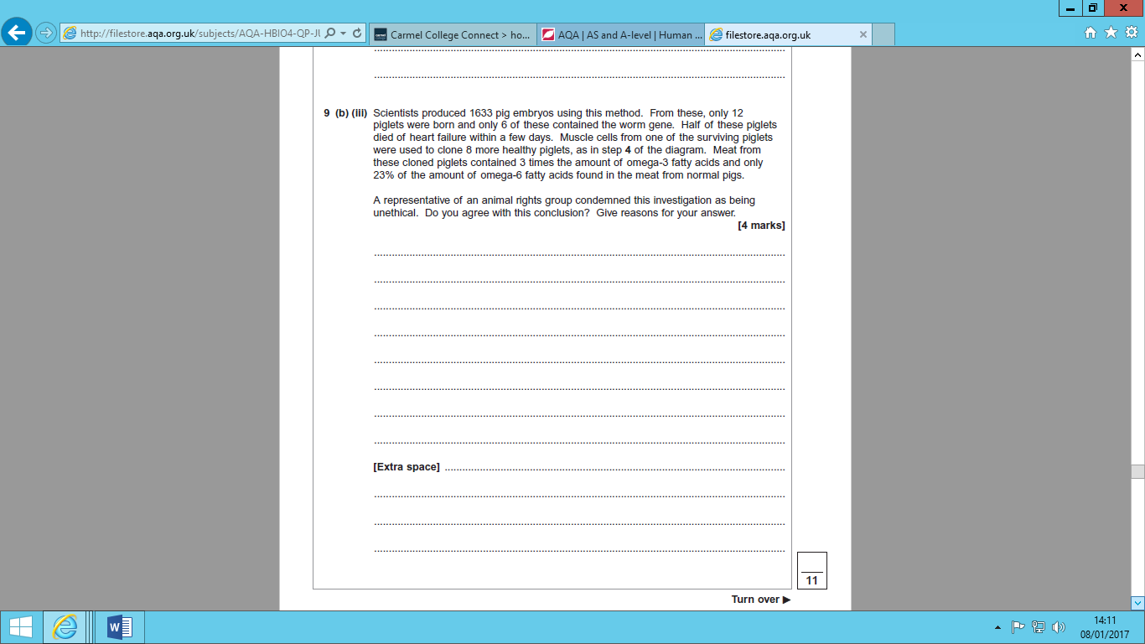

Yes because:
- Many embryos die/are discarded;
- Some offspring with heart failure;
- Introduction of new genes has unforeseen consequences for (future generations of) pigs;
No because:
4. Potential benefit for human (diet);
5. Successful production of at least some healthy cloned piglets.

Q2. Crop plants such as maize and oil-seed rape can be genetically modified to make them resistant to the herbicide glyphosate.
a) explain why it is useful to produce herbicide-resistant plants [2]
Can control herbicides as weeds among growing crops;
without harming crop
Weeds compete with crops/example
Weeds reduce yield of crop/herbicide increases yield

b) there is concern that the use of herbicides and herbicide-resistant crop plants, may lead to weeds becoming more resistant to herbicides.
i) Herbicide resistance may spread from herbicide-resistant crops to weeds – suggest how. [1]
Reproductrion/pollen/bacteria

ii) Sometimes weeds become resistant to herbicides when there are no herbicide-resistant crop plants present – suggest how. [1]
Mutation

Q.3 (a) Agrobacterium is a bacterium used in genetic engineering of plants. The diagram shows stages in the transfer of a gene into a plant.
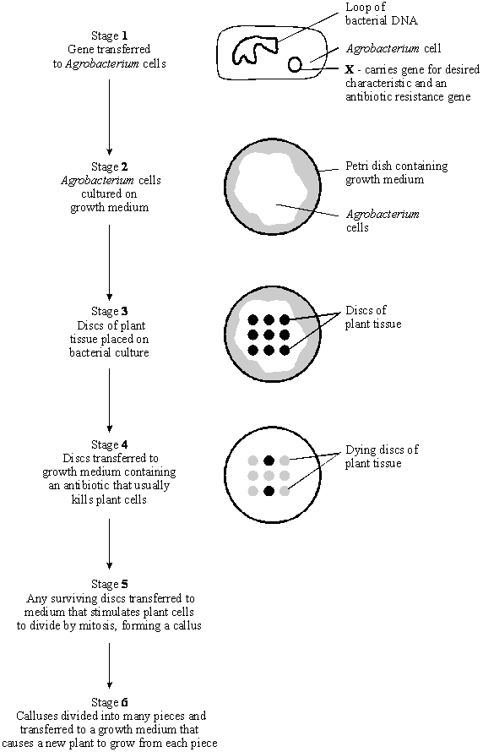

(i) Name structure X in stage 1.
Plasmid (1)
(ii) In stage 2, explain why the bacteria are cultured before the plant tissue is added.
The bacteria divide/grow. producing many copies of the desired gene/plasmid
OR
The bacteria divide/grow to cover the agar; (1)
(iii) In stage 4, explain why the growth medium contains antibiotic.
Plant tissue that has antibiotic resistance survives;
Identifies plant tissue which has desired gene/plasmid; (2)
(iv) Suggest why stages 5 and 6 are necessary for the commercial production of genetically engineered plants.
To clone plants/produce genetically identical plants with gene/characteristics and produce large numbers/quickly; (2)
(b) (i) A toxin that kills insects can be sprayed directly onto the leaves of crop plants. A gene has now been transferred into crop plants that makes their leaves produce this toxin. Explain one advantage to farmers of growing the genetically engineered crop plants, rather than spraying leaves with the toxin.
e.g. toxin present all the time;
save cost of buying/application of spray;
no spay drift onto other field/insects;
(ii) Suggest one reason why some people are concerned that the toxin gene might get transferred to wild plants that are related to the crop plants.
e.g. killing of harmless/useful insect that feed on the wild plants;
damage to food chains starting with wild plants; (1)
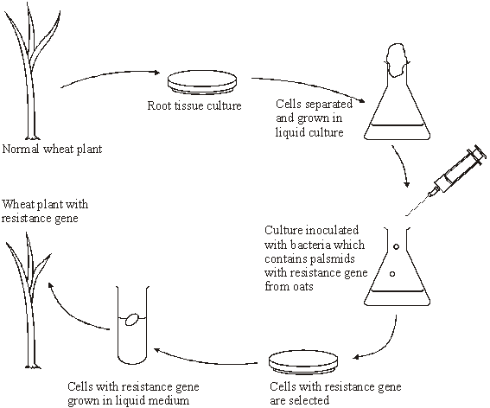
Q4.‘Take-all’ is a disease of wheat caused by a fungus. It can cause serious damage to the crop. There is no gene for resistance to this fungus in wheat. There is, however, a gene for resistance to this fungus present in oats. The diagram shows how this gene might be transferred to wheat.

(a) (i) The wheat plant with the resistance gene contains recombinant DNA. What is recombinant DNA?
Contains genes/nucleotides/sections of DNA/artificial DNA from two species/2 types of organisms; (1)
(ii) The plasmids act as vectors for the resistance gene. What is a vector?
Carries gene /DNA (into the other organism/gene carrier) (1)
(iii) Suggest how cells with the resistance gene might be selected.
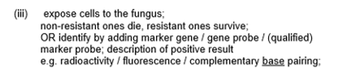 (2)
(b) A laboratory has oat plants containing the resistance gene and a supply of plasmids. Describe how bacteria may be produced which have the resistance gene in their plasmids.
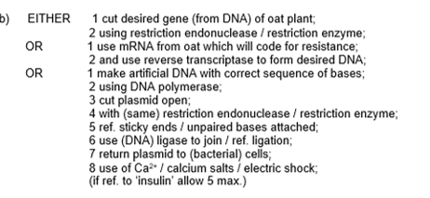 (6)
Gene therapy
Learning outcomes
- Relate recombinant DNA technology to gene therapy
- Explain the principles of gene therapy.
- Explain the use of liposomes and viruses in delivering genes into cells.
- Explain the difference between somatic and germ line therapy, and why germ line therapy is prohibited.
- Evaluate the effectiveness and risks of gene therapy

Definition:
Gene therapy: The treatment of genetic diseases by giving patients healthy copies of defective genes.

There are two main types of gene therapy: Somatic and germ line

Task:
- Log onto: http://learn.genetics.utah.edu/content/genetherapy/
- Read “What is Gene Therapy”, and make brief notes on first 2 paragraphs.
- Do interactive: “Gene delivery: tools of the trade” and read text to make a table on advantages and disadvantages of viral and liposomal vectors.
- Read “challenges in gene therapy” and make notes on the risks of gene therapy.
- Read “Gene therapy Success” and make notes on some of the applications of gene therapy in treating certain diseases.
- Do interactive: “Space doctor” - and enjoy yourself
Notes:
________________________________________________________________________________________
________________________________________________________________________________________
________________________________________________________________________________________
________________________________________________________________________________________
________________________________________________________________________________________
________________________________________________________________________________________
________________________________________________________________________________________
________________________________________________________________________________________
________________________________________________________________________________________
________________________________________________________________________________________
________________________________________________________________________________________
________________________________________________________________________________________

Gene therapy comparison table:

Somatic Cell gene therapy | Germline gene therapy
Functional gene inserted into body cell | Functional gene inserted into egg, sperm, zygote
Vectors required e.g. retrovirus, adenovirus, liposomes | Currently illegal so not tested.
If successful only affected cells are recombinant | If successful ALL cells are recombinant.
Functional gene not passed onto children | Functional gene will be passed onto offspring
Methods:  - Body cells are removed.  - Functional alleles of gene are inserted into cell using a vector.  - Cell are then reinserted back into the patient’s body.  - If large number of body cells cannot be removed safely, genes are inserted directly into the affected tissues. | Methods:  - A corrected/ functional, gene is inserted into an egg cell that has been fertilised in vitro (IVF).  - Embryo then develops and is then is re-implanted into mother’s uterus.
Examples:  Leukaemia – patient bone marrow cells are extracted, transfected, then replaced.  Cystic fibrosis | Examples:  Illegal so no examples.

Issues in Gene Therapy:

Somatic cell gene therapy | Germline cell gene therapy
Genetically modified viruses have been tried to get the allele into the genome, but the host becomes immune, so cells will not be accepted after the initial go. | It is unethical to engineer human embryos.
Functioning allele of the gene is introduced into target cells. | All cells derived from the germ line cells will contain a copy of the functioning allele. The offspring may also contain the allele.
Genetic manipulations are restricted to the actual patient. | Genetic manipulations may be passed on to the patient’s children.
Liposome are used to get the allele into the genome, but they may be inefficient. | The functioning allele of the gene is introduced into germline cells – delivery techniques are more straightforward.
Any treatment is short-lived. | Not possible to know if allele has been successfully introduced without unintentional changes to it, which may damage the embryo.
Treatment must be repeated regularly. | Single treatment would be required.
Treatment using vector could cause an immune response/rejection.
Harmful side effects from using vector such as viruses
It is difficult to get the allele into the genome in a functioning state.
Techniques to get the gene to the target are needed
Or, specific cells must be removed, treated and then replaced.

Exam questions:
Q1.(a) Adrenaline binds to receptors in the plasma membranes of liver cells. Explain how this causes the blood glucose concentration to increase.
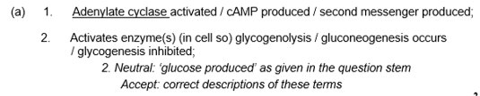(2)
(b) Scientists made an artificial gene which codes for insulin. They put the gene into a virus which was then injected into rats with type I diabetes. The virus was harmless to the rats but carried the gene into the cells of the rats.The treated rats produced insulin for up to 8 months and showed no side-effects. The scientists measured the blood glucose concentrations of the rats at regular intervals. While the rats were producing the insulin, their blood glucose concentrations were normal.
(i) The rats were not fed for at least 6 hours before their blood glucose concentration was measured. Explain why.
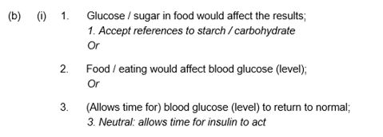_(1)
(ii) The rats used in the investigation had type I diabetes. This form of gene therapy may be less effective in treating rats that have type II diabetes. Explain why.
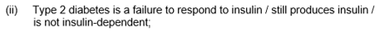 (1)

(iii) Research workers have suggested that treating diabetes in humans by this method of gene therapy would be better than injecting insulin. Evaluate this suggestion.
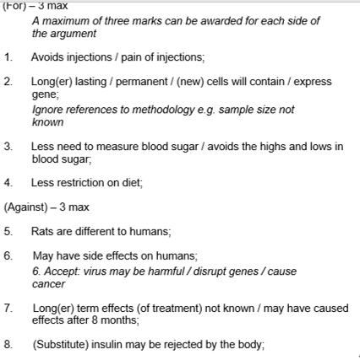 (4)
Q2. Gene therapy is used to treat the genetic disorder, ADA deficiency. Affected individuals are unable to produce the enzyme adenosine deaminase (ADA). Without this enzyme, T lymphocytes, a type of white blood cell, cannot provide immunity to infection. The diagram shows the processes involved in the treatment of ADA deficiency by gene therapy.
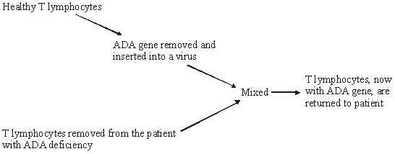
(a) What is meant by gene therapy?
Introduction n of healthy gene/replacement of defective gene ( 1)
(b) The ADA gene is inserted into a virus. Give two advantages of using a virus in gene therapy.
1. can enter cells/infect cells/inject DNA into the cells:
2. target specific cells;
3. Replicates in cells; (2)
(c) Individuals who have been treated by this method of gene therapy do not pass on the ADA gene to their children. Explain why.
Reproductive cells /gametes cells do not contain ADA allele/gene; (1)
(d) T lymphocytes are produced in bone marrow. A bone marrow transplant from a genetically matched donor can provide a permanent cure for ADA deficiency.
(i) Suggest why bone marrow for a transplant is obtained from a genetically matched donor.
To prevent rejection/immune response; (1)
(ii) Explain why treatment of ADA deficiency by gene therapy must be repeated at regular intervals, whereas a single bone marrow transplant can provide a permanent cure.
T lymphocytes have a limited life span/die off/do not reproduce;
Bone marrow provides continual supply of T lymphocytes/ ADA gene enzymes: (2)
Q3.(a) Plasmids can be modified by genetic engineering and inserted into bacteria. These bacteria can then make useful substances normally made by another organism. Explain how modified plasmids are made by genetic engineering and how the use of markers enable bacteria containing these plasmids to be detected.
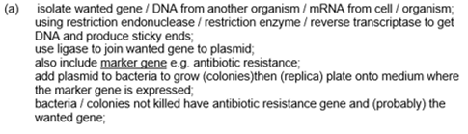 (6)
(b) In gene therapy, genes are introduced into a person who has defective genes which do not produce an important substance. Three experiments were done to compare techniques for introducing an important substance into a person with defective genes.
1. The substance was injected directly.
2. Harmless viruses carrying genes coding for the substance were injected.
3. The genes were put into a protein capsule which was inserted into the tissues.
The graph shows results of the experiments.
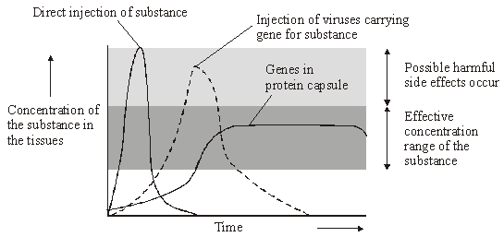
(i) Describe the results of the three experiments.
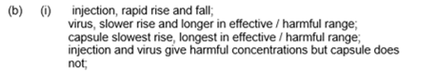(3)
(ii) Using the information in the graph, suggest one advantage and one disadvantage of the capsule method compared to the others.
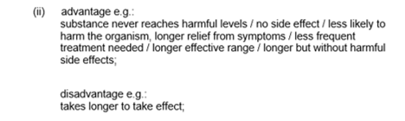(2)

