Recombinant DNA technology

Name: TEACHER
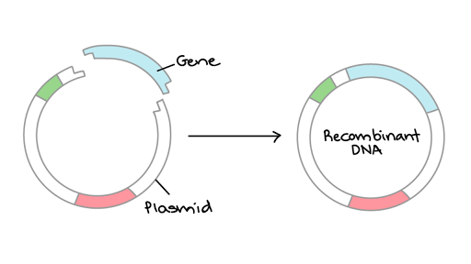
Reflection on learning outcomes | or | Target
Explain what is meant by recombinant DNA technology.

Explain the methods which could be used to isolate a gene and produce a DNA fragments including:

- conversion of mRNA to cDNA, using reverse transcriptase

- using restriction enzymes to cut a fragment containing the desired gene from DNA

- creating the gene in a ‘gene machine’.

Explain what is meant by a restriction endonuclease and how they work to leave sticky ends.

Explain the importance of the use of restriction enzymes and sticky ends

Describe the stages involved in in vivo gene cloning.
Explain the importance of the addition of promoter and terminator regions

Explain the methods used for transformation.
Explain the use of marker genes and replica plating.
Interpret information provided in exam questions, to interpret which colonies have been successfully transformed with recombinant DNA.

Outcome:
- Explain what is meant by recombinant DNA technology.

Definition:
Recombinant DNA: DNA from two different sources joined together (The 2 sources do not need to be from the same species).
In vivo: Experiments performed within the living organism.
In vitro: Experiments performed test tubes/petri dishes outside of the living organism.

The process of making a protein using DNA technology of gene transfer and cloning involves a number of stages:
OVERVIEW of Recombinant DNA Technology
Donor DNA | Restriction site | Gene probe | Same | Sticky ends
Vector | Plasmid | Sugar-phosphate | Bacterial | Recombinant
Recombinant | Transgenic | Protein synthesis | Product

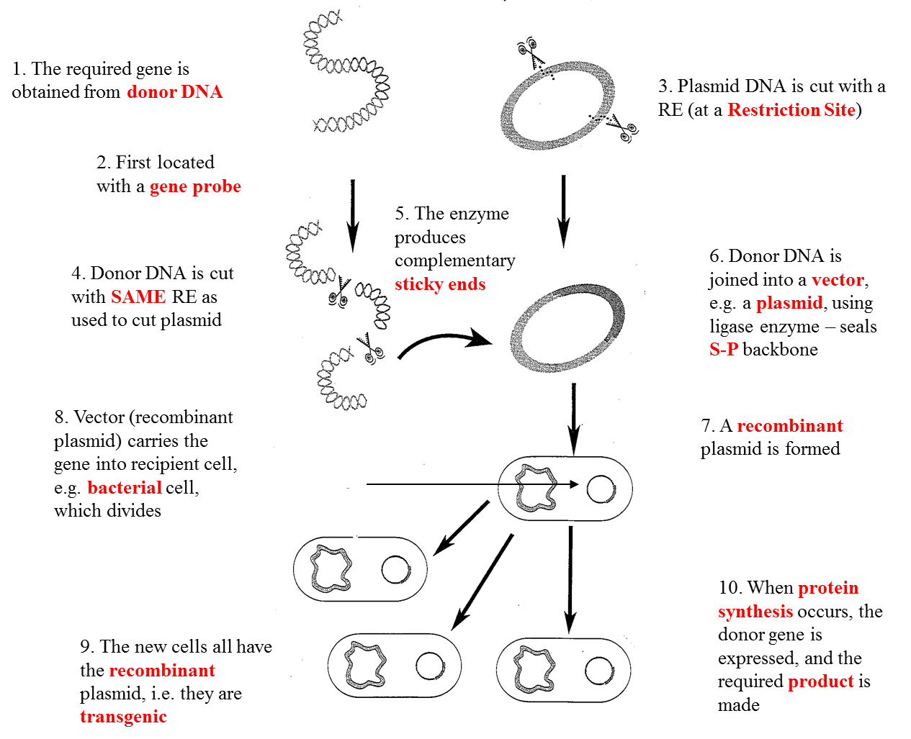

Use the two links below to help you consolidate your understanding of the process if needed.
Video 1: http://highered.mcgraw-hill.com/sites/0072437316/student_view0/chapter16/animations.html#
Video 2: http://m.youtube.com/watch?v=8Dd7M9PGhgQ
We most commonly use bacteria for this form of cloning but in modern labs there is a steady increase in the use of viruses and liposomes.

Now you need to look at the different stages in more detail.
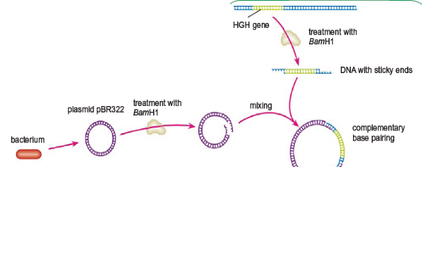
- Isolation
- Insertion
- Transformation
- Identification
- Growth/Cloning

Outcome:
- Explain the methods which could be used to isolate a gene and produce a DNA fragments including; conversion of mRNA to cDNA, using reverse transcriptase, using restriction enzymes to cut a fragment containing the desired gene from DNA, creating the gene in a ‘gene machine’.
- Explain what is meant by a restriction endonuclease and how they work to leave sticky ends.
- Explain the importance of the use of restriction enzymes and sticky ends.

Step 1: Isolation.
The gene may be a few hundred bases amongst many millions in the human genome. There a number of methods used to isolate the gene:
- Method 1: conversion of mRNA to cDNA, using reverse transcriptase
- Method 2: using restriction enzymes to cut a fragment containing the desired gene from DNA
- Method 3: creating the gene in a ‘gene machine’.
Method 1: conversion of mRNA to cDNA, using reverse transcriptase
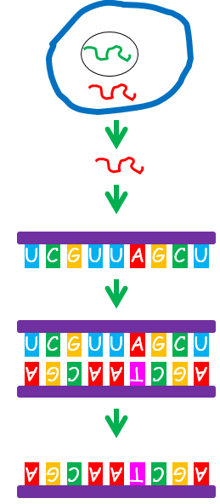
Example – Isolating human insulin gene
1.1. Beta Cells from islets of langerhans in the human pancreas –where the insulin gene is transcribed into mRNA (no introns)

2. mRNA coding for insulin is extracted from the cell

3. mRNA coding for insulin (no introns)

4. mRNA acts as a template on which a cDNA strand is formed using reverse transcriptase

5.Single stranded DNA

6.New nucleotides form hydrogen bonds with complementary base pairs.
Adenine- Thymine, Cytosine- Guanine,

7.DNA Polymerase joins the new adjacent nucleotides/forms phosphodiester bonds and double stranded cDNA is formed

8. Copy of Human Insulin gene can now be inserted into host cell/cloned.

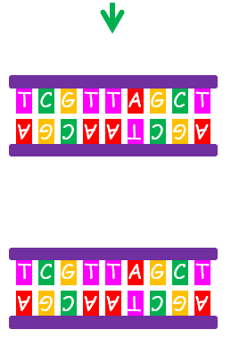

Why do scientists have to use mRNA to produce insulin, why can’t the scientists use the DNA instead?
- Insulin has a specific 2 separate mRNA chains which combine together
- The pre-mRNA has to be spliced to get usable instructions to make insulin
- Bacteria cannot splice mRNA

Match the complementary base pairs:

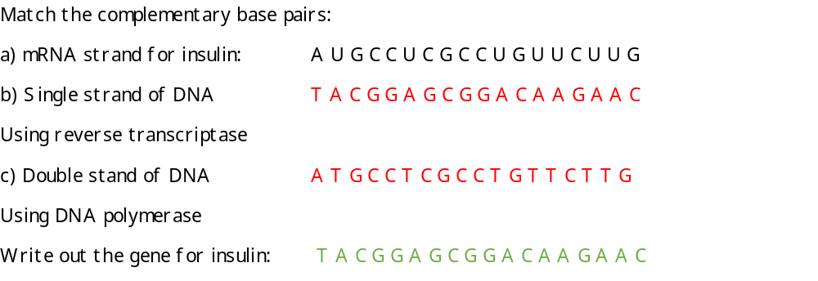
T/F quiz. If you think the statement is false, can you correct it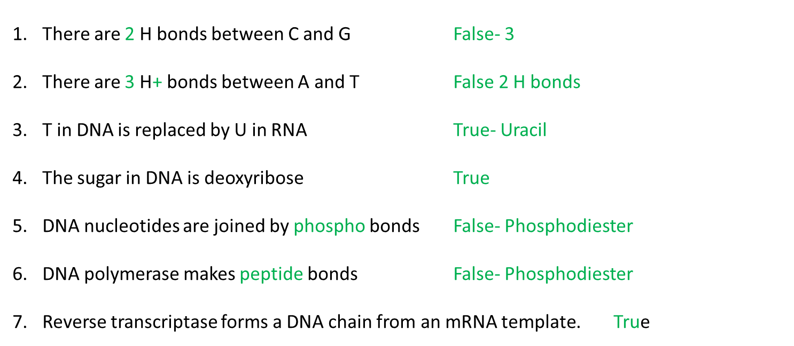 Advantages of using reverse transcriptase
- mRNA is easy to obtain as it can be found outside of the nucleus.
- Using mRNA isolated from cytoplasm means introns have been removed.

Method 2: using restriction enzymes to cut a fragment containing the desired gene from DNA
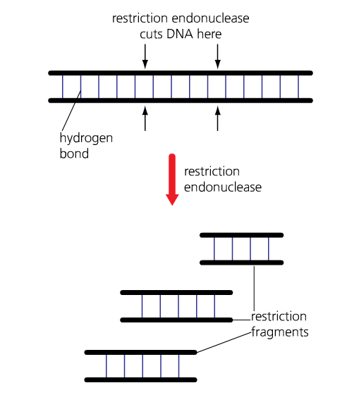
Restriction enzymes are also known as restriction endonucleases.
Restriction endonucleases are enzymes which cut (hydrolyse) DNA at specific base sequences (recognition sequences).
Different restriction endonucleases cut DNA at different specific sequence of bases (recognition sites) because the shape of the recognition site is complementary to the enzymes active site.
These recognition sites occur in the DNA of all species of organisms- but not in the same places!
These recognition sequences are palindromic - base pair read the same in opposite directions.
If recognition sequences for these enzymes are present at either side of the DNA fragment you want, you can use restriction endonucleases to separate it from the rest of the DNA. The DNA sample is incubated with the specific restriction endonuclease, which cut DNA fragment out of DNA.

NOTE: It is important that the recognition sequence for the selected restriction endonuclease does not occur within the gene you want to isolate.
Restriction enzymes are made by bacteria to cut out viral DNA sequences from the bacterial DNA.

The cut made at the recognition site is either straight (giving a blunt end) or staggered (producing a 'sticky end').
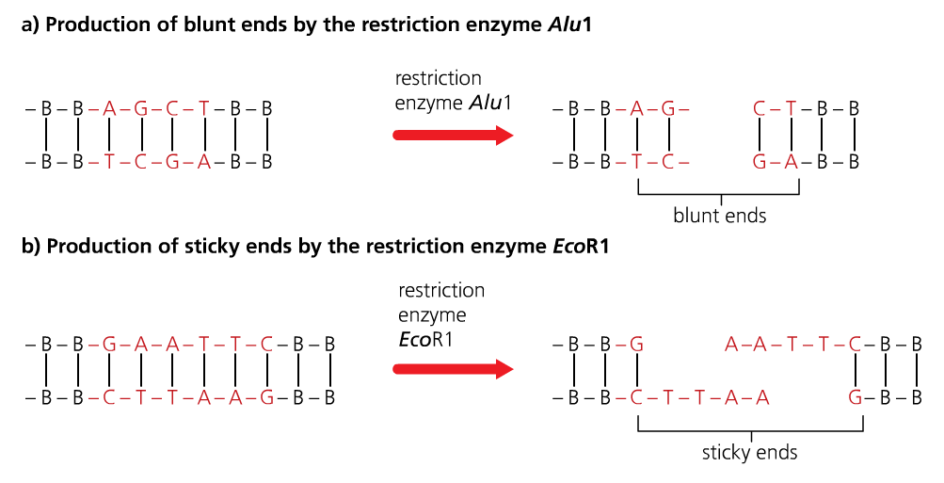
Definition:
Sticky end: Short, single stranded section at the end of a DNA molecule, the result of staggered cutting with a restriction endonuclease.
Sticky ends can be used to bind (anneal) DNA fragments together, if other DNA molecule has complementary 'sticky' end.
Sticky ends are important as they allow the DNA fragment to be inserted into another organism / species DNA, if the other organism’s DNA is cut using the same restriction enzyme.

Below are 5 identical bacterial DNA sequences and 5 different restriction endonucleases. On each DNA strand:
- Highlight the recognition sequence
- The enzyme reads the top chain of the recognition site first from left to right. On the top line draw a vertical line between the 2 bases the enzymes cuts
- The enzyme reads the bottom chain of the recognition site second from right to left. On the bottom line draw a vertical line between 2 bases the enzyme cuts
- Connect the 2 vertical lines with a horizontal line.
The first two have been done for you. Complete the rest of the activity.
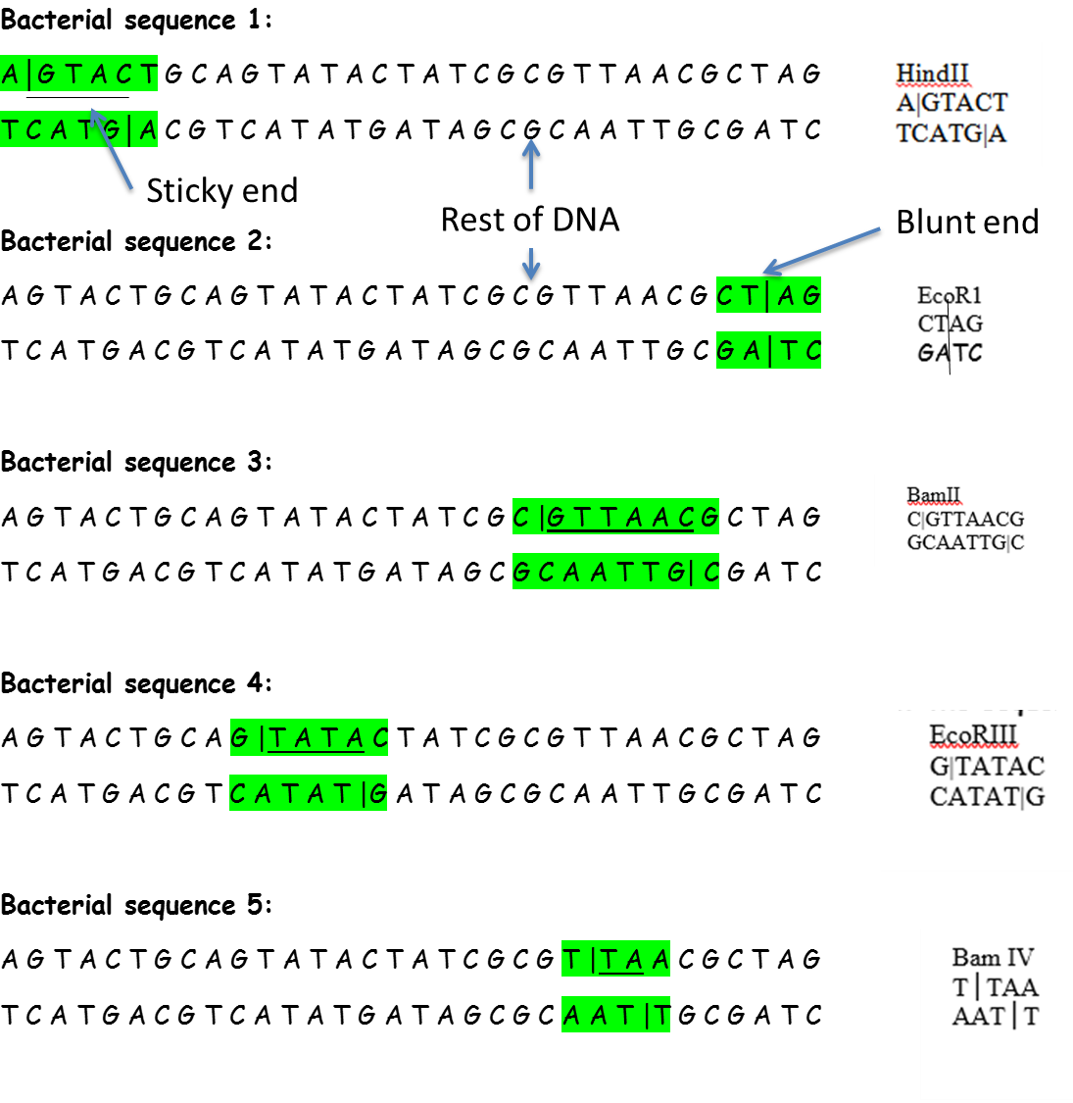
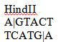
Complete the definitions table using page 5
Term | Definition
Restriction endonuclease/enzyme | Enzymes  Cut DNA at specific recognition site
Recognition site | 4-8 bases long nucleotide sequence  Where restriction enzyme attaches and cut
Palindrome | Base sequence reads the same forwards and backwards
Blunt sticky end | Recognition site cuts in a straight down
Staggered sticky end | Recognition site cuts leaving staggered exposed bases  Allows/ attached to complementary exposed bases.

Method 3: creating the gene in a ‘gene machine’.
- Protein sequence analysed
- Amino-acid sequence worked out (determined)
- mRNA sequence worked out
- DNA nucleotide base sequence worked out
- DNA nucleotide base sequence is uploaded into the computer
- Computer produces DNA base sequence by producing overlapping single strands of nucleotides called Oligonucleotides which can then be assembled into the gene.
Advantages of using the gene machine:
- Faster to use the gene machine rather than using reverse transcriptase or restriction endonucleases
- There are more steps involved in isolating the gene/mRNA as well as the enzyme catalysed reactions.
- Highly accurate.
Complete the table below:
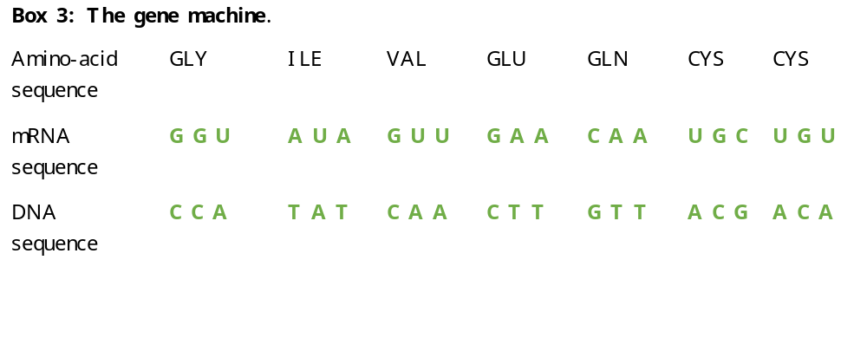
Maths question. The DNA sequence for insulin is normally 237 base pairs long, the mRNA chain is only 153 base pairs long. What is the % decrease in base pair length? Show your working.
Difference/original x 100
237 – 153 = 84 / 237 x 100 = -35% or 35% decrease
How long is the amino-acid sequence that the mRNA codes for. Show your working?
153 nucleotides long
3 nucleotides code for 1 amino-acid
153/3 = 51 amino –acids in length
Extension: Can you give a suggestion for the difference in base pair length?
DNA has introns which are removed/spliced out of the mRNA chain

REMEMBER: Gene cloning involves fragments of DNA being amplified by in vitro and in vivo techniques.
- In vitro – Polymerase chain reaction (PCR) - DNA techniques booklet
In vivo – Culture of transformed host cells - This booklet!
Outcome:
- Describe the stages involved in in vivo gene cloning,
- Explain the addition of promoter and terminator regions
Step 2: Insertion of the desired gene into a suitable vector.
Before a gene can be copied it has to be inserted into a suitable vector so the transgenic organism will be able to read and use the inserted genetic information to produce the protein we want.
Step 2(a): Preparing the DNA fragment for insertion.
Promotor region: | Binding site for RNA Polymerase on DNA
RNA Polymerase: | Enzyme that joins RNA nucleotides to form mRNA during transcription
Transcription factors: | Bind to RNA polymerase and promotor to begin transcription
Terminator region: | Region of DNA that releases RNA polymerase to stop transcription

Preparing the DNA fragment. Identify the promotor region by colouring it RED, add a label to this region and give its definition. Identify the enzyme RNA polymerase by colouring it BLUE, add a label and give its definition. Identify the terminator region by colouring it in YELLOW, add a label and give its definition. Identify the sticky ends by colouring them in ORANGE, add a label and give their definition.
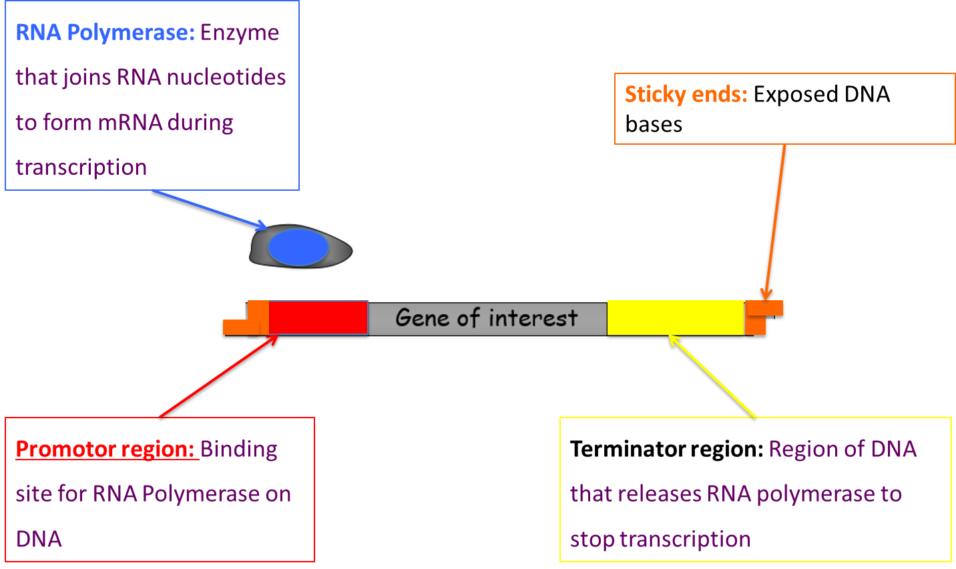

Answer the questions below, use and apply your knowledge.
- Explain why each of steps are important in preparing the gene of interest for insertion into a vector. (Can you remember what explain means in your exam?)
  - A specific promotor region is added in front of the gene of interest
So RNA Polymerase can bind , so transcription of the gene can start , producing the mRNA chain

  - A terminator region is added at the end of the gene of interest
So RNA Polymerase can unbind , so transcription of the gene can finish, the mRNA chain has been produced

  - Sticky ends are added at the beginning of the promotor region and at the end of the terminator region.
Sticky ends will be complementary to sticky end of the vector/plasmid , so the gene can be inserted into the vector.

  - Extension: The promotor region is complementary to RNA polymerase but not DNA polymerase.
Enzymes have specific active sites, which bind to a specific sequences on bases on promotor (maybe be aided by the transcription factors).
Step 2(b): Inserting the gene of interest into a vector.
Definition:
Vector: A DNA carrier (i.e. bacterial plasmid or virus) used to transfer DNA into cells.
- The most common type of vector is a PLASMID which can be inserted into a bacterial cell.
- To prepare the vector for the gene of interest the vector has to be opened by using the SAME restriction enzyme
- So the sticky ends are complementary
- DNA Ligase is then used to recombine the 2 pieces of DNA
- This is known as RECOMBINANT DNA
- https://www.youtube.com/watch?v=8rXizmLjegI
Draw A diagram below to repreent the information above to help remember this information.

Outcome:
- Explain the methods used for transformation
Step 3: Transformation.
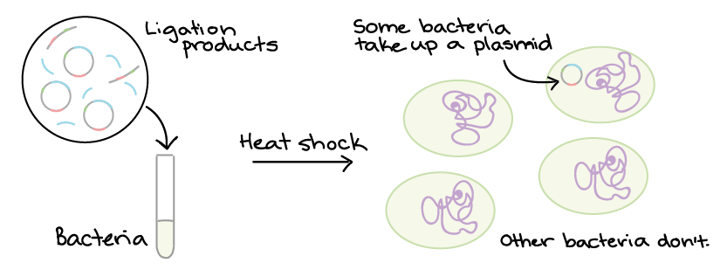
Now we have our vector which carries the gene of interest we need to get the recombinant DNA into our microorganisms so the microorganisms can get on with producing the gene that we require.

Step 1: Chemical transformation
Ca 2+ has a positive charge
DNA has a negative charge
+ charge attracted to – charge so DNa will not be repelled by membrane
Step 2: Heat shock
Drop temperature (Less kinetic energy)
QUICKLY increase temp (Burst of kinetic energy, lots of vibrations)
Create gaps in membrane for DNA to move into bacterial cell.

Draw a diagram to represent the 2 steps above.

Outcomes:
- Explain the use of marker genes and replica plating,
- Interpret information provided in exam questions, to interpret which colonies have been successfully transformed with recombinant DNA
Step 4: Identification of the transformed bacteria.
Only 1% of the bacteria that we try to transform actually take up the vector. The other 99% of the bacteria are useless to us. There is no point wasting time and money allowing all 100% of the bacteria to reproduce if we only want 1%. So, how do we identify the correct bacteria and what’s happened to the other 99%?
Firstly, we need to consider what might happen to the bacteria as shown below:
- Some of the plasmids will have resealed without becoming recombinant- we don’t want this.
- Some of the gene of interest will have resealed without becoming recombinant – we don’t want this.
- There will be some recombinant DNA – this is what we want.
- Some of the bacteria will not have transformed at all- we don’t want this.

In the boxes labelled below draw what this might look like. (Plasmid = blue, gene of interest = red, bacteria = green.)
 |  | 
Bacteria with resealed plasmid | Bacteria with resealed gene of interest | Bacteria with recombinant DNA | Bacteria that has not transformed.

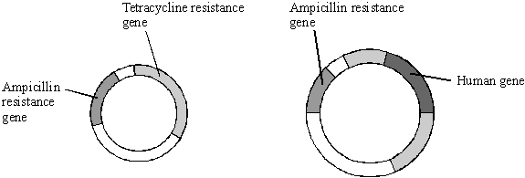
To help us identify the recombinant DNA in the transformed bacteria we use specialised plasmids as the one shown below- known as an R-plasmid.

Definition:
Antibiotic resistanceThe ability for microorganisms to withstand the adverse affects of antibiotics.
Genetic markers: Is a gene or DNA sequence with a known location on a chromosome that can be used for identification. Can be modified to be fluorescent or radioactive

Our R plasmid has two antibiotic resistant gene: 1) Resistant to ampicillin known as the AMP gene. 2) Resistance to tetracycline known as the TET gene.
Activity:
- If we use the BamIV restriction enzyme draw below what the recombinant plasmid would look like (AMP gene= red, TET gene= blue, gene of interest= green) using the gene of interest (e.g. Insulin gene) TAC GGA GCG GAC AAG AAC

- To your drawing add if the AMP gene would work (provide the bacteria with resistance) and if the TET gene would work (provide the bacteria with resistance). Justify your answer.
No recognition sequence in AMP gene , AMP gene intact /not disrupted, AMP gene works/bacteria are resistant to ampicillin antibiotic
Recognition sequence in TET gene, TET gene is not intact/TET gene contains gene of interest, TET gene doesn’t work/not resistant
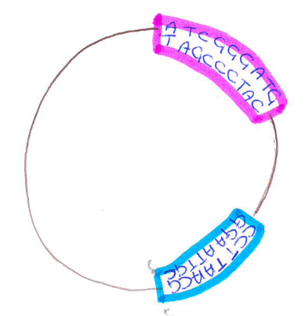
R – plasmid Recombinant plasmid
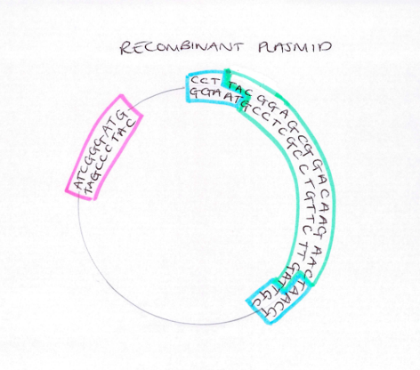
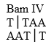

Complete the table below:
Drawing |  |  | 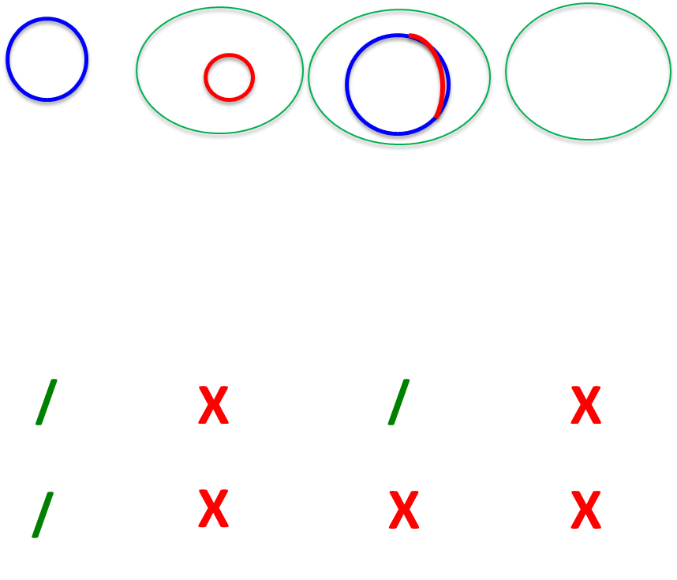
Bacteria | Bacteria with resealed plasmid | Bacteria with resealed gene of interest | Bacteria with recombinant DNA | Bacteria that has not transformed.
Resistance to AMP (/ or x)
Resistance to TET (/ or x)
Activity: Read the method below and complete the diagram to show how we use the R plasmid to identify the bacteria that have transformed and carry the recombinant DNA.
Replica plating: Method used to Identification of the transformed bacteria.
Master plate
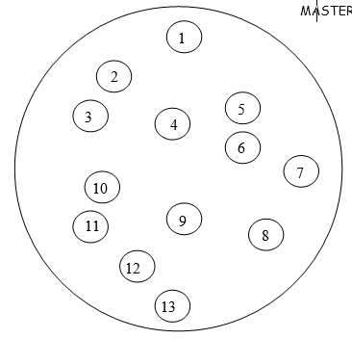
- On the MASTER plate ALL the bacterial colonies are grown.

- The colonies on the MASTER plate are transferred onto a plate containing antibiotics. This is called replica plating.
NOTE: The colonies must be transferred in exactly the same position

1st replica plate
3. The first REPLICA PLATE medium contain the antibiotic AMPLICILLIN.
4. The REPLICA PLATE is incubated.
5. On the diagram identify which bacterial colonies have died and describe these bacteria.
- Bacteria in colonies 3,4,6 and 13 died on AMP plate

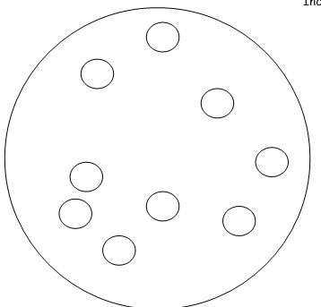

6. The surviving colonies are transferred onto a second replica plate.
NOTE: The colonies must be transferred in exactly the same position
7. The second REPLICA PLATE medium contains the antibiotic TETRACYCLINE.
8. The REPLICA PLATE is incubated.
9. On the diagram identify which bacterial colonies have died and describe these bacteria.
10. Now we go back to the master plate and can identify which is the recombinant bacteria. These were the colonies that survived the ampicillin plate but NOT the tetracycline plate.
Bacteria in colonies 2,8,11 and 12 died on TET plate, Bacteria not resistant to antibiotic TET/ Bacteria doesn’t have functional TET resistance gene , Return to MASTER plate and use the identified colonies.
We have now identified the RECOMBINANT bacteria- colonies 2,8,11 and 12
2nd replica plate

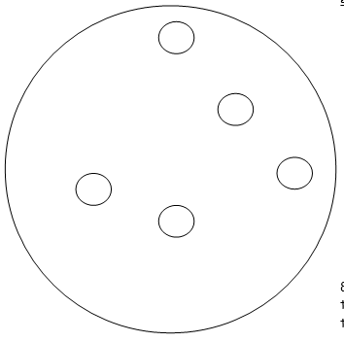

Exam questions: Enzymes
Q1. Scientists are working to produce a genetically modified bacterium to treat patients suffering from a disease of the digestive system. They plan to collect mRNA from human cells. This will be used to produce the DNA of the gene for the protein interleukin. They will then transfer this human gene into the bacterium Lactococcus. The scientists intend patients to swallow the genetically modified bacteria. These bacteria will release interleukin inside the digestive system to treat the disease.
(a) (i) Name the type of enzyme which will be used to produce the DNA from the mRNA.
Reverse transcriptase ._________________________________________________________________________________________(1)
(ii) It is easier to obtain the interleukin gene from mRNA rather than directly from the DNA removed from human cells. Explain why
mRNA is present in large amounts in cell making the protein/mRNA has been edited/does not contain introns/mRNA codes for single protein
(b) The scientists propose to put the gene directly into the DNA of Lactococcus.
Describe the role of the enzyme ligase in this process.
Splices/joins two piece of DNA/”Sticky ends”

Forming recombinant DNA
Q2. Plasmids can be used as vectors to insert lengths of foreign DNA into bacteria. The diagram shows how this is achieved.
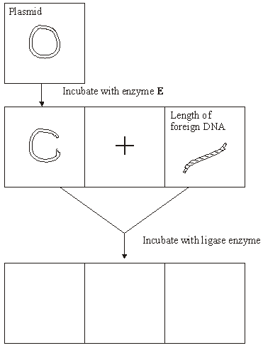

(a) Name enzyme E.
Restriction/endonuclease/named example
(b) Cut plasmids and lengths of foreign DNA can join. What features of their ends allows them to join?
Unpaired bases/sticky ends/staggered
Complementary/explained
(c) Draw three different structures that could be formed by incubating cut plasmids and lengths of foreign DNA with ligase. Use the spaces provided on the diagram. (3)
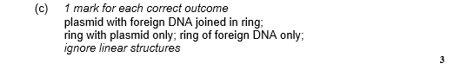
Questions on Vectors and identification
Q3. (a) (i) Some human DNA was cut into separate pieces using a restriction enzyme which produced a staggered cut. A scientist wanted to insert these pieces of DNA into plasmids and used the same restriction enzyme to cut the plasmids. Explain why the pieces of human DNA would be able to join to the cut DNA of the plasmids.
Sticky ends/description
Reference to complementary base pairing
(ii) Which other enzyme must the scientist have added to the mixture to form recombinant plasmids?
Ligase
(b) A plasmid may be used as a vector. Explain what is meant by a vector in this context.
Carrier of DNA/gene
Into cell/other organism/host
(c) Molecular biologists often use plasmids which contain antibiotic resistance genes. Explain the reason for this.
Act as marker gene
Allows detection of cells containing plasmis/DNA

Q4.Haemophilia is a genetic condition in which blood fails to clot. Factor IX is a protein used to treat haemophilia. Sheep can be genetically engineered to produce Factor IX in the milk produced by their mammary glands. The diagram shows the stages involved in this process.

 | Stage 1 | 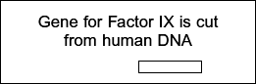
 | Stage 2 | 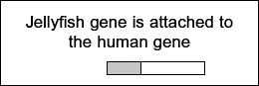
 | Stage 3 | 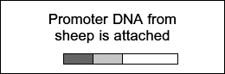
 | Stage 4 | 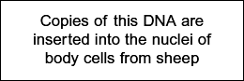
 | Stage 5 | 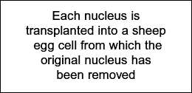
 | Stage 6 | 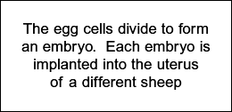

(a) Name the type of enzyme that is used to cut the gene for Factor IX from human DNA (Stage 1) .
Restriction enzyme/endonuclease
(b) (i) The jellyfish gene attached to the human Factor IX gene (Stage 2) codes for a protein that glows green under fluorescent light. Explain the purpose of attaching this gene.
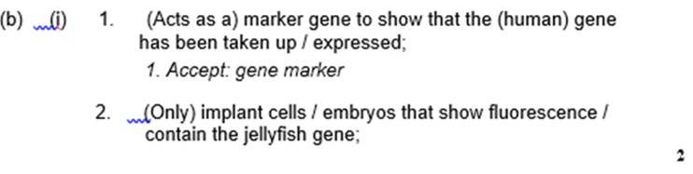
(ii) The promoter DNA from sheep (Stage 3) causes transcription of genes coding for proteins found in sheep milk.
Suggest the advantage of using this promoter DNA.
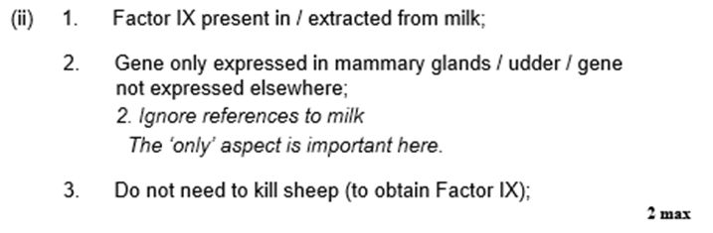

Q5.Silkworms secrete silk fibres, which are harvested and used to manufacture silk fabric. Scientists have produced genetically modified (GM) silkworms that contain a gene from a spider. The GM silkworms secrete fibres made of spider web protein (spider silk), which is stronger than normal silk fibre protein.
The method the scientists used is shown in the figure below.
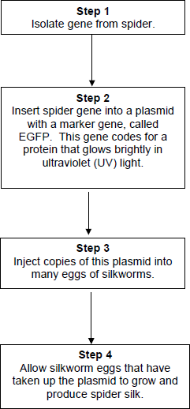
(a) Suggest why the plasmids were injected into the eggs of silkworms, rather than into the silkworms.
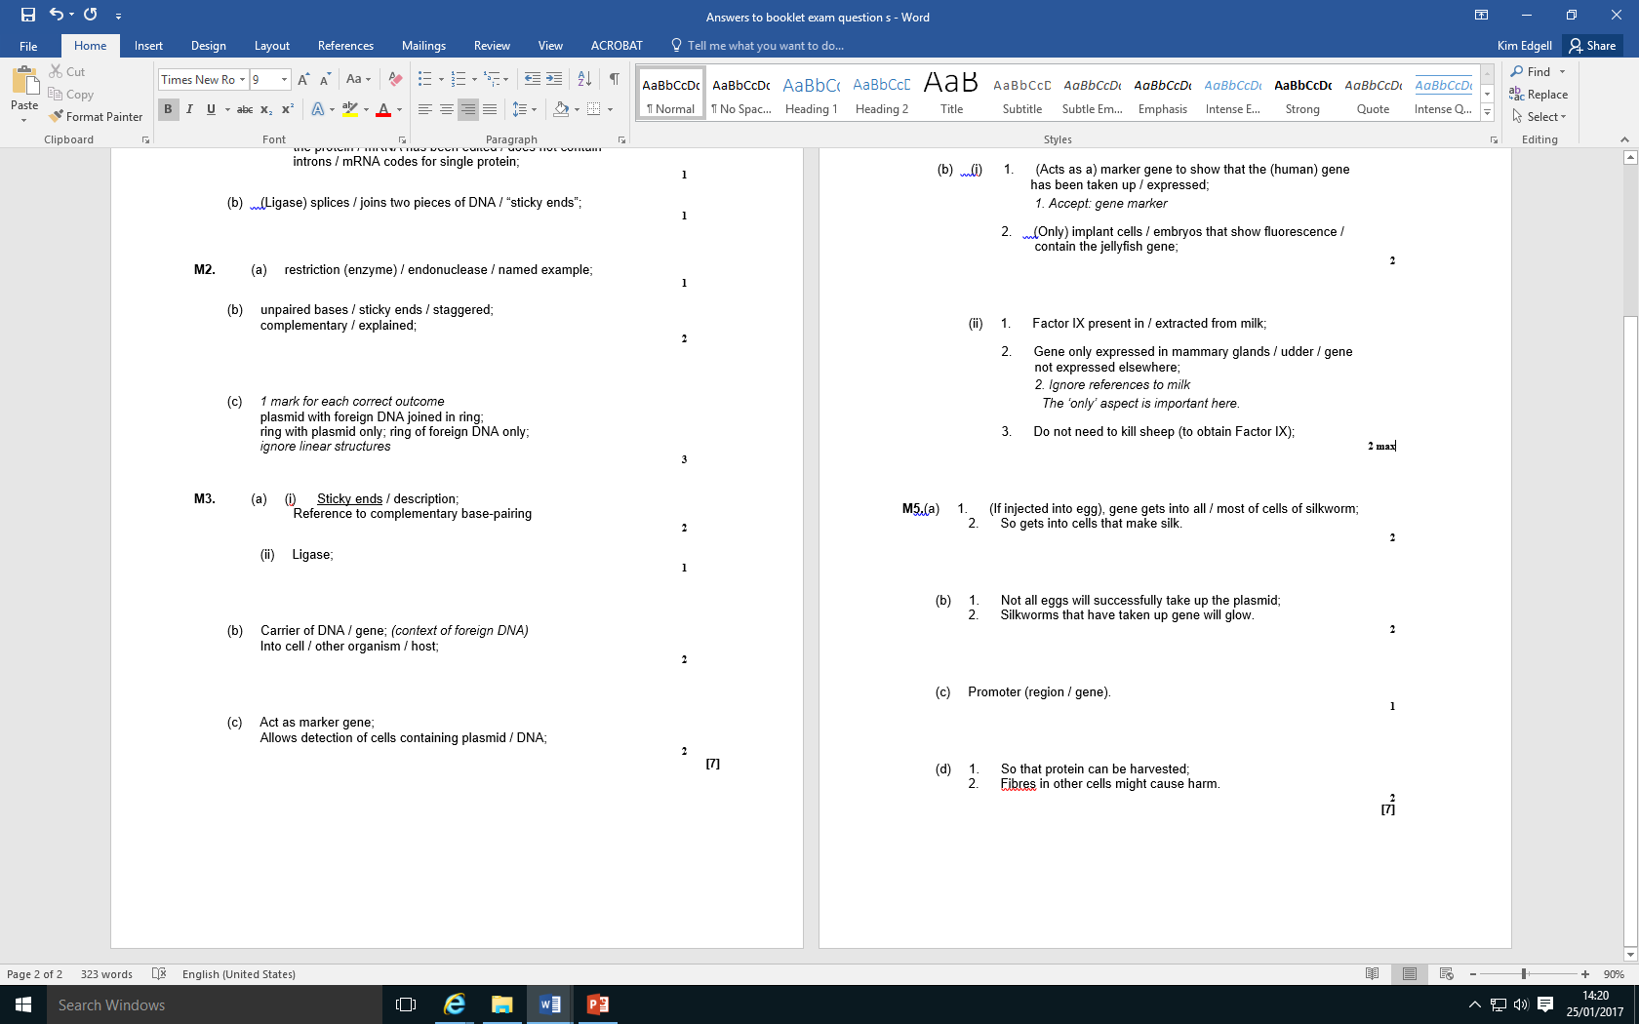
(b) Suggest why the scientists used a marker gene and why they used the EGFP gene.
The scientists ensured the spider gene was expressed only in cells within the silk glands.
(c) What would the scientists have inserted into the plasmid along with the spider gene to ensure that the spider gene was only expressed in the silk glands of the silkworms?
(d) Suggest two reasons why it was important that the spider gene was expressed only in the silk glands of the silkworms.

