3.6.4: Control of blood water potential
Name: __teacher booklet__________
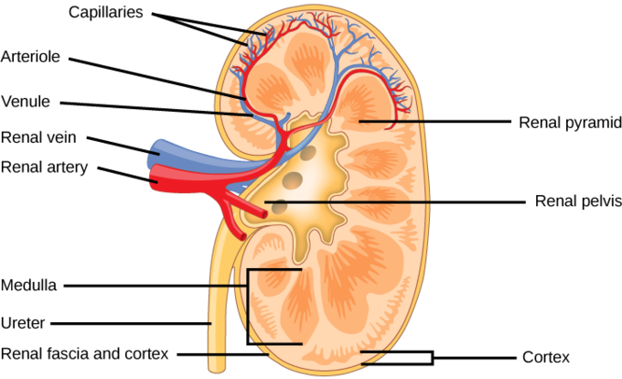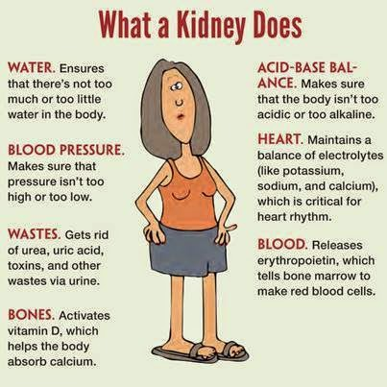

Reflection on Learning objectives | or | Targets
Describe the structure of a nephron
Explain the process of ultrafiltration and where it occurs
Explain the process of selective reabsorption, where it occurs along a nephron and the transport processes involved
Explain the adaptations of cells of the proximal convoluted tubule
Explain the importance of maintaining a sodium ion gradient in the medulla, and how this is achieved
Explain the reabsorption of water from the distal convoluted tubule and collecting ducts.
Explain the role of the hypothalamus and posterior pituitary gland in osmoregulation
Explain the responses which are brought about by the release of ADH and link this to negative feedback

Year 1 work recap questions:
Answer the questions below using your knowledge from Year 1.
- Define osmosis:
Water molecules, high WP to low WP down WP gradient, passive.
- What is added to water to lower the water potential?
_Solute
- What is the highest water potential possible?
__0_
- Put the following water potential values in order showing the direction of osmosis
-20 to -60 to -185 to -298 to -1896
Maths recap questions:
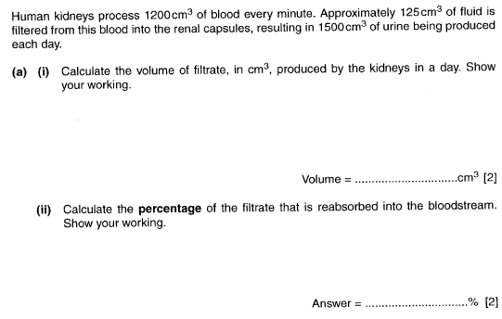
.

125 X 60 X 24= 180,000

180,000 – 1500
180,000 X100 = 99-99.2%

Outcome:
- Describe the structure of a nephron
Kidney Structure
Can you use the labelled images on pages 394-395 of the T & T textbook to label the 2 images below.
Note: The images are not exactly the same so you need to work out the labels, just like the images you will get in your exam
Bladder | Capillaries | Vena cava | Renal artery x 2 | Urethra | Right kidney
Medulla | Renal vein x2 | Aorta | Nephron | Collecting duct | Ureter x 2
 | Capsule | Cortex | Pyramid | Pelvis
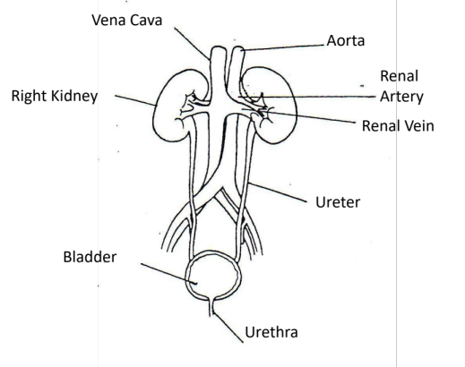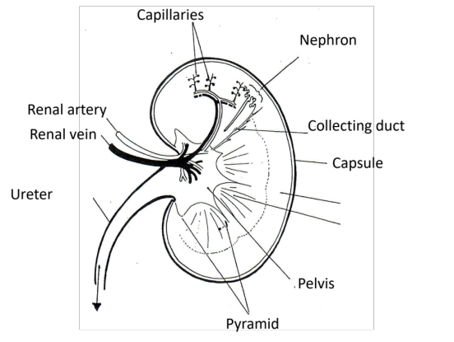
Image 1: Position of the kidney in humans Image 2: Longitudinal section through kidney
You DO NOT need to learn this. You DO NOT need to learn this.

Cortex | Medulla | Renal artery
Renal Vein | Pelvis | Capsule

Description | Structure
Outer region of the kidney. Contains Bowmans capsule, convoluted tubules and blood vessels | Cortec
Funnel shaped to collect urine into ureter | Pelvis
Supplies kidney with oxygenated blood | Renal Artery
Outer membrane to protect the kidney | Capsule
Leaves kidney containing deoxygenated blood | Renal vein
Darker inner region of the kidney (tastes salty). Contains loop of Henle, collecting duct and blood vessels. | Medulla

Nephron Structure.
The kidney is made of one million tiny tubular structure which we call the NEPHRON, these are the basic and functional units of the kidney.
https://www.youtube.com/watch?v=l128tW1H5a8 Nice video showing an overview of the whole process we will be looking at in the kidney.

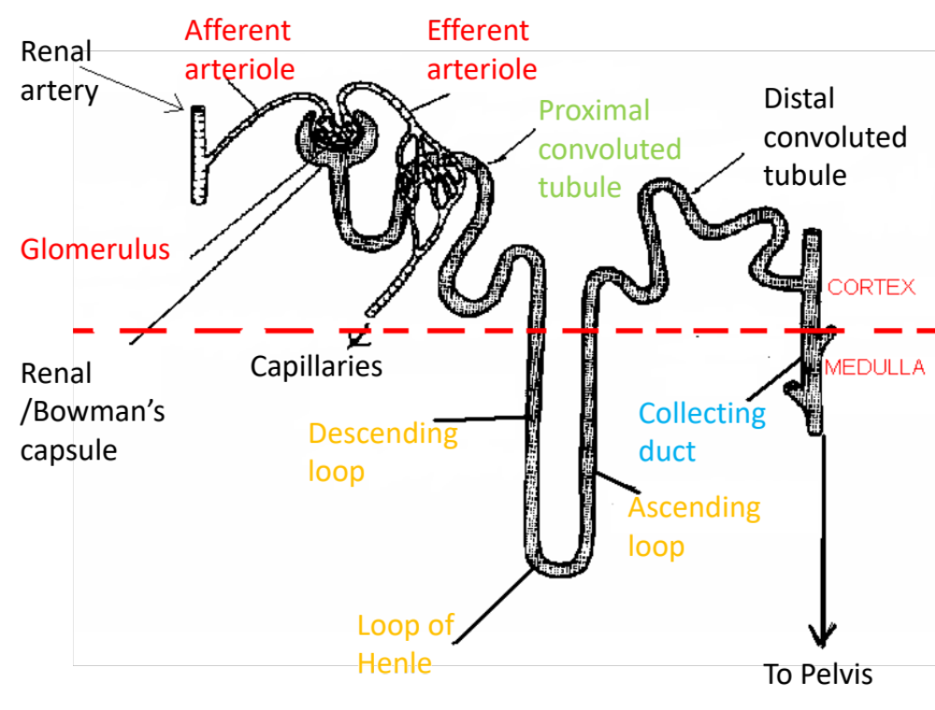
Renal artery | Capillaries | Renal/Bowman’s capsule | Afferent arteriole | Efferent arteriole
Proximal convoluted tubule | Collecting duct | To pelvis | Distil convoluted tubule | Ascending limb
Descending limb | Loop of Henle | Glomerulus
On the diagram colour in the following structure/parts of the nephron:
Ultrafiltration required the Afferent and efferent arterioles, the glomerulus and the Bowmans/Renal capsule. Colour these structures in RED
Selective reabsorption required the proximal convoluted tubule. Colour this structure in GREEN.
Reabsorption of water occurs in the Loop of Henle. Colour this structure in BLUE
Osmoregulation occurs in the collecting duct. Colour this structure in ORANGE.

Outcome:
- Explain the process of ultrafiltration and where it occurs.
https://www.youtube.com/watch?v=HK93luvVbYU
Ultrafiltration.
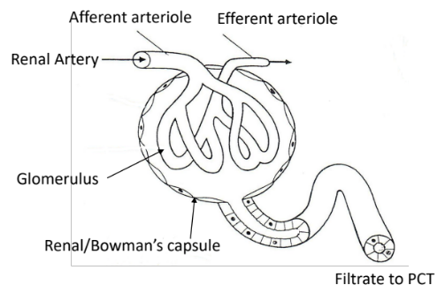
Higher hydrostatic pressure in glomerulus than in Bowman’s capsule
Forces small molecules and fluid out of glomerulus
Through gaps in the capillary walls into Bowman’s capsule
Basement membrane acts as a filter preventing
Large plasma proteins and RBC’s from leaving glomerulus
Podocytes are finger like projections to support the glomerulus.

Identify and correct the mistakes below. Words can be wrong or missing.
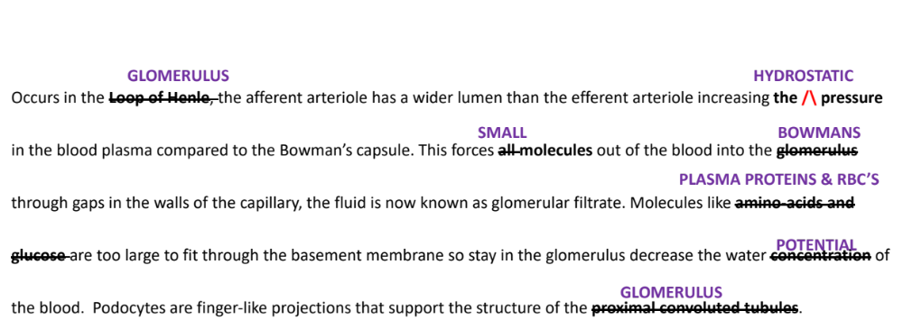
Maths activity: The hydrostatic pressure of the blood is 8kPa, the filtrate has a hydrostatic pressure of 2.7kPA. From the information work out the difference in hydrostatic pressure in the capillary and the glomerular filtrate.
Show your working with units __Blood = 8kPa, Filtrate = 2.7kPa 8-2.7= 5.3kPa
Mary suffers with hypertension and has a 20% increase in hydrostatic pressure in the capillaries. A person suffering from hypertension with a hydrostatic pressure up to 9.5kPa will not have permanent damage to their glomerulus but if the kPa goes above 9.5kPa then the person is at risk of permanent damage. Is Mary at risk of permanent damage?
Show your working _Normal hydrostatic pressure = 8kPa
20% of 8 = 1.6kPa
8 +1.6= 9.6kPa
Higher than 9.5kPA so yes at risk of permeant damage,

Outcome:
- Explain the process of selective reabsorption, where it occurs along a nephron and the transport process involved.
- Explain the adaptations of cells of the proximal convoluted tubule
Selective reabsorption
Exam Question- Year 1

(a) Cells lining the ileum of mammals absorb the monosaccharide glucose by co-transport with sodium ions. Explain how.

1. Sodium ions actively transported from ileum cell to blood;

2. Maintains / forms diffusion gradient for sodium to enter cells from gut (and with it, glucose);

3. Glucose enters by facilitated diffusion with sodium ions;
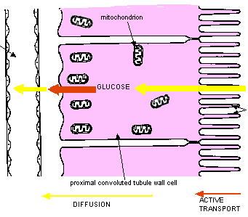


Cell adaptions
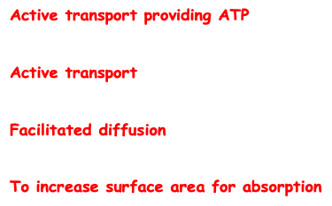
How are the cells of the proximal convoluted tubule specialised?
- MANY Mitochondria for __________________________________________________________________
- MANY carrier/co-transport proteins for _____________________________________________________
- MANY channel proteins for _______________________________________________________________
- MANY microvilli (known as the “brush border”) for ____________________________________________

The diagram above shows the proximal convoluted tubule, add the number to the correct place on the diagram.
Na+ actively transported from inside the PCT cells to the blood. Lowering the Na+ concentration …..
Inside the PCT cell. Na+ diffuse down a ….
Concentration gradient from the lumen of the PCT to inside the….
PCT cells through a co-transporter. The co-transporter also carries ALL the glucose or ALL…
The amino-acids. The glucose and the amino-acids will then diffuse from the PCT cells into the…
Blood. This is selective reabsorption.

Note: About 180dm³ of water enters the nephron each day, 1dm³ leaves the body as urine. 85% of the reabsorption of water occurs in the PCT through selective reabsorption.
Maths activity:
- Work out the volume of water that is actually reabsorbed in the PCT from the information above, show your answer as cm³.
153dm³ of water x 1000 = 153,000cm3
- The remaining water is reabsorbed in the collecting duct, work out the volume of water that is reabsorbed in the collecting duct in dm³.
180-1-153 = 26dm³
- Work out the % of water that is reabsorbed in the collecting duct.
26/180 x 100 = 14%

Exam questions:

Q1. Three processes are involved in the formation of urine in a mammalian kidney. These are ultrafiltration, selective reabsorption and concentration. The diagram shows where these processes take place in a nephron.

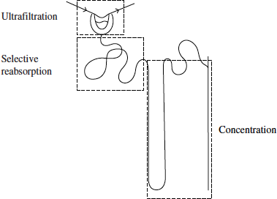

(a) Describe how ultrafiltration produces glomerular filtrate.

1. Blood pressure / hydrostatic pressure;

2. Small molecules / named example;

3. Pass through basement membrane / basement membrane acts as filter;

4. Protein too large to go through / large so stays behind;

5. Presence of pores in capillaries / presence of podocytes;

(b) Some people who have diabetes do not secrete insulin. Explain how a lack of insulin affects reabsorption of glucose in the kidneys of a person who does not secrete insulin.

1. High concentration of glucose in blood;

2. High concentration in tubule / in filtrate;

3. Reabsorbed by facilitated diffusion / active transport;

4. Requires proteins / carriers;

5. These are working at maximum rate / are saturated;

6. Not all glucose is reabsorbed / some is lost in urine;

Q2. In the kidney, ultrafiltration and selective reabsorption are two of the processes involved in the formation of urine.

(a) (i) Where does ultrafiltration occur?

Renal capsule / Bowman’s capsule / glomerulus / basement membrane;

(ii) Give one component of the blood which is not normally present in the filtrate.

blood cells / platelets / proteins / named plasma protein;

(b) The kidneys remove a substance called creatinine from the blood. The rate of creatinine removal is a measure of the rate of filtration of the blood.

In one hour, a person excreted 75 mg of creatinine in his urine. The concentration of creatinine in the blood entering his kidneys was constant at 0.01 mg cm⁻³.

Calculate the rate at which the blood was filtered in cm³ min⁻¹. Show your working.

75 divided by 60 / 75 divided by 0.01;

Answer 125; (Correct answer gains two marks)

Filtration rate = ____________________ cm³ min⁻¹(2)

(c) Reabsorption of glucose takes place in the proximal tubule. Explain how the cells of the proximal tubule are adapted for this function.

(Many) mitochondria provide ATP / energy for active transport;

(Many) carrier proteins for active transport / channel proteins for facilitated diffusion;

Microvilli / brush border provide large surface area (for absorption);

Outcome:
- Explain the importance of maintaining a sodium ion gradient in the medulla, and how this is achieved
- Explain the reabsorption of water from the distal convoluted tubule and collecting ducts.

The majority of the water in the filtrate is reabsorbed in the PCT, the role of the Loop of Henle is to concentrate the urine and reabsorb Sodium and Chloride ions from the filtrate. The length of the Loop differs between species, an adaption linked to availability of water.
The Loop of Henle
1. In the ascending limb Na+ actively removed into Medulla lowering WP;
2. Ascending limb impermeable to water;
3. In descending limb Na+ diffuse in;
4. Descending limb water moves out by osmosis down WP gradient into tissue fluid then into blood;
5. Low water potential in the medulla maintained;
6. The longer the loop / the deeper into medulla, the lower the water potential in medulla;
7. Water also leaves collecting duct / DCT by osmosis;
8. Counter current multiplier

This ensures there is always a lower water potential in the tissue fluid of the medulla than in the filtrate for the whole length of the loop of Henle and collecting duct. This means that water is always reabsorbed into the tissue fluid. Once in the tissue fluid it will be reabsorbed back into the blood.
In the space below draw out how the Loop of Henle works using the mark scheme above. To convert the mark scheme into a diagram requires more concentration so will help improve your memory.

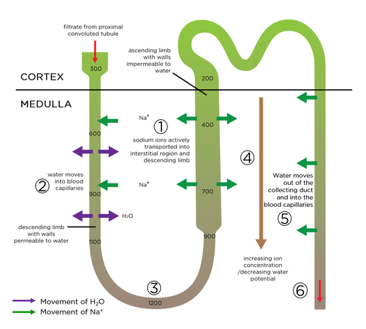

Outcome:
- Explain the role of the hypothalamus and posterior pituitary gland in osmoregulation;
- Explain the responses which are brought about by the release of ADH and link this to negative feedback
Osmoregulation
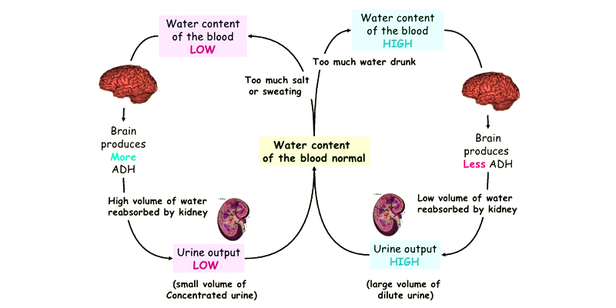
How is the osmoreceptor stimulated?
Year 2 recap exam questions. The graph shows changes in membrane potential that occur during an action potential. It also shows changes in the permeability of the axon membrane to sodium and potassium ions.

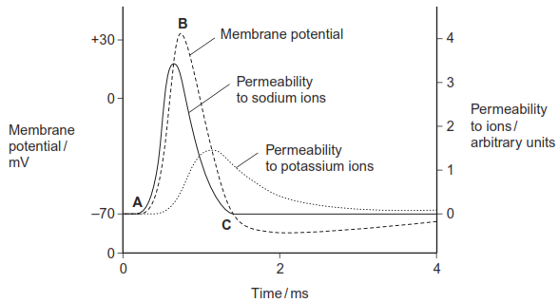

(a) Explain what causes

(i) the change in membrane potential between points A and B,
Mark (i) and (ii) as a whole
Sodium channels open / membrane more permeable to
sodium (ions);
Max 3 for each section
Sodium ions enter;
By diffusion / from high to low concentration;
Allow ‘diffusion’ point ONCE only
Ref. sodium ions have positive charge / cause change
from negative to positive potential;
Accept refs to sodium and potassium

(ii) the change in membrane potential between points B and C.
Sodium channels close;
Potassium channels open / membrane more permeable to
potassium ions;
Potassium ions leave;
By diffusion / from high to low concentration (ONCE only);

Negative feedback system for Osmoregulation.
Fill in the table for a mark scheme perfect answer.
If blood plasma WP is low… | If blood plasma WP is high…
Osmoreceptor in the hypothalamus detect a decrease in WP | Osmoreceptor in hypothalamus detects an increase in WP  The WP in osmoreceptor is lower than WP of blood  Water enters osmoreceptor by osmosis down a WP gradient  Osmoreceptor expands, membrane not deformed  Decrease frequency of action potentials to the pituitary gland stopping release of ADH into blood
The WP in the osmoreceptor is higher than the WP of the blood

Water leaves the osmoreceptor by osmosis down a WP gradient

Osmoreceptor shrinks deforming the membrane of the sensory neurone.

Increasing frequency of action potentials to the pituitary gland causing the release of ADH into the blood capillaries
In the space below draw diagrams to demonstrate how the osmoreceptor is stimulated.
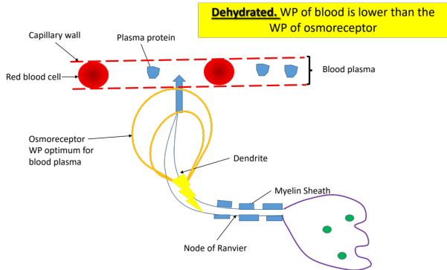
Reponses brought about by the release of ADH

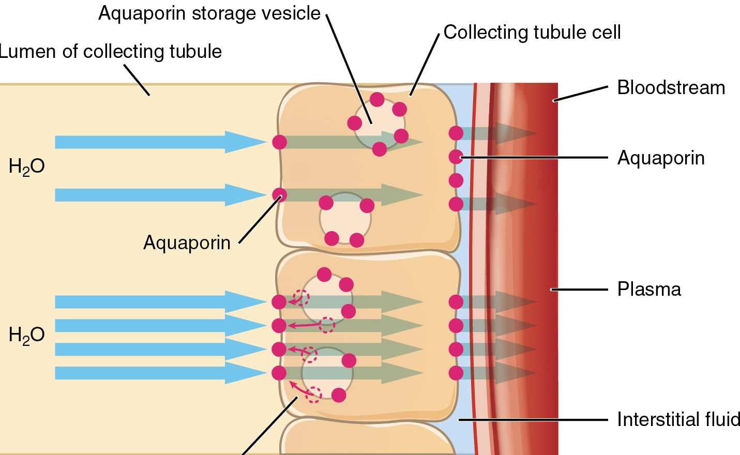

The diagram above is the target cells for ADH- the distal convoluted tubule and the collecting duct.
Read the statements below and add the statements to the diagram above.
- ADH in blood
- Binds to complementary receptors on the surface of collect duct cells
- Causes vesicles with aquaporins to move and fuse to collect duct membrane
- Increases permeability of collecting duct cells to water
- More water moves by osmosis down a WP gradient from collecting duct, into cells then into the blood
- More concentrated urine/smaller volume of urine.
Note: When the osmoreceptors are stimulated in the hypothalamus additional impulses are also sent out to STIMULATE THE THIRST CENTRES of the brain stimulating you to drink more water.

Exam questions:

Q1. The diagram shows a renal capsule where ultrafiltration occurs in the kidney.

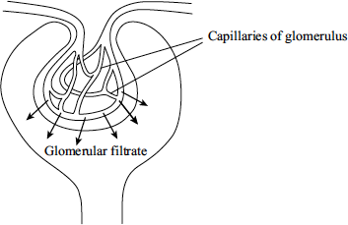

(a) Apart from water and glucose, name two substances which will be present in the glomerular filtrate.

e.g. urea / amino acids / fatty acids / glycerol / ion / small protein;

(one mark for two of above)

(b) The glomerular filtration rate is the total volume of filtrate formed per minute. Explain the effect on the glomerular filtration rate of a large loss of blood from the body.

blood pressure decreased;

(less pressure) forms less filtrate;

(c) Selective reabsorption from the glomerular filtrate occurs in the proximal convoluted tubule. Explain two ways in which the cells of the proximal convoluted tubule are adapted for reabsorption.

microvilli provide large surface area;

carrier proteins (in membrane) for active transport;

channel proteins for facilitated diffusion;

specific carriers for specific molecules / sodium pumps;

(many) mitochondria for active transport;

(d) The threshold value is the maximum plasma glucose concentration at which all the glucose can be reabsorbed from the filtrate. An investigation was carried out to determine the threshold value for glucose reabsorption in the kidneys of a mammal.The graph shows the results.

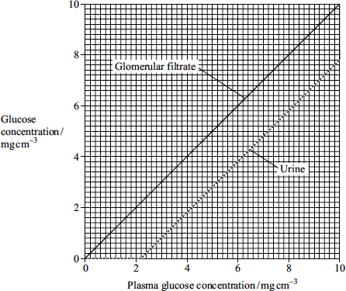

(i) Explain the change in the glucose concentration in the urine as the plasma glucose concentration increases from 0 to 4 mgcm⁻³.

up to 2.2 mg cm⁻³ all glucose reabsorbed / above 2.2 mg cm⁻³ excess glucose not reabsorbed / at 2.2 mg cm⁻³ threshold value reached;

saturation of carriers / active transport mechanism;

(ii) A person with diabetes may have a plasma glucose concentration greater than the threshold value for glucose reabsorption. Explain what causes this raised plasma glucose concentration.

decrease in insulin production / receptors not responsive to insulin / specific damage to tubule described / membrane less permeable to glucose;

Q2. (a) Humans can produce urine which is more concentrated than their blood plasma.

(i) Explain the role of the loop of Henle in the absorption of water from the filtrate.

(a) (i) 1. In the ascending limb sodium(ions) actively removed;

2. Ascending limb impermeable to water;

3. In descending limb sodium(ions) diffuse in;

4. Descending limb water moves out / permeable to water;

5. Low water potential / high concentration of ions in the medulla / tissue fluid;

6. The longer the loop / the deeper into medulla, the lower the water potential in medulla / tissue fluid;

7. Water leaves collecting duct / DCT;

8. By osmosis / down water potential gradient;

(credit once only)

(ii) Explain the role of ADH in the production of concentrated urine.

1. When water potential of the blood too low;

2. Detected by receptors in the hypothalamus;

3. Pituitary secretes / releases (more) ADH;

4. ADH increases the permeability / recruitment of aquaporins / opens channels for water in the DCT / collecting duct;

5. More water is reabsorbed / leaves the nephron moves into the blood;

6. By osmosis down the water potential gradient;

(b) A species of crayfish lives in fresh water. This crayfish does not have kidneys but it does have an organ which excretes nitrogenous waste and controls the amount of water in its body. The diagram shows this excretory organ.

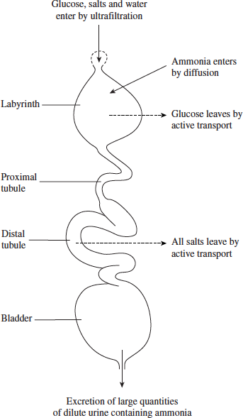

(i) Describe how excretion in this organ differs from excretion in a human nephron.

Ammonia not urea;

Ammonia (into labyrinth) enters by diffusion, not (ultra) filtration;

Reabsorption of glucose from labyrinth, not PCT / no reabsorption in PCT;

All salt reabsorbed / no salt in urine, comparison to humans;

Concentrated urine not produced;

(ii) Suggest how the production of large amounts of dilute urine enables the crayfish to survive in fresh water.

Water potential lower in cytoplasm of cells / fresh water higher water potential than cells / idea of water potential gradient;

(Removal of excess water) prevents osmotic damage;

OR

All salts reabsorbed (because difficult to replace);

Take in excess water and need to remove it;

Q3. Osmoreceptors are specialised cells that respond to changes in the water potential of the blood.

(a) Give the location of osmoreceptors in the body of a mammal.

Hypothalamus.

(b) When a person is dehydrated, the cell volume of an osmoreceptor decreases. Explain why.

Water potential of blood will decrease;

2. Water moves from osmoreceptor into blood by osmosis.

(c) Stimulation of osmoreceptors can lead to secretion of the hormone ADH. Describe and explain how the secretion of ADH affects urine produced by the kidneys.

1. Permeability of membrane / cells (to water) is increased;

2. More water absorbed from / leaves distal tubule / collecting duct;

3. Smaller volume of urine;

4. Urine becomes more concentrated.

The efficiency with which the kidneys filter the blood can be measured by the rate at which they remove a substance called creatinine from the blood. The rate at which they filter the blood is called the glomerular filtration rate (GFR).In 24 hours, a person excreted 1660 mg of creatinine in his urine. The concentration of creatinine in the blood entering his kidneys was constant at 0.01 mg cm^{–3}.

(d) Calculate the GFR in cm³ minute^{–1}.

115.2 / 115.3 (cm³ minute^{–1})

Answer = ____________________(1)

(e) Creatinine is a breakdown product of creatine found in muscle tissues. Apart from age and gender, give two factors that could affect the concentration of creatinine in the blood.

Any two of the following for 1 mark:Muscle / body mass

Ethnicity

Exercise

Kidney disease – do not accept ‘health’.

