3.6.4: Homeostasis and control of blood glucose
Name: _________________________
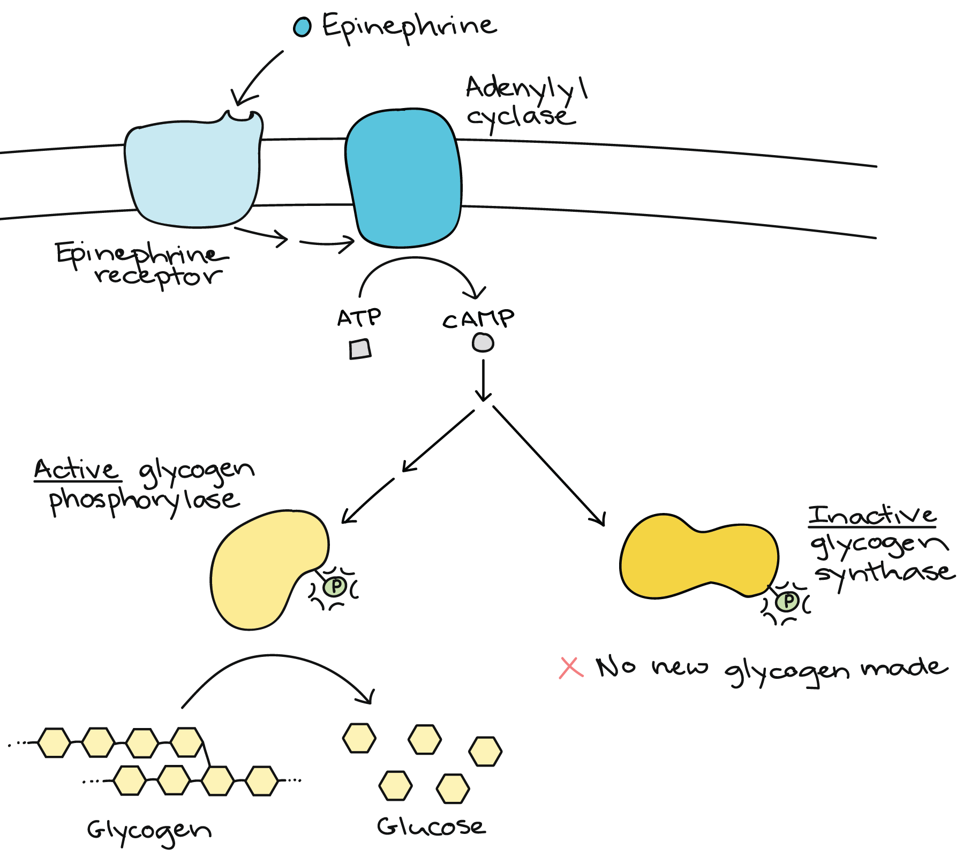
Reflection on Learning objectives | or | Targets
Define what homeostasis is
Describe some factors which are maintained by the body within restricted limits and explain why it is important that it is maintained within restricted limits and the consequences of not doing so
Explain what is meant by negative and positive feedback
Explain the general stages involved in negative feedback, and why these are used in homeostatic mechanisms
Explain the benefit of having separate mechanisms for different departures from the original level
Explain the factors which can influence blood glucose levels.
Explain how hormones work to bring about a response
Explain the role of the pancreas, specifically the α and β cells of the Islets of Langerhans, in regulating blood glucose concentration
Explain what is meant by the term’s glycogenesis, glycogenolysis and gluconeogenesis
Explain what triggers and stages in the release and action of insulin
Explain the role of the liver in glycogenesis, glycogenolysis and gluconeogenesis
Explain what triggers and stages involved in the release of glucagon
Explain what triggers the release of adrenaline and the second messenger model related to adrenaline and glucagon action
Explain the stages involved in the action of adrenaline (linked to blood glucose concentration)
Describe the role of adenyl cyclate, cyclic AMP and protein kinase in the second message model.
Explain the causes and controls of type 1 and type 2 diabetes
Evaluate the positions of health advisers and the food industry in relation to the increased incidence of type II diabetes

Principles of homeostasis
Outcomes:
- Define what homeostasis is
- Describe some factors which are maintained by the body within restricted limits and explain why it is important that it is maintained within restricted limits and the consequences of not doing so


Definition:
Homeostasis: The maintenance of a constant internal environment in the body
Within restricted limits
Despite external changes.
Factors which are maintained by the body within restricted limits:
Factor | Importance of maintaining in restricted limits
Core temperature | Body temp is optimum temp for enzyme  Excess heat denatures enzymes by altering tertiary structure  Alters shape of active site  Reactions slowed;  Too little reduces kinetic energy of molecules  Fewer collisions  Fewer ES complexes formed  Prevents named chemical reactions / metabolic pathways;
Blood pH | Blood pH is optimum for enzymes/proteins  Increase or decrease in pH will denature enzymes by altering tertiary structure  Alters shape or charge of active site breaking Ionic bonds  Reactions slowed  Fewer collisions  Fewer ESC formed  Prevents named chemical reactions/ metabolic pathways
Water potential of blood.
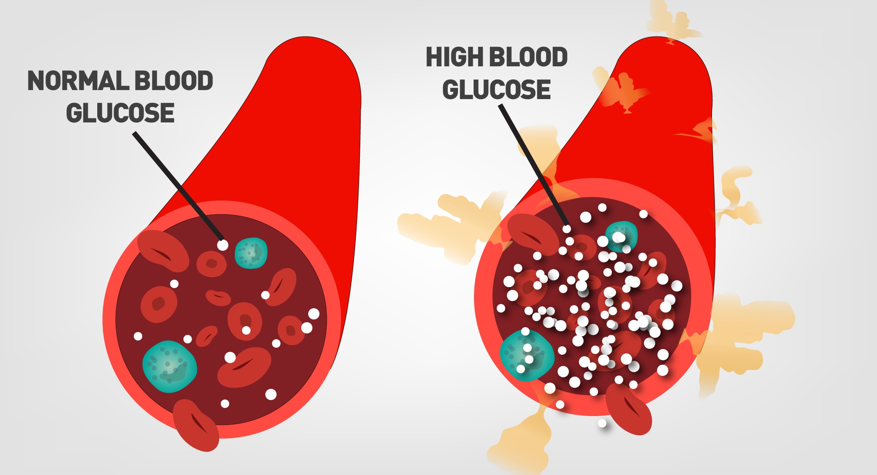
Log practice
- What is pH a measure of?
_____________________________________________________________________________________
- Why do we use a log scale?
_____________________________________________________________________________________
- What is the unit for measuring pH?
_____________________________________________________________________________________
- Draw a diagram to represent log scales.

- A patient has a blood sample has a hydrogen ion concentration of 5.50 x 10⁻⁸ mol dm^{-3.} Show your working

- Calculate the pH of a solution has a hydrogen ion concentration of 0.01mol dm^{-3.} Show your working

Principles of positive and negative feedback
Outcomes:
- Explain what is meant by negative and positive feedback
- Explain the general stages involved in negative feedback, and why these are used in homeostatic mechanisms
- Explain the benefit of having separate mechanisms for different departures from the original level

Feedback mechanism use receptors to detect a change in the system and effectors to bring about the appropriate response. You do NOT need to learn these terms but they are useful to understand and apply to new examples given in the questions.
In your exam they can give you ANY example of negative and positive feedback, you will need to apply these definitions to each example.
Term | Definition
Optimum point
Receptor
Coordinator
Effector

Negative feedback
Definition:
Negative feedback: A change to the normal level triggers a response which reverses / reduces the effect of, the change.
Apply the definition above and your knowledge of thermoregulation to annotate the graph below.

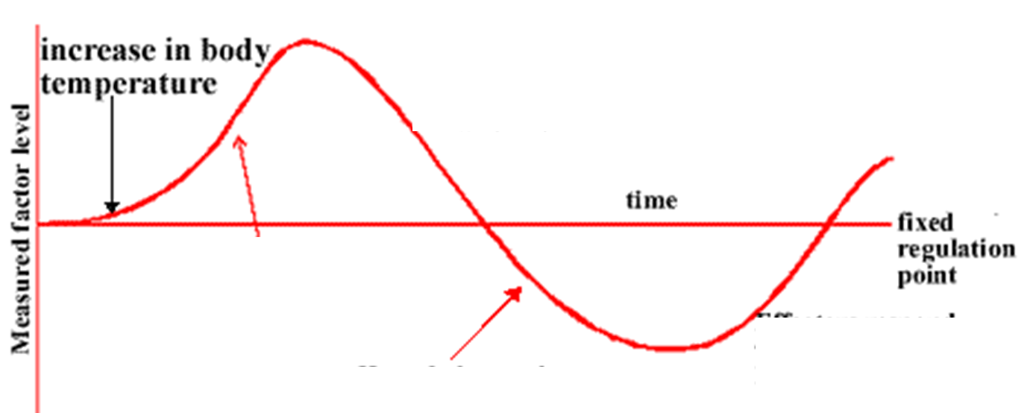

Positive feedback
Definition:
Positive feedback: A change to the normal level triggers a response which increases the effect of, the change.

For the Oxytocin example on the powerpoint can you fill in the table different the different terms.
Term
Stimulus
Receptor
Coordinator
Effector
Effect
Feedback Mechanism

Exam Questions:
Q1. (a) (i) What is meant by homeostasis?
______________________________________________________________
______________________________________________________________(1)
(ii) Giving one example, explain why homeostasis is important in mammals.
______________________________________________________________
______________________________________________________________
______________________________________________________________(2)
(b) Cross-channel swimmers may suffer from muscle fatigue during which the contraction mechan`ism is disrupted. One factor thought to contribute to muscle fatigue is a decrease in the availability of calcium ions within muscle fibres. Explain how a decrease in the availability of calcium ions could disrupt the contraction mechanism in muscles.
___________________________________________________________________
___________________________________________________________________
___________________________________________________________________
___________________________________________________________________(3)

Q2. Interferon gamma is a substance secreted by some types of white blood cells, including helper T cells. It regulates the production of a number of proteins by target cells. Which protein is produced depends on the type of target cell.

The diagram shows how interferon gamma regulates three genes.

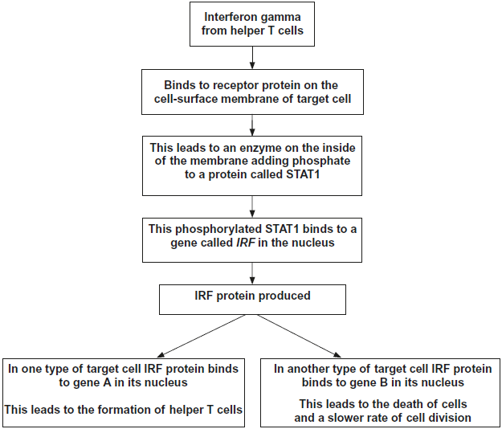

(a) Use information in the diagram to suggest how the binding of interferon gamma to its receptor protein leads to the production of phosphorylated STAT1.

___________________________________________________________________

___________________________________________________________________

___________________________________________________________________

___________________________________________________________________(2)

(c) The regulation of the formation of helper T cells by interferon gamma is an example of positive feedback. Explain why it is an example of positive feedback.

___________________________________________________________________

___________________________________________________________________

___________________________________________________________________(2)

Outcome:
- Explain how hormones work to bring about a response.
- Explain the factors which can influence blood glucose levels
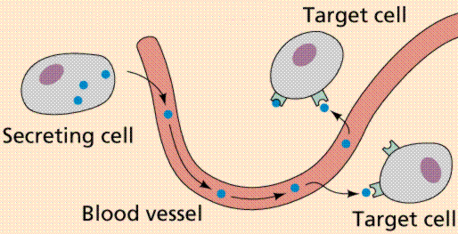

Characteristics of hormones.
Use the words in the box below to complete the gaps
- Produced in ________________.
- Which secrete them directly into ___________________
- Carried in ___________ ______________ to the cells where they act = _________ ___________
- These cells have specific _____________ on their cell surface _______________. that are ___________________ to the specific hormone
- This causes a sequence of events inside cells, using different messengers.
- They are effective in very _____________ ______________ but have ____________ _____________ and ____________ _______________effects.

Receptors | Complementary | Blood | Target cells
Blood plasma | Glands | Membranes | Wide spread
Low concentrations |  | Long-lasting

Controlling Blood Glucose Concentration- Factors
Briefly explain why it is so important to regulate blood glucose concentration. Here are some prompts to help you : Respiration, ATP, death of cell, brain cells
___________________________________________________________________________________________________________________________________________________________________________
Exam questions are usually application questions based on these factors. You need to learn the table but also be able to APPLY the table to different experiments. BGC = Blood Glucose Concentration.
Factor | How does it influence blood glucose concentration?
From diet, e.g. starch hydrolysed to maltose.  From cells, e.g. glycogen hydrolysis, in small intestine, stored in liver and muscle cells | BGC will increase from carbohydrate hydrolysis inside the cells and be released into the blood
Production of glucose from other sources. | BGC will increase. When carbohydrate sources are not available. Glucose is produced from glycerol/amino-acids inside cells.
Increase in mental and physical activity/ used in respiration. | Decrease BGC with increased uptake of glucose into the cells from blood by facilitated diffusion
Not eating | Decreases BGC as glucose/stores inside cells is used but not being replaced through diet.

T/F quiz- Identify the mistakes and correct them.
- All hormones are proteins so bind to specific and complementary receptors on the outside of the organelle.
- Hormones are produced by glands and secreted into blood plasma by exocytosis to be transported around the body
- Hormones have the same affects on their target cells
- Glucose is the only respiratory substrate for the brain and liver
- Glucose is able to produce the most ATP
- Amylase hydrolyses the glycosidic bond in starch to produce maltose, which is hydrolysed by maltase into alpha glucose
- Hydrolysing the glycogen in the blood will increase the blood glucose concentration
- Gluconeogenesis means the creation of new glucose from non-carbohydrate sources
- During your exams your blood glucose concentration drops as you uptake more glucose from the cells into the blood
- When you are fasting or your blood glucose concentration is low the body hydrolyses glucose and releases this into the blood
- A high blood glucose concentration causes a decrease in water potential of the blood, increases the blood pressure and causes accumulation of tissue fluid around cells.

Odd one out- Identify which word doesn’t fit the pattern then explain why you picked this word.
- Glucose Amino-acid Monoglyceride

- Glycogen hydrolysed Gluconeogensis Jogging

- Starch hydrolysed Gluconeogenesis Facilitated diffusion

- Adrenalin Insulin Oestrogen

- Age Genetics Carcinogens

Outcomes:
- Explain the role of the pancreas, specifically the α and β cells of the Islets of Langerhans, in regulating blood glucose concentration,
- Explain what is meant by the term’s glycogenesis, glycogenolysis and gluconeogenesis.
- Explain the role of the liver in glycogenesis, glycogenolysis and gluconeogenesis
Role of the pancreas in regulation of blood glucose concentration
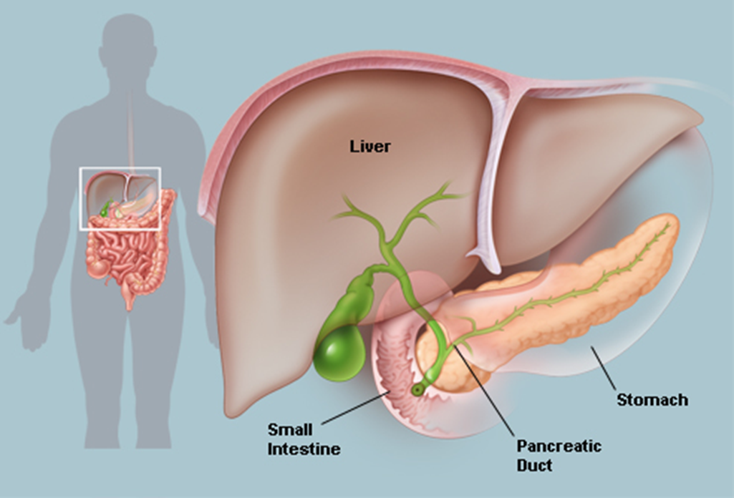
Islets of Langerhans.
The Islets are a tissue. From Year 1 define tissue.
______________________________________________________________________________________________
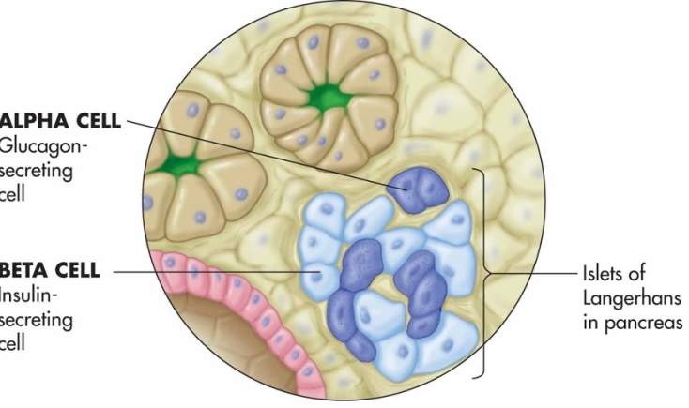
There are 2 types of cells
_______________ is produced by beta cells and _______________. blood glucose concentration
_______________ is produced by alpha cells and _______________ blood glucose concentration

Memory aid:

The alpha and beta cells are specialised to produce huge quantities of protein hormones insulin and glucagon. Describe and explain 3 adaptions would you expect to see in the cell.
Describe adaption | Explain adaptions
Role of Liver in regulation of blood glucose concentration
Hormones produced by pancreas have their effects in the liver; there are 3 important processes which occur:
- Glycogenesis: the conversion of glucose to glycogen,
Occur when BGC is HIGHER than normal,
Causes Liver to removes GLUCOSE from BLOOD,
Converted to GLYCOGEN inside liver cells.
- Glycogenolysis: the breakdown of glycogen. to glucose,
Occurs when BGC is LOWER than normal,
Causes Liver to HYDROLYSES GLYCOGEN to GLUCOSE,
GLUCOSE diffuses into BLOOD from liver cells.
- Gluconeogenesis: the production of glucose from glycerol/amino-acids,
Occurs when BGC is LOWER than normal,
Causes Liver to produces GLUCOSE from GLYCEROL/AMINO-ACIDS,
GLUCOSE diffuses into blood from liver cells.

Annotate the 3 terms on the images below, add arrows to name and show the reactions.

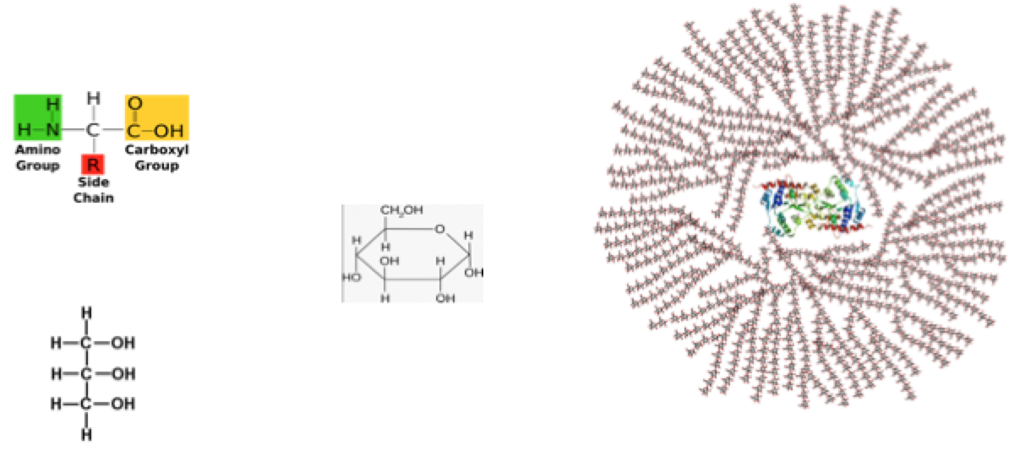

Important note: Insulin and Glucagon cause these processes to occur, the hormones are not enzymes so cannot carry out the processes.
Outcomes:
- Explain what triggers the release of insulin
- Explain the stages involved in the action of insulin
- Explain what triggers and stages involved in the release of glucagon
The action of Insulin and Glucagon
What triggers insulin and glucagon release?
Insulin |  | Glucagon
- Detected by ___________  - Secretes ______________  - Binds to ______________ | Trigger for release | - Detected by _______________  - Secretes __________________  - Binds to __________________
- Increase in no. of glucose transport channel proteins in plasma membrane  - So more glucose into cell by facilitated diffusion  - Activation of enzymes that convert glucose to glycogen (glycogenesis) and fat. | Action
- Absorption of glucose into (muscle/liver) cells as membrane more permeable  - Increased respiration  - Conversion of glucose into glycogen (glycogenesis) in muscle and liver cells | Consequences
- Decrease in BGC | Result | - Increase in BGC
Revision poster for how blood glucose concentration is controlled (pages 11-13)

Exam questions:
Q1. Homeostatic mechanisms maintain a constant environment in the body.
(a) The graph shows changes in plasma glucose concentration that occurred in a person who went without food for some time.
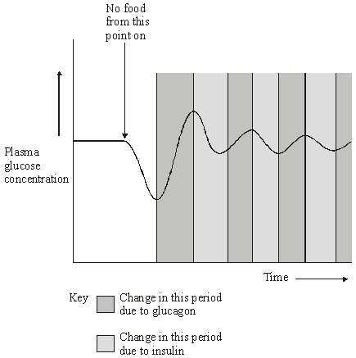
Use evidence from the graph to explain the role of negative feedback in the control of plasma glucose concentration.
___________________________________________________________________
___________________________________________________________________
___________________________________________________________________
___________________________________________________________________
___________________________________________________________________(5)
(b) How does maintaining a constant body temperature allow metabolic reactions in cells to proceed with maximum efficiency?
___________________________________________________________________
___________________________________________________________________
___________________________________________________________________
___________________________________________________________________
___________________________________________________________________
___________________________________________________________________
___________________________________________________________________(5)
Q2. (a) Describe how insulin reduces the concentration of glucose in the blood.
___________________________________________________________________
___________________________________________________________________
___________________________________________________________________
___________________________________________________________________
___________________________________________________________________
__________________________________________________________________(3)
Some people produce no insulin. As a result they have a condition called diabetes. In an investigation, a man with diabetes drank a glucose solution. The concentration of glucose in his blood was measured at regular intervals. The results are shown in the graph.
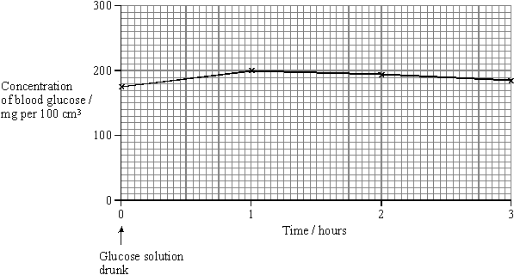
(b) Suggest two reasons why the concentration of glucose decreased after 1 hour even though this man’s blood contained no insulin.
1. _________________________________________________________________
___________________________________________________________________
2. _________________________________________________________________
___________________________________________________________________
(2)
(c) The investigation was repeated on a man who did not have diabetes. The concentration of glucose in his blood before drinking the glucose solution was 80 mg per 100 cm³. Sketch a curve on the graph to show the results you would expect.
(1)
(d) The diabetic man adopted a daily routine to stabilise his blood glucose concentration within narrow limits. He ate three meals a day: breakfast, a midday meal and an evening meal. He injected insulin once before breakfast and once before the evening meal.
The injection he used before breakfast was a mixture of two types of insulin. The mixture contained slow-acting insulin and fast-acting insulin.
(i) Explain the advantage of injecting both types of insulin before breakfast.
______________________________________________________________
______________________________________________________________
______________________________________________________________
______________________________________________________________
(2)
(ii) One day, the man did not eat a midday meal. Suggest one reason why his blood glucose concentration did not fall dangerously low even though he had injected himself with the mixture of insulin before breakfast.
______________________________________________________________
______________________________________________________________
______________________________________________________________
(1)

Outcomes:
- Explain what triggers the release of adrenaline and the second messenger model related to adrenaline and glucagon action
- Explain the stages involved in the action of adrenaline (linked to BGC)
- Describe role of adenyl cyclase, cyclic AMP, protein kinase in the second messenger model

Action of Adrenaline
Mechanism of hormone action (the second messenger model)
Definitions:
First messengers: Molecules that bind to receptors in the plasma membranes of target cells and cause changes to happen inside the target cell.
Second messengers: Molecules found inside the target cell that are affected by the binding of a first messenger to a receptor.
Adrenaline is a protein hormone (first messenger) released by the adrenal gland and is triggered by stress or excitement

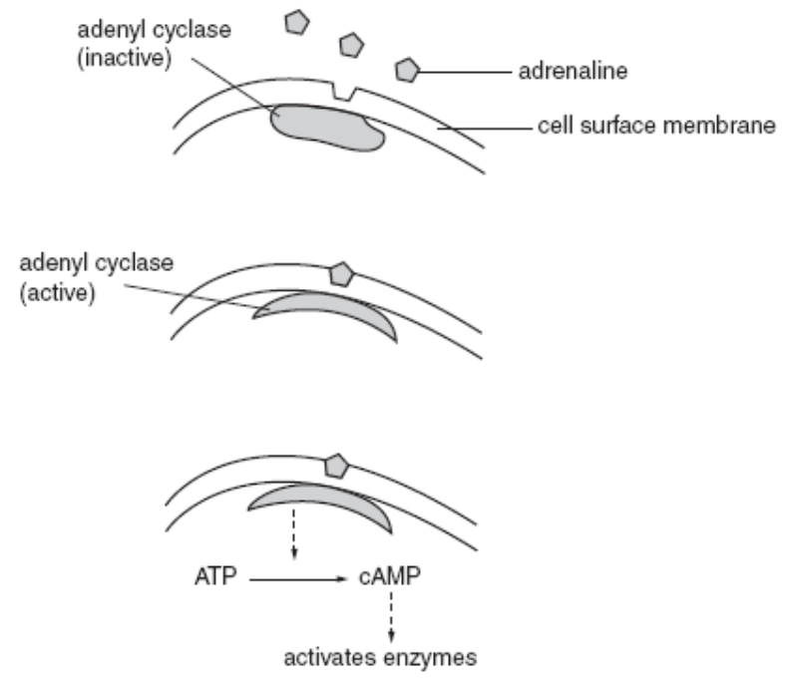

Glycogen --------------- Glucose

Note: Adenylate cyclase and adenyl cyclase are the same enzyme, both names can be used in the exam
Diabetes Mellitus
Causes of diabetes
Outcome:
- Explain the causes and controls of type 1 and type 2 diabetes
- Evaluate the positions of health advisers and the food industry in relation to the increased incidence of type II diabetes

Diabetes is a disease where the body cannot control its blood glucose concentration. This may lead to either very high blood glucose concentrations - hyperglycaemia. or very low blood glucose concentrations - hypoglycaemia
There are 2 types of Diabetes Mellitus:- Type 1 (Insulin dependent) and Type 2 (Non-insulin dependent)
Type 1 (Insulin dependent) | Type 2 (Non-insulin dependent)
Starts at an early age / in childhood (juvenile onset) | Develops with increasing age (usually above 40)
Develops quickly | Develops slowly
Signs and symptoms usually obvious | Signs and symptoms are less severe and may go unnoticed
Causes: Beta cells do not make insulin | Causes: Beta cells still secrete insulin but at low concentrations
Causes: Not linked to obesity, poor diet and sedentary lifestyle | Causes: Linked to obesity, poor diet and sedentary lifestyle
Causes: May be due to an autoimmune response where the immune system attacks its own beta cells | Causes: Glycoprotein receptors on target cells lose their responsiveness to insulin

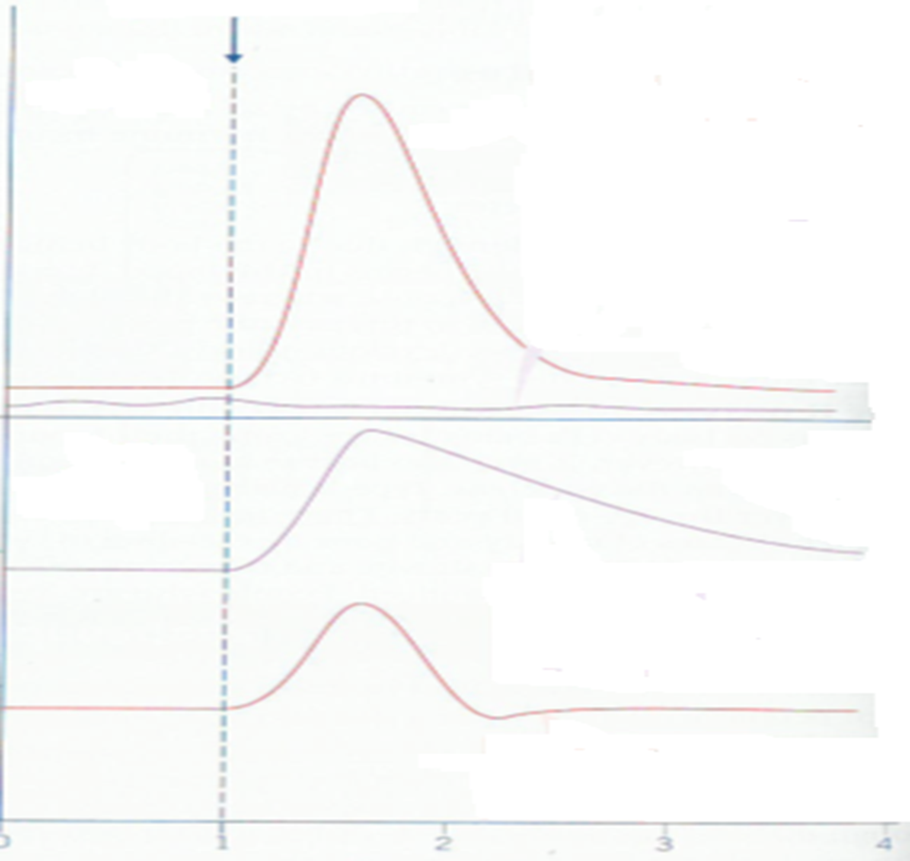
Line D
Line C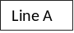
Line A
Line B
Line A
Line B
Line C
Line D

Key skills to remember when interpreting data in an exam:
__________________________________________________________________________________________________________________________________________________________________________________________________________________________________________________________________________________________
Control of Diabetes
Diabetes cannot be cured (currently) but can be successfully treated – type of treatment depends on type of diabetes. Read Page 391 of the text book. Comprehension task. Answer the questions below.
Type 1 diabetes: treated by insulin injections.
- Why can insulin not be taken by mouth?
______________________________________________________________________________________________________________________________________________________________________________
- What is the dose matched to?
______________________________________________________________________________________________________________________________________________________________________________
- What happens if too much insulin is taken?
______________________________________________________________________________________________________________________________________________________________________________
- What is used to ensure the correct dose?
_____________________________________________________________________________________________________________________________________________________________________________
- What else does a diabetic have to do to lead a normal life?
_____________________________________________________________________________________________________________________________________________________________________________

Type 2 diabetes:
Controlled by regulating the intake of __________________________
Matching to the amount of __________________________________
Supplemented by _________________________________________
Note: In your exam you will be given information about food manufacturers, health visitors, the government ect in the form of a comprehension or data. You will need to read the information and answer specific questions, you do not need to learn specific information about this specification point.
______________________________________________________________________________________________
Exam questions:
Q1. (a) Explain how insulin lowers the concentration of blood glucose.
___________________________________________________________________
___________________________________________________________________
___________________________________________________________________
___________________________________________________________________
___________________________________________________________________
___________________________________________________________________
___________________________________________________________________(3)
(b) Doctors studied a large group of people. They recorded the death rates for non-diabetic people, undiagnosed diabetics and diagnosed diabetics. They gave the death rates as deaths per 1000 years lived by people. The graph shows these death rates.
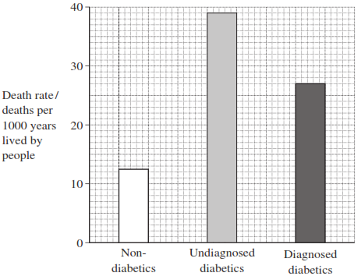
(i) Calculate the ratio of the death rate of diagnosed diabetics to undiagnosed diabetics.

Ratio ____________________(2)
(ii) People with undiagnosed diabetes were not receiving treatments, such as insulin injections. Suggest one reason for the difference in death rates for undiagnosed and diagnosed diabetics.
______________________________________________________________
______________________________________________________________
______________________________________________________________
______________________________________________________________(2)

Q2. (a) Adrenaline binds to receptors in the plasma membranes of liver cells. Explain how this causes the blood glucose concentration to increase.

___________________________________________________________________

___________________________________________________________________

___________________________________________________________________

___________________________________________________________________

___________________________________________________________________(2)

Q3. A glucose biosensor is an instrument used to measure glucose concentration. It contains an enzyme called glucose oxidase.

(a) A glucose biosensor detects only glucose. Use your knowledge of the way in which enzymes work to explain why.

___________________________________________________________________

___________________________________________________________________

___________________________________________________________________

___________________________________________________________________

___________________________________________________________________

___________________________________________________________________(3)

(b) It is better to use a biosensor than the Benedict’s test to measure the concentration of glucose in a sample of blood. Suggest two reasons why.

1. _________________________________________________________________

___________________________________________________________________

2. _________________________________________________________________

___________________________________________________________________(2)

(c) (i) Diabetes mellitus is a disease that can lead to an increase in blood glucose concentration. Some diabetics need insulin injections. Insulin is a protein so it cannot be taken orally. Suggest why insulin cannot be taken orally.

______________________________________________________________

______________________________________________________________(1)

(ii) A drug company produced a new type of insulin. Scientists from the company carried out a trial in which they gave this new type of insulin to rats. They reported that the results of this trial on rats were positive. A newspaper stated that diabetics would benefit from this new drug. Suggest two reasons why this statement should be viewed with caution.

1. ____________________________________________________________

______________________________________________________________

2. ____________________________________________________________

______________________________________________________________(2)

